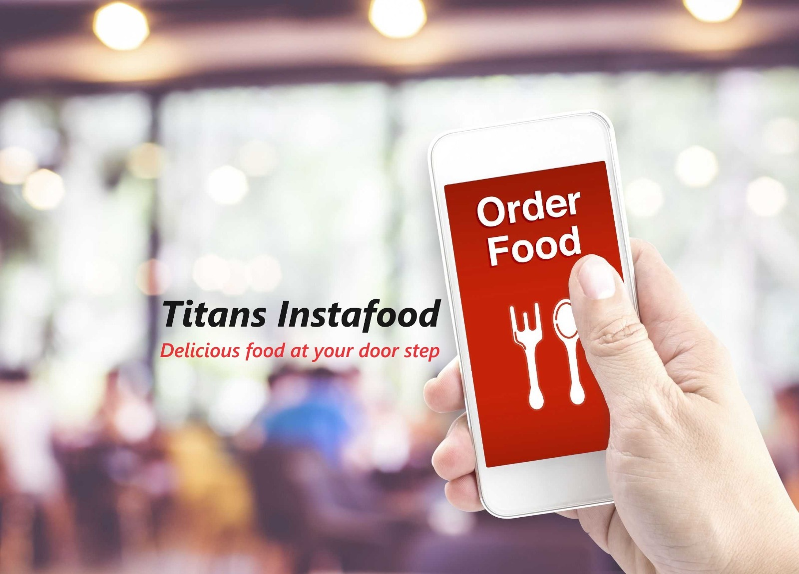

**Feasibility Analysis and Cost/Benefit**

**Solution Overview: Titans Food Ordering System**

The Food Ordering System is a comprehensive digital platform designed to streamline and enhance the process of ordering food from various restaurants. In a world where convenience and efficiency are paramount, this system aims to provide users with a seamless and enjoyable experience, bridging the gap between restaurants and customers. The system encompasses a user-friendly interface accessible through both web and mobile applications, allowing users to explore diverse menus, place orders, and track deliveries with ease. Customer orders are efficiently handled within the system. Restaurants receive notifications of incoming orders, which they can accept, reject, or modify, as necessary. Orders are tracked from placement to delivery or pickup, ensuring transparency and accountability throughout the process. The system integrates secure payment processing, enabling customers to pay for orders online usingcredit/debit cards, digital wallets, or other accepted methods. Restaurant owners receive payments directly, streamlining financial transactions and reducing manual processing. The system includes features for customers to leave feedback and ratings post-order completion. This allows restaurants to gather insights into customer satisfaction, identify areas for improvement, and uphold service quality.

**Technical Feasibility**

**Project Possibilities**

The proposed food ordering system requires strong technical capabilities to ensure seamless functionality. Our development team possesses extensive expertise in web and mobile application development and database management systems to ensure the project's technical viability. We will use flexible technologies to enable unified integration and adaptability to future enhancements. While our team is highly skilled, there is a high risk associated with the complexity of integrating various technologies, hence the need for continuous training and staying updated with the latest advancements, which will be crucial to mitigate this risk.

**Familiarity with Technology**

Our development team is well-versed in the technologies required for building a food ordering system. We have successfully implemented similar solutions in the past, demonstrating our familiarity with the tools and frameworks needed for this project.

Given our experience, the risk associated with technological familiarity is low. However, staying updated with emerging technologies is essential to mitigate any potential challenges.

**Familiar with Type of Data**

The proposed system involves handling diverse data sets, including user profiles, menus, and order histories. Our team has experience managing large datasets and implementing efficient data storage and retrieval mechanisms. Managing large datasets poses a moderate risk. Implementing proper data encryption, backups, and efficient algorithms will be crucial to mitigate potential data-related issues.

**Size of the Project**

Our team has successfully delivered projects of varying sizes, from small-scale applications to complex systems with extensive functionalities. This experience positions us well to manage the scope and scale of the proposed food ordering system.

The risk associated with project size is low, given our team's proven track record in handling diverse project scopes. However, regular project monitoring and communication will be essential to ensure timely delivery.

Overall, the technical feasibility of the food ordering system is deemed high. While there are essential risks associated with technology complexity and data handling, our team's expertise and experience provide a solid foundation for successful project execution. Regular training and updates will be essential to address potential challenges and ensure the continuous improvement of our technical capabilities.

**Organizational Feasibility**

The success of implementing a Food Ordering System for Titans Food is contingent upon the organization's readiness to embrace change and adopt modern technologies.

**Will the organization use what is requested?**

The willingness of Titans Food to use the proposed Food Ordering System is a crucial factor to suggest if the project will be feasible. Our finding shows that the average staff of Titan Food are skilled with digital tools with adept communication skills.

**How will the end users / management handle the change?**

The system will enable connections between the end users, management team and customers. Training is equally important to help such people adapt to change effectively and will be supported to ensure optimal returns. Due to these factors, management has expressed readiness to embrace and support the project. The ease with which Titans end users and management adapt to change in their process of food ordering plays an essential role in productivity. A complete change management plan is in place to address potential resistance. Though, the inherent risk associated with organizational change suggests a moderate level of concern regarding the smooth transition.

**Is there a project champion to promote the project?**

At least two project champions will be nominated to promote this project. A project champion is key in communicating the project process, providing leadership, and ensuring that the project aligns with the organization's goals.

**Will the management support the project?**

Our initial feedback engagement suggests a moderate risk in terms of overall enthusiasm. While there is recognition of the benefits, some receptacles of uncertainty may exist among end users regarding the necessity of a new system.

**Economic Feasibility**

Due to the increasing popularity of online ordering platforms in today's age, and the lifestyle changes of remote settings, there has been a growing demand for convenient food ordering and delivery services. Does not involve any manual labor on our part once started, more about maintaining a working product. The main revenue sources come from an increase in sales quantity through the system's promotional capabilities that will engage more customers, the system will eliminate spending on manual processes and reduce operational costs. Our pricing strategies will give rise to a retention rate while staying competitive with other similar companies. The system will take advantage of the geographical location and population within the axis and analyze customer behavior and the average order to sustain competitive advantage for the best profit margins.

**Cost Benefit Analysis**

|  |  |  |  |  |  |  |  |
| --- | --- | --- | --- | --- | --- | --- | --- |
|  | | **Year 1 ($)** | **Year 2 ($)** | **Year 3 ($)** | **Year 4 ($)** | **Year 5 ($)** | **Total** |
| **Benefits** | |  |  |  |  |  |  |
| 110 | Increased Revenues | 0 | 56000 | 78400 | 109760 | 153664 | 397824 |
| 111 | Increased Sales | 0 |  |  |  |  |  |
| 114 | Decreased Administrative Costs | 0 | 42,000 | 43,260 | 44,558 | 45,895 | 175,712 |
| 115 | Customer Retention | 0 |  |  |  |  |  |
|  | **Total Benefits** | **0** | **102,000** | **121,260** | **145,958** | **139,495** | **297,392** |
|  |  |  |  |  |  |  |  |
| **Development costs** | |  |  |  |  |  |  |
| 211 | Labor: Project Manager | 10,200 | - | - | - | - | 10,200 |
| 212 | Labor: Business Analyst | 14,400 | - | - | - | - | 14,400 |
| 213 | Labor: Senior Developer 1 | 19,200 | - | - | - | - | 19,200 |
| 214 | Labor: Web Designer | 4,800 | - | - | - | - | 4,800 |
| 214 | Labor: Web Designer | 8,320 | - | - | - | - | 8,320 |
| 214 | Quality Control | 3,200 | - | - | - | - | 3,200 |
|  |  |  |  |  |  |  |  |
|  | **Total development costs** | **60,120** | - | - | - | - | **60,120** |
|  |  |  |  |  |  |  |  |
| **Operational costs** | |  |  |  |  |  |  |
| 311 | Software Upgrades | - | 3,072 | 3,072 | 3,072 | 3,072 | 12,288 |
| 312 | Software Licenses | - | 10,000 | 15,000 | 15,000 | 15,000 | 20,000 |
| 313 | Database Administrator |  | 10,000 | 10,000 | 10,000 | 25,000 | 30,000 |
| 315 | System Recovery | - | 2,000 | 2,000 | 2,000 | 2,000 | 8,000 |
| 316 | Training | - | 2,000 | 2,800 | 2,800 | 2,800 | 2,800 |
|  | **Total operational costs** | **0** | **27,072** | **32,872** | **32,872** | **47,872** | **73,088** |
|  |  |  |  |  |  |  |  |
| **401** | **Total costs** | **60,120** | **27,072** | **32,872** | **32,872** | **47,872** | **133,208** |
| **402** | **Net benefits** | **(60,120)** | **74,928** | **88,388** | **113,086** | **91,623** | **164,184** |
| **403** | **Cumulative Net Cash Flow** | **(60,120)** | **14,808** | **103,196** | **216,282** | **307,904** |  |
|  |  |  |  |  |  |  |  |

**Overall Risk Assessment**

|  |  |  |
| --- | --- | --- |
| Questions | Answer | Rating |
| How long will it take to implement the proposed project | 1 to 6 months | 1 |
| What are the estimated project costs | $25,000 to $75,000 | 1 |
| Degree of anticipated change to existing business processes: | High | 100 |
| Number of employees impacted by the system | 1 to 20 | 1 |
| Number of agencies impacted by the system | four to Eight | 100 |
| Anticipated user attitude to the new process/system: | Neutral | 100 |
| Number of existing applications that must feed or receive data from the new system | 0 | 1 |
| Volume of required data to be converted from existing system to new system: | None | 1 |
| Complexity of the required conversion | No Conversion Required | 1 |
| Will the system be implemented with an off-the-shelf system | No | 500 |
| Has the Titans Food developed/implemented system similar in size and complexity in the past | No | 500 |
| Project teams' level of experience with the business process being impacted | Medium | 100 |
| Titans Food staffs experience with implementing systems with similar technologies | Low | 250 |
| Support of Department Head (s) and Senior Managers in the impacted agencies | High | 1 |
| Other external entity, such as the State, is involved in the project | External Entity is Playing a Minor Roles | 250 |
| **Project Score: 1803** |  | |
|  | | |
| **Risk Assessment based on Project Score range from 1,001 to 2,500 (Low Risk)** | | |
|
|  | | |

In summation, the overall feasibility risk for the Food Ordering System is assessed as low. While there is positive support from management, a designated project champion, and planned measures to facilitate user adoption, the Titans must remain vigilant in addressing potential challenges associated with change management and skepticism among end users. A proactive and adaptive approach will be crucial to navigate these organizational dynamics successfully. Regular assessments and feedback mechanisms are recommended to ensure continuous alignment with organizational goals and sustained enthusiasm throughout the project development and system usage.

**Recommendations**

Implementing a food ordering system is crucial for Titans Food to stay competitive in the current market and adapt to the changing demands of its customers. This initiative will not only improve the customer experience but also streamline operations and boost revenue growth. **Increased Customer Reach**: The implementation of a food ordering system will expand Titans Food's reach to customers, enabling them to place orders conveniently from their homes or while on the move using digital features. This accessibility will attract new customers and foster repeat business. **Efficient Operations:** By automating the ordering process and integrating with the latest devices and modern systems, we can enhance operational efficiency, minimize errors, and optimize workflow. This will allow the staff to focus on enhancing customer service and driving business growth. **Improved Customer Satisfaction:** With a user-friendly interface, real-time order tracking, and customization options, this will elevate the overall customer experience, resulting in higher satisfaction rates and positive referrals. Satisfied customers are more likely to become loyal supporters and advocates for the brand. **Insightful Data Analysis:** The food ordering system's analytics and reporting features will offer valuable insights into customer behavior, preferences, and market trends. This data-driven approach will empower Titans Food to make informed decisions, refine marketing strategies, and identify new growth opportunities. **Competitive Edge:** In today's competitive landscape, providing a seamless and convenient food ordering experience distinguishes us from our rivals. Investing in a food ordering system will highlight Titans' dedication to innovation and customer-centricity, positioning Titans Food as the food industry leader.

**Revenue Growth:** The food ordering system has the potential to attract new customers, foster repeat business, and generate higher order volumes, leading to an increase in revenue for the business. Over time, the initial investment will prove to be worthwhile as it translates into higher sales and profitability within the first two years. **Adaptation to Market Trends:** The system will ensure you stay relevant, as businesses must adapt and evolve in line with the growing trend of online and mobile ordering. By embracing technology and offering a modern food ordering solution, you demonstrate the ability to respond to changing consumer preferences and market dynamics. **Scalability and Futureproofing:** This well-designed food ordering system is not only scalable but also adaptable to future growth and technological advancements. It ensures Titans Food business remains flexible and capable of meeting the evolving needs of our customers and the industry as a whole. **Operational Efficiency:** By automating manual tasks and streamlining processes, the food ordering system will enhance operational efficiency, resulting in cost savings and increased productivity. This will enable us to allocate resources more effectively and concentrate on strategic initiatives that drive business growth. **Customer Retention:** By providing a seamless and convenient ordering experience, we can build customer loyalty and encourage repeat business. This will contribute to the long-term success of our business. We have full confidence that the proposed system will bring significant value to the business, and we eagerly anticipate its successful implementation. Thank you for considering this proposal. We are enthusiastic about the opportunity to bring this project to fruition and are

dedicated to delivering a top-notch food ordering system for Titans Food.