Impact of education level on mental health pre & post recesson

Emmanual C. Anadi ([eamadi45@gmail.com](mailto:eamadi45@gmail.com))

2023-07-05

Table of Contents

# Summary of findings

For all four measures of mental health (GHQ36, GHQG2, SRH and EQ utility scores), overtime and on average, the employed class of respondents had a better level of mental health compared to the rest groups and the retired class had showed the worst level of mental health. Interestingly, post 2008, the mental health of the retired class showed an upward trend where the other groups showed a downward trend - using EQ utility score as an a measure of mental health.

We used a Chi-squared test to assess the relationship between mental health (using SRH) and employment status pre and post 2008 recession and both tests confirmed that there was an statistically significant association between both variables before the recession and this continued to be the case in the years following the recession. It is worth nothing that we have not been able to verify one of the core assumptions of a Chi-squared test, which is in dependence of observations in the data. Even though a new sample is drawn for the HSE survey each year, we have not been able to verify that these respondents are unique for each year. Therefore is it worth assessing this relationship with another method.

# Methodology

# Limitations

1. Health Survey England draws a new sample of respondents every year (see [here](https://academic.oup.com/ije/article/41/6/1585/741862)), however from our review of the survey information, we cannot guarantee that all responds are unique through the years which is a key assumption for employing statistical tests such as Chi-Square and Fisher’s exact test.
2. Following from the point above, it is worth noting that there seem to be duplicated serial numbers (39,500). See appendix.

# Objective 1

In this section, we explore the trend of mental health between 2000-2019 between the different employment categories.

## Using GHQ36 as a measure of mental health

## `summarise()` has grouped output by 'year'. You can override using the  
## `.groups` argument.

## Warning: Removed 4 rows containing missing values (`geom_line()`).

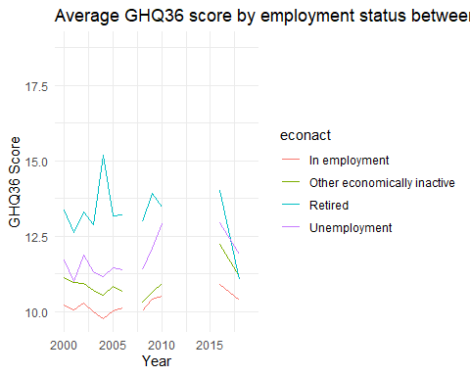

## `summarise()` has grouped output by 'year'. You can override using the  
## `.groups` argument.

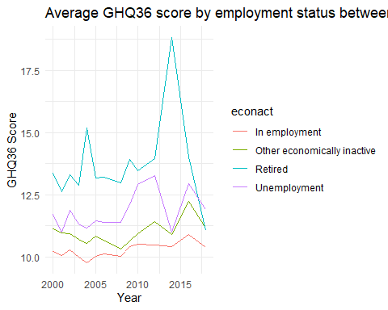

## Using GHQG2 as a measure of mental health

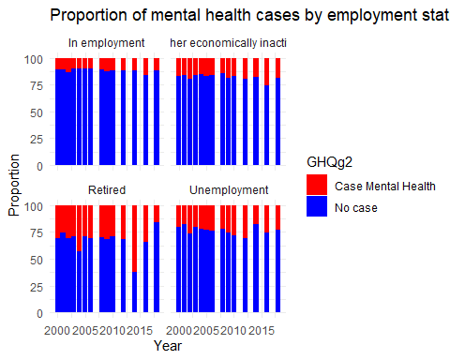

## Using EQ-3D scores

Note: 9 years of out the 19 we are examining do not have EQ. These are

## 2000, 2001, 2002, 2007, 2009, 2013, 2015, 2016, 2019

## `summarise()` has grouped output by 'year'. You can override using the  
## `.groups` argument.

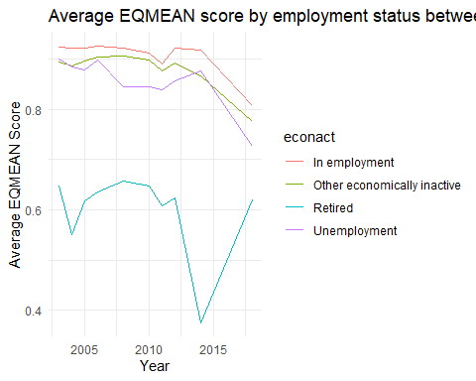

## Using SRH

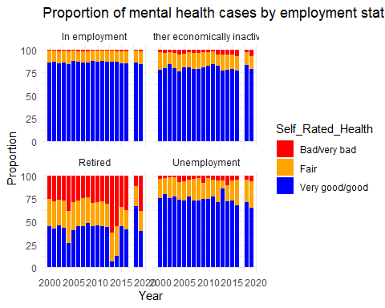

# Objective 2

To assess the relationship between employment status and mental health in different population groups (gender, weight and education) we make a selection of 3 cohorts. The 2000 cohort of respondents which is the earliest year we have data for, 2008 which is the year of significant event in our study i.e the recession and 2019 which is the latest year we have data for. It is worth noting that we do not have GHQ36 and GHQ2 data for 2019.

## Cohort 2000

### Using GHQ36 as a measure of mental health

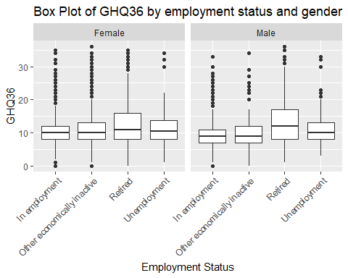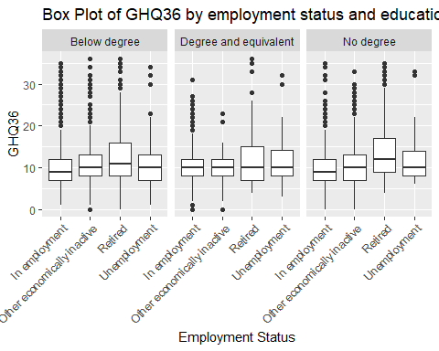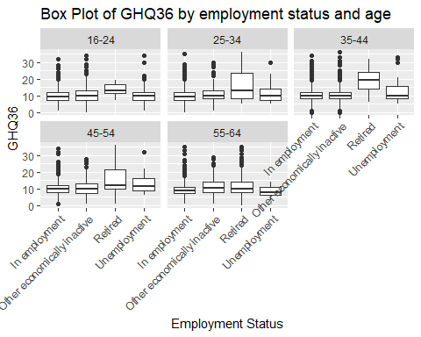 ### Using GHQG2 as a measure of mental health 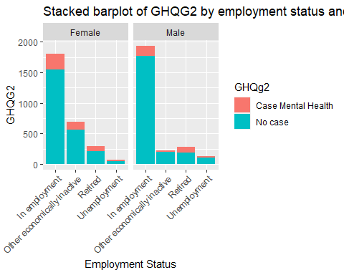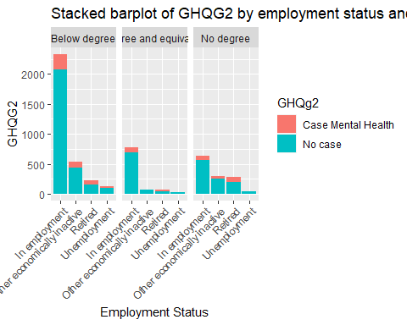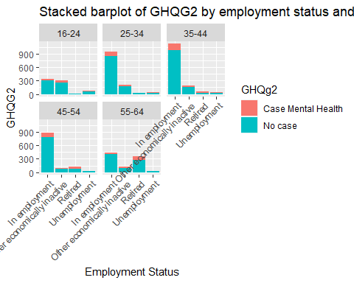 ### Using SRH as a measure of mental health 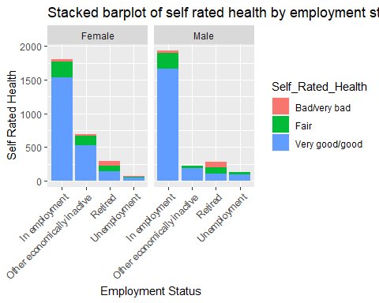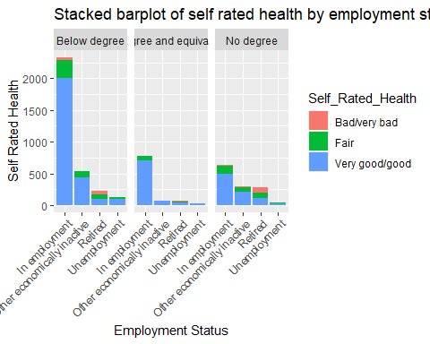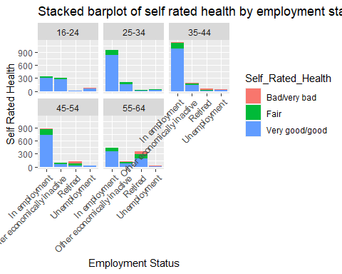

## Cohort 2008

### Using GHQ36 as a measure of mental health

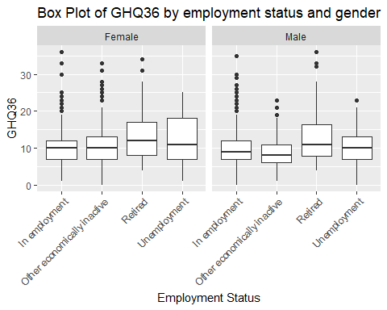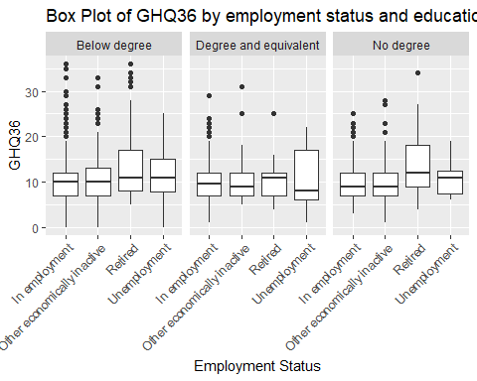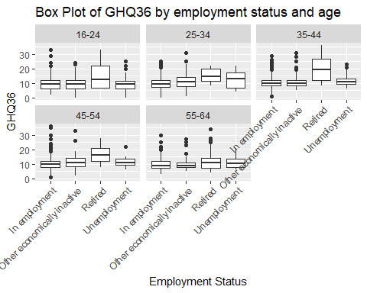 ### Using GHQG2 as a measure of mental health 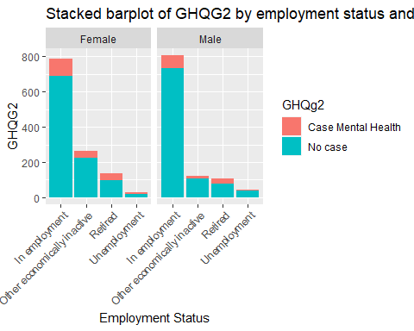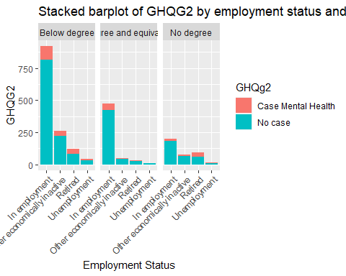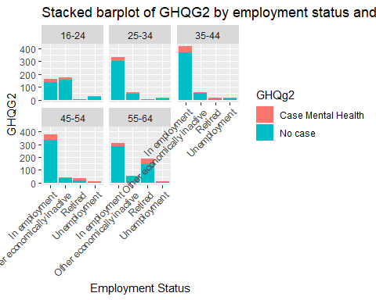 ### Using SRH as a measure of mental health 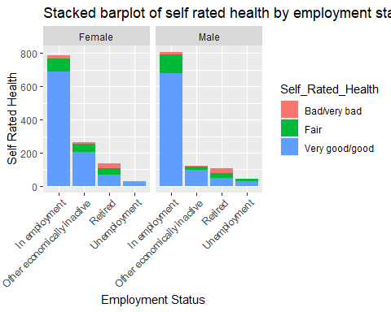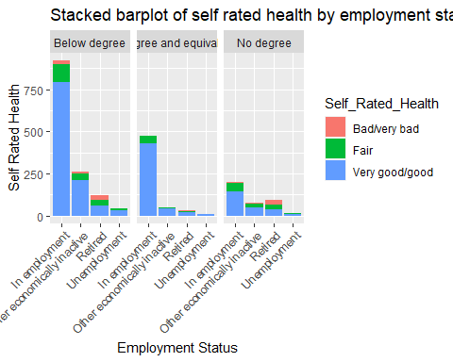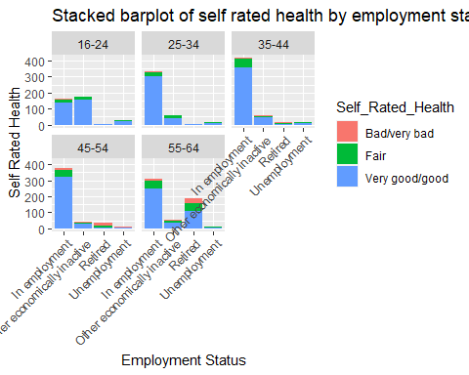

## Cohort 2019

### Using SRH as a measure of mental health

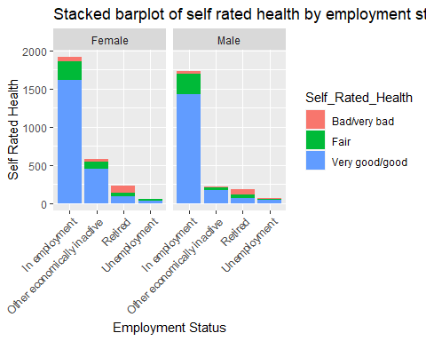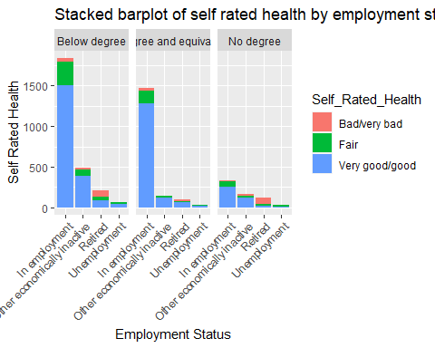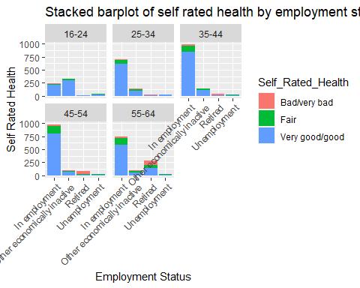

# Objective 3

Our aim in this section is to test the relationship between employment status and mental health before and after the 2008 recession. We use SRH as our measure of mental health, given that it is the only measure that has no missing value for all observations from 2000-2019. We have employed Chi-squared test of independence to assess this relationship separately for years preceding 2008 and post-2008. A better technique would be to do a log linear analysis which is the planned next step for this work.

## Hypothesis 1 (Pre-recession)

H0: Employment status is independent of mental health pre-recession H1: There is an association between employment status and mental health pre-recession

##   
## Cell Contents  
## |-------------------------|  
## | Count |  
## | Expected Values |  
## | Row Percent |  
## | Std Residual |  
## |-------------------------|  
##   
## Total Observations in Table: 52165   
##   
## | pre_2008$Self_Rated_Health   
## pre_2008$econact | Bad/very bad | Fair | Very good/good | Row Total |   
## ----------------------------|----------------|----------------|----------------|----------------|  
## In employment | 571 | 4406 | 30278 | 35255 |   
## | 1668.640 | 5369.519 | 28216.841 | |   
## | 1.620% | 12.498% | 85.883% | 67.584% |   
## | -26.871 | -13.149 | 12.270 | |   
## ----------------------------|----------------|----------------|----------------|----------------|  
## Other economically inactive | 373 | 1613 | 7923 | 9909 |   
## | 468.999 | 1509.192 | 7930.809 | |   
## | 3.764% | 16.278% | 79.958% | 18.995% |   
## | -4.433 | 2.672 | -0.088 | |   
## ----------------------------|----------------|----------------|----------------|----------------|  
## Retired | 1456 | 1567 | 2228 | 5251 |   
## | 248.533 | 799.755 | 4202.713 | |   
## | 27.728% | 29.842% | 42.430% | 10.066% |   
## | 76.592 | 27.130 | -30.461 | |   
## ----------------------------|----------------|----------------|----------------|----------------|  
## Unemployment | 69 | 359 | 1322 | 1750 |   
## | 82.829 | 266.534 | 1400.637 | |   
## | 3.943% | 20.514% | 75.543% | 3.355% |   
## | -1.519 | 5.664 | -2.101 | |   
## ----------------------------|----------------|----------------|----------------|----------------|  
## Column Total | 2469 | 7945 | 41751 | 52165 |   
## ----------------------------|----------------|----------------|----------------|----------------|  
##   
##   
## Statistics for All Table Factors  
##   
##   
## Pearson's Chi-squared test   
## ------------------------------------------------------------  
## Chi^2 = 8641.332 d.f. = 6 p = 0   
##   
##   
##   
## Minimum expected frequency: 82.82852

### Interpretation

There is a statistically significant association between employment status and mental health measured by SRH for the years preceding the 2008 recession. The test statistic (X2) is 8641.33 with a degree of freedom of 6 and significant at a p-value < 0.05. The minimum expected frequency is 82.83 (greater than 5) which verifies one of the core assumptions of a chi-squared test.

## Hypothesis 2 (Post-recession)

H0: Employment status is independent of mental health post-recession H1: There is an association between employment status and mental health post-recession

##   
## Cell Contents  
## |-------------------------|  
## | Count |  
## | Expected Values |  
## | Row Percent |  
## | Std Residual |  
## |-------------------------|  
##   
## Total Observations in Table: 47016   
##   
## | post_2008$Self_Rated_Health   
## post_2008$econact | Bad/very bad | Fair | Very good/good | Row Total |   
## ----------------------------|----------------|----------------|----------------|----------------|  
## In employment | 578 | 4114 | 28407 | 33099 |   
## | 1717.746 | 4734.362 | 26646.891 | |   
## | 1.746% | 12.429% | 85.824% | 70.399% |   
## | -27.500 | -9.016 | 10.782 | |   
## ----------------------------|----------------|----------------|----------------|----------------|  
## Other economically inactive | 430 | 1315 | 6791 | 8536 |   
## | 442.995 | 1220.959 | 6872.046 | |   
## | 5.037% | 15.405% | 79.557% | 18.156% |   
## | -0.617 | 2.691 | -0.978 | |   
## ----------------------------|----------------|----------------|----------------|----------------|  
## Retired | 1356 | 984 | 1642 | 3982 |   
## | 206.655 | 569.571 | 3205.774 | |   
## | 34.053% | 24.711% | 41.236% | 8.469% |   
## | 79.952 | 17.365 | -27.619 | |   
## ----------------------------|----------------|----------------|----------------|----------------|  
## Unemployment | 76 | 312 | 1011 | 1399 |   
## | 72.604 | 200.108 | 1126.288 | |   
## | 5.432% | 22.302% | 72.266% | 2.976% |   
## | 0.399 | 7.910 | -3.435 | |   
## ----------------------------|----------------|----------------|----------------|----------------|  
## Column Total | 2440 | 6725 | 37851 | 47016 |   
## ----------------------------|----------------|----------------|----------------|----------------|  
##   
##   
## Statistics for All Table Factors  
##   
##   
## Pearson's Chi-squared test   
## ------------------------------------------------------------  
## Chi^2 = 8493.521 d.f. = 6 p = 0   
##   
##   
##   
## Minimum expected frequency: 72.60422

### Interpretation

There is a statistically significant association between employment status and mental health measured by SRH for the years after the 2008 recession. The test statistic (X2) is 8493.52 with a degree of freedom of 6 and significant at a p-value < 0.05. The minimum expected frequency is 72.60 (greater than 5) which verifies one of the core assumptions of a chi-squared test.

# Appendix

1. Data completeness

See below for the number of missing observations we have for each variable.

## X year pserial Age   
## 0 0 18838 0   
## Weight econact topqual3 GHQg2   
## 0 0 0 25483   
## genhelf2 GHQ36Scr Sex Employment_Status   
## 0 25483 0 0   
## Self_Rated_Health Highest_Edu_Attain Int_Weight EQMEAN   
## 0 0 19360 47254   
## SerialA Seriala   
## 86848 97274

1. Duplicate serial numbers See below for the number of duplicate individual serial numbers

## [1] 39500