
Session - 02
Installation


Contents
Installation 3
What is Adobe Experience Manager? 3
Prerequisites 3
Installing Adobe Experience Manager on Your System 5
Starting an Adobe Experience Manager Instance 7
Using the GUI to Start an Adobe Experience Manager Instance 7
Using the Command Line to Start Adobe Experience Manager Author Instance 9
Using the Command Line to Start Adobe Experience Manager Publish Instance 10
Lab Activity 11
Task - Start an Adobe Experience Manager Author instance 11
Task - Start an Adobe Experience Manager Publish instance 12
Task - Start and install Adobe Experience Manager using command line [optional] 13

Installation

What is Adobe Experience Manager?
Adobe Experience Manager is a web-based client-server system for building, managing, and deploying commercial websites and related services. A number of infrastructure-level and application-level functions are combined into a single integrated package.
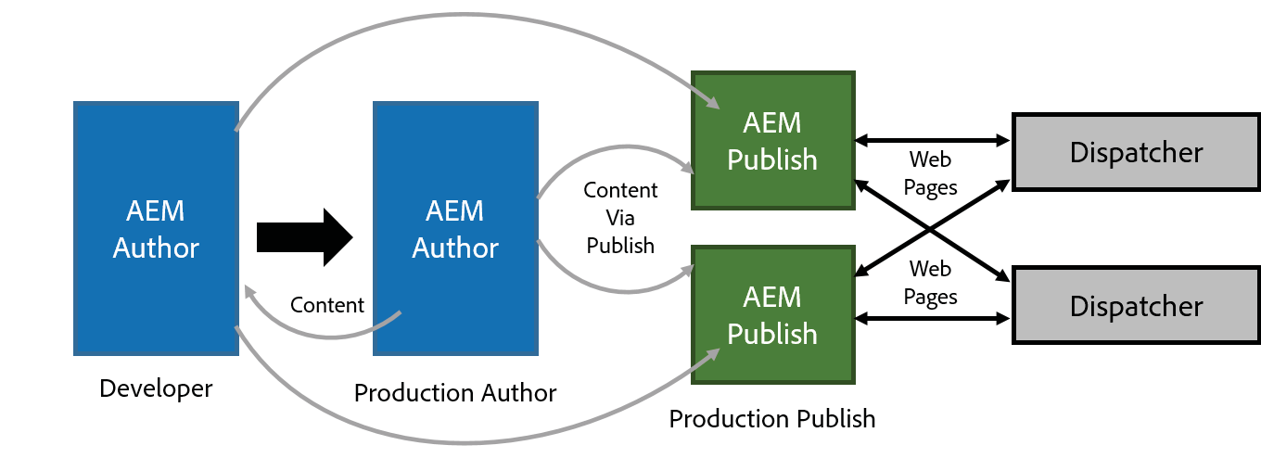

Adobe Experience Manager Workflow
In Adobe Experience Manager terminology, an “instance” is a copy of Adobe Experience Manager running on a server. Adobe Experience Manager installations usually involve at least two instances, typically running on separate machines:

    - Author: An Adobe Experience Manager instance used to create, upload, and edit content, and administer the website. After content is ready to go live, it is replicated to the Publish Instance.
    - Publish: An Adobe Experience Manager instance that serves the published content to the public. These instances are identical in terms of installed software. They are differentiated only by their configuration.
In addition, most installations use a Dispatcher:

    - Dispatcher: A static web server (Apache httpd, Microsoft IIS, and so on) augmented with the Adobe Experience Manager Dispatcher module. It caches webpages produced by the Publish instance to improve performance.

Prerequisites
To install Adobe Experience Manager, you need:

    - Adobe Experience Manager installation and startup JAR file
    - Valid Adobe Experience Manager license key properties file
    - JDK version 1.8 or JDK version 1.11
    - Approximately 4 GB of free space per instance

    - Approximately 4 GB of RAM (at the very minimum)
The Adobe Experience Manager installation and startup JAR file is also known as the “quickstart” file. You use the file to install Adobe Experience Manager. Once installed, the file is referred to as the Adobe Experience Manager startup file. During installation, you will notice the JAR file creates a root folder called crx-quickstart.

Installing Adobe Experience Manager on Your System
In general, when you want to install Adobe Experience Manager on your system, you would follow this procedure:

- Create a specific folder structure for your Adobe Experience Manager instance.

  - Author instance
For Windows: C:/adobe/AEM/author
For Mac OS or *x: /opt/adobe/AEM/author OR /Applications/AEM/author
  - Publish instance
For Windows: C:/adobe/AEM/publish
For Mac OS or *x: /opt/adobe/AEM/publish OR /Applications/AEM/publish
- Add the AEM Quickstart JAR file along with the license.properties file to the folder, which you created earlier.
- Rename the jar file to include the run mode as well as the port number. That is, rename the file to the format: aem-<run mode>-<port number>.jar
For example,
Author instance: aem-author-4502 Publish instance: aem-publish-4503
The first time you double-click the jar file, Adobe Experience Manager will be installed on your system, creating a root folder called crx-quickstart, which serves as your repository.
A sample folder structure for an Author instance is shown below.

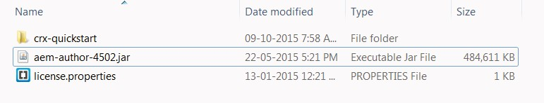


NOTE: The Adobe Experience Manager quickstart file is renamed for installation purposes. When running for the first time, the quickstart file will notice that it has to install Adobe Experience Manager. By renaming the file, you use a convention of passing instance name (Webpathcontext) and port number through the file name so that no user interaction is needed during the installation process. If no port number is provided in the file name, Adobe Experience Manager will select the first available port from the following list in this
specific order: 1) 4502, 2) 8080, 3) 8081, 4) 8082, 5) 8083, 6) 8084, or a random port.

NOTE: If you have multiple author and multiple publish instances, a best practice to consider is using an even/odd numbering paradigm for port numbers. So, you author instances ould be 4502, 4504, 4506 and so on. Your publish instances would be 4503, 4505, 4507 and so on

Perform Task - Start an Adobe Experience Manager Author Instance, from the Lab Activity section. Perform Task - Start an Adobe Experience Manager Publish Instance, from the Lab Activity section.

Starting an Adobe Experience Manager Instance
There are two ways of starting an Adobe Experience Manager instance—graphical and by command line. The latter is more powerful because the user has the possibility of providing additional performance-tuning parameters to the Java Virtual Machine (JVM).

Using the GUI to Start an Adobe Experience Manager Instance
In a Windows or Mac OS environment, you can double-click the aem-author-4502.jar file to start an Author instance (or the aem-publish-4503.jar file for a Publish instance).

      - Installation will take approximately 5-7 minutes, depending on your system’s capabilities.
      - A dialog box will pop up similar to the following:

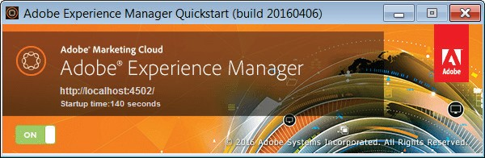

After Adobe Experience Manager starts, your default browser will open automatically, pointing to Adobe Experience Manager’s start URL (where the port number is the one you defined on installation).

- In the Sign In area that displays, enter the default administrator’s credentials (admin/admin), and then click

Sign In.

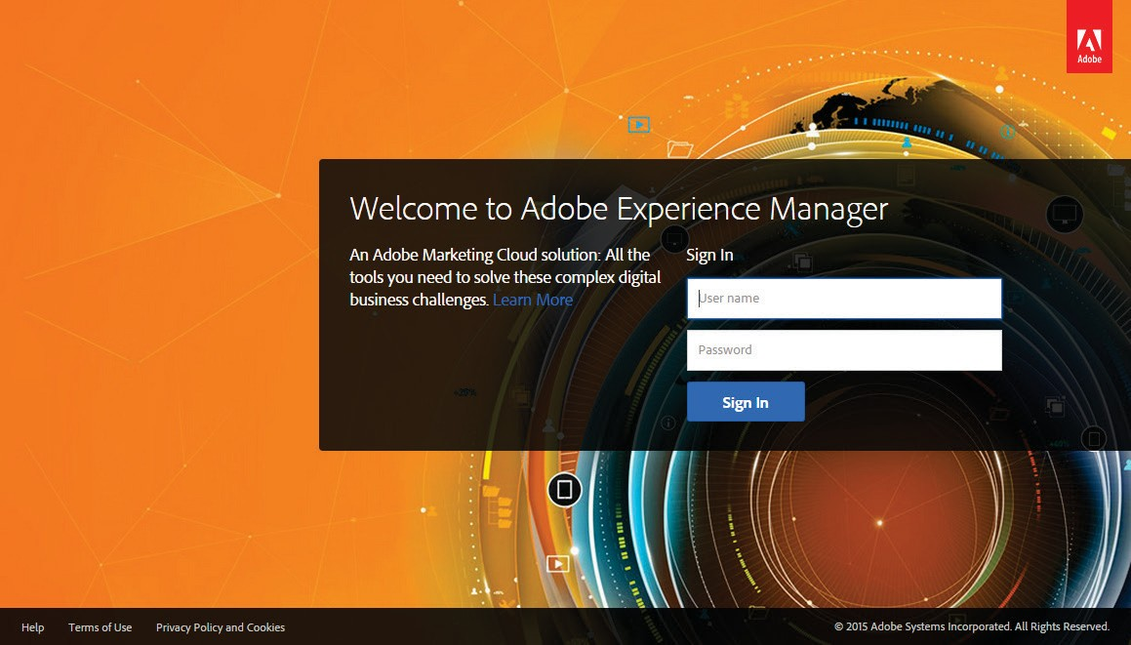

If this is the first time you are logging in, a wizard displays, asking if you want to configure Analytics & Targeting now.
- Click Cancel.

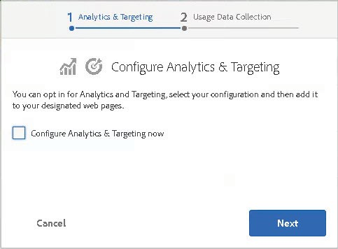

- A hover menu opens, asking if you want to be reminded to complete the Configure Analytics & Target wizard later, or not ask again (which means it will never open again when you first log in). For this class, click Don’t’ ask again.

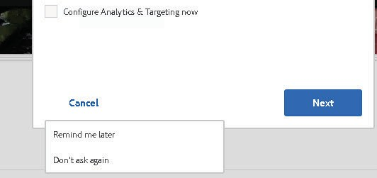

- The Welcome screen displays, with different consoles available for you.
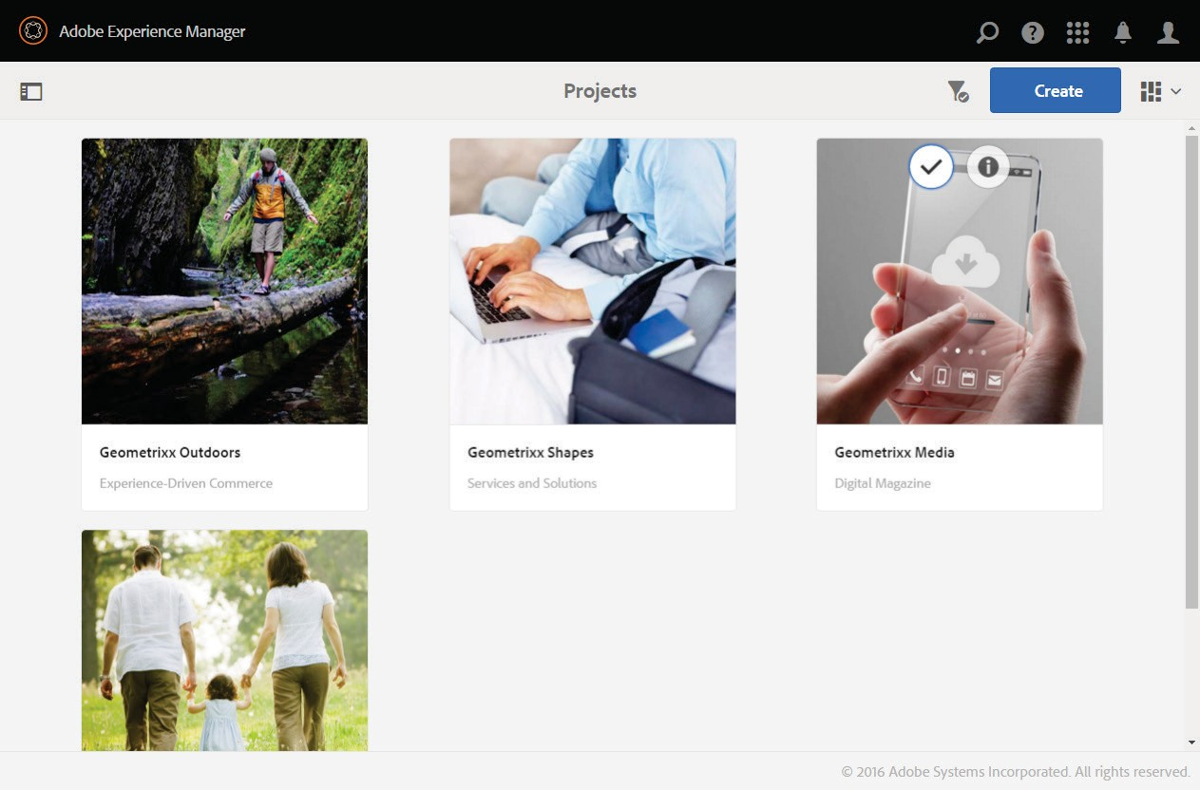

Using the Command Line to Start Adobe Experience Manager Author Instance
Prior to the installation, you may want to know which parameters are available to configure quickstart. Enter the following command to display a complete list of optional parameters:

java -jar aem-author-4502.jar -h

The Adobe Experience Manager quickstart installer will show all available command-line options without starting the server. In addition, you need to tune the JVM used for running Adobe Experience Manager. Tuning the JVM is an important and delicate task and requires a more realistic environment in terms of resources (hardware, operating system, and so on) and workload (content, requests, and so on). For now, it will be enough to know that you can start your instance (Author or Publish) using the following parameters:

-Xms --> assigns the initial heap size
Default value | 64 MB for a JVM running on 32-bit machines, or 83 MB for 64-bit machines
Recommended | Specific to physical memory available and expected traffic
Syntax | -Xms512m (sets the initial heap size to 512 MB)

-Xmx --> assigns the maximum size the heap can grow
Default value | 64 MB for a JVM running on 32-bit machines, or 83 MB for 64-bit machines
Recommended | Specific to physical memory available and expected traffic, but should be equal or greater than the initial size. To run Adobe Experience Manager, it is recommended to allocate at least 1024 MB of heap size.
Syntax | -Xmx1024m (sets the maximum size for the heap. In the example, we are letting it grow to 1024 MB; however, in production, this should be higher because Adobe Experience Manager consumes a lot of resources).

-XX:MaxPermSize --> assigns the heap to hold reflective data of the VM (for example, Java objects)
Default value | 32 MB for a JVM running as a client, or 64 MB when running as a server.
Recommended | The ‘PermSize’ should be set to at least 128 MB for ‘normal-sized’ Web apps or 256 MB for larger Web apps with significant Java activity.
Syntax | -XX:MaxPermSize=128m (sets the initial perm gen size to 128 MB).

NOTE: -XX:MaxPermSize is no longer an option in JDK 1.8.

You can now install and start Adobe Experience Manager from the command line together with increasing the Java heap and perm gen size, which will improve performance. See the image below for an example of the command line.

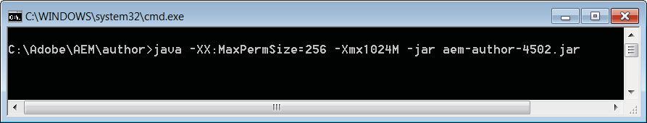

You can control the way Adobe Experience Manager is installed by defining properties via file name.

Perform Task - Start and install Adobe Experience Manager using command line, from the Lab Activity section.

Using the Command Line to Start Adobe Experience Manager Publish Instance
In your command prompt, navigate to the directory /adobe/AEM/publish, and enter the following command to install the publish instance:

java -jar aem-publish-4503.jar

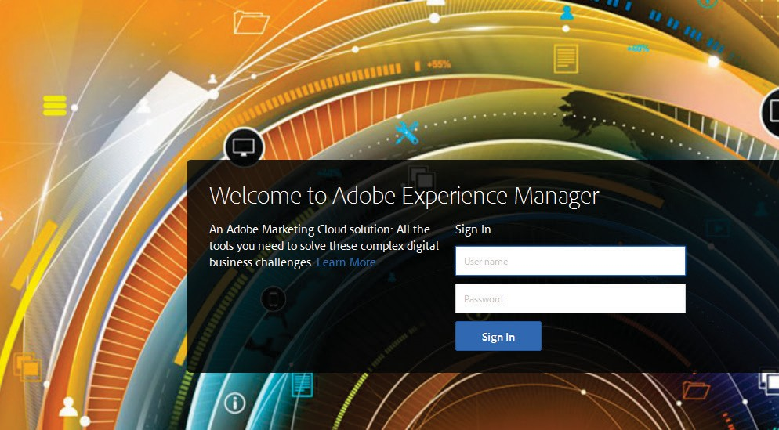
Lab Activity

Develop Website and Components in Adobe Experience Manager v6.x Student Guide

Task - Start an Adobe Experience Manager Author instance
    - Create a folder structure on your file system where you will store, install, and start Adobe Experience Manager. For example:

      - Windows: C:/adobe/AEM/author

      - MacOS X: /Applications/adobe/AEM/author or *x: /opt/adobe/AEM/author
    - Copy the aem-quickstart-6.2.0.jar and license.properties files from USB contents.
    - Rename the aem-quickstart-6.2.0.jar file to aem-author-4502.jar:
      - aem = Application

      - author = Web Content Management (WCM) mode it will run in (in this case, Author)
      - 4502 = Port it will run in (any available port is acceptable)

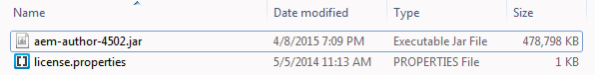
    - In a Windows or MacOS X environment, double-click the aem-author-4502.jar file. Installation will take approximately 5–7 minutes depending on your system’s capabilities.
After Adobe Experience Manager Author instance has started successfully, the start-up screen will change to something similar to the following:

In addition, after Adobe Experience Manager starts, your default browser will automatically open to Adobe Experience Manager’s start URL (where the port number is the one you defined on installation); for example: http://localhost:4502

Task - Start an Adobe Experience Manager Publish instance
- Create a folder structure on your file system where you will store, install, and start the Adobe Experience Manager. For example:

  - Windows: C:/adobe/AEM/publish

  - MacOS X: /Applications/adobe/AEM/publish or *x: /opt/adobe/AEM/publish
- Copy the aem-quickstart-6.2.0 JAR and license.properties files from USB contents.
- Rename the aem-quickstart-6.2.0.jar file to aem-publish-4503.jar
  - aem = Application
  - publish = WCM mode it will run in

  - 4503 = Port it will run in (any available port is acceptable)

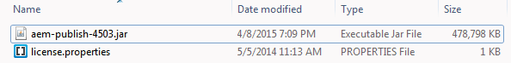
- Double-click the aem-publish-4503.jar file to start the Publish instance.
After Adobe Experience Manager Publish instance has started successfully, the start-up screen will change to something similar to the following:
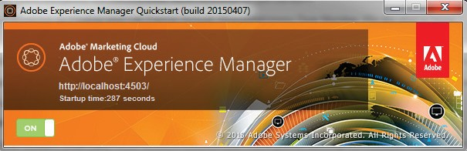
In addition, the Adobe Experience Manager login page opens from your default browser (where the port number is the one you defined on installation); for example, http://localhost:4503

The following screen appears once the Publish instance is up and running.



You have now successfully installed and started Adobe Experience Manager Author and Publish instances on localhost. To start Adobe Experience Manager in the future, double-click the renamed aem-quickstart-6.2.0.jar file; for example, aem-author-4502.jar.

Task - Start and install Adobe Experience Manager using command line [optional]
You already have an author instance and a publish instance running. Perform this task only when necessary or as an add- on exercise to try out beyond this class.

This is a powerful method because the user can provide additional performance-tuning parameters to the Java Virtual Machine (JVM). On Windows, MacOS X, or *x, you can install or start Adobe Experience Manager from the command line, while increasing the Java heap size, which improves performance.

A typical command line start will have the following:
java -Xmx1024m -jar aem-author-4502.jar -v

In your command prompt, navigate to the Adobe\AEM\author directory, and use the following command to install Adobe Experience Manager, without installing the Geometrixx sites:

java -jar aem-author-p4502.jar -r author, nosamplecontent -gui



