
Session - 01
Overview of AEM


Contents
1 Content Management System 3
1.1 What is Content Management System -: 3
2 Adobe Experience Manager – Overview 3
2.1 Why AEM 3
3 AEM Architecture – Overview 3
3.1 Overview 3
3.2 Infrastructure-Level Functions -: 3
3.3 Application-Level Functions -: 4
4 Architecture Stack 4
4.1 Basics of the Architecture Stack 4
4.2 Introduction to the Granite Platform 4
4.3 OSGi Framework 5
4.4 Introduction to the Java Content Repository 6
4.5 Introduction to Apache Sling 6
4.6 The Functional Building Blocks of Adobe Experience Manager 5
4.7 Task – Walkthrough of various application Modules. 5

Content Management System

What is Content Management System -:
Content management system (CMS) is a software application or set of related programs that are used to create and manage digital content. Typically, two CMS comes to our mind.
1. Enterprise content management (ECM)
2. Web content management (WCM).

Enterprise content management (ECM) -: An ECM facilitates collaboration in the workplace by integrating document management, digital asset management and records retention functionalities, and providing end users with role-based access to the organization's digital assets.

Examples -: DocuSign, OpenText, Oracle WebCenter, IBM FileNet, Doc Send, M Files. Etc.

Web content management (WCM) -: A WCM facilitates collaborative authoring for websites. It provides website authoring, collaboration, and administration tools that help users with little knowledge of web programming languages or mark-up languages create and manage website content.

Examples -: WordPress, Drupal, Sitecore, Joomla, SharePoint, AEM etc.

Adobe Experience Manager – Overview

Why AEM
AEM is a highly capable content management system. Also, one of the leading digital experience management solutions for marketers and IT to design, anticipate and deliver quickly adaptable experiences across web, mobile, in store and any end point in the customer journey.

- AEM is based on Components and templates
- Allows java based development
- Any one can author and update sites. No development knowledge required.
- Easy Maintenance
- Easy publish data to production
- Easy integration with third party applications

AEM Architecture – Overview

Overview
AEM is a content management system for building websites, content services, and forms. It is a web-based client-server system made up of number of infrastructure-level and application level functions. You can use these infrastructure and application-level building blocks to create customized solutions by building the required applications.

Infrastructure-Level Functions -:
- Web Application Server : You can deploy AEM in standalone mode or as a web application within a third-party application server, such as WebLogic and WebSphere. The standalone mode includes an integrated Jetty web server.
- Web Application Framework : AEM has a Sling web application framework that helps simplify the writing of REST, content-oriented web applications.
- Content Repository : AEM includes a Java Content Repository (JCR), a type of hierarchical database designed specifically for unstructured and semi-structured data.

Application-Level Functions -:
- Websites
- Content Services
- Forms
- Digital Assets
- Communities
- Online Commerce

Architecture Stack

Basics of the Architecture Stack
Adobe Experience Manager is a Java web application, and is based on technologies such as Open Service Gateway Initiative (OSGi), Java Content Repository (JCR), and Apache Sling.

The following diagram is a high-level view of the architecture stack.
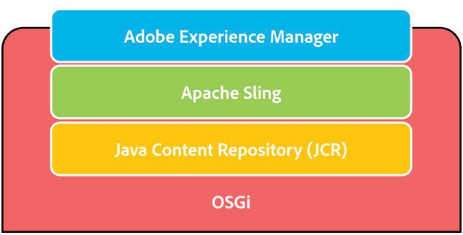

Introduction to the Granite Platform
Adobe Experience Manager runs on the Granite platform within an OSGi framework. This platform provides various components such as:
    - An application launcher
    - An OSGi framework into which everything is deployed
    - A number of OSGi compendium services to support building applications
    - A comprehensive Logging Framework providing various logging APIs
    - The CRX Repository implementation of the JCR API specification
    - The Apache Sling framework
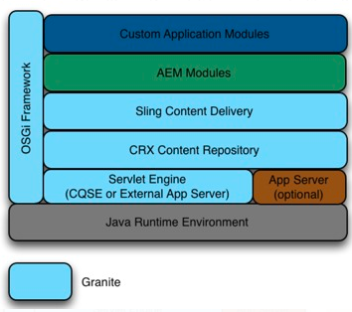

OSGi Framework

OSGi enables a collaborative and modular environment, where each application may be built and implemented as a small bundle. Each of these bundles is a collection of tightly coupled, dynamically loadable classes, JAR files, and configuration files that explicitly declare their external dependencies.

All content is stored in the content repository, and hence backup is done at the repository level. OSGi runtime hosts Java applications that can access the repository using the JCR API. As part of the application runtime, you get Apache Sling, a RESTful web application framework that exposes the full repository content using HTTP and other protocols.

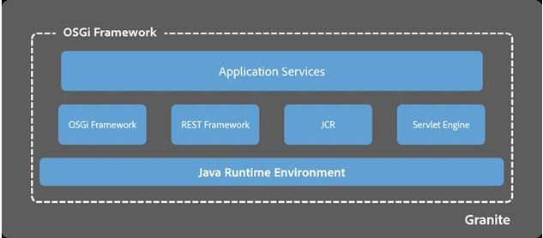
Apache Felix is an open source implementation of the OSGi that the Adobe Experience Manager framework makes use of. It provides a dynamic runtime environment, where code and content bundles can be loaded, unloaded, and reconfigured at runtime.

Introduction to the Java Content Repository
The JCR, specifically JSR-283, is a database that supports structured and unstructured content, versioning, and observation. All data pertaining to Adobe Experience Manager such as HTML, CSS, JS/Java, Images, and Videos are stored in the JCR object database. It is built with Apache Jackrabbit Oak. The Adobe implementation of JSR-283 is the Content Repository eXtreme (CRX), and the version of CRX that comes with Adobe Experience Manager supports JCR 2.x.
In addition to CRX, Adobe Experience Manager can also work with other JCR repositories such as Apache Jackrabbit and with a number of non-JCR data storesthrough connectors. As Adobe Experience Manager is built on top of this standard, it is capable of pulling content not just from its built-in CRX repository, but from any JCR-compliant source, such as a third-party repository (for example, Jackrabbit) or aconnector that exposes legacy storage throughJCR.

Advantages of using JCR
- JCR provides a generic application data store for structured and unstructured content. While file systems provide excellent storage for unstructured, hierarchical content, and databases provide storage for structured data, JCR provides the best of both data storage architectures.
- It supports namespaces. Namespaces prevent naming collisions amongitems and node types that come from different sources and application domains. JCR namespaces are defined with a prefix, delimited by a single colon (:); for example, jcr:title.

Introduction to Apache Sling
Apache Sling is a web application framework for content-centric applications, and uses a Java Content Repository, such as Apache Jackrabbit or CRX to store and managecontent.
    - It is based on REST principles
    - Its applications are built as a series of OSGi bundles
    - It is resource-oriented, and usually map into JCR nodes
The embedded Apache Felix OSGi framework and console provides a dynamic runtime environment, where code and content bundles can be loaded, unloaded, andreconfigured at runtime. Sling makes it easy to implement simple applications, while providing an enterprise-level framework for more complex applications.
Sling assumes that ‘Everything is a Resource’. That is, Sling is resource oriented, where the resources have URLs, and each resource is mapped into a JCR node. A request URLis first resolved to a resource, and then based on the resource, it selects the Servlet or script to handle that request. Servlets and scripts are handled uniformly in that theyare represented as resources themselves and are accessible by a resource path. Thismeans that every script, Servlet, filter, error handler, and so on is available from the ResourceResolver just like normal content—providing data to be rendered on request.

The Functional Building Blocks of Adobe Experience Manager
The Adobe Experience Manager application modules such as Sites, Assets, Communities, Forms, and Apps, sit on top of the Adobe Experience Manager shared framework, a framework known as Granite. This framework includes all the application layer functionality such as mobile functionality, multisite manager, taxonomy management, and workflow. These functionalities are shared among all the application modules. In addition to these functionalities, these Adobe Experience Manager applications share the same infrastructure and UI framework and are very tightly integrated with each other. All of this is encapsulated within the OSGi container.

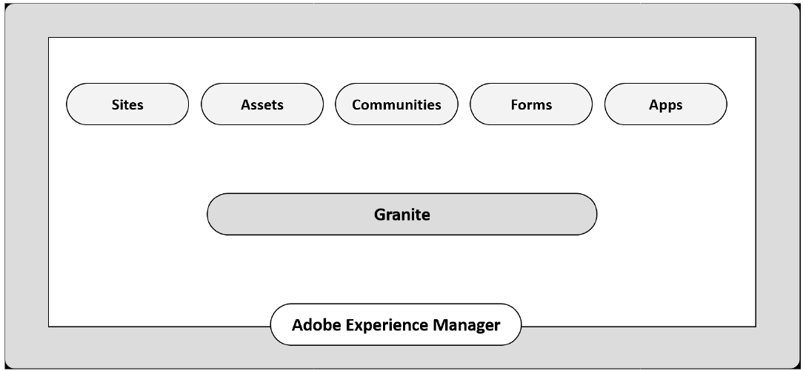

Task – Walkthrough of various application Modules.

Go to url http://localhost:4502/sites.html/content you will see this console where you can see many application module listed on the screen



