
Session - 15
Customizing AEM & Eclipse with AEM plugin Installation


Table of Contents
Table of Contents 1
Custom Components 2
Customize the AEM UI 2
Overlays 2
Sling Resource Merger 3
Exercise 1: Extend a core component 3
Exercise 2: Extend the navigation UI 6
Exercise 3 : Hide a navigation button 7
Exercise 4: Add a new navigation button 7
Eclipse Installation 8
AEM plugin Installation into Eclipse 8
Installing AEM Developer Tools 10
Exercise 5: Create an AEM project using latest archetype in eclipse. 11

Custom Components

Introduction
During development on AEM projects there will be many such use cases where you have to customize AEM product and its UI. This session covers that aspect of AEM. This session is continuation of the previous session.

Objectives
After completing this module, you will be able to:
- Extend the AEM navigation UI
- Installing Eclipse with AEM plugin

Customize the AEM UI
The AEM UI is based on a set of nodes in JCR and its underlying structure. These nodes reside in the /libs folder. When you create a project, any customization required is done by overlaying the corresponding content node in the JCR under the /apps folder. This is done by overlaying the content node in the JCR.

The two methods used for customizations are:

- Overlays
- Sling Resource Merger

Overlays

Sling’s Resource Resolver searches for resources in a list of specific paths, as defined by the Apache Sling JCR Resource Resolver. The default search path is first /apps and then /libs. As a result, you can change the out-of-the-box functionality as provided in /libs by adding a resource or file at the same path in /apps. This ability to override default functionality is called an overlay.

To use overlays in AEM:
- Recreate the node structures from /libs under /apps.
- Copy the content node that you want to change in /apps, and then work on this copy.
- When a resource is requested, it is resolved according to the search path logic.
- The Resource Resolver retrieves the resource from /apps, failing which, it looks at /libs.

An overlay involves taking the predefined functionality and imposing your own definitions over that to override the standard functionality.

Sling Resource Merger

The Sling Resource Merger is applicable only to the touch UI and enables you to customize consoles and page authoring. With Sling Resource Merger, you can overlay nodes without replicating all of their parent nodes.

The Sling Resource Merger provides services to access and merge resources. It merges the overlays of resources by using resource resolver search paths and difference mechanisms. A customized Sling vocabulary is used to manage the overrides of nodes and their properties. With this, the overlay resources/properties (defined in /apps) are merged with the original resources/properties (from /libs).

The Sling Resource Merger is used to ensure that all changes are made in /apps, and avoids the need to make any changes in /libs. After the structure is created, you can add your own properties to the nodes under /apps. The content of /apps has a higher priority than that of /libs. The properties defined in /apps indicate how the content merged from /libs are to be used.

The following table describes the differences between Overlays and Sling Resource Merger:
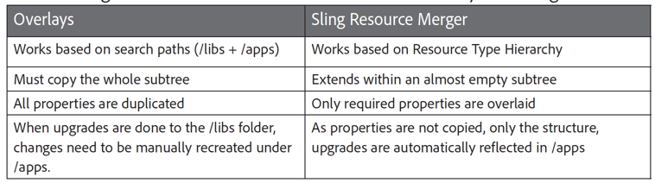
After you copy a system file from /libs to /apps to overlay it with custom code, your custom code will not pick up any modifications to the system component/file/script/dialog box, which results from the application of a hotfix, feature pack, or upgrade. A careful examination of the release notes of any upgrade, feature pack, or hotfix should be a step in your upgrade plan. This way, you will be able to evaluate changes and incorporate them into your application.

Exercise 1: Extend a core component
In this exercise, you will extend a core component without losing the functionality that it provides and ensuring it works for future core component upgrades.
To extend the Title component with the Sling Resource Merger:
- In CRXDE Lite, navigate to the /apps/training/components/content folder. Notice that a title proxy component is available.
- Navigate to the /apps/core/wcm/components/title/v2/title node, select the cq:dialog node, and click Copy from the actions bar.
- Navigate to the /apps/training/components/content/title node, and click Paste. The cq:dialog node is added to the title proxy component.
- Click Save All from the actions bar.
- Navigate to the /apps/training/components/content/title/cq:dialog/content/items/tabs/items/ properties/items/columns/items/column/items node, select the types node, and click Delete from the actions bar.
- Click Save All from the actions bar.
- Similarly, select the defaulttypes node that is below the items node, and click Delete from the actions bar.
- Click Save All from the actions bar.

Note: You must delete the form fields that you want to inherit from the v2 title component. As a result, the custom formfields you create next will be merged with the v2 title dialog.

- Select the title node, click Rename from the actions bar, and rename it to subtitle, as shown:
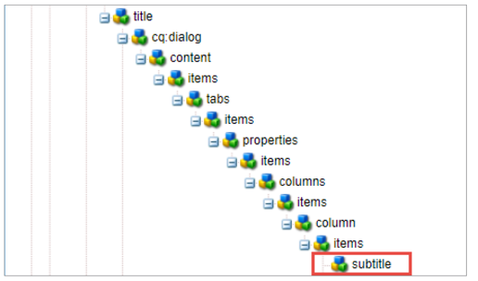
- Update the following properties of the subtitle node:
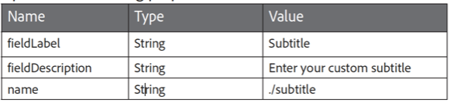
- Click Save All.
- Open the English page of We.Train site and click the Toggle Side Panel icon from the page toolbar. The panel opens.
- Click the Components icon. The Component browser opens.
- Drag the Title component from the browser below the Stockplex component. The Title component is added to the page.
- Select the Title component a and click the Configure (wrench) icon from the component toolbar. The Title dialog box opens.
- Notice that the Subtitle field is now added to the dialog box.
- Update the following details:
a. Title: My new title
b. Type / Size: H1
c. Subtitle: My custom subtitle
- Click the Done (checkmark) icon The English page opens.
Notice how at this point, you do not see the subtitle on the page. You must create a local title.html script to reference the new subtitle property.
- In CRXDE Lite, navigate to the /apps/training/components/content folder, select the title node, and click Create > Create File. The Create File dialog box opens.
- Enter title.html in the Name field, and click OK. The file is created below the title node.
- Click Save All.
- Double-click the title.html. The editor opens on the right.
- Copy the code from title.html exercise file provided to you, and paste it in title.html.
- Click Save All from the actions bar.
- Open the title.html to view the code that you added. Notice that the script is the exact same script as the core title component, except there is a new line of code that adds the subtitle to the component:
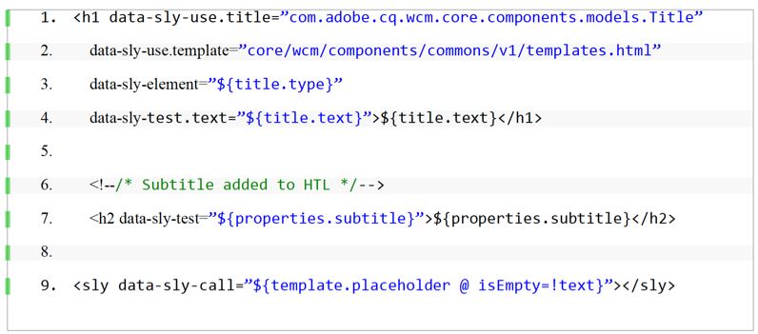
- Open the English page and observe that the new subtitle is now appearing. You have successfully extended the component. You added a new feature, a subtitle, to the core Title component by using the Sling resource merger to modify its dialog, and a minimal script override to modify its output.

Exercise 2: Extend the navigation UI
In this exercise, you will modify the navigation UI buttons by using the Sling Resource Merger.
- Click http://localhost:4502/aem/start.html. The Navigation UI opens. Notice the Sites navigation button.
To modify the navigation button:
- In CRXDE Lite navigate to the /libs/cq/core/content/nav node. Notice, how the child nodes of nav are the definition of the global navigation icons (consoles) for AEM.
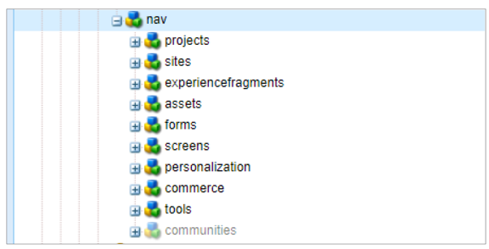
To modify the navigation icons, hide icons, or add a new icon, you must change the list under /libs/cq/core/content/nav. It is a best practice to recreate the structure in /apps by using the Sling Resource Merger to avoid any changes to the /libs structure.
- Navigate to the /libs/cq/core/content/nav node, select the sites node, and click Overlay Node from the actions bar, as shown. The Overlay Node dialog box opens.
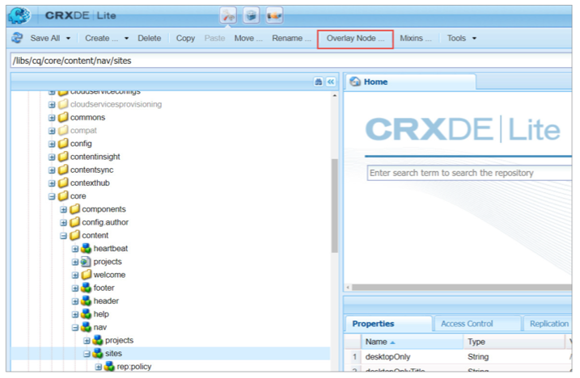
- Ensure the Overlay Location field has /apps/ as its value, select the Match Node Types checkbox, and click OK.
- Click Save All from the actions bar.
- Navigate to the /apps folder, and notice that the /cq/core/content/nav/sites structure is created. If you cannot view the /apps/cq folder structure, refresh the CRXDE Lite page.
Note: The overlay node structure is reproduced, but the properties are not created. Remember, the Sling Resource Merger will merge properties and nodes.

- Add the following property to sites under the /apps /cq/core/content/nav/ node:
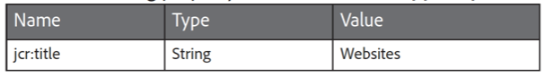
- Click Save All from the actions bar.
- Open the tab where the Navigation page is open. Refresh the page and notice that the Sites button is now renamed to Websites, as shown. You used the Sling Resource merger to modify the AEM application navigation.
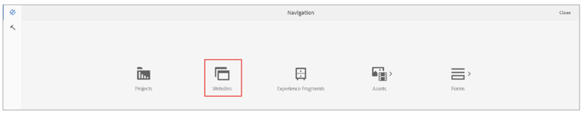

Exercise 3 : Hide a navigation button
To hide a navigation button:
- In CRXDE Lite, navigate to the /apps/cq/core/content/nav node, click Create > Create Node. The Create Node dialog box opens.
- Type communities in the Name field, and ensure the Type is nt:unstructured.
- Click OK. The node is created. Click Save All from the actions bar.
- Add the following property to the communities node:
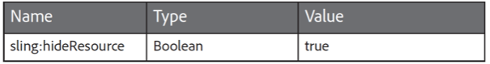
- Click Save All from the actions bar.
- Open the tab where the Navigation page is open. Refresh the page and notice that the Communities option is hidden from Navigation.

Exercise 4: Add a new navigation button
To add a new navigation button:
- In CRXDE Lite, navigate to the /libs/cq/core/content/nav node, select the screens node, and click Copy from the actions bar.
- Navigate to the /apps/cq/core/content/nav node, and click Paste from the actions bar. The screens node is added.
- Click Save All from the actions bar.
- Select the screens node, and rename it as mybutton.
- Click Save All from the actions bar.
- Update the following properties of the mybutton node:
- 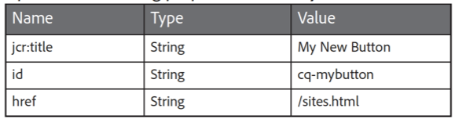
- Click Save All from the actions bar. Open the tab where the Navigation page is open. Refresh the page and notice that a new console, My New Button, is created, as shown:
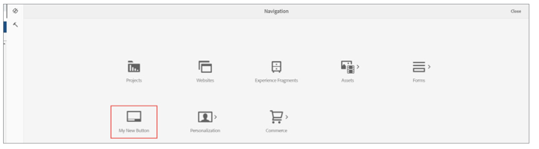
- Click My New Button. Notice that the Sites console opens.

Eclipse Installation
For this follow the internet.

AEM plugin Installation into Eclipse
Go to eclipse marketplace and install AEM plugin as shown:

After opening Eclipse Marketplace, you will see a popup. In this popup, enter AEM in the Find bar. It will search through the web and will display the AEM plugin for eclipse. Click on Install.

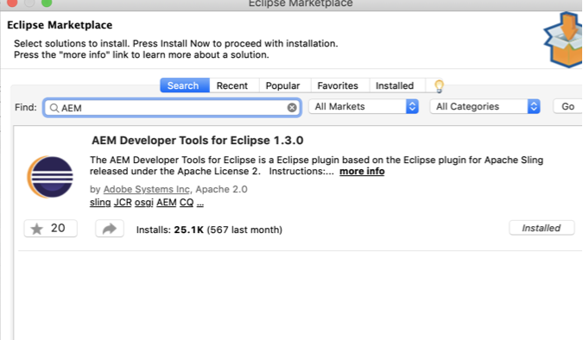

Accept the License agreement and Finish

The eclipse will take some time to install the software and will show a popup. Click on Install Anyway.

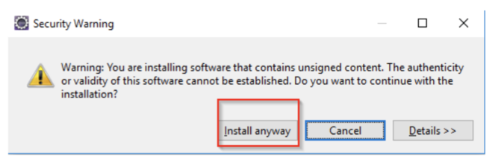

Once the software is installed, Restart the Eclipse to reflect changes.

Installing AEM Developer Tools
AEM developer tools provide us with many features such as integration of AEM server and eclipse, sync of content and bundles, debugging, modification of JCR properties and many more.
To install AEM Developer tools, follow the below steps -
- Go to AEM Developer Tools site.
- You will see an Installation Link. Copy it.

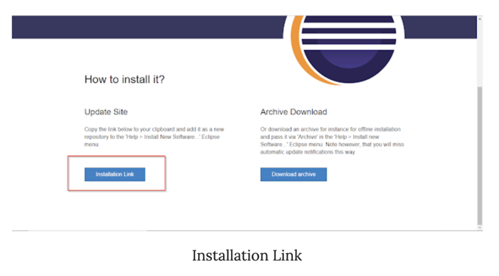
- In Eclipse, go to Help, then Install New Software...

- Click Add..., then in the name field, put "AEM Developer Tools" and in the location field. paste the installation link.
- Click Next, Next and Finish. Restart the eclipse to so the new changes are reflected.

Exercise 5: Create an AEM project using latest archetype in eclipse.

- Go to New, then New Project, then Other and select AEM Multimodule Project and click Next

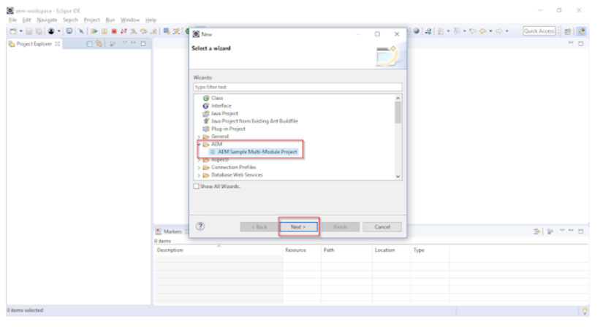

- Select latest Archetype (which is 23 as of now), click next.

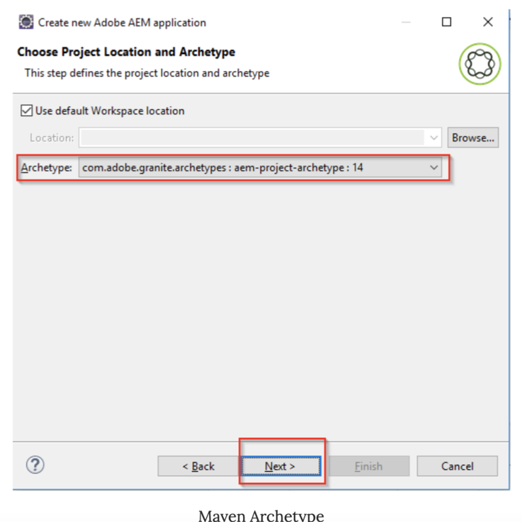

- Put the required fields as shown in the figure and click on Next

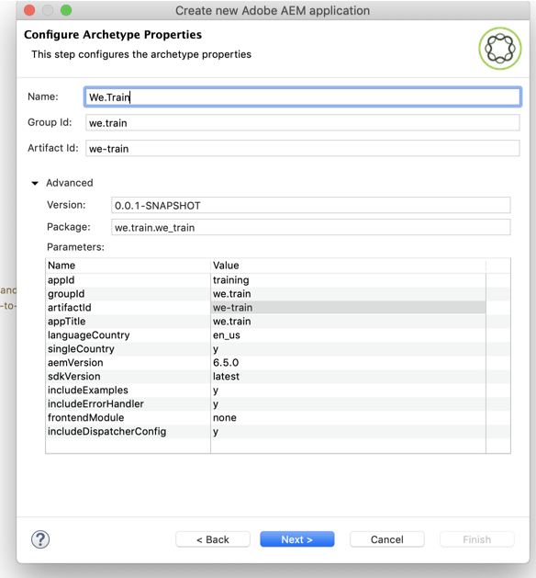

- Select Don't deploy on a server and click Finish

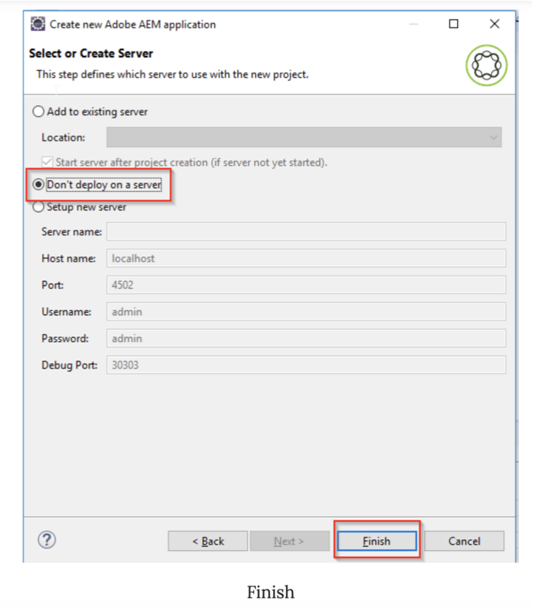
The project will be created will default template. This will have the following children projects - core, launcher, tests, apps and content.

