**Assignment 7**

*Frame Based Knowledge Representation*

Fan Chun

Junjun Guo

12.11.2014

1. Build the Knowledge Base

Canary

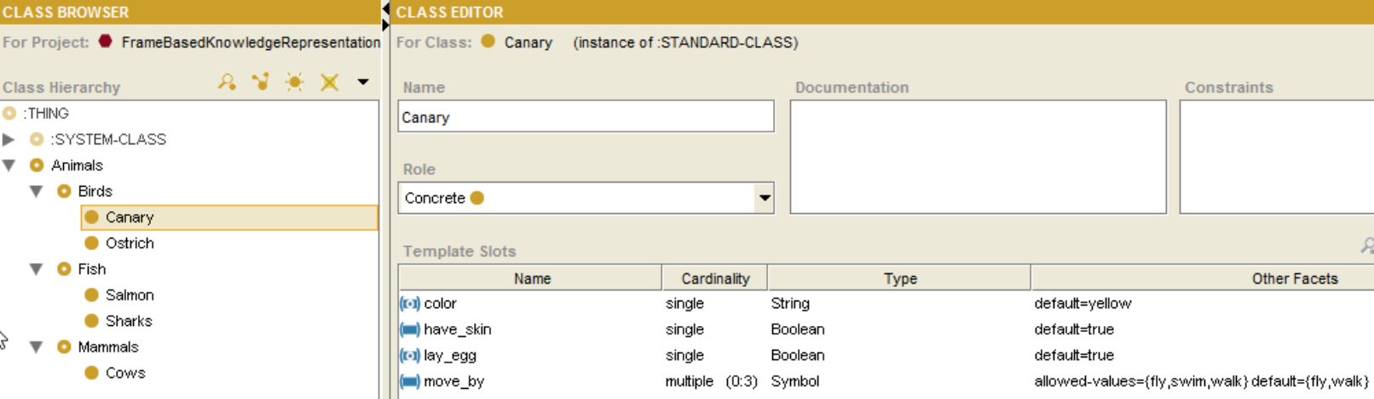

Ostrich

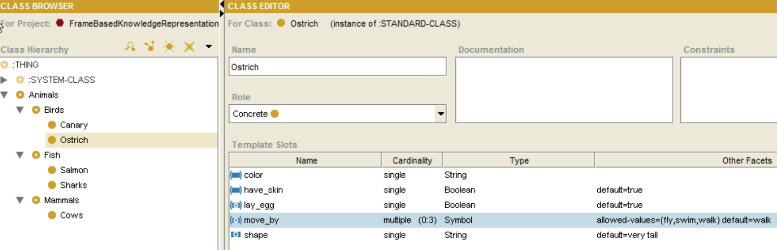

Salmon

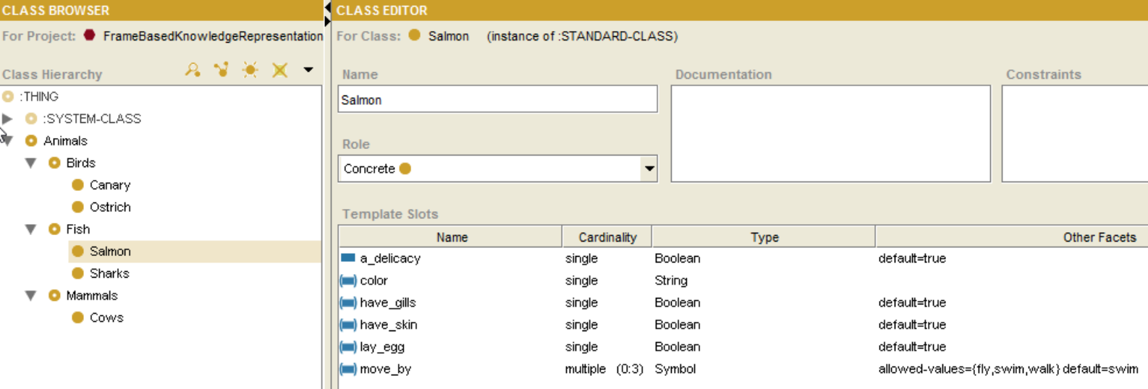

Sharks

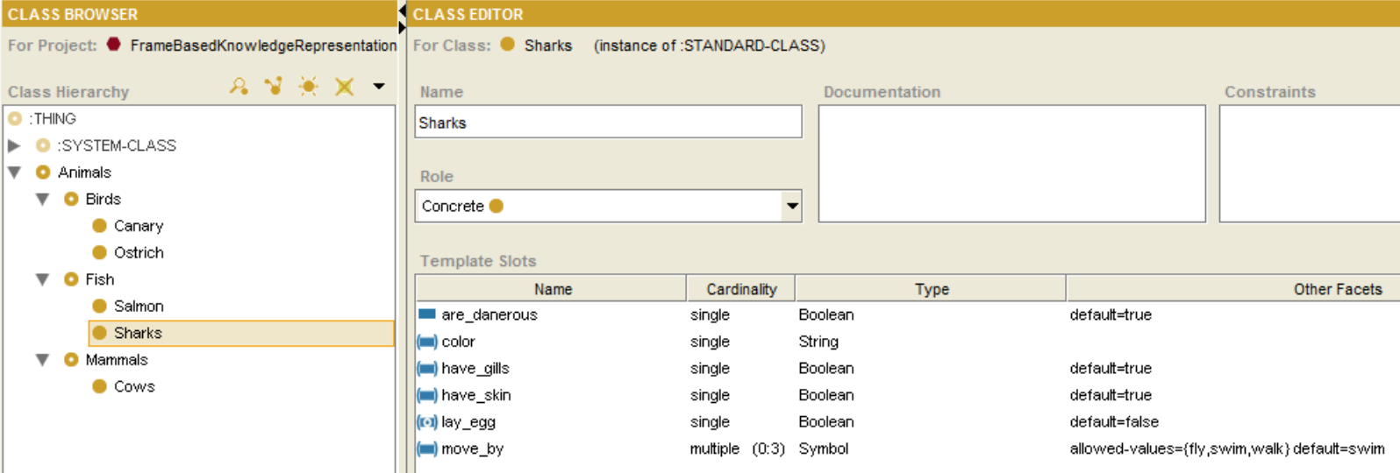

Cows

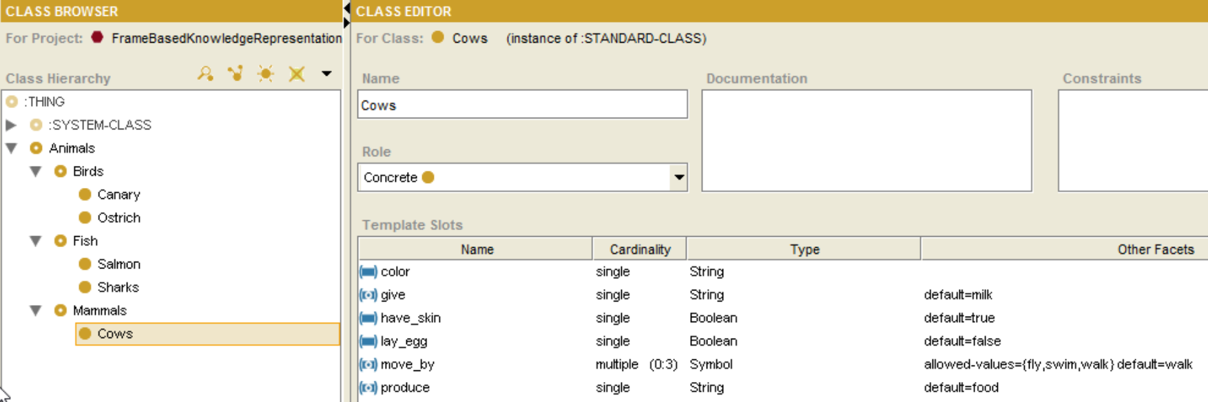

2. Reasoning

1. Can canaries fly? YES



1. What is the color of canaries? YELLOW



1. Can ostriches fly? NO





1. Does an ostrich have wings? YES



1. Are sharks dangerous? YES





1. Are ostriches dangerous?

Cannot answer this question, because dangerous is unknown in knowledge base for ostrich.

1. Which animals lay eggs? Salmon, Canary, Ostrich



1. Which animals are edible? COWS



1. Which animals move by swimming but do not lay eggs? SHARKS

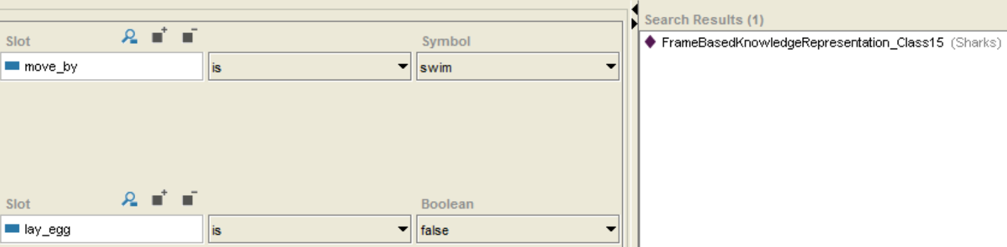

1. What does most fish and birds have in common? HAVE SKIN



1. List all animals in this knowledge base.

SALMON, SHARKS, CANARY, OSTRICH, COWS

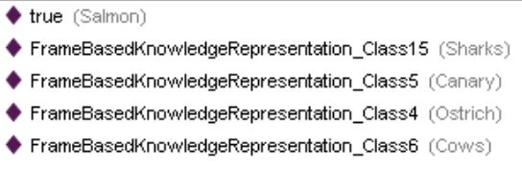

3. Multiple Inheritances

1. John is a Republican
2. John is a Quaker

Quaker

Pacifists

Republicans

Non-pacifists

John

3. Republicans are non-pacifists

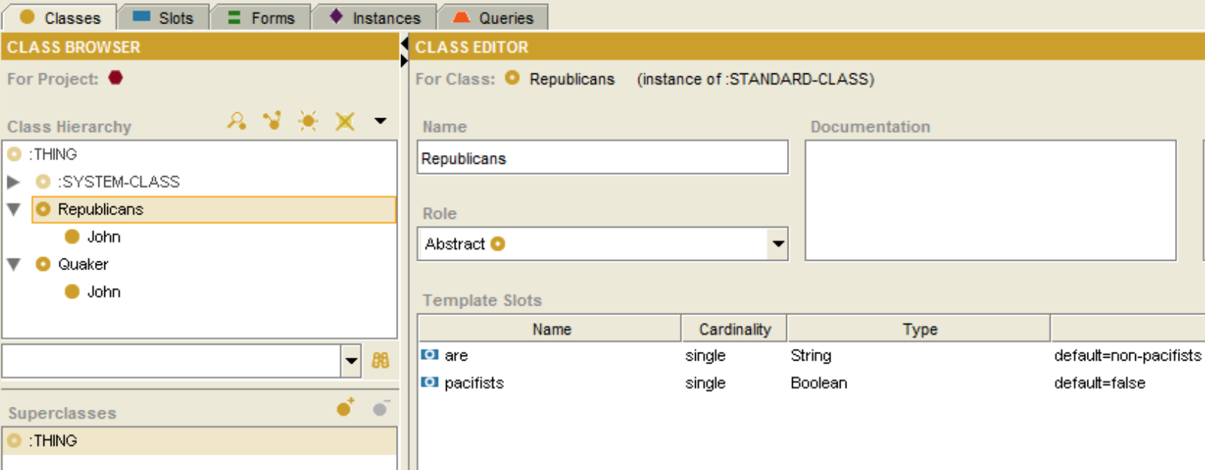

4. Quakers are pacifists

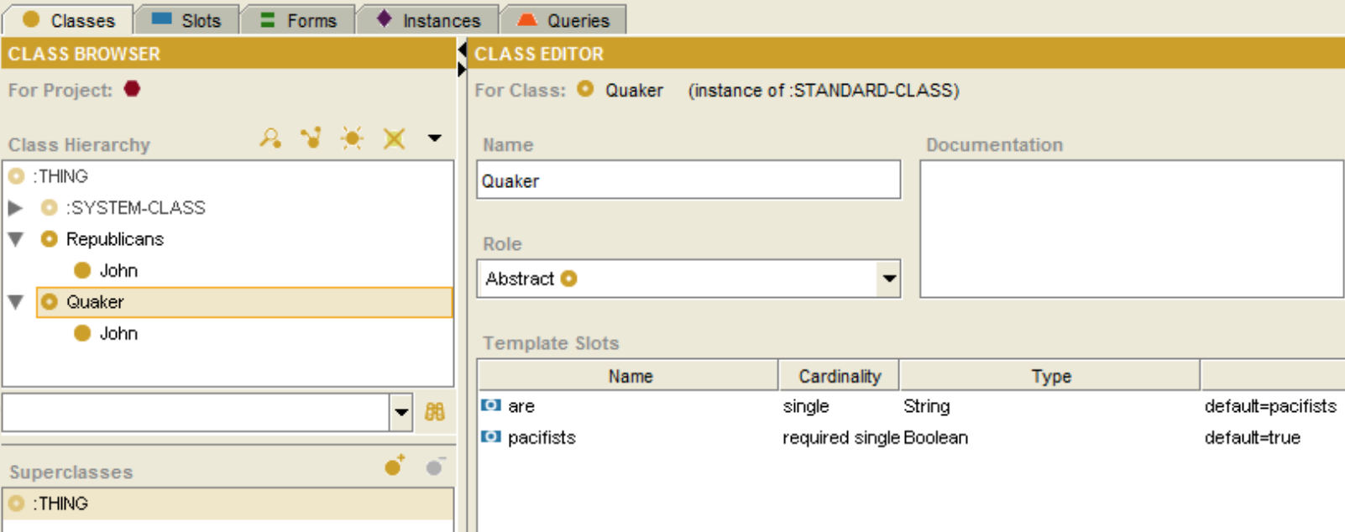

Discuss:

1. John is a Republican -> John is non-pacifists (inherited from Republican)
2. Add Quaker as a second superclass to John, Quaker is pacifists
3. There is a conflict, about which value John will inherited, from Republican or from Quaker, but Protégé decide that John has the value from the first superclass of John, which is Republicans “non-pacifists”

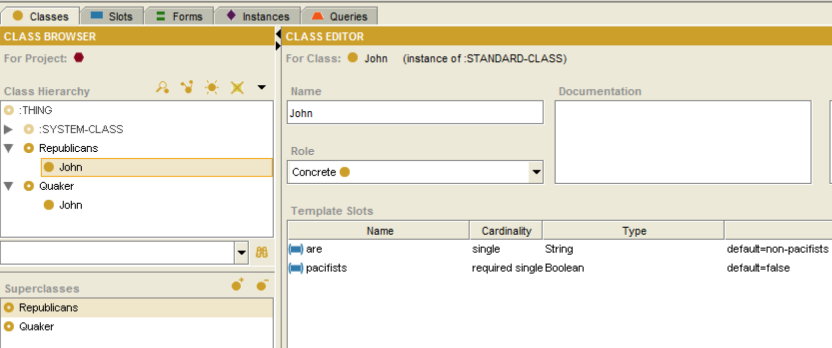

If we John’s first super class to Quaker, then add Republicans as John’s super class, John will inherit value from his first super class Quaker “pacifists”.

When we run the Queries, Protégé ignored conflicting and only show one of the value from John’s first inherited super class.

There is no evidence or message showing there is a conflict by Protégé, and we don’t have a way to handle it.

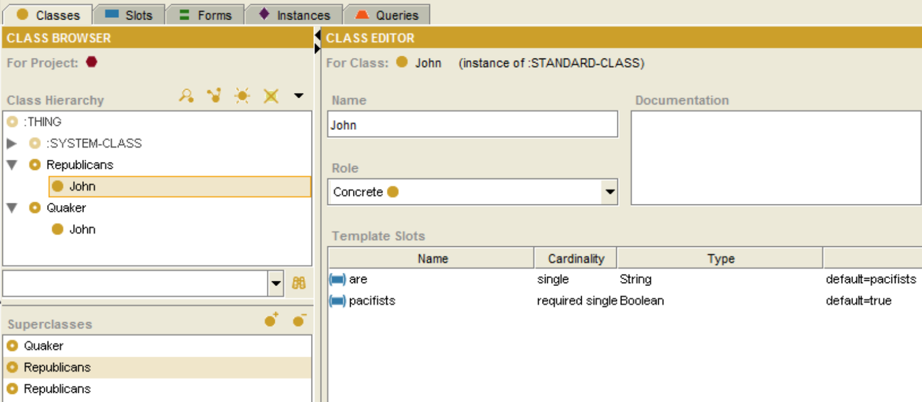

A frame based reasoner inspects the knowledge base and checks if the constraints are satisfied by the property values on the given model. Since the reasoned discovers the pacifist property on our given model, it will at least return a result. To make frame based reasoning capable of detecting the contradictory information, we could apply a search. An alternative might be to use the OWL paradigm instead. OWL performs consistency checking rather than constraint checking.