STEPS TO 2D AND 3D REPRESENTATION OF STUDY AREA (KWARA AND KOGI STATES)
- STUDY AREA
- Kwara State is bordered to the east by Kogi State, to the north by Niger State, and to the south by Ekiti, Osun and Oyo states, while its western border forms part of the international border with the Republic of Benin.
- The state was formed from the Northern Region on 27 May 1967 as West Central State. Its capital is Ilorin, and it has 16 local government areas.
- Kwara lies within latitude 8° 30′ N and longitude 5° 00′ E, covers about 36,825 km² (14,218 sq mi) and had a population of 2,371,089 (2006).
- Kogi State was created in 1991 from parts of eastern Kwara and western Benue states. It is the only state in Nigeria bordering ten other states, and it also borders the Federal Capital Territory (Abuja) to the north.
- Kogi is nicknamed the “Confluence State” because the River Niger and River Benue meet close to its capital, Lokoja.
- Kogi lies within latitude 7° 45′ N and longitude 6° 45′ E, covers about 29,833 km² (11,519 sq mi) and had an estimated population of about 4.5 million (2016).
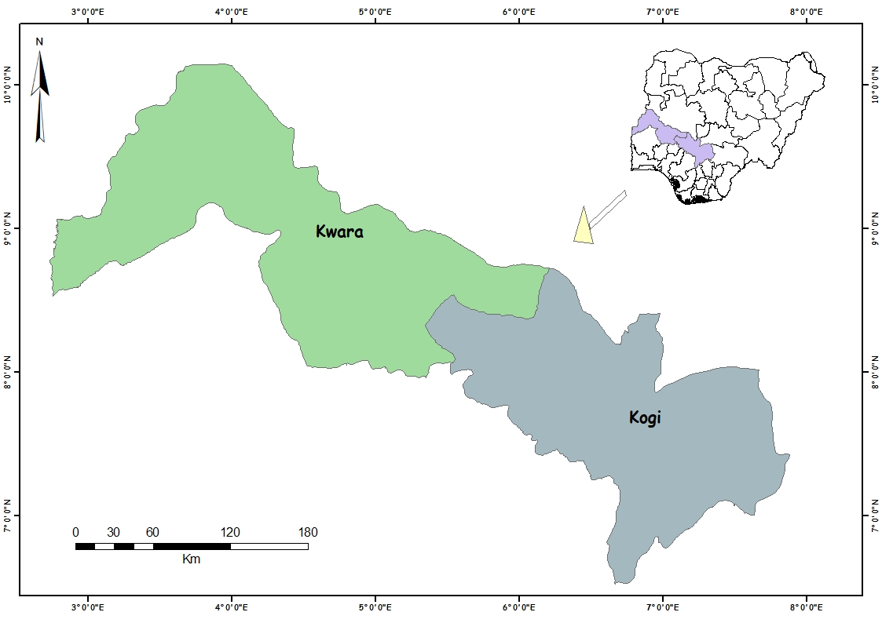
Map of Kwara and Kogi States
- MATERIALS AND DATA SOURCES
- Digital elevation data were acquired from three sources: the Shuttle Radar Topography Mission (SRTM), the ASTER Global Digital Elevation Model (GDEM) and JAXA’s Global ALOS 3D World (AW3D30).
- LiDAR DEM data were not readily available for the study area and would be costly to acquire.
- MOLA DEM data were not used because they cover the planet Mars only.
- ArcGIS 10.8 (ArcMap and ArcScene) was used for the spatial analysis, the 2D and 3D representations and the final map layout.
- DOWNLOADING THE ADMINISTRATIVE BOUNDARY
- Downloaded the country-level administrative data for Nigeria from the DIVA-GIS webpage (www.diva-gis.org).
- Extracted the shapefile data from the compressed folder.
- Added the state layer (NGA Adm1) to ArcMap.
- Selected the study area (Kwara and Kogi) with the Select Features tool and exported it as a separate shapefile.
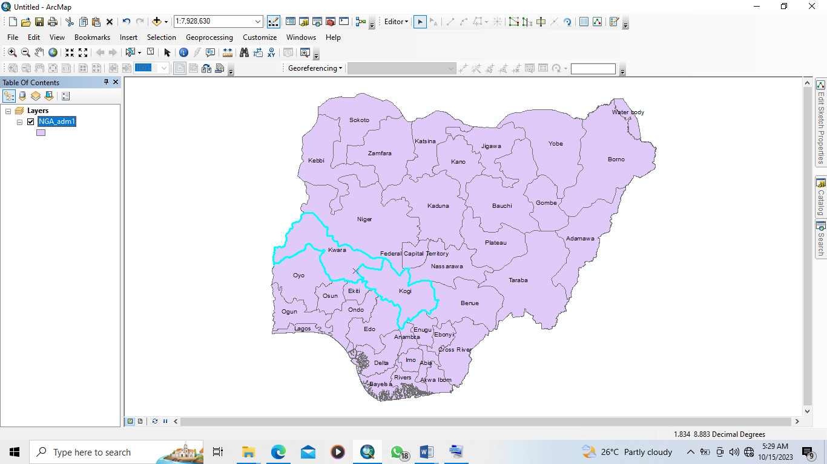
- DOWNLOADING THE SRTM DATA
- Visited the USGS Earth Explorer page (earthexplorer.usgs.gov).
- Created a boundary around the study area.
- Under datasets, checked the SRTM data.
- From the results, selected the tiles that fell within the study area and downloaded them in .tif format.
- Extracted the DEM from the compressed folder and copied it into the work folder.
- DOWNLOADING THE ASTER DATA
- Visited the USGS Earth Explorer page (earthexplorer.usgs.gov).
- Created a boundary around the study area.
- Under datasets, checked the ASTER data.
- From the results, selected the tiles that fell within the study area and downloaded them in .tif format.
- Extracted the DEM from the compressed folder and copied it into the work folder.
- DOWNLOADING THE ALOS DATA
- Visited the AW3D30 DSM data page (www.eorc.jaxa.jp/ALOS/en/aw3d30/) and registered.
- Zoomed into the area of interest and drew a polygon around the study area.
- Selected the tiles that fell within the study area and downloaded them in .tif format.
- Extracted the DEM from the compressed folder and copied it into the work folder.
- After downloading, all the DEM datasets were processed in the same way (steps 7 to 11).
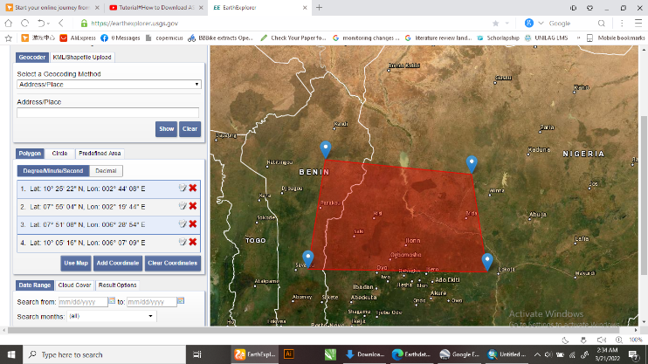
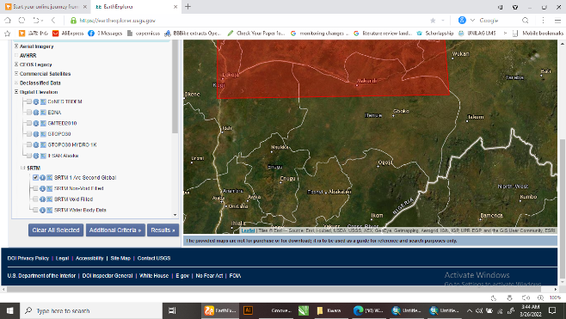
- MOSAICKING
- Several DEM tiles were downloaded from each source, so they had to be mosaicked into a single dataset.
- Opened ArcToolbox – Data Management Tools – Raster – Raster Dataset – Mosaic To New Raster.
- Selected the input tiles, set the output location and the raster dataset name (with extension), then clicked OK.
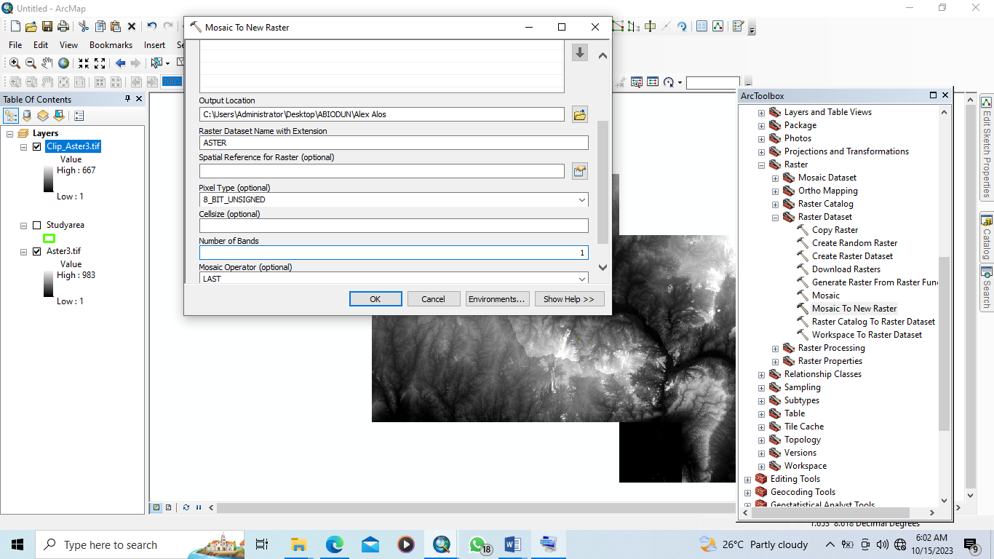
- EXTRACTION BY CLIPPING
- The Clip tool (ArcToolbox – Data Management Tools – Raster – Raster Processing – Clip) was used to extract the part of the DEM covered by the study area shapefile.
- Input Raster: selected the mosaicked DEM.
- Output Extent: selected the study area shapefile.
- Ticked Use Input Features for Clipping Geometry.
- Output Raster Dataset: typed a file name with the .tif extension and saved it in the work folder.
- Left all other settings at their defaults and clicked OK.
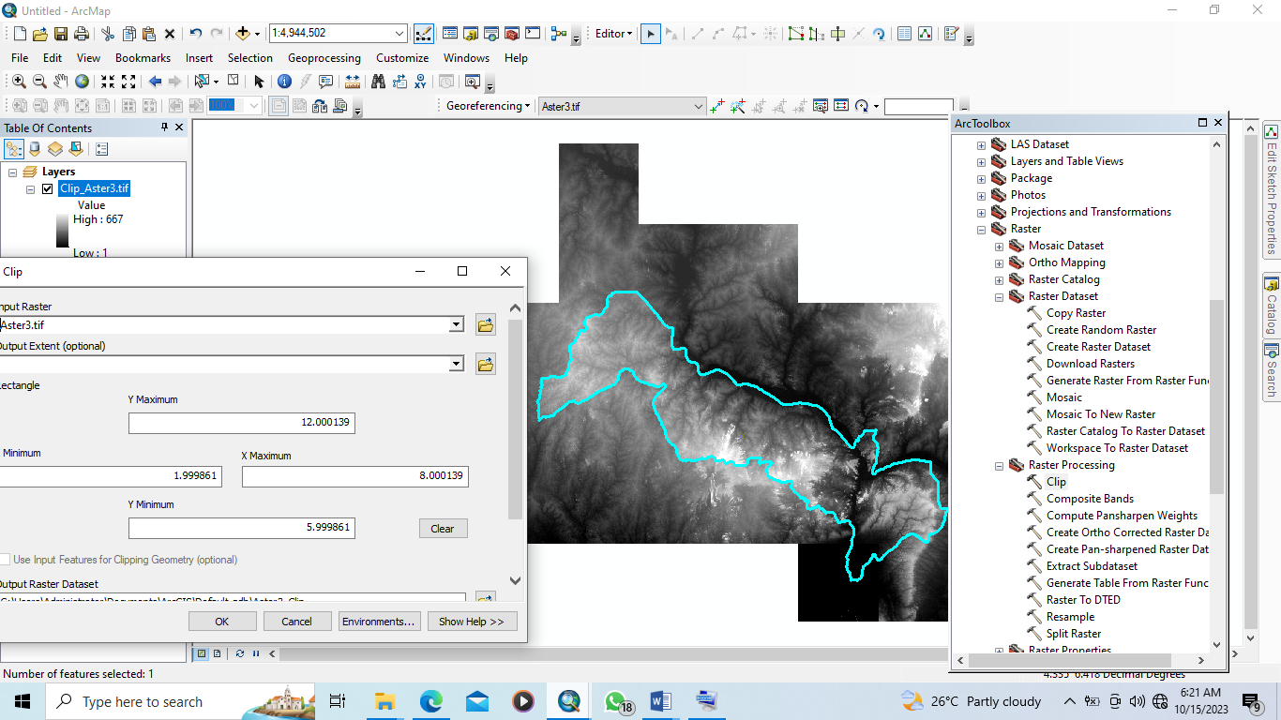
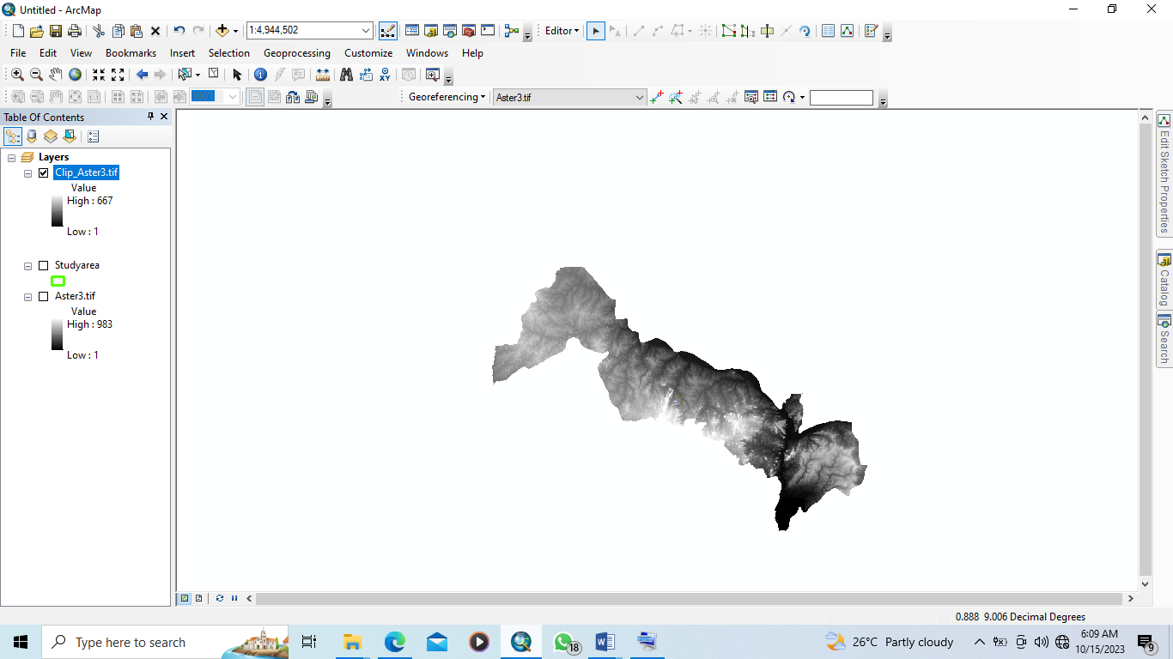
- PROJECT RASTER
- The Project Raster tool (ArcToolbox – Data Management Tools – Projections and Transformations – Raster) was used to convert the clipped DEM to a projected coordinate system, so that area and volume calculations can be done.
- Input Raster: selected the clipped DEM; its coordinate system was added automatically.
- Output Raster Dataset: selected the folder and assigned a name to the new dataset.
- Output Coordinate System: selected the projected coordinate system and clicked OK.
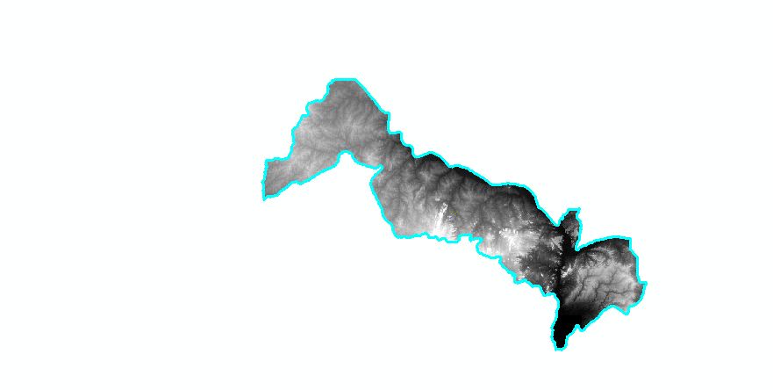
- CREATING THE 3D SURFACE (DONE IN ARCSCENE)
- Opened a new ArcScene document and added the projected DEM raster.
- Opened the layer properties – Base Heights – changed Elevation from surface to Floating on a custom surface.
- Used a vertical exaggeration value higher than 1 to increase the 3D protrusion of the DEM.
- Changed the symbology to match the one used for the 2D representation.
- Right-clicked in the scene, opened Scene Properties and clicked Calculate from Extent so the extent values were filled in automatically, then clicked OK.
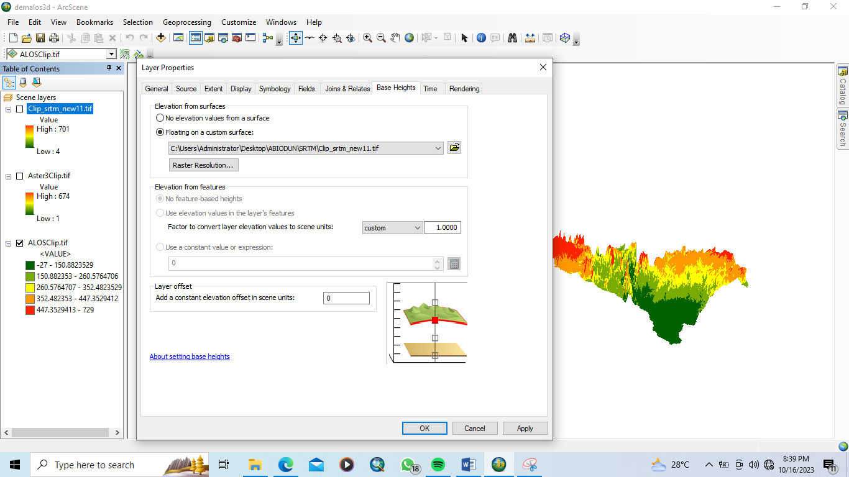
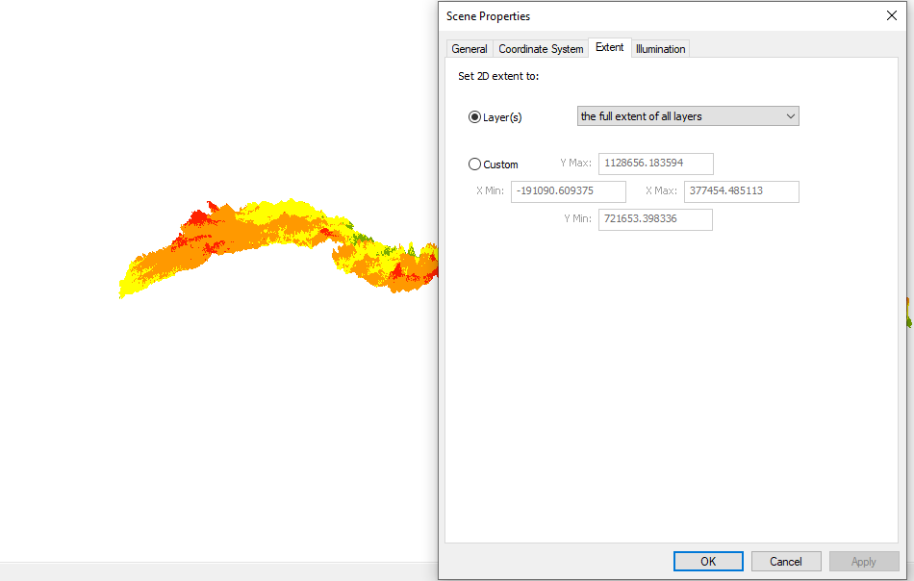
- CREATING CONTOURS (DONE IN ARCMAP)
- Added the clipped DEM raster to ArcMap.
- Opened ArcToolbox – Spatial Analyst Tools – Surface – Contour.
- Entered a contour interval of 100 m and clicked OK.
- Opened the raster properties – Symbology to change the colour ramp.
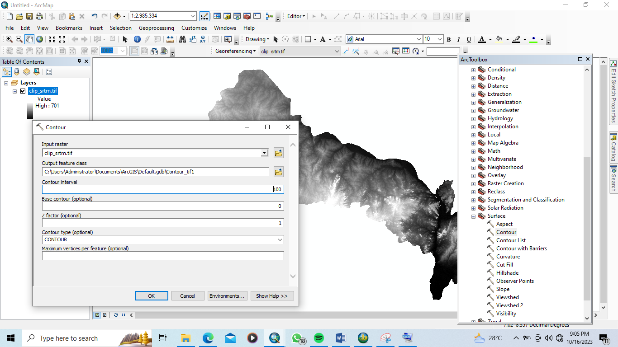
- RESULTS AND ANALYSIS
- From the SRTM, ASTER and ALOS data, the highest point was about 700 m and the lowest about 100 m above sea level.
- The widely spaced contour lines indicate hills with flat tops and steep slopes, and the jagged, rough contours point to large rock outcrops, cliffs and fractured areas.
- The DTMs and DEMs derived in ArcGIS show a lowland in Kogi State, caused by the confluence of the River Niger and River Benue, and considerably more highland in Kogi State than in Kwara State.
- SRTM 30 m is expected to be more accurate than ASTER 30 m because of the technique used: SRTM builds its DEM from radar observations, while ASTER uses stereo imagery and photogrammetric processing of sunlight reflected from the tree canopy.
- The ALOS DEM is considered more accurate than both because of its finer resolution.
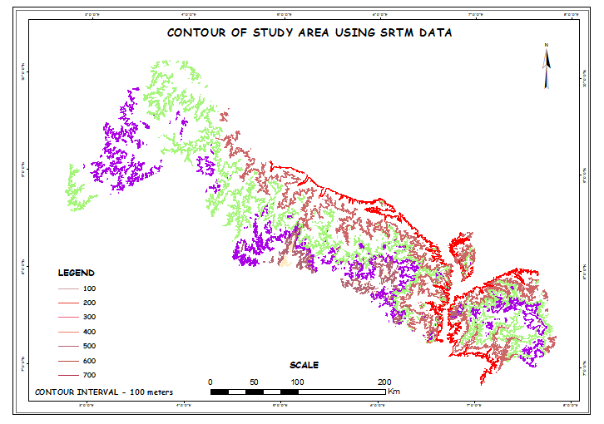
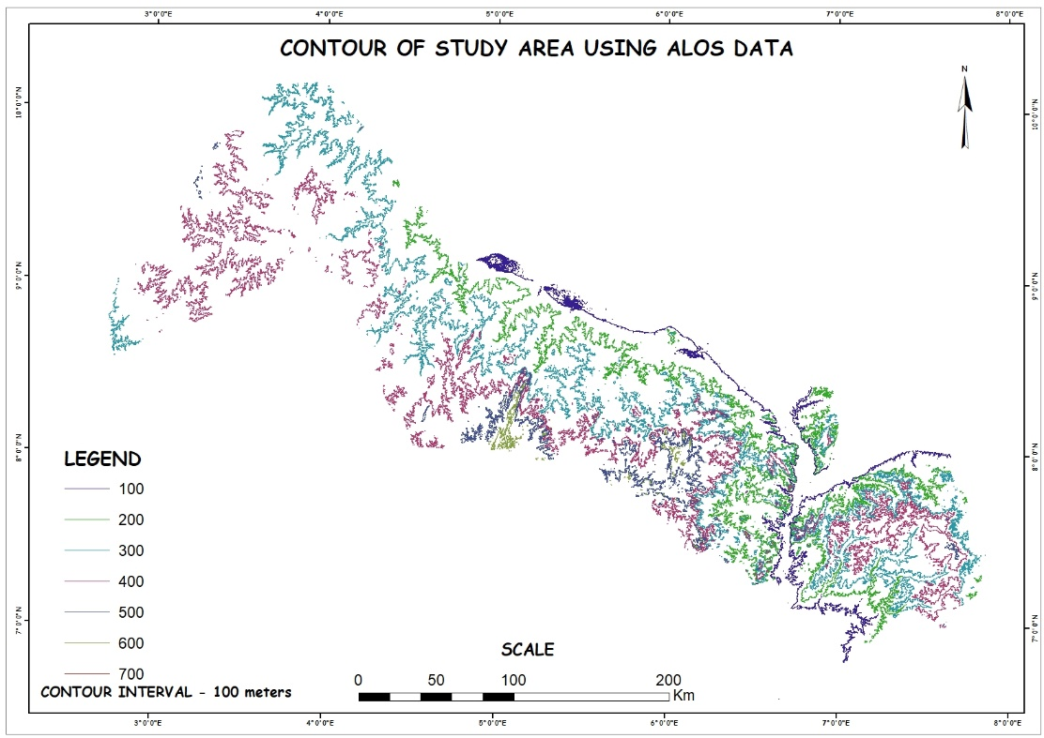
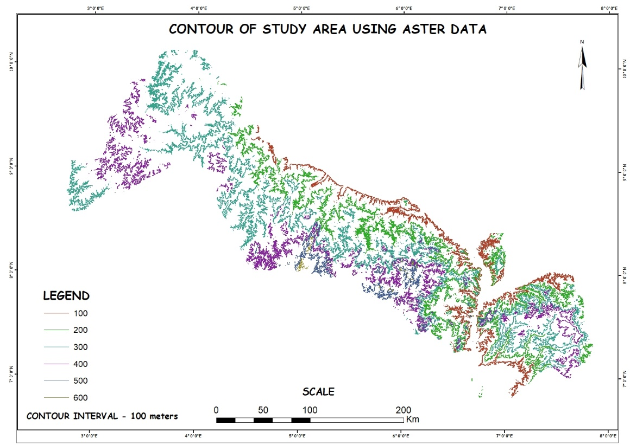
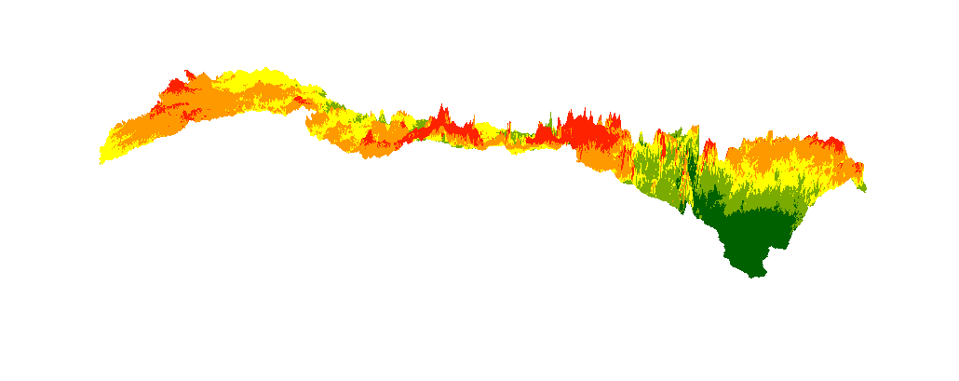
DTM (Digital Terrain Model) of study area using ALOS data
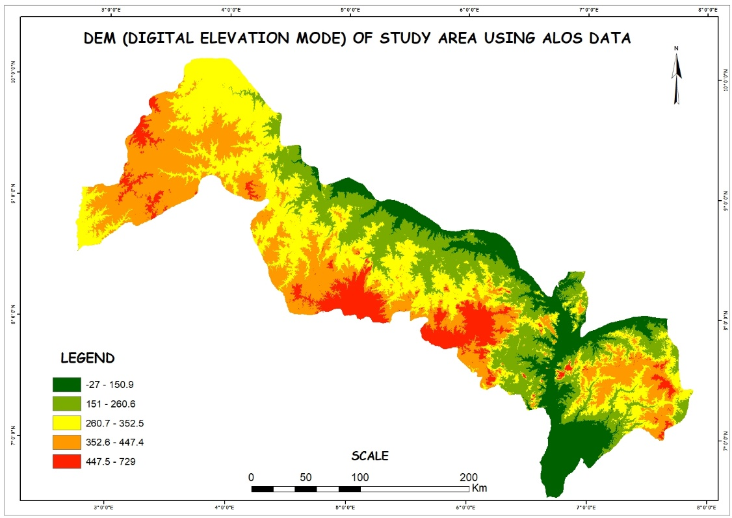
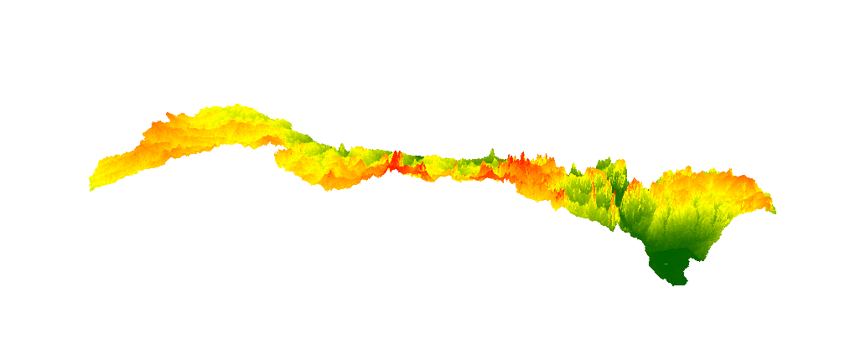
DTM (Digital Terrain Model) of study area using ASTER data
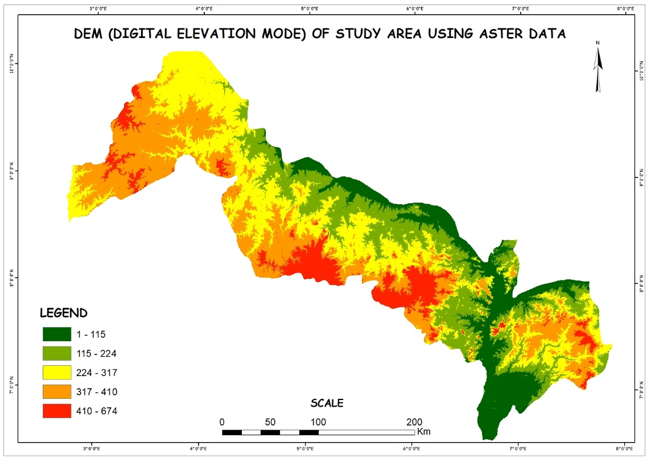
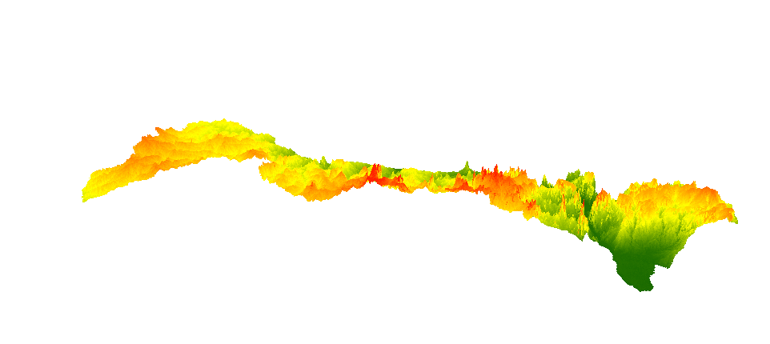
DTM (Digital Terrain Model) of study area using SRTM data
