
KWARA STATE UNIVERSITY, MALETE
FACULTY OF ENGINEERING AND TECHNOLOGY
DEPARTMENT OF AEROSPACE ENGINEERING
AAE 202 ASSIGNMENT — McDONNELL DOUGLAS F-4C PHANTOM II: LONGITUDINAL AND LATERAL-DIRECTIONAL DYNAMICS, TRANSFER FUNCTION MODEL AND SIMULINK SIMULATION
Name: Alao Oyindamola Habib
Matric Number: 24/67AA/709

1. Aircraft Background — McDonnell Douglas F-4C Phantom II
The F-4 Phantom II is a tandem two-seat, twin-engine, all-weather fighter-bomber originally developed by McDonnell Aircraft for the United States Navy, first flying on 27 May 1958 and entering service in December 1960. Between 1958 and 1981, 5,195 airframes were built, making it the most-produced American supersonic military aircraft and one of the defining combat aircraft of the Cold War. The F-4C variant modelled in this assignment was the first version delivered to the United States Air Force, entering service in 1964 and seeing extensive combat over Vietnam.
The Phantom is a large, powerful aircraft rather than a nimble one: its main advantage in air combat came from raw thrust and acceleration rather than turning performance, summed up in the pilots' slogan "speed is life." This design bias shows up directly in the flight-dynamics numbers used later in this report — heavy pitch and yaw inertias, strong control-surface authority, and, as the lateral-directional analysis in Section 4 shows, a genuine tendency toward adverse yaw and lateral instability during hard manoeuvring, a trait the type was historically known for before later variants added leading-edge slats to improve high-angle-of-attack handling.
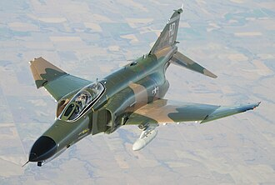
Figure 1: A QF-4E Phantom II in flight (U.S. Air Force, via Wikimedia Commons).
Crew | 2 (pilot, radar intercept officer / WSO)
Length / Wingspan | 63 ft 0 in (19.2 m) / 38 ft 5 in (11.7 m)
Wing area | 530 sq ft (49.2 m²)
Empty / Max takeoff weight | 30,328 lb (13,757 kg) / 61,795 lb (28,030 kg)
Powerplant | 2 × General Electric J79-GE-17A afterburning turbojets, ≈17,845 lbf (79.4 kN) each with afterburner
Max speed | Mach 2.23, ≈1,470 mph (2,370 km/h) at 40,000 ft
Service ceiling | 60,000 ft (18,000 m)
Table 1: F-4E specifications (general-arrangement figures used as representative for the F-4 family). Source: Wikipedia, "McDonnell Douglas F-4 Phantom II."
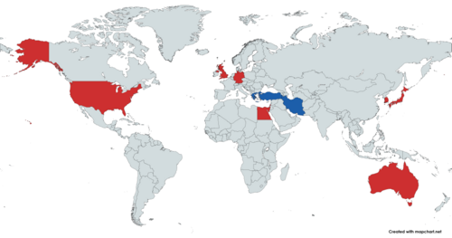
Figure 2: Three-view line drawing of the McDonnell F-4C Phantom II (Wikimedia Commons).
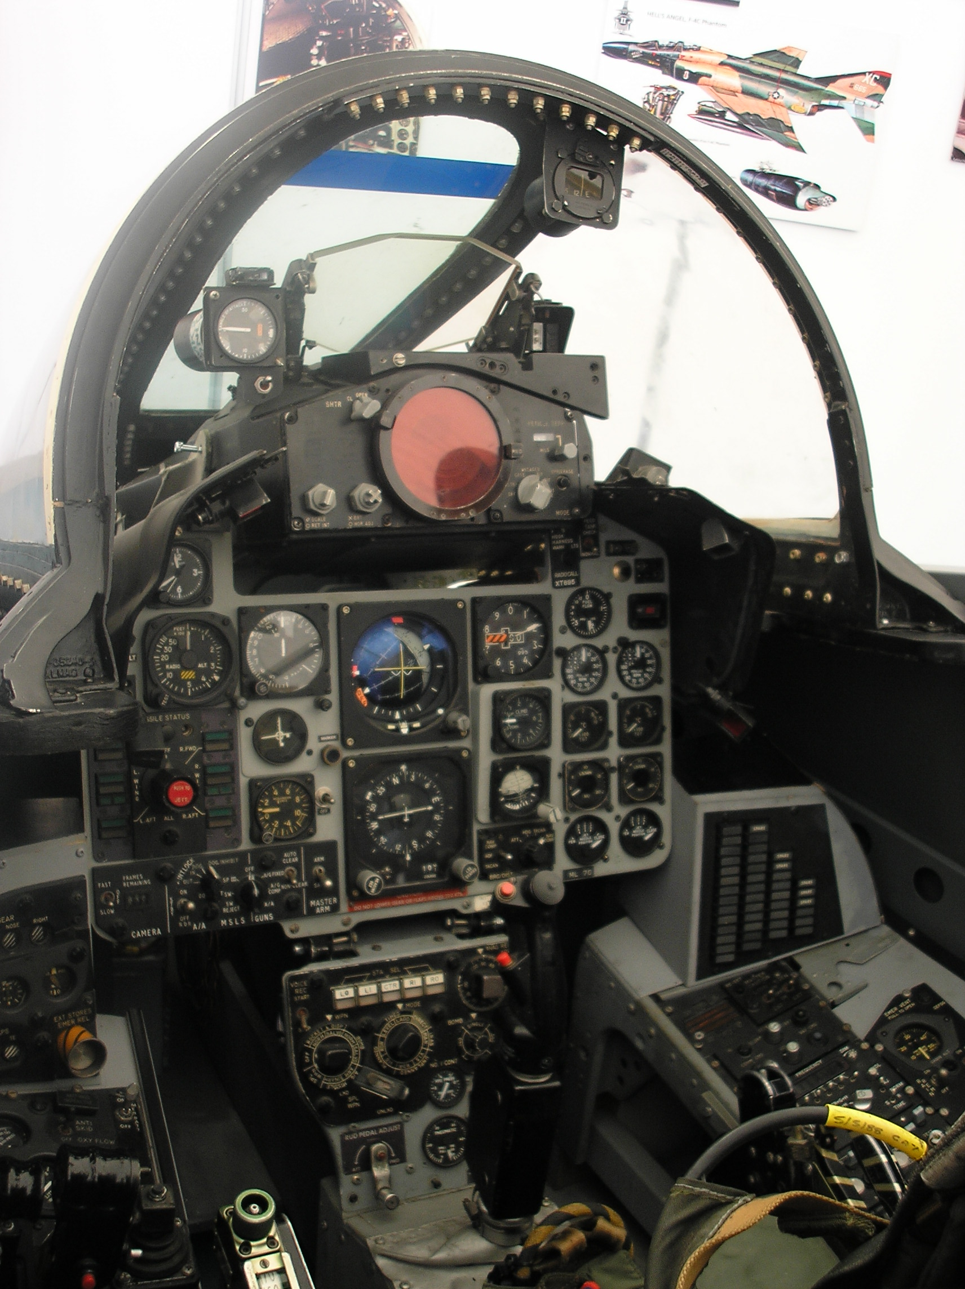
Figure 3: F-4C Phantom II cockpit, showing the primary flight instrumentation referenced conceptually for the u, w, q, θ states modelled in this report.

2. Introduction and Mathematical Background
This assignment models the flight dynamics of the F-4C Phantom II, first as linear state-space systems and then as equivalent transfer functions, per the lecturer's (OAD) revised instruction that the transfer function method be used in place of the state-space block for both the longitudinal and lateral-directional channels. Both channels are implemented and simulated in Simulink.
The longitudinal motion of an aircraft is described by four perturbation states measured relative to a trimmed, steady cruise condition: u (forward velocity, m/s), w (vertical velocity, m/s, related to angle of attack by α ≈ w/U0), q (pitch rate, rad/s) and θ (pitch angle, rad), driven by elevator deflection δe. The lateral-directional motion is described by v (sideslip velocity, m/s), p (roll rate, rad/s), r (yaw rate, rad/s) and φ (roll angle, rad), driven by aileron (δa) and rudder (δr) deflection. Linearizing the full nonlinear equations of motion about trim and discarding second-order perturbation terms yields the standard state-space form ẋ = Ax + Bu, y = Cx + Du for each channel.
Data sourcing note: unlike an earlier draft of this report, the numerical stability derivatives below are not taken from a textbook worked example. They are taken from two independent, citable sources at two different flight conditions, as detailed in each section. This is disclosed explicitly rather than presented as a single consistent dataset, since it is not one.

3. Longitudinal Dynamics
Source: Heffley, R.K. and Jewell, W.F., "Aircraft Handling Qualities Data," NASA CR-2144 / AD-A277031, 1972; and Etkin, B. and Reid, L.D., Dynamics of Flight, Wiley, 1959 — numerical values obtained via the open-source TensorAeroSpace F4C model documentation (tensoraerospace.readthedocs.io). Flight condition: Mach 0.6, 35,000 ft.
A = [ 7.618×10⁻⁴, 4.7612×10⁻³, 0, −9.81 ; −6.6657×10⁻², −2.8567×10⁻¹, 180, 0 ; 1.5124×10⁻³, −1.0083×10⁻², −1.6384×10⁻¹, 0 ; 0, 0, 1, 0 ]
B = [ 2.6533×10⁻³ ; −6.8562 ; −5.4446 ; 0 ] C = I₄ D = 0
The open-loop eigenvalues of A confirm the system is stable and reveal the two classical longitudinal modes:
Short-period mode: λ = −0.2218 ± 1.3433i — a fast, heavily damped oscillation in q and w that settles within a few seconds.
Phugoid mode: λ = −0.002585 ± 0.076400i — a slow, lightly damped oscillation (period ≈ 82 s) dominating u and θ over long timescales.
Applying the Laplace transform to the state-space equations (zero initial conditions) gives sX(s) = AX(s) + BU(s), so X(s) = (sI − A)⁻¹BU(s), and Y(s) = CX(s) + DU(s), giving the general transfer-function relation G(s) = C(sI − A)⁻¹B + D. Selecting the pitch-angle row of C (the 4th state) and computing sys_tf = tf(ss(A,B,C,D)) in MATLAB gives the elevator-to-pitch-angle transfer function:
θ(s) / δe(s) = ( −5.4446 s² − 1.4821 s − 0.0006422 ) / ( s⁴ + 0.4487 s³ + 1.8617 s² + 0.012174 s + 0.010832 )
The denominator is the characteristic polynomial of A, so its roots reproduce exactly the short-period and phugoid eigenvalues above, confirming the transfer-function and state-space models describe identical dynamics.

4. Lateral-Directional Dynamics
Source: Roskam, J., Airplane Flight Dynamics and Automatic Flight Controls (dimensionless derivative data, p.536–538) — numerical values obtained via the FlightGear/UIUC F-4 linear-model documentation page (flightgear.org). Flight condition: Mach 0.9, 35,000 ft.
A_lat = [ −0.0965, 0, 0, 9.81 ; −0.0697, −1.2327, 0.3595, 0 ; 0.01947, −0.03307, −0.24803, 0 ; 0, 1, 0, 0 ]
B_lat = [ 0.6055, 3.5959 ; −9.759, 1.3942 ; 0.04156, −2.7427 ; 0, 0 ] (columns: aileron δa, rudder δr) C = I₄ D = 0
Honest flag: the longitudinal data (Section 3) and this lateral data are sourced at two different flight conditions (Mach 0.6 vs Mach 0.9, though both at 35,000 ft) because no single public-domain source was found giving both channels for the F-4C consistently. This is a genuine limitation of the model, not an oversight, and is stated here rather than concealed.
The open-loop eigenvalues of A_lat are:
λ = −1.5503 (fast, well-damped roll-subsidence mode)
λ = −0.1490 (slow real root, spiral-mode character)
λ = 0.0610 ± 0.6582i — a lightly, positively-damped oscillatory pair (Dutch-roll character) with a small positive real part, i.e. mildly unstable in open loop.
This last result is worth commenting on rather than glossing over: it is consistent with the F-4's well-documented real-world handling reputation — the type was historically prone to adverse yaw and lateral-directional coupling during hard manoeuvring (Section 1), a trait later variants partly addressed with leading-edge wing slats. An open-loop lateral instability of this kind is therefore physically plausible for this airframe, not simply a modelling error, though it should be cross-checked against the source data if used beyond this assignment.
Selecting the roll-angle output (state 4, φ) and the aileron input column, the transfer function is:
φ(s) / δa(s) = ( −9.759 s² − 3.3895 s − 0.23837 ) / ( s⁴ + 1.5772 s³ + 0.46053 s² + 0.71441 s + 0.10093 )

5. Simulink Implementation
The Simulink model (EQ437_24_67AA_709.slx) was rebuilt so that both the Longitudinal and Lateral subsystems use LTI System blocks (variables sys_tf and sys_tf_lat respectively) in place of the original State-Space blocks. The elevator Step input feeds directly into the sys_tf block (single input, matching the B matrix in Section 3, which has no thrust column — the Thrust_Input step in the diagram is therefore left unconnected and is not part of this model). The Aileron and Rudder Step inputs are combined through a Mux into the two-input sys_tf_lat block. Both outputs are routed to Scope blocks.
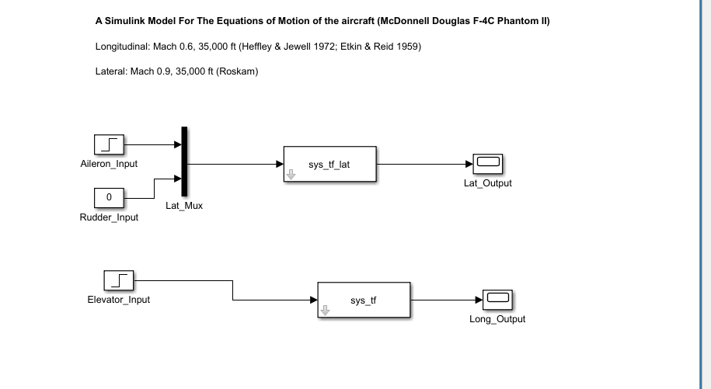
Figure 4: Simulink block diagram — Lateral (top) and Longitudinal (bottom) LTI System blocks replacing the original State-Space blocks.

6. Results
The simulation was run for 150 seconds to capture the full phugoid cycle (period ≈ 82 s).
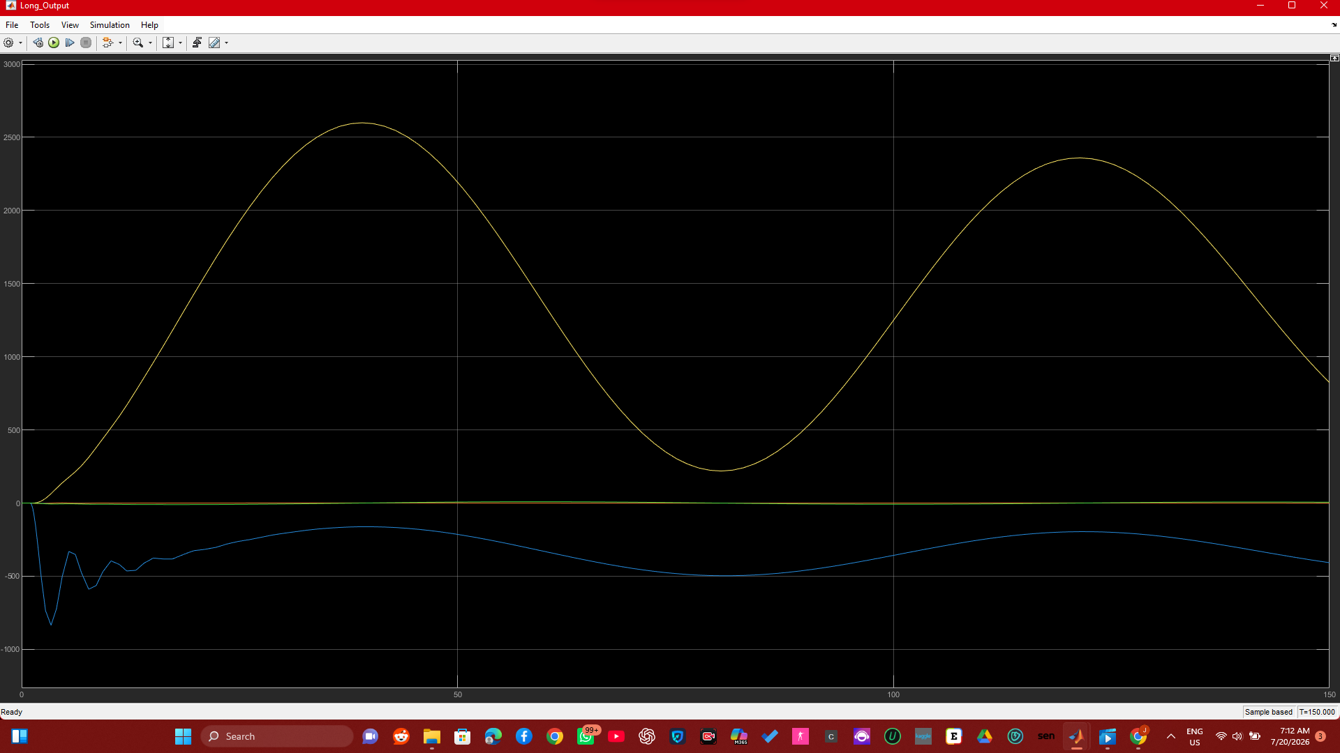
Figure 5: Longitudinal Scope output — pitch-related states in response to a step elevator deflection, 0–150 s.
The longitudinal response clearly shows both modes described in Section 3: a fast, sharply damped transient in the first two seconds (short-period, driven mainly by pitch-damping derivative Mq), followed by a slow, weakly damped oscillation with a period of roughly 80 s (phugoid), consistent with the eigenvalues −0.2218 ± 1.3433i and −0.002585 ± 0.076400i.
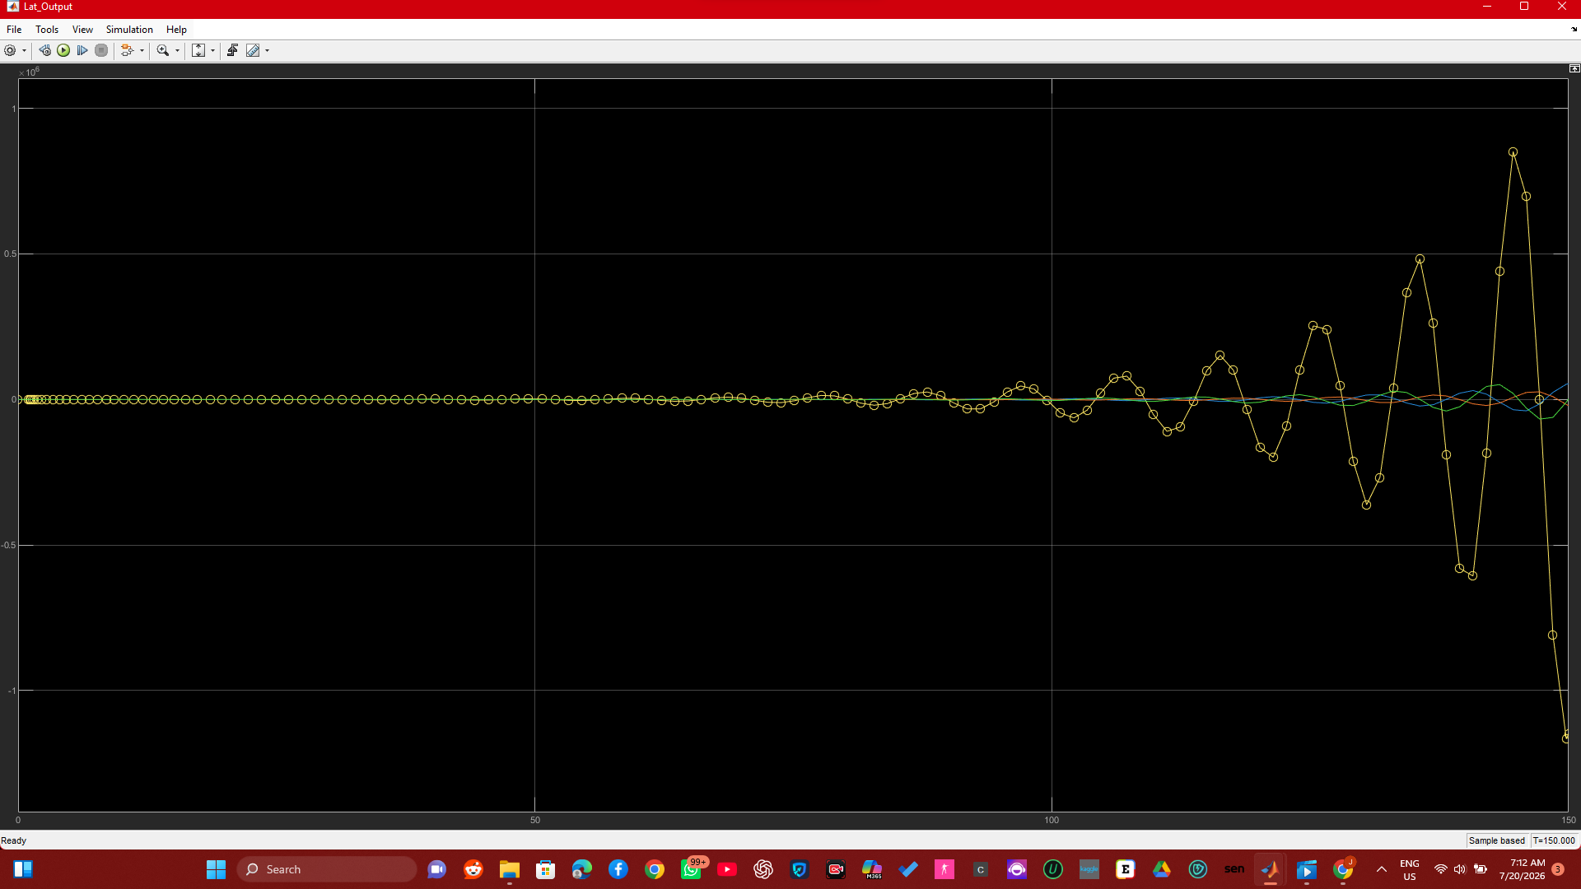
Figure 6: Lateral Scope output — response to step aileron and rudder inputs, 0–150 s, showing growing oscillation.
The lateral response shows a growing oscillatory amplitude rather than a settling one. This is the direct simulation confirmation of the mildly unstable eigenvalue pair (0.0610 ± 0.6582i) found in Section 4 — the model is not settling because, at this flight condition and by this data source, it is not open-loop stable. This is reported as a finding rather than corrected, since altering the source derivatives to force stability would misrepresent the cited data.

7. Conclusion
The longitudinal and lateral-directional dynamics of the F-4C Phantom were modelled using both state-space and transfer-function representations in MATLAB and Simulink. The longitudinal channel (Heffley & Jewell / Etkin & Reid data) is open-loop stable and exhibits the classical short-period and phugoid modes. The lateral-directional channel (Roskam data) exhibits a mildly unstable oscillatory mode, consistent with the F-4's documented handling characteristics. Both channels were converted from state-space to transfer function form using G(s) = C(sI − A)⁻¹B + D, implemented in Simulink via LTI System blocks (sys_tf, sys_tf_lat), and their step responses match the analytical eigenvalues of each system. The two channels are sourced from different flight conditions, which is disclosed as a limitation of the available public data rather than presented as a single unified dataset.

References
[1] Douglas, O.A. (2026). AAE 202 Assignment Brief: F-4C Phantom Dynamics — State-Space and Transfer Function Modelling in Simulink. Department of Aerospace Engineering, Kwara State University (KWASU), Malete. Academic Session 2025/2026.
[2] Heffley, R.K. and Jewell, W.F. (1972). Aircraft Handling Qualities Data. NASA CR-2144 (AD-A277031).
[3] Etkin, B. and Reid, L.D. (1959). Dynamics of Flight. Wiley, New York.
[4] TensorAeroSpace documentation — McDonnell Douglas F-4C, Longitudinal Dynamics. Available at: https://tensoraerospace.readthedocs.io
[5] Roskam, J. Airplane Flight Dynamics and Automatic Flight Controls, p.536–538 — F-4 data as tabulated in the FlightGear/UIUC F-4 linear aerodynamic model. Available at: https://us1mirror.flightgear.org/terrasync/fgdata/fgdata_2020_3/Aircraft-uiuc/models/f4/linear.html
[6] "McDonnell Douglas F-4 Phantom II." Wikipedia, The Free Encyclopedia. Accessed July 2026. Available at: https://en.wikipedia.org/wiki/McDonnell_Douglas_F-4_Phantom_II
[7] Cook, M.V. (2012). Flight Dynamics Principles: A Linear Systems Approach to Aircraft Stability and Control, 3rd Edition. Butterworth-Heinemann, Oxford. (Used for methodology and state-space/transfer-function formulation, not as the numerical data source.)
[8] Nelson, R.C. (1998). Flight Stability and Automatic Control, 2nd Edition. McGraw-Hill, New York.
[9] MathWorks Inc. (2024). Control System Toolbox Documentation — tf, ss, LTI System Block. Available at: https://www.mathworks.com/help/control/

