44 API CALLS MADE UNTIL THE TIMER WAS RESET

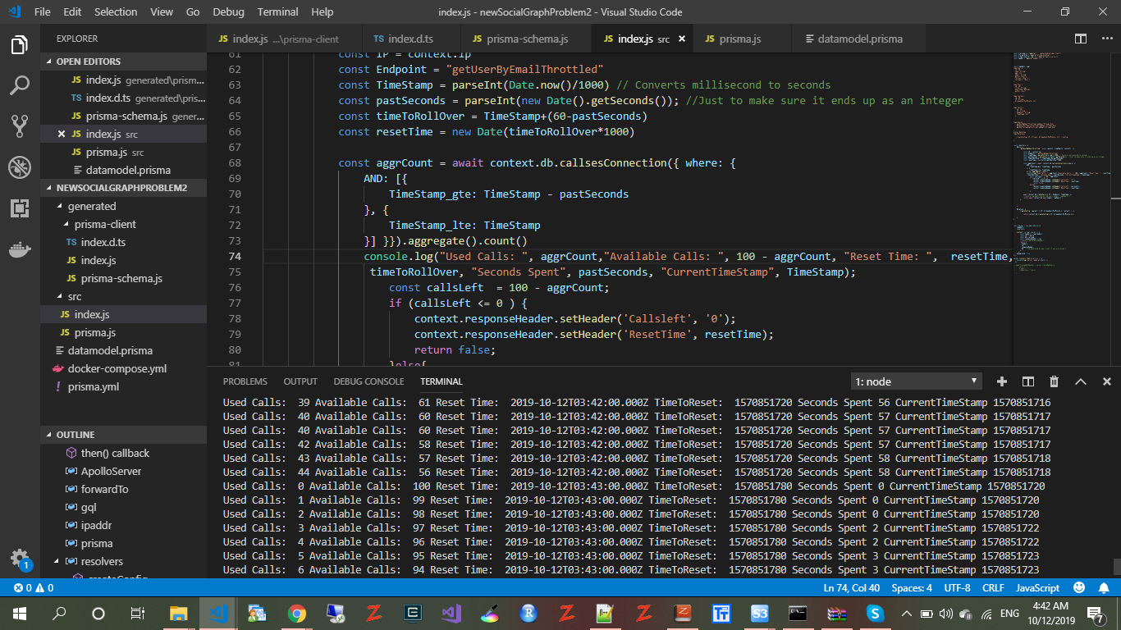

After a number of calls were made, **Callsleft was 71** and Reset time was **ResetTime was Sat Oct 12 2019 04:49:00 GMT+0100 (W. Central Africa Standard Time)** in the HTTP response header

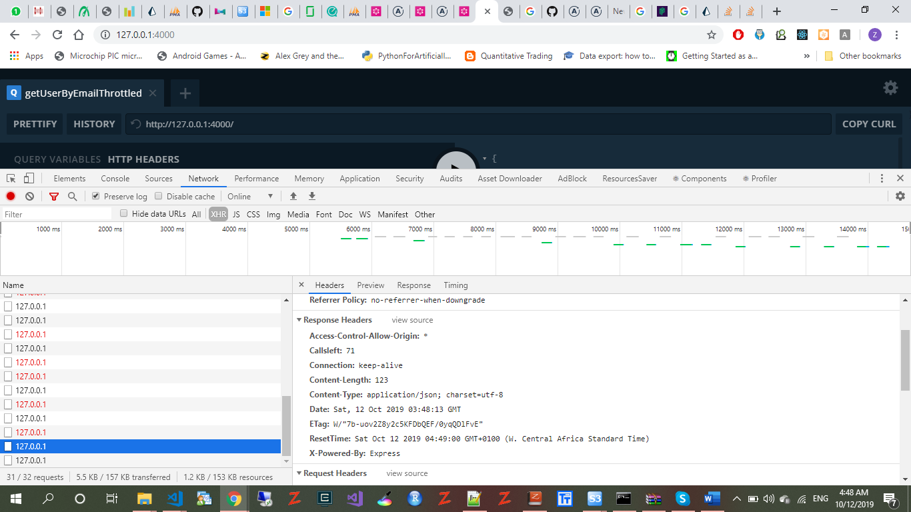

WHEN ALL THE AVAILABLE CALLS IN A MINUTE HAS BEEN EXHAUSTED

