CREATE USER ENDPOINT

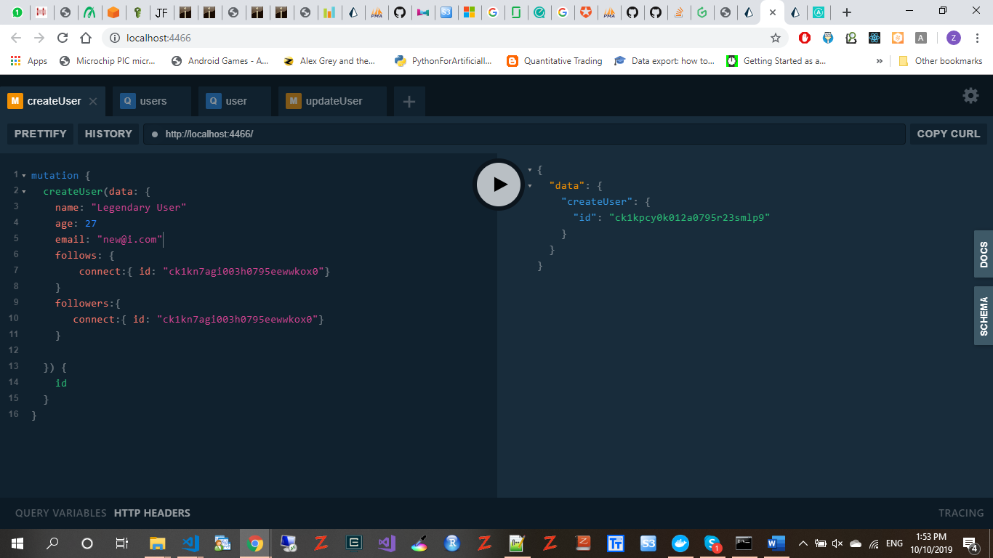

GET ALL USERS

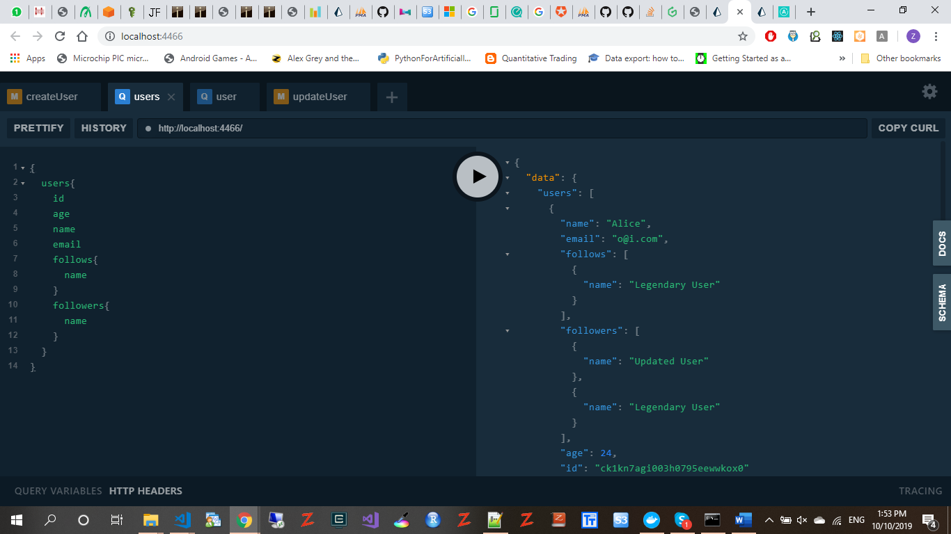

GET USER BY ID

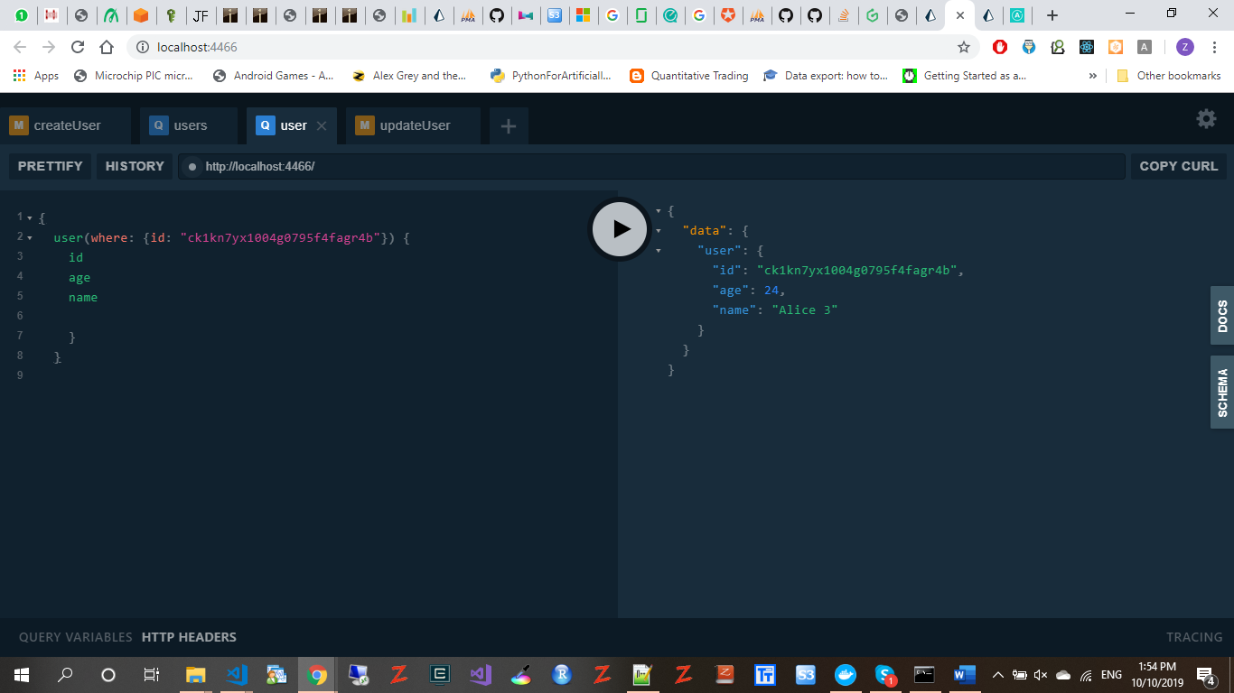

UPDATE USER QUERY

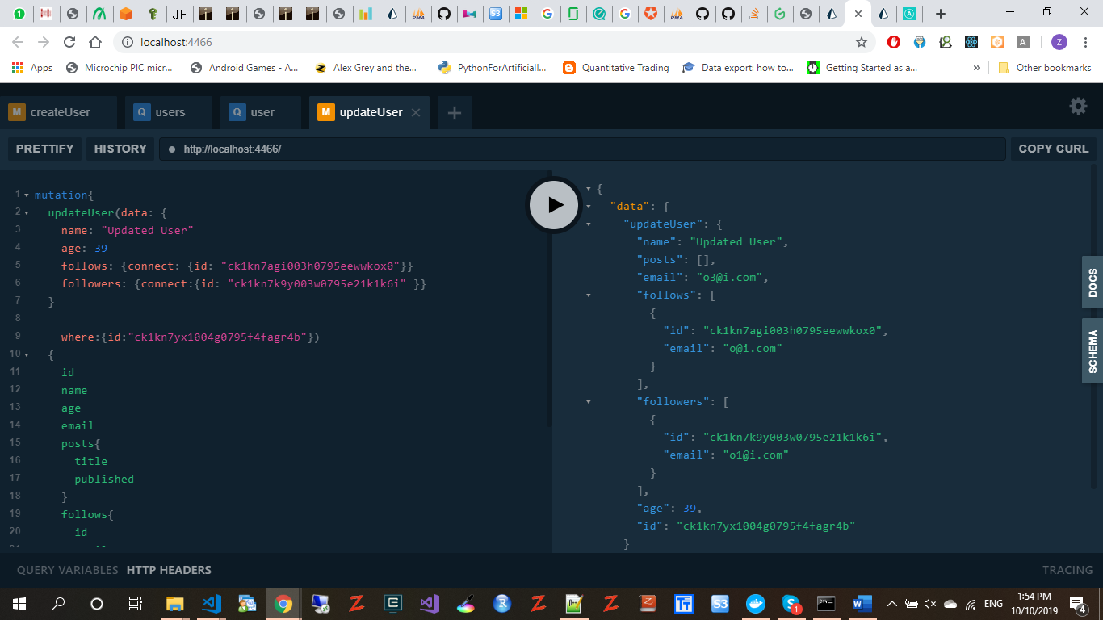

CREATE POST

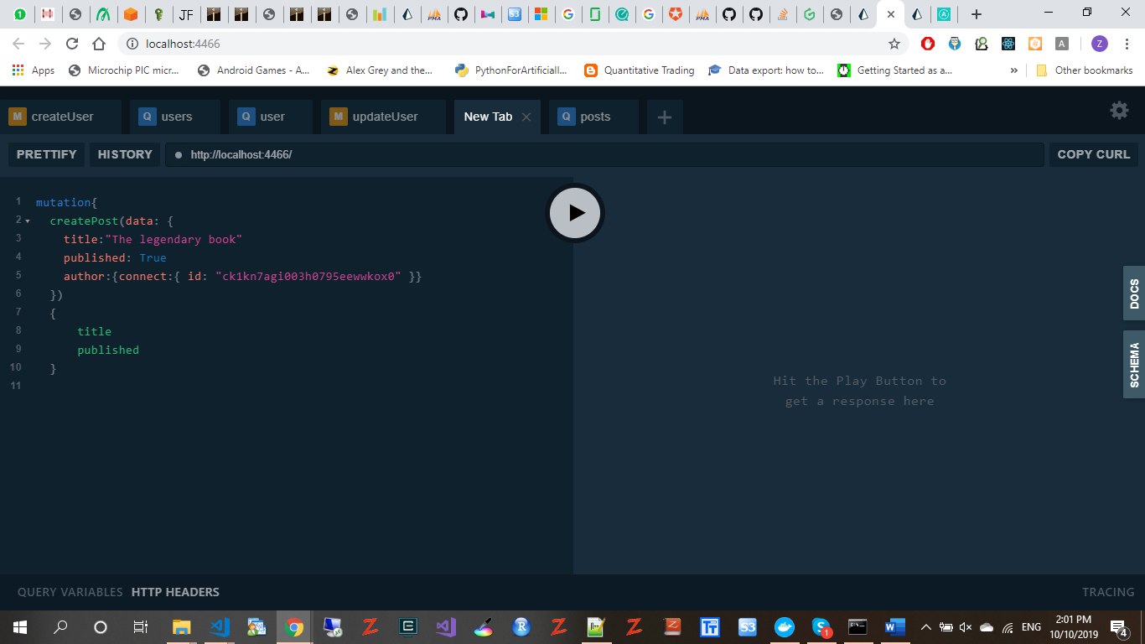

DATABASE TABLE CREATED:

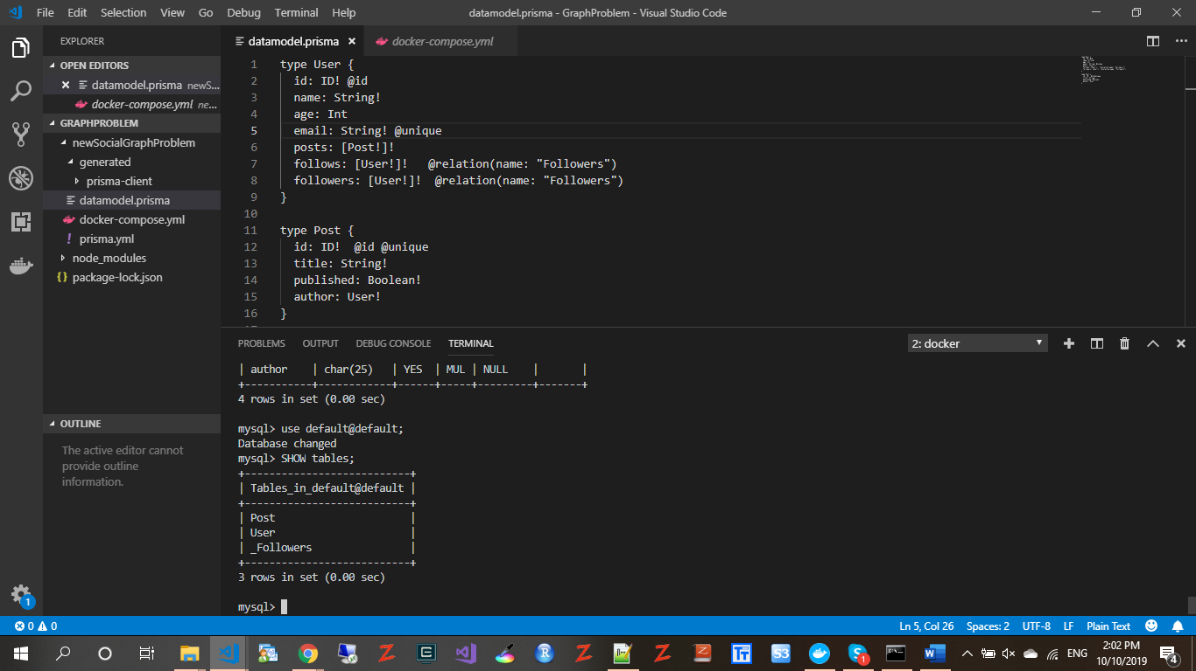

DATA IN THE USER TABLE:

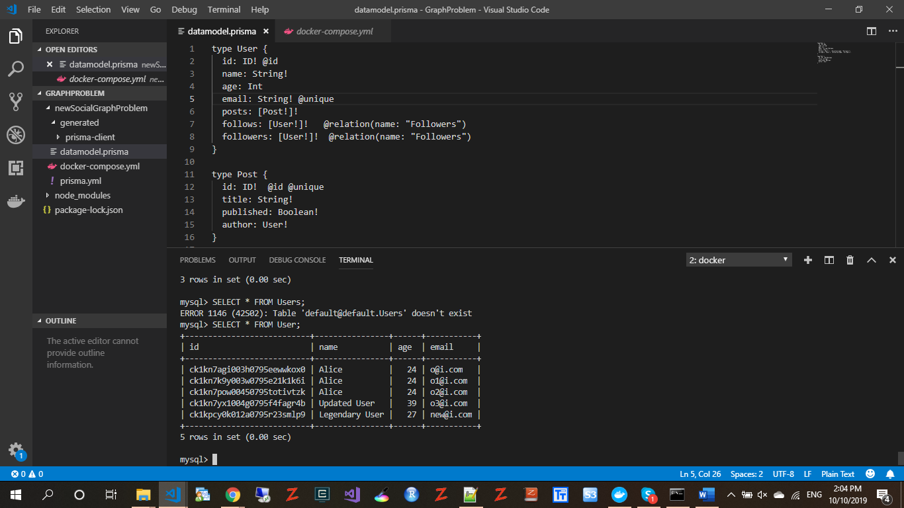

DATA IN THE _FOLLOWERS TABLE:

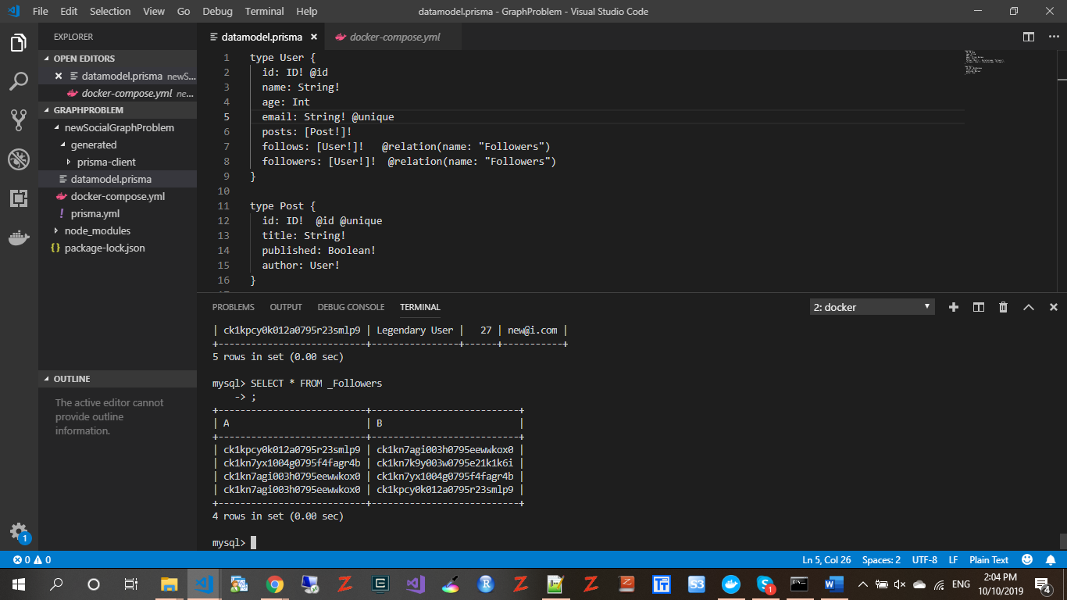

DOKER IS USED TO HOST THE DATABASE AND ALSO AS THE PRISMA ENDPOINT

