Sweet Bakery
Mobile Bakery Game — Submission Draft
Student name: [ADD YOUR NAME]

Required submission evidence
GitHub repository: [ADD PUBLIC REPOSITORY URL]
Successful GitHub Actions run: [ADD RUN URL AND INSERT SCREENSHOT OF ITS GREEN CHECK]
YouTube gameplay recording: [ADD UNLISTED VIDEO URL AFTER RECORDING THE ANDROID EMULATOR]
This draft is not ready for LMS submission until the fields above and genuine evidence are supplied. If a video is unavailable, insert actual emulator screenshots; the assignment assigns reduced credit to images alone.

Game concept and controls
Sweet Bakery is an English-language offline Android game set in a small bakery. During a 90-second shift, the player selects a customer, adds the exact ordered products to a tray and serves the order before the patience bar runs out. Three lost guests end the shift. Pause and replay are supported.

Diversity of meals
The menu includes cupcakes, donuts, croissants, bread, cake, cookies, pie and pretzels. Orders contain different combinations and quantities. Difficulty increases as successful service produces larger orders and faster arrivals.

Points management
Event | Points / consequence
Correct order | +100
Fast service (at least half patience remains) | +50 bonus
Correct-order streak | +10 per additional order, up to +50
Wrong order | −30; streak resets
Guest runs out of patience | −50 and one heart; streak resets
Score cannot fall below zero. A local best score rewards replay. A visible 1,000-point goal awards the Star Baker title without changing the scoring rules. Each service displays feedback explaining the outcome.

Visual details and language
The interface uses a rose and cream bakery palette, striped awning, pastry shelves, a warm oven, different customer appearances, illustrated food symbols, patience bars and a serving tray. All game text and instructions are in English.

Development previews — browser only
The images below were captured in a mobile-sized desktop browser. They demonstrate the design and must not be presented as Android emulator evidence.

Instructions
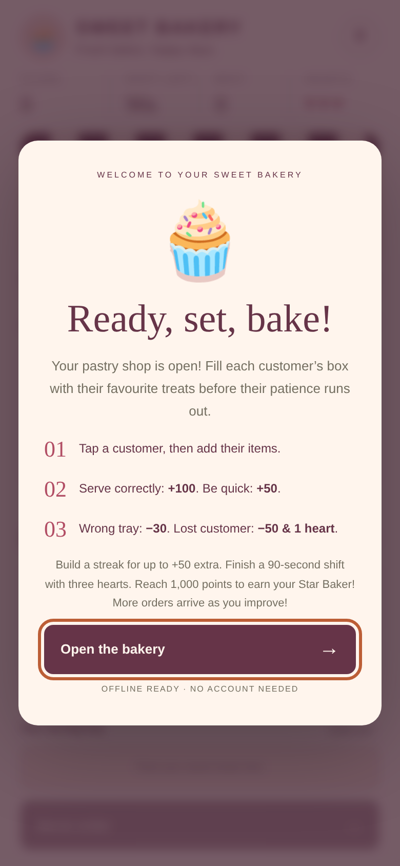

Gameplay and scoring
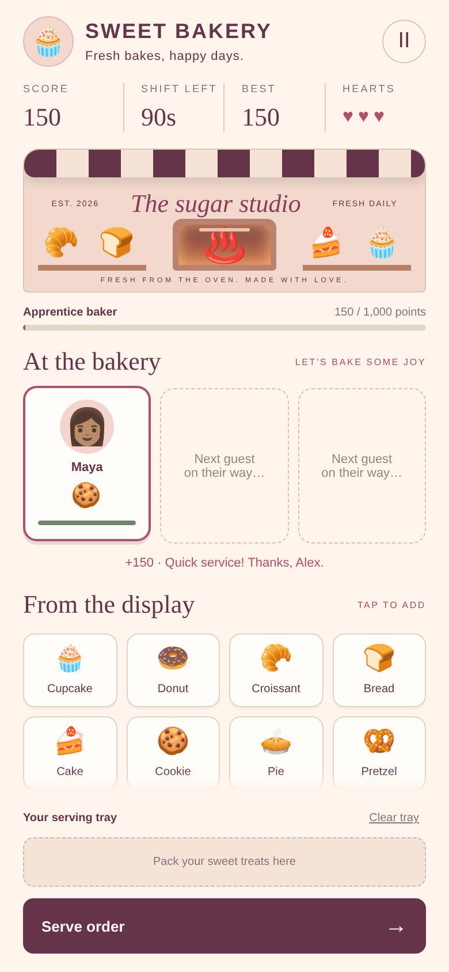

Shift result


