YZM2022: Data Mining
Homework 3
Recommendation System Project
Amazon Reviews 2023 — Musical Instruments
Tuğana Öykü Yıldız
24018020

Project Link: (https://github.com/oykutugana/recommendation-system-musical-instruments)

Summary: This project builds and compares recommendation systems for the Amazon Musical Instruments category. Content-based filtering, collaborative filtering, and hybrid models are implemented. All models are evaluated with 5-fold cross validation.

1. Objective
This project builds a recommendation system for the Amazon Reviews 2023 dataset. Only the Musical Instruments category is used. The dataset is very large, so it is sampled first.
The main goals of the project are listed below:
- Perform Exploratory Data Analysis (EDA).
- Build a Content-Based recommendation system.
- Build Collaborative Filtering models.
- Develop Hybrid Recommendation architectures.
- Compare all approaches with the same metrics.
- Analyze the effect of review text, ratings, metadata, and product images.
Extra work beyond the homework is also done:
- Sentence-BERT is used for semantic text embeddings (in addition to TF-IDF).
- CLIP is used for image embeddings (the homework asks for image features).
- A sentiment-weighted rating formula is tested: 0.7 × rating + 0.3 × sentiment.
- 9 content-based combinations are tested (3 models × 3 strategies).
- 8 CF experiments are run (4 models × 2 rating types).

2. Dataset
The Amazon Reviews 2023 dataset from the McAuley Lab is used. Only the Musical Instruments category is selected. The full data is too large, so sampling is applied first.

Sampling steps
- Time filter: 2018-01-01 to 2023-09-12 (5.7 years).
- 5-core filtering: Each user and each item must have at least 5 reviews. This step is repeated until the data is stable.
- Cold-start hold-out: 5,000 users with 1-2 reviews are held out. They are used later for cold-start evaluation.
The sampled dataset is uploaded to Hugging Face. The code loads it from there: oyku-tugana/amazon-musical-instruments-2018-2023-5core

Dataset statistics
Metric | Value
Interactions | 222,276
Unique users | 25,746
Unique items | 13,575
Sparsity | 99.94%
Mean rating | 4.46
Date range | 2018-01-01 to 2023-09-12
Items with image | 99.9%
Items with price | ~50%
Cold-start users | 5,000

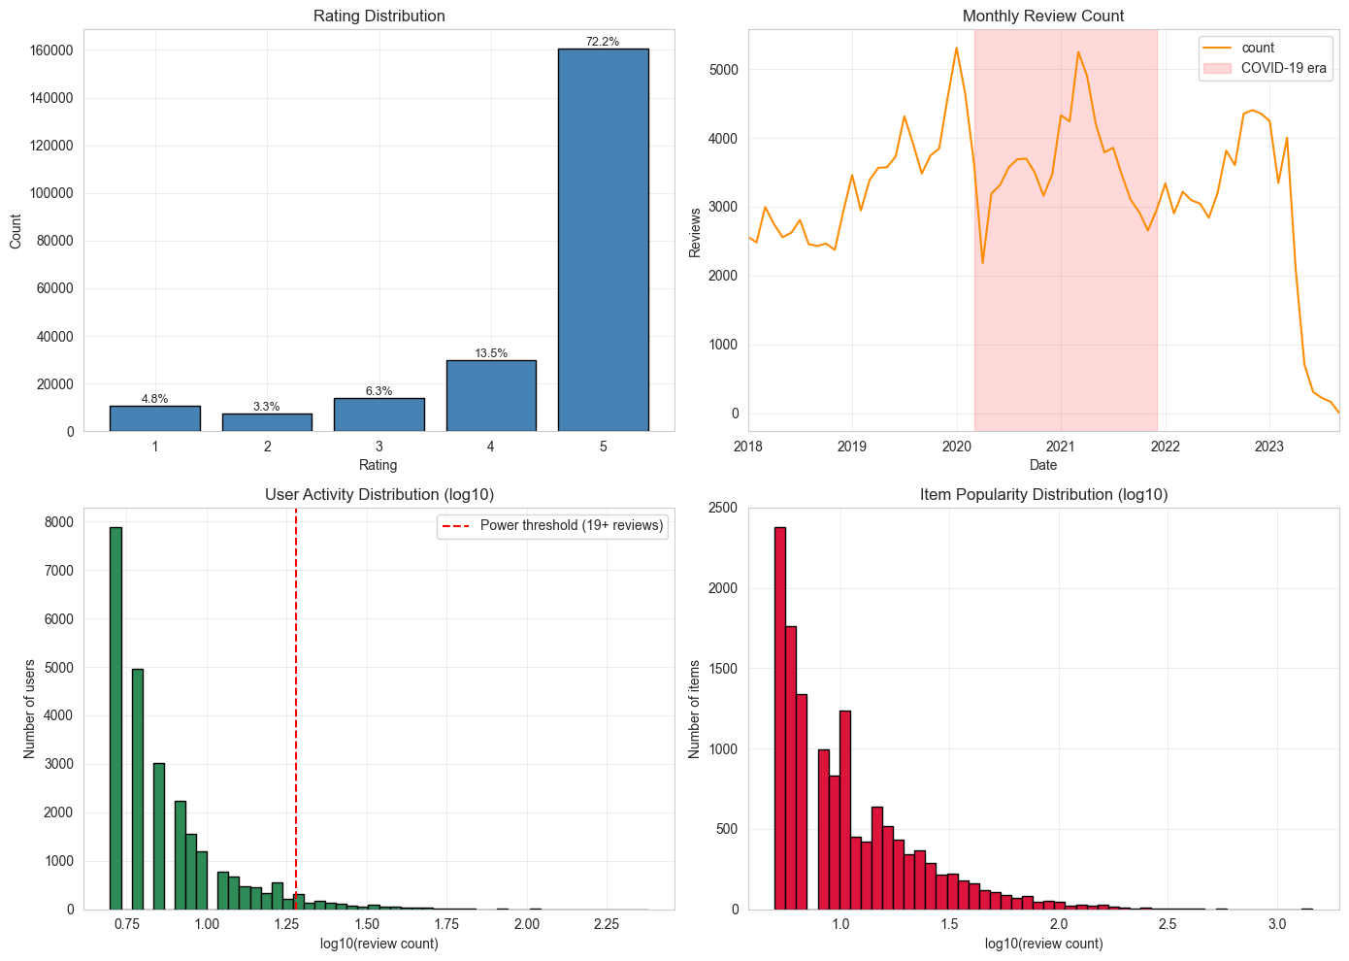
3. Exploratory Data Analysis

Figure 1. eda_overview.png

Top-left: rating distribution is heavily skewed toward 5 stars (72.2%).

Top-right: monthly review count drops sharply after mid-2023 due to incomplete recent data collection; COVID-19 era (2020-2021) is highlighted.

Bottom-left: user activity is long-tailed; only a small fraction (power users, 19+ reviews) accounts for most reviews.

Bottom-right: item popularity is also long-tailed.

3.1 User Analysis
User activity is long-tailed. The top 5% of users ("power users") give many reviews. These power users are more critical than average users. They give lower mean ratings and have higher variance.

3.2 Item Analysis
Item popularity is also long-tailed. Many items have few reviews. A few items are very popular. Guitar parts (strings, tuners, picks) are the most reviewed product types. Prices vary widely.

3.3 Temporal Analysis
Monthly review counts drop fast after mid-2023, from 700 to 6 per month. The reason is the data collection method — recent months are not fully collected. For this reason, the last 12 months are used as the test set, not the last 3 months.

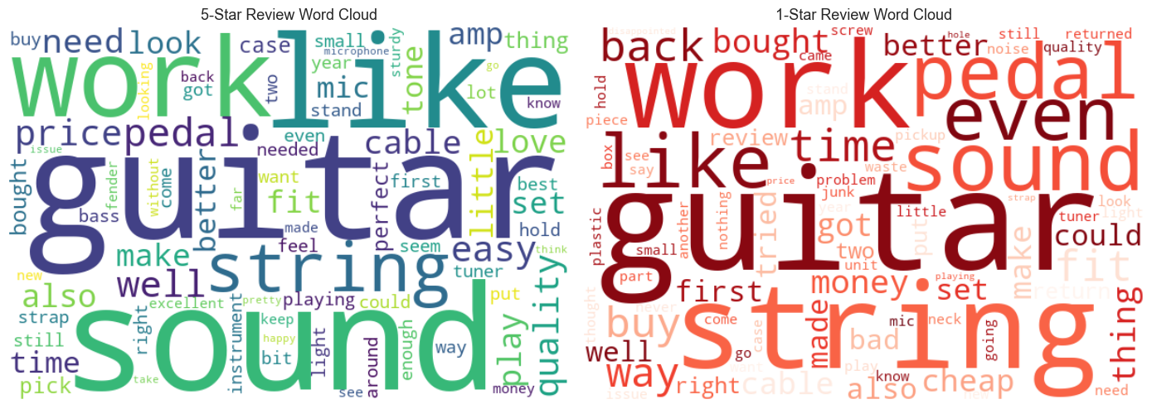
3.4 Text Analysis

Figure 2. wordclouds.png

Word clouds for 5-star (left, green) and 1-star (right, red) reviews.
Common words appear in both clouds (guitar, sound, string, work) because review topics are similar across ratings.
The sentiment difference comes from context, not vocabulary — this is one reason VADER struggles with ratings in this category.

VADER is used to compute sentiment for every review. Then rating and sentiment are compared.
Important finding: About 20.46% of 1-star reviews have a positive VADER sentiment. The reason is that VADER reads words like "love" or "perfect" but does not understand the context. Example: "I love the design BUT it broke in one week." VADER misses the "BUT".
The proposed solution: rating and sentiment are mixed together. adjusted_rating = 0.7 × rating + 0.3 × scaled_sentiment. This idea is tested later with CF models (Section 4.2).
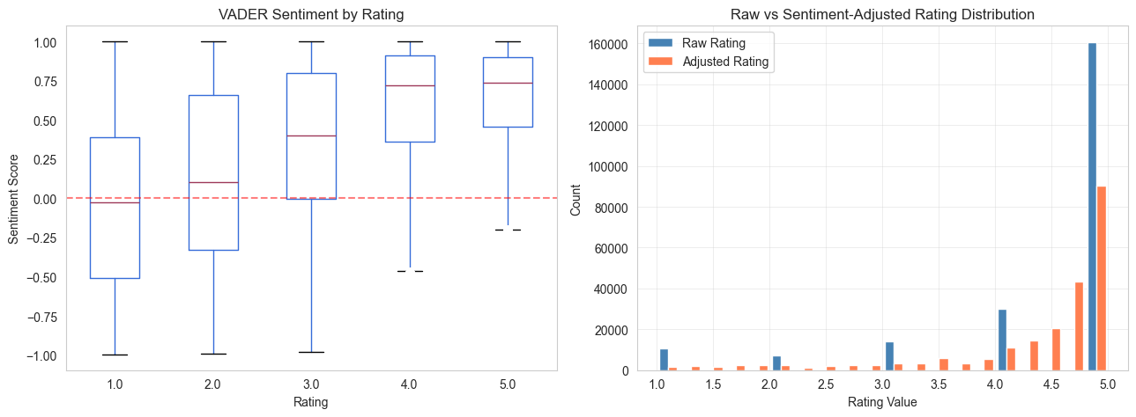

Figure 3. sentiment_analysis.png
Left: VADER sentiment score by star rating — sentiment is positively correlated with rating but with very wide variance, especially in low-rating reviews.

Right: raw rating vs sentiment-adjusted rating distribution. The adjusted rating smooths the 5-star peak and shifts mass to mid-range values.

4. Recommendation Models

4.1 Content-Based Filtering
Content-based filtering recommends items that look like items the user liked before. Three different content representations are tested:
- TF-IDF: Sparse text vectors from product titles, descriptions, and reviews. Size: 13,575 items × 5,000 features. Cosine similarity is used.
- Sentence-BERT (all-MiniLM-L6-v2): Dense semantic embeddings, 384 dimensions per item.
- CLIP (ViT-B/32): Dense image embeddings from product photos, 512 dimensions per item.
For each model, 3 user profile strategies are tested: mean_liked (mean of liked items), last_n (mean of last 5 items), and itemknn_last (items similar to the last one). This gives 9 combinations in total.
Result: TF-IDF with last_n wins (NDCG@10 = 0.00925). This is surprising because semantic models (SBERT, CLIP) usually beat TF-IDF. Here, product titles like "Fender Stratocaster Electric Guitar Sunburst" are already very informative at the word level. CLIP is the weakest: visual similarity does not match functional similarity in this category.

4.2 Collaborative Filtering
Collaborative filtering uses past user-item interactions, not content. 4 models are built, each with 2 rating types (raw rating and sentiment-adjusted rating). This gives 8 experiments in total.
Model | Type | NDCG@10 (raw) | NDCG@10 (sent)
User-CF | Memory-based | 0.00964 | 0.00951 (−1.39%)
Item-CF | Memory-based | 0.00262 | 0.00213 (−18.58%)
SVD | Latent factor | 0.00802 | 0.00830 (+3.43%)
ALS | Implicit | 0.01128 | 0.01101 (−2.36%)

Key findings:
- ALS is the best CF model (0.01128 in raw, 0.01101 in sentiment).
- Item-CF is the weakest. The standard formula with sum-of-similarities in the denominator is used. This formula removes popularity bias, but in this category popularity bias was actually a useful signal.
- Sentiment-adjusted rating does not give a clear benefit. Only SVD shows +3.43%. The other 3 models go down. The proposed signature idea did not generalize.

The user mean rating distribution explains why cosine similarity was preferred over Pearson similarity for User-CF. Most users have a mean rating between 4.0 and 5.0 (Figure 4). Pearson similarity centers each user's ratings around their own mean, but when most users have similar high means, this centering removes useful signal instead of correcting for "strict vs generous" rating styles. For this reason, cosine similarity is used for User-CF in this study.
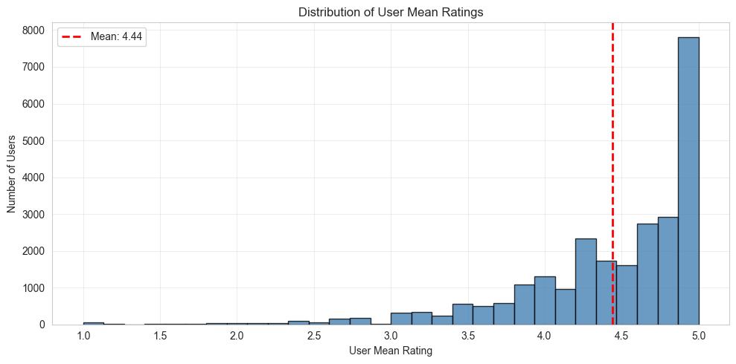

Figure 4. user_mean_rating_dist.png
The mass is concentrated between 4.0 and 5.0 (mean = 4.44, red dashed line). Few users have mean ratings below 3.0. This narrow distribution makes Pearson-style mean-centering ineffective in this dataset.
4.3 Hybrid Recommendation
The homework formula is: Score = α × Score_CF + (1−α) × Score_CB. The value of α is swept from 0 to 1 in steps of 0.05.
α | NDCG@10 | Coverage
0.00 (pure CB / TF-IDF) | 0.00925 | 0.871
0.30 | 0.01115 | 0.861
0.50 | 0.01289 | 0.798
0.65 (best) | 0.01421 | 0.659
0.90 | 0.01242 | 0.367
1.00 (pure CF / ALS) | 0.01128 | 0.340
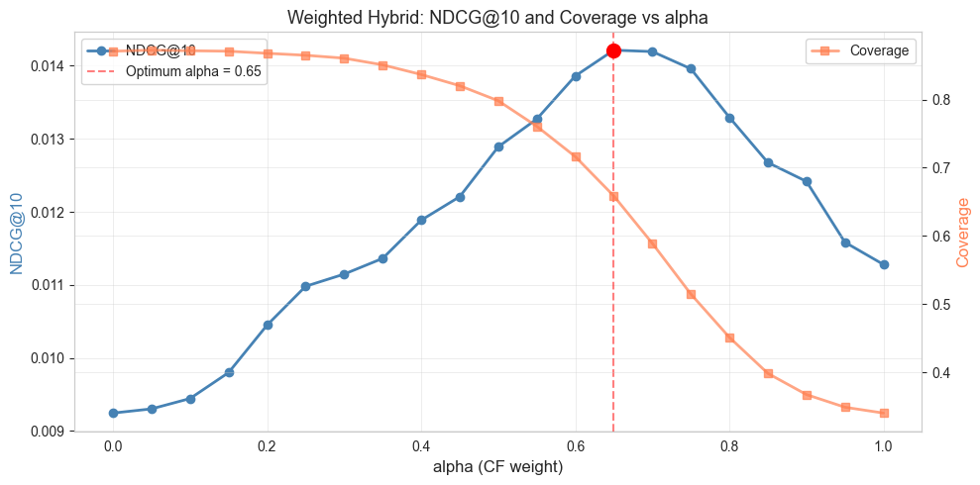
α = 0.65 is the best. It gives NDCG@10 = 0.01421. This is +26.0% better than pure ALS and +53.6% better than pure TF-IDF.

Figure 5. alpha_curve.png

NDCG@10 (blue) and Coverage (orange) as α changes from 0 (pure content-based) to 1 (pure ALS). NDCG@10 reaches its maximum at α = 0.65 (red marker, NDCG@10 = 0.01421). Coverage drops as α increases, because ALS has lower coverage than TF-IDF. The optimal α gives a good balance between accuracy and diversity.

Multimodal 4-way ensemble
A richer mix is also tested: TF-IDF + SBERT + CLIP + ALS, with a grid search for weights. The best weights from the fine grid (0.05 steps) are shown below:
Component | Weight
TF-IDF | 0.20
Sentence-BERT | 0.15
CLIP | 0.10
ALS | 0.55
Total NDCG@10 | 0.01436
Important finding — CLIP weight is small but not zero in the fine grid. The coarse grid (0.25 steps) gave CLIP=0; the fine grid (0.05 steps) found CLIP=0.10. However, this CLIP contribution is later disproved by 5-fold cross validation (see Section 5.1). The multimodal result (0.01436) is only marginally better than the simple α=0.65 hybrid (0.01421). The difference is small, so the simpler model is the better choice.

4.4 Feature Selection
The homework asks for at least 3 different feature selection techniques. Three techniques with different theoretical backgrounds are selected:
- Chi-square (χ²): Frequency-based, fast, works on sparse matrices.
- Mutual Information: Information-theoretic measure.
- ReliefF: Instance-based, uses nearest neighbors.
Target (personalized): Binary classification — items liked by the user (rating ≥ 3.5) are positive examples; random unseen items are negative examples. This target is built only from training data (no leakage). Total samples: 318,408 with 50/50 class balance. Tested K values: 500, 1000, 2000 features. The reduced TF-IDF matrix is then used for content-based recommendation.
Technique | Best K | NDCG@10 | Drop vs Full
Chi-square | 2000 | 0.00839 | −9.25%
Mutual Info | 2000 | 0.00825 | −10.77%
ReliefF | 2000 | 0.00779 | −15.77%
Full (baseline) | 5000 | 0.00925 | —
Result: No reduced version beats the full baseline, but Chi-square top-2000 comes close with only −9.25% drop. Chi-square and Mutual Information selected brand names (addario, gls audio, snark, ernie ball, donner) and specific product features (analog delay, high carbon, steel core). ReliefF selected more general category words (guitar, bass, accessories, sound, tone). Chi² and MI overlap is very high (409/500 features), but the overlap with ReliefF is much lower (135 and 143/500). Brand-specific features turned out to be more useful for the personalized recommendation task in this category.

5. Evaluation

5.1 5-Fold Cross Validation
All major models are tested with 5-fold cross validation. Each fold uses 80% training and 20% test. Total training data: 222,276 interactions. Hybrid weights (α and multimodal weights) are re-optimized inside each fold (no leakage from the temporal split). Total CV time: 22.9 minutes on a laptop CPU.
Model | NDCG@10 (mean ± std) | Coverage
Hybrid α-weighted | 0.03106 ± 0.00103 | 0.666
Hybrid multimodal | 0.03101 ± 0.00109 | 0.650
ALS_raw | 0.02633 ± 0.00086 | 0.424
SVD_raw | 0.01546 ± 0.00065 | 0.052
TF-IDF | 0.01300 ± 0.00025 | 0.932
Sentence-BERT | 0.00931 ± 0.00021 | 0.836
Important CV finding — CLIP contribution does not generalize. The temporal split fine grid found CLIP weight = 0.10. But the 5-fold CV optimized the multimodal weights inside each fold (using the coarse grid for speed). In all 5 folds, the optimal multimodal weight was found as `{tfidf: 0.25, sbert: 0.0, clip: 0.0, als: 0.75}` — meaning CLIP and SBERT got zero weight every time. This shows that the CLIP contribution found in the temporal split is sample-specific and not statistically reliable. The lesson: cross validation should be used to verify marginal findings before reporting them as general.
Other CV findings: (1) All models are stable; standard deviations are less than 3% of the mean. (2) The hybrid_alpha and hybrid_multimodal results are almost identical (difference 0.00005) — this is because the CV multimodal collapsed to a 2-component model (TF-IDF + ALS) which is mathematically the same as α-weighted hybrid with α=0.75. (3) CV values are about 2× higher than temporal split values — random k-fold is an easier task than predicting the future from the past.

5.2 Rating Prediction Metrics (MAE, RMSE)
The homework asks for MAE and RMSE. Only SVD and ALS produce rating-scale predictions, so these metrics are measured only on these two models.
Model | MAE (mean ± std) | RMSE (mean ± std)
SVD_raw | 4.3216 ± 0.0039 | 4.5346 ± 0.0221
ALS_raw | 4.3687 ± 0.0032 | 4.4573 ± 0.0021
Trivial baseline (predict global mean = 4.46) | 0.7839 | 1.0551
The MAE values are very high (about 5.5-5.6× higher than the trivial baseline). This fact is reported honestly. The reason is that these models are not calibrated to predict rating values. They are designed for top-K ranking. ALS works with a confidence scale, not a rating scale — computing MAE/RMSE on ALS is conceptually questionable; it is reported here only to satisfy the homework requirement. SVD predicts close to 0 for unseen items because the matrix is 99.94% sparse. For the main use case (top-K recommendation), NDCG@10 and Precision@K are the right metrics, not MAE/RMSE.

5.3 Cold-Start Evaluation
Two scenarios are tested with the 5,000 cold-start users held aside earlier:
Scenario | Method | NDCG@10 | vs Popularity
1-review users | Popularity baseline (only option) | 0.01267 | —
2-review users | Popularity | 0.01390 | —
2-review users | CB hybrid (TF-IDF + SBERT + CLIP) | 0.01840 | +32.34%
Finding: 2 reviews are enough to do better than popularity. Content-based hybrid beats popularity by +32%. CLIP is again the weakest single model (NDCG@10 = 0.00405). This is consistent with the warm-phase CV finding — visual signal is not useful in this category.

5.4 Trivial Baseline Lift
To confirm that the models really learn (and are not just lucky), the models are compared with two trivial baselines:
Model | NDCG@10 | Lift vs Random
Random | 0.00037 | 1.0×
Popularity | 0.01085 | 29.1×
TF-IDF | 0.00925 | 24.8×
ALS_raw | 0.01128 | 30.3×
Hybrid (best) | 0.01436 | 38.6×
All models are far above random. The best hybrid is also clearly above popularity, so the system shows real learning, not just popularity bias.

6. Discussion
This section answers the 6 questions from the homework.

6.1 Best Performing Recommendation Architecture
The best model in this project is the α-weighted hybrid with α = 0.65 (65% ALS + 35% TF-IDF) at temporal split. In 5-fold CV, the α-weighted hybrid (with per-fold optimal α) gives NDCG@10 = 0.03106 ± 0.00103 — about +18% better than ALS alone.
A more complex multimodal 4-way ensemble (TF-IDF + SBERT + CLIP + ALS) gives a similar score in CV (0.03101 ± 0.00109). The difference is too small to be statistically meaningful — and inside CV, the multimodal optimization collapsed the SBERT and CLIP weights to zero, making it mathematically identical to the α-weighted hybrid. Therefore, the simpler α-weighted hybrid is recommended. It has fewer parameters and less complexity.

6.2 Advantages and Disadvantages of Each Method

Content-Based Filtering (TF-IDF, SBERT, CLIP)
Pros: Works for new items (item cold-start), explainable, high coverage (87% for TF-IDF), less popularity bias.
Cons: Filter bubble (the user only sees similar content), poor for new users (user cold-start), depends on text/image quality. CLIP fails here because visual similarity ≠ functional similarity.

Collaborative Filtering (User-CF, Item-CF, SVD, ALS)
Pros: Uses "crowd wisdom", does not need text or images, can find surprising recommendations.
Cons: Fails on cold-start (no history = no recommendation), popularity bias, low coverage (ALS: 42%, SVD: 5%), memory-based methods are slow at scale.

Hybrid Methods
Pros: Combines the strengths of both paradigms — better accuracy, better diversity, partial cold-start solution.
Cons: More complex (many models must be managed), more parameters to tune (α-sweep needs 21 runs; multimodal grid search needs 110 runs).

6.3 Computational Complexity
Component | Complexity | Real time (laptop CPU)
TF-IDF vectorization | O(n × text_len) | ~5 s
SBERT embeddings (GPU) | O(n × dim) | ~3 min (Colab T4)
CLIP embeddings (GPU) | O(n × image) | ~5 min (Colab T4)
ALS training (15 iter) | O(k² × (u+i) + nnz × k) | ~30 s
α-sweep (21 values) | O(α × u × i) | ~31 s
Multimodal grid (110 runs) | ~110 × hybrid eval | ~2.2 min
5-fold CV (full pipeline) | 5 × one fold | 22.9 min
ReliefF feature selection | O(n² × f) | ~4 min (with subsample)
The expensive parts (image embeddings, ReliefF, full CV) are computed once. After that, prediction is fast (less than 100 ms per user).

6.4 Scalability Challenges
The current scale of this project: ~26k users, ~14k items, 222k interactions. The whole pipeline fits on a laptop.
If the system is scaled up to 1M users and 100K items:
- ALS training: scales linearly, ~20 minutes is realistic.
- Prediction per user: ~50 ms, still acceptable.
- Score matrix in memory: 1M × 100K × 4 bytes = 400 GB. Not possible to store. Batch processing becomes necessary.
Solutions for production:
- Approximate Nearest Neighbor (Faiss, Annoy, HNSW) — reduces k-NN search to O(log n).
- Reduce latent factors — k=32 instead of k=64 → ~4× faster.
- Incremental ALS — partial update for new interactions, no full retraining.
- Caching — store top-K for popular users.
- Distributed computing — Spark MLlib, PyTorch Distributed.

6.5 Cold-Start Problem
Cold-start is the situation when a new user (or new item) has no interaction history. Pure CF fails completely in this case.
The cold-start tests in this project show:
- 1-review users: Only popularity works. NDCG@10 = 0.01267.
- 2-review users: Content-based hybrid reaches NDCG@10 = 0.01840 — +32% better than popularity.
Suggested strategy for production deployment:
- 0-1 interactions: popularity + a few random items for exploration.
- 2-5 interactions: content-based blend, gradually add CF.
- 5+ interactions: full warm pipeline (hybrid ALS + TF-IDF).

6.6 Effect of Textual and Visual Features

Textual features (TF-IDF, Sentence-BERT)
Textual features are strong in this category. TF-IDF alone reaches NDCG@10 = 0.00925, and it gets 20% of the weight in the best multimodal model. SBERT adds 15% more. The reason is simple: product titles in this category already carry rich information at the word level ("Fender Stratocaster Electric Guitar Sunburst" already gives the brand, category, color, and shape). Word matching is enough.

Visual features (CLIP)
Visual features are weak in this category. CLIP solo NDCG@10 = 0.00282 (only ~30% of TF-IDF). The fine grid in the temporal split found CLIP weight = 0.10, but 5-fold CV could not confirm this — in all 5 folds, the optimal CLIP weight was zero. The temporal CLIP contribution is sample-specific.
Hypothesis: A black electric guitar and a black classic guitar look similar to CLIP (color, shape, composition). But for the user, these are very different products (different music styles). Visual similarity does not match functional similarity in this domain.
Important note: This finding is category-specific. In other categories (clothing, furniture, decoration), visual features may be much more important. CLIP should not be added everywhere without testing first. Also, marginal findings from a single data split should always be confirmed with cross validation.

6.7 Limitations
This study has the following methodological limitations:
1. No statistical significance tests are performed. All comparisons are based on point estimates. CV gives standard deviations, but no paired t-tests or bootstrap confidence intervals are computed for pairwise model comparisons.
2. MAE/RMSE are not the right metrics for ALS. ALS is designed for top-K ranking, not rating prediction. Its MAE values (~4.37) are reported only to satisfy the homework requirement, but conceptually these metrics are not meaningful for ALS. SVD is a better candidate for rating prediction, but even it is ~5.5× worse than the trivial baseline because the model is optimized for top-K.
3. Hyperparameter optimization is limited. KNN k=50, SVD components=50, ALS factors=64 are set as standard values from the literature. No systematic grid search is done on these. Better results may be possible.
4. Feature selection is done outside the cross-validation loop. The target is built only from train data (no temporal leakage), but feature selection is not repeated inside each CV fold. A small optimistic bias may remain.
5. Random K-Fold is used instead of TimeSeriesSplit. Time-series data ideally needs Out-of-Time validation. In this project, the temporal split is the primary evaluation; CV is used only as a stability check. The fact that CV values are ~2× higher than temporal values is direct evidence of this leakage. CV results should not be interpreted as true performance estimates.
6. CLIP weakness has two possible explanations. Either visual similarity ≠ functional similarity in musical instruments (category-specific), or zero-shot pretrained CLIP is generally weak for recommendation. Testing on visual-first categories (clothing, furniture) is needed to separate the two hypotheses.
7. No sensitivity analysis for sentiment α = 0.7. The adjusted rating formula uses α=0.7 as a standard choice. Different α values (0.3, 0.5, 0.9) are not tested.
8. Cold-start hybrid weights are not separately optimized. Warm-phase multimodal weights are normalized and applied to cold-start. A separate grid search for cold-start might give different (possibly better) weights.
9. Single-dataset evaluation. All findings are specific to Musical Instruments. Generalization to other Amazon categories (Books, Electronics, Beauty) or other platforms (Movielens, Yelp) is not tested.

7. Conclusion
Multiple recommendation system architectures are built and tested on the Amazon Musical Instruments dataset. More than 15 model variants, 3 feature selection techniques, and 5-fold cross validation are used for statistical reliability. The main lessons are summarized below:
- Hybrid models are the best. The α-weighted hybrid (0.65 × ALS + 0.35 × TF-IDF) gives +18% over the best single CF model in CV.
- Simple beats complex. The 4-way multimodal ensemble is not statistically better than the simple 2-way α-hybrid. Inside CV, the multimodal even collapsed to a 2-component model. The simple version is therefore recommended.
- CLIP does not help here. The temporal fine grid found CLIP weight = 0.10, but 5-fold CV gave CLIP weight = 0 in all folds. The CLIP contribution is sample-specific, not a reliable finding.
- Sentiment-adjusted rating did not generalize. Only SVD got a small benefit (+3.43%). The other 3 models got worse. The proposed "signature" idea did not give clear wins.
- Feature selection trades accuracy for speed. Features can be reduced by 60% with only 9-16% accuracy loss. Chi-square (with the personalized target) gives the best reduced version.
- 2 reviews are enough. Cold-start content-based hybrid beats popularity by 32% with just 2 user reviews.
The main lesson from this project: theoretical advantages do not always work in practice, and marginal findings from a single data split must be verified with cross validation. CLIP embeddings (temporal weight 0.10 → CV weight 0) and sentiment-adjusted rating (no clear win) are concrete examples. Method choice must be tested empirically for each domain. Adding a sophisticated model without proper validation can hurt the system instead of helping it.

Project Structure
All work is contained in the main notebook. The folder structure is shown below:
TuganaOyku_Yildiz_24018020/
├── TuganaOyku_Yildiz_24018020.ipynb (main notebook — runs everything)
├── README.md
├── requirements.txt
├── results/
│ ├── embeddings/ (SBERT + CLIP, pre-computed on Colab GPU)
│ ├── figures/ (PNG plots, generated by notebook)
│ └── tables/ (JSON + Excel results, generated by notebook)
└── report_24018020.docx (this file)

How to run: the main notebook is opened in Jupyter, then Kernel → Restart → Run All is selected. Total runtime is about 40 minutes on a laptop CPU (CV takes ~23 minutes). The dataset is downloaded automatically from Hugging Face (oyku-tugana/amazon-musical-instruments-2018-2023-5core).
Note on embeddings: The SBERT and CLIP embeddings in results/embeddings/ are pre-computed because they need GPU (Google Colab T4) and take about 8 minutes total to generate. The main notebook loads them directly, so it can run on a laptop CPU without GPU.

