

Al Imam Muhammad ibn Saud Islamic University College of Computer and Information System

Computer Science Department

2nd Semester 1443 H – 2022 G

**CS 438 – Internet Technologies**

**Project**

Penguin run

**By**

|  |  |
| --- | --- |
| Student Name | ID |
| ABDULAZIZ ALBARRAK | 439015815 |
| omar yahya musayri | 439011747 |
| ABDULAZIZ alothman | 439013755 |

5/12/2022

In this project, we have built an imitation of the classic dino game of google chrome, with a database that is connected to the login, registration of accounts and score pages. Using htm, javascript and php. It was a fruitful experience and a learning leap in our knowledge in web development.

## 1. Flow Chart

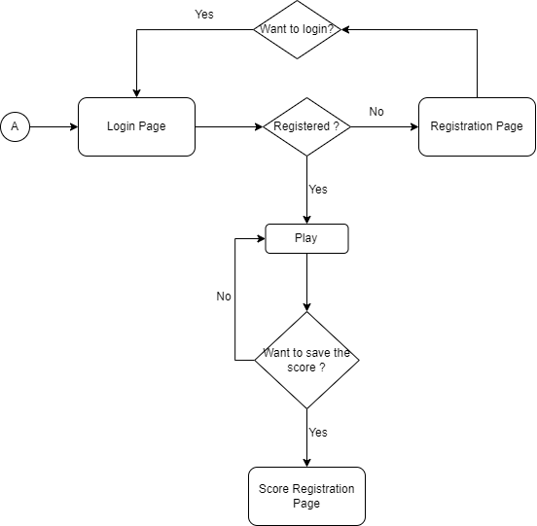

Figure the game diagram

## 2. Look & Feel

The design of the loging page was designed to make it easier for the user to choose between login or register, if the register was chosen the user is transferred to the registration page after filling the spaces the user gets registered in the database. Inside the game, the character we chose is a Penguin from a game we played with a cloud in the background and an ice-looking land.

## 3. Dynamic Components

On the web page main.js, a (jump) function was created for the jumping of the Penguin character in the game, a (check) صورة تحتوي على نص

تم إنشاء الوصف تلقائياًصورة تحتوي على نص

تم إنشاء الوصف تلقائياًFunction checks if any collision occurs if not the score keeps increasing. a (restart_btn) is used to restart the game after dying.

صورة تحتوي على نص

تم إنشاء الوصف تلقائياً

## 4. Business Logic

The database is set up as a list to save the players' information, including usernames, email, score and passwords. Furthermore, the player's score is preserved as a zero after registering, allowing any new player to register with this information and be added to the database. And the player's score is revealed after the user enters the score registration page.

صورة تحتوي على نص

تم إنشاء الوصف تلقائياًIn terms of a database call, after the player fills out the form on the (login.php) page, the data is sent to (login.php) via , and the data is retrieved from the database and verified. The player is transported to the beginning of the game displayed on the web page (index.php) based on the data supplied, and if the data sent is correct. For further information, please see the following image:

صورة تحتوي على نص

تم إنشاء الوصف تلقائياً

صورة تحتوي على نص

تم إنشاء الوصف تلقائياً

And through the code in the web page (index.php) the save button is linked with and through the page (scoreReg.php) and updates the player's score through this code: $ sql = "UPDATE user SET score = '$scorre' WHERE full_name= '$username'" ,the player information is called with the code:$sql = "SELECT id,full_name, score FROM user ORDER BY score DESC".

# GitHub link:

[**https://github.com/oymmusyri/CS438-project**](https://github.com/oymmusyri/CS438-project)

# References

1- <https://thecodingtrain.com/CodingChallenges/147-chrome-dinosaur.html>

2- <https://youtu.be/l0HoJHc-63Q>

3- <https://stackoverflow.com/questions/17902483/show-values-from-a-mysql-database-table-inside-a-html-table-on-a-webpage#:~:text=First%2C%20connect%20to%20the%20database,if%20the%20URL%20was%20%2Findex>

4- <https://www.php.net/manual/en/pdo.query.php>