📑 Project Proposal: Smart AI-Based Face Recognition Attendance System

Prepared by: [Group-6]
Course code: CSE-4326
Course title: Microprocessors and Microcontrollers Laboratory
Section: A
Date: January 3, 2026
Platform: Raspberry Pi & Computer Vision

🟦 1. Executive Summary

The proposed system addresses the inefficiencies of manual attendance through an automated, contactless solution. By leveraging Raspberry Pi and Computer Vision, we provide a high-accuracy, secure, and cost-effective method to track attendance in real-time, featuring anti-spoofing measures and a centralized web dashboard.

🎯 2. Vision & Scope

- Vision: To create a secure, contactless, and efficient attendance system that eliminates manual errors and improves data hygiene.
- Scope: * Automated logging for classrooms/workplaces.
  - Web-based admin dashboard with >95% recognition accuracy.
  - Offline-first operation with cloud synchronization.

⚠️ 3. Problem Statement

Time Consumption: Manual roll calls waste up to 10-15 minutes of productive time.
Proxy Attendance: Traditional cards or fingerprints are easily forged or shared.
Health & Hygiene: Contact-based biometrics pose risks in post-pandemic environments.

🛠️ 4. Technical Architecture

A. Hardware Components
Component | Specification | Purpose
Raspberry Pi 4/5 | 4GB RAM | Core processing unit
HQ Camera | 12.3 MP | High-definition face capture
OLED Display | SSD1306 | Visual feedback for users
LED Ring | 12V Relay Controlled | Lighting for low-light environments

B. Software Stack

- Language: Python 3.9+ (Logic & CV)
- Libraries: OpenCV, Dlib, Face_recognition
- Backend: Flask (API) & Supabase (Cloud Sync)
- Frontend: Vue.js 3 (Admin Dashboard)

🔄 5. Methodology & Workflow

A. System Workflow
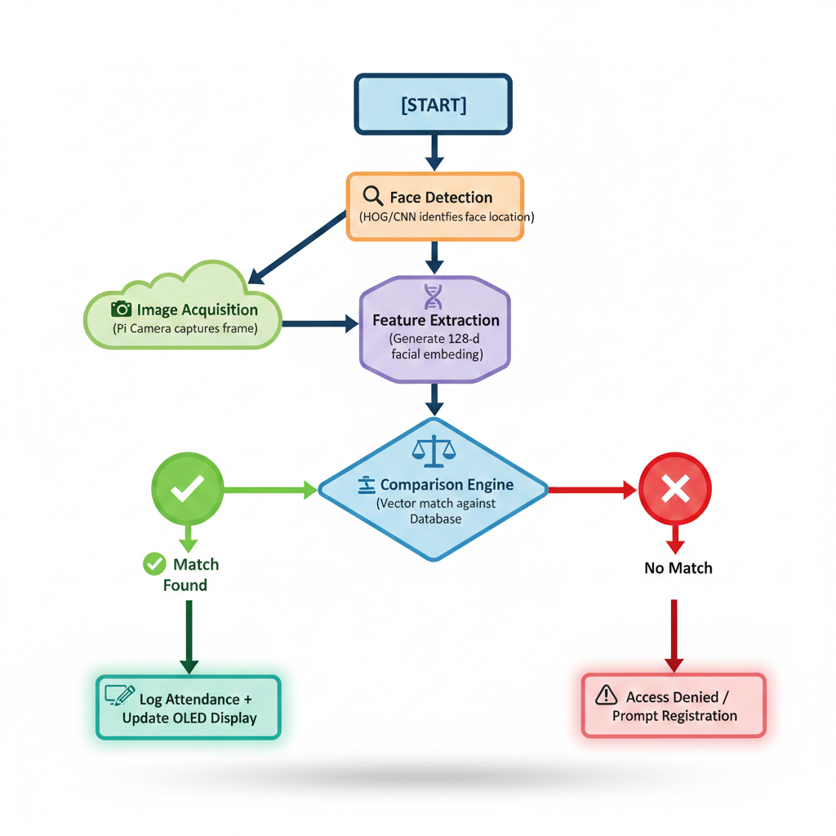

B. Database Design (ER Structure)

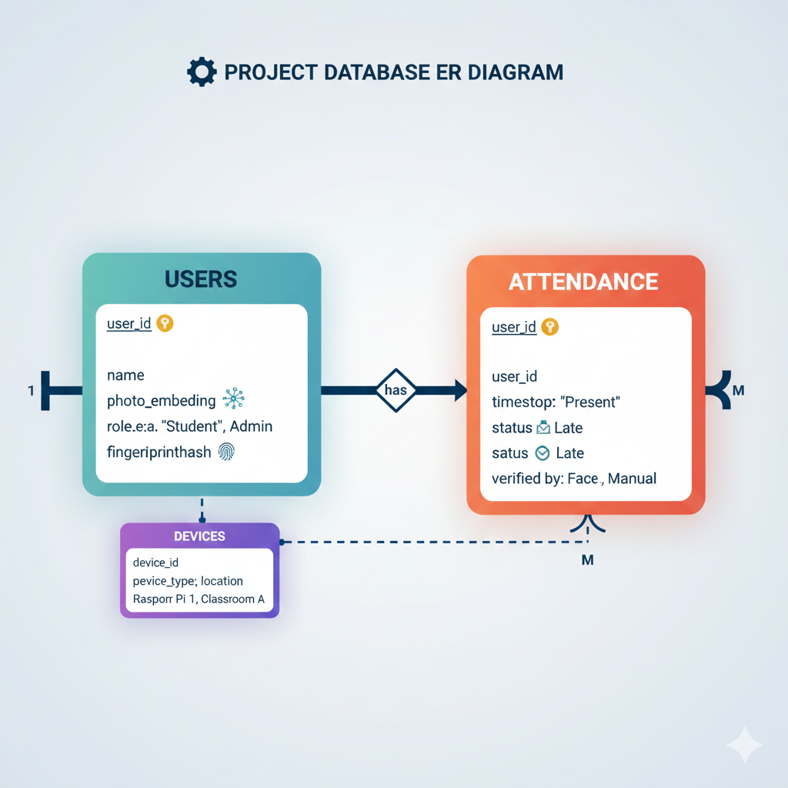

⚡ 6. Circuit Logic

The hardware integration follows a modular approach:
- I2C Bus: Connects the Raspberry Pi to the OLED Display.
- CSI Port: Dedicated ribbon cable for the High-Quality Camera.
- GPIO Pins: Controls the Relay Module to trigger the LED Ring Light during low-light detection.

💰 7. Timeline

Phase 1: Foundation & Infrastructure (Week 1)
- Hardware: Assemble Raspberry Pi, HQ Camera, and OLED display. Install Raspberry Pi OS (64-bit).
- Environment: Set up Python virtual environments and install core libraries (OpenCV, dlib, Flask).
- Database: Design the schema for Users and Attendance tables in SQLite/Supabase.

Phase 2: The Core AI Engine (Week 2)
- Face Logic: Implement face detection (HOG) and embedding extraction scripts.
- Training: Capture initial face data and generate the 128-d vector database.
- Optimization: Fine-tune the "matching threshold" to ensure accuracy under various lighting conditions.

Phase 3: Integration & Web Dashboard (Week 3)
- Backend: Build the Flask API to communicate between the Raspberry Pi and the database.
- Frontend: Develop the Vue.js dashboard to display real-time attendance logs.
- Sync: Enable auto-sync between local offline storage and the cloud (Supabase).

Phase 4: Refining & Final Deployment (Week 4)
- Anti-Spoofing: Add liveness detection (eye-blink or head movement check).
- Stress Testing: Conduct "Bulk Entry" tests to check system latency and heat management.
- Documentation: Finalize the user manual and technical documentation for handoff.

🏆 8. Expected Outcomes
- Efficiency: Reduce attendance marking time by 90%.
- Security: Eliminate proxy attendance via liveness detection.
- Data Integrity: Instant digital reports exportable to Excel/PDF.

