|  |  |  |  |
| --- | --- | --- | --- |
| Subject: | DCST1008 Software Engineering  Project Assignment | | |
| Class: BDIGSEC 2020 | | Work category: | Project |
|  | |
| Teachers: | Grethe Sandstrak Nils Tesdal  Alexander Holt |  | |
| Date of issue: | 19.02.2020 |  | |
| Deadline: | 24.04.2020 |  | |
| Presentation: | 24.04.2020 |  | |

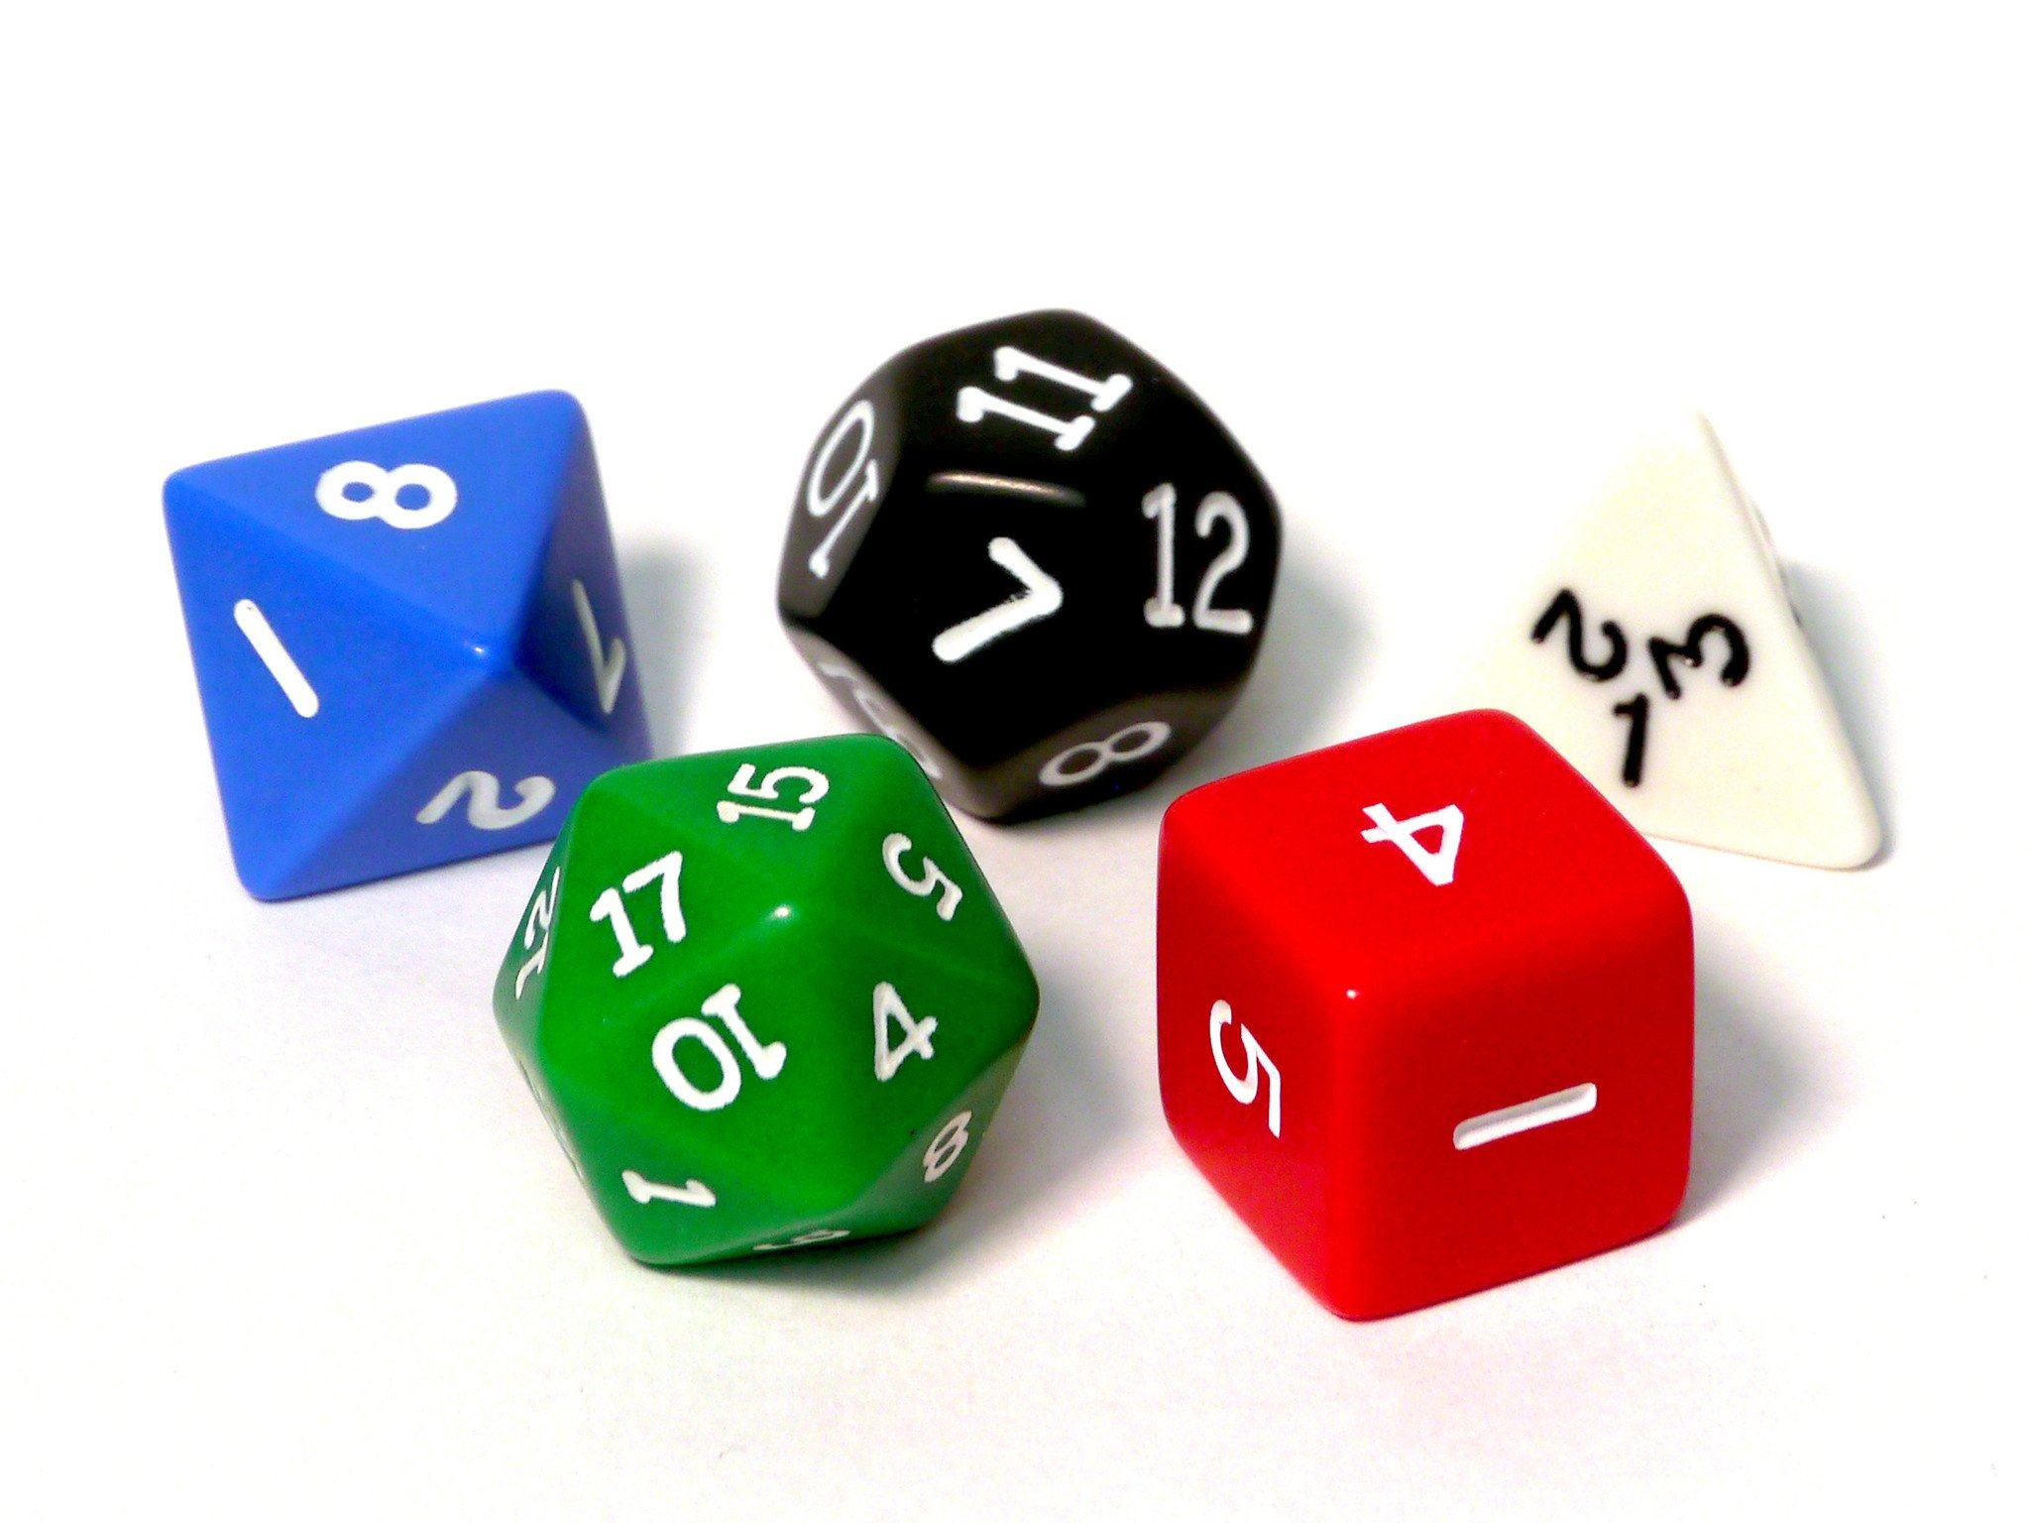

|  |  |
| --- | --- |
|  |  |
|  |  |

# Project Assignment

Your task is to create a game. The game shall not have any animated graphics, but you can use static graphics in the form of images, icons, charts and drawn objects like maps and so on.

There are no other functional requirements regarding the actual game, but there are some technical requirements and some requirements regarding the process.

The requirements explained above are not final. You are free to use your own imagination.

## Game ideas

You are free to create the game that you want to. But be sure to limit the possibilities in the game, both in order to complete the game in time and to make the game easier to play. If you think it is difficult to create a completely new game concept it is ok to use existing games as a starting point. Do however include some elements to make it your own game. A possible starting point could be a board game or a quiz.

Our recommendation is that you create a game that is played on a single computer. If you add multiplayer functionality where each player uses their own computer this will introduce many complicating factors regarding time and sharing game state.

## Technical requirements

1. The game must be made with the technology that has been used in your programming classes.
2. You may use additional technology but make sure there is a consensus in the group about it.
3. Use the MySQL database at the university to store high-scores and/or game state.
4. If the users log in, then user passwords should be hashed and salted. Find theory and examples of this online.

## Process

The project should be carried out in three iterations. The result of the two first iterations are presented in the first two team meetings, while the result of the third is presented in the project presentation. Iteration overview:

1. In the 1st iteration you should focus on the vision and requirements. Make an early game prototype using BalsamiQ and perform a usability test using the prototype with users outside of the team. Test both the user interaction and if the game is engaging. You should present this prototype at the first team meeting along with the vision document. You should also present the first version of the domain model, which is essential in explaining the game concepts.
2. In the 2nd iteration you should focus on making an MVP (Minimum Viable Product) using Java. This is a prototype, with just enough functionality to make the game playable. This prototype should also be (usability) tested. You should present this prototype at the second team meeting along with the first version of the requirements documentation WIKI.
3. In the 3rd iteration you should focus on design and finalizing the game and all the documentation and attachments.

Basic project elements

Your team is employed by a computer consulting company that has been commissioned to develop the new information system. Notice that the team must create its own full-fledged system. As a student, you will mainly play the role of a systems consultant designing and implementing the system. Teachers play the role as a client in addition to expert advisors.

* As a systems consultant, you have an hourly salary rate of NOK 1470.
* You must consider any costs in terms of personnel and software.
* Each team member has approx. 100 hours for her/his disposal +/ - 10 %.
* In the milestone plan, you will find deadlines for compulsory deliveries.
* To ensure the quality of the application the team must continuously undertake analytic testing of the code
* To ensure high usability and a good user experience the application must relate to Don Norman’s principles of interaction design
* In order to evaluate the user experience the team must carry out usability tests after the first and second iteration (wireframe and MVP)
* Universal Design – the application must be designed according to WCAG 2.1 principle 1 - Perceivable

# Resources You will find the project resources, including document templates, in the project-folder on Blackboard.

Usages of collaboration tools

The team must use collaboration tools as a part of the project. E.g. tools like Gitlab, GitLab WIKI, Slack, Gitlab Pages, Balsamiq, Google Drive etc. Experiences in using these tools must be summarized in the main report.

Slack invite: Available in Blackboard

Balsamiq license: Available in Blackboard

Submission of reports

Each team must deliver a separate main report as well as attachments (see below). The main report should include an evaluation of the teamwork. Here, the team must summarize experiences dealing with the project-work and cooperation within the team. Each team member must also document and evaluate his/her own performance.

Keywords are:

* This is how the teamwork progressed
* How was effort and result in accordance to what was planned
* This is what we are most pleased with
* We would have done this differently
* Source code or technical solutions the team is particularly satisfied with. Explain why
* Describe the choices and experiences (positive / negative) about the use of collaborative tools

Attachments to the Main report:

1. Collaboration agreement
2. Project plan with the schedule in the form of a Gantt chart
3. Timesheets with status reports for each team member
4. Meeting invitations and minutes
5. Vision document
6. Link to GitLab WIKI pages with the following content (NB! See lecture on documentation for a more specific description of each content element):

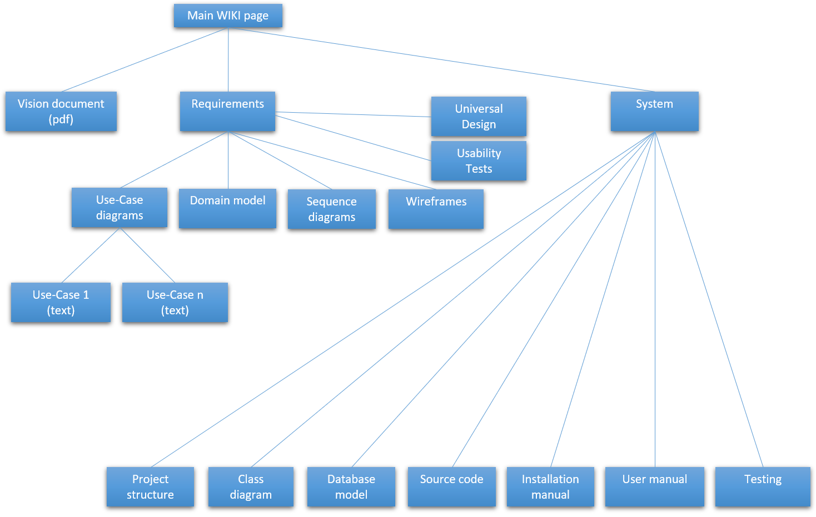

1. Link to JSDoc on GitLab Pages for the most important classes (<http://jsdoc.app> )

Final deliverable

All text documents should be merged into one pdf-file named *dcst1008_2020_teamname.pdf* and submitted on Blackboard.