

**CZ2006 Software Engineering**

Group Name : TeamLost

**Name:**

Li Jin Quan U1722463A

Lee Jian Hao U1721619C

Chen Xing Yu U1721205J

Kok Jia Hui U1721022E

Tee Wan Yi U1721844C

**Lab Group:** SSP5

Table of Content

**User Requirements** **3**

**Data Dictionary** **5**

**Use Case Diagram** **6**

**Use Case Description** **7**

UC001 7

UC002 8

UC003 9

UC004 11

UC005 13

UC006 15

UC007 16

**UI Mock-Up** **17**

# User Requirements

**Functional Requirements**

1. The user shall be able to make selection of various healthcare premises given by the system.
2. The user shall enter the desired location.
3. The system shall allow the user to do a quick search by area.
4. The system must be able to locate healthcare premises based on the entered location.
   1. The user shall be able to select the desired hospital.
      1. The system must be able to display the recommended route based on the user’s selection.
   2. The user shall be able to select the desired clinic.
      1. The system must be able to display the recommended route based on the user’s selection.
   3. The user shall be able to select the desired pharmacy.
      1. The system must be able to display the recommended route based on the user’s selection.
   4. The user shall be able to select the desired dental.
      1. The system must be able to display the recommended route based on the user’s selection.
   5. If the system fails to find any health premises during the search, the system must display a message to inform user about the search failure.
5. The user must enter user data to book an appointment.
   1. The system must send appointment details to user via SMS upon successful booking.
6. The user shall be able to make changes to their medical appointment using their NRIC.
   1. The user shall edit their medical appointment.
   2. The user shall cancel their medical appointment.
7. The system must send a SMS to remind the user 10 minutes before the actual appointment timing.

**Non-Functional Requirements**

|  |  |
| --- | --- |
| Usability | * Help messages must be displayed in local language. |
| Reliability | * In case of system failure, our system will make use of our backup server while the main server is being fixed. |
| Performance | * When an appointment is booked, the system must be able to detect it within 2 seconds. * The system must be able to retrieve information from Google map within 5 seconds. |
| Supportability | * The system database will be updated according to the latest version of MySQL, which is used in our system. |
| Security | * NRIC and mobile number given will be strictly kept confidential and it will not be disclosed. |

# 

# 

# 

# 

# 

# 

# 

# Data Dictionary

|  |  |
| --- | --- |
| Healthcare Premises | Includes Hospitals, Polyclinics, Private Clinics, Dental Clinics |
| CHAS | Community Health Assist Scheme |
| Local Language | English, Chinese, Malay and Tamil. |
| User data | Name, NRIC, Mobile number, Date/Time |
| Appointment details | Appointment ID, Name, NRIC, Date/Time |
| Personal details | Mobile number, NRIC and Date-Of-Birth |
| Appointment details | Date and Time of Appointment |
| Feedback details | Name, mobile number and message |

# Use Case Diagram

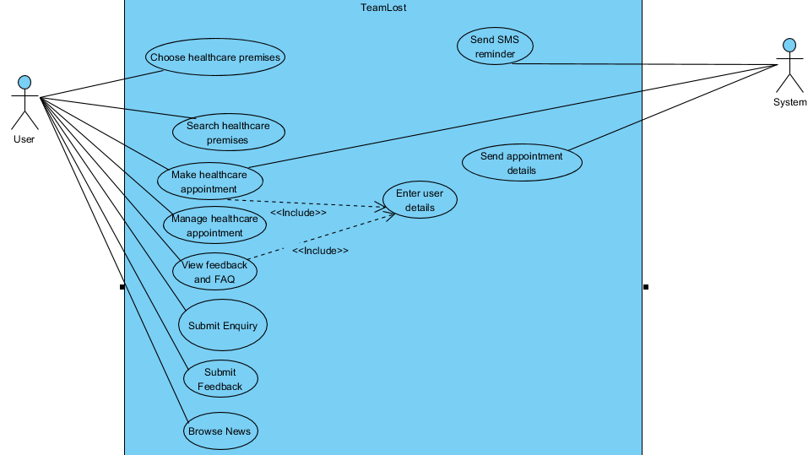

# Use Case Description

|  |  |  |  |
| --- | --- | --- | --- |
| Use Case ID: | UC001 | | |
| Use Case Name: | Browse news | | |
| Created By: | Team Lost | Last Updated By: |  |
| Date Created: | 4/9/2018 | Date Last Updated: | 11/9/2018 |

|  |  |
| --- | --- |
| Actor: | User (initiating actor) |
| Description: | User will be able to browse health related news |
| Preconditions: | - |
| Postconditions: | 1. Display of latest news |
| Priority: | - |
| Frequency of Use: | - |
| Flow of Events: | 1. The user clicks on the title of news in news feed 2. Upon clicking on the title of the news, system must be able to navigate the user to the original sources for more details. |
| Alternative Flows: | - |
| Exceptions: | - |
| Includes: | - |
| Special Requirements: | - |
| Assumptions: | - |
| Notes and Issues: | - |

Use Case Description

|  |  |  |  |
| --- | --- | --- | --- |
| Use Case ID: | UC002 | | |
| Use Case Name: | Choose the desired healthcare premises | | |
| Created By: | Team Lost | Last Updated By: |  |
| Date Created: | 4/9/2018 | Date Last Updated: | 11/9/2018 |

|  |  |
| --- | --- |
| Actor: | User (initiating actor) |
| Description: | Users select desired healthcare premises. |
| Preconditions: | - |
| Postconditions: | 1. User will be directed to another page where their current location will be automatically detected. |
| Priority: |  |
| Frequency of Use: |  |
| Flow of Events: | 1. The user will either select desired healthcare premises from navigation bar. 2. The system will lead the user to the page of selected healthcare premises where their current location will be detected and allow user to book appointment. |
| Alternative Flows: | - |
| Exceptions: | - |
| Includes: | - |
| Special Requirements: | - |
| Assumptions: | - |
| Notes and Issues: | - |

Use Case Description

|  |  |  |  |
| --- | --- | --- | --- |
| Use Case ID: | UC003 | | |
| Use Case Name: | search location | | |
| Created By: | Team Lost | Last Updated By: |  |
| Date Created: | 4/9/2018 | Date Last Updated: | 11/9/2018 |

|  |  |
| --- | --- |
| Actor: | User (initiating actor) |
| Description: | Allowing user to search healthcare premise according to detected current location or entered location. |
| Preconditions: | Users must select desired healthcare premises in order to find the nearby healthcare premises. |
| Postconditions: | 1. The system will display the map of the chosen healthcare premises that is near the entered location or based on user current location. |
| Priority: | - |
| Frequency of Use: | - |
| Flow of Events: | 1. The system will be able to detect user’s current location. 2. The page will then display all the selected healthcare premises around the entered location on the map. 3. The user clicks on the specific healthcare premise that is displayed beside the map. 4. The system will display information of the selected healthcare premise such as address and opening hour when user click on the “+” sign. |
| Alternative Flows: | User enter location manually   1. The system will display all of the selected healthcare premise that is within 5 kilometres of the entered location.   User enter invalid location   1. System will display error message and prompt user to enter again. |
| Exceptions: | - |
| Includes: | - |
| Special Requirements: | - |
| Assumptions: | - |
| Notes and Issues: | - |

Use Case Description

|  |  |  |  |
| --- | --- | --- | --- |
| Use Case ID: | UC004 | | |
| Use Case Name: | Book healthcare appointment | | |
| Created By: | Team Lost | Last Updated By: |  |
| Date Created: | 4/9/2018 | Date Last Updated: | 11/9/2018 |

|  |  |
| --- | --- |
| Actor: | User (initiating actor) |
| Description: | This use case allows user to book healthcare appointment |
| Preconditions: | 1. User must have selected the location where they wish to book an appointment at. |
| Postconditions: | 1. System will display a message indicating successful booking. 2. System will then automatically send appointment detail to the user via SMS. |
| Priority: | - |
| Frequency of Use: | - |
| Flow of Events: | 1. User selects “Book appointment” under “Appointment” in the navigation bar. 2. System will retrieve the location and address of the selected healthcare premise. 3. User will have to enter their personal details as well as appointment details and proceed by clicking “Book” button. 4. The system will display successful message upon successful booking of selected slot. 5. The system sends a message that includes all the booking details to user via SMS. |
| Alternative Flows: | User enter invalid NRIC   1. The system will display error message. 2. The system will then prompt user to re-enter their NRIC. 3. Return to step #3. |
| Exceptions: | - |
| Includes: | - |
| Special Requirements: | - |
| Assumptions: | - |
| Notes and Issues: | - |

Use Case Description

|  |  |  |  |
| --- | --- | --- | --- |
| Use Case ID: | UC005 | | |
| Use Case Name: | Manage healthcare appointment | | |
| Created By: | Team Lost | Last Updated By: |  |
| Date Created: | 5/9/2018 | Date Last Updated: | 11/9/2018 |

|  |  |
| --- | --- |
| Actor: | User (initiating actor) |
| Description: | Allowing user to edit and cancel their healthcare appointment |
| Preconditions: | 1. User must have entered their personal details. 2. User must have an existing appointment. |
| Postconditions: | 1. System will display a message indicating successful changes. 2. System will then automatically send the updated appointment detail to the user via SMS. |
| Priority: | - |
| Frequency of Use: | - |
| Flow of Events: | 1. At the appointment page, user keys in their personal details and proceed by clicking “Manage” button. 2. One-Time Password (OTP) will be send to user for verification. 3. Upon successfully verification, system will display a table of user’s existing appointment with a “Edit” or “Cancel” button. 4. If user selects “Edit” option, he or she will be able to make changes to their mobile number as well as date/time of the appointment. 5. Once user selects “Confirm” button after editing, there will be a OTP sent to user for confirmation. 6. The system will display successful message upon successful update of the changes and send a message that includes all the updated booking details to the user via SMS. 7. If the user selects “Cancel” option, system will prompt user to confirm the cancellation of the selected appointment. 8. Upon clicking on “Confirm”, the system will display successful message once the appointment has been cancelled successfully. 9. System sends a message to notify user on the successful cancellation of appointment. |
| Alternative Flows: | User enter invalid NRIC   1. The system will display error message. 2. The system will then prompt user to re-enter their NRIC. 3. Return to step #1.   User selects wrong appointment   1. User can click “Back” button to return to the page where all appointments will be displayed. 2. Return to step #3.   At step 1, no existing appointment found   1. System displays error message indicating no existing appointment 2. System directs user to book appointment page.   System fail to cancel appointment   1. System will display error message. |
| Exceptions: | - |
| Includes: | - |
| Special Requirements: | - |
| Assumptions: | - |
| Notes and Issues: | - |

Use Case Description

|  |  |  |  |
| --- | --- | --- | --- |
| Use Case ID: | UC006 | | |
| Use Case Name: | View FAQ | | |
| Created By: | Team Lost | Last Updated By: |  |
| Date Created: | 4/9/2018 | Date Last Updated: | 11/9/2018 |

|  |  |
| --- | --- |
| Actor: | User (initiating actor), Administrator |
| Description: | Allowing users to view Frequently Asked Questions (FAQ). |
| Preconditions: | - |
| Postconditions: | - |
| Priority: |  |
| Frequency of Use: | - |
| Flow of Events: | 1. User selects “Help” on the navigation bar. 2. System will navigate user to another page where they can view frequently asked questions. |
| Alternative Flows: | - |
| Exceptions: | - |
| Includes: | - |
| Special Requirements: | - |
| Assumptions: | - |
| Notes and Issues: | - |

Use Case Description

|  |  |  |  |
| --- | --- | --- | --- |
| Use Case ID: | UC007 | | |
| Use Case Name: | Submit feedback | | |
| Created By: | Team Lost | Last Updated By: |  |
| Date Created: | 4/9/2018 | Date Last Updated: | 11/9/2018 |

|  |  |
| --- | --- |
| Actor: | User (initiating actor) |
| Description: | Allowing users to submit feedback |
| Preconditions: | 1. User must have entered the feedback details. |
| Postconditions: | 1. The system will display a successful message upon submitting the feedback. |
| Priority: | Low |
| Frequency of Use: | Low |
| Flow of Events: | 1. User selects “Contact Us” on the navigation bar. 2. System will navigate user to a page where they can submit their feedbacks. 3. User must enter feedback details. 4. Upon clicking the “Submit” button, the system will display a successful message. |
| Alternative Flows: |  |
| Exceptions: | EX1: User clicks on the back button   1. The system will direct the user back to the home page. |
| Includes: | - |
| Special Requirements: | - |
| Assumptions: | - |
| Notes and Issues: | - |

# UI Mock-Up

Please refer to : **Team_Losts_UI Mock_Up.pptx**