**HW5: Exploring data with Shiny**

*25 points*

**Instructions**

This application is to explore the data for a crowdfunding website, Go Fund Me, using the data in the .csv file *HW5_GoFundMe.csv*. The first tab will allow the user to explore the relationship between one of the categorical variables and one of the outcome variables. The second tab will contain one static plot with an interesting insight into the data. The R script, *HW5_app.r*, contains the shell of the application.

Submit your R script via the “HW5_Shiny” assignment on Sakai **by Tuesday Nov 28 at 11:55pm**. Name the R script according to the following naming convention: HW5_app_*YourLastName*_*YourFirstInitial*.r. Publish the assignment on shinyapps.io and include in the link in your Sakai submission.

You may discuss the material with others but you must **submit your own work**.

1. Create the first tab that enables users to explore the data. Users should be able to choose a categorical variable and a numeric variable, and a plot should appear on the right when the user presses the Go button. An example screen shot is shown below.

* 1. Create the inputs for the user: the two drop down lists and the Go button. Be mindful of the parameter names that I have already used in the R script. *(3 pts)*
  2. Create the dataset that uses the restricted data, restrictedData(), to create another dataset for plotting. The resulting data needs to calculate the mean and standard error for the numerical data by the categorical data, and only produce the top 10 values if the categorical variable contains more than 10 values. *(5 pts)*
  3. Create the plot for the categorical data using the dataset created in question 1b. The plot should be attractive and easy-to-read, so you should change the axes, title, axis labels, etc. *(5 pts)*

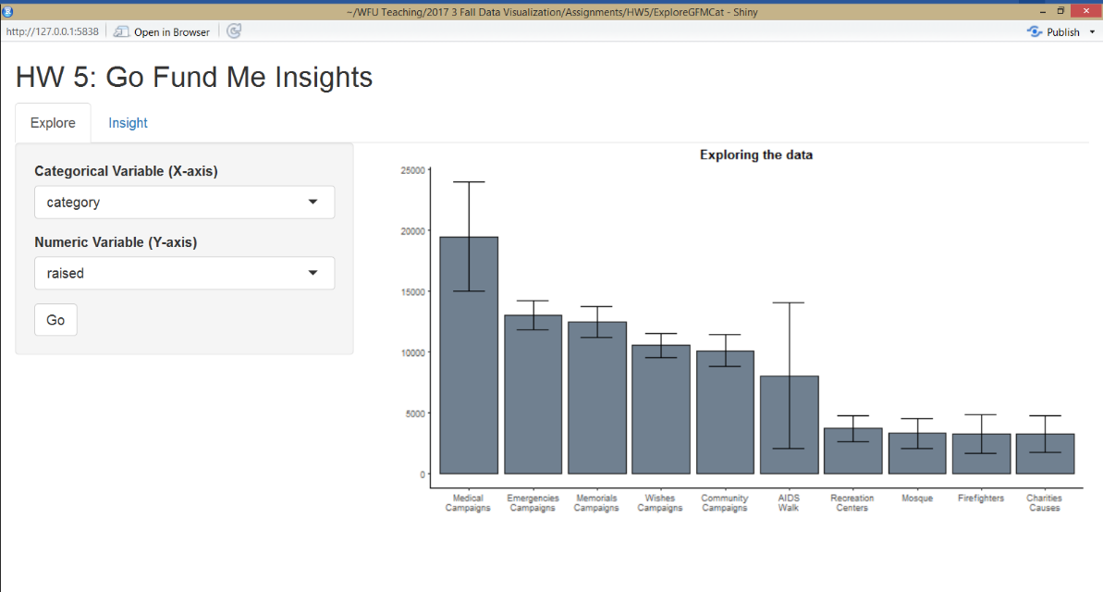

1. Create the second tab that showcases a key insight from the data. This tab can use any variable from the data, contain any type of chart and use any package—it is up to you to explore the Go Fund Me data and synthesize it into an interesting finding. The insight plot does not have to be interactive (but you can if you would like).
   1. Create the plot for your insight, preprocessing the data as necessary.
   2. Create a caption for your plot, highlighting at least 2 related observations about the data that is evident from your plot.

This plot will be graded on the following dimensions:

* Is your chart accurate to the data? *(4 pts)*
* Are your visualization choices appropriate for the analysis and data? *(2 pts)*
* Is your chart attractive, easy-to-read, well-labeled, and easy-to-understand? *(2 pts)*
* How well-supported are your conclusions? *(2 pts)*
* Did you put forth additional effort above and beyond the minimum? For example, did you create a more sophisticated chart? *(2 pts)*

You should publish this application to shinyapps.io and include the link in your submission on Sakai.