

JOMO KENYATTA UNIVERSITY OF AGRICULTURE AND TECHNOLOGY
NAIROBI CBD CAMPUS
SCHOOL OF COMPUTING AND INFORMATION TECHNOLOGY
DEPARTMENT OF INFORMATION TECHNOLOGY

ONLINE FOOD ORDERING MANAGEMENT SYSTEM
BY
MADHANG PHILIP MEEN
SCT121-C004-0521/2018

A project submitted in partial fulfilment of the requirements for award of the Diploma in Information Technology at Jomo Kenyatta University of Agriculture and Technology
2020

DECLARATION
I declare that this work has not been previously submitted and approved for the award of a diploma by this or any other University. To the best of my knowledge and belief, the research proposal contains no material previously published or written by another person except where due reference is made in the research proposal itself.

Student Name: ________________________________
Sign: _________________________________________
Date: _________________________________________

Supervisor
This project has been submitted by the above name student with my approval and I hereby certify that this to be a true report of the above project.

Supervisor’s Name: ___________________________
Sign: ________________________________________
Date: ________________________________________

DEDICATION
I dedicate this project to my family members especially my parents for their financial and moral support in my Education. Great thanks to my classmates for the conducive environment we shared in the university life.

ACKNOWLEDGEMENTS
This project was made possible by the cooperation and support of a number of people. I would like to express my sincere gratitude to the Pure Applied sciences & Information Technology department for their support and guidance throughout my project. I would specifically like to thank my supervisor, Mr. Patrick Mudambi for his endless encouragement and instructions on how to tackle specific tasks. I am sincerely indebted to him for supporting and assisting me thus contributing to the success of my project. I also want to appreciate the staff and the administration of university for their support during my period of writing my project. Lastly, I want to thank my family and friends for their financial and moral support throughout my project.

ABSTRACT
Over the years, cafeterias have heavily relied on the growth of its reputation on customer satisfaction due to the services they offer. Recently, they have begun to market themselves on social media platforms so as to attract the young generation that is mostly present in this platform. The main challenge facing these cafeterias has been that they are not able to analyze the large amount of data that they collect hence were not able to evaluate the services they provided. This application, however, aims to curb this problem by giving cafeterias an upper hand. The information that was collected from the customers of a cafeteria was analyzed and used to provide a better experience. The system required one to place an order so as to be able to get the data that was needed. The system was developed based on the Object-Oriented Development methodology. It used PHP version 7.4, HTML5, JAVASCRIPT CSS3 and MySQL as its main resources for implementation. All this process was accomplished in an agile manner in implementation of the system. In summary this system will be able to assist the cafeterias to analyze the data they collect from their customers so that they can better understand the customers’ preferences and hence provide better services and reduce wastage of food.

Table of Contents
DECLARATION ii
DEDICATION iii
ACKNOWLEDGEMENTS iv
ABSTRACT v
List of Figures viii
CHAPTER ONE 1
1.0 Introduction 1
1.1 Background of the study 1
1.2 Problem statement 2
1.3 Objectives 2
1.4 Justification of the study 2
1.5 Scope 3
1.6 Limitations 3
1.7 BUDGET 4
1.8 SCHEDULE 5
CHAPTER TWO 6
LITERATURE REVIEW 6
2.1 Introduction 6
2.2 Cafeterias in Kenya 6
2.3 Gaps in existing systems 7
2.4 Existing applications 7
2.4.1 Byte 7
2.4.2 Fishbowl 7
2.5 Conclusion 8
CHAPTER THREE 9
METHODOLOGY 9
3.1 Introduction 9
3.2 System Development methodology 9
CHAPTER FOUR 13
4.1 Introduction 13
4.2 Data Collection Methods 13
4.2.1 Questionnaires 13
4.2.2 Interviews 13
4.2.3 Observation 14
4.2.4 Online Research 15
4.3 Feasibility Study 15
4.3.1 Technical Feasibility 16
4.3.2 Social Feasibility 16
4.3.3 Economic Feasibility 17
4.3.4 Operational Feasibility 17
4.4 Functional and Non-Functional Requirements 18
4.4.1 Functional Requirements 18
4.4.2 Non-Functional Requirements 19
CHAPTER FIVE 20
SYSTEM DESIGN 20
5.1 Introduction 20
5.2 Current System Flow Chart 20
5.3 Proposed System Flow Chart 21
5.4 Use Case Diagram 21
5.5 Data Flow Diagram 23
5.6 Sequence Diagram 26
5.7 Class Diagram 29
5.8 Database Design 30
5.8.1 Conceptual Design 30
5.8.2 Logical Design 31
5.8.3 Physical Database Design 35
5.9 System Interfaces 36
CHAPTER SIX 40
6.1 Introduction 40
6.2 Interface Implementation 40
Front 40
6.3 Database Implementation 40
6.4 System Testing 41
CHAPTER SEVEN 44
CONCLUSION AND RECOMMENDATION 44
7.1 Conclusion 44
7.2 Recommendations 44
7.3 Future Works 44
APPENDICES 45
Appendix 1 45
Code snippets 45
REFERENCES 46

List of Figures
Figure 1: Budget 13
Figure 2: Schedule 14
Figure 3: Agile Methodology 20
Figure 4: Current System Flow Chart 29
Figure 5: Proposed System Flow Chart 30
Figure 6: Website Data FLow Diagram 32
Figure 7: User Login Data Flow Diagram 33
Figure 8: Food Menu Data Flow Diagram 33
Figure 9: Admin Data Flow Diagram 34
Figure 10: Admin Login Diagram 35
Figure 11:User Registration Diagram 36
Figure 12: User Login Diagram 36
Figure 13: Food Order Diagram 37
Figure 14:Class Diagram 38
Figure 15: ER Diagram 40
Figure 16: Order Details Table 40
Figure 17: User Table 41
Figure 18: Food Type Table 42
Figure 19:Orders Table 43
Figure 20: login page 45
Figure 21: HomePage 45
Figure 22: Menu Page 46
Figure 23: Cart Page 46
Figure 24: Admin Dashboard 47
Figure 25: Manage Admins Page 47
Figure 26: Admin Edit Menu Page 48
Figure 27: Admin Manage Categories Page 48
Figure 28: Testing Functionalities Table 51
Figure 29: Analytical test case table 52

CHAPTER ONE

Introduction
Food ordering has become important factor in modern society especially in the cafeteria industry hence the need to have Food Ordering management system. The online food ordering system sets up a food menu online and customers can easily place the order as per they like. Also with a food menu, online customers can easily track the orders. The management maintains customers’ database, and improve food delivery service.
This chapter will provide a brief understanding about background of study, definition of the project problem statement, its objectives, scopes, project justification, risks and project budget and schedule.

Background of the study
In this century, there has been an extensive growth of technology and its uses in many industries and sectors such as the cafeteria industry. In the hotel and cafeteria industry in the country, it has grown tremendously over the years and can be seen by the cultural festivals that are held annually to celebrate the different foods that are made by the different tribes in the country (7continentslist, 2017).
In most cafeterias, despite the variety of food they sell, usually there was a main product which they were known for example Burger King was well known for burgers. Therefore, as the customer base increased, there was a short supply of that particular food. Also, there is the emergence of online food ordering and advertisements using social media so as to capture the large market due to the change of how people used to perceive food. Nowadays customers viewed the food they take and the cafeterias they dined at as a reflection of their own personality and point of view (Hospitality Technology, 2016).
Currently in Kenya, most cafeterias find it difficult to cope up with the current trends such as online advertisements in their websites, advertising in social media and storing of the data that is collected by them (Summit, 2018). Some may opt to utilize the services of external parties to come and analyze the data for them which they may end up analyzing the data on a bias and give false information which may not be good for the cafeterias (Summit, 2018).
As a result of these, the need for an application that would make some of these challenges easier to handle. The application requires one to input the data that the cafeteria has on orders and analyze for them the data. This in turn reduces the expenses and time used to look for somebody to do the work for them and avoid leakage of sensitive information of the cafeteria. It also leads to better customer satisfaction due to the trends and data that would has been collected over the period of time they have been to the cafeteria.

Problem statement
Most cafeterias are faced with the problem of people not getting the food that they prefer for it might have finished. At times, there might be food that has been left by the end of the day because people were not interested in it. This may in turn cause cafeterias to suffer losses by the end of the business day for there will be food wastage, for they are not able to predict or know which kind of food its customers prefer at specific days from the data they might have collected over the period of time that they have been in operation.
Also, most cafeterias lack the proper systems to assist them in analyzing the data that they collect from the clients they serve each and every day. They are not able to differentiate the regular customers from new ones who come to the cafeteria except for the waiters who serve the clients. The lack of resources to analyze the data that they collect costs most cafeterias a number of clientele for they are not able to rectify on some of the feedback they give.

Objectives

- To review the challenges faces by cafeterias in the market and the data that they collect.
- To analyze the current food ordering application solutions and the various problems facing the users of these solutions.
- To design and develop a system that would be able to analyze data collected from food ordered.
- To test and validate the functionalities of the system and documentation.

Justification of the study
The major problem facing cafeterias is the food that is left over and a particular food getting finished before while people are in que waiting to be serve. Hence there is a need for a system that would be able to collect data from food orders, analyze it and get information that would be used to better serve the customer.

Scope
- The scope of the system will be able to collect data from the food that is ordered by the customers
- The system was also able to analyze the data that was collected from customers’ orders.
- The system was also able to analyze the data that was collected from customer’s orders based on days and time the orders were made
- To increase efficiency and improve services provided to the customers through better application of technology in daily operations.

- To be able to stand out from competitors in the food service industry

Limitations
- The limitations were that the accuracy of the data analyzed depended on the duration of orders which was in terms of years.
- Requires internet connection and also the user must be computer literate.
- The other limitation is that the system will only be convenient to people with a small geographical region, basically just around the restaurant i.e. can only help a small area.
- The set back of the system is that the customers targeted are adults with access to computer systems while the minors might have to go physically to the restaurant to purchase the food that they want or order food the food with the help of an adult.

BUDGET
Item | Description | Quantity | Price
Laptop Computer | Intel Core i3 Processor 4GB RAM,HARD DISK 500GB | 1 | Ksh. 30,000/=
Text Editor | Atom IDE | 1 | Free
Web Browser | Google Chrome | 1 | Free
Antivirus Software | Kaspersky | 1 | Ksh 1,000/=
Operating System | Windows 10 Pro | 1 | Ksh 2,000/=
Internet Services | Safaricom WIFI | 1 | Ksh. 5000/=
Miscellaneous Cost | Data Collection, printing, photocopy | 100 | Ksh. 4000/=
TOTAL COST |  |  | Ksh. 42,000/=

Figure 1: Budget

SCHEDULE
WEEKLY ACTIVITY | 1 | 2 | 3 | 4 | 5 | 6 | 7 | 8 | 9 | 10 | 11 | 12 | 13 | 14
TITLE IDENTIFICATION
INTRODUCTION
LITERATURE REVIEW
SYSTEM ANALYSIS
SYSTEM DESIGN
SYSTEM DOCUMENTATION
SYSTEM IMPLEMENTATION
CONCLUSION

Figure 2: Schedule

CHAPTER TWO

LITERATURE REVIEW

Introduction
This section reviewed the current systems that were being used, criticized them and showed the conceptual framework of the proposed system.

Cafeterias in Kenya
In the country today, there has been culture that formed through the customs and practices of several tribes living in the region for a long time. The countries food has been influenced by the different tribes in the country and its early settlers that is the Asians, Europeans and the Arabs from the Middle East (7continentslist, 2017). The most popular dishes include ugali, nyama choma, kachumbari, pilau among many others.
The rise of cafeterias in the country over the years had been due to the growth of the different people working in remote areas during the construction of the railway line so as to feed the different people working in the railway. This led to the rise of hotels that later developed to the status of cafeterias.
The Sarova Stanley more than a remote railway depot built in a brackish African swamp, the Sarova Stanley flourished into an enduring legacy offering elegant accommodations that provided a level of sophisticated comfort that was uncommon in the early 1900s and is unmatched today
A number of internationally branded hotels have opened in Nairobi in recent years and more are in the pipeline. Mid-range hotels targeted at business travelers who don’t want to spend too much money are also increasing. There is heightened competition in the industry and players risk losing business if they don’t up their game (7continentslist, 2017).
Alluding to DHL’S (Charles Brewer, 2017), managing director for sub-Saharan Africa observed that at DHL Express customers would benefit from leading global technology companies from topics covered on latest trends, innovation and solutions impacting supply chain and focusing on Africa specifically Kenya while speaking in a workshop held in Dubai early this year.

Gaps in existing systems
From the study stated above, there were problems that arose in the existing systems. The systems were able to assist in marketing and increase feedback but the issue of analyzing the data of the food that is being ordered was not the main priority in the mentioned systems. Also, with the 12 automation of operations in cafeterias, larger amount of data would be generated. Therefore, in particular, need to invest in server backup. You never know when a technical malfunction, may happen hence ruin all your hardware (Hoffer, George, & Vlacich, 2006). Also the understanding of customers ordering different items from menu cards was not taken into consideration for it is imperative for one to look at groups of customers to understand their consumption behavior (Mukherjee, 2016).

Existing applications

Byte
This application collects feedback and analytics from real customers on the menu item level. This data can be used to promote repeat business, increase table turnover, and determine what customers really want from their waiters. Much of this data is generated through BYTE’s mobile loyalty system. Managers have the ability to connect directly with disgruntled customers one-on-one through the mobile platform, and they have the opportunity to learn more about their customers with performance report cards that are provided by BYTE each month (Byte, 2018).
    - Fishbowl
This is used to predict sales and profitability by using data sources such as email or loyalty member databases, guest transaction links, POS transactions, and survey results. Cafeterias can predict dining behavior and preferences based on past engagement and transaction activity. They can also evaluate the real value of their loyalty programs and determine whether the limited-time discounts they publish are actually driving new sales (Fishbowl, 2018).

Conclusion
Online car rental management system is a web based application that will be developed from scratch using open source software tools. This will enable it to be integrated together with the previous system.
The online car rental management system will eliminate use of manual forms for renting cars as the client will register and reserve a car online. Also the terms of use will be online and the client will have to agree to them before approval of their reservation request.
Being an online service, the system will make it efficient for the car rental company to advertise and market their services. It will also enable them to manage and safeguard their car fleet as well as their client records.

CHAPTER THREE

METHODOLOGY

Introduction
This section of the research focuses on the best approaches to be used in the development of the system that is to be used. This chapter provides the methodology which is the framework that is used to aid in planning, analysis, design and development of the online car rental system. The methodology is identified for this particular project and adhered to it to enable the development of the system in a systematic and disciplined manner in order to avoid chaos and project failure.
The methodology includes the requirements analysis of the system, the hardware and software components used as well as the software development process.

System Development methodology
System development methodology is the process of defining the components, modules, interfaces, and data for a system to satisfy specified requirements. It can also be defined as a standard process of all necessary steps used to analyse, design, implement and maintain a system.
System development is the process of creating or altering systems, along with the processes, practices, models, and methodologies used to develop them. System development approaches vary with the difference in the functionalities of the system to be developed. Here,the methodology that was used is agile method. It is a development model that has a group of software development methodologies based on iterative development, where requirements and solutions evolve through collaboration between self-organizing cross-functional teams (What is Agile? , 2018).
The different stages in the above methodology and the tasks that were performed are:

- Requirements – all the requirements that the users of the system were collected and filtered using constraints like the scope required, time that was needed to complete the system, the resources that were required among others.
- Diagram requirements for the initial sprint - Once you have identified the project, work with stakeholders to determine requirements. The use of user flow diagrams or high-level UML diagrams was used to demonstrate how the new system was to function and how it would fit into your existing system. From there, the people working on the project was selected and the required resources were allocated.
- Testing – this was where the system was released for the first time (the prototype), the documentation and the quality testing. Several designs were made at this point.
- Delivery - this was the point where the necessary stakeholders to get a view of the final project that has been created for the period of time. In addition, the stakeholders had their view of the software used to analyze food ordered data by providing the necessary feedback and resources for the purposes of deployment of the whole project and were satisfied by the work that had been put into the whole project.
- Feedback - This phase is the final phase of the system development methodology whereby the system was run with and without the existing system. All the stakeholders and customers were using the system and getting the required output. Any additional feedback from the users was taken into consideration for the next iteration of the system. The software used to analyze food ordered data was at the learning phase, but due to ease of usability the learning curve was small and fast.

Figure 3: Agile Methodology
Reasons for choosing this model are:
- It provided a regular view to the client in case of adjustments required
- It was less expensive
- Less documentation was required
- Able to give quick response to changing requirements.
- The end result was of good quality software, in less possible time duration and satisfied customers’ requirements.
- Able to do face to face communication with client and continuous input of client’s requirements

CHAPTER FOUR
SYSTEM ANALYSIS AND REQUIREMENTS

Introduction
System analysis is conducted primarily for the purpose of studying a system requirements through the use of various data and information collection methods in order to achieve the system’s objectives. The data was gathered and analyzed though the use of various tools and methods.

Data Collection Methods
This refers to the data collected through a primary collection method whereby primary data consist of data collected for the first time and thus has not been altered or tampered with. These data collection methods include;
- Questionnaires
- Interviews
- Observation
- Online Research
- Survey

Questionnaires
A questionnaire was conducted in the city of Nairobi which has arguably the largest population of eatery goers. The questionnaire was filled by any person who frequents cafeterias especially over weekdays and holidays. It was an open questionnaire where the respondents were allowed to give their comments in addition to filling in the answers to the questions that were in the form.

Interviews
The interviews were conducted mostly with open –ended questions in an unstructured way. The aim was to produce detailed explanations and rich descriptions from the interviewee. A one on one interaction provided the opportunity to collect first-hand information from the source. The interviewees were divided into two categories
- A management person
- User
For the management person
- I sought to know the problems often encountered with clients who order food via the waiters or the cashiers at the till who lack online credentials.
- I sought to know how customers make orders for a particular food or meal. The aim was to know if the customer provided with a list of choices or menu to choose from or a particular manual food menu for particular food dishes.
- The interview also sought to know how the management manages the orders as well as their clients’ specific food preferences.
For the user or customer
- I sought to know how the customer is able to search online and find their preferred cafeteria. The customer lacked knowledge of looking online for their preferred cafeteria.
- The interview also sought to know how a customer makes an order for their preferred food or meal. The response was that they had to go to a cafeteria or call the café’s customer care number in order to make an order.
- I also sought to how the customer provided their personal details to the cafeteria management. The response again was that they had to personally go to the café itself so as to get a receipt.
- The interview also wanted to know the time taken to order a meal. Majority of the customers especially from far locations confessed that time is wasted in going to the restaurants and cafeterias then queue in line so as to be served.

This mode of data collection provided an insight to the flow of the various processes and challenges of the current food ordering system.

Observation
The observation method showed that most of the customers go direct to cafeterias to buy and order their meals with a minority opting to making direct calls to the cafeteria’s ordering front desk.

It was also observed that the customers did not have of the available meals which were on offer as well as the type and number. The cashier had to go through manual papers to confirm all the customers’ details leading to delays in the caller’s end and customer dissatisfaction with available choices.

It was observed that at times there were long queues at the cafes leading to delays in customer orders and food payment. This led to customers’ anger due to hunger leading to the customer preferring to move to other competitors such as hawkers.

Through observation I note that use of manual receipts and orders led to misplacement or at times loss of customer details. The use of manual forms also posed a health risk to the customer and the waiter due to touching of food and paper at the same time.

The management also lacked updated customer record details at any particular time due to the issuance of manual receipts to customers hence the management did have their customer details stored in any a record.

Online Research
Through reading of online journals I was to get insight on how other similar systems work. Visiting various overseas food ordering websites and viewing the details in some of them, I was able to see what is available and what was lacking. Majority of these websites have the single purpose of advertising various foods or meals without the option of user interaction.

Feasibility Study
Feasibility study represents a definition of a problem or opportunity to be studied, an analysis of the current mode of operation, a definition of the requirements, an evaluation of alternatives, and an agreed upon course of action. As such the following important types of feasibility studies were used;

Technical Feasibility
The technical feasibility refers to the technical resources that are available in the system, the technical resources needed for the new computerized system. The following resources were needed for the development of the system.

Software Requirements
- Server- side programming language: PHP 5.6
- Web development programming languages: HTML5, JAVASCRIPT, BOOTSTRAP, JQUERY
- Server: Xampp
- Database: MYSQL
- Operating System: Windows 10
- Text Editor(Visual Studio Code)
- Microsoft Office 2013
- Anti-virus Software

Hardware Requirements

- Desktop computer dual core processor 521MB, 250GB HARD DISK
- Uninterrupted Power Supply

Social Feasibility
Here the effect of the system on the social system which is primarily the users’ needs were addressed. The new system impact to the users include:
- The system makes it easier for customers to register, sign in and order for their preferred meal from the comfort of any location without having to visit the cafeteria or restaurant of choice.
- The system being web based system makes it easier for the cafe to quickly advertise their services in an efficient manner and reach a wide customer base thereby increasing their customers and revenue.
- The system makes it easier for the company’s users to store and retrieve customers’ details in quick manner and also safeguard customers’ information.

Economic Feasibility
The initial cost of the developing the system was high due to the quotation of high hardware and software requirements. The development of the system proved to be economically feasible and the company did not spend much money into the system development. The system led to the overall reduction of expenses in the company. The benefits include:
- Reduction of operational expenses e.g. buying papers, photocopy, printing since most of the work and information has been computerized and will be done online.
- Reduction in time wastage by customers who go to the café and be given manual receipts as well as time taken to retrieve customers’ information since all work and updates is via an online platform.
- Increased business opportunities for the company since most of the marketing and advertisements will be done online via the website thereby reaching a wider audience leading to increased customer base as well as increased revenues for the cafeteria.

Operational Feasibility
The developed system is one that is user friendly and is easier to operate by the users. Being a website little training is required for the users and its meets their needs as per the requirements. Any user with an internet connection can visit the website for any clarification. The staff were trained on how to check a customer’s details as well as retrieve the customer’s order details and provide an appropriate response to the customer in the minimum time possible.

Functional and Non-Functional Requirements

Functional Requirements
This defines what the system is supposed to do or the main functions of the system.
- Administrator Login Page; the administrator is provided with secure login credentials which are a username and a password. Through this page the administrator can access the dashboard and the database at any time where he can make modifications on the system.
- Administrator Dashboard; only the administrator is allowed to access this module to be able to configure the other modules of the website. Here the administrator is also able to view the database as well as update, retrieve and delete any particular customer records as well as car details.
- User Registration or Sign up Page; Here any user can be able to register with their preferred cafeteria of choice.
- User Sign in Page; the sign in page is going to be implemented in such a way that it has user name and password where a form-based authentication and authorization is used so as to ensure security of data. The user will enter their username and password and if the details are corrected, will be allowed to proceed. If the login details are incorrect then the user will receive an error message and be prompted to re-enter the login details.
- Menu Page; Contains the menu of the different types of food the cafeteria offers and which the customer can make their preferred choice.
- Ordering Page; after viewing the available food types, sizes and prices on the website then the system provides a page for the user to make an order of their choice of food. Before any order can take place the customer has to be first authenticated in the sign in page before they can be move to the food ordering page.
- Cart Page; Here the list of food ordered is shown so as to enable the customer to know the amount to pay as well as choose the mode of payment and delivery of the food.
- The website; the website provides a means of information as well as advertisement for the cafeteria or the food company that operates the system. It enables the customer to view and choose their favorite meal. It also helps the cafeteria to market and advertise itself to potential clients at minimal costs.
- Manage Admin Page; Here the Super Admin can add or remove other admins from the system.
- Edit Menu Page; this page is where the admin is able to edit the menu page by adding, editing and deleting the different food items.
- Manage Categories Page; Here the categories of food entries are edited or deleted by the admin.

Non-Functional Requirements
These describe how the system works. The non-functional requirements include;
- Performance: the system should be available all the times. Security: the system enables registered customers to review their own accounts.
- Usability: the user should find it easier to use the system without any tutorials on how to use the system.
- Maintainability – The web based application should have the ease, with which it can be understood, corrected, adapted, and enhanced.
- Availability – The system should be available, 24 hours a day, throughout the year
- Security – This deals with who can access the application. The application will include all available safeguards from unauthorized users who interact with the application.

CHAPTER FIVE

SYSTEM DESIGN

Introduction
Here the current system is evaluated whereby a model in a logical design is used to check and review the design needed for the proposed system. The requirements will be integrated with the proposed system design.

Current System Flow Chart
Start

Register Now

If details are valid

NO

YES
Search food details

Order Food

Sign Out

STOP

Figure 4: Current System Flow Chart

Proposed System Flow Chart

SYSTEM
ADMINISTRATOR
Get food order data analysis from the customers
Get order confirmation
Update menus
ORDER FOOD
CUSTOMER

Figure 5: Proposed System Flow Chart

Once a client logs into the system, they were able to view the different kinds of foods that were being offered and places they could get to order from. After placing the order, the system would then send a confirmation message. As for the administrator, they were able to update the menu of the day and get an analysis by the end of the day as to the amount of food that was ordered in form of graphs.

Use Case Diagram
Use case modelling employs use of use case diagrams and forms to describe the relationship among the different actors and use cases within a system. An actor is a person, organization or external system that interact with the system. A use case represents an activity within a system when an actor sends a certain command to the system.
The system was Web Based due to the following benefits:
- The system is accessible from anywhere in the world across all platforms: desktops, tablets, phones and laptops.
- It is a cost effective development.
- Ease of performing maintenance and customization on the system
- Adaptable to increased workload
Cancel Order
ONLINE FOOD ORDERING MANAGEMENT SYSTEM
Register
View Menu
Login
Order Food
Sign out

Create Food Menu
Update Menu
Add Users
View users
Remove Menu Items
Manage Users
Login
User
Admin

Data Flow Diagram

Food Category Management

Order Management
Food Management

Online Food Ordering System

System User Management
Customer Management

Login Management

Figure 6: Website Data FLow Diagram

User Login
User Registration

Figure 7: User Login Data Flow Diagram

Food Menu

Choose Food
View Food Menu

Figure 8: Food Menu Data Flow Diagram

Update Type of Food
Retrieve a Food Type
Create Type of Food

Cancel Client Food Orders
Delete A Food Type

Update Web Pages
Confirm Clients Orders
Admin Login

Manage Clients
Orders
Retrieve ClientsInformation

Update Order Details

Figure 9: Admin Data Flow Diagram

Sequence Diagram
Sequence Diagrams are interaction diagrams that detail how operations are carried out by the system that is they capture the interaction between objects in the context of a collaboration. Sequence Diagrams are time focus and they show the order of the interaction visually by using the vertical axis of the diagram to represent time what messages are sent and show object instances that play the roles defined in a collaboration (Visual Paradigm, 2018)

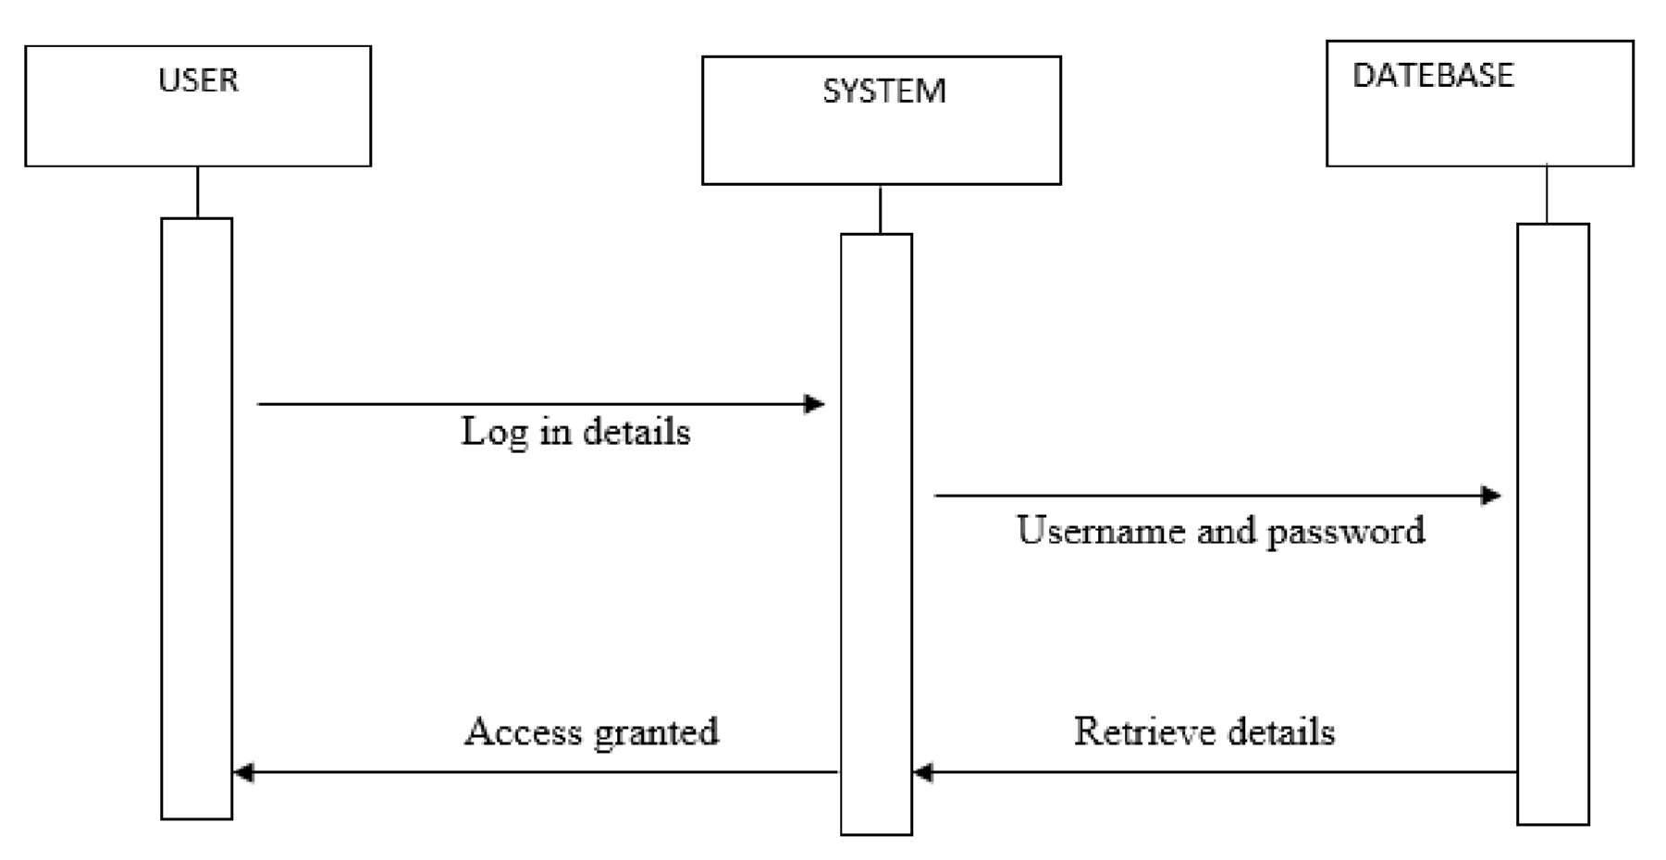
Figure 10: Admin Login Diagram

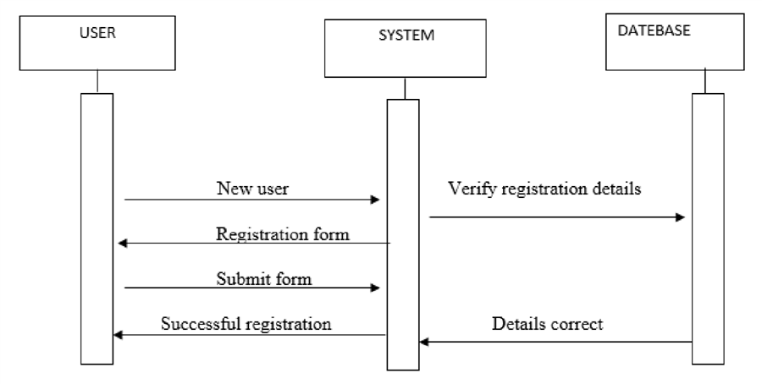
Figure 11:User Registration Diagram

USER
DATABASE
SYSTEM

Login Details
Verify username and password

Retrieve user details
Grant Access

Figure 12: User Login Diagram

USER
DATABASE
SYSTEM

Login Verify email and password

Grant Access Retrieve user details
Make Food Order
Verify Food Order details
Retrieve Food Order status
Display Food Ordered Cart

Figure 13: Food Order Diagram

Class Diagram
A class diagram is a blueprint of the classes (code level) required to build a software system that is they support architectural design and represents the basics of Object Oriented systems. They identify what classes there are, how they interrelate and how they interact (Class Diagram - Visual Paradigm Community Circle, 2018)

Figure 14:Class Diagram

Database Design

Conceptual Design
Database Schema
A database schema is the skeleton structure that represents the logical view of the entire database for it defines how the data is organized and how the relations among them are associated. It also formulates all the constraints that are to be applied on the data, its entities and the relationship among them. It contains a descriptive detail of the database, which can be depicted by means of schema diagrams.
Figure 15: ER Diagram

Logical Design
Here the process of constructing a model of information is done which is then mapped to the storage objects supported by the database management section of the proposed system. This whereby the database table are drawn to conform to the conceptual ER diagram of the new system.

Order Details Table
This the administrator table that stores that the specified username and password used by the administrator.
Field Name | Data type(Size) | Constraints | Description
id | Int(11) | Primary Key | It stores the admin id
order_id | Int(11) | Not Null | This specifies the food ordered
Item_id | Int(11) | Not Null | This specifies the food item id
Quantity | Int(11) | Not Null | It shows the quantity of food ordered
Price | Int(11) | Not Null | It show the food price

Figure 16: Order Details Table

User Table
This table stores a new user’s registration full details.
Field Name | Data type(size) | Constraints | Description
user_id | Int(11) | Primary Key | It stores user id
Role | Varchar(255) | Not Null | Role of the user .
Name | Varchar(255) | Not Null | stores users full names
username | Varchar(255) | Not Null | Stores user’s username
password | Varchar(255) | Not Null | stores new user’s preferred password
Email | Varchar(255) | Foreign Key | Stores the user email address
Address | Varchar(255) | Not Null | Stores the user’s home location
Phone_contact | Varchar(255) | Not Null | Stores the user’s contact number
verified | Int(11) | Not Null | Stores information of user confirmation to the system
Deleted | Int(11) | Not Null | Provides details of deleted customer details

Figure 17: User Table

Food Type Table
This table store all details about the food available for ordering as well as their prices.
Field Name | Data type | Constraints | Description
food_id | Int(11) | Primary Key | Stores to the food table id
Food_name | Varchar(255) | Not Null | This stores the particular food name
Price | Varchar(255) | Not Null | Stores the price of the food in the menu
Deleted | Varchar(255) | Not Null | Stores details of a particular food deleted from the menu

Figure 18: Food Type Table

Orders Table

Field Name | Data type(size) | Constraints | Description
id | Int(11) | Primary Key | It stores id
Customer_id | Int(11) | Not Null | Stores the customer id
address | Varchar(255) | Not Null | Stores the user’s home location
description | Varchar(255) | Not Null | Stores the type of order done by the customer
date | DATETIME | Not Null | Stores the date and time the food order was done
Payment_type | Varchar(255) | Foreign Key | Stores the type of payment for the ordered food
total | int(11) | Not Null | Stores the total payment done
status | Varchar(255) | Not Null | Stores the status of the ordered food
deleted | Int(11) | Not Null | Stores information of user confirmation to the system

Figure 19:Orders Table

Physical Database Design
Physical database design is the process of transforming a data model into the physical data structure of the database management system (DBMS). Physical Design is accomplished in multiple steps, which include expanding a business model or conceptual model into a fully attributed model (FAM) or logical model and then transforming the fully attributed model into a physical design model

System Interfaces

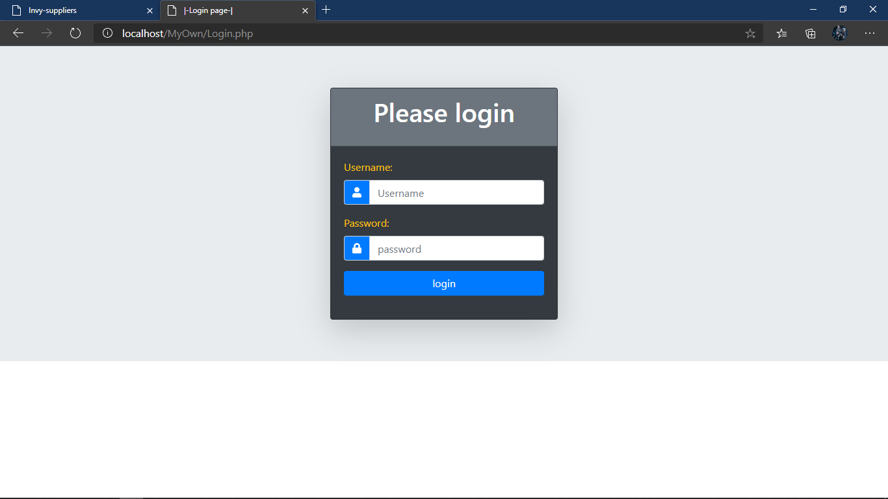
Figure 20: login page

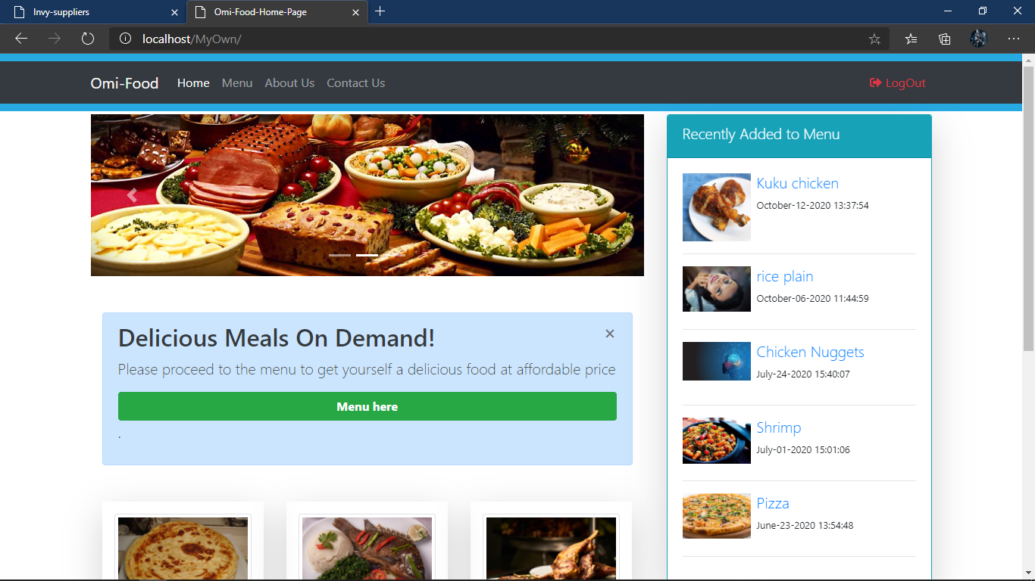
Figure 21: HomePage
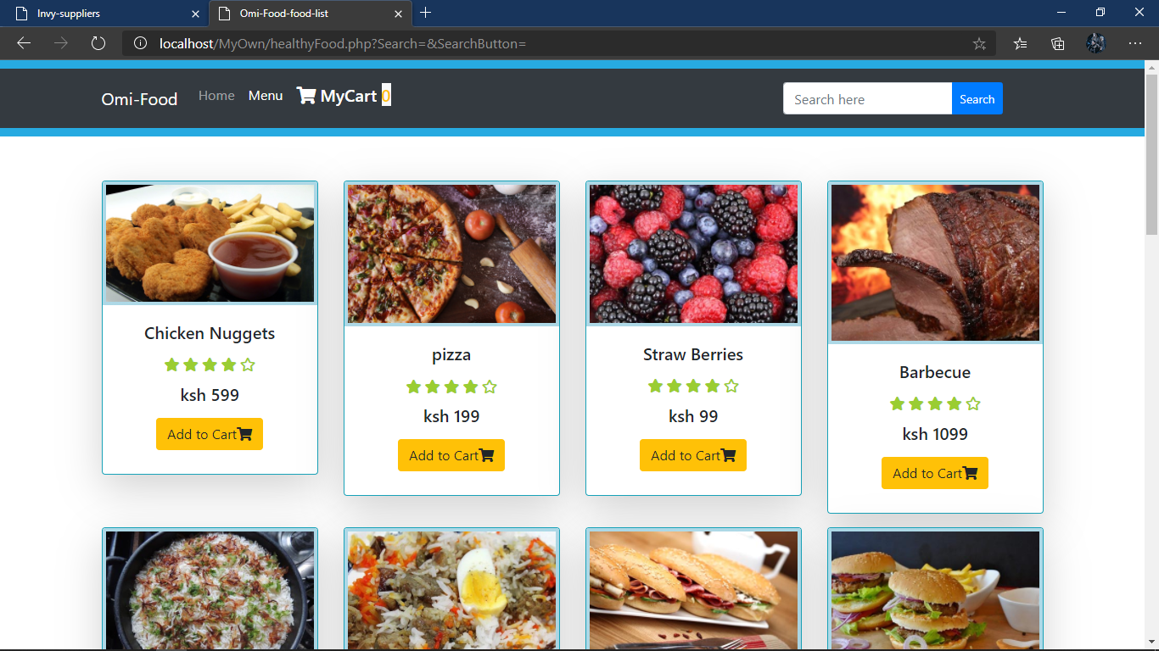
Figure 22: Menu Page

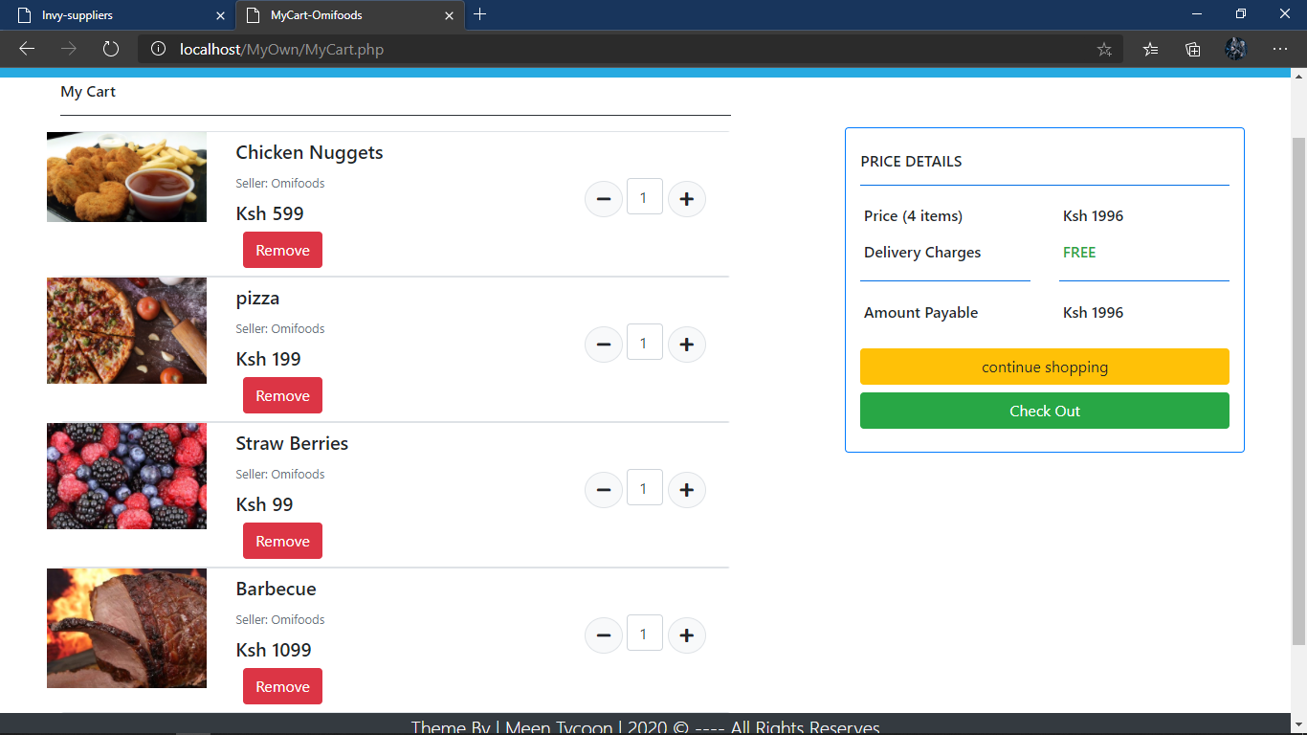
Figure 23: Cart Page

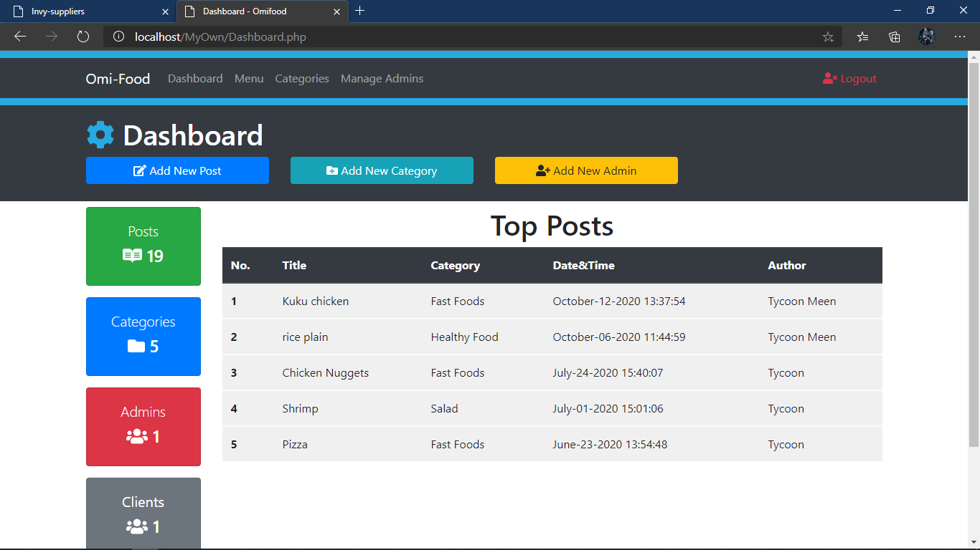
Figure 24: Admin Dashboard

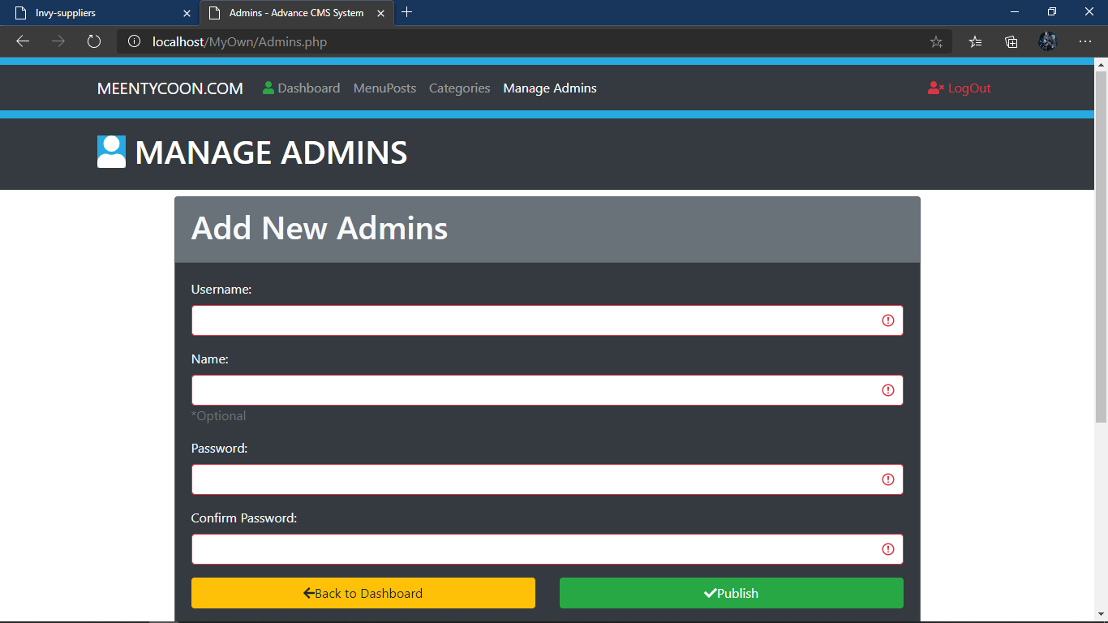
Figure 25: Manage Admins Page

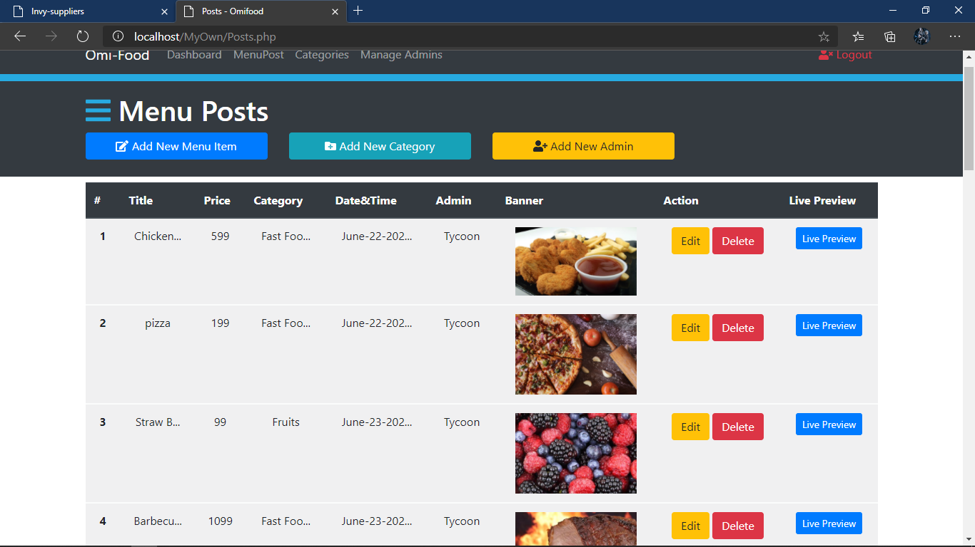
Figure 26: Admin Edit Menu Page

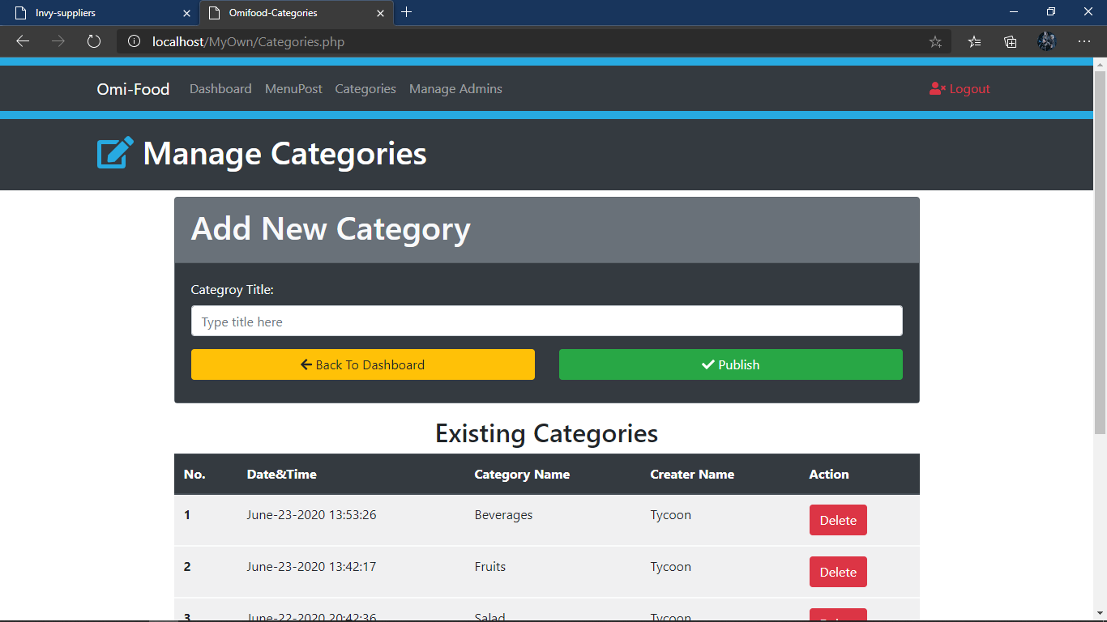
Figure 27: Admin Manage Categories Page

CHAPTER SIX
SYSTEM IMPLEMENTATION

Introduction
This chapter describes the evaluation and implementation process used on the system. In terms of implementation we discuss the development environment, tools, the platform used, database used and levels of system users. For testing, there is an explanation of the type of testing procedure used, test requirements and analysis made on the results for the testing procedure.
Establishment of the required development environment ensures that the implementation process runs smoothly. The following shows the functionalities of the system and test results.

Interface Implementation

Front-end Functionality
A user is able to register. The first step is to create an account and upon being successfully registered, a profile is created. The user can then be able to access the services after login.
Menu Data: Once the user signed in, he/she was able to submit orders that they make to the system’s back-end.

HTML
HTML was used to as the client-side scripting language to develop the system.

CSS and Bootstrap
Cascading style sheets (CSS) allowed us to style the interfaces thus making it appealing for the users. In addition to that, we also used bootstrap which is a framework that has component libraries which made styling easier, better and faster.

Database Implementation
Back-end Functionality
Access to menu data
The back-end user was allowed to access data on the menu items, which include their price and availability.

Analysis of data
All food ordered data was subjected to analysis, which were meant to reveal the various aspects such as most preferred food type, the days that people preferred a particular food and order trends while are all paramount when analyzing the different food types.

JavaScript

JavaScript (JS) was used together with its jQuery library to validate form inputs on the client side before sending the date to the server side. This reduced the work load on the server.

MySQL and XAMP
It was used to create the database which was used by the system. Xamp was used to host the database of the new system. It is a free web host where the database that was located.

PHP
PHP was used as the server side scripting language to develop the system and was used to create the connection to the database. PHP was used to send requests, store and retrieve information from the database in conjunction MySQL. It would be handling the logical part of the proposed system.

System Testing
System Testing (ST) is a testing technique performed to evaluate the complete system and the system's functionalities against specified requirements. In System testing, the functionalities of the system are tested to ensure that the set parameters are all incorporated and are working.

Functionality Test Cases
Table 5.1 Functionality test cases
Test Case Name: Test for functional and non-functional requirements
Test | Related Requirement | Inspection Check | Pre-  Condition | Test Data | Priority Level
Functional | The system was to enable only an authorized users to login | Did the system allow users to login? | The username and password should be provided. | Username & Password | High priority level
Functional | The system allowed the administrator to add and update menu items | Did the system allow the administrator to add and update menu items | Filling of menu items | Menu items filled | High priority level
Functional | The system allowed the administrator to analyse data collected | Did the system allow the administrator to analyse data collected | Completion of compiling order details | Orders made | High priority level
Non-functional | The system was to enable only an authorized administrator to update records of users of the system | Did the system allow only an authorized administrator to update records of the users of the system | The username and password should be provided to access these details. | Username & Password | High priority level

Figure 28: Testing Functionalities Table

Analytics
Test Case Name: Analytics
Brief Description: Once the user logged in he/she could process analysis button on the menu.
Pre-condition: The user should be logged in as an administrator to the system.
Step | Action | Expected results | Pass/Fail
1. | User logs into the application as an administrator. | The application loads the service menu. | Pass
2. | User taps on the analysis button within the menu. | The application loads the analysis form with a summary of the data in tabular form. | Pass
3 | The user keys in the analysis details on the form and can generate the analytics. | The system displays a visualization of the data analytics. | Fairly
Post condition: The analysis can be used for decision making
Figure 29: Analytical test case table

CHAPTER SEVEN

CONCLUSION AND RECOMMENDATION

Conclusion
The challenges encountered by cafeterias and their customers were determined in this research. The challenges included storage of data related to the orders that people make at different days and times. Another challenge was a proper record of analysis that could help track the different trends that are seen in food ordered and the most preferred ones over a period of time.
The main goal of the project was to develop an application that helped maximize the output of cafeterias by reducing the amount of food that goes to waste at the end of the day. Thus, system comes into play by providing a solution that enables cafeterias to be able to analyze the data they collected from their customers and analyze it so as to get to know their preferences.

Recommendations
The developed system is important for the cafeterias as it will increase the customer satisfaction for the cafeterias would be in a better position to know what their likes are. However, the users of the system should consider conduction of training on how to use the system. Workshops on the use of the application on both the front and back end would be very important.
The administrator should not be allowed to delete any information from the back end unless instructed through proper channels laid down; this could also have some sort of punishment.

Future Works
There can still be improvement on the solutions from this research which can be brought by changes in technology which change overtime, thus, more functionalities can be added. In addition, an application can be built for other platforms available like mobile devices, Blackberry’s RIM and Apples IOS for better view and a larger customer base. Also, better filters like weather conditions of the day.

APPENDICES

Appendix 1

Code snippets

REFERENCES
- 7continentslist. (2017). Facts about Kenya Food, Culture, History and Landmarks. Retrieved from 7continentslist.com: https://www.7continentslist.com/africa/kenya/facts.php
- Byte. (2018). Retrieved from BYTE: http://mybyteapp.com/
- Charles Brewer. (2017). Sub-Sahara, Africa.
- Class Diagram - Visual Paradigm Community Circle. (2018). Retrieved from Visual Paradigm Community Circle: https://circle.visual-paradigm.com/category/class-diagram/
- Dhanvani, P. (2018). Difference between Procedure Oriented Programming and Object Oriented Programming | Procedure Oriented Programming vs. Object Oriented Programming - FreeFeast.info : Interview Questions ,Awesome Gadgets,Personality Motivation Guide, Famous IT personalitie. Retrieved from FreeFeast.info : Interview Questions ,Awesome Gadgets,Personality Motivation Guide, Famous IT personalities: https://freefeast.info/general-it-articles/difference-between-procedure-oriented-programming-and-object-oriented-programming-procedure-oriented-programming-vs-object-oriented-programming/
- Felici, M. (2011). Sequence Diagrams. Sequence Diagrams.
- Find and Book event venues in Kenya | Venues, Halls, Gardens, Marquee | ogaVenue Kenya. (2018). Retrieved from ogavenue.co.ke: https://ogavenue.co.ke/
- Fishbowl. (2018). The Fishbowl Solution - Fishbowl. Retrieved 2018, from Fishbowl.com: https://www.fishbowl.com/the-fishbowl-solution/
- Hoffer, H., George, J., & Vlacich, J. (2006). Modern Systems Analysis and Design. Pearson Prentice Hall.
- Hospitality Technology. (2016). 5 Ways Restaurants Can Use Big Data. Retrieved from Hospitality Technology: https://hospitalitytech.com/5-ways-restaurants-can-use-big-data
- Introduction to PKI. (2018). Retrieved from tom's IT pro: http://www.tomsitpro.com/articles/public-key-infrastructure-introduction,2-884.html 28

- Kurz, W. (2018). Reasons for Object Oriented Modelling. Retrieved from Wkurz.com: http://wkurz.com/mdd3.htm
- Mukherjee, S. (. (2016, 4 22). How to use data science to grow your restaurant/cafe business ? Retrieved from https://www.linkedin.com/pulse/how-use-data-science-grow-your-restaurantcafe-snehamoy-mukherjee
- Object Oriented Programming vs Procedural Programming | W3Schools | Tutorialspoint | W3Adda. (2018). Retrieved from W3Schools | Tutorialspoint | W3Adda: http://w3adda.com/cpp-tutorial/object-oriented-programming-vs-procedural-programming
- Powell-Morse, A. (2018). Object-Oriented Analysis and Design: What is it and how do you use it? Retrieved from Airbrake Blog: https://airbrake.io/blog/software-design/object-oriented-analysis-and-design
- Rojatkar, D. V., Jengathe, G. M., Khairnar, A. B., & Lengure4, S. A. (March 2016). ANDROID APPLICATION DEVLOPMENT SOFTWARE – ANDROID STUDIO AND ECLIPSE. INTERNATIONAL JOURNAL FOR ENGINEERING APPLICATIONS AND.
- Singh, A., Sharma, S., & Singh, S. (2016). Android Application Development using Android Studio. International Journal of Computer Applications (0975 – 8887), 5-8.
- Spending Habits by Generation | U.S. Department of Labor Blog. (2018). Retrieved from Blog.dol.gov: https://blog.dol.gov/2016/11/03/spending-habits-by-generation
- Summit, E. A. (2018, may 2). East Africa Big Data & Cloud Computing Summit. Retrieved from https://www.eventbrite.com/: https://www.eventbrite.com/e/east-africa-big-data-analytics-and-cloud-computing-summit-39687502388
- Visual Paradigm. (2018). What is Sequence Diagram? Retrieved from Visual-paradigm.com: https://www.visual-paradigm.com/guide/uml-unified-modeling-language/what-is-sequence-diagram/
- What is Agile? . (2018). Retrieved from cPrime: https://www.cprime.com/resources/what-is-agile-what-is-scrum/

