Author’s Note

Hello, friends. I’m glad you are reading this. I have done so much research to bring me to this page. I am sad to say that nearly 100% of bird threats involve human activity. Agriculture alone puts 74% of the bird species in the entire world at risk of extinction. So I want to emphasize something many people don’t understand, and I want you to be here to hear it: It isn’t fair how birds are treated. I realize that many people think of birds as just an animal, and animals seem to be invisible to human activity. It’s like we don’t care that we harm the animals. So many people don’t know how bad this is to our environment and ecosystem. But I believe it is important to value every living being as a true living being. I did focus this book on birds, but they aren’t the only ones suffering. I hope you join me in saving wildlife, for many of these natural wonders were here long before we were. They respect us. Why don’t we respect them? Well, we can. But we don’t.

After reading my articles, I hope as you look out through your window and watch these birds hop around, you realize that they cause no harm. It is us doing all the damage, from tearing down their houses to polluting the air to using harmful chemicals. They are neighbors to us and are part of the planet Earth family. We seem like it’s no big deal, but it is. We harmed their peaceful lives, so we will fix it. It is our job to preserve birds. There are many ways to help, and I will be talking about my experience with birds and how I helped.

I started loving birds when I began writing this book, which is why I chose this as the topic. A bit after that, my mom bought me a hummingbird feeder and we hung it right outside the kitchen. It became a regular thing for Broad-Tailed Hummingbirds and Anna’s Hummingbirds to visit everyday. We also planted flowers that attracted these little hummingbirds. If you are interested, you can get a feeder, or maybe some flowers (red stands out to hummingbirds). Make sure feeders have fresh sugar water so that the hummingbirds will drink it. Sugar water is simple to make: just boil a pot of water and stir in sugar. Your yard can be a safe habitat for hummingbirds if pesticides aren’t used and there isn’t too much glass. There should also be shrubbery and trees for shelter and for the place to look and feel more like their natural habitats. I know at least one hummingbird has been happy living near my backyard.

Later, after about 1 or 2 years, my dad got me a bird feeder when my passion for birds sank even deeper. The camera allowed me to see the bird up close and clearly, something we can’t do with bare human eyes. I loved watching songbirds come through the app. It was a great opportunity for me to watch new species eat and enjoy the food. For example, the Chestnut-Backed Chickadee and House Finch were two new species I had never seen in the backyard. Feeders like this one help you more closely admire the beauty of birds of all shapes and sizes. Though it has not been done yet, my mom and I are planning to add a birdhouse to our backyard, another cozy safe addition to our bird-friendly backyard.

Hawks may be occasional visitors to feeders. Songbirds are attracted to areas with easy food, and so are hawks. If a hawk or eagle finds its way to your feeder and tries to kill the little feeder visitors, it is best to remove the feeder for a few days so it attracts less birds and the hawk should move on. Remember that hawks are also part of the ecosystem, so we shouldn’t hurt or cage them.

Even though none were written about in these chapters, endangered birds still exist everywhere. Around 90 are found in only the USA! Ones in the Bay Area include the California Chapper Rail, the California Least Tern, the Western Snowy Plover, the Marbled Murrlet, and the Burrowing Owl. We can also see that preservation in action is helpful. As written in the chapter about them, Peregrine Falcons used to be endangered, but thanks to conservation efforts, they have bounced back.

Currently, we are doing the opposite and hurting our feathered friends. We are expanding cities, not caring about the animals we hurt along the way. Birds are being forced to live in urban places, so we can create a safe home right near our house and give the birds some habitats. We can make cities bird-friendly ecosystems and continue to explore the wonder and beauty of birds! I encourage you to do your own research to explore the many ways to help keep the partners of our planet alive. Even going for 1 species and making a difference is progress. One person can’t save every bird. But the more people cooperating, the more birds can be helped. Step one is to learn. I want this website to help people understand birds so that they can help. I made it so that people can have an adventure into one of nature’s miraculous creations: birds. All you have to do now is to do it. Take action in saving them. Teach others to value birds as true living beings. It’s as simple as donating to a bird friendly organization. Or turning your yard into a bird welcome ecosystem. Start today, start now. You decide when. I can only provide information and encouragement. But I hope you work with me—and many others—to help birds. And in the future, respect them. Like we should.

About the Author
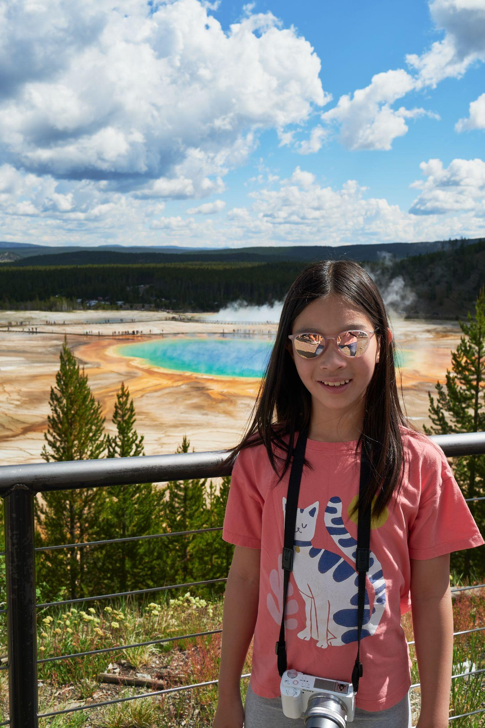
Olivia Chen is a 10 year old 5th grader who goes to Pinewood School. She lives in Los Altos, CA with her younger sister, Izzy, her mother, father, and grandma. Olivia has enjoyed writing since she was 5 years old: ever since she started taking lessons. She published her first book, called Olivia’s Fantasy Wonderland, at the age of 7. It’s a collection of fictional stories where her imagination meets the pages of the book. Her hobbies are reading, writing, drawing, swimming, and playing cello. She also enjoys traveling with her family. She loves looking for wildlife, especially birds. Through this website, Olivia hopes to inspire children around her age to care for birds and be aware of what they are doing to the environment.

“ I want children to learn how to respect nature
before they learn how to disrespect nature.”

-Olivia Chen

For more information, contact oyxchen@gmail.com

