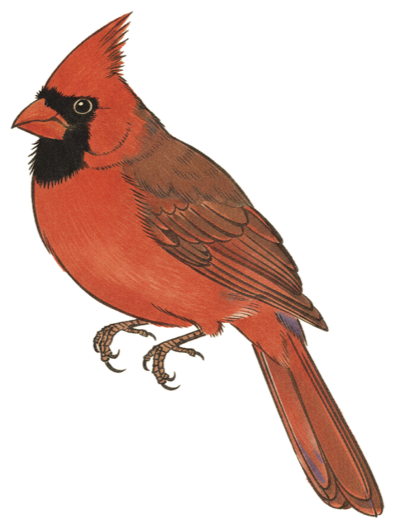
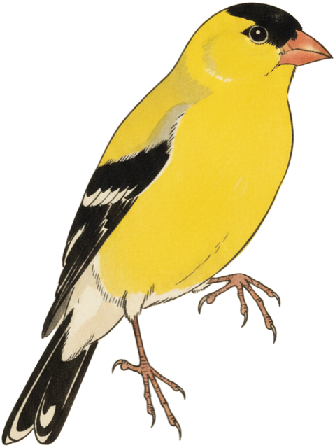
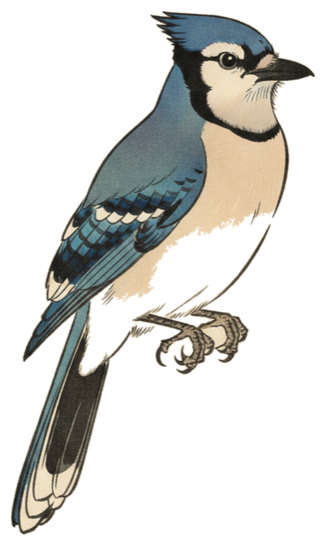

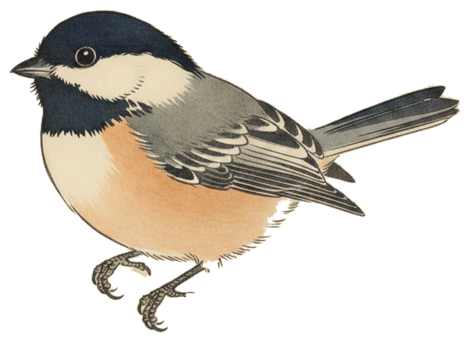
BirdWatch
Setup Guide A–Z
DFRobot ESP32-S3 AI Camera (DFR1154)
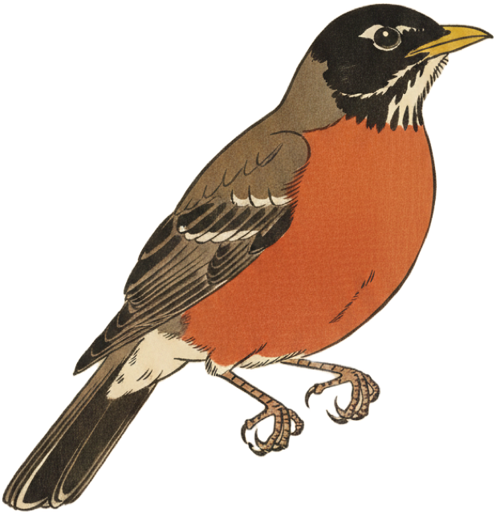
Everything you need to set up a BirdWatch camera from scratch.
github.com/oyyeahhh/birdwatch-cam

A. WHAT YOU NEED
› DFRobot ESP32-S3 AI Camera (DFR1154) — the camera itself
› USB-C data cable (some charge-only cables won’t work — if yours doesn’t show up, try a different one)
› MicroSD card, 32 GB or smaller, formatted FAT32
› A computer with the Arduino IDE installed (free from arduino.cc)
› Your school or home Wi-Fi name and password (must be 2.4 GHz, not 5 GHz)
› An OpenAI API key (starts with sk-) — your teacher may give you one
› A bird feeder placed 2–5 feet from a window

B. INSTALL THE ARDUINO IDE
The Arduino IDE is the free app you’ll use to put the BirdWatch software onto the camera. You only do this once.
1. Go to arduino.cc/en/software and download the Arduino IDE for your computer (Mac or Windows).
2. Install it like any other app — drag to Applications on Mac, or run the installer on Windows.
3. Open the Arduino IDE.

C. ADD THE ESP32 BOARD PACKAGE
The Arduino IDE doesn’t know about the ESP32 chip yet. You need to tell it where to find the board files.
1. In the Arduino IDE, go to Settings (Mac: Arduino IDE → Settings — Windows: File → Preferences).
2. Find the field called Additional boards manager URLs. Paste this URL on its own line:
https://espressif.github.io/arduino-esp32/package_esp32_index.json
3. Click OK to save.

D. INSTALL THE ESP32 BOARD CORE
1. Go to Tools → Board → Boards Manager.
2. Search for esp32.
3. Find “esp32 by Espressif Systems” and click Install. Pick version 3.x (the latest).
4. Wait for it to finish downloading (this can take a few minutes).

E. INSTALL THE ARDUINOJSON LIBRARY
1. Go to Tools → Manage Libraries.
2. Search for ArduinoJson.
3. Install version 7.x (the latest).

F. SET THE TOOLS MENU (VERY IMPORTANT)
These settings tell the Arduino IDE what chip is on the camera. If any are wrong, the code won’t upload or the camera will crash.
Setting | Set it to | Why
Board | ESP32S3 Dev Module | Under Tools → Board → esp32.
USB CDC On Boot | Enabled | So your computer can talk to the camera over USB.
Flash Size | 16MB (128Mb) | The camera has 16 MB of memory. Wrong = upload fails.
PSRAM | OPI PSRAM | Extra memory for photos. Without it the camera won’t start.
Partition Scheme | Huge APP (3MB No OTA/1MB SPIFFS) | Firmware is too big for the default partition.
Port | (appears when you plug in) | Mac: /dev/cu.usbmodem… Windows: COM3 or higher.
Everything else in the Tools menu can stay at the default.

G. PREPARE THE SD CARD
The SD card stores bird photos and the web app. Format it first, then copy the files.
1. Insert the microSD card into your computer (you may need an SD adapter).
2. Format it as FAT32. On Mac: Disk Utility → Erase → MS-DOS (FAT).
On Windows: right-click → Format → FAT32.
3. Open the birdwatch-cam folder on your computer.
4. Copy these files onto the SD card:
SD Card
├── web/
│ ├── index.html ← copy from web/local/index.html (note NO local folder on sd)
│ └── assets/
│ └── illustrations/ ← copy folder web/assets/illustrations/

5. Eject the SD card safely, then insert it into the camera’s card slot.

H. OPEN THE FIRMWARE CODE
1. In the Arduino IDE, go to File → Open.
2. Navigate to the birdwatch-cam folder and open esp32aicam/esp32aicam.ino.
3. Several tabs will open across the top — that’s normal. You don’t need to change anything in the code.

I. UPLOAD THE CODE TO THE CAMERA
1. Plug the camera into your computer with the USB-C cable.
2. Make sure Port in the Tools menu shows a device. If nothing appears, hold the tiny BOOT button on the camera while plugging in.
3. Click the Upload button (the → arrow in the toolbar). The IDE will compile and upload — about 1–2 minutes.
4. When you see “Done uploading” at the bottom, you’re done! If the camera doesn’t start, tap the tiny RST (reset) button once.

J. CONNECT THE CAMERA TO WI-FI
On first boot, the camera creates its own Wi-Fi hotspot so you can enter your network info.
1. On your phone or laptop, open Wi-Fi settings and join the network called AI-Camera-Setup.
2. A setup page should open automatically. If not, open a browser and go to 192.168.4.1.
3. Enter your Wi-Fi name, Wi-Fi password, your OpenAI API key, and a name for the camera (like “lab-window”).
4. Tap Save. The camera restarts and joins your Wi-Fi.

K. FIND THE CAMERA’S ADDRESS
1. In the Arduino IDE, open Tools → Serial Monitor. Set the speed to 115200 baud (dropdown in the top-right corner).
2. Press the RST button on the camera. Text scrolls by, and near the end you’ll see something like:
http://192.168.1.182/
That’s your camera’s address. Write it down — you’ll use it to open the app.

L. OPEN THE BIRDWATCH APP
On any device connected to the same Wi-Fi network as the camera, open a browser and type the camera’s address (e.g. http://192.168.1.182). You’ll see the BirdWatch app with five tabs:
Tab | What it shows
Collage | A visual cluster of all the birds seen so far.
Stats | A timeline showing when birds were detected each day.
Atlas | A field-guide grid of every species, with illustrations.
Health | Camera status, detection funnel, and error log.
Config | Settings — name, sharing mode, detection tuning.

M. AIM THE CAMERA
› Go to http://<camera-ip>/stream in your browser — this shows a live video preview.
› Mount the camera with the lens pressed flat against the window glass (the rubber gasket stops reflections).
› Place your bird feeder 2–5 feet away, centered in the preview. The perch should be clearly visible.
› Clean the glass on both sides.
› Make sure there are no lights behind the camera — they cause glare.

N. CONFIGURE YOUR CAMERA
Open the BirdWatch app and tap the Config tab.
Setting | What to enter
Device ID | A short name like yst-nj-lab (org-location-spot).
Region hint | “Backyard feeder in northern New Jersey.” This helps the AI know which species live near you.
Sharing mode | Start with Local — nothing leaves your network.
Everything else | Leave the defaults. They’re tuned for typical use.
Tap Save. Settings are saved even if the camera restarts.

O. TEST THAT IT WORKS
› In the Config tab, tap Test Capture. This takes a photo and saves it to the SD card without using an API call.
› Wave your hand in front of the feeder. Within about a minute, the Health tab should show a motion trigger.
› When a real bird lands, the camera takes a photo, asks the AI “is there a bird?”, then asks “what species?” The bird appears in the Collage and Atlas.

P. HOW THE CAMERA IDENTIFIES BIRDS
Here’s what happens automatically, all day long:
# | Step | What happens
1 | Motion detected | The camera compares each frame to the last one. If enough pixels change, something moved.
2 | Photo taken | It snaps two photos — one instantly and one 400ms later (after the bird settles).
3 | Bird gate | A fast AI model looks at the photo: “Is there a bird?” If no → done.
4 | Species ID | A smarter AI model identifies the species and gives a confidence score (0–100%).
5 | Logged | High confidence = gallery. Lower confidence = review queue for you to check.

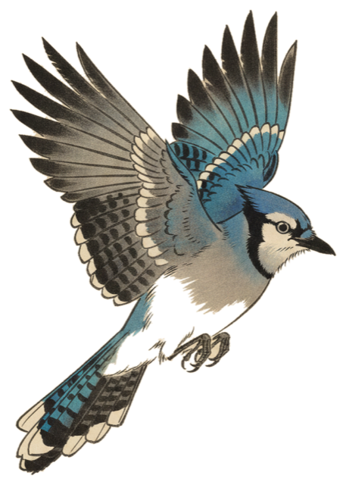 |  | 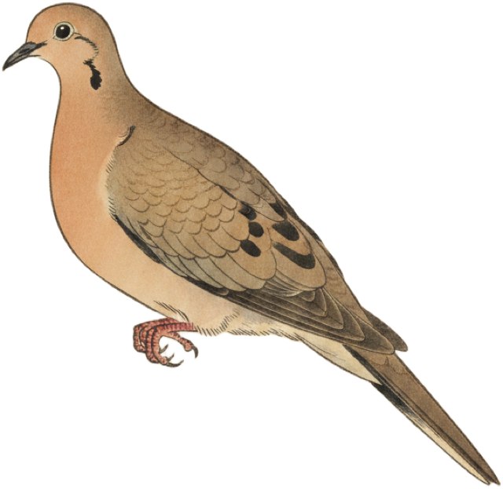 | 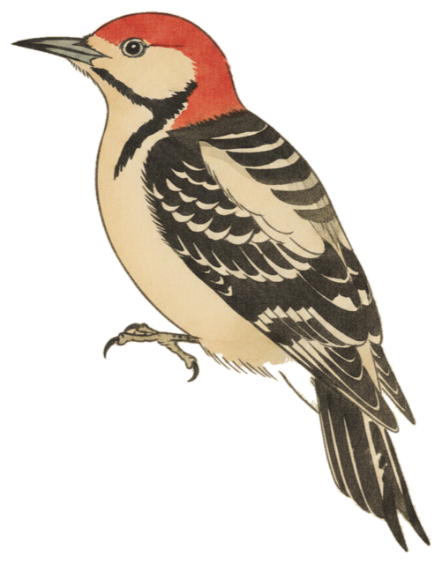 | 
Blue Jay · Cardinal · Mourning Dove · Red-bellied Woodpecker · American Robin

Q. UPDATING THE APP (OVER WI-FI)
If there’s an updated version of the web app, you don’t need to pull the SD card. From a terminal:
tools/push_web.sh 192.168.1.182
Replace the IP with your camera’s address. This uploads the latest app and illustrations over the network.

R. TROUBLESHOOTING
Problem | Fix
I don’t see the AI-Camera-Setup network | Hold the BOOT button for 10 seconds while plugging in USB to factory-reset Wi-Fi.
Upload fails / no port appears | Hold BOOT while plugging in the cable. Try a different USB cable (some are charge-only).
“SD Card Mount Failed” in serial monitor | Reformat the card FAT32. Make sure it’s 32 GB or smaller. Push it in firmly.
Plain white page instead of the app | The /web folder is missing on the SD card. Go back to step G.
Triggers but never identifies anything | Check that the OpenAI key is correct and the account has credit. Errors show on Health tab.
Too many false triggers | Lower motion sensitivity in Config. Check for moving branches or reflections in the preview.
Camera was working but now I can’t reach it | The IP address probably changed. Ask for a DHCP reservation from whoever runs the network.
Camera keeps restarting (boot loop) | Check serial monitor at 115200 baud. Make sure PSRAM is set to OPI PSRAM in Tools menu.

S. TIPS FOR BETTER RESULTS
› Clean the window regularly — smudges confuse the motion detector.
› Suet feeders attract woodpeckers. Tube feeders with sunflower seed attract finches, chickadees, and titmice.
› The camera only works during daylight by default. At night it saves API calls.
› The camera uses about 60 API calls per day. If it hits the limit, it stops until midnight.
› Tap any bird in the Atlas to see its illustration in perched and flying poses.
› The Live tab shows what the camera sees right now — useful for checking the aim.

✓ VERIFIED These instructions were tested on a real DFR1154 camera. Follow each step and it works.
github.com/oyyeahhh/birdwatch-cam
CIJE BirdWatch Cam · 2026

