

马拉松运动分组分时间及路程长短与拥堵时间封路事件关系及解决方案

In order to better understand and tackle the thorny issue of refugee influx in Europe, a series of models are established.

In Model 1 Metrics of Refugee Crisis, specific factors of each route are defined into five parameters: transportation, safety, probability of asylum, distance and life insurance. Analytical Hierarchy Process is employed to calculate the overall effects of the five factors to determine which route to take. The weights of the six routes are thus obtained.

In Model 2 Flow of Refugee, with the weights of routes from Model 1, the metrics built in Model 1 can determine the number of refugees. We designed a graph algorithms to handle the problem meanwhile make the distribution of the host countries well-proportioned and the overall cost least. Dividing the refugee arrangement into two synergic models makes this problem solved easily and precisely.

In Model 3 Dynamics of the Crisis, our team wisely choose a key parameter --country’s capacity to measure the dynamics of the crisis. We prove the relationship between capacity and other factors mathematically, namely we prove that other factors can directly or indirectly affect a country’s capacity. Moreover, the result shows that our model is quite adaptable and can be extended to a variety of situations.

Based on the three models we establish, policies to support our refugee model for the ideal set of conditions ensuring the optimal migration pattern are thus proposed. Odds are that our solution can be taken into consideration and help to relieve the nervous situation.

Exogenous events are carefully studied in this part. Two aspects are focused on to solve this problem: deciding the routes and the capacity of receiving countries. The immigration policies that we recommend be designed are proved to be resilient to these types of events in the case.

To handle a larger scale of refugees, our team introduce a new parameter estimating people’s living quality affected by the larger scale. We also demonstrate the changes in the factors in our previous model, simultaneously extend and strengthen our model.

Assumptions 4

Model 1: Metrics of Refugee Crisis 4

Model 2: Flow of Refugee 8

1. A Simplified Model 8

Situation 1: 8

Situation 2: 9

2. An upgraded model. 10

3. Sensitivity 13

Partition of refugees. 13

Capacity. 13

Model 3: Dynamics of the Crisis 14

Policy to Support Refugee Model. 17

Exogenous events 18

Scalability 20

Parameters in Model 1 20

Parameters in Model 2 21

Strengths and Weaknesses 22

Reference 23

**Introduction**

With thousands of refugees moving across Europe and more arriving each day, a series of problems have arisen, bothering both European authorities and the refugees themselves. Although considerable attention has been given to refugee integration policies and practices in many countries and regions, effective policies are still needed to manage the unique challenges brought by the crises.

In order to ensure a safe and efficient movement for the refugees, the entire problem is divided it into six parts:

1. Model 1: Metrics of refugee crises
2. Model 2: Flow of refugee
3. Model 3: Dynamics of the crisis
4. Policy to support refugee model
5. Exogenous events
6. Scalability
7. For Model 1, we determine the specific factors of each route, which can either enable or inhibit the safe and efficient movement of refugees, into five parameters: transportation, safety, probability of asylum, distance and life insurance. Analytical Hierarchy Process (AHP), a simple way of dealing with the complicated and ambiguous, especially with those difficult to be completely quantitative analyzed problems, is employed to deal with the problem. Our aim is direct: to make the best route for the refugees so that they can arrive at their destination fast and safe. AHP algorithm is therewith employed to calculate the overall effects of the five factors to determine which route to take. The weights of the six routes are thus obtained.
8. For Model 2, it works cooperatively with Model 1 we design an optimal refugee movement that incorporates projected flows of refugees across the six travel routes mentioned hereinafter. Our focus comes to the capacity of countries and we prove the correctness of doing so. We use the metrics in Model 1 to determine the number of refugees. Then study the capacity of the destination countries and according to their characteristics, then decide and allocate the number of refugees in the destination of the 6 routes. Next, we design a graphic algorithm to handle the problem and calculate the minimum overall distance of all the refugees have to take and make the distribution of the host countries well proportioned.
9. In Model 3, the capacity of a country is chosen as the key parameter to measure the dynamics of the crisis. Capacity is easy to estimate and determine, and is the direct factor which can decide the Model 2 above and effect the final refugee arrangement significantly. Other factors can directly or indirectly effect a country’s capacity easily. The known dynamic changes can have its corresponding population adjustment. The dynamics of transportation, safety, cultural difference and so on will change the country’s capacity and finally affect the refugee arrangement.
10. Based on the three models we have established, and combined with the health and safety of refugees and the local populations as well, the laws and cultural constraints of the effected countries, the role and actions of nongovernmental organizations, we thus propose our policies to support our refugee model for the optimal set of conditions ensuring the optimal migration pattern. We sincerely hope that our solution can be taken into consideration and help to relieve the nervous situation.
11. Exogenous events, which are highly likely to occur and alter the situation parameters in these volatile environments, are also taken into consideration in this paper. The parameters that would likely shift or change completely in a major exogenous event and the cascading effects on the movement of refugees in neighboring countries are carefully studied. We focus on two aspects to solve this problem: deciding the routes and the capacity of receiving countries. The factors that can affect the decision of the route include transportation, safety, and probability of asylum, distance and life insurance. The capacity of receiving countries depends on the policy and warfare (including riots) to a great extent and is properly handled with in our model. Our immigration policies that we recommend be designed are proved to be resilient to these types of events in the case.
12. Things change dramatically when the scope increases sharply. We adjust Model 1 to make it practical for 10 times refugees, by changing some of its parameters and explain the changes in parameters. Furthermore, our team introduce a new parameter α to estimate the effect caused by the larger scale, we do also demonstrate the linear relationship between α and refugee’s living quality, simultaneously extend and strengthen our model. Finally, we expand the crisis to a larger scale by a factor of 10 to test its scalability and the results are satisfying, giving promises to handle the current issue effectively.

# Assumptions

1. Refugees get started from the southeast of Europe and they can choose any one of the 6 routes.
2. Each destination of the 6 routes is a start point, and refugees are required to be distributed to 6 selected countries in the map. Since the six countries are selected as they received the most refugees. The journey of the route is so prominent that the process of arriving at the start point of each route can be ignored.
3. We focus on most important factors, including transportation, safety, probability of admittance, distance and life insurance, others being neglected.
4. We mainly use distance of each route to represent its according cost as is often the case in reality. The overall cost equals distance multiplied by the refugee number.

# Model 1: Metrics of Refugee Crisis

There are six known routes for the refugees, including: from the Middle East through (1) West Mediterranean, (2) Central Mediterranean, (3) Eastern Mediterranean, (4) West Balkans, (5) Eastern Borders, and (6) Albania to Greece [3]22, shown in Fig. 1.

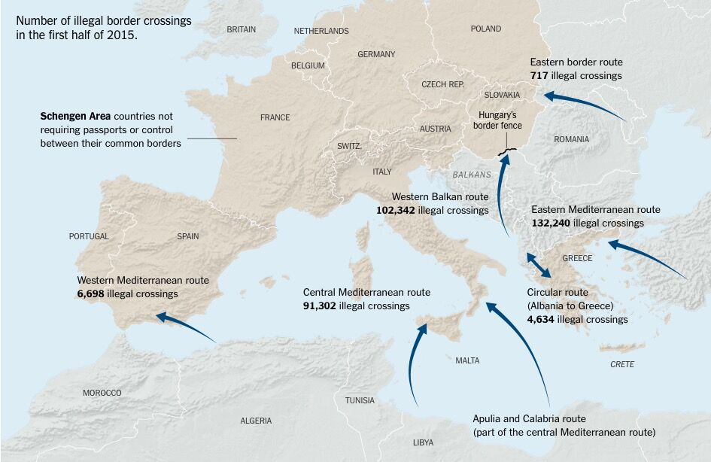

Figure 1. The routes of the refugees

To make the complex real situation into a feasible and comprehensible model, we simplify the parameters and factors and abstract the problem to a mathematical level. The important factors aforesaid are set into 5 parameters:

1. Transportation

Transportation stands for difficulty or inconvenience of transport. We assume the order to be: hilly road > seaway > plain.

1. Safety

Safety stands for the level of danger. We consider seaway and wild areas to be dangerous. Here we refer to death rate from the internet. [3].

1. Probability of Asylum

As some factors are not decisive, we define Probability of asylum as a comprehensive index of receiving countries’ acceptance rate and policy [4], border passing rate and religion factor, along with variety of choices. The choice of countries will be discussed in Model 2.

1. Distance

Distance is the geographical distance from Middle East to destinations of routes.

1. Life Insurance

Life insurance represents availability of food supply and environment for accommodation. [4]

In order to avoid injustice and minimize subjective conjecture, here we deploy the Analytical Hierarchy Process (AHP) algorithm to determine the amount of components of the factors affecting the allocation of routes.

|  |  |  |
| --- | --- | --- |
| B1: Transportation | C1: Western Mediterranean |  |
| B2: Safety | C2: Central Mediterranean |  |
| B3: Probability of asylum | C3: Eastern Mediterranean |  |
| B4: Distance | C4: West Balkans |  |
| B5: Life insurance | C5: Eastern Borders |  |
|  | C6: Albania to Greece |  |

Six matrices are thus built:

Matrix A =

Rows and columns represent B1, B2, B3, B4 and B5 respectively.

In matrix A,

=

Where is the effect of and is the effect of.

Matrices are built in the similar way.

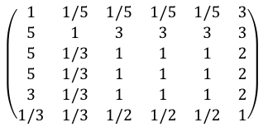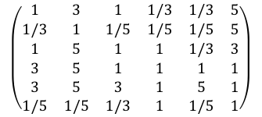

Matrix B1 = Matrix B2 =

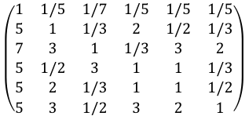

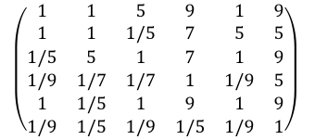

Matrix B3 = Matrix B4 =

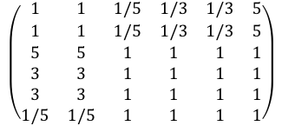

Matrix B5 =

Rows and columns represent C1, C2, C3, C4, C5 and C6 respectively.

All the six matrices have passed consistency inspection. Using MATLAB, we calculate the overall effects of the five factors to determine which route to take. The weight of each route is obtained henceforth and is shown in Table 1.

Table 1. Weights of the routes

|  |  |  |  |  |  |
| --- | --- | --- | --- | --- | --- |
| West  Mediterranean | Central  Mediterranean | Eastern  Mediterranean | West  Balkans | Eastern  Borders | Albania to  Greece |
| 0.1496 | 0.2038 | 0.1978 | 0.1406 | 0.2362 | 0.0721 |

A flow chart is built to explain the logic behind the algorithm and is shown in Fig. 2. It contains three levels: Goal, Criteria and Alternatives.

Figure 2. AHP algorithm relationship

Determine the routes

Transportation

Safety

Prob. of asylum

Distance

Life insurance

West

Mediterranean

Central

Mediterranean

Albania to Greece

Eastern

Borders

West

Balkans

Eastern

Mediterranean

# Model 2: Flow of Refugee

In this model, referencing to the UNHCR Refugee Coordination Model. [10] We assume population and population capacity to be critical factors among all. [1]- [3] We study the capacity of the destination countries and according to their characteristics, we decide and allocate the number of refugees in the destinations of the 6 routes. By doing so, the total distance of all the refugees have to take is minimized and the distribution of the host countries is well proportioned. Finally, we provide a picture which contains the detailed arrangement and the minimum cost. The important factors aforesaid can be classified as follows:

1. Population and population capacity
2. Capacity of the destination countries.
3. Number of refugees in the destination of the 6 routes.
4. Distance and distribute all refugees.
5. We define the following parameters to estimate this model:
   1. Ni: The number of refugees in each line.
   2. Di: The distance of each line.
   3. D: The sum of Di
   4. C: The total cost (n is the number of routes)

We define the **nearest line**, by which the refugees can get to the nearest country. Greedy algorithm is employed to calculate the minimum cost. Thus, we can provide two promoted strategies.

1. Refugee number priority:

We arrange the harbor with the most refugees in advance.

1. Distance(cost) priority:

We arrange that countries receive refugees near them as many as possible.

Thus the problem is just a matter of strategy choice.

## A Simplified Model

### Situation 1:

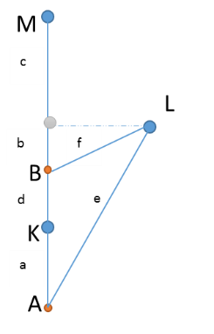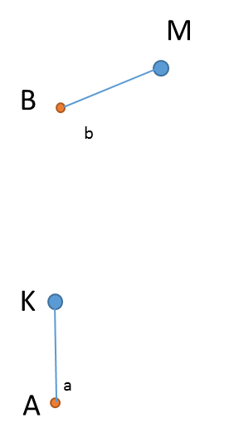

Figure 3. Situation 1 Figure 4. Situation 2

In Fig.3, the capacity of both country ***K*** and ***M*** exceeds the total number of refugees from the nearest harbor ***A*** and ***B***. Obviously the total cost is minimized by arranging that the refugees from ***A*** get to ***K*** and ***B*** to ***M***, namely, to arrange the refugees to get to the nearest country.

### Situation 2:

1. In Fig.4, we assume ***A, B*** as the start point and ***K, L, M*** the destination countries. The lower letter ***a -> e*** represents the length of each corresponding line. Assuming that ***A, B, C, K, L*** and ***M*** are in the same line and A contains 2 unit of people, ***B*** contains 1 unit in order to simplify the question.
2. We assume that the refugees in ***A*** and ***B*** have to be sent to the European countries ***K, L*** and ***M,*** and the blue line is the transportation route which represents the distance and can decide the arrangement.
3. The number of refugees in ***A*** exceeds the capacity of ***K*** or ***L*** or ***M,*** so we should arrange refugees in ***A*** into two countries. ***A->K*** and ***B->L*** are the nearest lines, however, we need to send some people to ***M***.
4. Solution process:
   1. Refugee number priority:
   2. Distance(cost) priority:
   3. Comparison

Thus the Refugee number priority is recommended under this simple condition.

## An upgraded model.

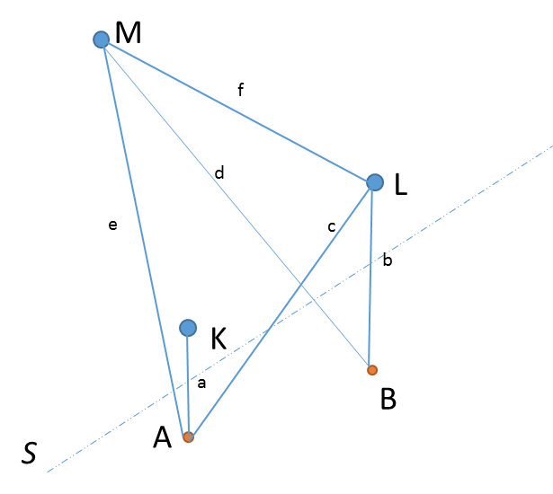

Figure 5. Upgraded model for strategy 2.

1. We upgrade the model in strategy 1 and consider more elements to be more practical and adopt to the real situation, especially geographically:
   1. The refugee harbors are in one side of the map, and the destination countries are in the other side. S is the boundary line.
   2. ***a, b*** are the nearest lines for ***A*** and ***B***. According to the definition of nearest line, it’s less than any line except itself.
   3. The rest of the assumptions in simplified model remain unchangeable.
2. According to the map of the European refugees, we find the refugees are crowded in some specific areas (***A***), comparing with the less people area (***B***), the order of magnitudes in ***A*** is significantly greater than ***B***. Thus, we can assume the ***Ni*** of ***A*** is 11 and the Ni of ***B*** is.
   1. The refugee capacity of ***K*** is ***L*** is, ***M*** is 10.
3. Solution process:
   1. Refugee number priority:
   2. Distance(cost) priority:
   3. Comparison

Since c and b are too less than e and d, we can ignore these two parameters.

Other conditions are similar. We can simplify most conditions into the condition above. Moreover, refugee number priority is beneficial for the refugee management and reduce the potential conflict and disease apparently. From the result above, we come up the conclusion that the Refugee number priority is recommended under most conditions. Using the “Refugee number priority” principle, we employ Greedy algorithm by C++ to design the best strategy to arrange the refugees. The fake code is below:

*/\**

*‘A’ contains two elements: numbers of refugees, distance to European countries. ‘capacity’ is European countries’ refugee capacity, MapInfo is for recording the map information of this algorithm which contains the flag(to indicate whether this line is use) and number of people in one specific line.*

*\*/*

*Refugee-Arrangement (A,capacity,mapInfo)*

*Let the array A[1…N], capacity[1….M], MapInfo[1...N][1…M] be new array；*

*sort(A)；*

*for i=0 to N-1；*

*while ( A[i].number)*

*choose the nearest country and get the id of this country ‘j’;*

*if( A[i].number <= capacity[j])*

*send all the people to the country and break;*

*renew the MapInfo;*

*else*

*send part of the people to the country and continue;*

*renew the mapInfo;*

*print mapInfo;*

In order to put our model into practical use, we input a set of data for test. The approximate distance of each route to each country, obtained from Google Earth, is shown in Table 2. Distance of each route to each country.

Table 2. Distance of each route to each country.

|  |  |  |  |  |  |  |
| --- | --- | --- | --- | --- | --- | --- |
| Distance（Km） | Italy | Germany | France | Sweden | Switzerland | Hungary |
| Route 1 | 1303.93 | 1608.70 | 747.67 | 2327.84 | 1391.29 | 2053.72 |
| Route 2 | 50.00 | 1403.88 | 1422.76 | 2256.47 | 1052.56 | 1635.88 |
| Route 3 | 1285.86 | 1268.84 | 1698.08 | 1825.91 | 1363.46 | 714.82 |
| Route 4 | 592.72 | 541.77 | 988.23 | 1091.01 | 738.50 | 50.00 |
| Route 5 | 1102.07 | 606.95 | 1141.54 | 849.63 | 1099.20 | 50.00 |
| Route 6 | 912.75 | 1009.87 | 1415.48 | 1697.97 | 1132.54 | 588.43 |

Referencing from BBC, the total refugee number for land and sea reaching more than 1006000[1]. Since we only consider 6 European countries with most refugees, we assume the total number of refugees to be 503,000, a half of the known number. Combining with the result from Model 1, the refugee distribution of each route is obtained and shown in Table 3 and the refugee capacity of each country in Table 4[5].To ensure the capacity of countries is greater than refugee number, we expand the capacity slightly.

Table 3. Total refugee number in the harbor of each route.

|  |  |  |  |  |  |  |
| --- | --- | --- | --- | --- | --- | --- |
| Harbor | Route 1 | Route 2 | Route 3 | Route 4 | Route 5 | Route 6 |
| refugee | 40,542 | 94,866 | 113,427 | 74,092 | 96,777 | 83,247 |

Table 4. Refugee capacity of each country.

|  |  |  |  |  |  |  |
| --- | --- | --- | --- | --- | --- | --- |
| Europe Countries | Italy | Germany | France | Sweden | Switzer-land | Hungary |
| capacity | 54000 | 210000 | 30000 | 72000 | 18000 | 120000 |

Running the C++ program we can have an arrangement portrayed in Table 6.

Table 5.Refugee arrangement

|  |  |  |
| --- | --- | --- |
| From | To | Number of refugee |
| Route 1 | Sweden | 40542 |
| Route 2 | Italy | 54000 |
| Italy | 22866 |
| Switzerland | 18000 |
| Route 3 | Hungary | 113427 |
| Route 4 | Germany | 23683 |
| France | 30000 |
| Sweden | 30409 |
| Route 5 | Germany | 90204 |
| Hungary | 6573 |
| Route 6 | Germany | 83247 |

The refugee number distribution of each route and its according distance is shown in Table 6. Distance of each lines

Table 6. Distance of each lines

|  |  |  |  |  |  |  |
| --- | --- | --- | --- | --- | --- | --- |
| Ni | 113427 | 90204 | 6573 | 54000 | 22866 | 18000 |
| Di /km | 714.82 | 606.92 | 50 | 50 | 1403.88 | 1052.56 |
| Ni | 83247 | 13683 | 30000 | 30409 | 40542 |  |
| Di /km | 912.75 | 541.77 | 988.23 | 1091.01 | 2327.84 |  |

The overall distance which is related to the total cost is thus obtained.

From the result we can find that refugees are more likely to be arranged to the near country, and distant countries like Sweden are more likely to arrange the refugees who have no near countries to choose at the end of the refugee arrangement.

## Sensitivity

The final result obtained from our model is a picture arranging the refugees. Thus, our team choose 2 typical parameters in Model 1 and Model 2 which impact the final arrangement significantly to test the sensitivity.

### Partition of refugees.

1. The relationship of each route’s partition is determined by the AHP algorithm in Model 1, we can change the partition of two countries to simulate the estimating sensitivity process.
2. We exchange the partition of Italy and Sweden, then watch the changes in value.

Table 7. Sensitivity test of parameters in Model 1

|  |  |  |  |  |  |  |
| --- | --- | --- | --- | --- | --- | --- |
| Europe Countries | Italy | Germany | France | Sweden | Switzerland | Hungary |
| Change in original line | -1.94% | 0% | 0% | 1.48% | 0% | 0% |

### Capacity.

We change European countries’ capacity by 10% and observe the changes.

Table 8. Sensitivity test of parameters in Model 2

|  |  |  |  |  |  |  |
| --- | --- | --- | --- | --- | --- | --- |
| Europe Countries | Italy | Germany | France | Sweden | Switzerland | Hungary |
| Change in arrangement | 10.00% | -4.29% | 10.00% | -60.89% | 10.00% | 10.00% |

1. The countries with more capacity are less sensitive to data changes, and the countries which is distant from the refugee point are much more sensitive to changes.
2. We can find the changes are quite different, actually this result indicates that our model is accurate and the result varied significantly if some disturbance on the parameter capacity happened.

# Model 3: Dynamics of the Crisis

In this model, we choose the capacity of a country as the key parameter to measure the dynamics of the crisis [7]-[9] .Capacity is easy to estimate and determine, and is the direct factor which can decide Model 2 above and affect the final refugee arrangement significantly. Other factors can directly or indirectly affect a country’s capacity easily. For example, the increase of refugees leads to stricter migration policies in host countries, which will in turn accept less refugees in the next period. Also when there are more resources such as food and houses, the migration policy is likely to be less rigid and then there will be more refugees to come, involving both Model 1 and Model 2 to make further adaption. The above all dynamic changes can have its corresponding population adjustment. This subtle connection is illustrated in Fig.6. Therefore, it stands to reason to estimate the dynamics of the situation by the change of population. The dynamics of transportation, safety, cultural difference and so on change the country’s capacity and finally affect the refugee arrangement.

Figure 6. Relationship between capacity and other factors

Are there other factors affecting the capacity of a country? The answer is affirmative and it can be divided into two parts:

1. Positive effect. Such as peace, economic prosperity and slack migration policy which will add to the capacity of a country.
2. Negative effect. Such as war and conflict. We can use AHP to estimate the effect of these elements above to get the capacity of a country in one specific period of time.

To see the effect of capacity on this model, we conduct two tests on the capacity parameter to watch the impact caused by capacity changes on the refugee arrangement.

First we assume there be more capacity. We expand the capacity of 6 countries in the Model 2 by 1.1 times, and we get the result below as shown in Fig.7.

Figure 7. Positive dynamic of capacity

And the total distance is:

With these results above, we can arrive at 3 conclusions:

1. For refugees, near countries like France, Italy will be chosen more likely if their government expand their refugee capacity.
2. Distant country (Sweden) will have less refugees if the near countries are still available for refugees.
3. Comparing with the cost before expand the capacity of each country by 10%, we reduce the cost by 18.58%. More capacity means less cost, and it’s recommended for EU countries to expand their capacity and reduce the cost of refugee migration.

Now we take a look when there is less capacity. Since there less refugees are allowed to pass to the Europe, thus it’s meaningfulness to compare the cost and we omit this.

Figure 8 Negative dynamic of capacity

With the result above, we can find:

1. The partition of refugees will remain the same before, but finally less refugees could get into European countries.
2. Repatriation is needed to keep the total capacity of European country to be greater than the total amount of refugees.

**Conclusion**

1. To handle the rapid changes of refugee condition, the government should focus on improving the capacity of the country, a lager capacity means more methods to arrange the refugees properly, verses less capacity in our model means compulsory decrease on the number of refugees and the final partition of refugee will not change.[10]
2. Resources which can expand the country’s capacity directly is preferentially recommended such as more houses. The NGO can play an intermediate role in persuading government to adapt literal migration policy to increase the capacity, meanwhile send the real-time capacity information and arrangement to the refugees.
3. It can be seen that our model is actually quite adaptable and can be extended to a variety of situations. Capacity is a simple parameter, it’s possible for other country to use this model to get a route but practical refugee arrangement.
4. Simple as our model is, it is still a little premature. More matured investigation and definition will get a more accurate capacity and increase the precision of the model.

# Policy to Support Refugee Model.

From the result of the dynamic analysis, we can improve the current situation in two aspects: the optimization of refugee distribution on each route and augment of refugee capacity.

Refugee distribution: From the result of Model 2 we can arrive at a shortest total distance, which is directly linked to the cost of transportation. As is proven in Model 2, the distance priority principal should be applied to the current situation. Therefore, we highly recommend that our solution in Model 2 (shown in Fig. 9) should be taken into consideration. Also we can see from Model 1 and Model 3 that increasing the country`s capacity of refugee is beneficial to improve the current situation. It is demonstrated in Model 3 that the capacity of a country is the key parameter to measure the dynamics of the crisis. When facing changeable situation at this critical point, the best solution is to enlarge the total refugee capacity, even a short period can really relieve the case.

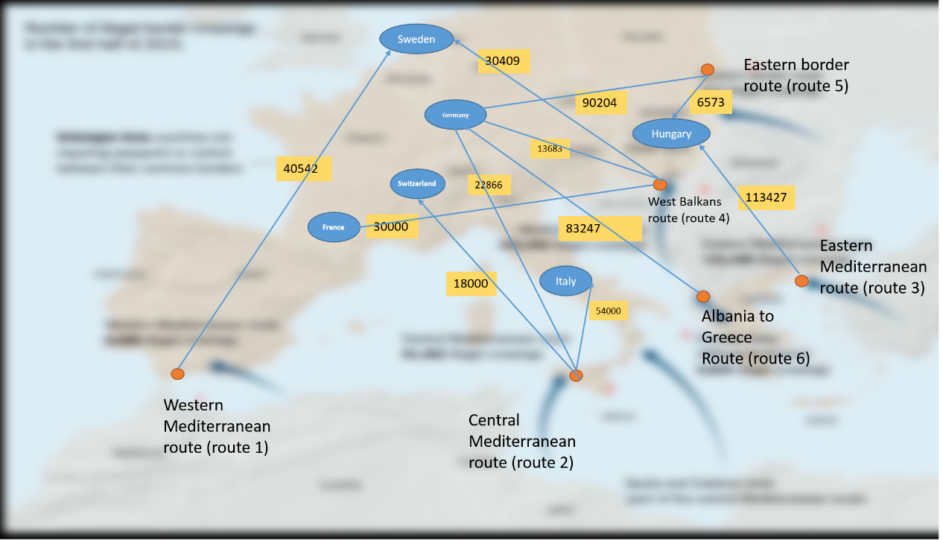

Figure 9. Solution for refugee distribution of each route and country

However, is it all we can do? The answer is definitely no! First we appeal to fewer wars or conflicts in both Europe and the Mideast. Reducing wars is a long term goal which needs collected effort by all of the world together. We seek for international coordination. Second, reducing the conflicts among the refugees can be achieved in a short term. Separating the refugees in terms of religion is recommended. Setting perimeters between the local residence and the refugees can also relieve the situation. More financial support and police patrol is highly desired.

# Exogenous events

As is highly likely to occur in these volatile environments and alter the situation parameters, exogenous events are also taken into consideration. In this case, we assume that exogenous events alter the situation parameters in two major aspects.

1. Deciding the routes

Exogenous events change the decision of routes in several factors.

* 1. Transportation

1. Blockade of certain areas (common routes of migration) would change the original route.
2. Natural disasters like seasonal tides and storms would exert a tremendous effect on seaway transportation.[3]
3. Landslides block hilly roads.
   1. Safety
4. Warfare and riots would cause danger at certain areas.
5. Natural disaster cause danger to refugees.
   1. Probability of asylum

This part affects the capacity of receiving countries indirectly.

1. Severe conflicts between religions
2. Change in asylum policy
   1. Distance

Exogenous events do not change the geographical distance.

* 1. Life insurance

1. Adverse weather and seasonal changes would reduce availability of food and exacerbate accommodation conditions.
2. Robbers in poor areas cause lack of food.
3. The capacity of receiving countries

The capacity of receiving countries depends on the policy and warfare (including riots) to a great extent.

**Model Testing**

To test the feasibility of our analysis, we take a simulation application to the Paris attack in November 2015. Similar to Model 1, we build 6 matrices.

Matrix A = .

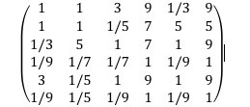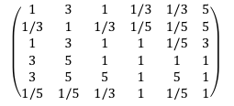

Matrix B2 = Matrix B3 =

Matrices B1, B4, B5 and B6 remain the same as in Model 1. Running MATLAB, the weight of each route is obtained and shown in Table 9.

Table 9. Weights of the routes

|  |  |  |  |  |  |
| --- | --- | --- | --- | --- | --- |
| West  Mediterranean | Central  Mediterranean | Eastern  Mediterranean | West  Balkans | Eastern  Borders | Albania to  Greece |
| 0.1216 | 0.2085 | 0.1761 | 0.1226 | 0.2961 | 0.0751 |

**Conclusion**

1. From the result above we find that the Paris attack causes the weights of route 1 and route 4 which lead to France to decrease, from 0.1496 and 0.1406 to 0.1216 and 0.1226, respectively. Also, the weight of route 3 declines from 0.1978 to 0.1761, for that the activity of ISIS has brought danger to the East Mediterranean area which changes the parameters of Matrix B2 and B3. Accordingly, the weights of the rest 2 routes increase, from 0.2038 to 0.2085 for route 2 and 0.2362 to 0.2961 for route 5. Thus, the model works in exogenous events.
2. The cascading effects on the movement of refugees in neighboring countries, according to our model, is that the country should be prepared to offer necessities including food and accommodation, in case that the refugee number exceeds the capacity of neighboring countries. Also, police should stand by in case of emergency.
3. Judging from the result above, in order to make our proposed policy to be resilient to these types of events, we’d like to appeal for more international cooperation and flexible convert. In exogenous events, the parameters that shift are Safety and Probability of asylum. The Distance does not change. Life insurance and transportation changes only under extreme and special conditions. Considering the case of Paris attack in 2015, the refugee capacity of France declined sharply changed distribution of the 6 route. In order to maintain the stability of the refugee situation, international cooperation on this case is imperative to some extent.

# Scalability

## Parameters in Model 1

When the scope of the crisis increases dramatically, the quantity of refugees is expanded by 10 times. Some features of Model 1 are not scalable to larger populations. We adjust Model 1 to make it practical for 10 times refugees, by changing some of its parameters. As a result, determination of routes changes.

1. **Transportation**

Seaway adds to its difficulty. Under this circumstance, we assume the order to be: seaway > hilly road > plain.

1. **Safety**

Seaway adds to its danger.

1. **Probability of Asylum**

The change in population of refugees causes changes in policy of receiving countries, border passing rate, which is complex, but still remains its significance.

1. **Distance**

Distance remains the same.

1. **Life insurance**

Lack of food would make the living condition more severe as people increase. Life insurance becomes more significant among the five factors.

Again, we build 6 matrices, as in Model 1.

Matrix A =

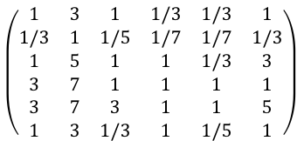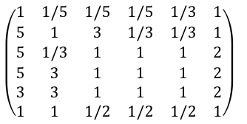

Matrix B1 = Matrix B2 =

In Matrix A, we add to the weight of B5 (Life Insurance), and thus the weight of Distance becomes the lowest.

In Matrix B1 and B2, we cut down the weight of route 1 and 2 (both containing long distance of seaway) in order to reflect the inconvenience and danger of seaway.

## Parameters in Model 2

According to the assumption of our Model 2, if the amount of refugee is greater than the capacity of European countries, European countries are supposed to expand the capacity or repatriate the refugees. Now we assume the European countries could handle the 10 times refugees. To demonstrate this fact better, we define a new parameter to indicate people’s living quality.

Where M is the refugee capacity of European countries, N is the real number of refugees.

We get the refugees’ happiness index from UNHCR, and we calculate the of the corresponding refugee’s country, we can conclude the Table 12 below:

Table 10. Relationship between refugee living quality and

|  |  |  |  |  |  |
| --- | --- | --- | --- | --- | --- |
| (%) | 100 | 95.23 | 83.72 | 75.21 | 61 |
| People’s living quality | Cozy | Normal | Endurable | Uncomfortable | Bad |

We can find that with the decrease of, refugees living quality drops. For the government deciders, they should determine the of this country and try to maintain a higher.

**Conclusion**

1. The analysis has shown that the increase of people changes the model in many factors. The priority of seaway in Transportation and Safety shifts. Distance becomes irrelevant comparing to other factors.
2. We add a new parameter to demonstrate people’s living quality and help manage the amount of refugees in case the situation becomes uncontrollable.
3. The introduction of guarantees that the time of replacement of refugees would be limited to a reasonable level. Otherwise, 10 times of refugees would have negative effects on local people’s life.
4. The problems occur mainly on two aspects. First, low quality life and long distance travel may cause disease to refugees which would be introduced to European countries.[6] Second, anxiety and worries of refugees and religion difference causes riots in receiving countries.
5. The time threshold works when reaches 60%, which depends on the specific population and capacity of each country. At this point, governments should take action to avoid the problems mentioned before.
6. New policies should be adopted. Hospitals should focus more on isolation and classification of diseases, as well as getting prepared for a baby boom.

# Strengths and Weaknesses

1. **Model 1**

Strength

Our model has its unique conceptual simplicity. The complex real situation is simplified into 5 parameters that rule out the disturbance of unimportant ones and make it a feasible and comprehensible model. The 5 parameters are the most typical and common factors. As our model is based on quantitative analysis and employ AHP algorithm, the process of result is both objective and efficient. The accuracy of our model is guaranteed by reference of canonical materials including papers, theses, publications and news from websites.

Weakness

Other relatively less important factors are not considered thus the complexity is ignored to some extent. The attributes of the refugee themselves are not taken into consideration, such as their age distribution, gender rate and wealth they possess. Some problems the European world is confronted with are beyond our ability.

1. **Model 2**

Strength

Attention is given to country`s capacity. As we only have to focus on one point, the problem becomes easier to handle with. Dividing the refugee arrangement into two synergic models makes this problem solved easily and precisely.

Weakness

As only one aspect of the situation is taken into consideration, the model may not be resilient to relatively extreme conditions.

1. **Model 3**

Strength

Similar to Model 2 but more consideration is paid. Capacity changes including both increase and decrease are studied. The result confirms our model quite adaptable and can be extended to a variety of situations.

Weakness

Simple as our model is, it is still a little premature. More matured investigation and definition will get a more accurate capacity and increase the precision of the model.

1. **Policy to support refugee model**

Strength

Our solution and policy is given by the consideration of our model, therefore it is both subjective and comprehensive. It can be applied to a variety of situation as long as we modify the parameters of the matrices.

Weakness

The policy does not consider the complex international tensions and may not work well under economy depression situation.

# Reference

1. Migrant crisis: Migration to Europe explained in graphics

http://www.bbc.com/news/world-europe-34131911

1. Mapping Mediterranean migration

http://www.bbc.com/news/world-europe-24521614

1. 6 charts and a map that show where Europe's refugees are coming from - and the perilous journeys they are taking

http://www.independent.co.uk/news/world/europe/refugee-crisis-six-charts-that-show-where-refugees-are-coming-from-where-they-are-going-and-how-they-10482415.html

1. Europe’s migrant acceptance rates

http://www.economist.com/blogs/graphicdetail/2015/09/daily-chart

1. This map shows the routes of Europe's refugee nightmare — and how it's getting worse

http://www.businessinsider.com/map-of-europe-refugee-crisis-2015-9

1. Migration and health: key issues

http://www.euro.who.int/en/health-topics/health-determinants/migration-and-health/migrant-health-in-the-european-region/migration-and-health-key-issues

1. Newland K. The governance of international migration: Mechanisms, processes, and institutions[J]. Global Governance: A Review of Multilateralism and International Organizations, 2010, 16(3): 331-343.
2. Collett E. The development of EU policy on immigration and asylum. Rethinking coordination and leadership[J]. Policy Brief Issue, 2015 (8).
3. Thielemann E R. Between Interests and Norms: Explaining Burden‐Sharing in the European Union [J]. Journal of Refugee Studies, 2003, 16(3): 253-273.
4. Steel Z, Momartin S, Silove D, et al. Corrigendum to “Two year psychosocial and mental health outcomes for refugees subjected to restrictive or supportive immigration policies”[Soc. Sci. Med. 72 (2011) 1149–1156][J]. Social Science & Medicine, 2015, 138: 101.
5. Newland K. The governance of international migration: Mechanisms, processes, and institutions [J]. Global Governance: A Review of Multilateralism and International Organizations, 2010, 16(3): 331-343.

**Report**

Dear UN Secretary General and Chief of Migration:

We are college students from China.

The refugee crisis in Europe is urgent and needs to be settled in a decent way. Millions of people from the Middle East are suffering from warfare and homelessness. Some European countries are receiving refugees currently. To help more people find home in Europe, we did research on the status quo in Europe from political, economic and geographical aspects. Using mathematical methods and computer programs, we built mathematical models to study the ideal allocation of asylum seekers, to several European countries. We sincerely hope our effort will ameliorate the refugee crisis.

We concluded our models and have made several suggestions. In the period of arranging refugees, we suggest that:

1. Governments act as leaders, caring about distributions of the asylum seekers. Our models estimate the amount of refugees for each country to receive. The governments should comply with the rules formulated by EU.
2. The mechanism of health care should be improved to adapt to the rising population. Classification and isolation of diseases should be prioritized in case that new diseases emerge.
3. Education system should be adjusted for different students from diverse religions and countries.
4. Public security needs to be strengthened. More police are needed to keep social order lest riots and conflicts between locals and refugees.
5. NGOs take the responsibility of managing the refugees. It contains duties such as community service and public health, including accommodation, environment protection, and charity etc.
6. The introduction of refugees, namely the rise of population causes social unrest. Social economy and capital market would suffer great impingement which places a greater demand on bankers and capitalists.

The refugee capacity of a country is the key to optimize the current situation and to measure the dynamics of the crisis. Our suggestions are that:

1. City planning should be upgraded to optimize the usage of land, making it possible to solve the accommodation problem for asylum seekers.
2. Accelerate the construction of newly built houses for refugees.
3. Education of local people should be adjusted so that the acceptance rate rises, which maximizes the capacity of refugees, on a social level.

The advice is from our rigorous analysis and modeling. We sincerely hope that our suggestion can be put into proper use and wise both European and Middle Eastern people all the best.

Yours,

Ouyang, Xiao, Yan

Feb 1, 2016