Default run

Mobile Net V4 Conv Medium

cspresnext50

Volo

Best cspresnext50

Aug

Def + RR 40

Def + vertical flip 0.5

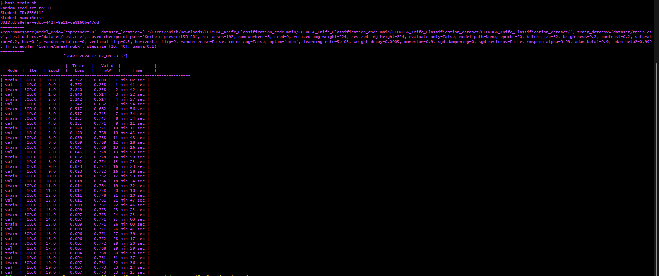

Def + horizontal flip 0.5

Def + RR 40 + horizontal flip 0.5 + vertical flip 0.5

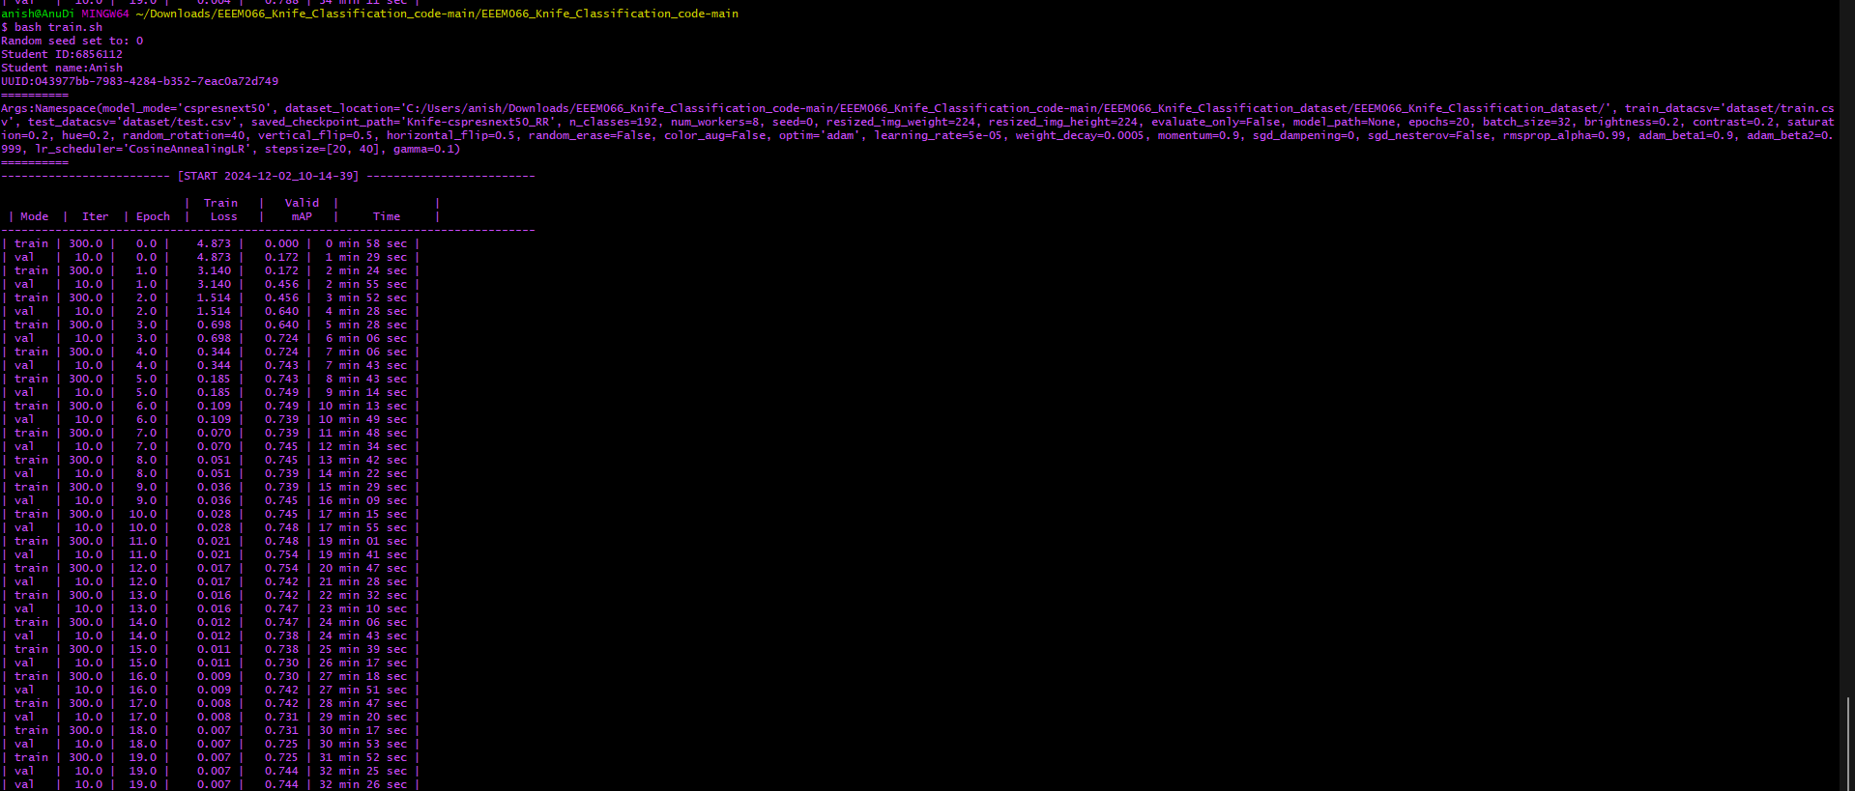

Def + horizontal flip 0.5 + vertical flip 0.5

Def + horizontal flip 0.5 + random erase

Def + horizontal flip 0.5 + color aug

Def + color aug

Def + horizontal flip 0.5 + vertical flip 0.5 + color aug

def + horizontal flip 0.4

