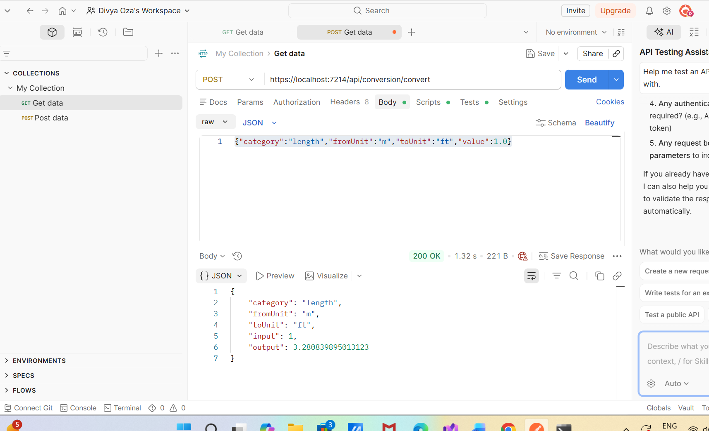

POST:
https://localhost:7214/api/conversion/convert
Authorization: No Auth
Body: Raw JSON
INPUT:
{"category":"length","fromUnit":"m","toUnit":"ft","value":1.0}
OUTPUT:
{
"category": "length",
"fromUnit": "m",
"toUnit": "ft",
"input": 1,
"output": 3.280839895013123
}

Temperature
{"category":"temperature","fromUnit":"c","toUnit":"f","value":100}
OUTPUT:
{
"category": "temperature",
"fromUnit": "c",
"toUnit": "f",
"input": 100,
"output": 211.99999999999994
}
____________________________________________
{"category":"temperature","fromUnit":"c","toUnit":"k","value":100}
OUTPUT:
{
"category": "temperature",
"fromUnit": "c",
"toUnit": "k",
"input": 100,
"output": 373.15
}
_________________________________________________________
WEIGHT
{"category":"weight","fromUnit":"g","toUnit":"kg","value":1000}
OUTPUT:
{
"category": "weight",
"fromUnit": "g",
"toUnit": "kg",
"input": 1000,
"output": 1
}

TEST CASE
