K-Means for Clustering

Osama Bin Zahir

2023-10-28

#Importing data

library(readr)  
Pharm = read.csv("C:\\Users\\Osama Zahir\\Downloads\\Pharm.csv")  
df= Pharm

#Viewing the summary of the dataset

summary(df)

## Symbol Name Market_Cap Beta   
## Length:21 Length:21 Min. : 0.41 Min. :0.1800   
## Class :character Class :character 1st Qu.: 6.30 1st Qu.:0.3500   
## Mode :character Mode :character Median : 48.19 Median :0.4600   
## Mean : 57.65 Mean :0.5257   
## 3rd Qu.: 73.84 3rd Qu.:0.6500   
## Max. :199.47 Max. :1.1100   
## PE_Ratio ROE ROA Asset_Turnover Leverage   
## Min. : 3.60 Min. : 3.9 Min. : 1.40 Min. :0.3 Min. :0.0000   
## 1st Qu.:18.90 1st Qu.:14.9 1st Qu.: 5.70 1st Qu.:0.6 1st Qu.:0.1600   
## Median :21.50 Median :22.6 Median :11.20 Median :0.6 Median :0.3400   
## Mean :25.46 Mean :25.8 Mean :10.51 Mean :0.7 Mean :0.5857   
## 3rd Qu.:27.90 3rd Qu.:31.0 3rd Qu.:15.00 3rd Qu.:0.9 3rd Qu.:0.6000   
## Max. :82.50 Max. :62.9 Max. :20.30 Max. :1.1 Max. :3.5100   
## Rev_Growth Net_Profit_Margin Median_Recommendation Location   
## Min. :-3.17 Min. : 2.6 Length:21 Length:21   
## 1st Qu.: 6.38 1st Qu.:11.2 Class :character Class :character   
## Median : 9.37 Median :16.1 Mode :character Mode :character   
## Mean :13.37 Mean :15.7   
## 3rd Qu.:21.87 3rd Qu.:21.1   
## Max. :34.21 Max. :25.5   
## Exchange   
## Length:21   
## Class :character   
## Mode :character   
##   
##   
##

#Attaching required libraries

library(tinytex)  
library(tidyverse)

## ── Attaching core tidyverse packages ──────────────────────── tidyverse 2.0.0 ──  
## ✔ dplyr 1.1.0 ✔ purrr 1.0.1  
## ✔ forcats 1.0.0 ✔ stringr 1.5.0  
## ✔ ggplot2 3.4.2 ✔ tibble 3.1.8  
## ✔ lubridate 1.9.2 ✔ tidyr 1.3.0  
## ── Conflicts ────────────────────────────────────────── tidyverse_conflicts() ──  
## ✖ dplyr::filter() masks stats::filter()  
## ✖ dplyr::lag() masks stats::lag()  
## ℹ Use the ]8;;http://conflicted.r-lib.org/conflicted package]8;; to force all conflicts to become errors

library(ISLR)  
library(flexclust)

## Loading required package: grid  
## Loading required package: lattice  
## Loading required package: modeltools  
## Loading required package: stats4

library(FactoMineR)  
library(ggcorrplot)  
library(ggplot2)  
library(factoextra)

## Welcome! Want to learn more? See two factoextra-related books at https://goo.gl/ve3WBa

## Question A: Use only the numerical variables (1 to 9) to cluster the 21 firms. Justify the various choices made in conducting the cluster analysis, such as weights for different variables, the specific clustering algorithm(s) used, the number of clusters formed, and so on.

#Subsetting the data

names(df)

## [1] "Symbol" "Name" "Market_Cap"   
## [4] "Beta" "PE_Ratio" "ROE"   
## [7] "ROA" "Asset_Turnover" "Leverage"   
## [10] "Rev_Growth" "Net_Profit_Margin" "Median_Recommendation"  
## [13] "Location" "Exchange"

dataset=df[,c(1,3:11)]  
row.names(dataset)=dataset[,1]  
dataset=dataset[,-1]  
head(dataset)

## Market_Cap Beta PE_Ratio ROE ROA Asset_Turnover Leverage Rev_Growth  
## ABT 68.44 0.32 24.7 26.4 11.8 0.7 0.42 7.54  
## AGN 7.58 0.41 82.5 12.9 5.5 0.9 0.60 9.16  
## AHM 6.30 0.46 20.7 14.9 7.8 0.9 0.27 7.05  
## AZN 67.63 0.52 21.5 27.4 15.4 0.9 0.00 15.00  
## AVE 47.16 0.32 20.1 21.8 7.5 0.6 0.34 26.81  
## BAY 16.90 1.11 27.9 3.9 1.4 0.6 0.00 -3.17  
## Net_Profit_Margin  
## ABT 16.1  
## AGN 5.5  
## AHM 11.2  
## AZN 18.0  
## AVE 12.9  
## BAY 2.6

#Normalizing the dataset

dataset2 = scale(dataset)  
distance=get_dist(dataset)  
fviz_dist(distance)

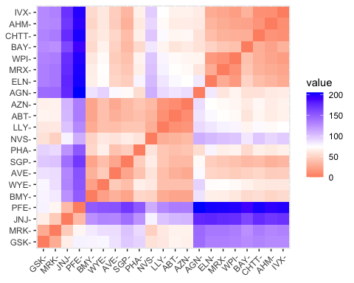

#Using euclidean distance formula which is given by: d=√((x_2-x)1)^2+(y_2-y_1 )^2 )

Corr=cor(dataset2)  
ggcorrplot(Corr,outline.color = "black",lab = TRUE,hc.order = TRUE,type = "full")

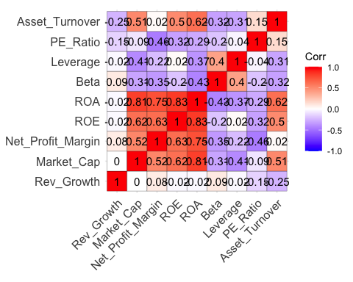

#Installing factoextra and cluster to plot elbow chart and silhouette chart

library(cluster)  
library(factoextra)

#Finding the number of clusters using elbow chart

set.seed(100)  
fviz_nbclust(dataset2, kmeans, method = "wss")

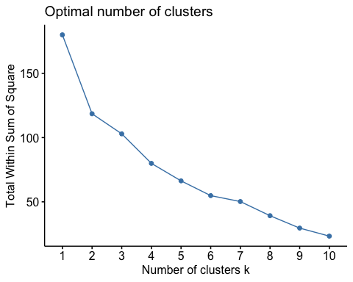

#After looking at the elbow chart, it shows that the optimal number of clusters is 2 or 7 #Finding the number of clusters using silhouette method

fviz_nbclust(dataset2,kmeans,method = "silhouette")

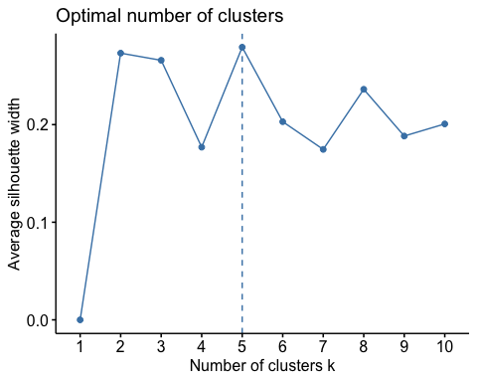

#After looking at the elbow chart, it shows that the optimal number of clusters is 5. Therefore, we will try and find an optimal value between 2 and 7 per the results gathered from elbow and silhouette method respectively

k2<-kmeans(dataset2,centers =2,nstart=25)  
k3<-kmeans(dataset2,centers =3,nstart=25)  
k4<-kmeans(dataset2,centers =4,nstart=25)  
k5<-kmeans(dataset2,centers =5,nstart=25)  
k6<-kmeans(dataset2,centers =6,nstart=25)  
k7<-kmeans(dataset2,centers =7,nstart=25)  
p1<-fviz_cluster(k2,geom = "point", data=dataset2)+ggtitle("k=2")  
p2<-fviz_cluster(k3,geom = "point", data=dataset2)+ggtitle("k=3")  
p3<-fviz_cluster(k4,geom = "point", data=dataset2)+ggtitle("k=4")  
p4<-fviz_cluster(k5,geom = "point", data=dataset2)+ggtitle("k=5")  
p5<-fviz_cluster(k6,geom = "point", data=dataset2)+ggtitle("k=6")  
p6<-fviz_cluster(k7,geom = "point", data=dataset2)+ggtitle("k=7")

#Attaching library gridExtra to combine the clusters

library(gridExtra)

##   
## Attaching package: 'gridExtra'

## The following object is masked from 'package:dplyr':  
##   
## combine

grid.arrange(p1,p2,p3,p4,p5,p6)

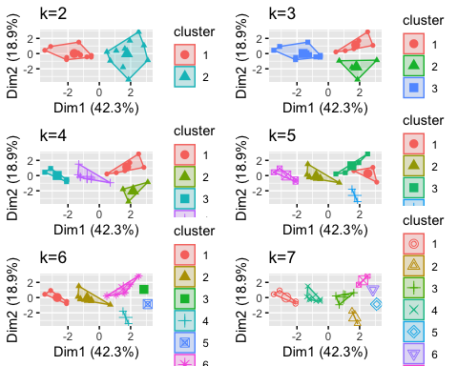

#The optimal number of clusters was determined using both the elbow method and the silhouette method. The elbow method suggested K=2 or K=7, while the silhouette method pointed to K=5 as a balanced choice. The final selection of K=5 was based on achieving a reasonable trade-off between granularity and meaningful differentiation within the dataset.

#No specific weights were assigned to individual variables. Instead, the dataset was normalized using the scale function to ensure that all variables contributed equally to the clustering process. Normalization was applied to center variables around a mean of 0 and a standard deviation of 1, thereby preventing any undue influence of one variable over another.

## Question B: Interpret the clusters with respect to the numerical variables used in forming the clusters.

# after reviewing the clusters, K = 5 seems appropriate as per the grouping.

#using K=5 for the analysis

k5=kmeans(dataset2, centers = 5, nstart = 25)  
k5$size

## [1] 3 8 2 4 4

k5$cluster

## ABT AGN AHM AZN AVE BAY BMY CHTT ELN LLY GSK IVX JNJ MRX MRK NVS   
## 2 3 2 2 4 1 2 1 4 2 5 1 5 4 5 2   
## PFE PHA SGP WPI WYE   
## 5 3 2 4 2

k5$centers

## Market_Cap Beta PE_Ratio ROE ROA Asset_Turnover  
## 1 -0.87051511 1.3409869 -0.05284434 -0.6184015 -1.1928478 -0.4612656  
## 2 -0.03142211 -0.4360989 -0.31724852 0.1950459 0.4083915 0.1729746  
## 3 -0.43925134 -0.4701800 2.70002464 -0.8349525 -0.9234951 0.2306328  
## 4 -0.76022489 0.2796041 -0.47742380 -0.7438022 -0.8107428 -1.2684804  
## 5 1.69558112 -0.1780563 -0.19845823 1.2349879 1.3503431 1.1531640  
## Leverage Rev_Growth Net_Profit_Margin  
## 1 1.36644699 -0.6912914 -1.320000179  
## 2 -0.27449312 -0.7041516 0.556954446  
## 3 -0.14170336 -0.1168459 -1.416514761  
## 4 0.06308085 1.5180158 -0.006893899  
## 5 -0.46807818 0.4671788 0.591242521

k5$withinss

## [1] 15.595925 21.879320 2.803505 12.791257 9.284424

fviz_cluster(k5, data = dataset2)

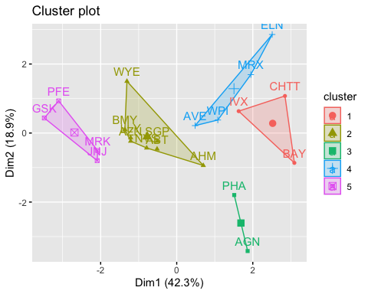

#Interpretation of the clusters #The entire data is divided into 5 different clusters: Cluster #5 have the 4 companies and their net profit margin is high as well as their asset turnover making them a credible institutions. On the other hand, cluster #1 has 3 companies and their net profit margin is -1.32 as they are more dependent on levraging (1.36) and less on equities (-0.61)

#Plotting graphs of data grouped in clusters

Centroid <- data.frame(k5$centers) %>% rowid_to_column() %>% gather('Columns', 'Centers', -1)  
print(Centroid)

## rowid Columns Centers  
## 1 1 Market_Cap -0.870515113  
## 2 2 Market_Cap -0.031422109  
## 3 3 Market_Cap -0.439251341  
## 4 4 Market_Cap -0.760224892  
## 5 5 Market_Cap 1.695581115  
## 6 1 Beta 1.340986857  
## 7 2 Beta -0.436098941  
## 8 3 Beta -0.470180039  
## 9 4 Beta 0.279604106  
## 10 5 Beta -0.178056346  
## 11 1 PE_Ratio -0.052844340  
## 12 2 PE_Ratio -0.317248516  
## 13 3 PE_Ratio 2.700024643  
## 14 4 PE_Ratio -0.477423799  
## 15 5 PE_Ratio -0.198458234  
## 16 1 ROE -0.618401510  
## 17 2 ROE 0.195045857  
## 18 3 ROE -0.834952524  
## 19 4 ROE -0.743802224  
## 20 5 ROE 1.234987906  
## 21 1 ROA -1.192847826  
## 22 2 ROA 0.408391543  
## 23 3 ROA -0.923495091  
## 24 4 ROA -0.810742783  
## 25 5 ROA 1.350343113  
## 26 1 Asset_Turnover -0.461265604  
## 27 2 Asset_Turnover 0.172974602  
## 28 3 Asset_Turnover 0.230632802  
## 29 4 Asset_Turnover -1.268480411  
## 30 5 Asset_Turnover 1.153164010  
## 31 1 Leverage 1.366446992  
## 32 2 Leverage -0.274493115  
## 33 3 Leverage -0.141703357  
## 34 4 Leverage 0.063080849  
## 35 5 Leverage -0.468078185  
## 36 1 Rev_Growth -0.691291399  
## 37 2 Rev_Growth -0.704151557  
## 38 3 Rev_Growth -0.116845875  
## 39 4 Rev_Growth 1.518015830  
## 40 5 Rev_Growth 0.467178770  
## 41 1 Net_Profit_Margin -1.320000179  
## 42 2 Net_Profit_Margin 0.556954446  
## 43 3 Net_Profit_Margin -1.416514761  
## 44 4 Net_Profit_Margin -0.006893899  
## 45 5 Net_Profit_Margin 0.591242521

ggplot(Centroid, aes(x = Columns, y = Centers, color = as.factor(rowid))) + geom_line(aes(group = as.factor(rowid))) + geom_point()

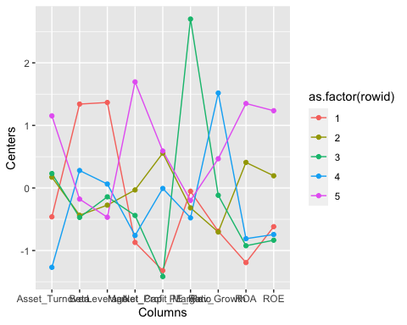

# Question C: Is there a pattern in the clusters with respect to the numerical variables (10 to 12)?

#Considering the last three variables; median_recommendation, location, and exchange

pattern <- df%>% select(c(12,13,14)) %>% mutate(Cluster = k5$cluster)  
print(pattern)

## Median_Recommendation Location Exchange Cluster  
## 1 Moderate Buy US NYSE 2  
## 2 Moderate Buy CANADA NYSE 3  
## 3 Strong Buy UK NYSE 2  
## 4 Moderate Sell UK NYSE 2  
## 5 Moderate Buy FRANCE NYSE 4  
## 6 Hold GERMANY NYSE 1  
## 7 Moderate Sell US NYSE 2  
## 8 Moderate Buy US NASDAQ 1  
## 9 Moderate Sell IRELAND NYSE 4  
## 10 Hold US NYSE 2  
## 11 Hold UK NYSE 5  
## 12 Hold US AMEX 1  
## 13 Moderate Buy US NYSE 5  
## 14 Moderate Buy US NYSE 4  
## 15 Hold US NYSE 5  
## 16 Hold SWITZERLAND NYSE 2  
## 17 Moderate Buy US NYSE 5  
## 18 Hold US NYSE 3  
## 19 Hold US NYSE 2  
## 20 Moderate Sell US NYSE 4  
## 21 Hold US NYSE 2

#identifying if there are any trends

Median_Recommenation <- ggplot(pattern, mapping = aes(factor(Cluster), fill=Median_Recommendation)) + geom_bar(position = 'dodge') + labs(x='Clusters', y='Frequence')  
Location <- ggplot(pattern, mapping = aes(factor(Cluster), fill=Location)) + geom_bar(position = 'dodge') + labs(x='Clusters', y='Frequence')  
Exchange <- ggplot(pattern, mapping = aes(factor(Cluster), fill=Exchange)) + geom_bar(position = 'dodge') + labs(x='Clusters', y='Frequence')  
grid.arrange(Median_Recommenation,Location,Exchange)

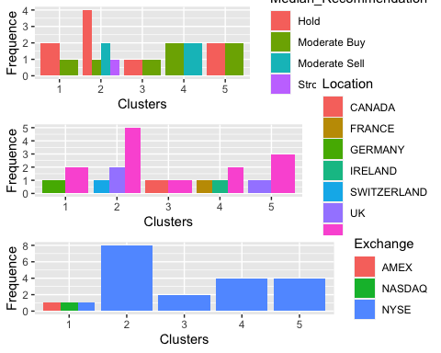

#A discernible pattern is observed in the clusters concerning numerical variables (10 to 12):  
  
# Median_Recommendation: Clusters 2 and 3 primarily consist of companies with "Moderate Buy" and "Strong Buy" recommendations, suggesting growth potential. Cluster 5 predominantly comprises companies with "Hold" recommendations, indicating stability and profitability.  
  
# Location: Cluster 1 primarily consists of companies from the US, listed on various exchanges. Cluster 2 includes companies from the US, UK, and Switzerland, all listed on NYSE, indicating moderate risk and potential growth. Cluster 3 includes companies from Canada and the US, listed on NYSE, reflecting some growth potential. Cluster 4 contains companies from France, Germany, and the US investing in NYSE, indicating the highest risk. Cluster 5 comprises companies from the US and the UK listed on NYSE, representing stable and profitable companies.  
  
# Exchange: All clusters are predominantly associated with companies listed on NYSE, indicating its significance in the dataset. Variations in exchanges occur primarily within each cluster, suggesting that the location variable plays a more influential role in determining clusters.

# Question D: Provide an appropriate name for each cluster using any or all of the variables in the dataset.

# Cluster 1: "Well-Ordered Companies" - Comprising low-risk companies with stable financial performance, characterized by a significant portion of market capitalization in assets.  
  
# Cluster 2: "Growth Potential Companies" - Representing companies with growth potential and moderate risk, indicated by substantial market capitalization and reasonable financial performance.  
  
# Cluster 3: "High-Risk Growth Companies" - This cluster includes companies with significant growth potential but a higher level of risk.  
  
# Cluster 4: "Risk-Taking Companies" - Comprising companies willing to take risks for potential growth, characterized by higher asset turnover and associated risk.  
  
# Cluster 5: "Stable and Profitable Companies" - These companies demonstrate stability, profitability, and a lower level of risk.  
  
# These cluster names are derived from a combination of financial characteristics and recommendations, providing an appropriate description of their attributes.