Kathmandu University

Dhulikhel, Kavre


A Project Report

on

“Fixed Point Iteration”

[Code No.: MCSC 202]

Submitted by

Raghav Sitaula (57)

BSc. Computer Science

Submitted to

Khim Bahadur Khattri

September 17 , 2023

1. Introduction

1.1 Background

The fixed point iteration method in numerical analysis is used to find an approx-imate solution to algebraic and transcendental equations(like exponentials, loga-rithms, trigonometric functions or others.). Sometimes, it becomes very tedious to find solutions to cubic, bi-quadratic and transcendental equations; then, we can apply specific numerical methods to find the solution.

Fixed points are significant because they provide insight into stability, con-vergence, and equilibrium in various mathematical and computational contexts. Whether in iterative algorithms, differential equations, or optimization problems, understanding fixed points helps researchers and practitioners analyze and solve a wide range of problems across diverse fields, from physics and engineering to eco-nomics and computer science.

1.2 Objectives

The objectives of this mini project are:

- To implement the Fixed-Point Iteration algorithm using MATLAB or any other programming language.

- To understand the theoretical concepts and mathematical principles behind the method.

- To analyze the convergence behavior and efficiency of the algorithm through practical examples.

- To know the advantages and limitations of Fixed-Point Iteration as a numeri-cal technique.

1

2. Theory

2.1 Fixed-Point Iteration Method

Suppose we have an equation f(x) = 0, for which we have to find the solution. The equation can be expressed as x = g(x).Choose g(x) such that |g′(x₀)| < 1 at x = x_{o} where x_{o} is some initial guess called fixed point iterative scheme. Then the iterative method is applied by successive approximations given by x_{n} = g(x_{n−1} ), that is, x₁
- g(x₀), x₂ = g(x₁) and so on.

g′(x)=ϕ′(x)

Consider the following cases for ϕ′(x)
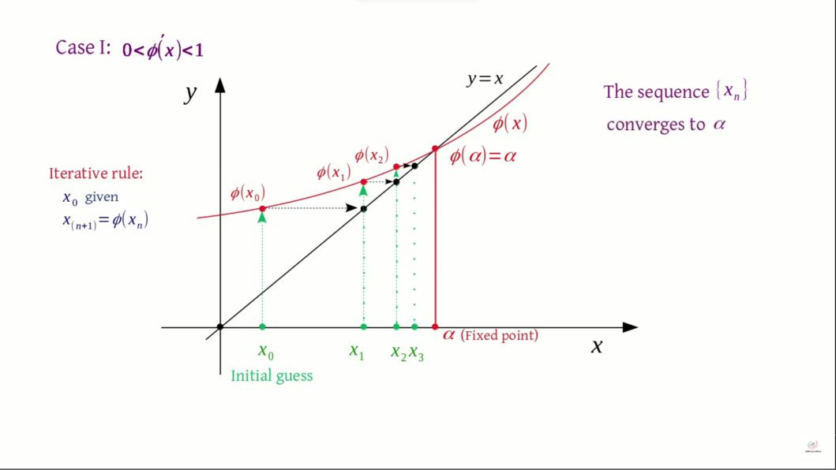

Fig 1 (a) :When 0 <ϕ′(x)< 1

2

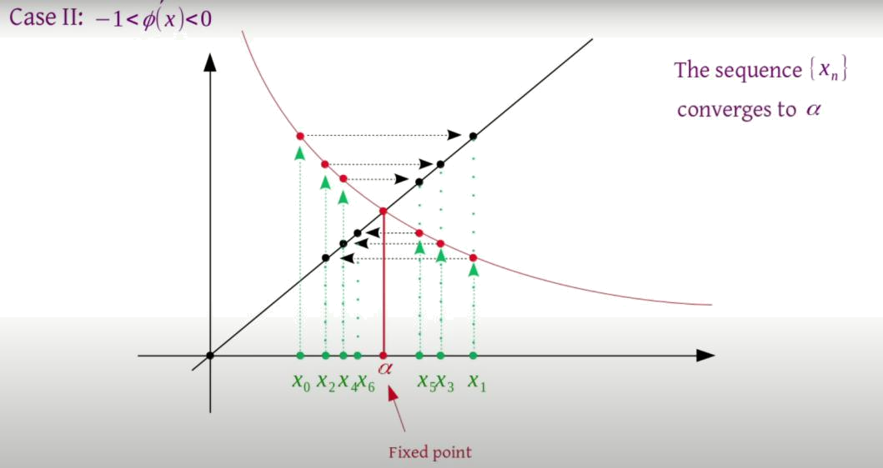

Fig 1 (b) :When −1 <ϕ′(x)< 1
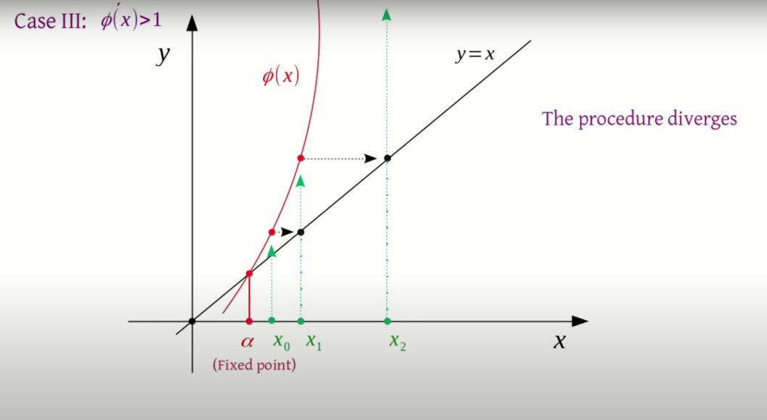

Fig 1 (c) :When ϕ′(x)> 1

3

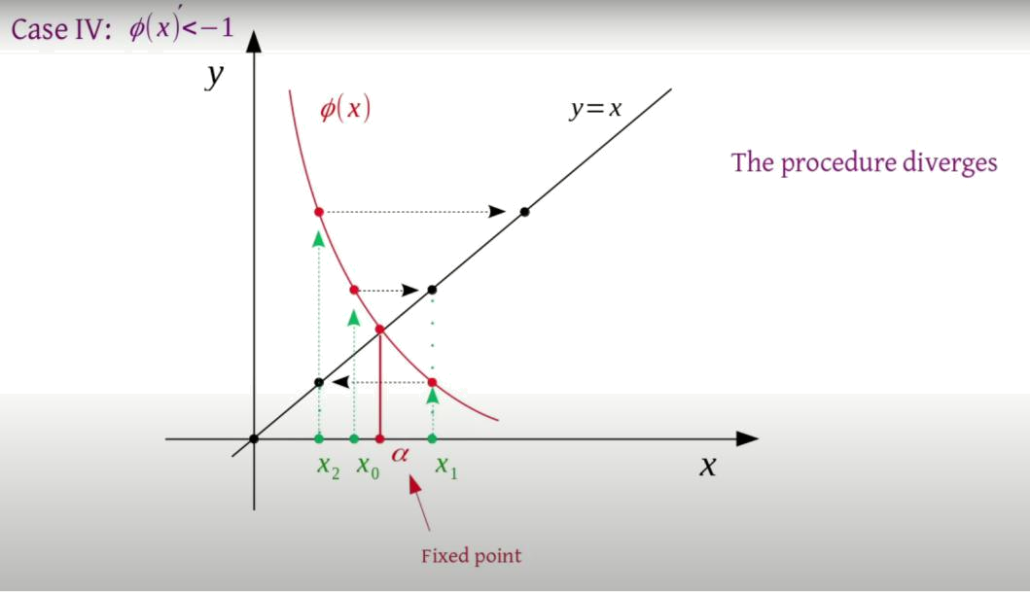

Fig 1 (d) :When ϕ′(x)< −1

Thus,we can conclude that,if |ϕ′(x₀)| < 1 then the procedure converges else the procedure diverges.

2.2 Important Notes

Some important notes about the fixed point iteration method are

- The form of x = g(x) can be chosen in many ways. But we choose g(x) for which |g′(x)| < 1 at x = x_{o}.

- By the fixed-point iteration method, we get a sequence of x_{n}, which converges to the root of the given equation.

- Lower the value of g′(x), fewer the iterations are required to get the approxi-mate solution.

- The rate of convergence is more if the value of g′(x) is smaller.

- The method is useful for finding the real roots of the equation, which is the form of an infinite series.

- The type of convergence seen is linear.

4

 | 3. | Implementation in MATLAB
 | 3.1 | MATLAB Code
1 | syms x;
2 | close all
3 | disp(’Put @ (x) before writing a function’)
4 | f=input(’Enter a function f(x) : ’);
5 | g=input(’Enter a function g(x) : ’);
6
7 | for j=0:10
8

- if (f(j)>0 && f(j+1)<0 ) || (f(j)<0 && f(j+1)>0)

10
11 | if f(j)==Inf || f(j+1)==Inf
12 | continue
13 | end
14 | p=j;
15 | q=j+1;
16 | break;
17

- end

19

- end

21

22 disp("Root lies between : ")

- A=sprintf("[%d,%d]",p,q);

- disp(A);

25
26 | n=input (’Enter no. of iterations : ’);
27 | x0=input (’Enter Your initial guess : ’);
28 | e=input(’Enter Tolerance : ’);
29
30 | row=sprintf(’Iterations | X | Error’);

- disp(row);

- for i=1:n

5

- DF=diff(g,x);

- values=subs(DF,x0);

35

- if (abs(values))>1

- errordlg("Iterative method is not convergent")

- return

- end

40

- x1=g(x0);

42 | print=sprintf(’%3d | %11.10f | %11.10f’,
 | i,x1,abs(x1-x0));

- disp(print);

44

- if abs(x1-x0)<e

- disp(’The Root of the equation is’)

- z=sprintf(’%.10f’,x1);

- disp(z);

49

- break;

- end

- x0=x1;

53

- end

55

56 Y=@(x) x;

57

58 hold on

- fplot(g,[p,q],’b-’,’LineWidth’,2)

- fplot(Y ,[p,q],’r-’,’LineWidth’,2)

- title(’Fixed Point Iteration Converging’)

62

63 hold on

- plot(x0,g(x0),’ko’)

- legend(’g(x)’,’y=x’)

- hold off

6

3.2 Overview of MATLAB Code

The above code is interactive and requests input from the user for both the functions f(x) and g(x), along with several parameters essential for the root-finding process. Given below is a summary of the above code :

- The program initiates by prompting the user to input the functions f(x) and g(x).

- It proceeds to execute a loop, systematically identifying an interval within which the function f(x) undergoes a change in sign. This alteration suggests the potential presence of a root within that interval.

- The user is further prompted to provide key parameters, including the number of iterations, an initial guess, and a tolerance level. These parameters play a crucial role in governing the root-finding process.

- The program runs the Fixed-Point Iteration method, continually estimating the root based on the function g(x). This iterative process runs until it meets either the predefined iteration limit or the specified tolerance condition.

- The program exhibits the results in the form of a table, displaying essential information such as iteration count, the current estimate, and the associated error.

- When the error is below the tolerance, the program concludes by displaying the estimated root.

- Additionally, the program features a graphical representation, plotting the functions g(x) and y = x within the identified interval. It also marks the points where convergence occurs.

It is essential to note that this program assumes the functions provided by the user are valid to the requirements of the Fixed-Point Iteration method and possess convergence properties.

7

Example Problems:
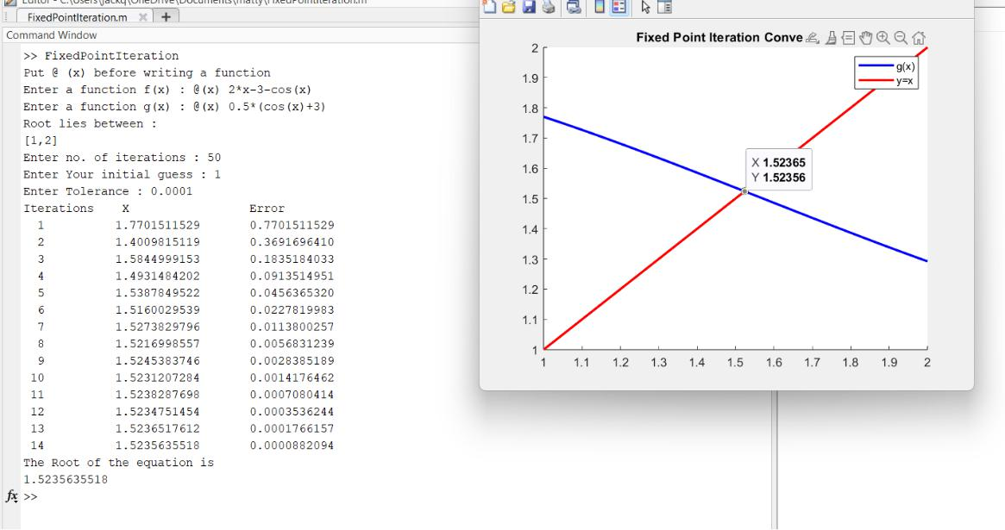

Fig 2:Solution of f(x) = 2x − 3 − cos(x)
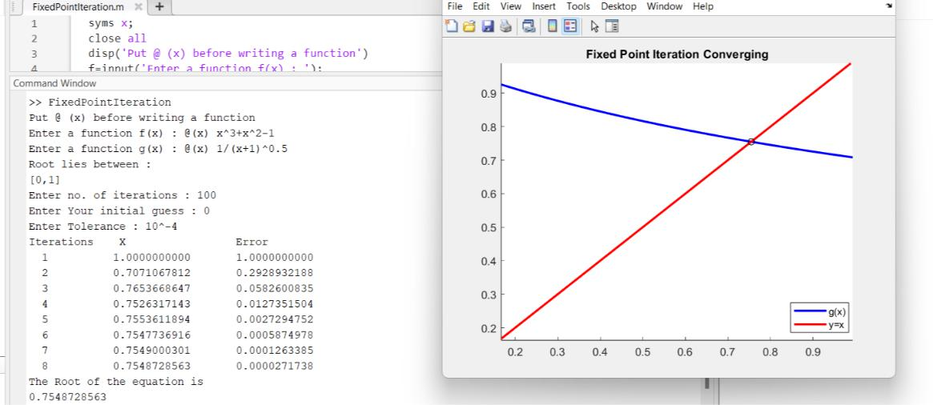

Fig 3:Solution of f(x)=x³ + x² − 1

8

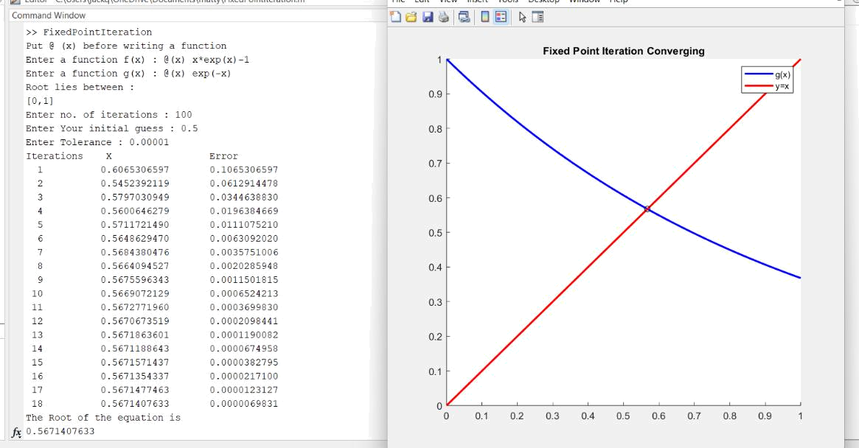

Fig 4:Solution of f(x) = xe^{x} − 1
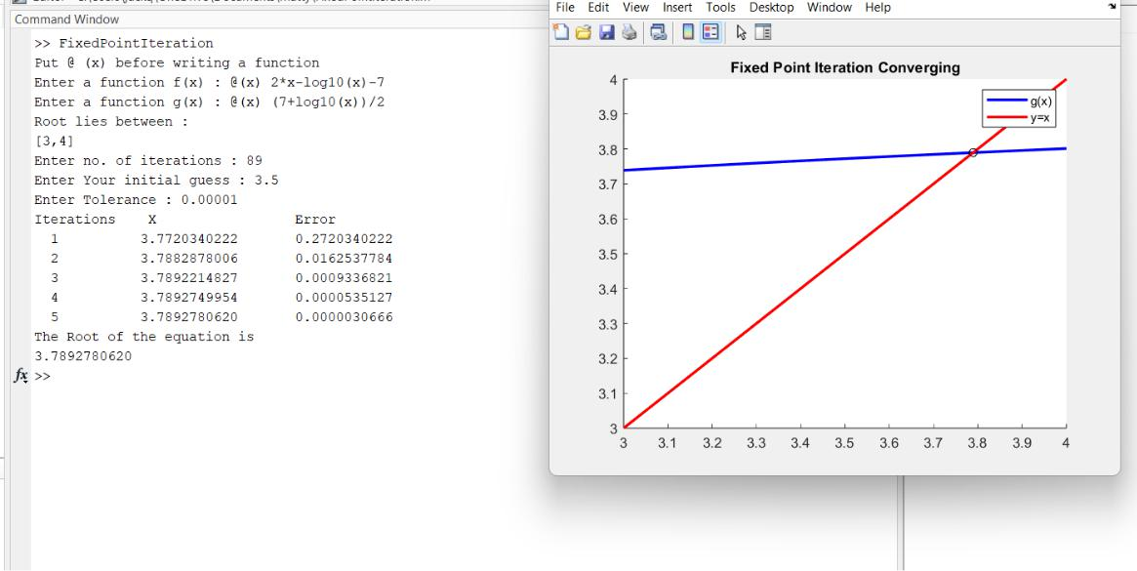

Fig 5:Solution of f(x) = 2x − log₁₀(x) − 7

9

4. Advantages and Disadvantages

4.1 Advantages of Fixed Point Iteration Method

- Fixed-Point Iteration is easy to understand and implement, making it accessi-ble for solving various mathematical problems.

- It can be applied to a wide range of problems, including algebraic equations, transcendental equations.

- The accuracy of the result is dependable.

4.2 Disadvantages of Fixed Point Iteration Method

- Success relies heavily on choosing an appropriate iterative function g(x) and initial guess. Ensuring convergence can be challenging.

- Fixed-Point Iteration can converge slowly.

- The choice of the initial guess is critical. An incorrect initial guess may result in divergence or slow convergence.

- The method often converges locally, meaning it may find different solutions depending on the initial guess.

10

5. Conclusion

The Fixed-Point Iteration algorithm is a valuable numerical technique for approxi-mating solutions to equations and finding fixed points of functions.The accuracy and efficiency of the algorithm was compared with known solutions or other numerical methods. It is widely used in mathematics, physics, engineering, economics, and various other fields.

11

