**BIL105E**

Introduction to Scientific and Engineering Computing

2010 Spring

**Report of Homework 1**

Date of Submission : 11.03 2010

Student Name : Ozan Arkan Can

Student Number : 040090573

Instructor : Yasar Erenler

## CRN: 20959

**1-Introduction**

The purpose of this homework is to develop a C program to determine the arrangement status of two lines. The program should read the coefficients (A1, B1, C1, A2, B2, C2).

The general equation for a straight line in the cartesian coordinate is Ax+By+C=0.

The arrangement status of two lines can be one of the followings:

• The two lines **“intersect”** with α angle.

• The two lines are **“perpendicular”** with 90 degrees.

• The two lines **“coincide**”. (They lie on the same straight line.)

• The two lines are **“parallel”**.

**2-Development and Operating Environments**

**MS Windows**

The Dev-C++ environment has been used to write the source code, compile and run

the program.

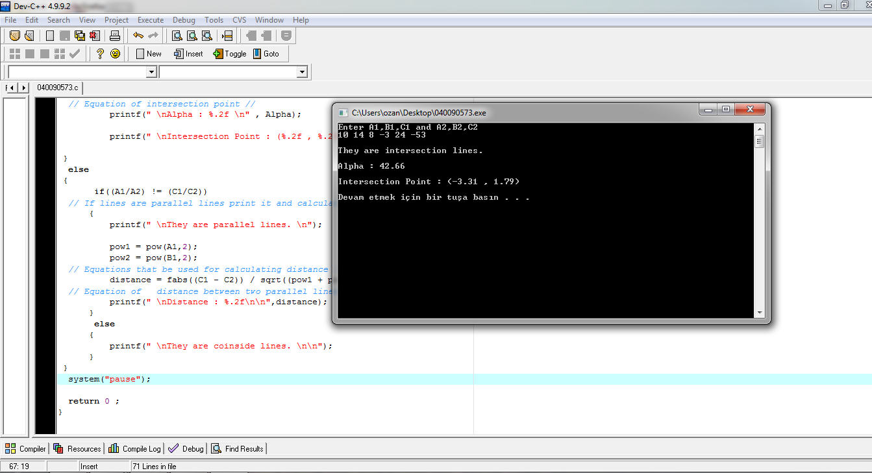

**Unix**

The source code has been also copied to Unix, then compiled and tested with the

GNU C Compiler. The following is the commands used:

To compile : gcc –lm 040090573.c –o 040090573.exe

To run : ./040090573.exe

**3-Data Structures and Variables**

No data structures were used in this program. The followings are the variables and

their initial values:

float A1,B1,C1,A2,B2,C2; // Values of coefficients.

float slope, Alpha ; // Angle between two intersection lines

float xzero, yzero ; // Intersection point

float distance, pow1, pow2 ; // Distance between two parallel lines

**4-Program Flow**



**5-Conclusion**

In this homework, I have learned the followings :

 In this homework , I have learned how to draw a Flowchart with Microsoft Visio and paste it to my report ( MS Word document)

 I have learned to use if … else selection statement.

 I have learned to use the following mathematical functions, which are defined

in the <math.h> header file.

atan(x) “ Arc tangent of x “

fabs(x) " Absolute value of x “

sqrt(x) " Square root of x “

− I have learned how to edit and run the C program both in Windows and Unix environments.