**BIL105E**

Introduction to Scientific and Engineering Computing

2010 Spring

**Report of Homework 2**

Date of Submission : 01.04. 2010

Student Name : Ozan Arkan Can

Student Number : 040090573

Instructor : Yasar Erenler

## CRN: 20959

**1-Introduction**

The purpose of this homework is to develop a C program that reads in a sequence of

several circles from standard input (KEYBOARD), then does the followings:

1) Find the circle that **intersects** with the most other circles, and print to standard output

(SCREEN) the circle info and the number of circles that it intersects. If there is no

intersection, then program prints “There is no intersection” message.

2) Find the circle that **contains** the most other circles, and print to standard output

(SCREEN) the circle info and the number of circles that it contains. If there is no

containment, then program prints “There is no containment” message.

i) A circle is specified in the coordinate system by its center (x , y) and its radiusr.

ii) Circle *i* intersects circle *j* if the Euclidean distance between their centers is less than or equal to the sum of their radii.

iii) Circle *i* contains circle *j* if the Euclidean distance between their centers is less than or equal to the radius of circle *i* minus the radius of circle *j*.

**2-Development and Operating Environments**

**MS Windows**

The Dev-C++ environment has been used to write the source code, compile and run

the program.

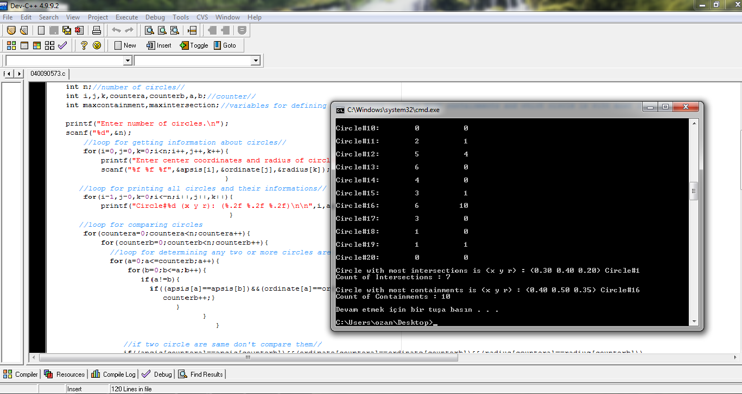

**Unix**

The source code has been also copied to Unix, then compiled and tested with the

GNU C Compiler. The following is the commands used:

To compile : gcc –lm 040090573.c –o 040090573.exe

To run : ./040090573.exe

**3-Data Structures and Variables**

No data structures were used in this program. The followings are the variables and

their initial values:

float radius[MAX],apsis[MAX],ordinate[MAX]; //arrays of circles' center coordinates and radius.

int containment[MAX]={0}; //counter of containment for every circle.

int intersection[MAX]={0}; //counter of intersection for every circle.

int n;//number of circles.

int i, j, k, countera, counterb, a, b; //counter.

int maxcontainment, maxintersection; //variables for defining which circle is with most containments and which circle is with most intersection

maxintersection=0;//assign zero for first value of max intersection.

maxcontainment=0;//assign zero for first value of max containment.

**4-Program Flow**







**5-Conclusion**

 In this homework , I have learned how to draw a Flowchart with Microsoft Visio and paste it to my report ( MS Word document)

 I have learned to use if … else selection statement.

 I have learned to use for repetition statement.

− I have learned to use arrays.

 I have learned to how find the greatest element of an array.

 I have learned to use the following mathematical functions, which are defined

in the <math.h> header file.

fabs(x) " Absolute value of x “

sqrt(x) " Square root of x “