**BIL105E**

Introduction to Scientific and Engineering Computing

2010 Spring

**Report of Homework 3**

Date of Submission : 22.04. 2010

Student Name : Ozan Arkan Can

Student Number : 040090573

Instructor : Yasar Erenler

## CRN: 20959

**1-Introduction**

The purpose of this homework is to develop a **C program** that reads the followings for each student from standard input (KEYBOARD). Number of student records is arbitrary, so in order to signal the end of input, the value (-1) for Student Number will be used as a sentinel data.

The following inputs for students will be entered to the program. Each value will be separated

by a blank space.

• Student number

• First name

• Last name

• Midterm exam result

• Final exam result

• Homework1 result

• Homework2 result

Grade of a student should be calculated as the sum of followings:

• Final (%40)

• Midterm (%25)

• HW1 (%15)

• HW2 (%20)

The corresponding grade Letter for a student should be determined such that;

If Grade ≥ m + 1.5σ letter is AA.

If m + 1.0σ ≤ Grade < m + 1.5σ letter is BA.

If m + 0.5σ ≤ Grade < m + 1.0σ letter is BB.

If m ≤ Grade < m + 0.5σ letter is CB.

If m - 0.5σ ≤ Grade < m letter is CC.

If m - 1.0σ ≤ Grade < m - 0.5σ letter is DC.

If m – 1.5σ ≤ Grade < m - 1.0σ letter is DD.

If Grade < m – 1.5σ letter is FF.

If Midterm=Final=HW1=HW2=0 letter is VF.

Mean is calculated by dividing sum of grades to number of students.

Standart deviation is calculating by square root of sum of square of difference between grades and mean.

**2-Development and Operating Environments**

**MS Windows**

The Dev-C++ environment has been used to write the source code, compile and run the program.

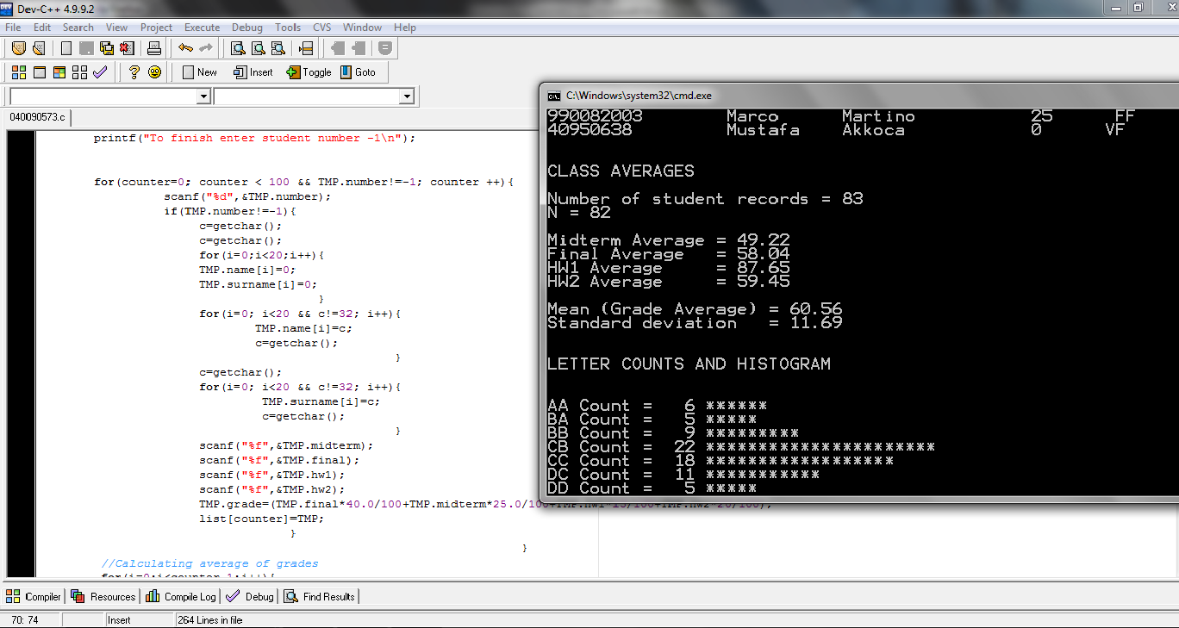

**Unix**

The source code has been also copied to Unix, then compiled and tested with the GNU C Compiler. The following is the commands used:

To compile : gcc –lm 040090573.c –o 040090573.exe

To run : ./040090573.exe

**3-Data Structures and Variables**

Struct s was used in this program and it was used for keeping number,name ,surname,midterm result, final result,homework1 result and homework2 result of a student. The followings are the variables and their initial values:

Int number; //number of a student

Char name[20]; //an array for a student’s name

Char surname[20]; // an array for o student’s surname

Float midterm,final,hw1,hw2;// Exams and homeworks results of a student.

Student list[100];//array of student list and number of maximum element is 100

Int i,j;//counter

Int counter;//number of students number

Char c;//variable for getting name and surname

Int pass;// counter of bubble sorting

Int holdgrade;//Temporary variable for grade during sorting

Int holdnumber;//Temporary variable for number during sorting

Char holdname[20];//Temporary array for student’s name during sorting

Char holdsurname[20]; // Temporary array for student’s surname during sorting

Float mean;//average of grades

Float total1=0.0;//sum of grades and initial value is 0

Float deviation;//variable for standart deviation

Float total2=0.0;//a variable for calculating standart deviation and initial value is 0

Float mtavg;//average of midterm results

Float total3=0.0;//sum of midterm results and initial value is 0

Float favg;//average of final results

Float total4=0.0;//sum of final results and initial value is 0

Float hw1avg;//average of homework1 results

Float total5=0.0;//sum of homework1 results and initial value is 0

Float hw2avg;//average of homework2 results

Float total6=0.0;//sum of homework2 results and initial value is 0

int aa=0;

int ba=0;

int bb=0;

int cb=0;

int cc=0;

int dc=0;

int dd=0;

int ff=0;

int vf=0;

//Counters for every letter grade and their initial values are 0

4- Pseudocode

Begin

Define struct and its variables/arrays

Define some counter for loop

Define number of maximum element of array Student list to 100

Define variables and arrays to use sorting

Define variables for average of grades, midterm results,final results, homework1 results and homework2 results

Initialize sum of grades,m midterm results,final results, homework1 results and homework2 results to zero

Initialize counter of letter grades to zero

While the user has not as yet entered the sentinel and if the counter is not equal to 100

Get number of student

If the number is not -1

Get name(loop),surname(loop),midterm,final,hw1,hw2

Calculate the grade of student

While counter is less than number of students

If grade is not equal to -1

Add to grade total

Add one to the counter

Add one to the counter of denotes student

Set the mean to the total divided by counter of denotes student

While counter is less than number of students

If grade is not equal to -1

Add to square of difference between grade and mean

total

Add one to the counter

Set the standart deviation to square root of the total divided by counter of denotes student

While counter is less than number of students

Add to midterm result total

Add one to the counter

Set the average of midterms to the total divided by counter of denotes student

While counter is less than number of students

Add to final result total

Add one to the counter

Set the average of finals to the total divided by counter of denotes student

While counter is less than number of students

Add to homework1 result total

Add one to the counter

Set the average of homework1 results to the total divided by counter of denotes student

While counter is less than number of students

Add to homework2 result total

Add one to the counter

Set the average of homework2 results to the total divided by counter of denotes student

While pass counter is less than counter of denotes student

While counter is less two point than counter of denotes student

If first grade is less than second grade

Copy first student’s information to temporary variables

Copy second student’s information to first student

Copy temporary variables to second student’s information

Add one to counter

Add one to pass counter

While counter is less one point than counter of denotes student

Print number,name and surname of student

Look grade is which letter grade interval(Conditional) and print letter grade

Add one to counter

Print number of students records

Print number of students records(without VF)

Print midterm average

Print final average

Print homework1 average

Print homework2 average

Print number of students who got AA and draw a histogram

Print number of students who got BA and draw a histogram

Print number of students who got BB and draw a histogram

Print number of students who got CB and draw a histogram

Print number of students who got CC and draw a histogram

Print number of students who got DC and draw a histogram

Print number of students who got DD and draw a histogram

Print number of students who got FF and draw a histogram

Print number of students who got VF and draw a histogram

End

5-Conclusion

In this homework ,

-I have learned how to set pseudocode.

-I have learned how to use a struct.

-I have learned how to sort an array by using bubble sort

-I have learned to use following functions,which are defined <string.h>

header file.

strncpy(x,y,size)

get char()

-I have learned how to use function floor that is defined

<math.h>header file.

-I have learned how to read file to program in cmd.

-I have learned what is histogram and how draw it.