**BIL105E**

Introduction to Scientific and Engineering Computing

2010 Spring

**Report of Homework 4**

Date of Submission : 20.05. 2010

Student Name : Ozan Arkan Can

Student Number : 040090573

Instructor : Yasar Erenler

## CRN: 20959

**1-Introduction**

The purpose of this homework is to develop a **C program** to read a color image file which name will be entered to the program by user , in PPM (Portable Pixel Map) format , then generate 6 new image files that are described below, also in PPM format.

-PPM files are color image files which can be viewed by the *iview* program.

-PPM files are text files; when a PPM file is opened with a text editor such as Notepad, the following information will be shown.

* The first line contains the file format information. It must be P3 for all PPM files.
* The second line contains the Dimensions (Columns and Rows) of the image.
* The third line contains the Maximum Color value (usually 255) .
* The other numbers are the pixel values of the image, from left to right from top to down order.
* A pixel consists of three numbers: Red, Green, and Blue.

Program should create all of the following 6 image files in PPM format.

1. **Mirror.ppm** : Mirror image thru right vertical axis.
2. **Rotated.ppm** : Left rotated image by 90 degree.
3. **Negative.ppm** : Negative image, to find new Red, Green, Blue values, subtract old Red, Green, Blue values from Max Color (255).
4. **Grey.ppm** : Grey image, Avg = (Red+Green+Blue)/3,the new Red,Green,Blue will be same as Avg.
5. **Small.ppm** : Skip even row and column.
6. **Big.ppm** : Repeat every column and row pixels twice.

At the end, program should display a message as shown below:

6 output image files have been generated.

PROGRAM ENDED.

**2-Development and Operating Environments**

**MS Windows**

The Dev-C++ environment has been used to write the source code, compile and run the program.

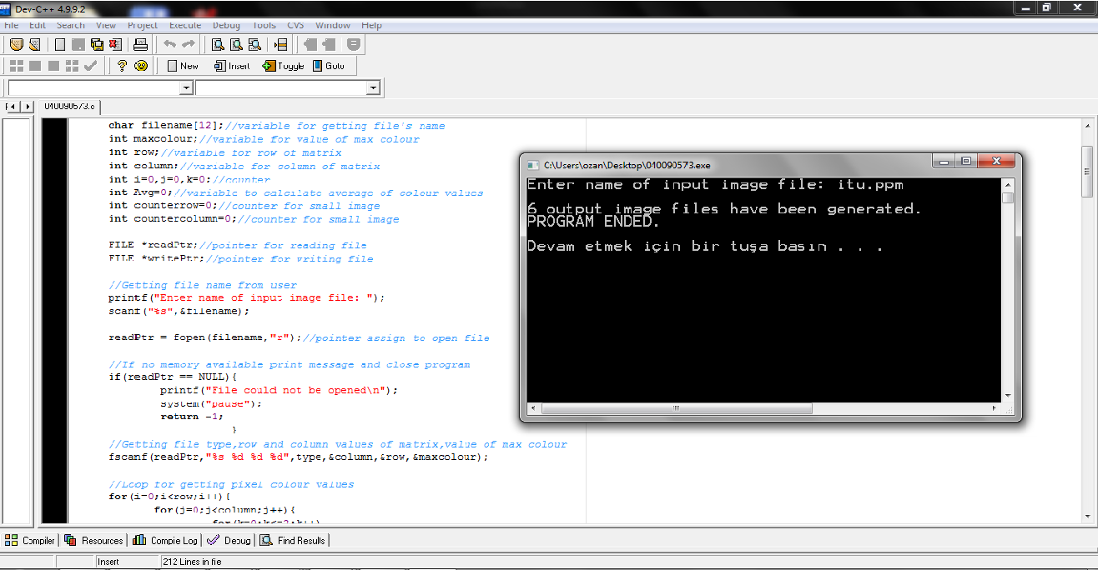

**Unix**

The source code has been also copied to Unix, then compiled and tested with the GNU C Compiler. The following is the commands used:

To compile : gcc 040090573.c –o 040090573.exe

To run : ./040090573.exe

**3-Data Structures and Variables**

No data structures were used in this program. The followings are the variables and their initial values:

* int pixel[263][651][3];//array for getting values of colour
* char *type[3];//pointer for file type
* char filename[12];//variable for getting file's name
* int maxcolour;//variable for value of max colour
* int row;//variable for row of matrix
* int column;//variable for column of matrix
* int i=0,j=0,k=0;//counter
* int Avg=0;//variable to calcılate average of colour values
* int counterrow=0;//counter for small image
* int countercolumn=0;//counter for small image
* FILE *readPtr;//pointer for reading file
* FILE *writePtr;//pointer for writing file

4- Pseudocode

Begin

Define an array for getting pixel color value

Define two arrays forgetting file type and name

Define some variables for getting max color, number of row and column

Define some counter for loops

Define two pointer to read file and to write a file

Get file name

If

It can be possible open file and get information from file

Else

Print a message about file not opening and end program

Close file

To generate negative image;

If

It can be possible open file and print file type, numbers of row and column, and value of max color

Write pixel color values to file by subtracting them from Max Color (255)

Close file

To generate grey image;

If

It can be possible open file and print file type, numbers of row and column, and value of max color

Calculate average of every pixel color values and write pixel color values as average to file

Close file

To generate mirror image;

If

It can be possible open file and print file type, numbers of row and column, and value of max color

Write pixel color values to file from right to left, from top to down

Close file

To generate rotated image;

If

It can be possible open file and print file type, numbers of row and column by switching them, and value of max color

Write pixel color values to file from right to left, from down to top

Close file

To generate big image;

If

It can be possible open file and print file type, numbers of row and column by multiply them with two, and value of max color

Write pixel color values to file by repeating every column and row pixels twice.

Close file

To generate small image;

If

It can be possible open file and calculate numbers of row and column for small image

Print file type, numbers of row and column, and value of max color

Write odd pixels color values

Close file

Display ending message

End

5-Conclusion

In this homework ,

-I have learned how to use a multiple dimension array

-I have learned how to process an image file

-I have learned how to read a file and write a file

-I have learned what PPM file is