EarthScape Climate Agency
Big Data Climate Intelligence Platform
Final Project Report · October 2026
  - Working application, portable Windows runtime, automated Hadoop stack and verified submission evidence.

Delivered package
- Role-based climate dashboard and authenticated ingestion
- HDFS/YARN job verified on two DataNodes
- Forecasting, anomaly detection, correlations and alerts
- Support workflow, user administration and encrypted recovery
- Source code, datasets, database, diagrams, screenshots and website demonstration

Contents
1. Problem definition and project objectives
2. Requirements and implemented behavior
3. System architecture
4. Processing workflow
5. Data model and formats
6. Models, evaluation and interpretation
7. Security and operational controls
8. Installation and operating instructions
9. Executed validation evidence
10. Website screens
11. Handover and references

1. Problem definition and objectives
EarthScape Climate Agency needs a unified application for climate observations collected from weather stations, environmental sensors and satellite sources. Disconnected files make it difficult to validate records, inspect changing conditions, identify unusual readings and communicate findings to stakeholders.
The project combines ingestion, an operational query store, encrypted raw archives, Hadoop distributed processing, machine learning and an interactive dashboard. Users receive role-appropriate access to observations, models, alerts, support and administration.
The objective is an executable educational system with a repeatable evaluation workflow. The package supplies a clean seeded database, complete application dependencies for offline Windows use, automatic full-stack setup and recorded evidence of actual operation. The 720 observations and image fixtures are synthetic, representing four stations over 180 dates.
Success criteria: retain timestamped sensor readings; report invalid/duplicate records; generate interpretable analytical outputs; execute a Hadoop job; enforce server-side permissions; preserve recoverable backups; and supply enough installation, user and developer documentation for an evaluator to run the project.

2. Requirements and implemented behavior
The implementation maps the functional brief to the following behavior. Production service-level and compliance objectives are deployment responsibilities and are described separately from laboratory verification.
Requirement | Implemented behavior
Authentication / authorization | PBKDF2 password hashes; administrator, analyst and viewer roles; protected API mutations.
Historical / live ingestion | CSV/JSON imports and authenticated timestamped sensor push; shared validation pipeline.
Satellite ingestion | Verified PNG/TIFF asset uploads stored encrypted, with archive metadata.
HDFS storage | Monthly encrypted raw partitions, durable upload outbox and HDFS curated job inputs/results.
Parallel processing | Hadoop Streaming station/month aggregation using YARN and two reducers.
Prediction / anomalies / correlations | Linear regression forecast; Isolation Forest flags; Pearson correlation; missing-value handling.
Visualization | Responsive dashboard, station selector, charts, model statistics and observation CSV export.
Notifications / alerts | Automatic threshold alerts, ten-second refresh, configurable threshold and acknowledgment.
Feedback / support | Owner-private tickets; administrator review and resolution.
Security / recovery | CSRF, role checks, login throttling, encrypted archive/snapshots and integrity-checked restore.
Monitoring / operations | Request count, average response time, errors, uptime, DB size, pipeline queue and job status.
Documentation / video | Source, fixtures, database, operating guides, test/cluster logs, report and website recording.

3. System architecture
The browser communicates with the Python API. SQLite serves the local operational queries. The processing worker manages a persistent upload outbox and job table; Hadoop mode sends archives/curated inputs to HDFS and submits a real MapReduce job.
The full-stack supervisor starts a NameNode, two separate DataNode processes, ResourceManager and NodeManager. The Hadoop job emits station/month keys and calculates mean temperature and count in two reducers. Completed results return to the website. The same algorithms can run locally for offline use.
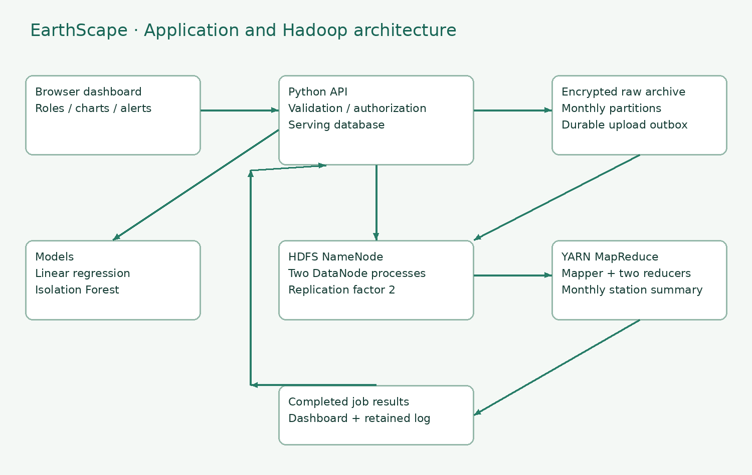

4. Processing workflow
A user signs in, chooses a file or pushes a sensor reading. Validation normalizes UTC timestamps, checks numerical ranges and source labels, and reports rejected rows. A database uniqueness constraint prevents duplicate timestamp/station/source identities while preserving multiple readings on one day.
Accepted measurements generate threshold alerts. Encrypted archive files are written locally and enter the HDFS outbox. Analysts submit processing jobs, which snapshot input, stage it in HDFS, run MapReduce and persist output and logs. Temporary archive failures remain queued and visible instead of losing the local archive.
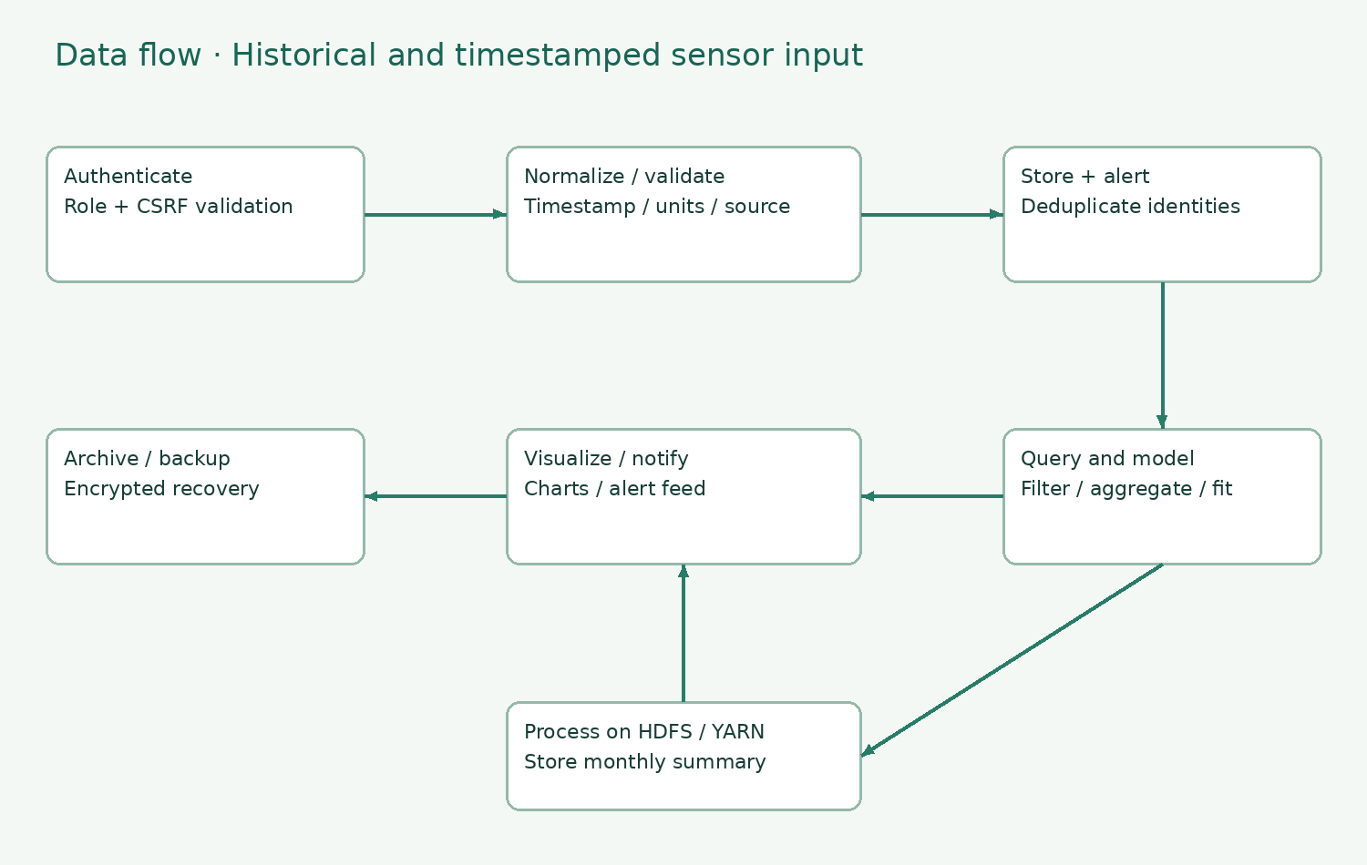

5. Data model and supported formats
Users store username, salt, password hash and role. Observations store day, station, temperature, rainfall, CO2, source and a normalized timestamp. Additional tables hold alerts, tickets, settings, audit entries, assets and processing jobs. Station/date and alert-state indexes support common queries.
CSV columns: day, station, temperature, rainfall, co2, source; timestamp may additionally be supplied. JSON uses an array of matching objects. Dates follow ISO 8601, with naïve dates interpreted in UTC. Temperature is Celsius, rainfall millimetres and CO2 parts per million. At least one measurement is required. Blank numerical fields remain null.
Validation bounds are -100..70°C, 0..3000 mm rain and 100..3000 ppm CO2. These broad bounds detect malformed input; they are not a substitute for scientific station calibration. PNG/TIFF uploads are verified by Pillow and archived with Fernet encryption. Raster imagery is not treated as measured weather without a separate calibrated extraction method.
Hadoop curated data is newline-delimited JSON. Reducer outputs are tab-separated station|month, mean-temperature and count records. A Jupyter notebook, R script and optional Impala table DDL accompany the source; the TSV/CSV exports can be loaded into Tableau.

6. Machine learning and evaluation
The clean all-station seed has 720 records, mean temperature 26.21°C, time-ordered holdout MAE 5.87°C and temperature/CO2 correlation 0.131. Isolation Forest flags 29 observations for review.
LinearRegression fits daily average temperature against elapsed days. The first 80% of dates supplies training data and the last 20% supplies test data, avoiding a random temporal split. After MAE evaluation, the model refits on all dates and predicts fourteen future days.
IsolationForest uses temperature, rainfall and CO2 with eighty trees, a .04 contamination setting and seed 42. Missing feature values receive dataset medians; entirely missing features receive zero. Temperature-free records do not enter this model. Forecasting needs ten dates; anomaly detection needs twenty temperature-bearing records.
Ingestion invalidates the fifteen-second analytics cache. Fresh analytics retrains the estimators and writes model metadata/forecast to runtime/models. Anomalies are review flags, not proof of climate events. Correlation does not establish causation. Pooling stations can capture legitimate geographical differences, so station-level exploration is encouraged. The forecast is an educational trend baseline, not an operational weather prediction.

7. Security, alerts and recovery
Passwords use salted PBKDF2-HMAC-SHA256 with 310,000 iterations. One-hour sessions use random tokens, HttpOnly and SameSite=Strict cookies. Authenticated mutations require CSRF tokens and server-side role checks. Failed sign-ins are throttled after ten failures in five minutes. Parameterized SQL and escaped frontend content protect data handling.
Administrators configure thresholds, create/update accounts, create backups, review audits and resolve tickets. Analysts ingest and process records and acknowledge alerts. Viewers explore data and create their own tickets. Changing a user password/role invalidates their sessions; the last administrator cannot be demoted.
New temperatures over the configured limit create alerts. Users see the alert feed refreshed every ten seconds and can acknowledge notifications when permitted. Support tickets remain private to their owner except for administrators.
Fernet protects raw archives, uploaded satellite assets and manual/hourly snapshots. Snapshot filenames are unique and a lock serializes backup operations. Restore refuses overwrites and checks SQLite integrity. The serving SQLite database and curated Hadoop files rely on operating-system storage protection in the lab. Production must add encrypted disks/HDFS encryption zones, managed keys, TLS and independent backups.

8. Installation and operation
Offline Windows: extract the ZIP completely and double-click START_EARTHSCAPE.bat. The embedded Python 3.12.10 runtime and Windows dependencies are included. The launcher starts the application, opens http://127.0.0.1:8080 and records startup errors in runtime/launcher.log. Keep the window open; Ctrl+C stops the service.
Full Hadoop: install/start Docker Desktop and double-click START_FULL_STACK.bat. It builds and starts the supplied Docker configuration and opens http://localhost:8081. The first build requires internet to download Hadoop/Java dependencies. No manual Hadoop configuration is required. STOP_FULL_STACK.bat stops services while preserving named volumes.
The supervisor formats the NameNode only for an empty state, waits for two live DataNodes and for safe mode to end, then starts the application. A container restart policy and HTTP health check assist recovery. Jobs interrupted by a server restart return to Queued.
The lab uses two DataNode processes on one host, demonstrating replication without host-level redundancy. Multi-host data storage, a shared scalable serving database, TLS, monitoring and measured uptime objectives are production extensions. The 99% uptime requested in the brief is an operating target, not a guarantee established by a short laboratory test.
User | Password | Role
admin | EarthDemo!2026 | Administrator
analyst | AnalystDemo!2026 | Analyst
viewer | ViewerDemo!2026 | Viewer

9. Executed validation evidence
Eighteen unit checks passed. Ten HTTP integration checks passed. Fifteen browser checks passed without JavaScript errors. The tests cover validation, duplicate and missing data, timestamp retention, UTC normalization, models, encryption, unique backups, local processing, role restrictions, CSRF, authentication, CSV export, satellite archive, live alerts, support resolution, account management and responsive layout.
A genuine HDFS/YARN MapReduce job consumed 720 observations and produced 24 station/month summaries using two reducers. The HDFS report confirms two live DataNodes. Job logs and summaries are included in docs/hadoop-execution.log, hdfs-report.txt, hadoop-results.json and monthly_hadoop.tsv.
The completed website recording shows the real interface and exercised workflows. Screenshot evidence accompanies this report. Model dependencies are pinned and the same Python package versions are bundled for Windows. The application logic and Hadoop supervisor were exercised on Linux; the embedded Windows runtime was assembled from official Windows distributions. Docker Desktop itself was not installed in the laboratory; the supplied recipe runs the tested supervisor.
The two launch modes are deliberately explicit: Local mode executes the mapper/reducer on this machine; Hadoop mode runs HDFS/YARN. Previous completed Hadoop evidence is retained in the seed database. No production load benchmark, multi-host failover exercise or compliance certification is asserted.

10. Website screens · Overview
Captured from the working application during the executed browser walkthrough.
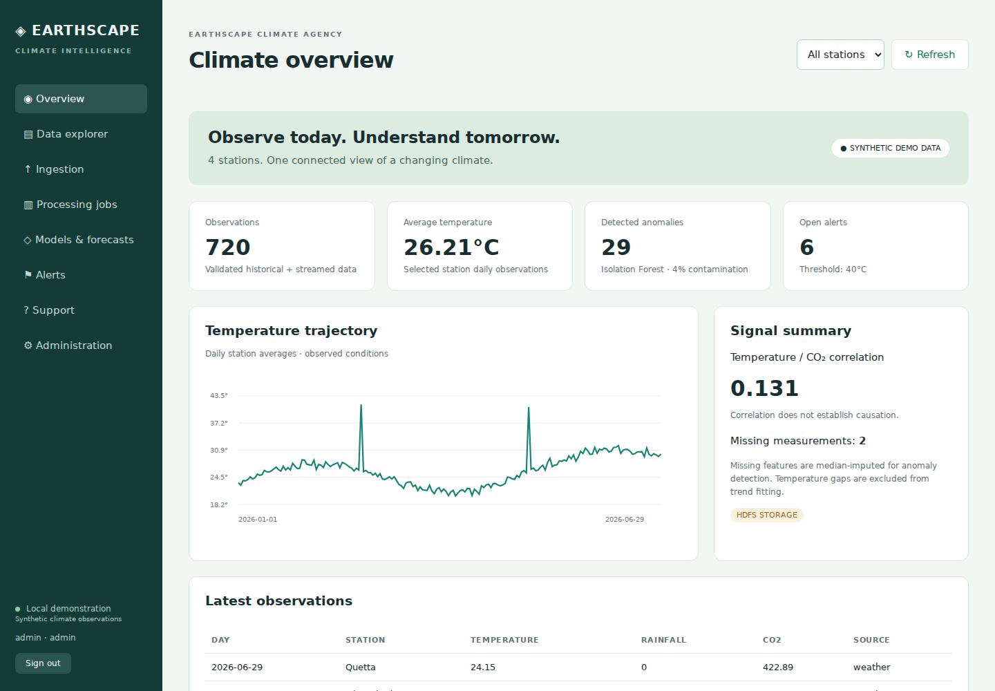

10. Website screens · Models
Captured from the working application during the executed browser walkthrough.
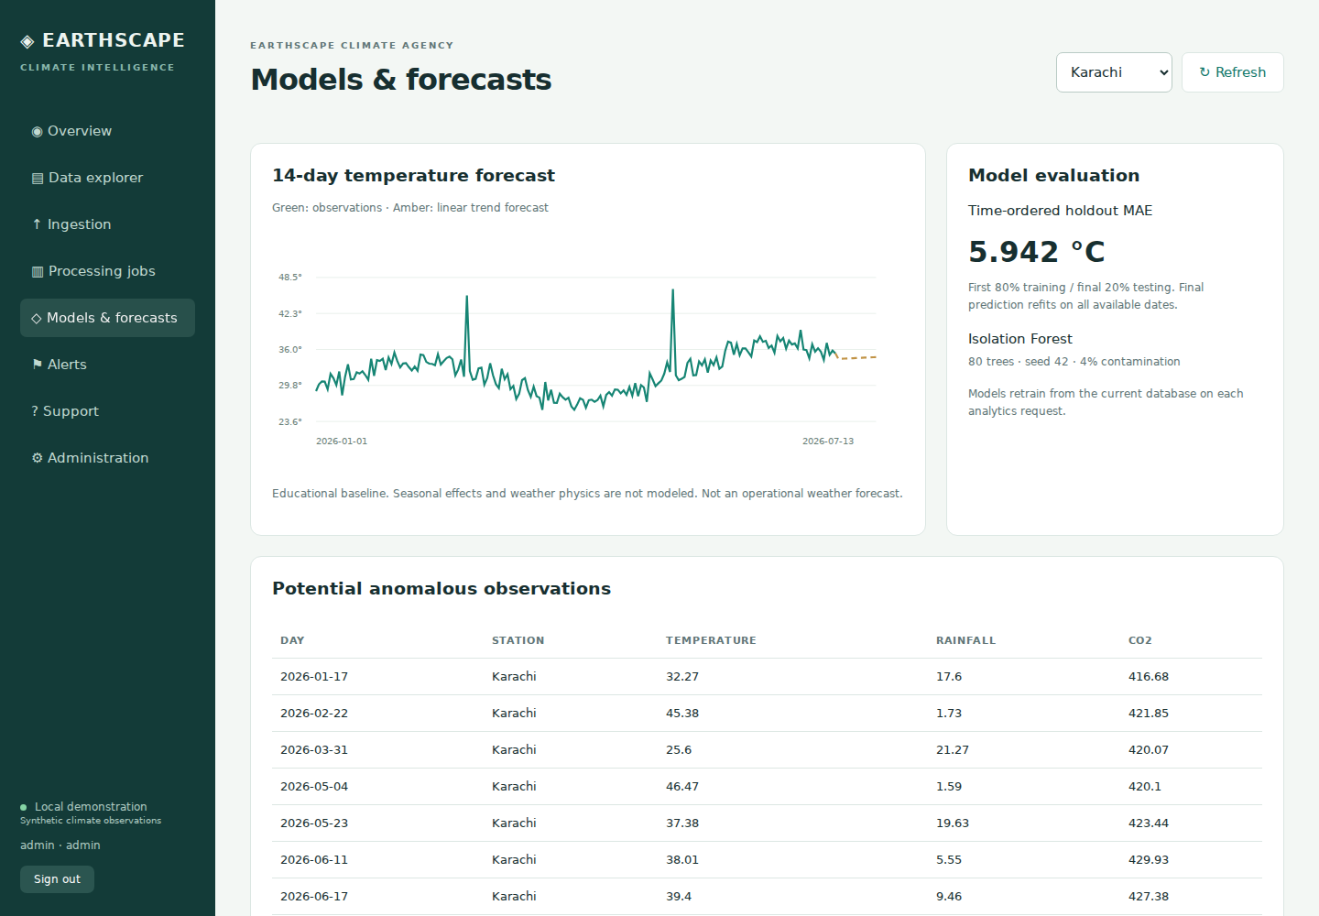

10. Website screens · Processing
Captured from the working application during the executed browser walkthrough.
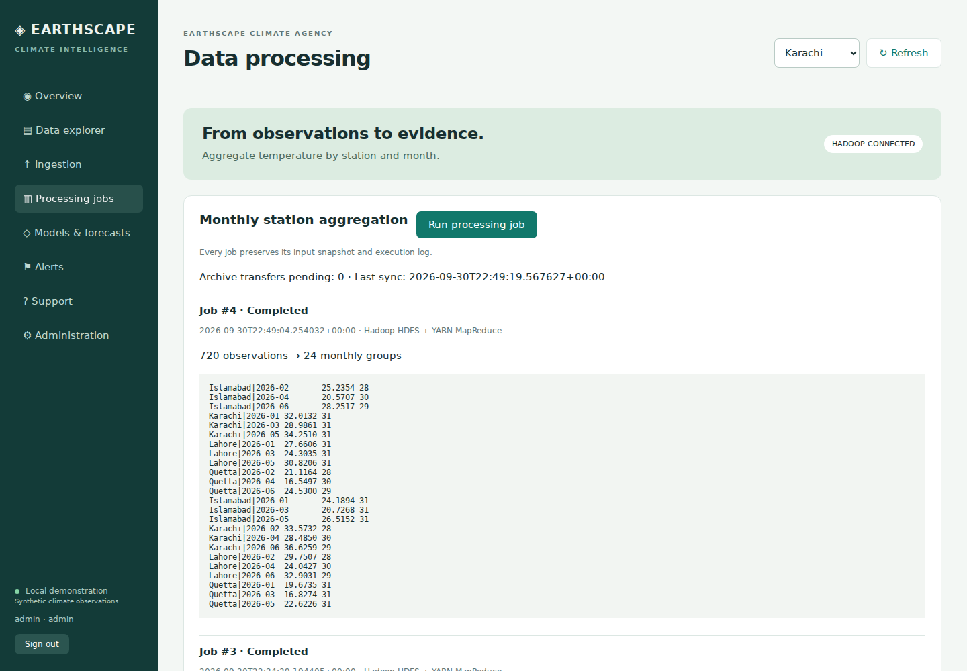

10. Website screens · Ingestion
Captured from the working application during the executed browser walkthrough.
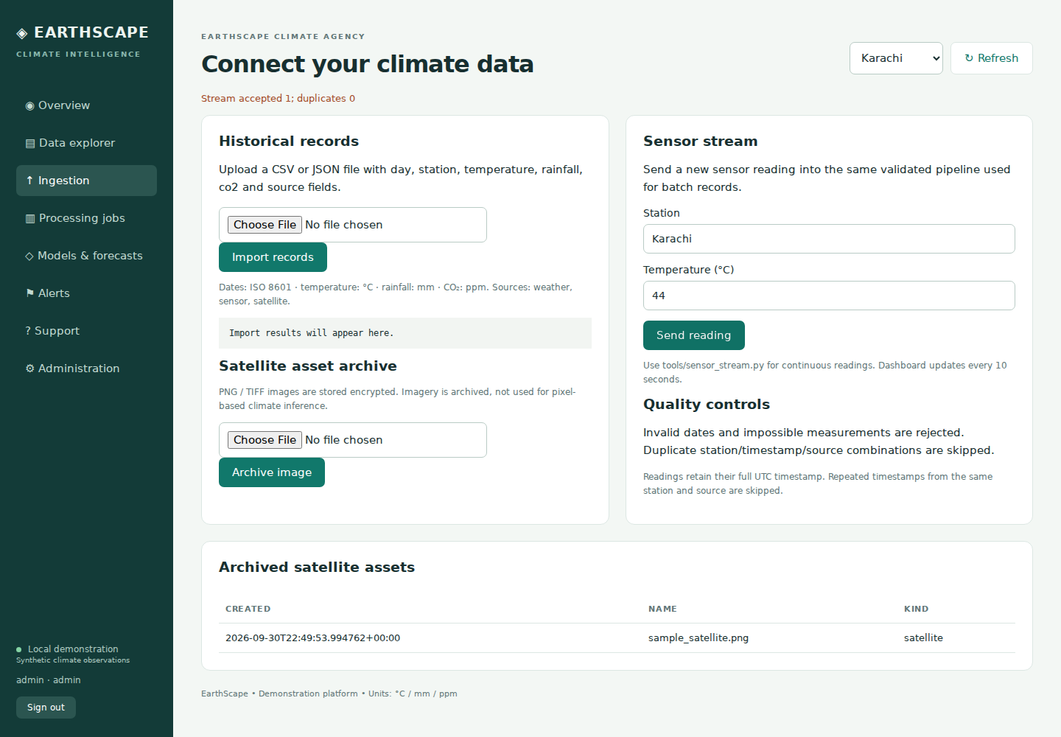

10. Website screens · Administration
Captured from the working application during the executed browser walkthrough.
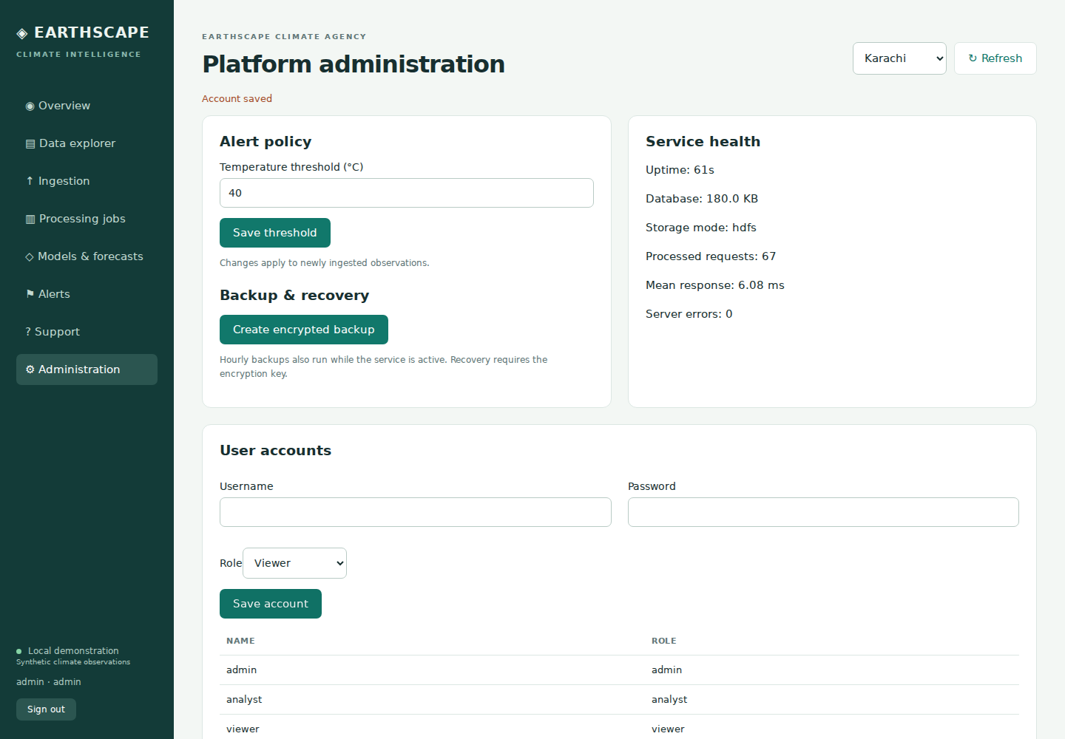

10. Website screens · Mobile
Captured from the working application during the executed browser walkthrough.
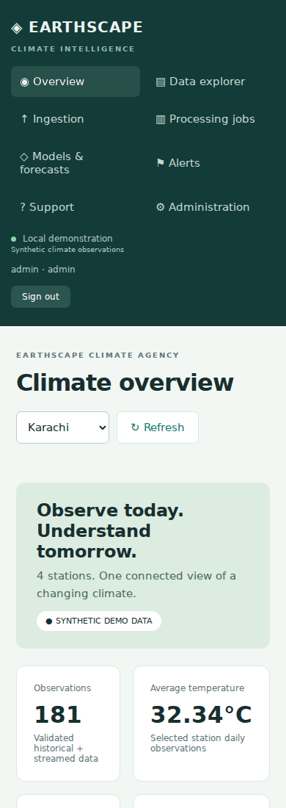

11. Handover and references
The package includes application/frontend source, portable Windows runtime, automated Hadoop deployment, clean seeded database, matching encryption key, encrypted snapshot, test fixtures, source notebook/R scripts, report, screenshots, executed logs and website video. SHA256 checksums are supplied for package files.
Original administrative templates are included. Student/enrollment/batch/group/centre details must be genuine; the separate Submission_Details document provides editable fields. The supplied process requests one final submission per group.
Requirements and process: supplied Big Data-EarthScape_Climate_Agency.docx and EarthScape Climate Agency.rar.
Apache Hadoop Streaming: https://hadoop.apache.org/docs/stable/hadoop-streaming/HadoopStreaming.html
Apache HDFS documentation: https://hadoop.apache.org/docs/current/hadoop-project-dist/hadoop-hdfs/WebHDFS.html
scikit-learn: https://scikit-learn.org/stable/modules/generated/sklearn.ensemble.IsolationForest.html and https://scikit-learn.org/stable/modules/generated/sklearn.linear_model.LinearRegression.html
Python embedded distribution: https://www.python.org/downloads/windows/; Fernet: https://cryptography.io/en/latest/fernet/. Third-party license notices remain with the bundled distributions.

