A PROPOSED CNN ARCHITECTURE TO DIAGNOSE PNEUMONIA AND ITS CAUSES FROM CHEST X-RAY CT
Ozan Güldali 509191238, Cihat Kırankaya 507192112
https://github.com/ozanguldali/final-covid-chestxray

- INTRODUCTION

COVID-19 has infected more than 85 million people worldwide, killed 1.85 million and is still spreading rapidly around the world. It is important to detect COVID-19 as quickly and accurately as possible in order to control the spread of the disease and treat patients. While PCR is still the core truth of COVID-19 diagnosis, the sensitivity of PCR testing is not high enough for the low viral load or lab error present in test samples.
The whole world is sometimes faced with epidemics as it is currently facing COVID-19 disease. The spread and infection factors of this disease are very high. Large numbers of people from most countries become infected and continue to spread within six months of their first report. The systems necessary for any pandemic are not ready for some stages; therefore, mitigation becomes necessary with the available capacity. On the other hand, on a large scale, the use of Deep Learning techniques can be used to mitigate COVID-19-like outbreaks in terms of stopping the spread, diagnosis of disease, drug and vaccine discovery, treatment, patient care, and much more.

## TODO:
- CovidNet, DarkCovidNet ve NovelNet modellerinden kısacık bahsedilebilir
- Genel zatürre üzerine çalışma yaptığımız için, zatürre ve onun çeşitleri (bakteriyel, virüsel, Covid19 kaynaklı virüsel) üzerine anlatım yapılabilir (üstteki 2 paragraf buna göre revize edilebilir)
- Bu şekilde 4-sınıflı çalışmalar varsa kısaca onlardan bahsedilebilir
- En son olarak da bizim propose ettiğimiz yaklaşım anlatılabilir

- MATERIALS AND METHODS

2.1. Dataset

The four main classes were considered on the given dataset such as healthy people (normal), bacterial pneumonia patients (bacterial), COVID19 pneumonia patients (viral-covid) and other viral pneumonia patients (viral-other). The original structure contains highly unbalanced data, that is why we construct a new structure, that is a new dataset from original. Since the total number of COVID-19 labeled data is too small, we augmented the Viral-Covid labeled training data after dividing original COVID-19 data into train and test data by the ratio of 0.3. That is, we chose 40 COVID-19 data as training set and rest 18 data as testing set. Then we augmented the chosen Viral-Covid labeled training data by horizontal flip, vertical flip, 90 degrees rotation, 180 degrees rotation and 270 degrees rotation. That is, we create 5 more data from 1 data, and in the end, we obtained 240 Viral-Covid labeled training data. Testing data was left untouched. Finally, we chose 240 training data and 80 testing data for Normal, Bacterial and Viral-Other labels from original. The process is as follow:

Class | Original Set | Training Set |  | Testing Set
 |  | Chosen | After Augmentation
Normal | 1576 | 240 | 240 | 80
Bacterial | 2772 | 240 | 240 | 80
Viral-Covid | 58 | 40 | 240 | 18
Viral-Other | 1493 | 240 | 240 | 80
Total | 5899 | 760 | 960 | 258

Table 1: Dataset Re-Construction

2.2. CNN Layers and Proposed Model

CNNs are architectures made up of multiple sequential layers. These layers perform different functions. To reveal the distinctive features of data in these architectures according to the problem type they are applied [2]. Layer functions used in the model proposed in the study are as follows:

2.2.1 Convolution Layer

This layer is the building block of CNN architectures and is used to reveal the distinctive features of input data. This layer applies various filters to the data to reveal low- and high-level features in the data [3]. After convolution, the size of the input data changes. These dimensions vary according to the layers to be applied. The outputs of the convolution layers are called activation maps and are basically shown as:

$$X_{j}^{l}=f\left(\sum_{i∈M_{j}}{X_{i}^{l-1}*k_{ij}^{l}+b_{j}^{l}}\right)$$

The convolution process is defined as above. Here, the previous layers are shown with $X_{i}^{l-1}$, the learnable kernels are $k_{ij}^{l}$ and the bias term is $b_{j}^{l}$. $M_{j}$matches the input map section [4].

2.2.2 Rectified Linear Units (ReLU)

The nonlinear layer follows the convolution layer in the model. This layer gives the system a non-linear feature and is called the activation layer. Activation maps are used to calculate the outputs of the neural network using linear combinations.
For this purpose, the most frequently used activation function Rectifier (ReLU) was preferred. The function is defined as follows:

$$f\left(x\right)=max⁡(0,x)$$

2.2.3 Pooling Layer

It is common to periodically insert a Pooling layer in-between successive Conv layers in a CNN architecture. Its function is to progressively reduce the spatial size of the representation to reduce the number of computational nodes in the network. Hence overfitting is tried to under control.
An input with size $W_{1}xH_{1}xD_{1}$ is allowed in this layer. 2 parameters can be mentioned here; their spatial extent F, the stride S, produces a volume of size $W_{2}xH_{2}xD_{2}$ where:

$W_{2}$=($W_{1}$−F)/S+1 , $H_{2}$=($H_{1}$−F)/S+1 , $D_{2}$=$D_{1}$

In our proposed model, MaxPooling was applied at the exit of each convolutional block.

2.2.4 Batch Normalization

Batch normalization is a technique for training deep neural networks that standardize inputs to one layer for each mini group. This has the effect of stabilizing the learning process and significantly reducing the number of training sessions required to train deep networks. This processing element has been used in all convolutional layers.

2.2.5 Fully-Connected Layers

This structure is used to transfer the activations obtained by transferring data over the network for the next unit. It is located at the end of the architecture to provide connections between all the activations and compute nodes on these layers. 3 layers are used in the proposed modelx.

In this study, a new CNN model that consists of 4 Convolutional Blocks and 3 Fully-Connected Layers for diagnose pneumonia. At the end of the proposed model, the cross-entropy loss is used. The details of the proposed model are given in Table 2 below.

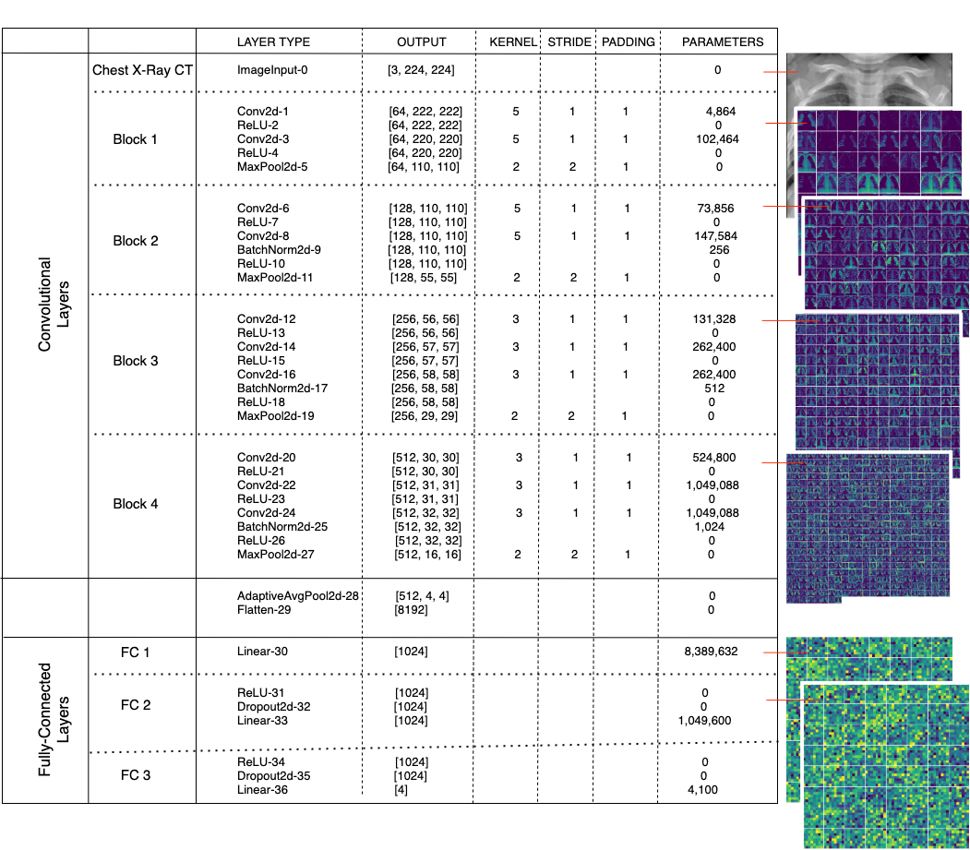
Table 2: The Details of the Proposed Model with the corresponding Activation Maps

2.4. Cross-Entropy Loss Function

Cross-Entropy objective function is the combination of Log SoftMax and Negative Log-Likelihood Loss functions.
Each estimated class likelihood is compared to the target performance 0 or 1 of the actual class, and a loss is determined that penalizes the probability depending on how far the real expected value is formed.

$$-\frac{1}{n}\sum_{i=1}^{n}{y_{i}ln⁡(\hat{y_{i}})}$$
such that y: actual label and $\hat{y}$: classifier’s output where n is the number of samples

2.5. Optimization Methods

In the experiments, Adam with weight decay, Adam with decoupled weight decay and SGD with momentum were used. The short brief of optimizers can be found in Table 3.

Optimizer | Brief | Formulae
SGD Momentum | Stochastic gradient descent is an iterative method for optimizing an objective function with suitable smoothness properties. It can be regarded as a stochastic approximation of gradient descent optimization. Momentum remembers the weight update at each iteration, and determines the next update as a linear combination of the gradient and the previous update [5]. | $$g_{t}=∇_{θ}f_{t}(θ_{t-1})$$  $$υ_{t}=βυ_{t-1}+(1-β)g_{t}$$  $$θ_{t}=θ_{t-1}-ηυ_{t}$$
Adam Weight Decay | Adaptive Moment Estimation is an optimization algorithm that uses the running averages of both the gradients and the second moments of the gradients. Before each step, the gradient of loss function is calculated and a step in the opposite direction is taken with corresponding rate. This process is also called as Adam with L2 regularization [6]. | $$g_{t}=∇_{θ}f_{t}\left(θ_{t-1}\right)+wθ_{t-1}$$  $$m_{t}=β_{1}m_{t-1}+(1-β_{1})g_{t}$$  $$υ_{t}=β_{2}υ_{t-1}+(1-β_{1})g_{t}^{2}$$  $$θ_{t}=θ_{t-1}-η\frac{{m_{t}}/{\left(1 - β_{1}^{t}\right)}}{\sqrt{{v_{t}}/{\left(1 - β_{2}^{t}\right)}}+ϵ }$$
Adam Decoupled Weight Decay | Adam with decoupled weight decay does not use the regularization as the normalized by square root of v. Thus, it is only proportional to the weight itself [6]. | $$g_{t}=∇_{θ}f_{t}\left(θ_{t-1}\right)$$  $$m_{t}=β_{1}m_{t-1}+(1-β_{1})g_{t}$$  $$υ_{t}=β_{2}υ_{t-1}+(1-β_{1})g_{t}^{2}$$  $$θ_{t}=θ_{t-1}-η\frac{{m_{t}}/{\left(1 - β_{1}^{t}\right)}}{\sqrt{{v_{t}}/{\left(1 - β_{2}^{t}\right)}}+ϵ }+ wθ_{t-1}$$

Table 3: Optimizers
(f : loss function / $η$: initial learning rate / $β, β_{1,2}$: momentum parameters / $g_{t}$: gradient at time t along $θ$ / $w$: weight decay rate)

2.6. Experimental Setup

The source code was written as Python programming language with the help of PyTorch and Sklearn. For GPU support, Google Colaboratory was used with the number of workers as 4 on experiments.
The dataset was constructed by choosing 240 samples for training and 80 samples for testing from each of Normal, Bacterial and Viral-Other labels of the given original data. From the Viral-Covid labeled data, 18 samples were chosen for testing, and 40 samples were chosen for training and then each Viral-Covid training datum was augmented 5 times. That is, the dataset totally has 960 training and 258 testing samples. The training data was shuffled on each epoch during experiments.
To prepare the data for experiments, each was resized to 112*112, center cropped (squared), gray-scaled, and normalized by the mean of [0.485, 0.456, 0.406] and standard deviation of [0.229, 0.224, 0.225]. The size of each batch was experimented from 2^5 to 2^7.
AlexNet, ResNet50 and SqueezeNet1_1 were used as pretrained on ImageNet, and ProposedNet, NovelNet, CovidNet and DarkCovidNet was coded and experimented from scratch.

Cross-Entropy loss was chosen as the objective function, and SGD with Momentum, Adam and Adam with decoupled weight decay were experienced to optimize the loss. Various learning rates, momentum values, betas and weight decay parameters were experimented to obtain the optimal results. The learning rate update was also experienced as reducing the learning rate by 0.1 for each quarter of total epoch size.
Final hyperparameter settings for our Proposed CNN model are as in Table 4.

Optimizer | Learning Rate | Schedular | Betas | Weight Decay | Momentum
SGD Momentum | 1e-4 | True | (0.9, 0.999) | 1e-4 | -
Adam | 1e-4 | True | (0.99, 0.99) | 1e-4 | -
AdamW | 1e-3 | False | - | - | 0.9

Table 4: Final Hyperparameters for ProposedNet

Each experiment was run in 200 epochs with test data validation once in 10 epochs. In comparison, the accuracy was compared with the previously stored results for each validation and the final test and saved as a new model weight file if it is higher than the older one.
Grid Search was used to get the best settings on SVM. In total, 720 possibilities were experienced. The final hyper-parameters of SVM:
- Regularization parameter: ‘5.0’ over [0.01, 0.05, 0.1, 0.5, 1.0, 5.0]
- kernel type: ‘RBF (Radial Basis Function)’ over [linear, rbf, sigmoid]
- gamma: ‘scale’ over [scale, auto];
i.e., (1 / (number of features * variance(feature data))) is used as the value of gamma
- decision_function_shape: ‘one-vs-one’ over [one-vs-one, one-vs-rest]
- seed: ‘4’ over [1, 2, 4, 13, 17, 23, 25, 100, 999, 1773]
10-fold cross validation for ML algorithms was used with the seed as 4.
Feature extraction from the ProposedNet model weights on Fully-Connected-2 layer was applied to whole dataset. 1024 features were obtained for each sample, and these features were saved as *.npy files to use in experiments. Then by using 10-fold cross validation, SVM were performed on extracted feature sets.

- RESULTS AND DISCUSSION

In this study, we proposed a novel CNN architecture for the diagnosed of pneumonia over four classes from Chest X Ray images. To compare the efficiency of ProposedNet, we obtained results from recently proposed models NovelNet, CovidNet, Dark CovidNet and pretrained models AlexNet, ResNet50, SqueezeNet1_1 as explained in Section 2.6. At the end, we achieved the most successful results on ProposedNet with Adam optimizer.
Different models reached their best accuracies on different hyperparameters settings and with different optimizers. This detailed review can be found on Table 5.
The accuracy and loss curves of training and validation stages are shown in Figures from 1 to 4 below.

 |  | Accuracy
Pretrained | Model | Adam | AdamW | SGD Momentum
FALSE | *ProposedNet | 87.21  (40 epochs) | 87.21  (120 epochs) | 87.21  (190 epochs)
FALSE | DarkCovidNet | 84.88 | 86.05 | 83.33
FALSE | CovidNet | 86.04 | 84.88 | 82.55
FALSE | NovelNet | 79.84 | 81.00 | 82.55
TRUE | AlexNet | 82.64 | 84.88 | 86.04
TRUE | ResNet50 | 83.72 | 84.49 | 86.82
TRUE | SqueezeNet1_1 | 83.72 | 84.88 | 75.88

Table 5: Prediction performance results obtained CNN

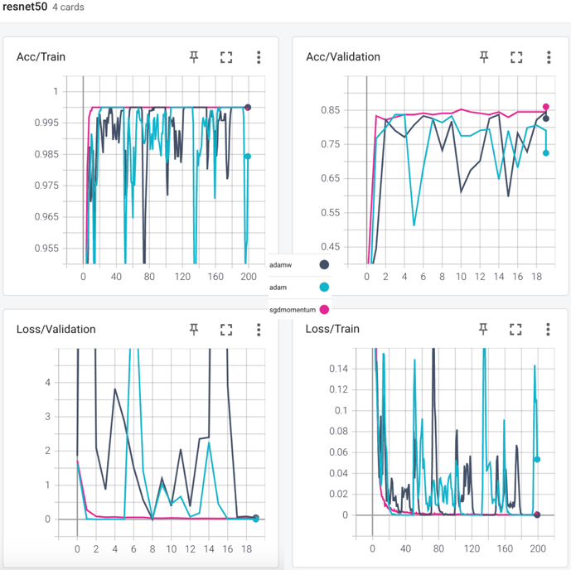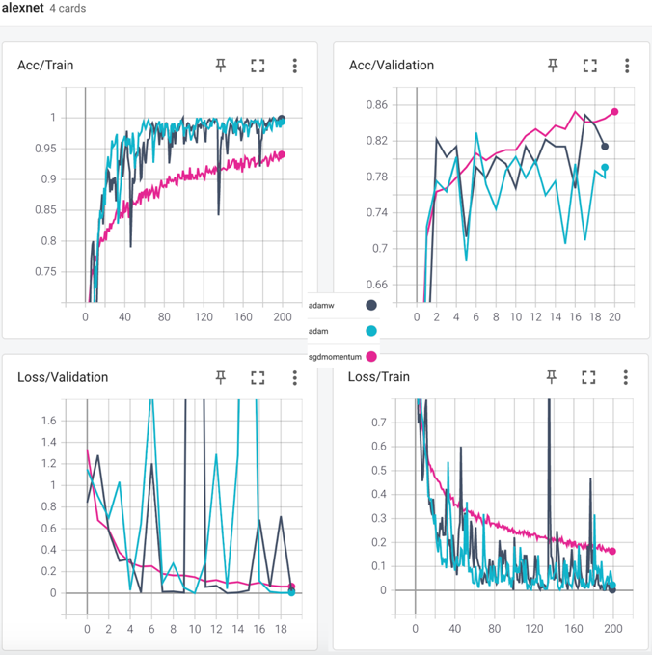
Figure 1: The Performances of Pretrained Resnet50 & Pretrained AlexNet

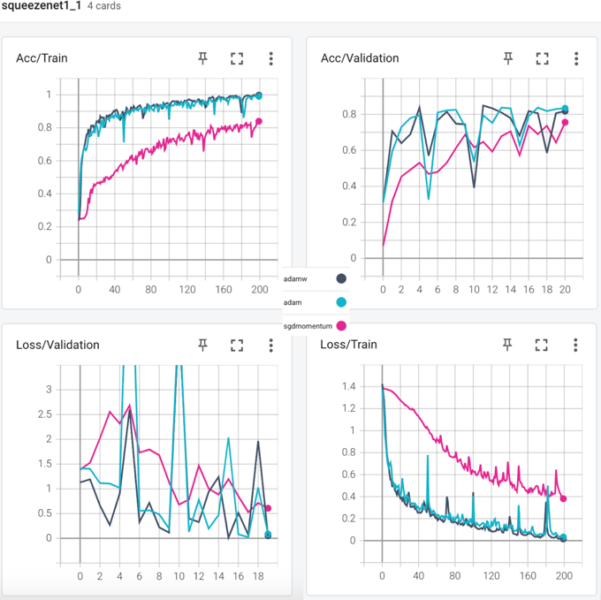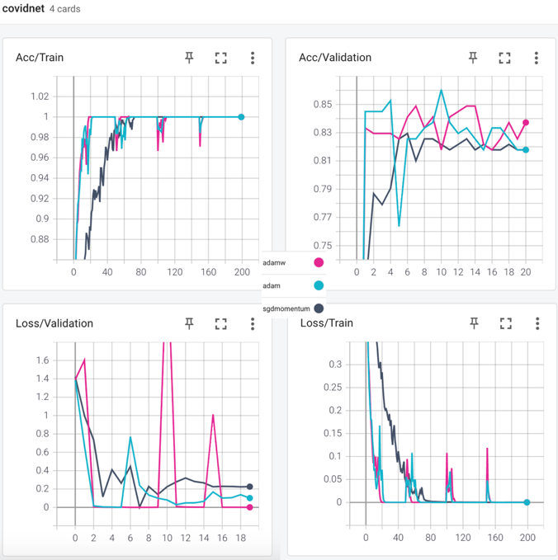
Figure 2: The Performances of Pretrained SequeezeNet1_1 & CovidNet

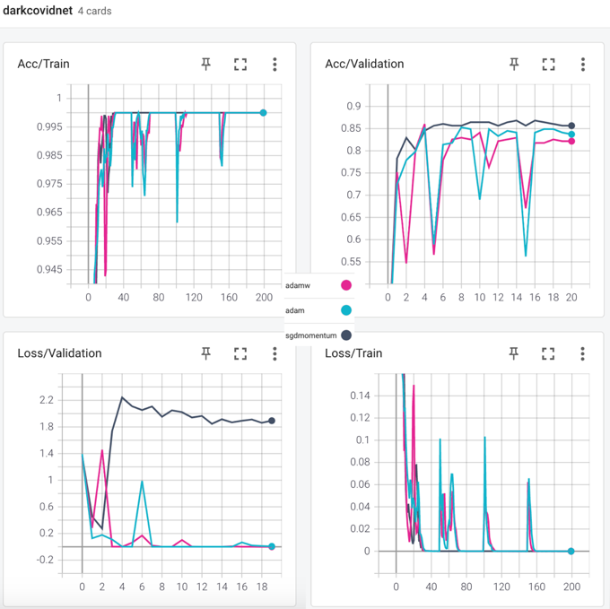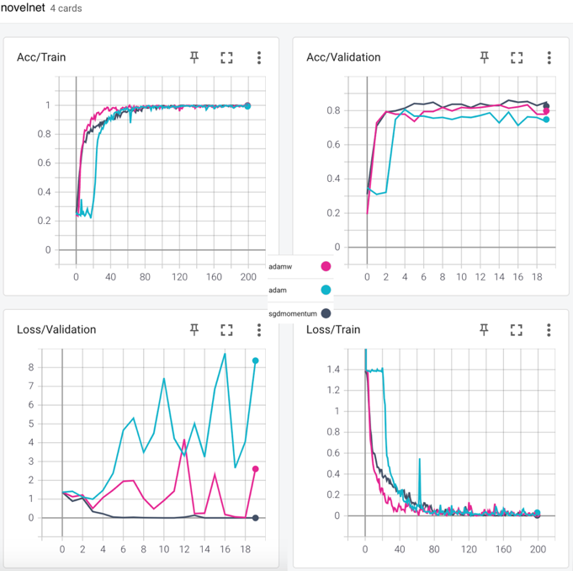
Figure 3: The Performances of DarkCovidNet & NovelNet

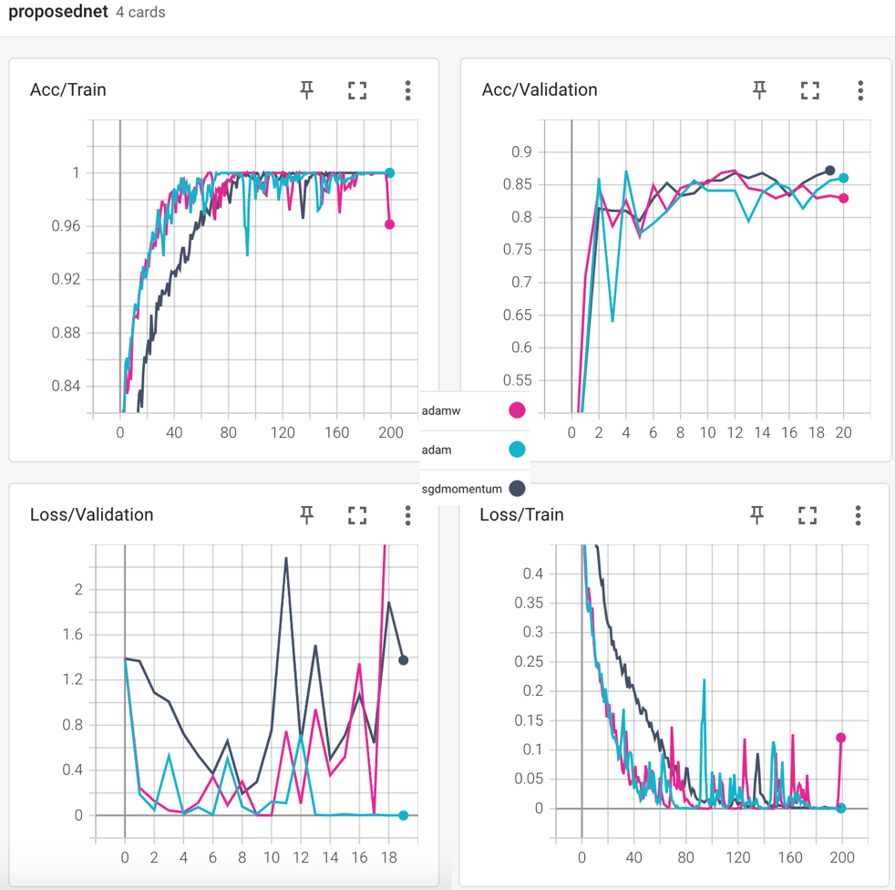
Figure 4: The Performance of ProposedNet

It can be seen from the Table 5 that the best result was obtained faster by using Adam in ProposedNet model with the accuracy of 87.21% and the AUC Score of 0.967805.
To solve the problem of 4-class classification on pneumonia disease with the highest and useful result, we collected the deep features of dataset from the FC-2 layer of weighted ProposedNet. Then SVM was experienced and performed as explained in Section 2.6. The overall final results and comparison can be found in Table 6.

Method | Accuracy (%) | Sensitivity (%) | Specificity (%) | Precision  (%) | F1-Score  (%)
SVM | 84.65 | 84.84 | 84.86 | 84.43 | 84.49
Pretrained Squeezenet1_1  (AdamW) | 84.88 | 84.88 | 84.98 | 84.65 | 84.65
Pretrained AlexNet  (SGD Momentum) | 86.04 | 86.04 | 86.26 | 86.08 | 86.80
Pretrained ResNet50  (SGD Momentum) | 86.82 | 86.68 | 87.02 | 86.93 | 86.70
NovelNet  (SGD Momentum) | 82.55 | 82.55 | 82.72 | 82.55 | 82.36
CovidNet  (Adam) | 86.04 | 86.04 | 86.26 | 85.88 | 85.76
DarkCovidNet  (AdamW) | 86.05 | 86.43 | 86.64 | 86.02 | 86.17
ProposedNet  (Adam) | 87.21 | 87.21 | 87.40 | 87.34 | 87.03
SVM with features extracted from ProposedNet weights | 97.95 | 97.94 | 97.97 | 97.94 | 97.94

Table 6: Performance metrics

Sensitivity = TP / (TP + FN)

Accuracy = (TP + TN) / (TP + TN + FP + FN)

Specificity = TN / (TN + FP)
a)

b)
Figure 13: a) The form of confusion matrix, and the computation of Sensitivity, Accuracy and Specificity. b) Confusion Matrices of ML results using deep features from ResNet18.

- CONCLUSION

Autism spectrum disorder (ASD) is a common neuro developmental disorder, which has affected 62.2 million ASD cases in the world in 2016. Clinicians still rely on manual delineations, a prohibitively time-consuming process, which depends on rater variability and is prone to inconsistency (4). Therefore, there is a critical need for fast, accurate, reproducible, and fully automated methods for segmenting MRI brain data. Hence It has been evaluated that it is crucial to classify Autism spectrum disorder quickly and effectively.
The study consists of 2 main stages. In phase 1, The most used pre-trained models such as ResNet18, AlexNet, VGG16, VGG19 and Densenet169 have been trained and tested on Autism dataset. All pre-trained models were trained with Adam, Padam and SGD Momentum optimizer, and Cross-Entropy method, and results were obtained. At this stage, the best result was obtained by using Adam in ResNet18 model with 84.35%. In the CNN model, the convergence speed for Adam, Padam, SGD Momentum was observed as VGG16, DenseNet169, VGG19, respectively. In phase 2, the deep features obtained from ResNet18 pre-trained model are used to train and test on ML algorithms. 10-fold cross validation method was chosen and results were obtained. The best results were obtained with Logistic Regression using deep features from ResNet18 pretrained model as the accuracy of 96.05% and the AUC score of 0.9855. For the reproducibility of results, the saved model weights of ResNet18 can be reached via GitHub link and machine learning experiments can be re-run with the seed of 17.
Hereby, it is considered that the results obtained are better than other results in the literature and a significant contribution is made to the literature for the diagnosis of Autism disease with the proposed structures. In future studies, the same brain MRI can be used to diagnose neural diseases such as schizophrenia, autism, and Alzheimer's. This may be pave the way for the study to be conducted on animals as well.

REFERENCES

- H.A. Rothan , S.N. Byrareddy , The epidemiology and pathogenesis of coronavirus disease (covid-19) outbreak, J. Autoimmun. (2020) 102433 .
- E. Başaran, Z. Cömert, Y. Çelik, Convolutional neural network approach for automatic tympanic membrane detection and classification, Biomed. Signal Process. Control 56 (2020) 101734, http://dx.doi.org/10.1016/j.bspc.2019.101734.
- M. Toğaçar, B. Ergen, Z. Cömert, BrainMRNet: Brain tumor detection using magnetic resonance images with a novel convolutional neural network model, Med. Hypotheses. 134 (2020) 109531, http://dx.doi.org/10.1016/j.mehy.2019.109531.
- M. Nour, Z. Cömert, K. Polat: A Novel Medical Diagnosis model for COVID-19 infection detection based on Deep Features and Bayesian Optimization (2020) 106508, https://doi.org/10.1016/j.asoc.2020.106580
- Sutskever, Ilya; Martens, James; Dahl, George; Hinton, Geoffrey E. (June 2013). Sanjoy Dasgupta and David Mcallester (ed.). On the importance of initialization and momentum in deep learning (PDF). In Proceedings of the 30th international conference on machine learning (ICML-13). 28. Atlanta, GA. pp. 1139–1147. Retrieved 14 January 2016.
- F. M. Graetz; Why AdamW Matters (2018), https://towardsdatascience.com/why-adamw-matters-736223f31b5d

