**DETECTION OF AUTISM SPECTRUM DISORDER BASED ON DEEP FEATURES EXTRACTED FROM CONVOLUTIONAL NEURAL NETWORK MODEL**

Cihat Kırankaya 507192112, Ozan Güldali 509191238

<https://github.com/ozanguldali/interim-brain-mri>

1. **INTRODUCTION**

Accurate segmentation of the brain structure is extremely important for the correct diagnosis of diseases such as schizophrenia, Parkinson, and autism [1]. It has been evaluated that some abnormalities in the brain structure may be related to the diagnosis of various diseases and the emergence of possible behavioral disorders [2].

Autism is known as a “spectrum” disorder because there is wide variation in the type and severity of symptoms people experience. ASD occurs in all ethnic, racial, and economic groups. Although ASD can be a lifelong disorder, treatments and services can improve a person’s symptoms and ability to function.

Autism spectrum disorder (ASD) is a disorder based on common brain functions and in 2016 there were 62.2 million ASD cases worldwide. Autism Imaging Data Exchange (ABIDE) initiative is a data program created by collecting from around the world. These data include MRI (Magnetic Resonance Imaging) brain scans, anatomical and phenotypic datasets [3].

Automating the brain's structure segmentation remains challenging, despite significant research interest and efforts devoted to this computational problem. Experts still rely on assessments that are very dependent on the assessor, which are manual and time consuming. [4]. Therefore, there is a critical need for fast, accurate, reproducible, and fully automated methods to compartmentalize MRI brain data.

It is considered that dividing and interpreting these structures correctly will help to understand such complex disorders, to monitor their progress, and to evaluate treatment outcomes. For all these reasons, it is determined crucial to include a study in which autism is diagnosed with a deep learning model based on MRI brain data to the literature. Many studies have been conducted for ASD diagnosis. Studies mostly focused on CNN, RNN and Autoencoder based models. A few of these are summarized below.

Guo et al. [5] made a diagnosis of ASD using the DNN structure. Effective results have been obtained in different architectures. Based on expert opinions, brain functions were compared with the behavioral effects of this disease.

Kong et al. [6] proposed a DNN model to make ASD classification. According to the results obtained, it proved that the proposed model can reach 90.39% accuracy and the area under the receiver operating characteristic curve (AUC) of 0.9738. The results obtained showed that the proposed model has been evaluated to give better results than many models in the literature.

Li et al. [7] proposed a model for determining ASD and extraction of unknown and causative features of this disease. According to the results, it was determined that the proposed model had better results than traditional methods, and it was evaluated that the proposed model could be an alternative to other models in the literature.

Khosla et al. [8] proposed a new model based on the new 3D-CNN model to evaluate data and make ASD classification. The proposed model has been tested on the ABIDE dataset. Based on the results, it allows us to understand the proposed model brain structure and better identify the elements that cause the disease.

Parisot et al. [9] proposed the new Graph Convolutional Networks (GCN) concept that combines data and feature for brain analysis and feature representation in populations. The proposed model relationship structure enables to predict tags from unknown features and structures. The GCN model was trained with this predicted labeled data. Based on the results, it is considered that it would be beneficial to integrate the proposed structure with other existing models.

Anirudh and Thiagarajan [10] proposed a preloaded version of graphical convolutional neural networks (G-CNNs) using a group of G-CNNs capable of structure selection and reducing the precision of models in graph structure selection. The results were recorded by testing the proposed model on the ABIDE data set. According to the results obtained, the proposed model is considered to be more effective and robust than other methods.

Bi et al. [11] proposed a model called random neural networks to better classify ASD patients. The proposed model is chosen from the challenging brain imaging data exchange database. They aimed to obtain five different results by producing five different random neural networks. According to the result of the neural network that has the best result from the produced neural networks, it is evaluated that the proposed model is an alternative to other methods.

Dvornek et al. [12] suggested the use of recurrent neural networks with long short-term memory (LSTM) to classify individuals with ASD disease and MR time series data. They used a random dataset from the entire large, multisite Autism Brain Imaging Data Exchange database to train and test LSTM models to train the proposed LSTM model. According to the results obtained, the proposed model achieved an accuracy percentage of 68.5%. It is stated that this value is higher than the result obtained by other methods. They also evaluated that the LSTM model is an effective model in ASD classification.

For clarity, the studies described above and more are summarized in below with Table 1.

**Table 1**: Overview of papers using deep learning techniques for ASD diagnosis

|  |  |  |  |  |  |
| --- | --- | --- | --- | --- | --- |
| Author | Year | Subject | | Model | Accuracy(%) |
| ASD | Normal |
| Kong et al. [6] | 2019 | 78 | 104 | Autoencoder | 90.39 |
| Saeed et al. [13] | 2019 | 505 | 530 | Autoencoder | 70.10 |
| Anirudh et al. [10] | 2019 | 404 | 468 | Graph CNN | 70.8 |
| Yao et al. [14] | 2019 | 438 | 544 | Graph CNN | 67.3 |
| Li et al. [7] | 2018 | 82 | 48 | 3D CNN | 89.0 |
| Heinsfeld et al. [15] | 2018 | 505 | 530 | Autoencoder | 70.0 |
| Khosla et al. [8] | 2018 | 542 | 625 | 3D CNN | 73.30 |
| Bi et al. [11] | 2018 | 50 | 42 | RNN | 84.7 |
| Ktena et al. [18] | 2018 | 403 | 468 | Graph CNN | 62.90 |
| Guo et al. [5] | 2017 | 55 | 55 | Autoencoder | 86.36 |
| Choi et al. [16] | 2017 | 465 | 507 | Autoencoder | 60.00 |
| Hazlett et al. [17] | 2017 | 106 | 42 | Autoencoder | 88.00 |
| Parisot et al. [9] | 2017 | 403 | 468 | Graph CNN | 69.50 |

The aim of this study is to establish an effective model by determining which deep learning models are most effective on classification of the Autism MRI data. Hence, we have proposed classification of ASD by Machine Learning algorithms using deep features obtained from deep convolution neural network based on pre-trained models and brain MRI. For this aim, we have used ResNet18, AlexNet, VGG16, VGG19 and DenseNet169 pre-trained models to obtain a higher prediction accuracy for dataset. Cross-Entropy Loss, which is the combination of Log SoftMax and Negative Log-Likelihood Loss functions, were used separately with the two novel, SGD+Momentum & Adam, and one recent, Padam [20], optimizers experimentally. The model that gives the best result among the pre-train models has been used to extract deep features of dataset, then the features were inserted into ML algorithms to final classification. The results of SVM, kNN and Logistic Regression models were analyzed comparatively. The study is organized as follows: Dataset is explained in detail in Section 2.1. Deep learning models and experimental setup parameters are summarized in Section 2.2 and 2.3, respectively. Discussion and obtained results from proposed models are presented in Section 3. Finally, in Section 4 the conclusion and the future works are summarized.

1. **MATERIALS AND METHODS**

**2.1. Autism Brain Imaging Data Exchange Dataset**

There is considerable optimism in clinical neuroimaging communities that magnetic resonance imaging (MRI) will provide much-needed objective biomarkers to diagnose and monitor the severity of psychiatric and neurodevelopmental disorders. Training classifiers require an enormous and diverse set of training data sets to predict disease status and severity, which is resistant not only to the significant heterogeneity present in these disorders, but also to variation in systems and protocols used to collect MRI data [19].

Autism Brain Imaging Dataset Exchange (ABIDE) database is a database that collects brain MR data collected from 17 different regions of the world. This database helps us to understand the neural bases of autism and to determine which functions in the brain cause this disease. There are 2 different collections in this database: ABIDE I and ABIDE II. Both collections were created by combining data sets collected independently from more than 24 neuroimaging laboratories around the world. These data are available to researchers for analysis.

The data used in this study were obtained from <http://adni.loni.usc.edu/>. Analysis was conducted by converting the data from .nii to .png format. Our dataset consists of 1190 samples which contain 583 individuals with ASD and 607 normal subjects. Gender and age were not considered as a feature for the classifier. MR images of ASD and normal subject can be found in Figure 1 and Figure 2.

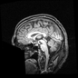 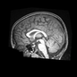

**Figure 1**: MRI of ASD

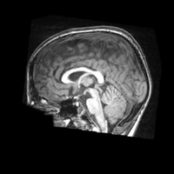 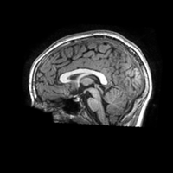

**Figure 2**: MRI of Normal

**2.2. Pretrained CNN Models**

Deep learning techniques used in recent years are frequently used in medical image processing and classification areas as in many fields. By applying deep learning techniques to MRI, X-ray or other related data, meaningful results are tried to be obtained from medical data. Analysis of image and signal data obtained with MRI or related data with the help of deep learning models. As a result of these analyzes, the detection and diagnosis of diseases such as Parkinson's, pneumonia and schizophrenia are facilitated. Classification results were obtained according to different proposed structures.

In this study, we have proposed the classification of ASD based on the deep features extracting from convolution neural networks and brain MRI. The ResNet18, AlexNet, VGG16, VGG19 and DenseNet169 pre-trained models output becomes the input of the specified network topology. Output is obtained by passing through the data layers. For each pre-trained model, Adam, Padam and SGD Momentum optimizer were run separately to optimize Cross-Entropy Loss function. The experiment was run separately for each pre-trained model. This structure is described in Figure 3.

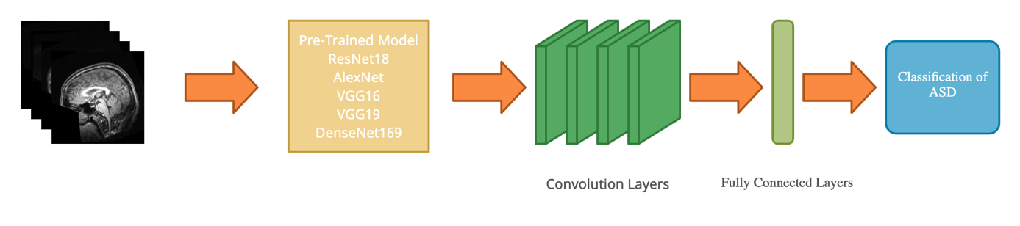

**Figure 3**: Representation of pre-trained models for the prediction of ASD

Brain MR's as input reaches the fully connected network by passing through the convolutional layers. Then the classification process is conduct. A visual representation of the activation maps is given below with Figure 4.

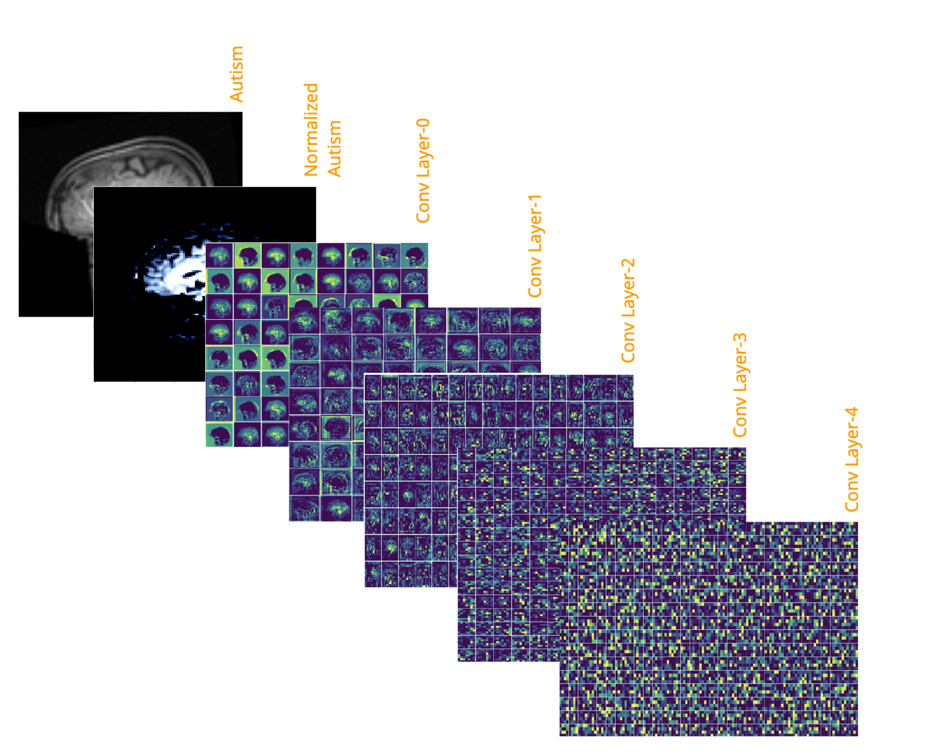

**Figure 4**: Visual representation of Conv Layer maps in the Resnet18 model

In order to increase the accuracy rate on classification task, extracted deep features over ResNet18, which is the best result among pre-trained models, and ML algorithms are combined. The established structure was operated separately with 3 different ML algorithms (SVM, kNN, Logistic Regression) and the results were observed. This structure is described in Figure 5.

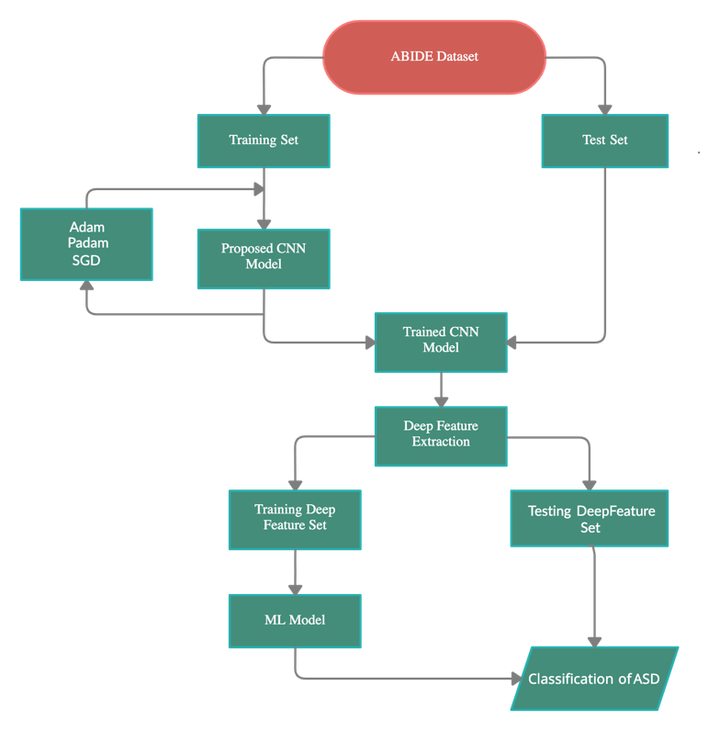

**Figure 5**: Block diagram of the combined method of CNN and ML

**2.3. Experimental Setup**

Python programming language, with the base of PyTorch and Sklearn for CNN and ML respectively, was used to train, test and classify on our environment. All experiments were performed on the Google Colaboratory using its GPU with the number of workers as 4.

The dataset used was randomly split into two independent datasets with the ratio of 0.75, that is 896 for training and 294 for testing. Furthermore, training and testing datasets were resized to 112*112, center cropped (squared), gray-scaled, and normalized by the mean of [0.485, 0.456, 0.406] and standard deviation of [0.229, 0.224, 0.225]. Train data were also set to be shuffled on each epoch and the batch size was experimentally set from 2^5 to 2^7.

CNN models (ResNet18, AlexNet, VGG16, VGG19 and DenseNet169) were used as pre-trained on ImageNet, and fine-tuning (frozen first convolution block) and full-training were experimented as well.

Cross-Entropy as the combination of Log SoftMax and Negative Log-Likelihood Loss functions was chosen to be the loss function as in Figure 6:

Take the average across observations for each minibatch to compute the final loss

**Figure 6:** Construction of Cross-Entropy Loss Function

SGD Momentum, Adam and Padam optimizers were used with various learning rate, momentum, partial, betas and weight decay parameter values. Final hyperparameter settings are as follows; learning rate as 0.01 and momentum as 0.9 for SGD Momentum, learning rate as 0.001 for Adam, learning rate as 0.001, partial as 0.125, weight decay as 0.025 and betas as (0.9, 0.99) for Padam. Moreover, for Adam and Padam, the learning rate was reduced by 0.1 for each quarter of total epoch size. For example, in a 200 epochs training, if one started with lr = 1e-2, it is updated to 1e-3 in epoch 50, 1e-4 in epoch 100, and 1e-5 in epoch 150.

Each experiment was run on 200 epochs with validation using test data once in 10 epochs. Moreover, on each validation and the final test, the accuracy was compared with the previously stored results and saved as a new model weight *.pth file if it is better than the older.

10-fold cross validation (Figure 7) for ML algorithms was used with the seed as 17 in order to prevent the partitioning consistency on each run. RBF (Radial Basis Function) kernel function was used in the SVM classification. In LR model, L-BSFG (Limited Memory Broyden–Fletcher–Goldfarb–Shanno) solver was chosen. For kNN, Minkowski metric was used with Euclidean distance, and algorithm choice was left to the used library to auto decide one in (“Ball Tree”, “K-Dimensional Tree”, “Brute-Force”) based on the values passed.

After getting results from pre-trained CNN models, feature extraction via the best CNN model was applied to whole dataset. Then by using 10-fold cross validation, SVM, LR and kNN were performed on extracted feature sets.

Test Set

Train Set

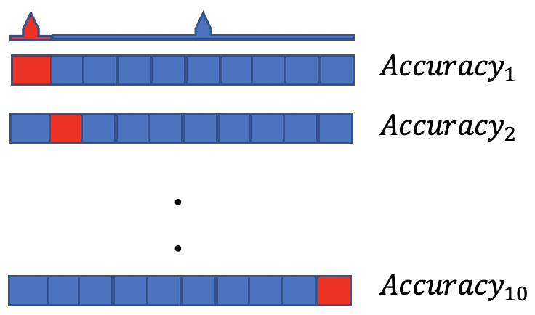

**Figure 7**: Display of the 10-Fold Cross Validation

1. **RESULTS AND DISCUSSION**

In this study, Autism disorder MR images have been used for the classification of ASD patients. The most used pre-trained models such as ResNet18, AlexNet, VGG16, VGG19 and Densenet169 have been trained and tested on MR. The training stage has been conducted up to 200 epochs, and tested & compared to avoid results from overfitted trainings. It can be seen from Figures that It has been observed that all models have reached nearly 100% training accuracy with all optimizers. However, it is seen that Adam optimizer on almost all models shows a faster training process than other optimizers. Although the pre-trained models give very high initial values, the initial values are below 70% due to the low amount of data. In the CNN model, the convergence speed for Adam, Padam, SGD with Momentum is observed as VGG16, DenseNet169, VGG19, respectively. The accuracy and loss values of training and validation stages of ResNet18, AlexNet, VGG16, VGG19 and DenseNet169 are shown in Figures from 8 to 12 below.

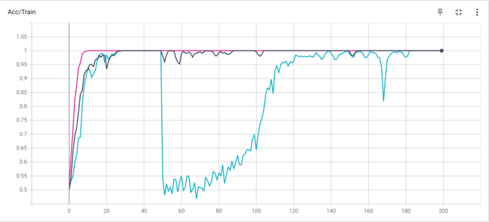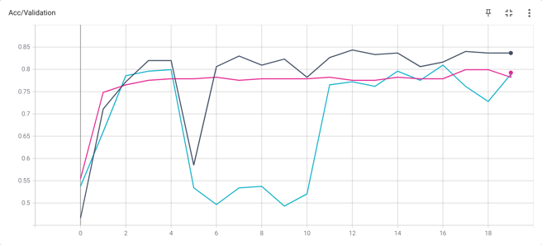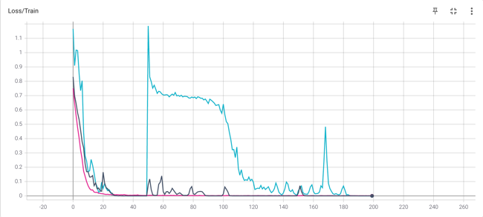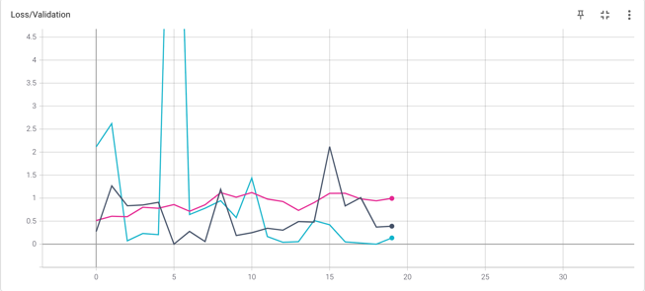

**Figure 8**: The Performance of Resnet18 (Colors for Adam, SGD and Padam)

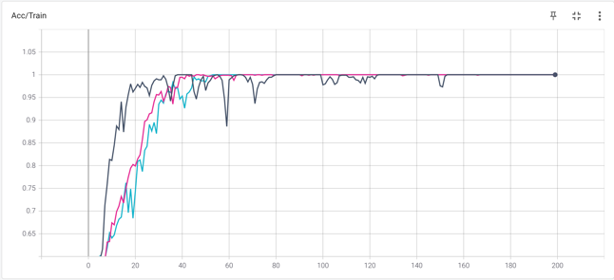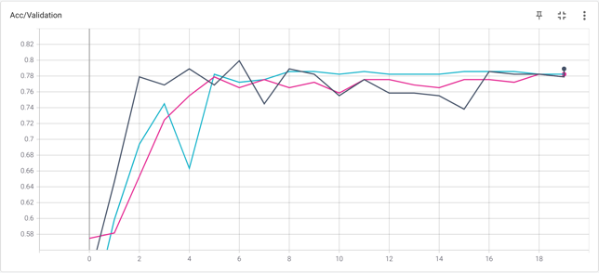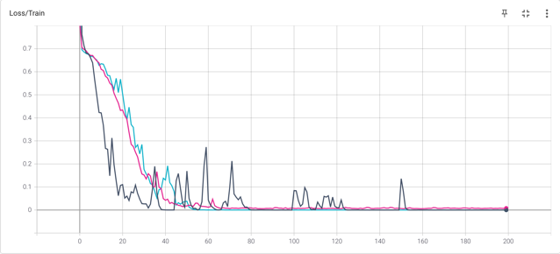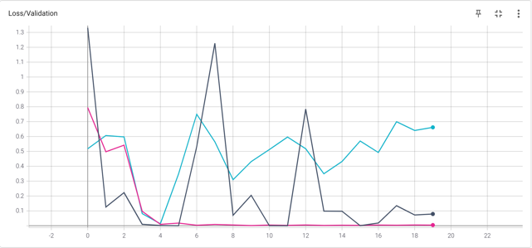

**Figure 9**: The Performance of AlexNet (Colors for Adam, SGD and Padam)

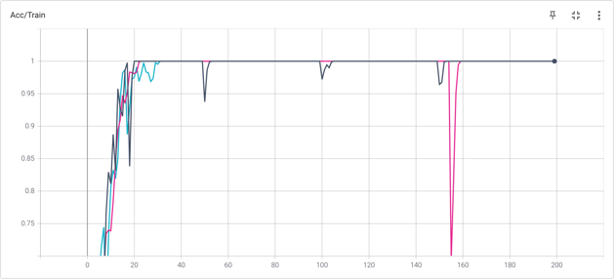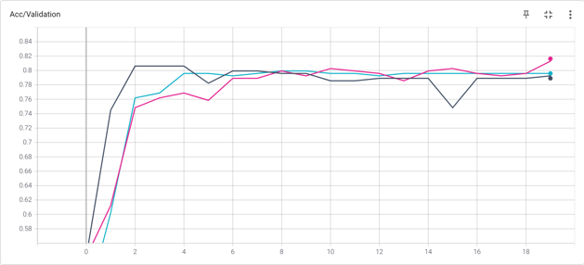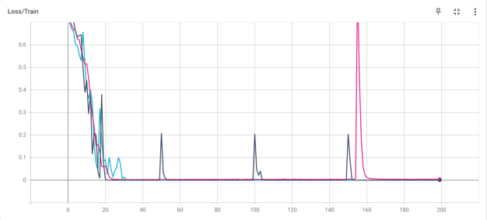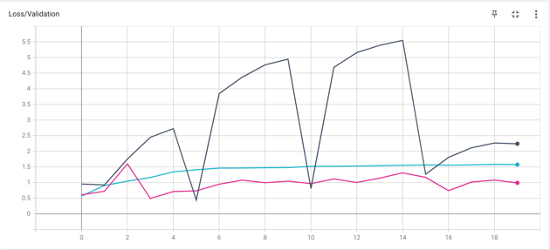

**Figure 10**: The Performance of VGG16 (Colors for Adam, SGD and Padam)

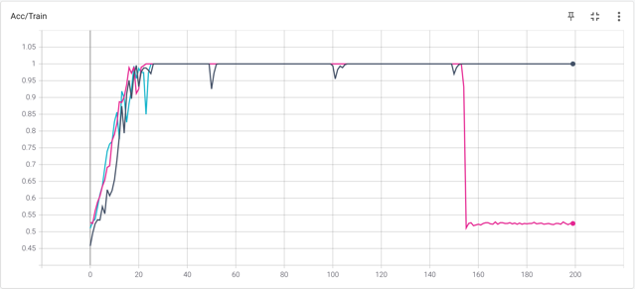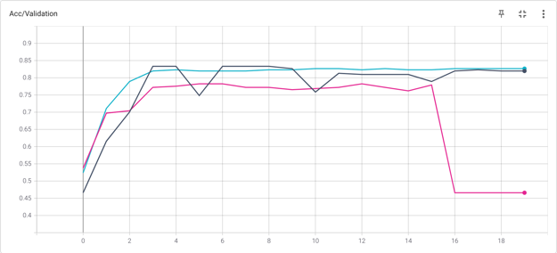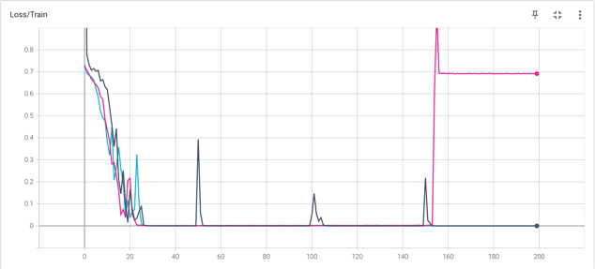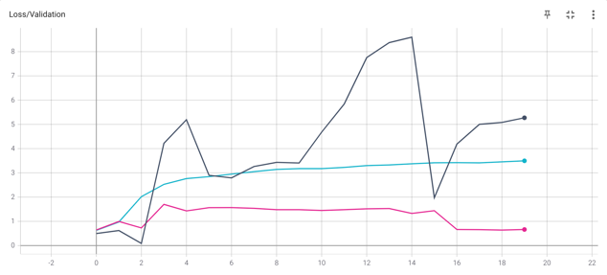

**Figure 11**: The Performance of VGG19 (Colors for Adam, SGD and Padam)

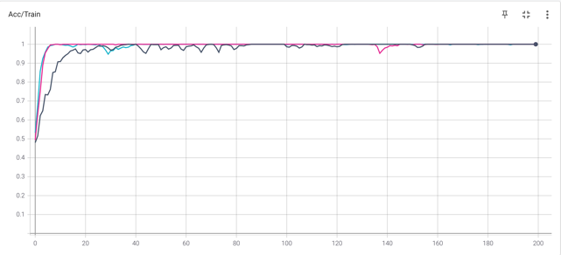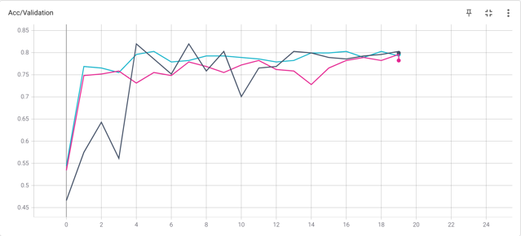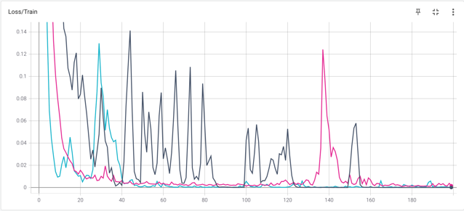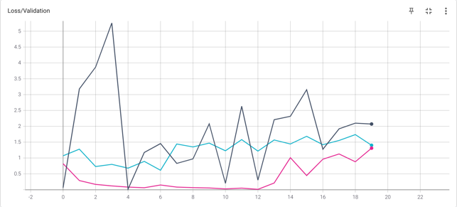

**Figure 12**: The Performance of DenseNet169 (Colors for Adam, SGD and Padam)

**Table 2**: Prediction performance results obtained CNN

|  |  |  |  |
| --- | --- | --- | --- |
|  | Test Accuracy (%) | | |
| CNN Model | Adam | SGD Momentum | Padam |
| Resnet18 | **\***84.35 (120 epoch) | 80.95 (160 epoch) | 79.93 (180 epoch) |
| AlexNet | 79.93 (60 epoch) | 78.57 (80 epoch) | 78.23 (180 epoch) |
| VGG16 | 80.61 (20 epoch) | 79.93 (80 epoch) | 81.63 (190 epoch) |
| VGG19 | **\***83.33 (30 epoch) | **\***82.65 (100 epoch) | 78.23 (60 epoch) |
| DenseNet169 | 81.97 (40 epoch) | 80.27 (50 epoch) | 79.59 (190 epoch) |

It can be seen from the Table 2 that the best result was obtained by using Adam in ResNet18 model with 84.35%. Hence ResNet18 pre-trained model and ML algorithms were combined and the results were obtained. Feature extraction were performed by the cut of the feature block of model ResNet, and 2D Adaptive Average Pooling and finally flattening. In the end, 512 features were obtained for each sample. Results are as follows.

**Table 3**: Performance metrics obtained from CNN & ML models separately and combined

|  |  |  |  |  |
| --- | --- | --- | --- | --- |
| **Approach** | **Method** | Accuracy (%) | Sensitivity (%) | Specificity (%) |
| Machine Learning  (10-Fold CV) | Support Vector Machine | 62.26 | 63.67 | 61.28 |
| **\***Logistic Regression | 63.94 | 63.23 | 64.63 |
| k-Nearest Neighbors | 57.22 | 54.51 | 63.24 |
| Convolutional Neural Networks  (Bests from Table 2) | **\***Resnet18 (Adam) | 84.35 | 90.51 | 78.98 |
| VGG19 (Adam) | 83.33 | 89.20 | 78.06 |
| VGG19 (SGD+Momentum) | 82.65 | 86.01 | 79.47 |
| ML Classifier with Deep Features Extracted from CNN | SVM with feature extraction of Resnet18 | 95.96 | 97.85 | 94.29 |
| **LR with feature extraction of Resnet18** | **96.05** | **97.85** | **94.44** |
| kNN with feature extraction of Resnet18 | 93.02 | 90.71 | 95.48 |

Table 3 provides that the approaches of using purely ML and CNN methods have their best in-approach results from Logistic Regression and ResNet18 respectively. However, apparently, extracting the deep features from the convolutional base (feature block) of ResNet18, and then classifying them on LR have the overall best results for our experiments. The average confusion matrices after 10-Fold CV of all ML models used on classifying the samples with deep features obtained from ResNet18 are as Figure 13.

Sensitivity = TP / (TP + FN)

Accuracy = (TP + TN) / (TP + TN + FP + FN)

Specificity = TN / (TN + FP)

a)

b)

**Figure 13: a)** The form of confusion matrix, and the computation of Sensitivity, Accuracy and Specificity. **b)** Confusion Matrices of ML results using deep features from ResNet18.

1. **CONCLUSION**

Autism spectrum disorder (ASD) is a common neuro developmental disorder, which has affected 62.2 million ASD cases in the world in 2016. Clinicians still rely on manual delineations, a prohibitively time-consuming process, which depends on rater variability and is prone to inconsistency (4). Therefore, there is a critical need for fast, accurate, reproducible, and fully automated methods for segmenting MRI brain data. Hence It has been evaluated that it is crucial to classify Autism spectrum disorder quickly and effectively.

The study consists of 2 main stages. In phase 1, The most used pre-trained models such as ResNet18, AlexNet, VGG16, VGG19 and Densenet169 have been trained and tested on Autism dataset. All pre-trained models were trained with Adam, Padam and SGD Momentum optimizer, and Cross-Entropy method, and results were obtained. At this stage, the best result was obtained by using Adam in ResNet18 model with 84.35%. In the CNN model, the convergence speed for Adam, Padam, SGD Momentum was observed as VGG16, DenseNet169, VGG19, respectively. In phase 2, the deep features obtained from ResNet18 pre-trained model are used to train and test on ML algorithms. 10-fold cross validation method was chosen and results were obtained. The best results were obtained with Logistic Regression using deep features from ResNet18 pretrained model as the accuracy of 96.05% and the AUC score of 0.9855. For the reproducibility of results, the saved model weights of ResNet18 can be reached via [GitHub link](https://github.com/ozanguldali/interim-brain-mri/blob/master/cnn/84.35_PreTrained_resnet18_Adam_dataset_out.pth) and machine learning experiments can be re-run with the seed of 17.

Hereby, it is considered that the results obtained are better than other results in the literature and a significant contribution is made to the literature for the diagnosis of Autism disease with the proposed structures. In future studies, the same brain MRI can be used to diagnose neural diseases such as schizophrenia, autism, and Alzheimer's. This may be pave the way for the study to be conducted on animals as well.

**REFERENCES**

1. Koolschijn, P., van Haren, N.E., Lensvelt-Mulders, G.J., Pol, H., Hilleke, E., Kahn, R.S., 2009. Brain volume abnormalities in major depressive disorder: a meta-analysis ofmagnetic resonance imaging study. Human Brain Mapp. 30 (11), 3719–3735.
2. Langen, M., Schnack, H.G., Nederveen, H., Bos, D., Lahuis, B.E., de Jonge, M.V., vanEngeland, H., Durston, S., 2009. Changes in the developmental trajectories of striatum in autism. Biol. Psychiatry 66 (4), 327–333.
3. Martino A Di, C. G. Yan, Q. Li, E Denio, F. X. Castellanos, K Alaerts, J. S. Anderson, M. Assaf, S. Y. Bookheimer, and M Dapretto. The autism brain imaging data exchange: Towards a large-scale evaluation of the intrinsic brain architecture in autism. Molecular Psychiatry, 19(6):659-667, 2014.
4. Deeley, M., Chen, A., Datteri, R., Noble, J., Cmelak, A., Donnelly, E., Malcolm, A.,Moretti, L., Jaboin, J., Niermann, K., 2011. Comparison of manual and automatic segmentation methods for brain structures in the presence of space occupying lesions: a multi-expert study. Phys. Med. Biol. 56 (14), 4557.
5. Xinyu Guo, Kelli C. Dominick, Ali A. Minai, Hailong Li, Craig A. Erickson, and Long J. Lu. Diagnosing autism spectrum disorder from brain resting-state functional connectivity patterns using a deep neural network with a novel feature selection method. Frontiersin Neuroscience, 11:1-19, 2017.
6. Yazhou Kong, Jianliang Gao, Yunpei Xu, Yi Pan, Jianxin Wang, and Jin Liu. Classification of autism spectrum disorder by combining brain connectivity and deep neural network classier. Neurocomputing, 324:63-68, 2019.
7. Xiaoxiao Li, Nicha C Dvornek, Xenophon Papademetris, Juntang Zhuang, Lawrence HStaib, Pamela Ventola, and James S Duncan. 2-channel convolutional 3D deep neural network (2CC3D) for fMRI analysis: ASD classification and feature learning. In 2018 IEEE15th International Symposium on Biomedical Imaging (ISBI 2018), pages 1252-1255. IEEE, 2018.
8. Meenakshi Khosla, Keith Jamison, Amy Kuceyeski, and Mert R Sabuncu. 3D convolutional neural networks for classification of functional connectomes. In Deep Learning in Medical Image Analysis and Multimodal Learning for Clinical Decision Support, pages137-145. Springer, 2018.
9. Sarah Parisot, Soa Ira Ktena, Enzo Ferrante, Matthew Lee, Ricardo Guerrerro Moreno, Ben Glocker, and Daniel Rueckert. Spectral graph convolutions for population-based disease prediction. In International Conference on Medical Image Computing and Computer-Assisted Intervention, pages 177-185. Springer, 2017.
10. Rushil Anirudh and Jayaraman J Thiagarajan. Bootstrapping graph convolutional neural networks for autism spectrum disorder classification. 2019 IEEE International Conference on Acoustics, Speech and Signal Processing (ICASSP), pages 3197-3201, ICASSP, 2019.
11. Xia-an Bi, Yingchao Liu, Qin Jiang, Qing Shu, Qi Sun, and Jianhua Dai. The diagnosis of autism spectrum disorder based on the random neural network cluster. Frontiers in human neuroscience, 12:257, 2018.
12. Nicha C. Dvornek, Pamela Ventola, Kevin A. Pelphrey, and James S. Duncan. Identifying autism from resting-state MRI using long short-term memory networks. In International Workshop on Machine Learning in Medical Imaging, pages 362-370. Springer, 2017.
13. Fahad Saeed, Taban Eslami, Vahid Mirjalili, Alvis Fong, and Angela Laird. ASD-diagnet: A hybrid learning approach for detection of autism spectrum disorder using fmri data. Frontiers in Neuroinformatic, 13:70, 2019.
14. Dongren Yao, Mingxia Liu, Mingliang Wang, Chunfeng Lian, Jie Wei, Li Sun, JingSui, and Dinggang Shen. Triplet graph convolutional network for multi-scale analysis of functional connectivity using functional MRI. In International Workshop on Graph Learning in Medical Imaging, pages 70-78. Springer, 2019.
15. Anibal Solon Heinsfeld, Alexandre Rosa Franco, R. Cameron Craddock, Augusto Buchweitz, and Felipe Meneguzzi. Identification of autism spectrum disorder using deep learning and the abide dataset. Neuroimage Clinical, 17:16-23, 2018.
16. Hongyoon Choi. Functional connectivity patterns of autism spectrum disorder idented by deep feature learning. arXiv pre-print arXiv:1707.07932, 2017.
17. Heather Cody Hazlett, Hongbin Gu, Brent C Munsell, Sun Hyung Kim, Martin Styner, Jason J Wol, Jed T Elison, Meghan R Swanson, Hongtu Zhu, Kelly N Botteron, et al. Early brain development in infants at high risk for autism spectrum disorder. Nature, 542(7641): 348, 2017.
18. Sofia Ira Ktena, Sarah Parisot, Enzo Ferrante, Martin Rajchl, Matthew Lee, Ben Glocker, and Daniel Rueckert. Metric learning with spectral graph convolutions on brain connectivity networks. Neuro Image, 169:431-442, 2018.
19. Castellanos FX, Di Martino A, Craddock RC, Mehta AD, Milham MP (2013) Clinical applications of the functional connectome. NeuroImage 80: 527‑40.
20. Jinghui Chen, Quanquan Gu. Padam: Closing the Generalization Gap of Adaptive Gradient Methods in Training Deep Neural Networks, pages 1-16, ICLR, 2019.