CLASSIFYING AUTISM SPECTRUM DISORDER USING THE DEEP FEATURES OF CONVOLUTIONAL NEURAL NETWORK MODEL

- INTRODUCTION

Accurate segmentation of the brain structure is extremely important for the correct diagnosis of diseases such as schizophrenia, Parkinson, and autism [1]. It has been evaluated that some abnormalities in the brain structure may be related to the diagnosis of various diseases and the emergence of possible behavioral disorders [2].

Autism is known as a “spectrum” disorder because there is wide variation in the type and severity of symptoms people experience. ASD occurs in all ethnic, racial, and economic groups. Although ASD can be a lifelong disorder, treatments and services can improve a person’s symptoms and ability to function.

Autism spectrum disorder (ASD) is a disorder based on common brain functions and in 2016 there were 62.2 million ASD cases worldwide. Autism Imaging Data Exchange (ABIDE) initiative is a data program created by collecting from around the world. These data include MRI (Magnetic Resonance Imaging) brain scans, anatomical and phenotypic datasets [3].

Automating the brain's structure segmentation remains challenging, despite significant research interest and efforts devoted to this computational problem. Experts still rely on assessments that are very dependent on the assessor, which are manual and time consuming. [4]. Therefore, there is a critical need for fast, accurate, reproducible, and fully automated methods to compartmentalize MRI brain data.

It is considered that dividing and interpreting these structures correctly will help to understand such complex disorders, to monitor their progress, and to evaluate treatment outcomes. For all these reasons, it is determined crucial to include a study in which autism is diagnosed with a deep learning model based on MRI brain data to the literature. Many studies have been conducted for ASD diagnosis. Studies mostly focused on CNN, RNN and Autoencoder based models. A few of these are summarized below.

Guo et al. [5] made a diagnosis of ASD using the DNN structure. Effective results have been obtained in different architectures. Based on expert opinions, brain functions were compared with the behavioral effects of this disease.

Kong et al. [6] proposed a DNN model to make ASD classification. According to the results obtained, it proved that the proposed model can reach 90.39% accuracy and the area under the receiver operating characteristic curve (AUC) of 0.9738. The results obtained showed that the proposed model has been evaluated to give better results than many models in the literature.

Li et al. [7] proposed a model for determining ASD and extraction of unknown and causative features of this disease. According to the results, it was determined that the proposed model had better results than traditional methods, and it was evaluated that the proposed model could be an alternative to other models in the literature.

Khosla et al. [8] proposed a new model based on the new 3D-CNN model to evaluate data and make ASD classification. The proposed model has been tested on the ABIDE dataset. Based on the results, it allows us to understand the proposed model brain structure and better identify the elements that cause the disease.

Parisot et al. [9] proposed the new Graph Convolutional Networks (GCN) concept that combines data and feature for brain analysis and feature representation in populations. The proposed model relationship structure enables to predict tags from unknown features and structures. The GCN model was trained with this predicted labeled data. Based on the results, it is considered that it would be beneficial to integrate the proposed structure with other existing models.

Anirudh and Thiagarajan [10] proposed a preloaded version of graphical convolutional neural networks (G-CNNs) using a group of G-CNNs capable of structure selection and reducing the precision of models in graph structure selection. The results were recorded by testing the proposed model on the ABIDE data set. According to the results obtained, the proposed model is considered to be more effective and robust than other methods.

Bi et al. [11] proposed a model called random neural networks to better classify ASD patients. The proposed model is chosen from the challenging brain imaging data exchange database. They aimed to obtain five different results by producing five different random neural networks. According to the result of the neural network that has the best result from the produced neural networks, it is evaluated that the proposed model is an alternative to other methods.

Dvornek et al. [12] suggested the use of recurrent neural networks with long short-term memory (LSTM) to classify individuals with ASD disease and MR time series data. They used a random dataset from the entire large, multisite Autism Brain Imaging Data Exchange database to train and test LSTM models to train the proposed LSTM model. According to the results obtained, the proposed model achieved an accuracy percentage of 68.5%. It is stated that this value is higher than the result obtained by other methods. They also evaluated that the LSTM model is an effective model in ASD classification.
For clarity, the studies described above and more are summarized in the table below.

Table 1: Overview of papers using deep learning techniques for ASD diagnosis
Author | Year | Subject |  | Model | Accuracy(%)
 |  | ASD | Normal
Kong et al.[6] | 2019 | 78 | 104 | Autoencoder | 90.39
Saeed et al.[13] | 2019 | 505 | 530 | Autoencoder | 70.10
Anirudh et al. [10] | 2019 | 404 | 468 | Graph CNN | 70.8
Yao et al. [14] | 2019 | 438 | 544 | Graph CNN | 67.3
Li et al. [7] | 2018 | 82 | 48 | 3D CNN | 89.0
Heinsfeld et al.[15] | 2018 | 505 | 530 | Autoencoder | 70.0
Khosla et al. [8] | 2018 | 542 | 625 | 3D CNN | 73.30
Bi et al. [11] | 2018 | 50 | 42 | RNN | 84.7
Ktena et al. [18] | 2018 | 403 | 468 | Graph CNN | 62.90
Guo et al. [5] | 2017 | 55 | 55 | Autoencoder | 86.36
Choi et al. [16] | 2017 | 465 | 507 | Autoencoder | 60.00
Hazlett et al. [17] | 2017 | 106 | 42 | Autoencoder | 88.00
Parisot et al. [9] | 2017 | 403 | 468 | Graph CNN | 69.50

The aim of this study is to establish an effective model by determining which deep learning models are most effective on classification of the Autism MRI data. Hence, we have proposed classification of ASD using a deep convolution neural network based pre-trained models and brain MRI. For this aim, we have used ResNet18, AlexNet, VGG16, VGG19 and DenseNet169 pre-trained models to obtain a higher prediction accuracy for dataset. For each pre-trained model, Adam, Padam and SGD optimizer are run separately. The model that gives the best result among the pre-train models has been combined with the ML model to feature extraction. The results of SVM, kNN and Logistic Regression models were analyzed comparatively. The study is organized as follows: Dataset is explained in detail in Section 2.1. Deep learning models and experimental setup parameters are summarized in Section 2.2 and 2.3, respectively. Discussion and obtained results from proposed models are presented in Section 3. Finally, in Section 4 the conclusion and the future works are summarized.

- MATERIALS AND METHODS

2.1. Autism Brain Imaging Data Exchange Dataset

There is considerable optimism in clinical neuroimaging communities that magnetic resonance imaging (MRI) will provide much-needed objective biomarkers to diagnose and monitor the severity of psychiatric and neurodevelopmental disorders. Training classifiers require an enormous and diverse set of training data sets to predict disease status and severity, which is resistant not only to the significant heterogeneity present in these disorders, but also to variation in systems and protocols used to collect MRI data [19].
Autism Brain Imaging Dataset Exchange (ABIDE) database is a database that collects brain MR data collected from 17 different regions of the world. This database helps us to understand the neural bases of autism and to determine which functions in the brain cause this disease. There are 2 different collections in this database: ABIDE I and ABIDE II. Both collections were created by combining data sets collected independently from more than 24 neuroimaging laboratories around the world. These data are available to researchers for analysis.
The data used in this study were obtained from http://adni.loni.usc.edu/. Analysis was conducted by converting the data from .nii to .png format. Our dataset contains 896 individuals with ASD and 286 normal subjects. Gender was not considered as a feature for the classifier. MR images of ASD and normal subject are below.

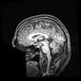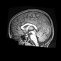

Figure 1: MRI of ASD

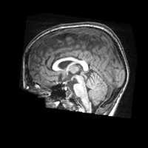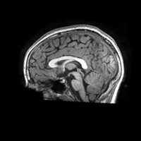

Figure 2: MRI of Normal

2.2. Pretrained CNN Models

Deep learning techniques used in recent years are frequently used in medical image processing and classification areas as in many fields. By applying deep learning techniques to MRI, X-ray or other related data, meaningful results are tried to be obtained from medical data. Analysis of image and signal data obtained with MRI or related data with the help of deep learning models. As a result of these analyzes, the detection and diagnosis of diseases such as Parkinson's, pneumonia and schizophrenia are facilitated. Classification results were obtained according to different proposed structures.

In this study, we have proposed classification of ASD using a deep convolution neural network based pre-trained models and brain MRI. The ResNet18, AlexNet, VGG16, VGG19 and DenseNet169 pre-trained models output becomes the input of the specified network topology. Output is obtained by passing through the data layers. For each pre-trained model, Adam, Padam and SGD Momentum optimizer are run separately. The experiment was run separately for each pre-trained model. This structure is described in the figure below.

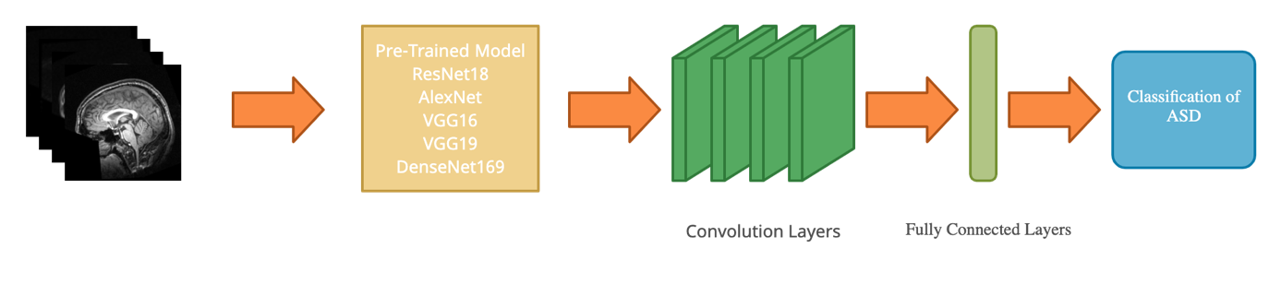
Figure 3: Representation of pre-trained models for the prediction of ASD

Brain MR's as input reaches the fully connected network by passing through the convolutional layers. Then the classification process is conduct. A visual representation of the activation maps is given in figure below.

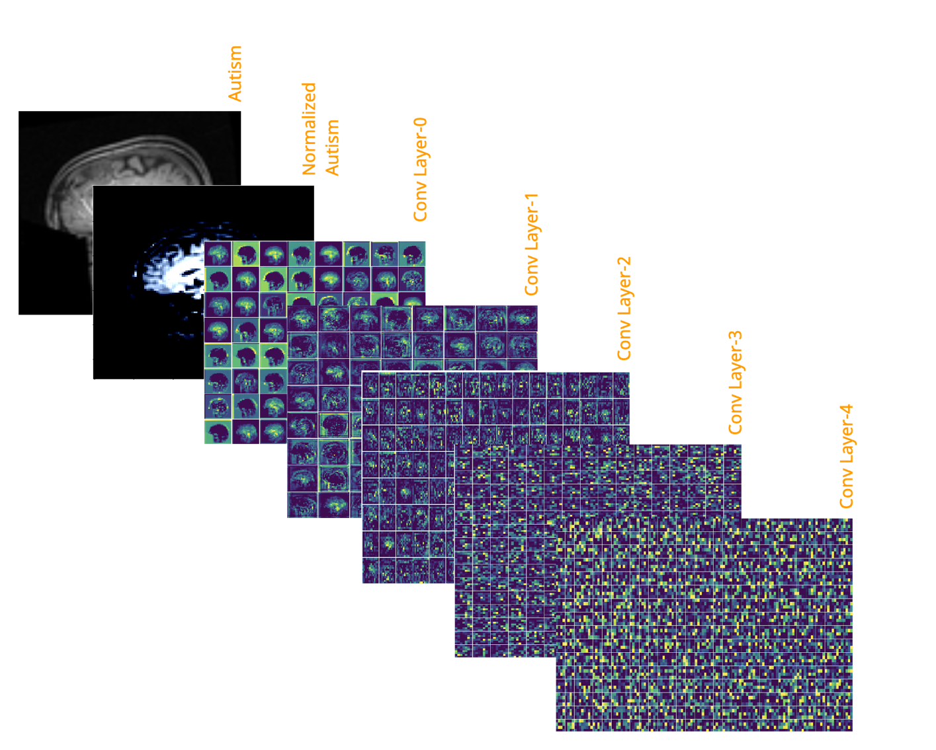
Figure 4: Visual representation of Conv Layer maps in the Resnet18 model
In order to increase the accuracy rate by extracting features, Resnet18, which is the best result among pre-trained models, and ML algorithms are combined. The established structure was operated separately with 3 different ML algorithms (SVM, kNN, Logistic Regression) and the results were observed. This structure is described in the figure below.

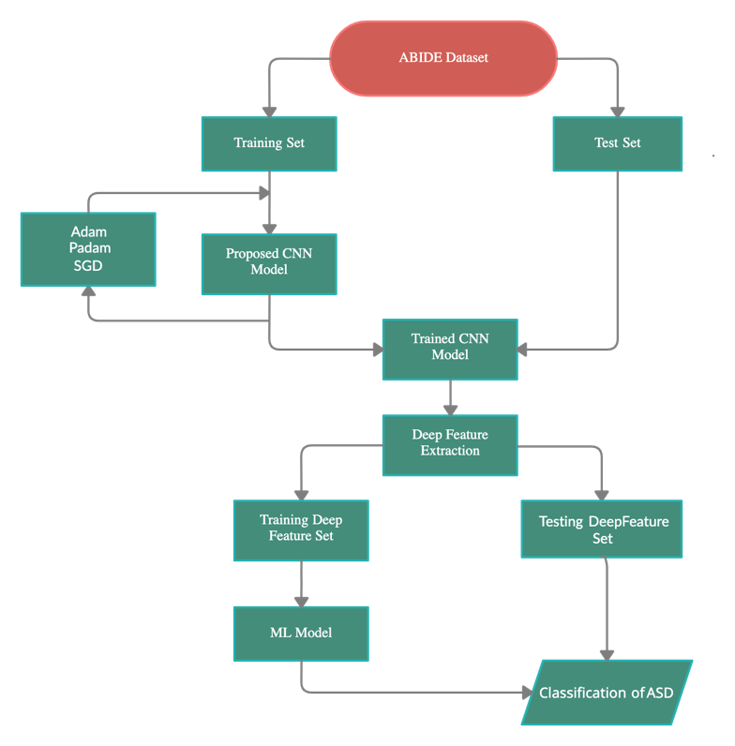
Figure 5: Block diagram of the CNN+ML model

2.3. Experimental Setup

Python programming language, with the base of PyTorch and Sklearn for CNN and ML respectively, was used to train and test the on our environment. All experiments were performed on the Google Colaboratory using its GPU with the number of workers as 4.
The dataset used was randomly split into two independent datasets with the ratio of 0.8, that is 896 for training and 294 for testing. Furthermore, training and testing datasets were resized to 112*112, center cropped (squared), gray-scaled, and normalized by the mean of [0.485, 0.456, 0.406] and standard deviation of [0.229, 0.224, 0.225]. Train data were also set to be shuffled on each epoch and the batch size was experimentally set from 2^5 to 2^7.
CNN models (ResNet18, AlexNet, VGG16, VGG19 and DenseNet169) were used as pre-trained on ImageNet, and fine-tuning (frozen first convolution block) and full training were experimented as well. Two novel, SGD+Momentum & Adam, and one recent, Padam, optimizers were used with various learning rate, momentum, partial, betas and weight decay parameter values. The learning rate for Adam, Padam, and SGD was 0.001, 0.001 and 0.01, respectively. Moreover, for Adam and Padam, the learning rate was reduced by 1/10 for each quarter of total epoch size. For example, in a 200 epochs training, if started with lr = 0.001, it is updated to 0.0001 in epoch 50, 0.00001 in epoch 100, and 0.000001 in epoch 150.
Each experiment was run on 200 epochs with validation using testing data once in 10 epochs. Moreover, on each validation and the final test, the accuracy was compared to previously stored results and saved as a new weight file if it is better than the older.
On the 10-fold cross validation partitioning for ML algorithms, seed was set to 17 in order to prevent the result consistency.
After getting results from pre-trained CNN models, feature extraction via the best CNN model was applied to whole dataset. Then by using 10-fold cross validation, SVM, LR and kNN were performed on extracted feature sets.
Train Set
Test Set

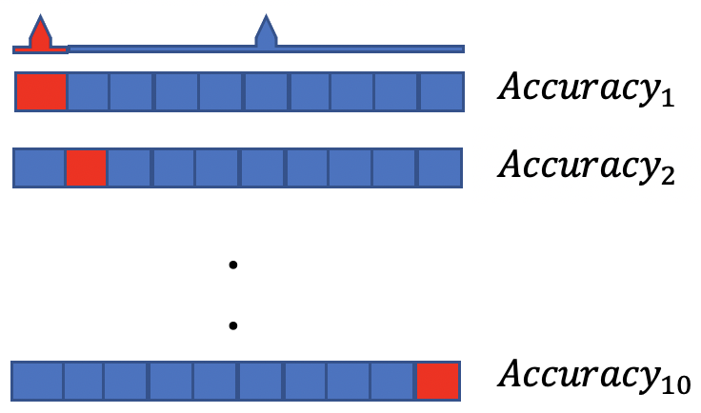
$$\frac{1}{10}\sum_{k=1}^{10}{{Accuracy}_{k}}$$
Figure 6: Display of the 10-Fold Cross Validation

- RESULTS AND DISCUSSION

In this study, Autism disorder MR images have been used for the classification of ASD patients. The most used pre-trained models such as ResNet18, AlexNet, VGG16, VGG19 and Densenet169 have been trained and tested on MR. The training stage has been conducted up to 200 epochs, and tested & compared to avoid results from overfitted trainings. It can be seen from Figures that It has been observed that all models have reached nearly 100% training accuracy with all optimizers. However, it is seen that Adam optimizer on almost all models shows a faster training process than other optimizers. Although the pre-trained models give very high initial values, the initial values are below 70% due to the low amount of data. In the CNN model, the convergence speed for Adam, Padam, SGD with Momentum is observed as VGG16, DenseNet169, VGG19, respectively. The training accuracy, Validation and loss values of ResNet18, AlexNet, VGG16, VGG19 and DenseNet169 are shown in Figures below.
Colors for Adam, SGD and Padam are as specified here.

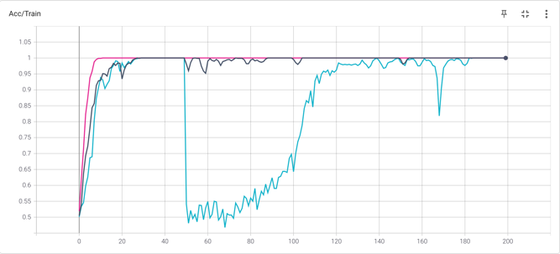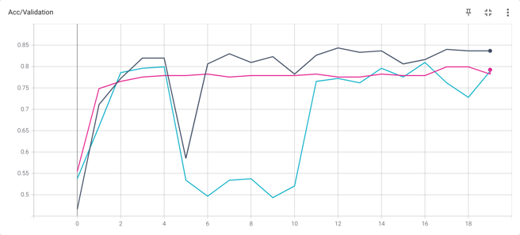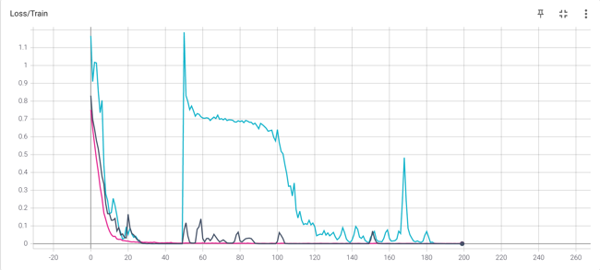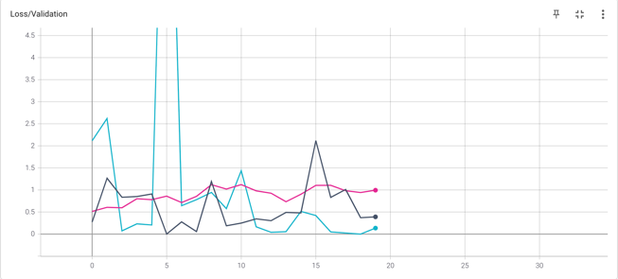
Figure 7: The Performance of Resnet18

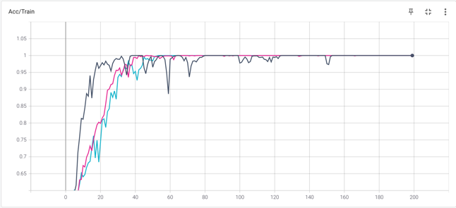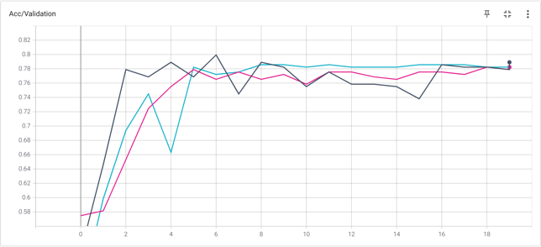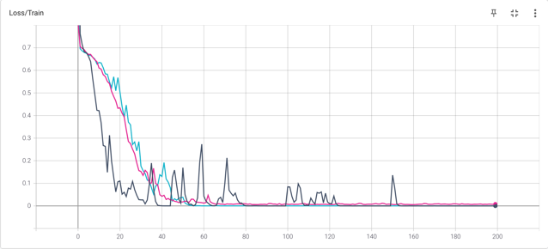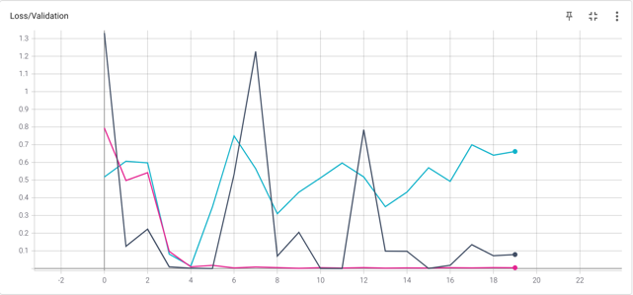
Figure 8: The Performance of AlexNet

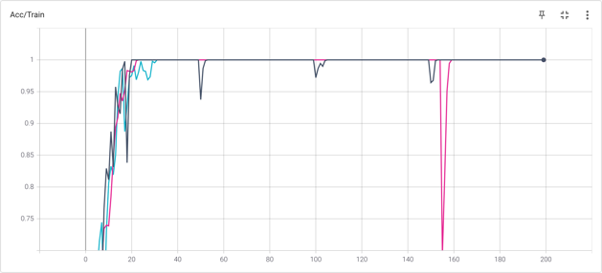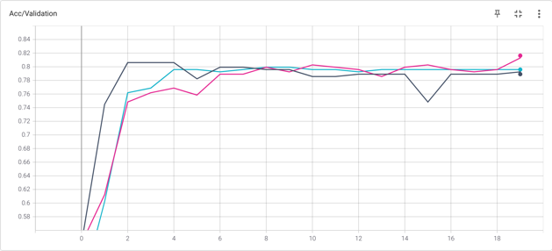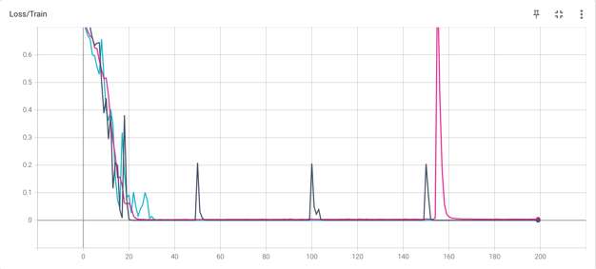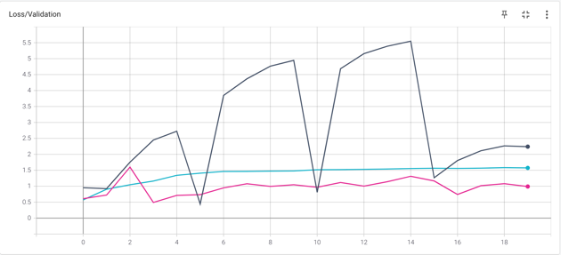
Figure 9: The Performance of VGG16

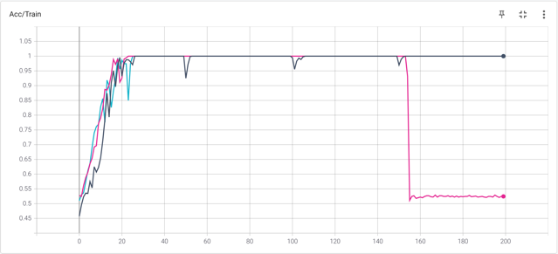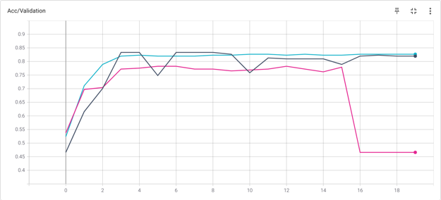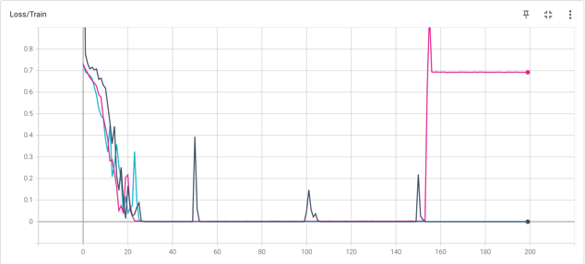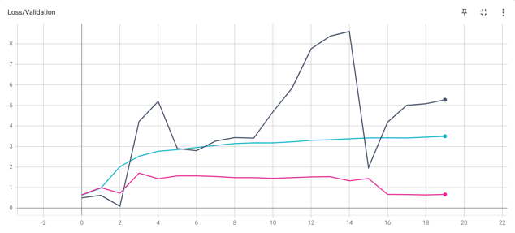
Figure 10: The Performance of VGG19

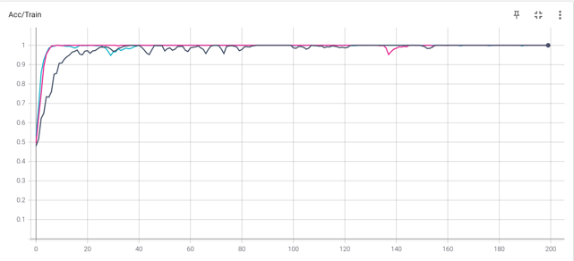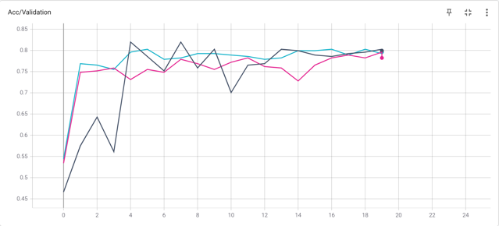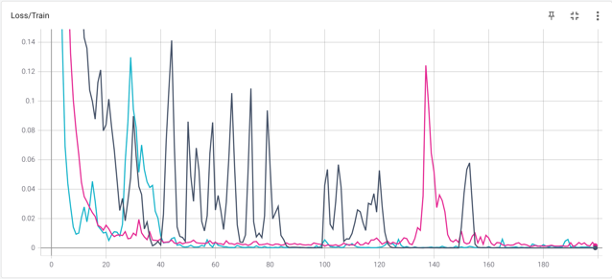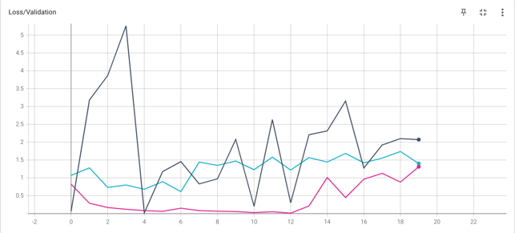
Figure 11: The Performance of DenseNet169

Table 2: Prediction performance results obtained CNN
 | CNN
Test Accuracy (%) | Adam | SGD Momentum | Padam
Resnet18 | 84.35 (120 epoch) | 80.95 (160 epoch) | 79.93 (180 epoch)
AlexNet | 79.93 (60 epoch) | 78.57 (80 epoch) | 78.23 (180 epoch)
VGG16 | 80.61 (20 epoch) | 79.93 (80 epoch) | 81.63 (190. epoch)
VGG19 | 83.33 (30 epoch) | 82.65 (100 epoch) | 78.23 (60 epoch)
DenseNet169 | 81.97 (40 epoch) | 80.27 (50 epoch) | 79.59 (190 epoch)

It can be seen from the above table the best result was obtained by using Adam in ResNet18 model with 84.35%. Hence ResNet18 pre-trained model and ML algorithms were combined and the results were obtained. Results are as follows. Feature extraction were performed by the cut of the feature block of Torchvision model ResNet, and 512 features were obtained for each sample.

Table 3: Performance metrics obtained from CNN & ML models separately and combined
Approach | Method | Accuracy (%) | Sensitivity (%) | Specificity (%)
Machine Learning  (10-Fold CV) | Support Vector Machine | 62.43 | 63.76 | 61.49
 | *Logistic Regression | 63.44 | 62.62 | 64.23
 | k-Nearest Neighbors | 57.64 | 54.77 | 64.18
Convolutional Neural Networks  (Bests from Table 2) | *Resnet18 (Adam) | 84.35 | 90.51 | 78.98
 | VGG19 (Adam) | 83.33 | 89.20 | 78.06
 | VGG19 (SGD+Momentum) | 82.65 | 86.01 | 79.47
ML Classifier with Deep Features Extracted from CNN | SVM with feature extraction of Resnet18 | 95.96 | 97.85 | 94.29
 | LR with feature extraction of Resnet18 | 96.05 | 97.85 | 94.44
 | kNN with feature extraction of Resnet18 | 93.02 | 90.71 | 95.48

It can be seen from the above table that the approaches of using purely ML and CNN methods have their best in-approach results from Logistic Regression and ResNet18 respectively. However, apparently, extracting the deep features from the convolutional base (feature block) of ResNet18, and then classifying them on LR have the overall best results for our experiments. The average confusion matrices after 10-Fold CV of all ML models used on classifying deep features obtained from ResNet18 are as follows:

Sensitivity = TP / (TP + FN)

Accuracy = (TP + TN) / (TP + TN + FP + FN)

Specificity = TN / (TN + FP)

- CONCLUSION

Autism spectrum disorder (ASD) is a common neuro developmental disorder, which has affected 62.2 million ASD cases in the world in 2016. Clinicians still rely on manual delineations, a prohibitively time-consuming process, which depends on rater variability and is prone to inconsistency (4). Therefore, there is a critical need for fast, accurate, reproducible, and fully automated methods for segmenting MRI brain data. Hence It has been evaluated that it is crucial to classify Autism spectrum disorder quickly and effectively.

The study consists of 2 main stages. In phase 1, The most used pre-trained models such as ResNet18, AlexNet, VGG16, VGG19 and Densenet169 have been trained and tested on Autism dataset. All pre-trained models were trained with Adam, Padam and SGD optimizer, and results were obtained. At this stage, the best result was obtained by using Adam in ResNet18 model with 84.01%. In the CNN model, the convergence speed for Adam, Padam, SGD was observed as VGG16, DenseNet169, VGG19, respectively. In phase 2, ResNet18 pre-trained model and ML algorithms were combined and the results were obtained. 10-fold cross validation method was chosen and results were obtained the best results for SVM, Logistic Regression and kNN users were obtained from SVM + CNN model with 95.29%. It is considered that the results obtained are better than other results in the literature and a significant contribution is made to the literature for the diagnosis of Autism disease with the proposed structures. In future studies, the same brain MRI can be used to diagnose neural diseases such as schizophrenia, autism, and Alzheimer's. This may be pave the way for the study to be conducted on animals as well.

REFERENCES

- Koolschijn, P., van Haren, N.E., Lensvelt-Mulders, G.J., Pol, H., Hilleke, E., Kahn, R.S., 2009. Brain volume abnormalities in major depressive disorder: a meta-analysis ofmagnetic resonance imaging study. Human Brain Mapp. 30 (11), 3719–3735.
- Langen, M., Schnack, H.G., Nederveen, H., Bos, D., Lahuis, B.E., de Jonge, M.V., vanEngeland, H., Durston, S., 2009. Changes in the developmental trajectories of striatum in autism. Biol. Psychiatry 66 (4), 327–333.
- Martino A Di, C. G. Yan, Q. Li, E Denio, F. X. Castellanos, K Alaerts, J. S. Anderson, M. Assaf, S. Y. Bookheimer, and M Dapretto. The autism brain imaging data exchange: Towards a large-scale evaluation of the intrinsic brain architecture in autism. Molecular Psychiatry, 19(6):659-667, 2014.
- Deeley, M., Chen, A., Datteri, R., Noble, J., Cmelak, A., Donnelly, E., Malcolm, A.,Moretti, L., Jaboin, J., Niermann, K., 2011. Comparison of manual and automatic segmentation methods for brain structures in the presence of space occupying lesions: a multi-expert study. Phys. Med. Biol. 56 (14), 4557.
- Xinyu Guo, Kelli C. Dominick, Ali A. Minai, Hailong Li, Craig A. Erickson, and Long J. Lu. Diagnosing autism spectrum disorder from brain resting-state functional connectivity patterns using a deep neural network with a novel feature selection method. Frontiersin Neuroscience, 11:1-19, 2017.
- Yazhou Kong, Jianliang Gao, Yunpei Xu, Yi Pan, Jianxin Wang, and Jin Liu. Classification of autism spectrum disorder by combining brain connectivity and deep neural network classier. Neurocomputing, 324:63-68, 2019.
- Xiaoxiao Li, Nicha C Dvornek, Xenophon Papademetris, Juntang Zhuang, Lawrence HStaib, Pamela Ventola, and James S Duncan. 2-channel convolutional 3D deep neural network (2CC3D) for fMRI analysis: ASD classification and feature learning. In 2018 IEEE15th International Symposium on Biomedical Imaging (ISBI 2018), pages 1252-1255. IEEE, 2018.
- Meenakshi Khosla, Keith Jamison, Amy Kuceyeski, and Mert R Sabuncu. 3D convolutional neural networks for classification of functional connectomes. In Deep Learning in Medical Image Analysis and Multimodal Learning for Clinical Decision Support, pages137-145. Springer, 2018.
- Sarah Parisot, Soa Ira Ktena, Enzo Ferrante, Matthew Lee, Ricardo Guerrerro Moreno, Ben Glocker, and Daniel Rueckert. Spectral graph convolutions for population-based disease prediction. In International Conference on Medical Image Computing and Computer-Assisted Intervention, pages 177-185. Springer, 2017.
- Rushil Anirudh and Jayaraman J Thiagarajan. Bootstrapping graph convolutional neural networks for autism spectrum disorder classification. 2019 IEEE International Conference on Acoustics, Speech and Signal Processing (ICASSP), pages 3197-3201, ICASSP, 2019.
- Xia-an Bi, Yingchao Liu, Qin Jiang, Qing Shu, Qi Sun, and Jianhua Dai. The diagnosis of autism spectrum disorder based on the random neural network cluster. Frontiers in human neuroscience, 12:257, 2018.
- Nicha C. Dvornek, Pamela Ventola, Kevin A. Pelphrey, and James S. Duncan. Identifying autism from resting-state MRI using long short-term memory networks. In International Workshop on Machine Learning in Medical Imaging, pages 362-370. Springer, 2017.
- Fahad Saeed, Taban Eslami, Vahid Mirjalili, Alvis Fong, and Angela Laird. ASD-diagnet: A hybrid learning approach for detection of autism spectrum disorder using fmri data. Frontiers in Neuroinformatic, 13:70, 2019.
- Dongren Yao, Mingxia Liu, Mingliang Wang, Chunfeng Lian, Jie Wei, Li Sun, JingSui, and Dinggang Shen. Triplet graph convolutional network for multi-scale analysis of functional connectivity using functional MRI. In International Workshop on Graph Learning in Medical Imaging, pages 70-78. Springer, 2019.
- Anibal Solon Heinsfeld, Alexandre Rosa Franco, R. Cameron Craddock, Augusto Buchweitz, and Felipe Meneguzzi. Identification of autism spectrum disorder using deep learning and the abide dataset. Neuroimage Clinical, 17:16-23, 2018.
- Hongyoon Choi. Functional connectivity patterns of autism spectrum disorder idented by deep feature learning. arXiv pre-print arXiv:1707.07932, 2017.
- Heather Cody Hazlett, Hongbin Gu, Brent C Munsell, Sun Hyung Kim, Martin Styner, Jason J Wol, Jed T Elison, Meghan R Swanson, Hongtu Zhu, Kelly N Botteron, et al. Early brain development in infants at high risk for autism spectrum disorder. Nature, 542(7641):348, 2017.
- Sofia Ira Ktena, Sarah Parisot, Enzo Ferrante, Martin Rajchl, Matthew Lee, Ben Glocker, and Daniel Rueckert. Metric learning with spectral graph convolutions on brain connectivity networks. Neuro Image, 169:431-442, 2018.
- Castellanos FX, Di Martino A, Craddock RC, Mehta AD, Milham MP (2013) Clinical applications of the functional connectome. NeuroImage 80: 527‑40.

## TODO:
- Padam için referans eklenmeli
- Optimizerlar için final momentum, partial, betas, weight decay değerleri
  - Gerekli mi?
- ResNet18 %84.35 sonuç alınan pth dosyasının drive/github linki eklenmeli

