Introduction
Before colleges can recruit students, they must assemble a pool of prospective students. This presents a classic “make-or-buy” decision about organizational boundaries (Coase 1937; Pfeffer and Salancik 1978). In practice, most colleges do both, building prospect pools through their own outreach and relationships while also purchasing leads from a well-developed third-party lead-generation industry (Ruffalo Noel-Levitz 2022b). Therefore, the population available for recruitment is substantially assembled outside colleges’ organizational boundaries (EAB 2018). Understanding college recruiting requires examining not only what colleges do with prospect pools, but also the third-party organizations and products through which those pools are constructed.
Yet scholarship on college access has paid little attention to how third-party products classify students and construct the populations on which colleges act. Recent syntheses show that college-access scholarship centers familiar actors – students and families, schools, colleges, and policymakers – and institutional processes such as curriculum and tracking, advising, recruiting, admissions, financial aid, and college choice (Domina et al. 2017; Stevens et al. 2008). Taken together, this literature focuses on the processes through which students and direct providers (i.e., schools and colleges) interact. Even studies of recruiting generally treat it as behavior undertaken by colleges (Stevens 2007; Author XXXXa, XXXXb; Khan 2011). Third-party vendors, products, and infrastructures that sort and classify students on behalf of colleges looking for customers have not become a central object of inquiry in college-access scholarship.
The integration of Geomarkets into the College Board Student Search Service illustrates how vendors shape which prospective students become available for recruitment. Scholarship has extensively examined College Board’s student-facing testing products (Rodriguez and McGuire 2019; Goodman et al. 2020) but has largely overlooked the college-facing enrollment-management products built atop its testing platform. Student Search Service sells “student lists” containing prospective students’ contact information, or “profiles.” Colleges select which profiles to purchase using search filters such as test score, graduation year, and geography. Geomarkets, developed by Zemsky and Oedel (1983), are proprietary recruiting territories that divide states and metropolitan areas into smaller geographic units. We conceptualize Geomarkets and Student Search Service as distinct but integrated market devices that define categories, organize prospect populations, and make particular recruiting actions possible (Muniesa et al. 2007; Hirschman and Garbes 2019). Within Student Search Service, colleges can use the Geomarket search filter to include or exclude prospects. Because residential space is racially and socioeconomically structured, filtering by Geomarket may produce unequal visibility among academically similar students, thereby structuring college access before admissions begins.
This manuscript investigates how Geomarket filtering within Student Search Service can shape the racial/ethnic and first-generation composition of academically similar prospect pools. When colleges purchase a student list, they observe only the profiles generated by the filters they select. They do not observe the counterfactual prospect pools that alternative filter selections would have returned. We construct these counterfactual prospect pools by analyzing student-list purchases that include all Geomarkets within a metropolitan area. Holding academic criteria constant, we use these pools to answer three questions about the categories defined by the filter, the distribution of groups across those categories, and the consequences of excluding particular categories:
- What is the composition of each Geomarket? To what extent do College Board Geomarkets partition academically similar prospects into racially and socioeconomically distinct pools within metropolitan areas?
- Where does each group come from? Which Geomarkets contribute disproportionately to different racial/ethnic and first-generation-status groups within academically similar prospect pools?
- What happens when a Geomarket is excluded? How does excluding particular Geomarkets change the composition of the prospect pool made visible to colleges?
We answer these questions using actual student lists purchased by public universities, which we obtained through public records requests. We digitized College Board Geomarket maps published in College Board (2023) into GIS shapefiles and assigned prospects to Geomarkets. We present detailed analyses of the Chicago metropolitan area and compare the results with those for other metropolitan areas in the Online Appendix. Geomarkets partition academically similar prospects into racially and socioeconomically distinct pools, making the representation of particular groups depend on which territories are included in a purchase. In Chicago, excluding the “IL 11 - City of Chicago” Geomarket disproportionately reduces the representation of Black, Hispanic, and first-generation Asian prospects. Across metropolitan areas, many Black, Hispanic, and first-generation Asian students with competitive test scores live outside affluent Geomarkets. Filtering toward affluent Geomarkets and away from poorer ones can therefore disproportionately exclude these students from colleges’ prospect pools.
These analyses contribute to college-access scholarship by moving inquiry upstream from observable college behavior to the third-party products that make particular forms of organizational behavior possible. The Geomarkets case shows how inequality can be structured through product features that organize which students become the object of recruiting. Products neither dictate institutional behavior nor neutrally execute preexisting preferences; their consequences emerge as product affordances interact with organizational priorities and established practices. More broadly, this case motivates a sociology of vendor-mediated education that understands products purchased by direct providers as integrated stacks of market devices. Decomposing these stacks allows researchers to isolate particular device arrangements that can amplify inequality when a product is used as intended. The broader edtech market is largely composed of for-profit companies, including private-equity-owned and publicly traded firms (Nichols and Dixon-Román 2024). A sociology of vendor-mediated education should therefore connect the edtech market – investors, firms, and products – to the device arrangements through which educational sorting and inequality occur.
In the following sections, we review scholarship on college access and student lists, provide background on Geomarkets and the Market Segment Model, develop a conceptual framework based on market devices, describe the data and methods, present results for Chicago and other metropolitan areas, and discuss implications for scholarship.

Literature and Case

Literature Review
College access. Sociology explains inequality in college access through two broad traditions. The status-attainment tradition argues that educational attainment and college destinations are strongly patterned by family socioeconomic background, especially parental education, occupation, and income (Blau and Duncan 1967; Sewell and Shah 1968). A second tradition, drawing on Bourdieu’s (1984) theory of cultural capital and Weberian accounts of status-group competition (Collins 1994), emphasizes how privileged households and elite institutions reproduce advantage (Huang 2023; Lee and Kramer 2013; Karabel 2005). A related body of scholarship examines how college behavior and processes shape access for students. This literature focuses on selective admissions processes (e.g., holistic admissions, test-optional) (Hsu and Sharkey 2025; Bastedo et al. 2016) and to a lesser extent financial aid (McPherson and Schapiro 1998; Doyle 2010), and is often set against macro institutional forces such as college rankings, affirmative action, and college entrance exams (e.g., Alon 2009).
A growing literature on recruiting examines how colleges identify and solicit the prospective students they hope to convert into applicants. Ethnographies by Stevens (2007) and Khan (2011) identify connections between private school guidance counselors and college admissions officers as a mechanism for social reproduction. In turn, recruiting visits to high schools are a means of maintaining ties with guidance counselors at feeder schools (Stevens 2007; Ruffalo Noel-Levitz 2022b). Quantitative case-studies of off-campus recruiting visits by public research universities and by selective private universities reveal a preference for visiting private schools and affluent, predominantly White public schools (Author XXXXb, XXXXc, XXXXa). From the student perspective, Holland (2019) finds that underrepresented students were drawn to colleges that made them feel wanted, often attending institutions with lower graduation rates and requiring larger loans than other college options. Cottom (2017) shows that for-profit colleges found a niche in Black and Latinx communities because traditional colleges ignored these communities. Collectively, this literature examines where colleges direct recruiting efforts and how students respond, largely taking for granted how the population available for recruitment is constructed.
However, analyzing recruiting as college behavior obscures the commercial infrastructures that structure which students are targeted by which colleges. College recruiting is shaped by the broader enrollment management industry, including third-party servicers (e.g., College Board and EAB) that supply databases, classifications, software, and consulting services. Collectively, these products do not merely execute colleges’ preferences; they help define the options available to colleges and the populations on which they can act. Scholarship on college access has largely ignored the role of third-party servicers (but see Huang 2023). One important exception is Hamilton et al. (2024). Their analysis of contracts between public universities and online program managers shows how outsourcing recruitment can create incentives to target marginalized students for potentially extractive online programs. By contrast, this manuscript investigates the incorporation of proprietary geographic territories within a third-party, lead-generation product to show how seemingly “mundane administrative arrangements” (Selznick 1957) can encode and reproduce inequality in college access.
Student list products. Lead generation is the process of converting “prospects” – consumers a business wants to target – into “leads” – prospects whose contact information has been obtained (Federal Trade Commission 2016). In enrollment management, “student lists” (also called “names”) are spreadsheets that contain the contact information of prospects (Belkin 2019). Student lists are a fundamental input for undergraduate recruiting campaigns because purchased names – alongside prospects who reach out on their own – constitute the set of prospects who receive subsequent recruiting interventions (e.g., mail, email) designed to push them to apply and enroll. Student list products are “selection devices” – routines for making decisions about who receives an intervention (Hirschman and Bosk 2020) – that enable colleges to select which names they purchase by incorporating search filters (e.g., HS graduating class, state, test score). For example, a college might select all California prospects from the 2028 HS class, with a GPA of 3.5+, and an SAT score between 1200-1300. Historically, the largest student list vendors are College Board and ACT, which create student list products based on their database of test-takers. In 2021, the College Board Student Search Service charged $0.50 per name (College Board 2021).
Ruffalo Noel-Levitz (2022b) reports that 86% of public colleges and 87% of private colleges purchase student lists. For public universities that purchased lists, 80% purchase more than 50,000 names annually. Ruffalo Noel-Levitz (2022a) reports that student lists were the top expenditure item in the undergraduate recruiting budget for both private and public institutions in 2022. Prior research finds a positive relationship between student lists and student outcomes [Howell et al. (2021)]. After controlling for SAT scores, parental education, and school fixed effects, 41.1% of SAT test-takers who opted into Student Search Service – thereby allowing colleges to purchase their contact information – attended a four-year college, compared with 32.8% of those who opted out (Howell et al. 2021).
However, Author (XXXXd) argue that student list products are selection devices that exacerbate racial inequality in college access. Norris (2021) defines “racialized inputs” as ostensibly race-neutral inputs that are systematically correlated with race because marginalized racial/ethnic groups have historically been excluded from the input. Several frequently utilized student list filters (e.g., zip code, AP test score) meet the criteria of racialized inputs. For example, colleges may purchase prospects that achieve a certain score on a certain AP test, but Black and Hispanic students are more likely to attend high schools with fewer AP offerings (Rodriguez and McGuire 2019). Using a national sample of high school students and also data from actual student lists purchased by public universities, Author (XXXXd) show that racialized search filters have a strong negative relationship with the selection of Black and Latinx prospects.
Because residential space in the United States is racially and socioeconomically segregated, selection devices that include or exclude prospects based on geography can function as ostensibly neutral mechanisms of unequal selection (O’Neil 2016; Harcourt 2007). Student Search Service offers filters based on familiar geographic boundaries (e.g., ZIP codes, counties, CBSAs, and states) as well as proprietary boundaries created by College Board, including Geomarkets. Many third-party lead-generation products incorporate proprietary geographies (Author XXXXe; McKelvey 2022). These classifications warrant particular attention because they may be strongly related to race and class, yet product users may be unaware of these relationships. Although Author (XXXXd) analyzed multiple racialized filters, they did not analyze Geomarkets because doing so requires reconstructing the proprietary boundaries. This manuscript investigates which prospects are included or excluded when student list purchases filter on particular Geomarkets, thereby showing how vendor-created categories can change the racial and class composition of colleges’ prospect pools.

The Case: Geomarkets and The Market Segment Model
Zemsky and Oedel (1983) developed Geomarkets and the Market Segment Model for a project that sought to predict demand for any college by students from any locality. The College Board underwrote the project – providing financial support and data – as part of its entry into the market for student-recruitment services. Because the project sought to “capture and quantify” (p. 11) the knowledge of admissions officers, the initial analytic task was to define geographic boundaries “in a manner consistent with admissions officers’ intuitive understanding of student pools” (Zemsky and Oedel 1983, 4). As such, Zemsky and Oedel (1983) [p. 11] created “three types of boundaries – region, state, and community.” The initial regions in the project were New England, Middle States, and the South. Next, they “divided each state into as few as two and as many as thirty community-based enrollment markets or pools, for a total of 143 separate markets” (p. 11). These enrollment markets, later called Geomarkets, were intended to reflect admissions counselors’ own understandings of catchment markets. Zemsky and Oedel (1983, 11–12) described the creation of Geomarket borders briefly:
In many cases, the market boundaries match formal political and educational divisions, reflecting natural channels of communication. Each major metropolitan area is composed of several markets, usually corresponding to the inner city, a first ring of suburbs, and an outer ring of suburbs.
Described as “nothing more than a set of simple rules for disaggregating high school seniors into similar groups” (Zemsky and Oedel 1983, 4), the Market Segment Model classified prospective students into one of four market segments – local, in-state, regional, national – based on their SAT score-sending behavior. Students in the “local” segment submit more SAT scores to colleges in their home Geomarket than to colleges in any other geographic category, while students in the “in-state” segment submit more scores to colleges outside their Geomarket but within their state than to colleges in any other category, etc.
The Market Segment Model yielded tautological, yet powerful recommendations for college recruiting efforts. For example, students in the local market segment are considering colleges in their home Geomarket. Community colleges rely on enrollment from students who live nearby and should concentrate recruitment on students from the local segment who live in the same Geomarket as the college. By contrast, selective private colleges – and public universities looking for out-of-state students – should focus on students from the regional and national market segments.
Zemsky and Oedel (1983) identify four variables – parental education, family income, scholastic aptitude, and educational aspirations – that predicted whether a student belongs to the local, in-state, regional, or national market segment. The resulting thesis is that student demand for college is a function of social origin. However, Geomarkets differ in the relative abundance of students with particular socioeconomic characteristics. As college leaders sought new sources of patronage, the Market Segment Model yielded implications about which communities to target. Zemsky and Oedel (1983, 44) recommend that colleges target Geomarkets with desirable compositions of socioeconomic characteristics in order to reach students from desired student market segments:
On occasion, senior spokespersons for the profession worry that students outside the main [Geo]market areas remain forgotten and hence, unchallenged. Inevitably, the increasing competition for students, the expense of travel and mailings, and internal political constraints compel institutions to concentrate their efforts where they will do the most good. The result is a natural reinforcing of the basic socioeconomic patterns that gave shape in the first place to the structure of college choice.
In 1984, the logic and analytic outputs associated with the Market Segment Model became the basis for the College Board Enrollment Planning Service (EPS), an early software-as-a-service product sold to colleges. EPS helps colleges identify which Geomarkets to recruit from and which high schools to visit within those Geomarkets (College Board 2022). College Board (2005) marketing material describes EPS as, “the marketing software that pinpoints the schools and Geomarkets where your best prospects are most likely to be found.” Market research suggests that EPS was highly salient. In 1995, 37% of 4-year publics and 49% of 4-year privates used EPS, while 41% of 4-year publics and 16% of 4-year privates used ACT’s market analysis service product (Noel-Levitz 1998).
Geomarkets also became a search filter in the Student Search Service. Anticipating this integration, Zemsky and Oedel (1983, 42–44) describes a hypothetical selective college that realizes its enrollment goals by filtering on affluent Geomarkets when deciding which prospect profiles to purchase. College Board (2022) marketed EPS as a complement to the Student Search Service, describing it as “an analysis and reporting service that enables admission professionals to better understand the student market and the lists they license with Student Search Service.”

Theoretical Framework: Market Devices
Muniesa et al. (2007) argue that markets do not exist a priori waiting to be observed; they are constructed by market devices. Market devices are tools for calculating, comparing, and classifying (e.g., algorithms, metrics, rankings) that become incorporated into products and transactions “that make economic action possible” (Hirschman and Garbes 2019, 1176). Muniesa et al. (2007, 2) define market devices as a “way of referring to the material and discursive assemblages that intervene in the construction of markets.” Assemblages refers to a bundle of heterogeneous components that work together, suggesting that market devices consist of and build upon other market devices. Commonly studied market devices include spreadsheets, interactive dashboards, credit scores, and financial trading software (Muniesa et al. 2007). We conceive of Geomarkets and the Student Search Service as distinct but integrated market devices. Within Student Search Service, the Geomarket market device is incorporated as a search filter that enables colleges to identify and select prospective students.
Market devices shape what actors can do and what they can see. The “affordances” of a market device are the practical actions the device enables, including built-in options, settings, and outputs that enable users to do some things more easily than others. “Framing” refers to how the device constructs the decision situation, including what is rendered visible, eligible, and meaningful for action. In Student Search Service, the relevant affordance is the ability to include or exclude prospects using predefined filters. The Geomarket filter affords users the ability to select prospects who live in particular Geomarkets. The relevant frame of the Student Search Service is the purchased list of prospects that satisfied all search criteria. Here, users observe who appears in the selected list, not the counterfactual pools associated with alternative filter choices. The potential harm from the affordances or framing of a market device is consistent with scholarship on algorithmic bias (Hirschman and Garbes 2019), which demonstrates how seemingly neutral data systems can yield disparate treatment without discriminatory intent (O’Neil 2016; Harcourt 2007). The concern is whether the market device creates stratified affordances based on racial and socioeconomic classification that render differential treatment as a routine organizational practice.
In the market devices framework, neither market devices nor actors have agency in isolation. Agencement refers to an arrangement that creates capacity for action. It is a configuration of devices, people, organizational goals, routines, and incentives that makes some courses of action available, recognizable as choices, and more likely than others (Çalışkan and Callon 2010). Consider a public research university in the South that’s facing prolonged state disinvestment, has strong enrollment demand in the South and Southwest, and decides to prioritize nonresident enrollment growth as a means of pursuing the enrollment goals of tuition revenue and academic profile. Agencement is the arrangement linking state disinvestment, enrollment goals, Student Search Service filters, recruitment communications, and financial aid leveraging routines. Student Search Service enables the university to purchase prospect pools that are responsive to these financial pressures and enrollment goals. It makes particular actions, such as buying names from particular regions or score bands, available and legible while leaving alternative prospect pools outside the frame of the chosen search.
Analysis of the Houston residential real estate market by Korver-Glenn (2018), as interpreted by Hirschman and Garbes (2019), shows how geographic market devices can be a mechanism of racial inequality. Every home listing is assigned to a Houston Association of Realtors (HAR) “market area” – a market device akin to Geomarkets – based on the address of the property. Korver-Glenn shows that HAR market areas were racially uneven in both composition and population size. Majority-White HAR market areas were greater in number but with fewer residents and more socioeconomically homogeneous than majority-Black or majority-Hispanic market areas (Korver-Glenn 2018). Because appraisals are based on recent comparable sales within the same HAR market area, homes in high-income white neighborhoods received higher appraisal values than homes in high-income Black or Hispanic neighborhoods.
Although larger than HAR market areas, Geomarket borders may be highly correlated with race and class. Geomarkets translated the class-centered Market Segment Model into a set of recruiting territories. Because Geomarkets often follow the urban core versus suburban ring divisions of metropolitan areas (Zemsky and Oedel 1983) that correspond to U.S. class segregation (Reardon and Bischoff 2011) and racial segregation (Korver-Glenn 2018), we expect Geomarkets in large metropolitan areas to be correlated with both race and class. For example, the affluent, predominantly White “IL 9 - North Shore” Geomarket, had a 2020 population of about 161,000 while “IL 13 - South & Southwest Suburbs” Geomarket had a 2020 population of about 1.2 million [AUTHOR CALCULATIONS]. Additionally, some Geomarket boundaries mirror familiar racialized divisions in metropolitan housing markets. Examples include: the “South and South Central Los Angeles” Geomarket (CA21); the “City of Oakland” Geomarket (CA07), surrounded by the “Alameda County excluding Oakland” Geomarket (CA08); and the “Wayne County Detroit” Geomarket (MI01), surrounded by the “Detroit’s Northern Suburbs” (MI02) and “Ann Arbor” (MI03) Geomarkets.

Application to the case
Our overarching research question is, how do Geomarket filters within College Board’s Student Search Service shape the racial/ethnic and first-generation composition of academically similar prospect pools made visible to colleges? This question is motivated by concepts from the market devices literature. The “affordances” of a market device are the potential actions that it enables or makes easy, given its design. The “action” the Student Search Service device allows is a student list purchase. The “outcome” is a spreadsheet that contains one row for each prospective student who met all search criteria. For a college representative interested in recruiting prospects from a particular metropolitan area, the Geomarket filter affords the ability to select any Geomarket or combination of Geomarkets. “Framing” refers to how the device constructs the decision situation, including what is rendered visible, eligible, and meaningful for action. The design of the Student Search Service product frames the decision by showing the college representative only the outcome associated with the chosen set of search filters, not the counterfactual outcomes associated with filters they could have selected (Author XXXXf). As a consequence, college representatives do not observe socioeconomic and racial differences between the student list they purchased and the student lists they could have purchased had they filtered on different Geomarkets. Therefore, the market device obscures the distributional consequences of actions by removing counterfactual outcomes from the decision-making frame.
Our analyses create a “counterfactual affordance map” that describes the racial and socioeconomic composition of prospect profiles that would have been purchased, had a student list purchase filtered on specific Geomarkets. At minimum, student list purchases typically filter on high school graduating class, a standardized test score (e.g., SAT, PSAT, AP) and/or GPA range, and a geographic filter (Author XXXXf). Holding academic criteria constant, our analyses vary the Geomarket filter to show how different filter choices change the composition of the visible prospect pool. The resulting map shows which prospects become visible under a given Geomarket selection and which academically similar prospects become invisible when particular Geomarkets are excluded. We answer the overarching question through three specific questions that examine the Geomarket filter from complementary angles: the categories it defines, the group distributions those categories organize, and the consequences of excluding particular categories from a search.
RQ1 asks, do Geomarkets partition academically similar prospects into racially and socioeconomically distinct pools? Geomarkets classify students geographically, but not explicitly by race/ethnicity or first-generation status. RQ1 asks whether those geographic categories produce racially and socioeconomically distinct prospect pools. It also shows the prospect pool generated by filtering on a single Geomarket.
RQ2 asks, which Geomarkets contribute disproportionately to different racial/ethnic and first-generation-status groups within academically similar prospect pools? Our analyses show where different racial/ethnic and first-generation groups are concentrated across the Geomarket category structure. If, for example, first-generation Asian prospects in a metropolitan area disproportionately come from one or two Geomarkets, then their visibility to colleges depends on whether those Geomarkets are included in the student list purchase.
Finally, RQ3 asks, how does excluding particular Geomarkets change the composition of the prospect pool made visible to colleges? This question examines the device’s filtering affordance by estimating how the visible prospect pool changes when a particular Geomarket is excluded from a student list purchase.
Grounding our analysis in a market devices framework directs attention to the potential for harm embedded in a device’s affordances. Consistent with scholarship on algorithmic bias (e.g., O’Neil 2016; Harcourt 2007), we examine whether filtering on different Geomarkets makes exclusionary patterns possible and actionable. This focus is salient because research documenting recruiting behavior “in the wild” demonstrates that selective private colleges and public research universities recruiting out of state focus disproportionately on affluent, predominantly White schools (Stevens 2007; Author XXXXa, XXXXb; Khan 2011). Geomarket filtering thus operates within an enrollment-management agencement consisting of market devices, organizational priorities, and recruiting practices that collectively prioritize affluent student markets. Within this agencement, the ability to include or exclude geographically defined prospect markets may make existing recruiting priorities operational. We therefore reconstruct counterfactual prospect pools to reveal the distributional consequences of this affordance.

Data and Methods

Research Design and Case Selection
Since Geomarkets partition metropolitan space into proprietary recruiting territories, we utilize a quantitative case study design in which metropolitan areas are the cases. Our empirical goal is to reconstruct how Geomarket filters within the College Board Student Search Service shape the racial/ethnic and first-generation composition of academically similar prospect pools made visible to colleges. We do so by analyzing actual student-list purchases and varying Geomarket inclusion and exclusion while holding academic search criteria constant. Consistent with our conceptual framing, Student Search Service is treated as a market device whose built-in filters define a menu of possible actions. The analyses therefore focus on the distributional consequences of one filtering affordance built into the product.
Our research questions require observing all Geomarkets within a metropolitan prospect pool. We therefore restrict analyses to metropolitan areas for which we have student-list purchases that (A) include every Geomarket, (B) define prospect pools primarily by graduating class and test-score range, and (C) repeat that structure across low, middle, and high test score bands. The primary analyses focus on prospects in the middle test score band, with results for low and high bands in the Online Appendix. We exclude purchases that layer on additional search criteria, like intended major or preferred college size, that produce dramatic and non-random reductions in prospect pools. The final sample includes the Bay Area, Chicago, Dallas, Detroit, Long Island, Los Angeles, Northern New Jersey, Orange County, Philadelphia, and San Diego.
Given space constraints, we present Chicago as the primary case because its seven Geomarkets follow the canonical metropolitan structure described by Zemsky and Oedel (1983) while exhibiting substantial racial and socioeconomic differentiation. This allows readers to observe the relationship between Geomarket composition (RQ1), group distributions (RQ2), and exclusion consequences (RQ3) within a single metropolitan structure. Results for all metropolitan areas are reported in the Online Appendix, but we provide a brief comparative discussion of high-level results across all metropolitan areas in the sample. We emphasize that Chicago is presented as an illustrative case rather than a representative metropolitan area.

Data
The primary data consist of student lists purchased through the College Board Student Search Service by public universities. We obtained these data through public records requests submitted to public universities in California, Illinois, Texas, and Arizona. The broader project dataset this manuscript draws from includes a total of 414 orders associated with 2,549,085 prospects made by 11 public universities from 2016 through 2020. Although lists were purchased by individual universities, the resulting prospect pools are a function of the search criteria specified for that student list purchase. A different university that selected the same search filters would obtain the same resulting prospect profiles, except where universities opted to exclude prospect profiles previously purchased.
For each student list purchased, we requested two related pieces of data: (1) the order summary specifying search criteria; and (2) the de-identified prospect-level list produced from those criteria. Prospect-level records contain information about students’ high schools, geographic location, race/ethnicity, parental education, and other variables included in the purchased list. We use parental education to construct a first-generation indicator.
Although this study does not aim to estimate the prevalence of Geomarket filter usage, our records request data provide some insight into how it is used in practice. Of the 414 orders in the project dataset, approximately 13% (N=52) used a Geomarket filter. These orders spanned multiple universities, years, academic thresholds, and metropolitan areas throughout the U.S. Records also suggest Geomarket filters were sometimes used to distinguish affluent communities from lower income ones within the same metropolitan area, but the frequency of this practice varied across locations. For instance, 39 of the 52 order purchases using Geomarket filters targeted Chicago. Almost 80% (N=31) of these orders included one or more affluent suburban Geomarkets while excluding the lowest-income City of Chicago Geomarket. Similarly, orders targeting the DC/Maryland/Virginia metropolitan area predominantly selected for more affluent Geomarkets (e.g., Montgomery Metropolitan; Arlington & Alexandria; Fairfax County; Central Maryland (w/o Baltimore)) while excluding poor, substantially Black Geomarkets (e.g., Prince George’s Metropolitan; Baltimore (Urban)). Although we do not claim that such data represent how all colleges use Geomarkets, such patterns indicate that selective filtering across Geomarkets is neither isolated nor incidental. These patterns support our conceptualization of Geomarket filters as selection devices that provide various affordances for differential inclusion and exclusion, rather than serving as descriptive reporting regions within EPS.
We also incorporated data from the 1980 Decennial Census, the 2000 Decennial Census, and the 2020 ACS 5-year estimates to provide descriptive historical and contemporary context about the racial and socioeconomic composition of Geomarkets.

Geomarket boundaries and prospect assignment
We digitized College Board Geomarket maps published in College Board (2023) into GIS shapefiles. To assign each Census tract to a Geomarket, we georeferenced the College Board’s Geomarket maps by overlaying PDF images onto spatial coordinates aligned with census tract boundaries. We then extracted vector data by manually tracing the Geomarket boundaries and generating individual shapefiles for each Geomarket. This approach aligned precisely with 2020 census tract boundaries from ACS 5-year estimates; that is, each census tract corresponded uniquely to a Geomarket generated from the College Board images. Finally, we spatially assigned prospect records to Geomarkets based on the geographic coordinates of their high school.

Analyses
We utilize descriptive statistics, tables, and maps to analyze how Geomarket filters structure the composition of visible prospect pools. First, we provide contextual descriptive analyses of Geomarkets themselves by describing the racial and socioeconomic differentiation across Geomarkets from 1980, 2000 and 2020.
Analyses for RQ1-RQ3 rely on student list purchase data. For RQ1, we examine the racial/ethnic and first-generation composition of academically similar prospects – based on test score thresholds – within each Geomarket. These analyses show how Geomarket filtering partitions academically similar students into prospect pools that differ by race/ethnicity and parental education. For RQ2, we calculate the share of each racial/ethnic and first-generation group contributed by each Geomarket within a metropolitan prospect pool. These analyses identify Geomarkets that disproportionately contribute particular groups to the overall pool of academically eligible prospects. For RQ3, we show how the racial/ethnic and first-generation composition of the prospect pool changes when specific Geomarkets are excluded from a student list purchase. These analyses estimate which groups become disproportionately invisible under alternative Geomarket selections.

Limitations
Our primary limitation is geographic coverage. Analyses require student list purchases that encompass all Geomarkets within a metropolitan area. Without such purchases, we cannot reconstruct the full metropolitan prospect counterfactual pool or estimate how the pool changes when individual Geomarkets are excluded. We further restrict analyses to metropolitan areas where we have purchases across a range of test-score thresholds and where purchases do not condition on filters beyond high school graduation year, GPA, test-score threshold, and geography. Consequently, this reduces the study’s case sample to the ten metropolitan areas listed above. Results should be interpreted as case-based evidence of how the Geomarket filter operates in metropolitan areas we analyze, not as nationally representative estimates of Geomarket filtering across all U.S. metropolitan areas.

Results

Geomarket socioeconomic and racial context
Figure 1 provides a static map of the seven “Greater Chicago” Geomarkets, as defined by College Board (2023). The Online Appendix provides an interactive version, showing change over time in population, race/ethnicity, poverty, and educational attainment at the tract- or Geomarket-level. The Geomarkets vary substantially in population size. In 2020, populations range from about 161,000 in North Shore to 3.2 million in the City of Chicago, with Western Suburbs (1.4 million) and South & Southwest Suburbs (1.2 million) also substantially larger than Evanston & Skokie (309,000).
Figure 2 shows Geomarkets also vary substantially by socioeconomic characteristics. Focusing on 2020, North Shore has the highest median income, followed by Evanston & Skokie, Western Suburbs, Northwest Suburbs, and Chain of Lakes. At the opposite end, the City of Chicago has the lowest median income and highest poverty rate, followed by the South & Southwest Suburbs, which has the lowest share of population with a bachelor’s degree or higher.
Figure 3 shows similar sharp variation across racial/ethnic composition. By 2020, City of Chicago remained the most diverse Geomarket, with no racial/ethnic group constituting a majority, while North Shore remained comparatively White. Since 1980, several predominantly White suburban Geomarkets became more racially heterogeneous, especially the Chain of Lakes, Northwest Suburbs, Western Suburbs, and South and Southwest Suburbs. This change reflects growth in Hispanic populations, alongside increases in Black residents in the South and Southwest Suburbs and Asian residents in the Northwest Suburbs and Evanston and Skokie. By 2020, Black and Hispanic residents together accounted for 55.4% of the City of Chicago Geomarket and 43.0% of the South and Southwest Suburbs.

Research Question 1
RQ1 asks the extent to which College Board Geomarkets partition academically similar prospects into racially and socioeconomically distinct pools within metropolitan areas. Figure 4 shows the racial/ethnic composition of purchased student profiles by Geomarket across three different SAT score ranges: 1020 - 1150, 1160 - 1300, and 1310 - 1600. Focusing on the middle test score range, the racial/ethnic composition of prospect pools varied sharply across Chicago-area Geomarkets. White prospects were concentrated in North Shore, Evanston & Skokie, and Western Suburbs, while Asian prospects were concentrated in Evanston & Skokie, Northwest Suburbs, and North Shore. Black and Hispanic prospects were concentrated most heavily in the City of Chicago and South & Southwest Suburbs. Asian representation increases especially sharply in North Shore and Western Suburbs at the highest score range, however these broad racial differences in Geomarket composition persist across all score ranges.
Figure 5 shows similarly large differences in first-generation composition across Geomarkets, with the share of first-generation students generally declining as test score thresholds rise. In the middle score range, first-generation prospects comprise approximately 47% of profiles in the City of Chicago and 38% in South & Southwest Suburbs, compared to 22% in Western Suburbs, 19% in Evanston & Skokie, and 11% in North Shore. Northwest Suburbs (29%) and Chain of Lakes (24%) fall between these ranges. Such patterns reflect broader population socioeconomic differences described above, as Geomarkets with lower median income, higher poverty, and lower educational attainment contain substantially larger shares of first-generation prospects.
Figure 6 presents first-generation status by race for the middle test score range for White, Asian, Black, and Hispanic students. The figure shows first-generation status varies substantially across Geomarkets even within the same racial/ethnic group. These within-race differences are largest for Asian and Hispanic prospects and smaller for White and Black prospects. Among Asian prospects, more than 50% of students from the City of Chicago are first-generation, compared to roughly 20% in Western Suburbs. Among Hispanic prospects, approximately 75% of students from the City of Chicago are first-generation, compared to about 25% in North Shore. Together, results indicate Geomarkets separate not only racial/ethnic groups from one another; they also distinguish socioeconomically different subsets within racial/ethnic groups.

Research Question 2
RQ2 asks which Geomarkets contribute disproportionately to different racial/ethnic and first-generation groups within academically similar prospect pools. Figure 7 shifts attention from the composition of individual Geomarkets to their contributions to the overall Chicago metropolitan prospect pool. The lollipop lines show each Geomarket’s share of a given racial/ethnic group, while the grey bars show its share of all prospects; lines longer than their corresponding grey bars indicate overrepresentation, and shorter lines indicate underrepresentation.
White prospects are disproportionately drawn from suburban Geomarkets, especially Western Suburbs, South & Southwest Suburbs, Chain of Lakes, and Northwest Suburbs, while City of Chicago contributes disproportionately fewer White prospects. Asian prospects are concentrated in Western Suburbs, City of Chicago, Northwest Suburbs, and Evanston & Skokie, with North Shore also contributing disproportionately more Asian prospects. Black prospects are disproportionately concentrated in City of Chicago and South & Southwest Suburbs, with affluent suburban Geomarkets contributing disproportionately fewer Black prospects. Hispanic prospects are similarly concentrated in the City of Chicago while also drawing substantial contributions from Western Suburbs, South & Southwest Suburbs, Chain of Lakes, and Northwest Suburbs. Overall, Figure 7 shows selecting or excluding a Geomarket changes not only the size of the prospect pool but also which racial/ethnic groups are disproportionately made visible or invisible within that pool.
Figure 8 shows similar patterns by first-generation status. The City of Chicago stands out as an engine for first-generation prospects, contributing 23% of all prospects but 35% of first-generation prospects. Similarly, South & Southwest Suburbs contributes 17% of all prospects but 21% of first-generation prospects. By contrast, North Shore and Western Suburbs contribute disproportionately more non-first-generation prospects relative to their overall share of the metropolitan prospect pool.
Figure 9 compares each Geomarket’s contribution to the overall prospect pool (gray bars) with its contribution to first-generation (blue lines) and non-first generation (red lines) within each racial/ethnic group. Differences between the gray bars and colored lines indicate where race-by-first-generation subgroups are over- or underrepresented relative to the overall prospect pool. Among White prospects, first-generation students are drawn more heavily from the South & Southwest Suburbs, while non-first-generation students are drawn more heavily from the Western Suburbs. City of Chicago, by contrast, contributes a smaller share of both first-generation and non-first-generation White prospects than it does of the overall prospect pool. Among Black prospects, both first-generation and non-first-generation students are concentrated overwhelmingly in the City of Chicago and South & Southwest Suburbs, with relatively small contributions from the remaining Geomarkets.
Asian prospects exhibit a different pattern. First-generation Asian prospects are drawn especially heavily from the City of Chicago, which contributes a much larger share of first-generation Asian prospects than of the overall prospect pool. Non-first-generation Asian prospects, by contrast, are drawn more heavily from the Western Suburbs and Northwest Suburbs. This pattern is not uniform, however; Evanston & Skokie contributes disproportionately larger shares of both first-generation and non-first-generation Asian prospects than it does of the overall prospect pool. Hispanic prospects show a similarly sharp first-generation split. First-generation Hispanic prospects are concentrated especially heavily in the City of Chicago, while non-first-generation Hispanic prospects are more broadly distributed across suburban Geomarkets.
Overall, Figure 9 suggests that the relationship between Geomarket and first-generation status differs across racial/ethnic groups. For Black prospects, the City of Chicago and South & Southwest Suburbs contribute disproportionately large shares of the overall Black prospect pool, but first-generation and non-first-generation students are distributed similarly across Geomarkets. In other words, Black students’ representation is strongly tied to particular Geomarkets, but those Geomarkets do not substantially distinguish first-generation from non-first-generation prospects. Among Asian and Hispanic prospects, first-generation status is more sharply geographically patterned, with first-generation students drawn heavily from the City of Chicago and non-first-generation students drawn from suburban Geomarkets. White prospects fall between these patterns: first-generation and non-first-generation White students are less geographically separated, but South & Southwest Suburbs contributes a larger share of first-generation than non-first-generation White prospects.

Research Question 3
RQ3 asks how excluding particular Geomarkets changes the composition of the prospect pool made visible to colleges. Figure 10 and Figure 11 estimate these counterfactual exclusion scenarios by race/ethnicity, showing changes in percentage point and relative percent change, respectively. Figure 10 shows White students represent 60.4% of the prospect pool when all Greater Chicago Geomarkets are included. Excluding the Western Suburbs Geomarket reduces White representation by 3.1 percentage points, which is equivalent to a 5% relative decline as shown in Figure 11. By contrast, excluding the City of Chicago increases it by 7.6 percentage points.
By contrast, Black students represent 7.0% of the full prospect pool, but excluding the City of Chicago Geomarket reduces their representation by 2.6 percentage points, equivalent to a 36% relative decline (Figure 11) Similarly, excluding the South & Southwest Suburbs reduces Black student representation by 0.8 percentage points, from 7.0% to 6.2% of the overall prospect pool, an 11% decline. By contrast, excluding the Western Suburbs would increase Black students’ share of the remaining prospect pool by 1.4 percentage points, from 7.0% to 8.4%, a 20% relative increase.
Hispanic students show comparable patterns. Excluding the City of Chicago reduces Hispanic students’ share of the remaining prospect pool by 5.2 percentage points, from 18.8% to 13.6%, a 28% decline relative to their full-pool baseline. By contrast, excluding the Western Suburbs would increase Hispanic students’ share of the remaining prospect pool by 2.0 percentage points, from 18.8% to 20.8%, a 10% increase relative to their full-pool baseline. Together, results show that excluding the City of Chicago would not merely remove a large Geomarket from the purchase. It disproportionately reduces the visibility of Black and Hispanic prospects while increasing visibility of White prospects.
Figure 12 and Figure 13 repeat the counterfactual analysis by first-generation status. First-generation students comprise 30.5% of the prospect pool across all Geomarkets, but a disproportionate share of these students come from the City of Chicago and South & Southwest Suburbs Geomarkets. Excluding the City of Chicago would reduce the first-generation share by 4.8 percentage points, from 30.5% to 25.7% of the remaining pool, or a 16% relative decline (Figure 13) Similarly, excluding South & Southwest Suburbs would reduce the first-generation share by 1.5 percentage points, from 30.5% to 29.0%, representing 5% decline relative to the full-pool baseline. Results for non-first-generation students move in the opposite direction. Excluding Western Suburbs or North Shore would reduce the non-first-generation share of the remaining pool, while excluding the City of Chicago or South & Southwest Suburbs would increase it.
Figure 14 and Figure 15 extend the counterfactual analysis to race by first-generation subgroups. Excluding the City of Chicago produces the clearest reduction in visibility for students who are both non-White and first-generation. Relative declines shown in Figure 15 are greatest for first-generation Black (43%), Hispanic (37%), and Asian (21%) prospects. Excluding the City of Chicago also reduces the relative representation of non-first-generation Black (33%) and Hispanic (13%) prospects, but increases non-first-generation Asian representation by 11%. For White students, however, excluding the City of Chicago yields a 10% relative increase in first-generation representation and a 13% relative increase in non-first-generation representation.
South & Southwest Suburbs offers an interesting contrast. Like City of Chicago, its exclusion generates a relative decline in Black representation for both first-generation (12%) and non-first-generation prospects (10%). Unlike City of Chicago, however, excluding South & Southwest Suburbs also reduces first-generation White representation, producing a 17% relative decline. Western Suburbs provides the clearest counterpoint. Excluding Western Suburbs reduces the relative representation of non-first-generation White prospects and increases the relative representation of several first-generation and racially minoritized subgroups.

Other metropolitan areas
Metropolitan areas in the Online Appendix, including Philadelphia, Detroit, and Dallas, exhibit Geomarket dynamics similar to Chicago. In each, one or two key Geomarkets reflecting concentrated geographical inequality largely determine the (in)visibility of first-generation prospects across racially minoritized groups. In Philadelphia, excluding central-city Philadelphia County Geomarket, which contains the lowest income and educational attainment communities, reduces the relative representation of first-generation Black (-51%), Hispanic (-42%), and Asian (-37%) prospects¹. In Detroit, excluding Wayne County similarly reduces first-generation Black and Hispanic prospect representation, whereas excluding the Northern Suburbs Geomarket increases it. Dallas also shows exclusion concentrated in two key Geomarkets. Although the urban-core City of Dallas Geomarket ranks lowest in median income and educational attainment and the more rural Dallas County ranks near the middle, excluding either reduces the representation of first-generation Hispanic and Black prospects. Together, these metropolitan areas show that where Geomarket boundaries align closely with concentrated racial and socioeconomic divisions, Geomarkets enable colleges to act on clearly delineated inequalities by excluding key Geomarkets central to the visibility of first-generation and racially minoritized prospects.
Unlike Chicago, metropolitan areas like Los Angeles exhibit more dispersed, overlapping, and multicentered patterns of race and class, such that no single Geomarket drives the potential for exclusion across all groups. For instance, excluding the affluent West Los Angeles and West Beach Geomarket produces the same relative reduction of first-generation Black prospects (-9%) as excluding the lower-income South and South Central Los Angeles Geomarket. Yet, excluding South and South Central Los Angeles would also reduce first-generation Hispanic representation, whereas excluding West Los Angeles and West Beach would increase it. Similarly, including East Los Angeles Geomarket is most important for increasing first-generation Asian representation while decreasing first-generation Black representation.
Comparable dynamics appear in the Bay Area for middle PSAT score thresholds. Excluding Contra Costa County reduces first-generation Black and Hispanic representation while increasing first-generation Asian representation. Excluding the City of San Jose increases both first-generation Black and Asian representation but produces almost no change for Hispanic prospects. Similar patterns are evident across the inclusion versus exclusion of Middlesex County, Bergen County, and Essex and Southern Passaic County Geomarkets in the New Jersey metropolitan area. In such polycentric metropolitan areas where racial and class inequalities are not reducible to a single disadvantaged core, Geomarket filters enable affordances for acting on geographical inequalities that do not otherwise appear as clearly bounded or mutually exclusive. By geographically dividing metropolitan areas like Los Angeles, the Bay Area, and New Jersey, Geomarket filters package overlapping inequities into selectable recruiting options with consequences for who is included versus excluded.

Discussion
The analyses show that Geomarkets structure which students become visible to colleges as recruitable prospects. Among academically similar students, Geomarket boundaries separate prospects into racially and socioeconomically distinct pools. Some racial/ethnic and first-generation groups come disproportionately from particular Geomarkets, making their visibility depend on whether those Geomarkets are included in a student-list purchase. In contexts like Chicago, where disadvantage is concentrated within a small number of consequential Geomarkets, excluding poorer Geomarkets sharply reduces the visibility of multiple racially minoritized and first-generation groups. In polycentric areas like Los Angeles, the Bay Area, and New Jersey, disadvantage is spread across several Geomarkets, so excluding one territory has a smaller effect. Yet targeting affluent Geomarkets while excluding poorer ones produces the same overall pattern: racially minoritized and first-generation prospects become less visible.
This manuscript contributes to college access scholarship by moving inquiry upstream from college behavior to the third-party products that make such behavior possible. Although notable exceptions examine private intermediaries and third-party servicers (Huang 2023; Hamilton et al. 2024), major reviews of the field indicate that college access scholarship treats recruiting, admission, advising, and other interventions as actions undertaken by schools and colleges (Domina et al. 2017; Stevens et al. 2008). Yet institutions increasingly act on students through third-party products that classify populations, define available choices, and make some actions easier than others. These products do not simply execute institutional preferences; they help organize the populations and actions on which those preferences operate. Our analysis of proprietary geographic boundaries within Student Search Service shows how a seemingly neutral product feature can shape which students become available for recruitment consideration. The implication is not that all vendor products reproduce inequality, but that product design is consequential and warrants sociological investigation.
Beyond its contribution to scholarship on college access, our analysis demonstrates the value of a market devices framework for sociology of education by identifying how vendor products, organizational priorities, and established practices can interact to reproduce inequality. Together, these elements constitute an enrollment-management agencement in which products neither dictate organizational behavior nor neutrally transmit institutional preferences (Muniesa et al. 2007; Pinzur and Duterme 2025). The Market Segment Model repositioned a premise familiar from status-attainment research – that college-going is patterned by socioeconomic background – for enrollment managers asking where to look for students. Geomarkets translated this class-centered account of demand into recruiting territories, and Student Search Service transformed those territories into actionable prospect pools. Because higher-income, college-educated households are concentrated in particular Geomarkets, the model encourages selective private colleges and public research universities seeking out-of-state students to focus recruiting interventions on those territories (Zemsky and Oedel 1983). This affordance aligns with established recruiting practices that prioritize affluent, predominantly White schools (Stevens 2007; Author XXXXa, XXXXb; Khan 2011). Filtering toward affluent Geomarkets is therefore not a hypothetical misuse of the tool; it is invited by the logic of the interconnected devices and their fit with colleges’ recruiting priorities. Contrary to Zemsky and Oedel (1983), our analyses show that many students with competitive test scores live outside the “main” Geomarkets. Geography-based filters therefore risk converting unequal residential space into unequal access to college marketing and recruiting interventions.
This case motivates a broader sociology of vendor-mediated education that understands third-party products as integrated stacks of market devices. Such stacks link devices that produce data, define categories, analyze populations, and structure institutional action (Muniesa et al. 2007; Pinzur and Duterme 2025). College Board’s enrollment-management infrastructure is an exemplar. Whereas research on College Board has focused almost exclusively on student-facing testing products (Rodriguez and McGuire 2019; Goodman et al. 2020), a critical sociology of College Board should interrogate the business-facing enrollment-management products built atop its testing platform. SAT and PSAT scores commensurate students (Espeland and Stevens 1998), and score-sending data make student demand measurable. The Market Segment Model interprets those patterns; Geomarkets classify territory; EPS makes those categories available for market analysis; and Student Search Service turns them into filters for purchasing prospect names. Across the stack, distinct devices collectively shape what can be compared, which markets can be targeted, and which students become visible. Decomposing products into component devices allows researchers to identify which classifications, calculations, filters, interfaces, or integrations create problematic affordances rather than treating entire products as either harmful or benign. It also helps policymakers identify points at which transparency requirements, evaluation, procurement rules, or other interventions might be applied.
A sociology of vendor-mediated education must situate product stacks within the firms that build them and the markets in which they are sold. College Board is an unusual nonprofit in a largely for-profit edtech industry that includes private-equity-backed software firms. Sociology of education has not developed a robust empirical literature on this industry. EAB’s Enroll360 illustrates why one is needed. Through acquisitions and partnerships, EAB combined Cappex’s proprietary prospect database, Intersect’s access to Naviance users, YouVisit virtual tours, and Wisr student communities within a subscription software platform (Author XXXXe; Koppenheffer 2021). Rather than selling names to any college at a per-prospect price, EAB restricts access to these prospect populations to institutions that purchase its software and consulting services. The integrated stack therefore converts controlled access to proprietary prospect populations into a source of recurring revenue and potential institutional dependence. The College Board case demonstrates how decomposing vertically integrated product stacks can illuminate the vendor-mediated transformation of education and identify specific market devices whose design can amplify inequality in educational opportunity. College access is therefore structured not only by the decisions colleges make, but by the third-party products that shape which students become visible and actionable in the first place.

Endnotes
1. Relative percent changes in race by first-generation composition is reported for middle threshold PSAT scores 1190-1260 across Philadelphia student list purchase orders.

References
Alon, Sigal. 2009. “The Evolution of Class Inequality in Higher Education: Competition, Exclusion, and Adaptation.” American Sociological Review 74 (5): 731–55.
Author. XXXXe.
Author. XXXXf.
Author. XXXXc.
Author. XXXXa.
Author. XXXXb.
Author. XXXXd.
Bastedo, Michael N., Joseph E. Howard, and Allyson Flaster. 2016. “Holistic Admissions After Affirmative Action: Does ‘Maximizing’ the High School Curriculum Matter?” Educational Evaluation and Policy Analysis, ahead of print. https://doi.org/10.3102/0162373716642407.
Belkin, Douglas. 2019. “For Sale: SAT-Takers’ Names. Colleges Buy Student Data and Boost Exclusivity.” The Wall Street Journal, November. https://www.wsj.com/articles/for-sale-sat-takers-names-colleges-buy-student-data-and-boost-exclusivity-11572976621.
Blau, Peter Michael, and Otis Dudley Duncan. 1967. The American Occupational Structure. Wiley.
Bourdieu, Pierre. 1984. Distinction: A Social Critique of the Judgment of Taste. Harvard University Press.
Çalışkan, Koray, and Michel Callon. 2010. “Economization, Part 2: A Research Programme for the Study of Markets.” Economy and Society 39 (1): 1–32. https://doi.org/10.1080/03085140903424519.
Coase, Ronald. 1937. “The Nature of the Firm.” Economica 4: 386–405.
College Board. 2005. Enrollment Planning Services. October. Vol. 2005. College Board. www.collegeboard.com/highered/ra/eps.html.
College Board. 2021. Pricing and Program Updates Coming to Search This Fall. https://allaccess.collegeboard.org/pricing-and-program-updates-coming-search-fall.
College Board. 2022. Enrollment Planning Service (EPS) Snapshot. College Board; PDF. https://highered.collegeboard.org/media/pdf/eps-snapshot.pdf.
College Board. 2023. Connections Geographies: Detailed Connections Geography Maps. https://drive.google.com/file/d/1d7nVl5yL6txrG84o6l7Bg5RerqC457eS/view?usp=drive_link.
Collins, Randall. 1994. Four Sociological Traditions. Oxford University Press.
Cottom, Tressie McMillan. 2017. Lower Ed: The Troubling Rise of for-Profit Colleges in the New Economy. The New Press.
Domina, Thurston, Andrew Penner, and Emily Penner. 2017. “Categorical Inequality: Schools as Sorting Machines.” Annual Review of Sociology 43: 311–30. https://doi.org/10.1146/annurev-soc-060116-053354.
Doyle, William R. 2010. “Changes in Institutional Aid, 1992-2003: The Evolving Role of Merit Aid.” Research in Higher Education 51 (8): 789–810. https://doi.org/10.1007/s11162-010-9177-0.
EAB. 2018. Making Your Digital Ads Count: 15 Lessons on New and Emerging Techniques in Undergraduate Recruitment Marketing. EAB.
Espeland, Wendy N., and Mitchell L. Stevens. 1998. “Commensuration as a Social Process.” Annual Review of Sociology 24: 313–43. https://doi.org/10.1146/annurev.soc.24.1.313.
Federal Trade Commission. 2016. "Follow the Lead" Workshop. http://www.ftc.gov/system/files/documents/reports/staff-perspective-follow-lead/staff_perspective_follow_the_lead_workshop.pdf.
Goodman, Joshua, Oded Gurantz, and Jonathan Smith. 2020. “Take Two! SAT Retaking and College Enrollment Gaps.” American Economic Journal: Economic Policy 12 (2): 115–58.
Hamilton, Laura T., Heather Daniels, Christian Michael Smith, and Charlie Eaton. 2024. “The for-Profit Side of Public u: University Contracts with Online Program Managers.” Socius 10: 23780231231214952. https://doi.org/10.1177/23780231231214952.
Harcourt, Bernard E. 2007. Against Prediction: Profiling, Policing, and Punishing in an Actuarial Age. University of Chicago Press.
Hirschman, Daniel, and Emily Adlin Bosk. 2020. “Standardizing Biases: Selection Devices and the Quantification of Race.” Sociology of Race and Ethnicity 6 (3): 348–64. https://doi.org/10.1177/2332649219844797.
Hirschman, Daniel, and Laura Garbes. 2019. “Toward an Economic Sociology of Race.” Socio-Economic Review 19 (3): 1171–99. https://doi.org/10.1093/ser/mwz054.
Holland, Megan M. 2019. Divergent Paths to College: Race, Class, and Inequality in High Schools. Rutgers University Press. https://doi.org/10.36019/9780813590288.
Howell, Jessica, Michael H. Hurwitz, Zachary Mabel, and Jonathan Smith. 2021. Participation in Student Search Service Is Associated with Higher College Enrollment and Completion. College Board. https://cbsearch.collegeboard.org/pdf/college-outreach-and-student-outcomes.pdf.
Hsu, Greta, and Amanda Sharkey. 2025. “Same Policy, No Standardized Outcome: How Admissions Values and Institutional Priorities Shape the Effect of Test-Optional Policies on Campus Diversity.” American Sociological Review 90 (5): 813–47. https://doi.org/10.1177/00031224251352432.
Huang, Tiffany J. 2023. “Translating Authentic Selves into Authentic Applications: Private College Consulting and Selective College Admissions.” Sociology of Education, ahead of print. https://doi.org/10.1177/00380407231202975.
Karabel, Jerome. 2005. The Chosen: The Hidden History of Admission and Exclusion at Harvard, Yale, and Princeton. Houghton Mifflin Co.
Khan, Shamus Rahman. 2011. Privilege: The Making of an Adolescent Elite at St. Paul’s School. Princeton Studies in Cultural Sociology. Princeton University Press.
Koppenheffer, Michael. 2021. Introducing Enroll360: Unlock the Power of a Thriving Recruitment Ecosystem. EAB. https://eab.com/insights/blogs/enrollment/introducing-enroll360-recruitment-ecosystem/.
Korver-Glenn, Elizabeth. 2018. “Compounding Inequalities: How Racial Stereotypes and Discrimination Accumulate Across the Stages of Housing Exchange.” American Sociological Review 83 (4): 627–56. https://doi.org/10.1177/0003122418781774.
Lee, Elizabeth M, and Rory Kramer. 2013. “Out with the Old, in with the New? Habitus and Social Mobility at Selective Colleges.” Sociology of Education 86 (1): 18–35.
McKelvey, Fenwick. 2022. “When the New Magic Was New: The Claritas Corporation and the Clustering of America.” Ieee Annals of the History of Computing 44 (4): 44–56. https://doi.org/10.1109/mahc.2022.3214223.
McPherson, Michael S., and Morton Owen Schapiro. 1998. The Student Aid Game. Princeton University Press.
Muniesa, F., Y. Millo, and M. Callon. 2007. “An Introduction to Market Devices.” Sociological Review 55: 1–12. https://doi.org/10.1111/j.1467-954X.2007.00727.x.
Nichols, T. Philip, and Ezekiel Dixon-Román. 2024. “Platform Governance and Education Policy: Power and Politics in Emerging Edtech Ecologies.” Educational Evaluation and Policy Analysis 46 (2): 309–28. https://doi.org/10.3102/01623737231202469.
Noel-Levitz. 1998. National Enrollment Management Survey: Findings for Fall 1997 Four-Year Institutions. Noel-Levitz.
Norris, Davon. 2021. “Embedding Racism: City Government Credit Ratings and the Institutionalization of Race in Markets.” Social Problems, ahead of print. https://doi.org/10.1093/socpro/spab066.
O’Neil, Cathy. 2016. Weapons of Math Destruction: How Big Data Increases Inequality and Threatens Democracy. First edition. Crown.
Pfeffer, Jeffrey, and Gerald R. Salancik. 1978. The External Control of Organizations: A Resource Dependence Perspective. Harper & Row.
Pinzur, D., and T. Duterme. 2025. “Market Devices and Infrastructures: How They Differ and Why It Matters.” Journal Article. Journal of Cultural Economy 18 (2): 212–29. https://doi.org/10.1080/17530350.2024.2409798.
Reardon, Sean F., and Kendra Bischoff. 2011. “Income Inequality and Income Segregation.” American Journal of Sociology 116 (4): 1092–153. https://doi.org/10.1086/657114.
Rodriguez, A., and K. M. McGuire. 2019. “More Classes, More Access? Understanding the Effects of Course Offerings on Black-White Gaps in Advanced Placement Course-Taking.” Review of Higher Education 42 (2): 641–79. https://doi.org/10.1353/rhe.2019.0010.
Ruffalo Noel-Levitz. 2022a. 2022 Cost of Recruiting an Undergraduate Student Report. Ruffalo Noel-Levitz. https://www.ruffalonl.com/thank-you/download-the-2022-cost-of-recruiting-an-undergraduate-student-report/.
Ruffalo Noel-Levitz. 2022b. 2022 Marketing and Recruitment Practices for Undergraduate Students Report. Ruffalo Noel-Levitz. https://www.ruffalonl.com/papers-research-higher-education-fundraising/marketing-and-recruitment-practices-for-undergraduate-students/.
Selznick, Philip. 1957. Leadership in Administration: A Sociological Interpretation. Harper & Row.
Sewell, William H., and Vimal P. Shah. 1968. “Parents’ Education and Children’s Educational Aspirations and Achievements.” American Sociological Review 33 (2): 191–209. <Go to ISI>://A1968ZA11500001.
Stevens, Mitchell L. 2007. Creating a Class: College Admissions and the Education of Elites. Harvard University Press.
Stevens, Mitchell L., Elizabeth A. Armstrong, and Richard Arum. 2008. “Sieve, Incubator, Temple, Hub: Empirical and Theoretical Advances in the Sociology of Higher Education.” Annual Review of Sociology 34: 127–51. https://doi.org/10.1146/annurev.soc.34.040507.134737.
Zemsky, Robert, and Penney Oedel. 1983. The Structure of College Choice. College Entrance Examination Board.

Figures
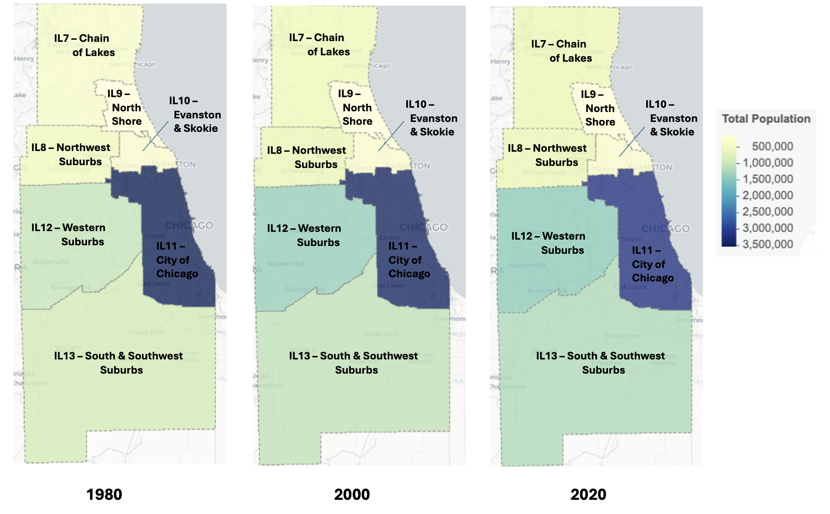
Figure 1: Population of Chicago area Geomarkets over time

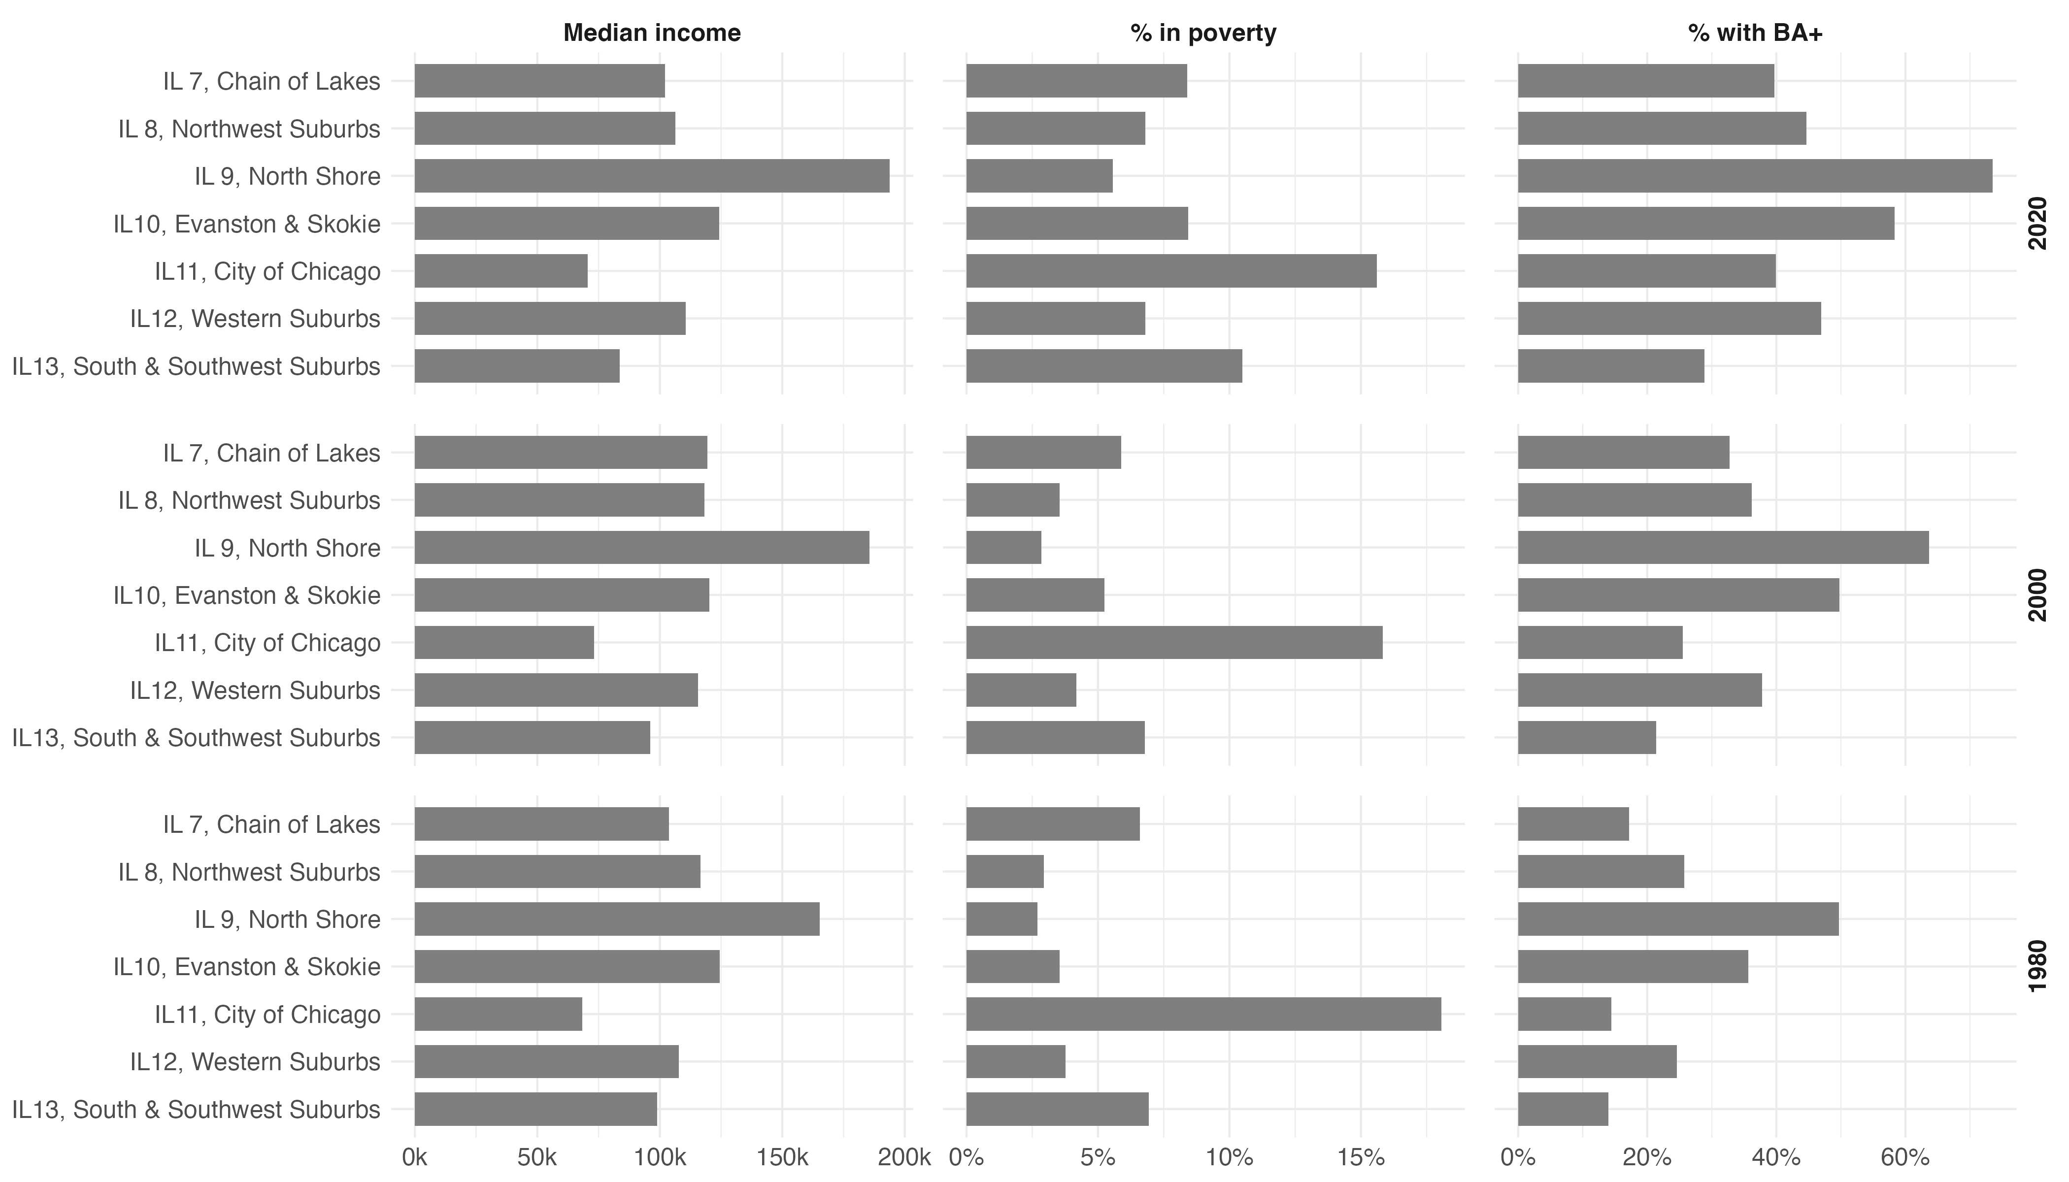
Figure 2: Socioeconomic characteristics of Chicago area Geomarkets

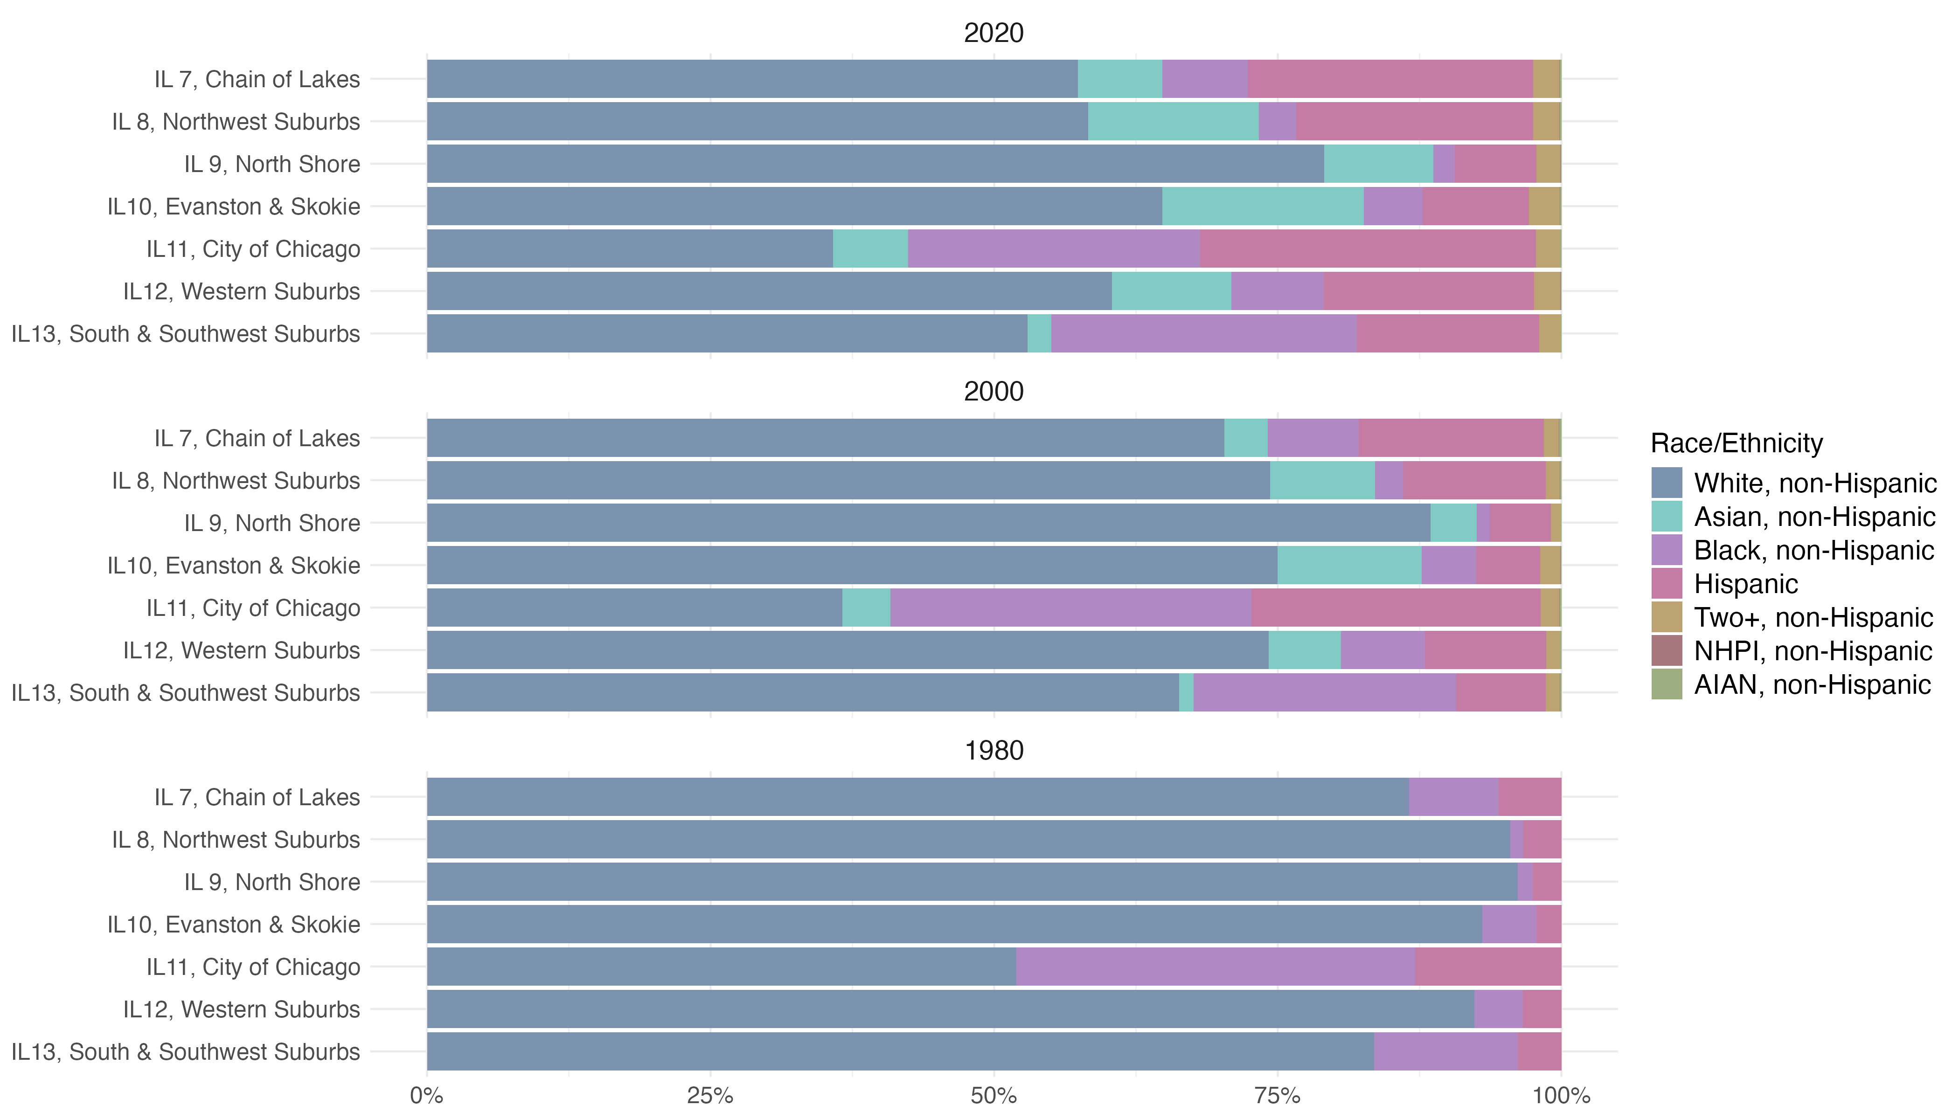
Figure 3: Racial/ethnic composition of Chicago area Geomarkets

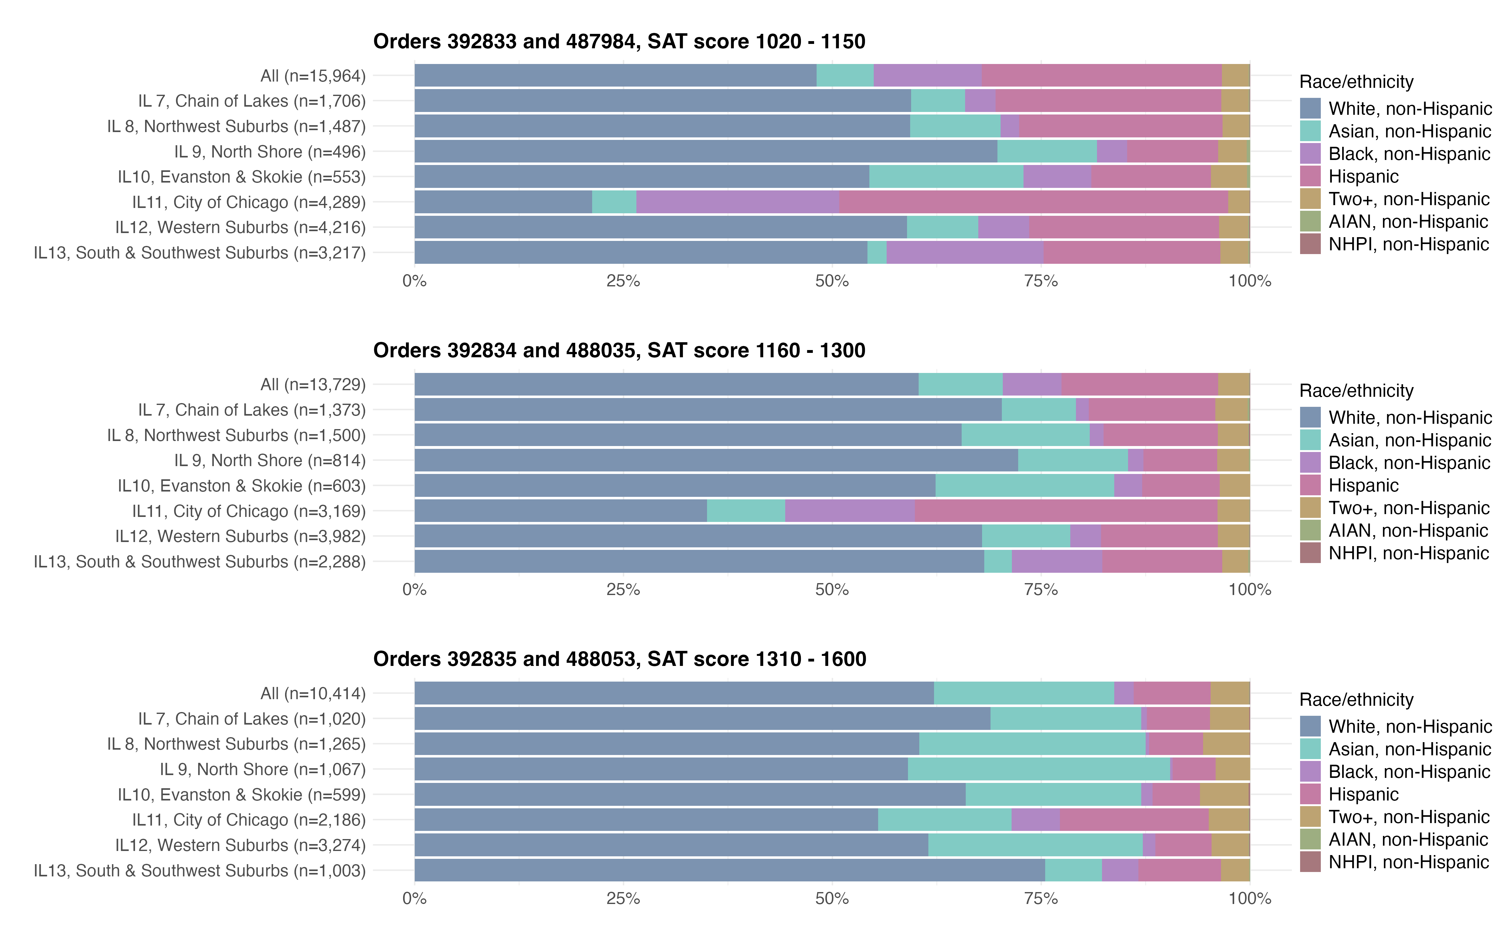
Figure 4: Racial/ethnic composition of purchased student profiles by Geomarket, Chicago area

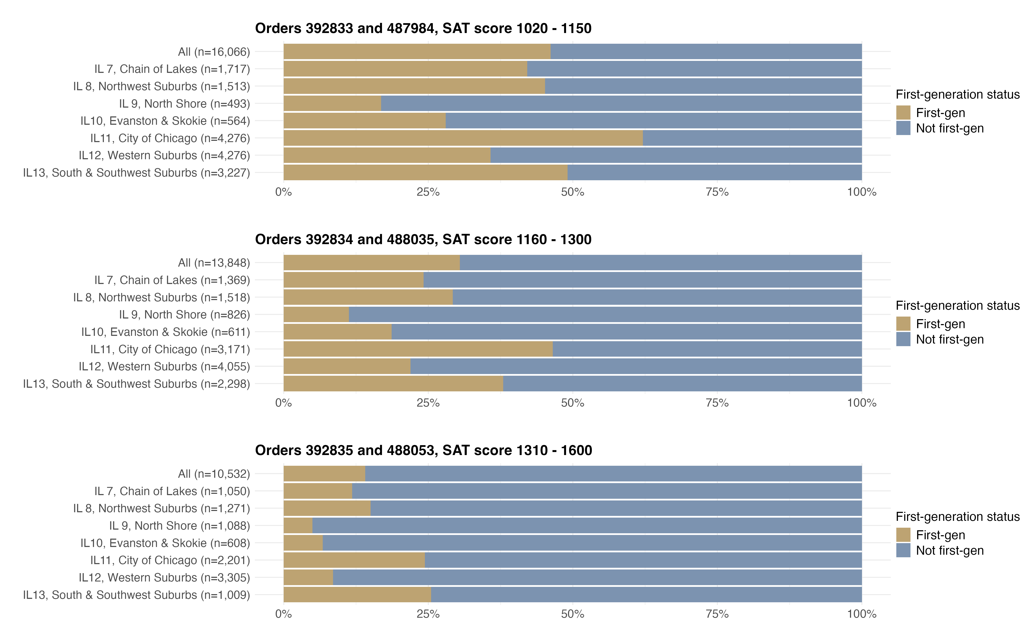
Figure 5: First-generation status composition of purchased student profiles by Geomarket, Chicago area

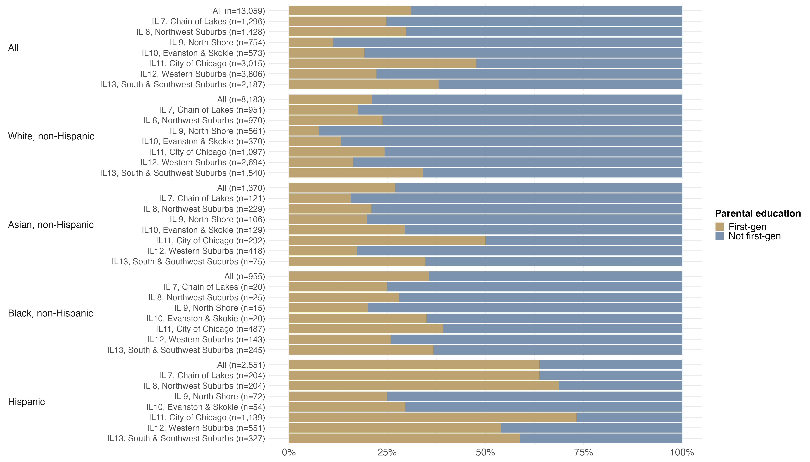
Figure 6: First-generation status by race for Chicago area Geomarkets, SAT score 1160 - 1300

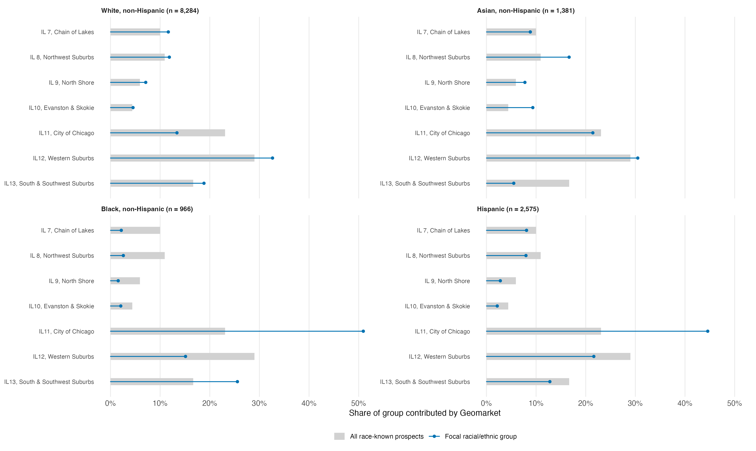
Figure 7: Geomarket contributions to each racial/ethnic group: Chicago, SAT score 1160–1300

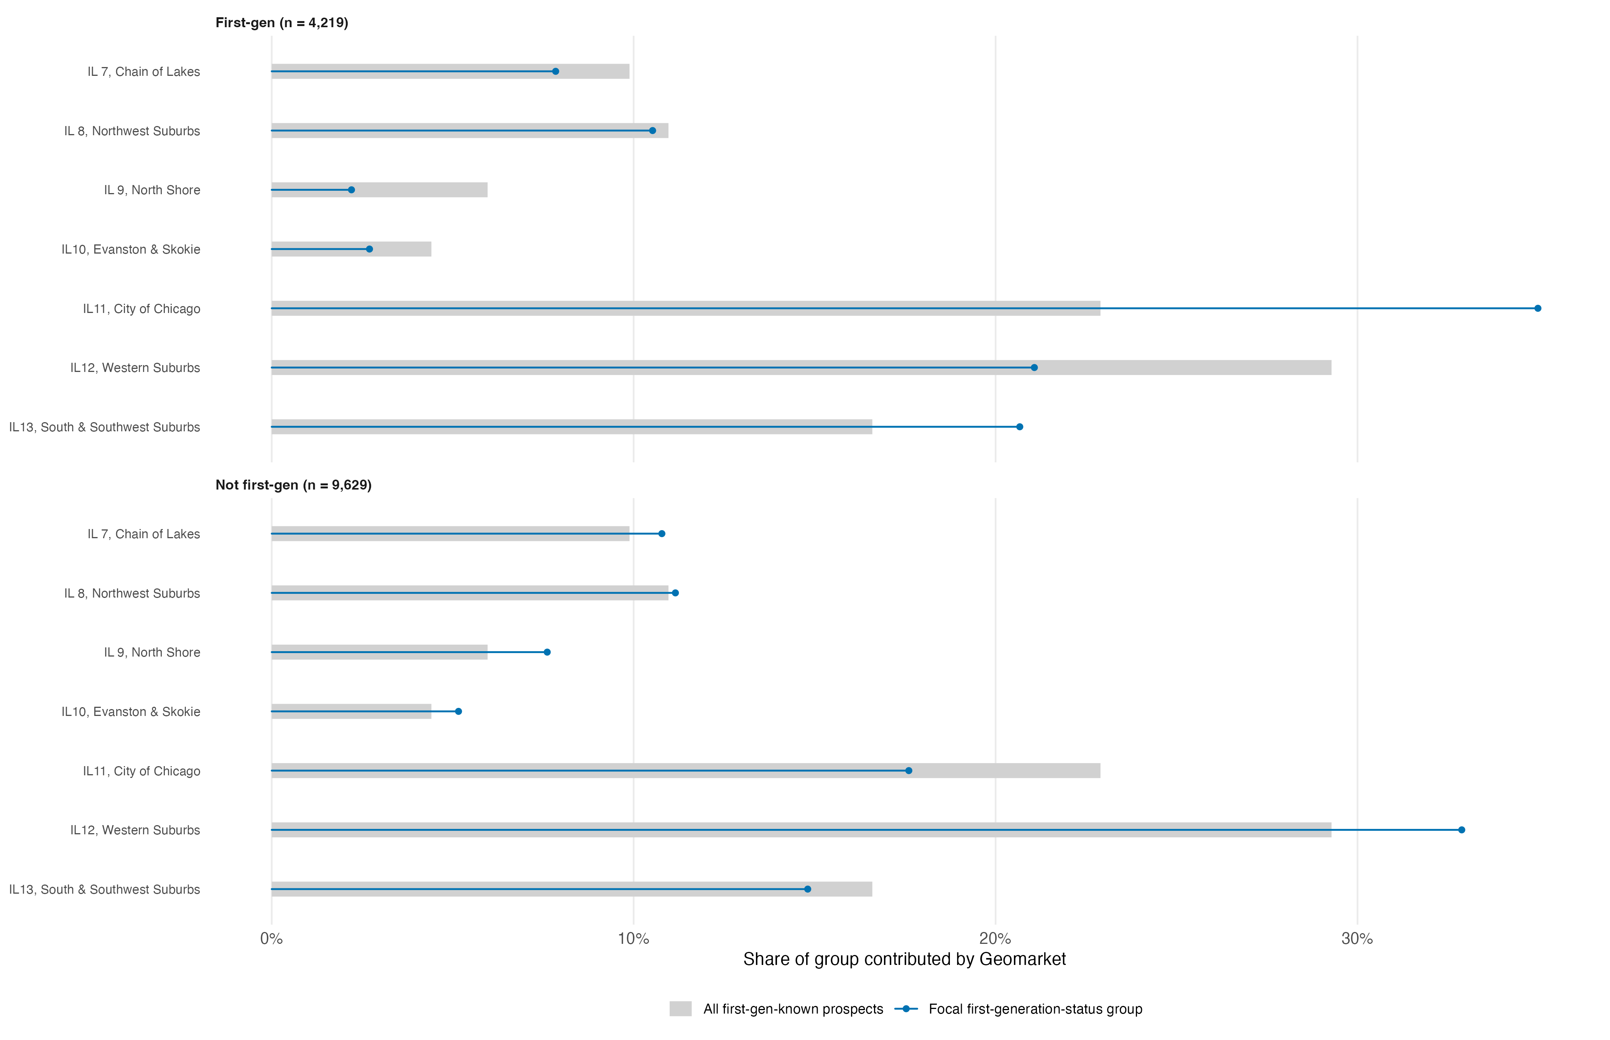
Figure 8: Geomarket contributions by first-generation status: Chicago, SAT score 1160–1300

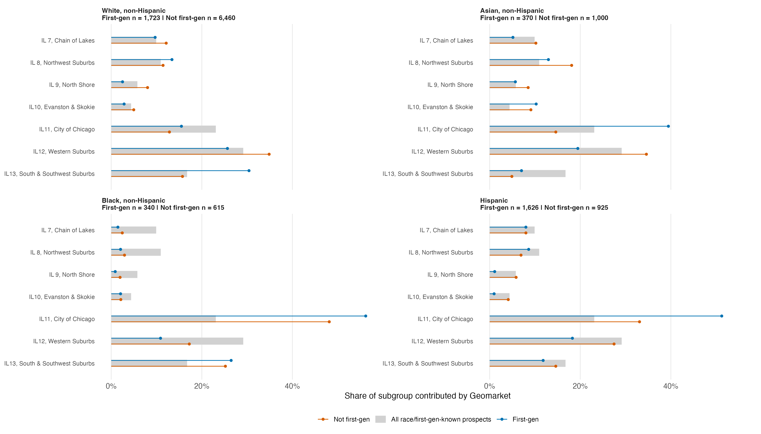
Figure 9: Geomarket contributions by race and first-generation status: Chicago, SAT score 1160–1300

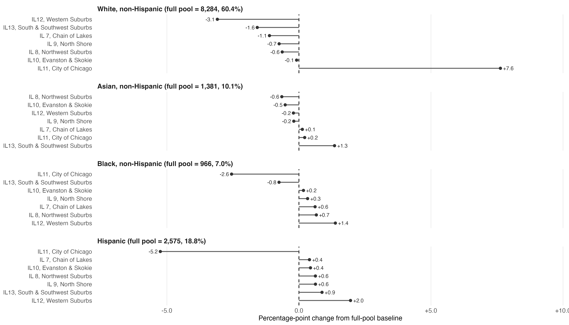
Figure 10: Percentage-point change in racial/ethnic composition after excluding each Geomarket: Chicago, SAT score 1160–1300

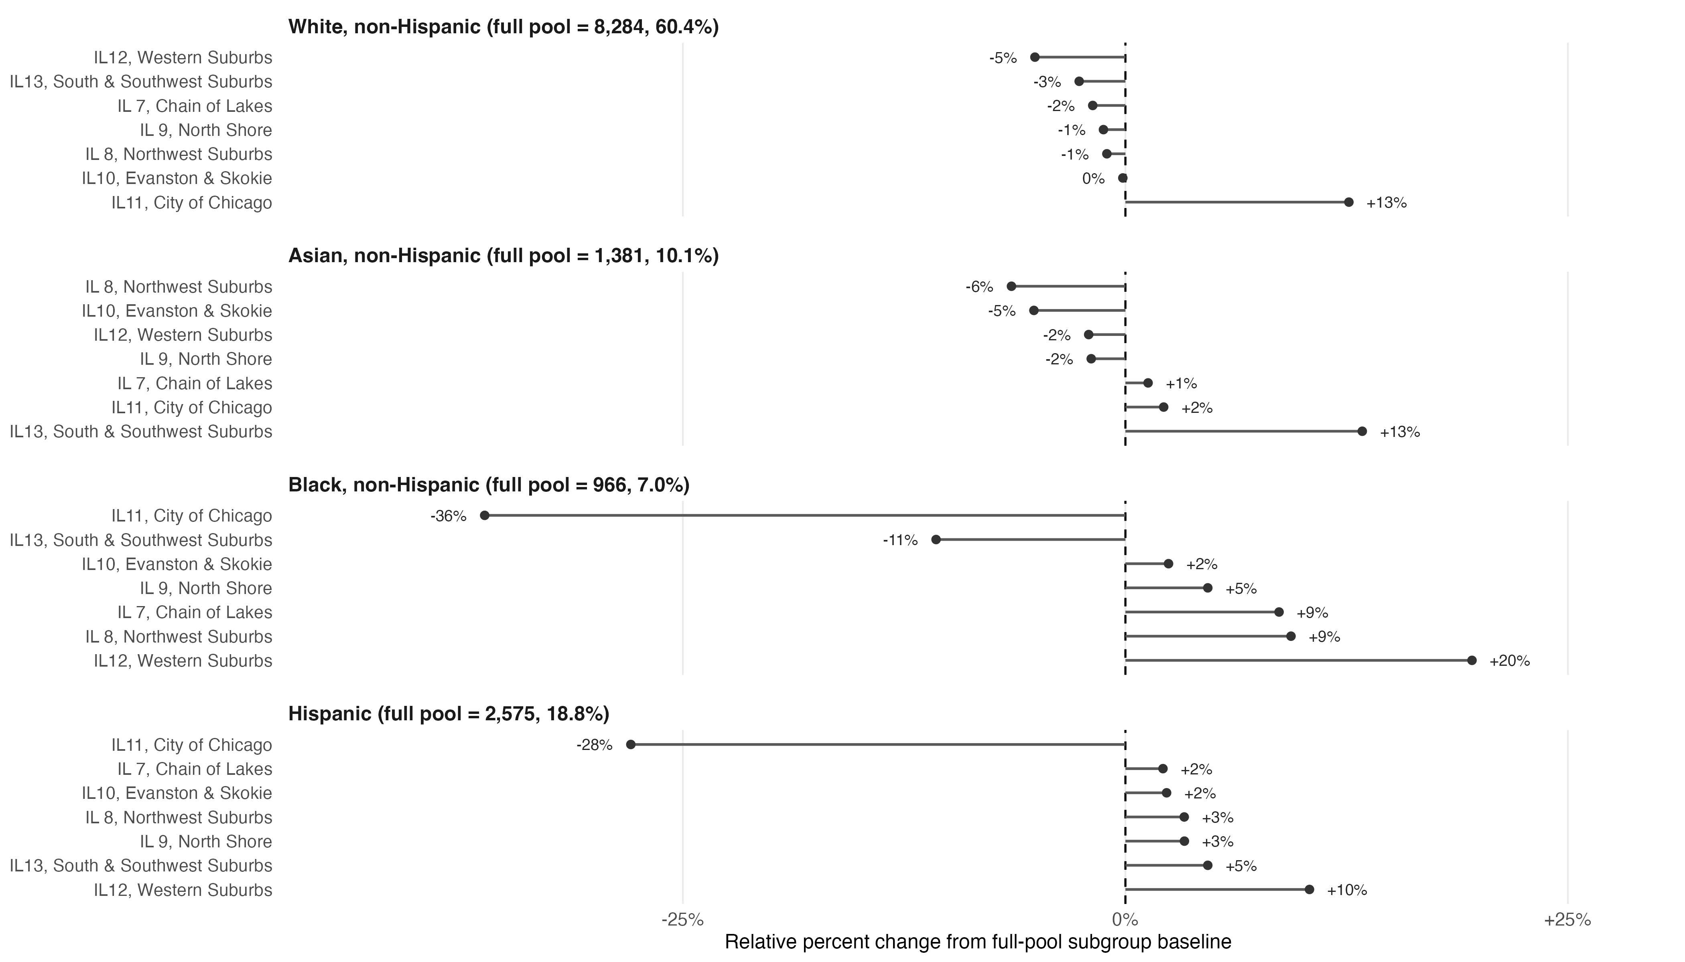
Figure 11: Relative percent change in racial/ethnic composition after excluding each Geomarket: Chicago, SAT score 1160–1300

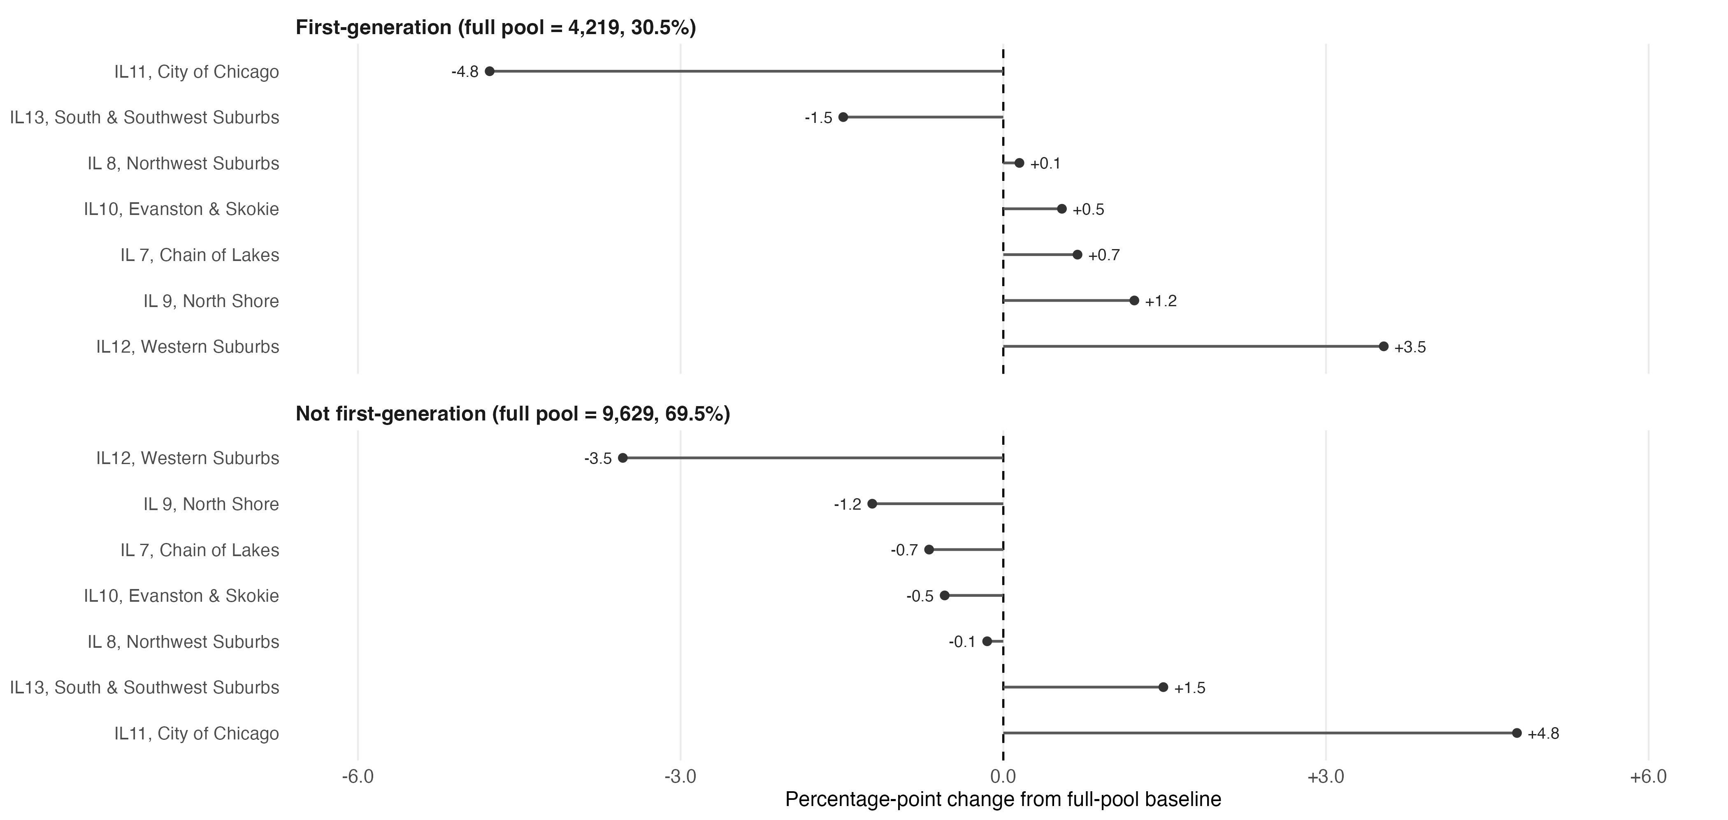
Figure 12: Percentage-point change in first-generation status composition after excluding Geomarket: Chicago, SAT score 1160–1300

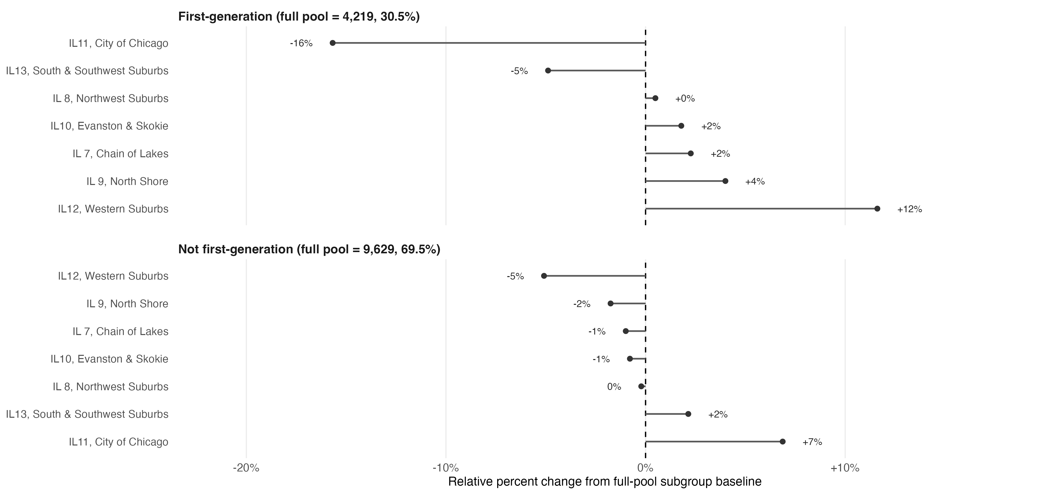
Figure 13: Relative percent change in first-generation status composition after excluding Geomarket: Chicago, SAT score 1160–1300

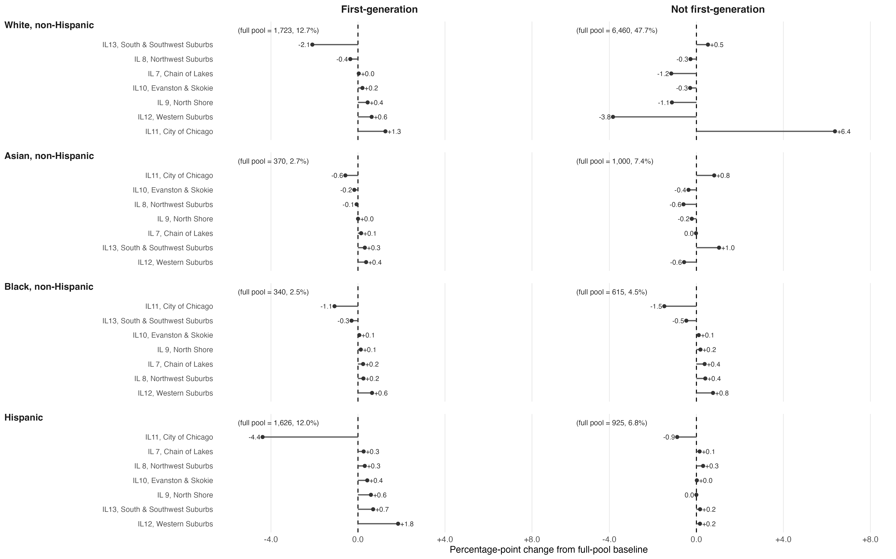
Figure 14: Percentage-point change in race × first-generation composition after excluding Geomarket: Chicago, SAT score 1160–1300

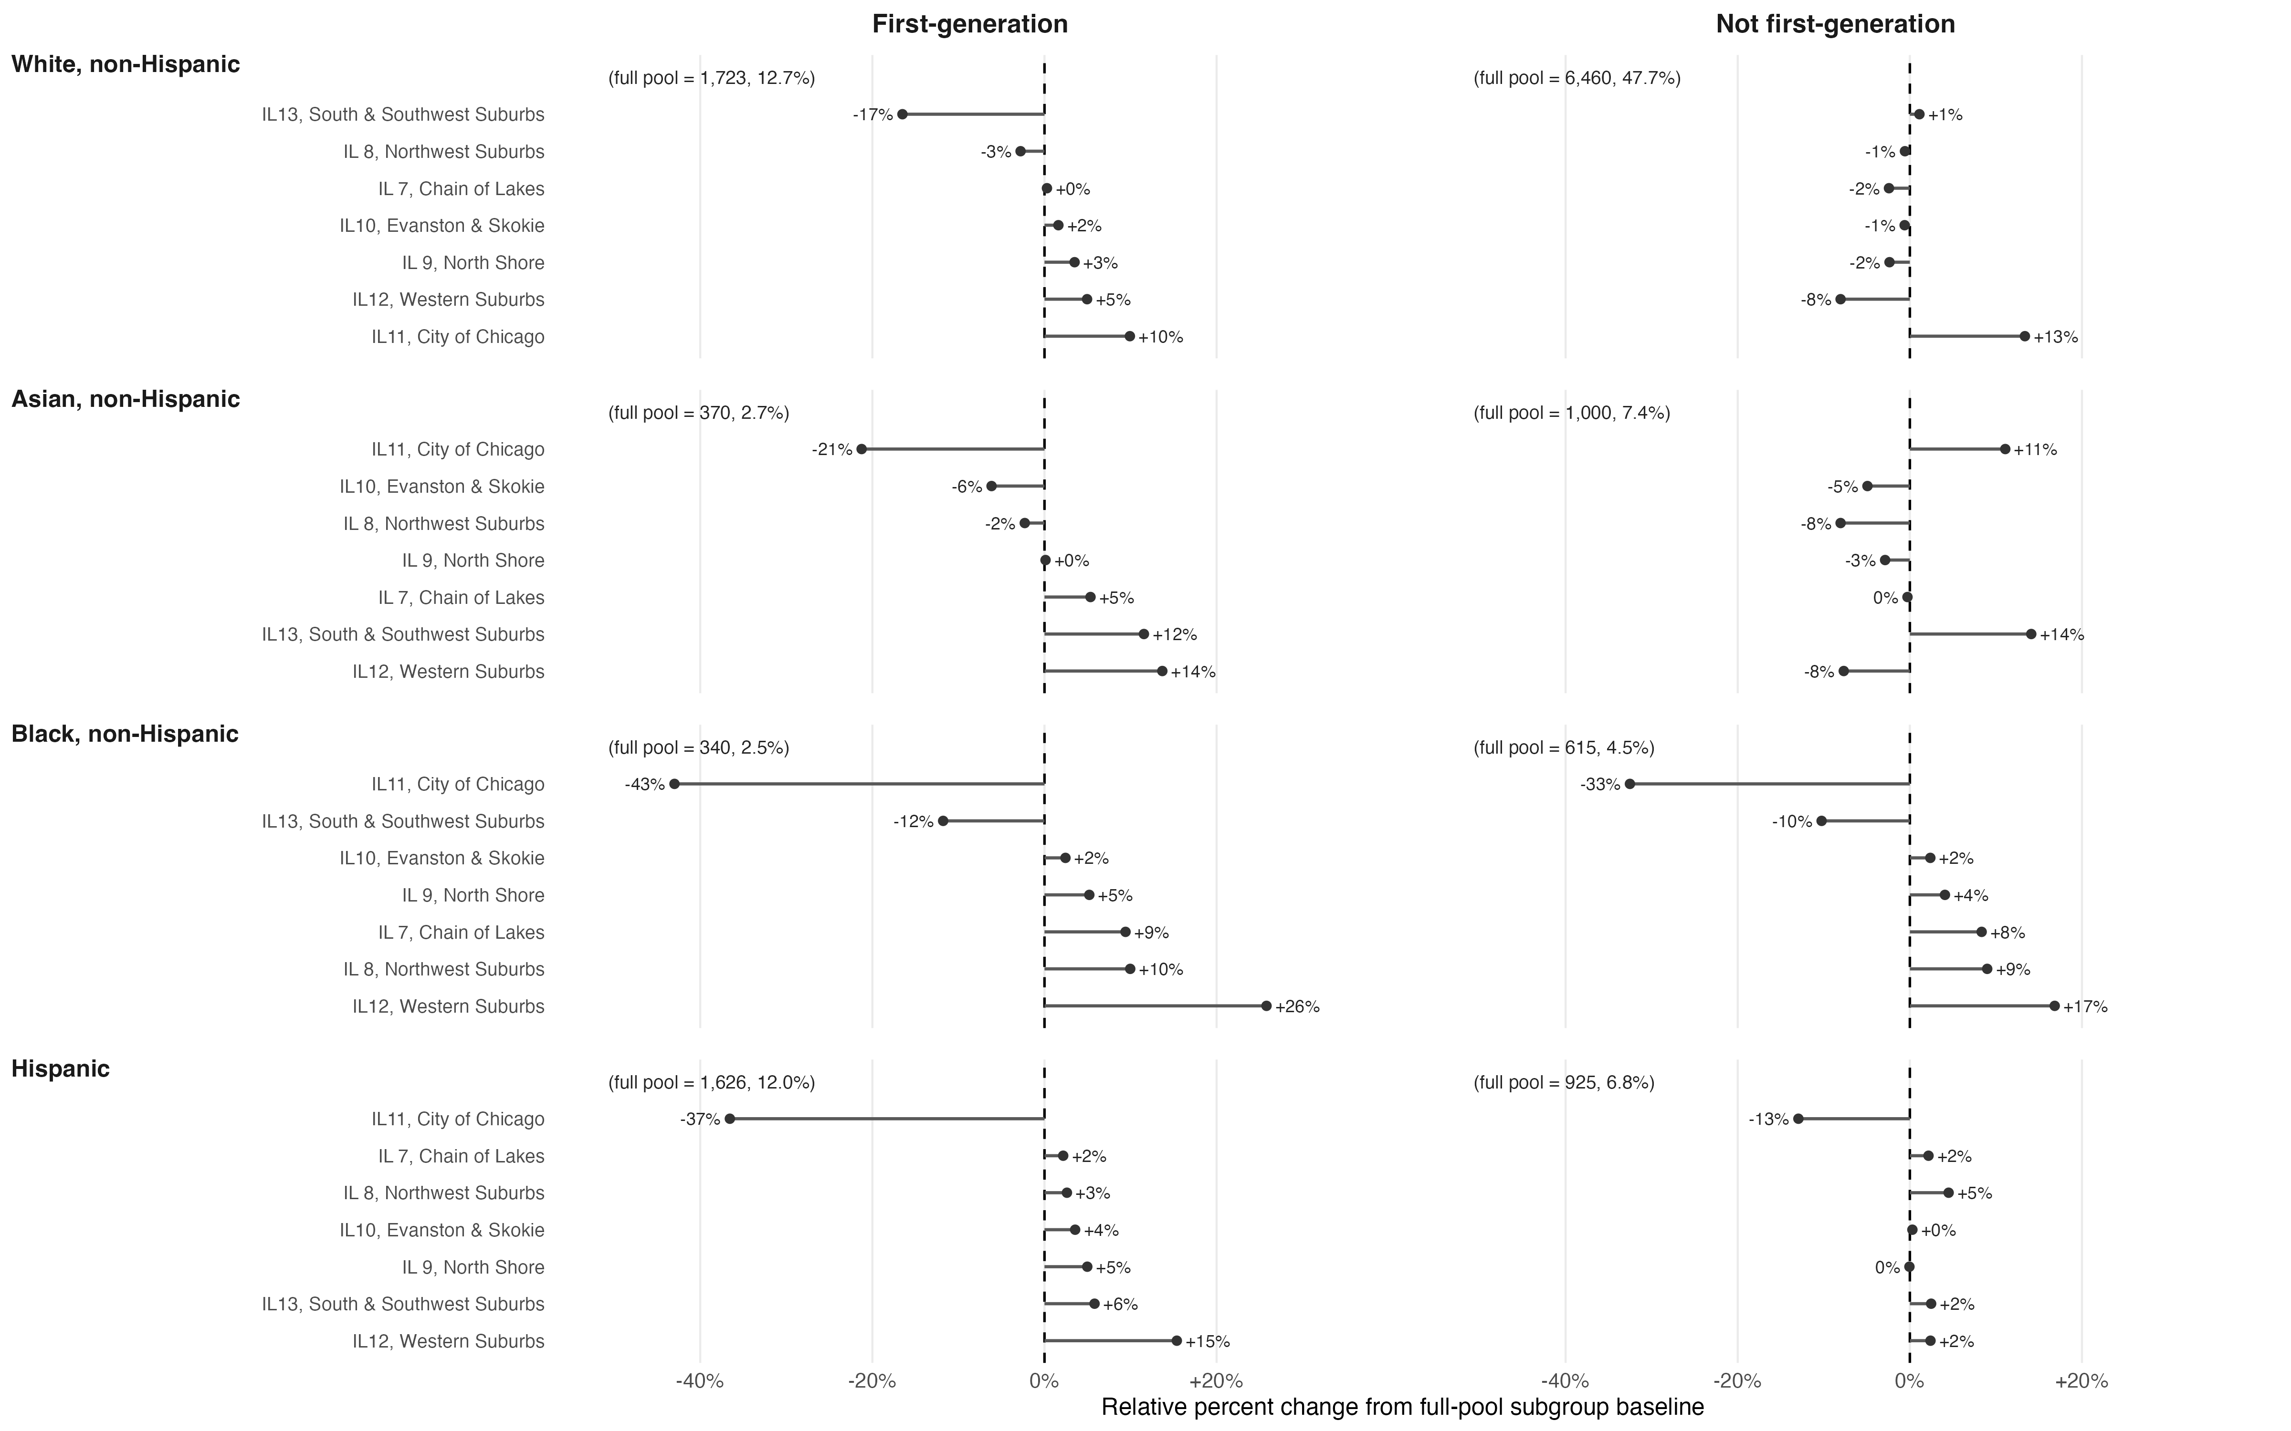
Figure 15: Relative percent change in race × first-generation composition after excluding Geomarket: Chicago, SAT score 1160–1300

