DOKUZ EYLUL UNIVERSITY
ENGINEERING FACULTY
DEPARTMENT OF COMPUTER ENGINEERING

CME1252 PROJECT BASED LEARNING – II
FINAL REPORT
PROJECT – I

SHAPER

Ozan Kalkan
Doğuser Yarar
Veysel Karani Saydam
Sude Uğurlu
Hasan Balıkçı

18.03.2022
IZMIR

CHAPTER ONE
PROGRESS DESCRIPTION

The aim of our project is to design a competition called "Who Wants to Be a Millionaire". This project is a game in which the contestant can progress as long as he/she answers correctly and wins a prize according to his/her answers. This project consists of 4 separate parts.

The first part is to read the text files and integrate them into the competition. In the second part, the spell checking mechanism and the word cloud are created. After that, the competition part of the game is played by the contestant. Finally, statistics according to the contestants are generated and shown to the user.

We have tried to complete the tasks assigned to us in our project at the desired time according to the weeks and we have advanced our project in an orderly manner. As a group, we completed our project by holding online meetings and face-to-face idea exchanges.

We had problems in some parts of our project. In order to solve these problems, we showed our teachers the problems. Then, we created solutions with the ideas that our teachers gave us.

As a result, we completed the project completely by following the weekly schedule given to us and doing research on our problems and asking our teachers questions.

CHAPTER TWO
TASK SUMMARY

Completed Tasks

Ozan Kalkan: I took part in reading the files. I created the spell checking mechanism. I have worked on the creation of classes. I have edited the conditions of the game with various boolean variables. I provided that the same words were not present in the word cloud. i tokenized the words to be able to use them in the control parts. I worked on the gameplay and continuity of the competition. I made the creation of lifelines and their integration into the options. I have ensured that lifelines are not reused after they have been used. I created the timer by using loops and enigma commands. I have enabled it to receive input from the user when the timer is counting down. I have created important functions and methods in the Millionaire Game class and other classes and made the code more effective. I helped my friends in the statistics part. I took part in keeping the answers given by the contestant in the Participant class. I took part in storing the participant ID, Question ID and whether the question was answered correctly in the txt file. I worked on improving the game visually. I tried to find bugs by testing the game. I fixed the errors that I found and tried to make the code error-free.

Veysel Karani Saydam: I wrote the code for the table showing the distribution of the questions by category and difficulty level. I generated the screen clearing function and used the "set cursor position" commands. I helped my friends by stating my ideas in the lifelines section and other sections. I wrote code that finds these statistics: -The most successful contestant -On average, how many questions did contestants in each age group answer correctly? Age<=30, 30<Age<= 50, Age>50 -The city with the highest number of participants.

Doğuser Yarar: I prepared the menu of the game. I ensured that the given files are read and the read data is assigned to the relevant arrays and classes. I created Participant,GivenAnswer and Location classes to hold the necessary information. I created a word cloud algorithm that selects a random word from the question and writes it to the screen. I played a role in the creation of the necessary algorithms in the competition part(selection of the competitor,answer check,keeping the correct answers,the prize received...). I created the category algorithm with the most correct and incorrect answers for the statistics part. I helped convert the most common places in the code into functions. We have researched console coloring commands in c# to improve the visualisation of our project. We have developed special structures for showing messages to the user. Finally, we have added new features to make the game more fun. As a result, we have improved the project thanks to the fact that we have more time left for research

Sude Uğurlu: I printed the word cloud. It consists of random words selected from questions of the same difficulty level. After the user selects a word from here, I print the question containing the selected word to the console

Hasan Balıkçi: In this project i designed the screen. I designed some of classes. I created necessary data structures and worked on competition part of the project. I tried to help my teammates. I tried to gave them algorithm ideas.

Incomplete Tasks: Reasons and Explanations
Sude Uğurlu: I'm having trouble creating and using class structures. As the project grew more and more complex with the progress week by week, I encountered a different problem every time I wrote code in the statistics section. I had difficulties while writing the code and could not come up with a result. But with the help of my teammates we completed the statistics part.

As a result, all the tasks requested from us in this project have been completed,
there is no unfinished tasks.

Additional Improvements to the Project
We have developed the game visually using various commands.
We have made the game more playable by adding various conditions.

CHAPTER THREE
EXPLANATION of algorıthms

Screenshots
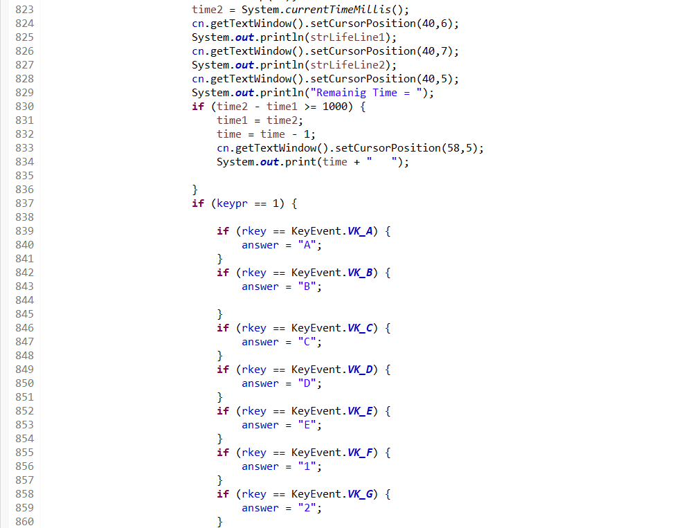

Part of the timer and “rkey”, “keypr” commands.

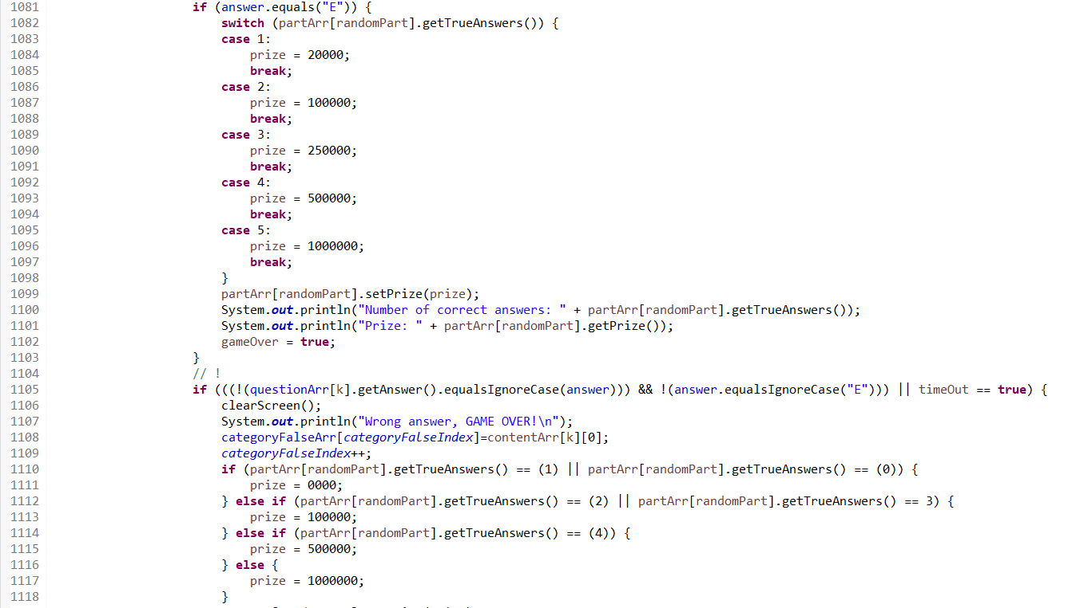
Setting the prize in case of wrong answer or exit.

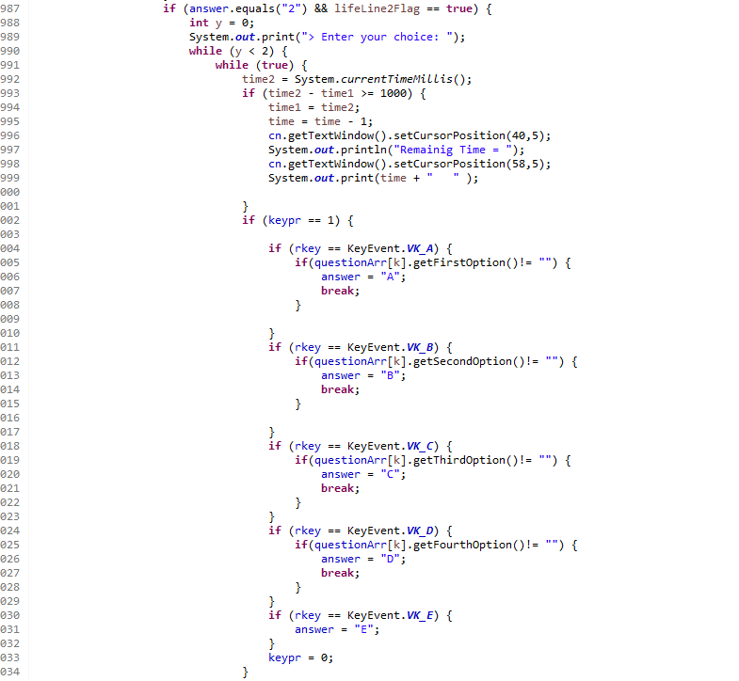
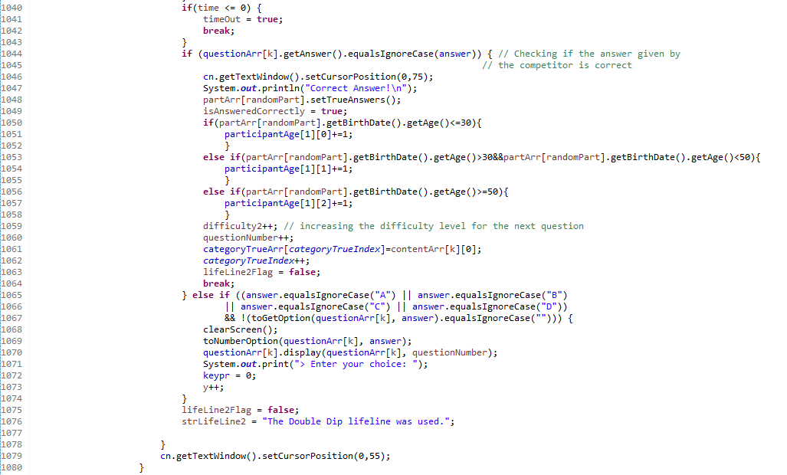
Double Dip lifeline part.

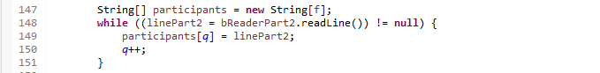
Thanks to the static variable, we have made it possible to use the length of the text file in each method.
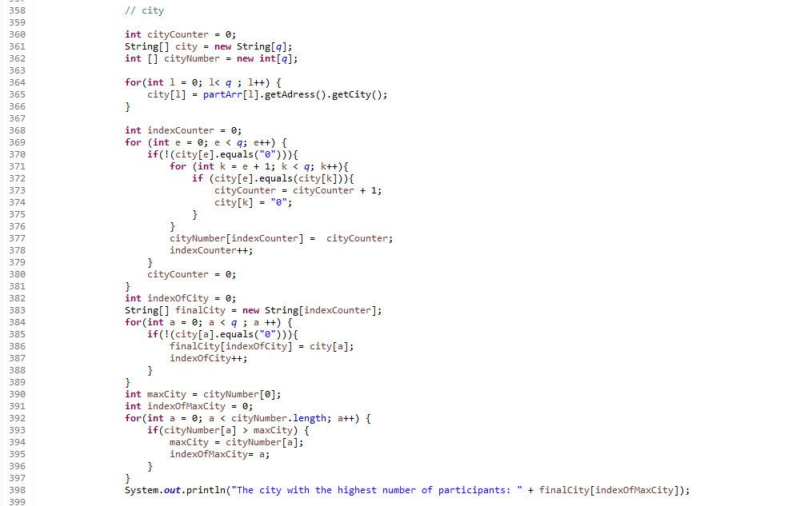

The city with the most participants.

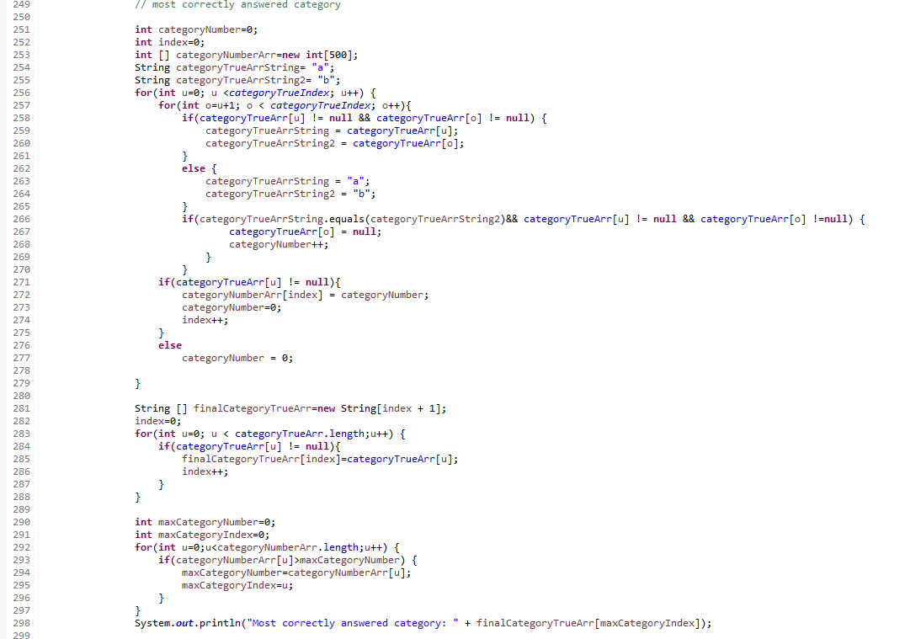
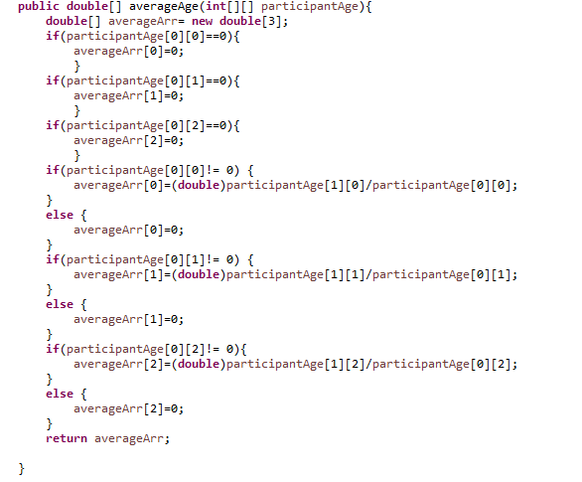
Most correctly answered category.

Correct answer rate according to the age of the contestants.

Functions
We used these methods and functions in our code:
Enigma Codes
BufferedReader
wordCloud()
spellCheck()
readingFiles()
menu()
category()
difficultyLevel()
competition()
toNumberOption()
toGetOption()
clearScreen()
averageAge()
parseIntOrNull()

Algorithms and Solution Strategies
Using the 'get' and 'set' commands, we assigned values ​​to the variables of the classes and got the values ​​as data. By using the constructor structure, we used class structures more effectively in our project. We learned the usage of 'public' and 'private' variable types and used them in our project.

Since we have already determined the sizes of our arrays, we have set up loops to calculate how many lines of text files there are in our code, and we used these values instead of the lengths of the arrays. In this way, we have ensured that null indexes do not enter loops and we have maintained the continuity of the loops.

We had to write optimized code so that we had a fast-running code. That's why we tried to minimize the elements that slow down our code. We tried to use nested loops as little as possible. We have used only reading from file operations for now, but we will also need the writing part in the future. We tried to reinforce what we learned by using the class structures that we have just started to learn.

In order to create statistical data covering all players, we created data in a static structure and thus gathered all players into a common group.

In order to make the time counter, we used the enigma commands such as "rkey", "keypr". Thanks to this, the code was not waiting when receiving input from the user, and it could count the time correctly.

We used commands such as SetCursorPosition and Clear Screen(), as we needed to print most of the things we needed to print to the console properly and aligned in the project.

CHAPTER FOUR
PROBLEMS ENCOUNTERED
1) Since we have just learned the classroom structures, we had difficulty in using this structure effectively and defining it correctly in the first weeks.

2) We created a static variable and had problems using this variable.

3) Due to incorrect formats in the file reading section, we got errors while dividing by category and difficulty level. Then we wrote some lines of code that corrected these formats.

4) We defined our arrays as public with certain limits at the beginning of the code. Therefore, when we used the lengths of these arrays in loops, the indexes that were null caused us problems in the operations performed.

5) We had to use enigma in the project because we couldn't get input from the user when counting down the time. Integrating Enigma's codes into the project and using them correctly has been one of the challenges we have faced.

6) We had to keep the statistics accurate and use a static data type to cover all the contestants and maintain the statistical values by creating extra sequences. It took some time to make them.

7) Continuing to use lifelines without changing the timer and receiving inputs from the user again with the "rkey" command was one of the problems we encountered.

CHAPTER FIVE
conclusıon
As a result, we learned a lot of new things in this project. These are important structures such as class structures, enigma commands, creating getters and setters, public and static data types.

The fact that the project was long and time consuming allowed us to conduct effective time management and do everything we wanted on time.

Thanks to the structures we use in the project, we have learned that we can easily overcome the problem by dividing the problems we encounter into smaller parts and creating same solutions for the same type of problems.

Consequently, This project has taught us a lot of new structures and improved our abilities such as time management, the ability to create effective solutions to problems.

REFERENCES
Java Classes and Objects. (2019). W3schools.com.
Java Classes and Objects - W3Schools

Static variables in Java. (n.d.). Www.tutorialspoint.com. Retrieved March 17, 2022, from
Static variables in Java - Tutorialspoint

Java Class Methods. (n.d.). Www.w3schools.com.
Java Class Methods - W3Schools

What is the difference between public, protected, package-private and private in Java? Stack Overflow (2008, October 18). .
What is the difference between public, protected, package ...
‌

