DOKUZ EYLUL UNIVERSITY
ENGINEERING FACULTY
DEPARTMENT OF COMPUTER ENGINEERING

CME1251 PROJECT BASED LEARNING – I
FINAL REPORT
PROJECT – III

CENG Checkers

by
Ozan Kalkan
Efkan Kıraç Tercan
Amir Ferdosi

07.01.2022

CHAPTER ONE
PROGRESS DESCRIPTION
The aim of the project is to create a game such as checkers, which is played against a computer in an 8*8 area, where both sides are trying to be the first players to move 9 pieces to their home area.

We have completed all the requirements requested from us in the project by the second week. We spent the rest of our time adding improvements, improving our code, and testing/debugging.

We have changed the pawns and the board to visually improve our game. To facilitate the playability of the game, we made the movement operations with the W-A-S-D keys. We have added 2 modes to the game, easy and hard. We also added sound effect and menu to the game.

As a result, we have improved the project, as we have more time left for improve

CHAPTER TWO
TASK SUMMARY

Completed Tasks
Ozan Kalkan: I have made step operations for human and for computer. I coded a function . Also I worked on the visualization of the game.

Efkan Kıraç Tercan : I have coded the jumping situations for the computer and for the player also. Have coded the chain-jump situations and to end it.

Amir Ferdosi: I’ve coded single jump operation for human in our game.also figuring out new ideas for our project.

Incomplete Tasks: Reasons and Explanations
There are no uncompleted tasks in our project. We have completed all the tasks requested from us and added all the improvements which we were trying to add.

Additional Improvements to the Project
We added 2 directions mode which has another AI Structure.
We added sound effect.
We added menu.
We added info about game to the menu.
We colored the board.
We made it look like a checkers board.
We used symbols instead of alphabetical chars
We move the pawns with the W-A-S-D keys
To end the jump you need to press enter. So you can move the pawns back.

CHAPTER THREE
EXPLANATION of algorıthms

Screenshots

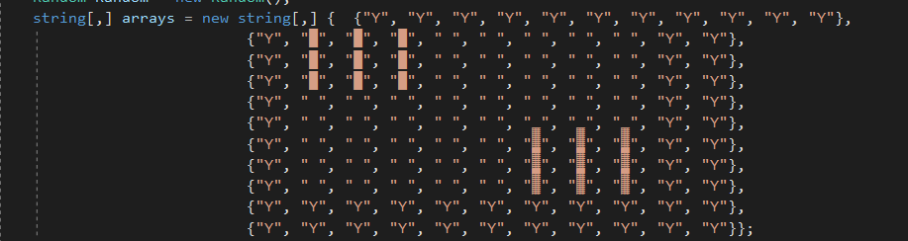
"Y" strings in the arrays of our game are the borders of our game field. When the bot tries to jump from the 8th column to 10th column, program was shutting down because of the array bounds.
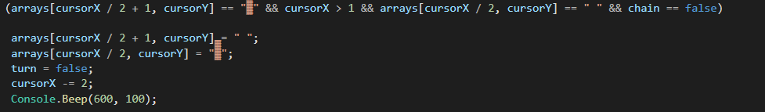

Since our pawns consist of two units side by side, we had problems finding the right position of cursor and array's indexes. We solved this by multiplying and dividing the x values.

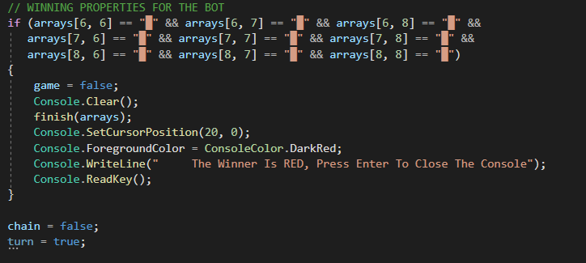
We checked the winning properties for the player and the bot, and in these cases we printed the winner as a message.
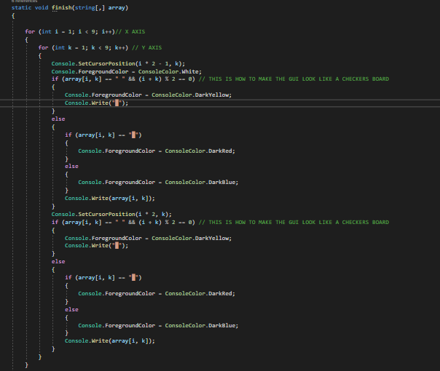

We have coded a function that prints the table in the end state.

Functions
We have coded a function that prints the board in its final form at the end of the game, and we have used it in the winning situations of the player and the computer.

Algorithms and Solution Strategies
Ozan Kalkan: Since our pawns consist of two units side by side, we had problems finding the right position of cursor and array's indexes. We solved this by multiplying and dividing the x values.

Efkan Kıraç Tercan: "Y" strings in the arrays of our game are the borders of our game field. When the bot tries to jump from the 8th column to 10th column, program was shutting down because of the array bounds.

Amir Ferdosi: single jump operation for human controlling the adjancey space if its available for jump or not .

CHAPTER FOUR
PROBLEMS ENCOUNTERED

Ozan Kalkan. We expanded the playing field because we wanted to improve the game visually. That's why we created our pawns from two units side by side. The fact that the pawns consisted of two units created problems with finding the correct position of the cursor and the indexes of the array.

Efkan Kıraç Tercan When the bot tries to jump from the 8th column to 10th column, program was shutting down because of the array bounds. So I've added extra elements to the arrays.

Amir Ferdosi while i was trying to integrate my code(single jump) with the main code ifaced problems then descriptions helped me during this process . Finally i’ve learned how to code as a team member.

CHAPTER FIVE
conclusıon
We have done what was asked of us by working in a planned manner from the beginning of the project. We worked hard for the first 2 weeks, and we finished the project earlier than expected. Thus, we have more time to research.
In the remaining 3 weeks, we thought about how to make the computer's moves better and worked on it. While developing the bot, we have made additional improvements to make the game more visually advanced
As a result of our research to do what is required in the project and to make additional improvements, we learned the operation and use of the codes that are very important to us.
In addition to these, we have improved our teamwork skills after working hard together.

REFERENCES
- Moving elements in array c#. (n.d.). Stack Overflow. https://stackoverflow.com/questions/7242909/moving-elements-in-array-c-sharp
- B. (2021, October 1). Arrays - C# Programming Guide. Microsoft Docs. https://docs.microsoft.com/en-us/dotnet/csharp/programming-guide/arrays/

AppendIx A
Poster/Web page of the Project

