**CE 102: INTRODUCTION TO CIVIL ENGINEERING**

TERM PROJECT GUIDELINE

**Spring 2014**

**Suspended Pedestrian Bridge Design**

Group 222

**April 28th, 2014**

**Introduction**

The aim of this project is to understand how suspended pedestrian bridges are structured and designing one. We have made some researches about suspended pedestrian bridges and used some formulas to calculate the necessary statistics of such a bridge. We have also drew the technical drawings of our design included in this report.

**Project Team**

Sercan (Technical drawings)

Ozan (Design)

Ceren (Research on Suspended Bridges)

Mert Can (Design)

## SUSPENDED BRIDGES

## Bridges touch all our lives every day we are likely to cross or go under a bridge. But how many of us stop to consider how the bridge works and what sort of people designed and built it? There are three practical requirements for a successful bridge; firm foundations, strong structure, and effective working. Also there are many types of bridge in the world but we will explore suspended bridges.

## A suspended bridge is a type of bridge which is built by suspending the roadway from cables attached to a master cable which runs above the length of the bridge. In addition to being strong and lightweight, these types of bridges are also beautiful, exciting,absorbing and interesting.They are exciting because they can be light and daring with long spans. They are absorbing because they can be refined works of art and interesting because at one level the flow of forces in hanging bridges is easy to understand; yet. When we dig down to a deeper level we find that they are statically indeterminate and are a blend of many time-dependent complex processes.

## Bridges like all man made objects, have a life cycle. They are conceived, promoted, financed, designed, built, used and dismantled. Time is particularly important for the builders of rope suspension bridges.

## The principle of the rope suspension bridge is that of a simple clothes line. We stretch a rope between two anchor points and prop the line up in one or more places then hang objects from it. Ropes, chains, or cables are suspended between two towers with vertical hanger cables attached at intervals stretching down to a stiff road deck. The deck distributes the forces from the traffic on the bridge to the hangers and onto the cables.

## Cable stayed bridges hang in a different way. There are two main forms :the fan and the harp, but there are others, such as cable net, and there are many variations on these basic themes.The fan system has cables radiating out from a single point on the tower. The harp has parallel stays from tower to deck. The cable net system has cables connecting the stays to form a network. Some stays are in a single line along the centerline of a bridge. More commonly, two sets of stays to the two sides of the bridge deck help to resist twisting.

## The development of cable-suspended pedestrian bridge construction has played aninteresting role in the history of human civilization (Gade, 1972). The first recorded bridge with suspenders connecting handrail and walkway cables was built as early as285 BC in the Province of Sichuan in China (Peters, 1987). Other known suspensionstructures during a similar time period were documented in the Eastern Himalayasand consisted of single woven cable, transversed by holding onto either two handrailcables or in a movable basket. Perhaps in a parallel line of invention or speculativelythrough early Chinese travelers, similar technical knowledge emerged in SouthAmerica (Peters, 1987). Ancient Incan civilization used rope bridges to span deepgorges, connecting footpaths between villages. These bridges consisted of a pair of stone anchors and massive woven grass cables and two additional woven cables forguardrails. Consistent maintenance and annual replacement of the woven cablesmade these bridges strong enough to carry the Spaniards while riding horses afterthey arrived (Gade, 1972). Such primitive rope bridges led to the basic idea ofmodern cable bridges.The modern cable-suspended bridges constructed by Bridges to Prosperity do notvary greatly from many of the historical bridges. The simple design, constructedusing manually-powered tools and only locally available materials are all the samechallenges faced by designers for rural developing world bridges today.

## BridgeVector.jpeg

## There is a photo to clearly understand structure of suspended pedestrian bridges.

## There are many examples in the world to road suspension bridges. We will analyze three of them which are Carrick a Rede Rope Bridge in Irish, Capilano Suspension Bridge in Coulombia an lastly Langkawi Sky Bridge in Maleysia.

## 1)Carrick-A-Rede Rope Bridge, Northern, Irish

## Carrick-A-Rede-Rope-Bridge-Northern-Ireland-1536x2048.jpg

## Carrick -A- Rede Rope Bridge is located on the North Antrim Coast between Ballycastle and Balintoy. Local fishermen have keep a bridge here since the mid-1600s. The name Carrick-A-Rede (Carraig-a-Rade) means *the rock in the road* .The road being the sea migration route of salmon past the island to which the bridge crossed from the mainland. It spans 20 metres (66 ft) and is 30 metres (98 ft) above the rocks below. Traditionally fishermen erected the bridge to Carrick-a-Rede island over a 23m-deep and 20m-wide chasm to check their salmon nets. Today visitors are drawn here simply to take the rope bridge challenge! The rope bridge originally consisted of a single rope hand rail which has been replaced by a two hand railed bridge by the National Trust.

## 2)Capilano Suspension Bridge, Vancouver, British Columbia

## Capilano-Suspension-Bridge-in-Vancouver.jpg The Capilano Suspension Bridge is a [simple suspension bridge](http://en.wikipedia.org/wiki/Simple_suspension_bridge) crossing the [Capilano River](http://en.wikipedia.org/wiki/Capilano_River) in the [District of North Vancouver](http://en.wikipedia.org/wiki/North_Vancouver,_British_Columbia_(district_municipality)), [British Columbia](http://en.wikipedia.org/wiki/British_Columbia), [Canada](http://en.wikipedia.org/wiki/Canada).  The current bridge is 136 metres long and 70 metres above the river. It is part of a private facility, with a charge for admission, and draws over 800,000 visitors a year.

## 3)Langkawi Sky Bridge, Maleysia

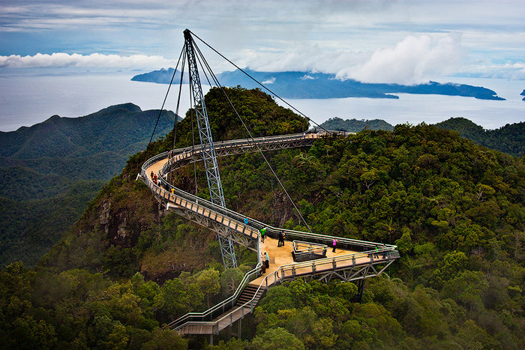

## The Langkawi Sky Bridge is located at the end of the Cable Car ride. One of the island’s highlights, it is a 410ft-long curved pedestrian bridge above Mount Mat Cinchang. Located 2,300ft above sea level, the Sky Bridge is easily accessible by the Langkawi Cable Car. The views on the way to the top of Langkawi’s second-highest peak include those of the Telaga Tujuh Waterfalls and the rainforest. Those with a fear of heights might be a little afraid of the altitude, but it is a very safe bridge with double steel railings and an enclosed wire mesh. The 1.8m wide bridge has two triangular platforms that act as ‘stops’ where you can admire the view and rest your feet.

**DESIGNING A REAL CABLE-SUSPENDED BRIDGE (THEORETICAL EXAMPLE)**

We have chosen our gap to be 80m and sagging height 2m and our weight as 500kg.

Wc=500(kg) x 9,81 (N/kg) / 80(m)

=0,06131kN/m



= 24.524 kN

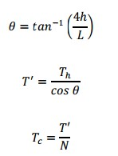

= 5,71 **°**

=21.25 kN

=12,323 kN

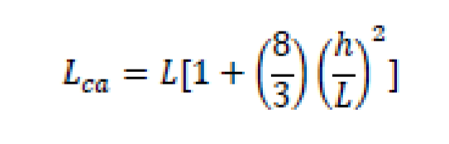

=80,13 m

|  |  |  |
| --- | --- | --- |
| Design Team Information | | |
| Team Number | 222 | |
| Team Members | SERCAN SELOĞLU 1932656  OZAN SÜLÜKPINAR 1932698  CEREN MADEN 1932508  MERT CAN ŞİMŞEK 1933332 | |
| Design Limits | | |
| Bridge span (Gap) | | 80m |
| Assumed sag limit (h) | | 2m |
| Design Loads | | |
| Types of load considered | | Up to 6 Pedestrians |
| Total load Wc | | 0.06131 kN/m |
| Design Calculations | | |
| Horizontal Tension Th | | 24.524 kN |
| Cable deflection angle (θ ) | | 5,71 **°** |
| Tension on the main cable (T’) | | 21.25 kN |
| Cable Specifications | | |
| Cable type (see the Table 2) | | 3/8 |
| Cable Load (Tc) | | 12,323 kN |
| Number of cables (N) | | 2 |
| Main cable length (Lca) | | 80,13 m |

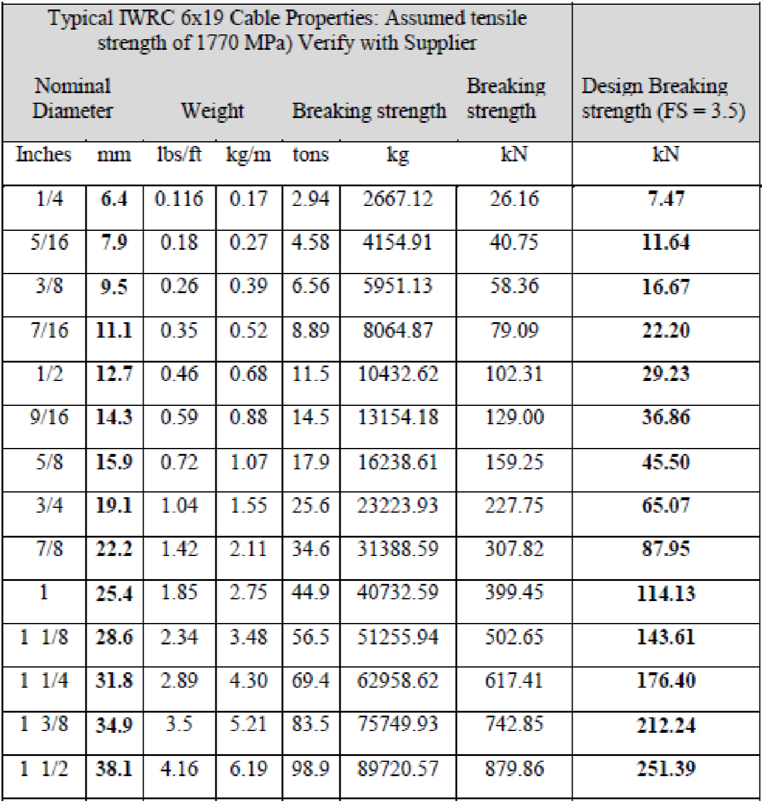

**5. TECHNICAL DRAWINGS**

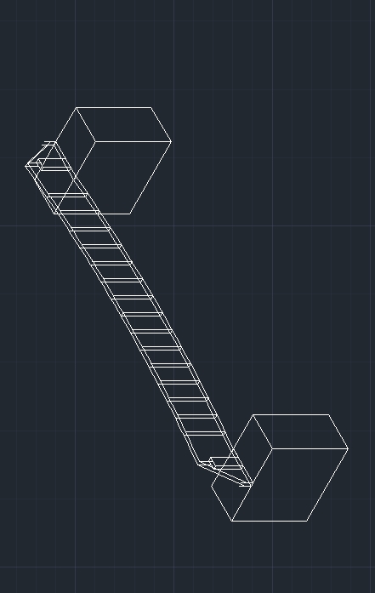**ISOMETRIC**

**FRONT**

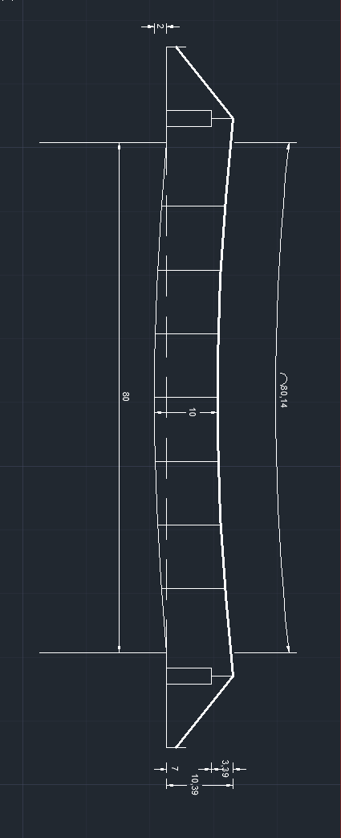

**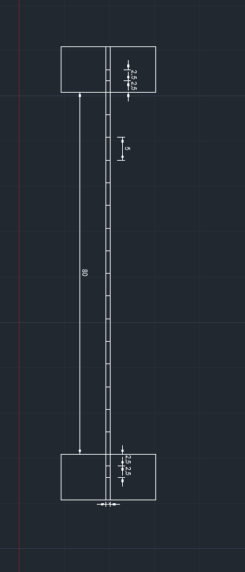   
TOP**

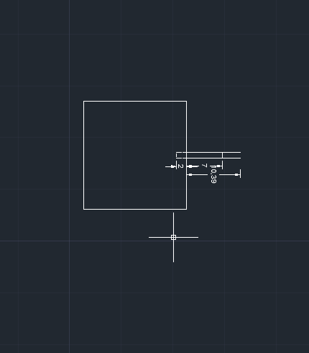**RIGHT**

**6. CONCLUSION**

We have learned how a suspended bridge is constructed and designed and also we learned how a report should be written. Theoretical examples are mostly different from the real values but still, it is possible to arrange a bridges statistics using the formulas.

## REFERENCES

## 1- Cooper, James D. ["World's Longest Suspension Bridge Opens in Japan,"](http://www.fhwa.dot.gov/publications/publicroads/98julaug/worlds.cfm) *Public Roads* (US), July/August 1998, Vol. 62, No. 1; retrieved 2012-3-24.

## 2- Blockley D. "BRIDGES the science and art of the world's most insipiring structures," Oxford University Press Inc.(US), 2010

## 3- Bang L. "Cable Suspended Pedestrian Bridge Design For Rural Construction," B.S.University of Iowa, 200

## 4-  <http://www.langkawi-beaches.com/langkawi-sky-bridge.html>

## 5-  Habdank, Joanna, Weldon, James. "[www.northshorenews.com More snow adds to woes and record]", North Shore News, December 1, 2006.

## 6- http://russelllabs.blogspot.com.tr/2011/10/week-1-rope-and-wood-plank-suspension.html

## 7-  Simon Bell (2008). [*Design for Outdoor Recreation*](http://books.google.com/books?id=0TRY_STMZvoC&pg=PA145&dq=%22simple+suspension+bridge%22) (2nd ed.). Taylor & Francis. p. 232

## 8-Arthur Morley (1912). [*Theory of structures*](http://books.google.com/books?id=edD0aVHa5v0C&pg=PA482&dq=%22simple+suspension+bridge%22). Longmans, Green, and Co. pp. 482–484, 574.