Middle East Technical University

Department of Civil Engineering

CE300



Name:

Surname:

Student No:

Section No: 6

Surveying Group No: 4

Surveying Group Members;

Date of Completion: 19.09.2011

Dates of Summer Practice: 13.06.2011-08.07.2011

Contents

1. Introduction 4

2. Activities 6

2.1 Field Trips 6

2.1.1 Steel Structures – Atak Mühendislik 6

2.1.2 Excavation – Pasific Inşaat + EgeGrup 7

2.1.3 Kurtboğazı and Eğrekkaya Dams, Ivedik Water Treatment Facility 8

2.1.4 Green Building – Eser Inşaat 10

2.1.5 Reinforced Concrete Structures – Gimsa 11

2.1.6 Ilgaz Traverse & Kam 12

2.1.7 Landslides 13

2.1.8 Concrete Mixing Station – Oyak Beton 14

2.2 Surveying 15

2.2.1 Angle and Distance Measurement 16

2.2.2 Leveling 16

2.2.3 Curve and Building Layout 17

2.2.4 Traversing 17

2.2.5 Topographic Survey 17

2.3 MATLAB 18

2.3.1 Introduction to MATLAB 18

2.3.2 Scripts & Functions 19

2.3.3 Graphical User Interface 19

2.4 ‘What Else Civil Engineers Do?’ Presentations 19

2.4.1 Computational Fluid Dynamics By: Mete Köken 19

2.4.2 Green Construction Materials By; Sinan T. Erdoğan 20

2.4.3 Network Traffic Management under Disaster Conditions By: Hediye Tüydeş Yaman 20

2.4.4 The Atmosphere, Global Warming and Its Consequences on Water Resources Engineering By: Ismail Yücel 20

2.4.5 Computational Modeling of Synthetic and Biological Materials By: Serdar Göktepe 21

3. Conclusion 21

4. List of Figures 23

5. References 24

# Introduction

After successfully finishing the second grade of civil engineering department of METU, students were obliged to take a summer course called CE300. This courses main purpose was to teach the students some main parts of civil engineering while showing them different aspects of it. The course thought them how civil engineers worked and what other work possibilities they had. They weren’t only thought in school but also had the opportunity to see the real action going on in the construction sites, industrial plants etc. This was their first time actually seeing the real work that civil engineers do so it was the most important one as well.

The course mainly had 5 sections. These were the field trips, surveying, MATLAB lessons and ‘what else civil engineers do’ presentations, and the student presentations.

**Field Trips:** As the name implies the students were taken on trips to various places. They had a chance to see the work done in the work field with their own eyes which is a great new experience for them. They visited places such as; dams, excavation sites, landslide sites, a green building, a structural steel fabrication facility, a water treatment facility, a concrete railroad tie fabrication facility, a precast concrete fabrication facility, a concrete mixing station and a green building.

**Surveying:** According to Wikipedia surveying is the technique, profession and science of accurately determining the terrestrial or three-dimensional position of points and the distances and angles between them. In CE300 surveying lessons students used an expensive gadget called the total station and reflectors. Students learned how to use the total station, and draw topographical maps of a field.

**MATLAB Lessons:** Nowadays almost everything is done with the use of computer – computer programs. MATLAB is the program that eases the work of a civil engineer. It helps calculate, form, and create various things. During CE300 most of the students did not learn MATLAB well enough to write their own programs but it still thought them the idea and the usage of it, so in the future when they need it, it will not be too hard for them to learn it properly.

**‘What else civil engineers do’ presentations:** During these presentations some of the teachers denoted the different work places of civil engineers. Such work opportunities were introduced to the students; transportation engineering and computational mechanics of biological systems, computational fluid dynamics, effects of global warming on water resources engineering, and green construction materials.

# Activities

## Field Trips

During this course we have been to 8 different trips. Not all of the trips were as beneficial as the rest but we did learn something from each and every one of them.

### Steel Structures – Atak Mühendislik

This trip was scheduled for 13th of June but due to my illness I went there on the 16th with sections 3 and 4.

Steel has many uses in civil engineering. It is one of the strongest ductile materials. It is also an expensive one so engineers try to decrease the use of this material as much as possible to gain the most profit from the structure they make.

During our visit we first had a brief explanation of steel then we toured the Atak Mühendislik facility to see the cold working and learn about the techniques of shaping steel.

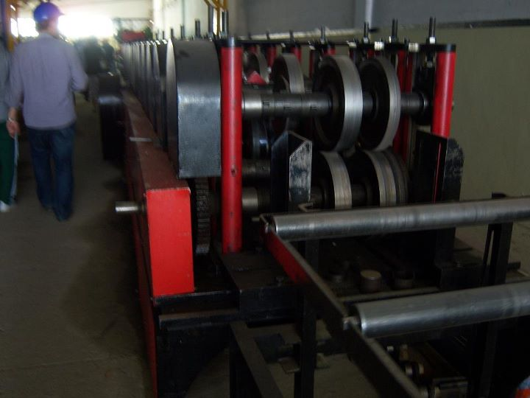

Figure 1

### Excavation – Pasific Inşaat + EgeGrup

### 

Excavations are done to increase the length of the construction underground. In other words when the construction needs foundation – underground garage etc. excavations are done. In the Pasific Inşaat’s construction the excavation needed retaining walls because of the force the soil around the construction site made. From the four types of retaining walls in this construction anchored retaining wall type was used because of the construction type.

To make anchored retaining walls first the required amount of holes are drilled in to the soil at about 30 degrees from horizontal line. Then anchors are put in the holes and get filled with concrete. After the concrete solidifies tension is applied on the anchors. Then the anchors are locked in the tension so the retaining wall is ready for that current level. In the Pasific Inşaats construction there were 13 levels of this application. It can be seen from the picture how it looks.

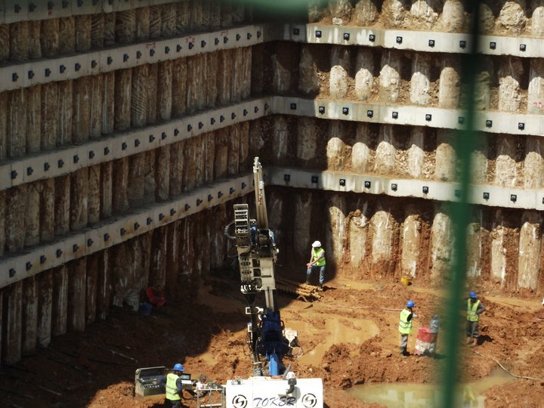

Figure 3: Anchored Retaining Wall. Photo By: Seda Ozdemir.

### 2.1.3 Kurtboğazı and Eğrekkaya Dams, Ivedik Water Treatment Facility

#### 2.1.3.1 Kurtboğazı Dam

It has been built for irrigation and drinking water on the river named Kurtbogazi. It has been constructed between 1963 and 1967. Soil body filling type can be seen with a volume of 834000 m³ and the lake area is 5.5km square.

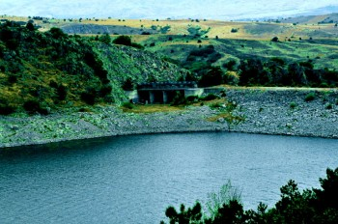

Figure 4: Kurtboğazı Dam

#### 2.1.3.2 Eğrekkaya Dam

It is a damn 3km far from Kizilcahaman on the Sey River. It has been constructed between 1985 and 1992 to feed the Kurtbogazi dam. The maximum water volume is around 112000000 m³ with a lake area of 1.91 km².

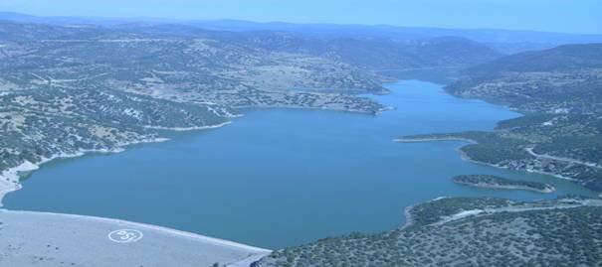

Figure 5: Eğrekkaya Dam

#### 2.1.3.3 Ivedik Water Treatment Facility

Before being sent to the city, Ankara’s water first visits the Ivedik water treatment facility. It gets water from both Kurtbogazi & Camlidere dams. It was built in 1969 and has a service life of 50 years. This is how it is being treated in the facility;

First the water is being aerated. Then aluminum sulfate and polyelectrolyte are added to water so that some unwanted small particles stick together to form a lump. Then the water is untouched for a while for the lump to settle down. Then the water is run through some filters so that other unwanted particles are separated. Now the water is treated with chlorination, ozone, or ultraviolet radiation to eliminate any disease-causing pathogens. Then it is ready to be pumped out to the city.

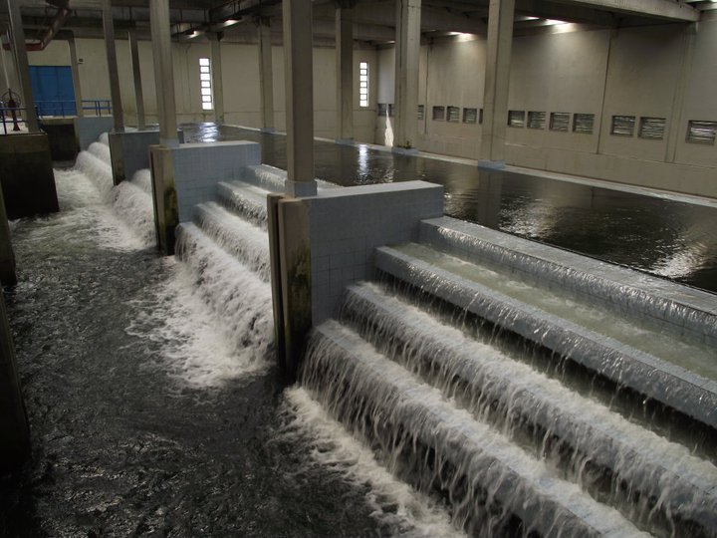

Figure 6: Ivedik water treatment facility, Aeration, Photo By: Seda Ozdemir

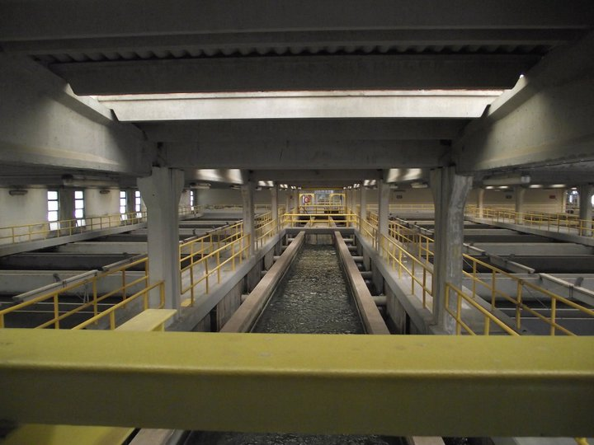

Figure 7: Ivedik water treatment facility, Sedimentation, Photo By: Seda Ozdemir

### 2.1.4 Green Building – Eser Inşaat

Green buildings are environmental friendly buildings. They aim to have low energy and water cost while while also decreasing the pollution caused to the environment.

Eser Insaat has made their main buildings a green building and have won a platinium LEED certificate for it. They have used many ways to make their building energy and water efficient. The gray water was being used second time where clean water was not needed, solar panels were put to different places to increase energy gain, the building had a special isolation to increase the isolation. The toilets had two flushing options and so on.

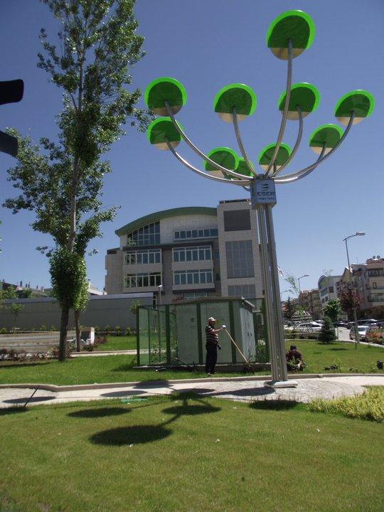

Figure 8: Eser Insaat, Photo By: Seda Ozdemir

### 2.1.5 Reinforced Concrete Structures – Gimsa

Reinforce concrete has been made to increase the weak parts of concrete. It is somewhat an improved version of concrete. Concrete is a good material to withstand compression and steel is a good material to withstand tension. When you put those together it forms reinforced concrete and it becomes the most suitable material ever made.

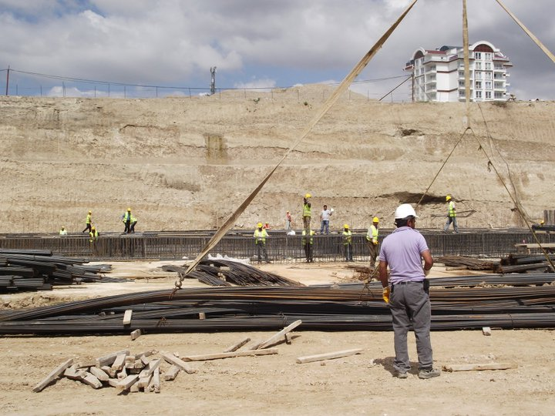

Figure 9: Gimsa Reinforced Concrete, Photo By: Seda Ozdemir

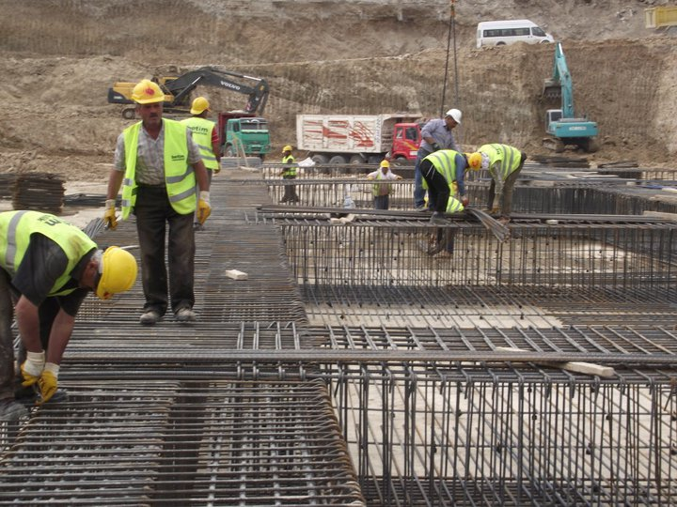

Figure 10: Gimsa Reinforced Concrete a closer look at the steel cage, Photo By: Seda Ozdemir

### 2.1.6 Ilgaz Traverse & Kam

At Ilgaz Traverse they first stretch the inside of cases then pour concrete in the cases. Then it is taken to a room with a necessary temperature and held there for a while for it to solidify. After that they just turn it upside down and take out the part that they need. This is the most common process they do to make materials.

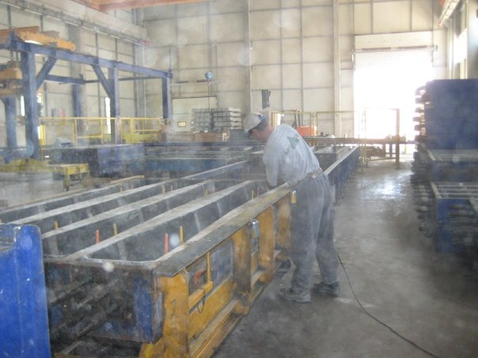

Figure 11: Ilgaz Traverse

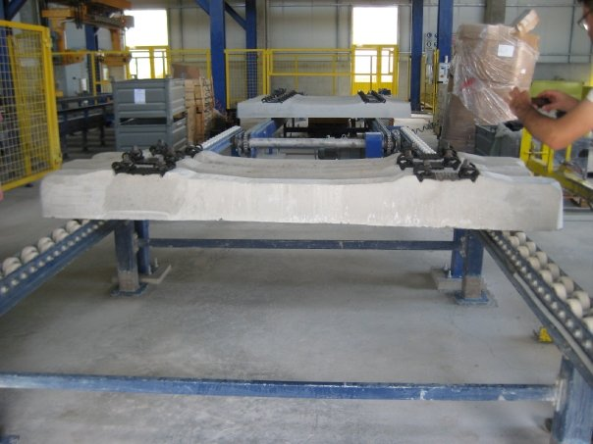

Figure 12: Ilgaz Traverse, The Final Product

Kam has a precast concrete factory where they make huge materials with concrete. They are able to make almost any shapes and sizes. At first they gave us a little presentation with some food and drinks on the table. Then they helped us around the factory explaining the types and some other parts of concrete materials.

### 2.1.7 Landslides

Landslides in other words called landslips can basically be explained by large amounts of ground movement. The primary factor effecting this is gravity due there are other things like the slope stability.   
We went to see a few land slides, some of them were new and some of them were old but the most intresting one was that the one that had half of the road slip down (Figure 13).

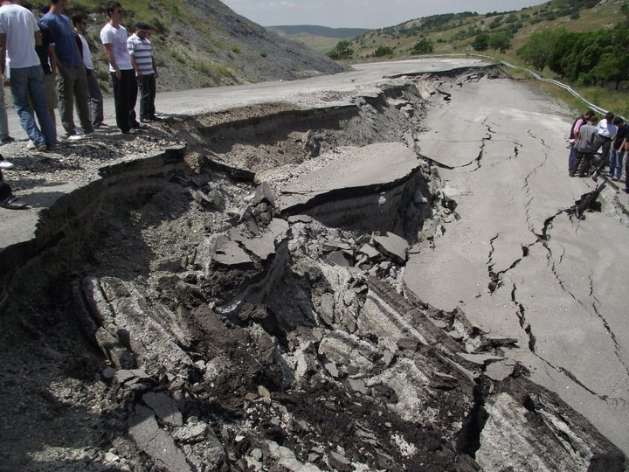

Figure 13: Landslides, Photo By: Seda Ozdemir

In some cases an average man was able to fit the hole in the road which was done by a landslide(Figure 14).

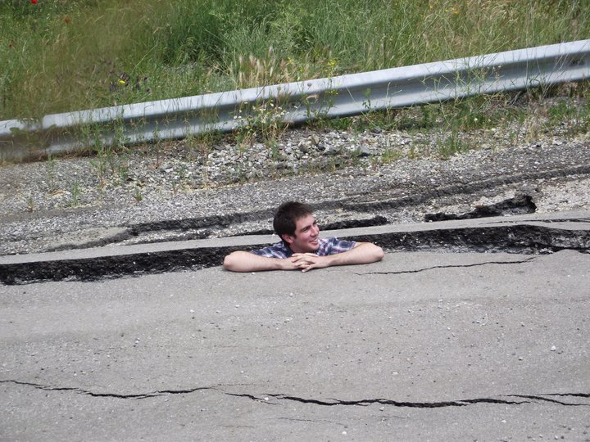

Figure 14: Landslides, Man in the hole, Photo By: Seda Ozdemir

### 2.1.8 Concrete Mixing Station – Oyak Beton

Oyak Beton is one of Turkey’s best concrete provider. There are lots of details when producing concrete but the most important thing I learned there was that they constantly test the product at every single stage of its production. That is how they make one of the most quality mounted concrete (hazir beton) in Turkey. They even test the sand and the water before getting them. Here are a few pictures of their text examples.

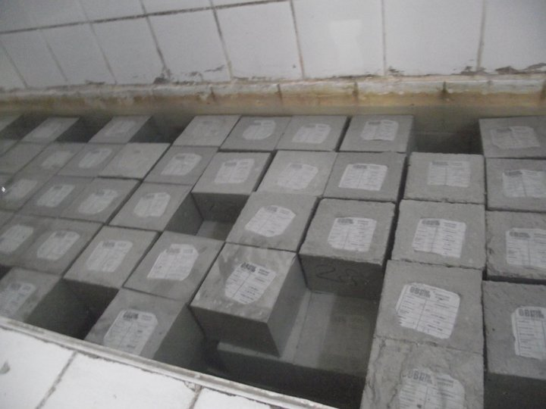

Figure 15: Concrete Samples, Photo By: Seda Ozdemir

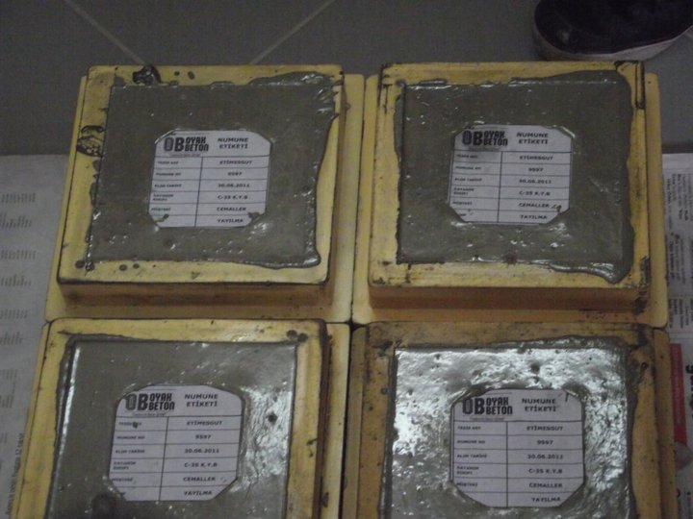

Figure 16: Concrete Samples 2, Photo By: Seda Ozdemir

## Surveying

Throughout CE300 we had surveying lessons once every three days. At each lesson we had a theoretical part and a field part. In the theoretical part we listened to our teachers in the classroom and learned the theory of the lesson. Then on the field part we used that knowledge to practice in the field. I can say that this was the hardest part of CE300 because we were spending most of our time out in the sun. It was boiling hot then but we managed to make it through. We had a total of 5 lessons and through that we can divide surveying in to 5 parts.

* Angle and distance measurement
* Leveling
* Curve and building layout
* Traversing
* Topographic survey

### Angle and Distance Measurement

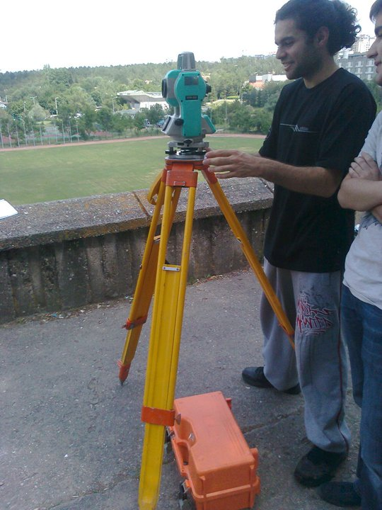At the first surveying lesson we basically learned how to use the total station, we learned how to set it up, how to identify sharp corners, how to measure angles, and the meaning and how to find some terms such as: zenith angle, elevation, bearing, azimuth, direct and reverse reading, vertical angle, vertical line, horizontal angle, horizontal line etc. After each of the group member using and learning how the total station works the class was over.

Figure 17: Me getting to know my new best friend. Photo By: Mustafa Kemal Turkeri

### Leveling

In this part we learned such terms as; benchmark, backside reading, foresight reading, turning point etc. We learned how to calculate the elevation difference and collimation error of level. We started our work from the top of the stadium and went 40 m horizontal distance and calculated the elevation difference in the field. We made two peg tests at the same spot.

### Curve and Building Layout

Figure 18: My team strugling in the football field, Photo By: Mustafa Kemal Turkeri

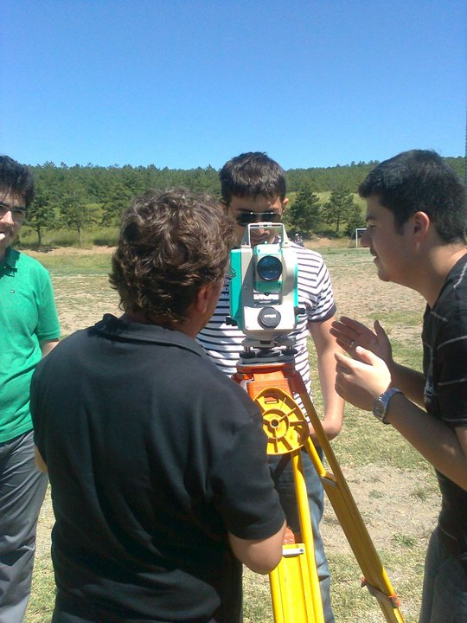At this part of surveying we learned how to generate curve layout. We went to the football field to perform this task by using reflectors and pins. We formed a curve according to the given data and placed the pins on the spots we found by measuring. We used trial and error as a method. And when all the pins were down the curve layout was finished.

### Traversing

We also worked on the American football field in this task. After setting up the total station the first thing was to get the coordinates of the place. There were 6 different reflectors placed around the football field and the goal was to measure them all and get 400 grad.

### Topographic Survey

In the last part of surveying we made a topographic map of the football field by measuring over 120 points around the field. The measurements were done using reflectors. After recording all the points in the total station its memory was used to get the data to an autocad file and ease our drawing of the map.

## MATLAB

MATLAB is the short form of Matrix Laboratory . It is a program which makes life easier for a civil engineer. It can be used to overcome different problems, create applications, graphs, tables, implement algorithms, and it can also interface with programs writtin in other languages such as C, C++, Java and Fortran.

### Introduction to MATLAB

In the first lesson students learned stuff about different programming languages. Such as high level language and low level language. After discussing what these are the introduction to MATLAB began.

First we learned how to assign variables. Then addition, subtraction, multiplication, division, power etc. After learning these basic steps we were asked to write an easy program. But the most important thing we learned was that the important thing was not writing the mess of commands but the constructing the algorithm – logic of the problem. After that we learned a few data types and how some parts of MATLAB is used such as; command history, workspace, command window, editor window, figure window. Then we learned what some mathematic functions do such as; abs(x), sign(x), exp(x), log(x), log10(x), sqrt(x), rem(x), sind(x), asind(x). Then we learned some frequently used functions such as; disp, fprintf, help, edit, prod, cumsum, all, end, linspace, sort, dec2bin, bin2dec, now, tic…toc. Then we learned some file types and saving our work in different ways.

### Scripts & Functions

Before writing scripts & functions first we learned some operators such as; < ,> , <=, >=, ==, ~=, isnan(), isinf(), &&, || , ~, xor. Then we learned some conditionals such as; if statements, else and elseif clauses, switch clause, while and for statements. Then we learned some structs.

After all that knowledge we were ready to write scripts. We learned how to write them and wrote a few scripts then a few functions and saw what this program could really do.

### Graphical User Interface

On our last lesson we were supposed to make a calculator. But we somehow did not have enough time so the teacher made it while we watched how it was done.

By using GUI we were able to make things happen by clicking a button. Before we needed to write the code to make the program work but now we were able to do it in a more efficient way with the use of GUI. The teacher only showed us how to make a calculator but there is much more to matlab than we know.

## ‘What Else Civil Engineers Do?’ Presentations

### Computational Fluid Dynamics By: Mete Köken

Civil engineering has many branches connected with fluids such as; hydrology, water resources engineering, coastal engineering etc. Fluid mechanics are the most dynamic mechanics since they vary a lot it is hard to calculate it. Since it is hard to get to a solution with all these changing properties there is a thing called CFD which makes all these calculations easier for the experimenter.

### Green Construction Materials By; Sinan T. Erdoğan

Mr. Erdogan first explained some key words such as;sustainability, environment friendliness, and philosophical background of becoming green.

Then he said that there are 3 important parts of sustainability: environment, economy and society. So without all of these there the society will collapse. So it is crucial to have them all.

### Network Traffic Management under Disaster Conditions By: Hediye Tüydeş Yaman

Transportation engineering is part of civil engineering and network traffic management is a part of it also. Mrs. Tuydes has been working in this part for many years now and she is very experienced in her class.

There are lots of details about traffic management under disaster conditions. One must look in to every corner and try to see every piece of material before attempting to find a solution. The variables are too much and this makes the work harder to do but as Mrs. Tuydes said it also makes it more intresting and fun.

### The Atmosphere, Global Warming and Its Consequences on Water Resources Engineering By: Ismail Yücel

Global warming is one of the most important things of our age. The earth has gone out of balance which brings lots of problems with itself. The reason is mainly humans. The fossil burning and the various types of human activities cause this global warming to increase it speed.

From that we can easily see that the water cycle is also affected by it. It is raising the sea levels while shrinking the Arctic. It also increases the amount of disasters connected with water. It also increases the taking of carbondioksite of the oceans hence increasing the surface heat of the oceans.

### Computational Modeling of Synthetic and Biological Materials By: Serdar Göktepe

This is a new and bare branch of engineering. Mr.Goktepe gave some examples about the biomechanical side of civil engineering such as rubber polymers and the human heart.

# Conclusion

I do not think that this summer practice was useful at all. A lot more could have been done in the given time.

First of all the field parts of the surveying lessons were unnecessary. It should be held as a lesson and kept that way. During the lessons I learn how to do the task that is wanted from me and when I am out in the field it becomes really easy for me to do it. But I do not feel the need to do it in the field. It just seems useless to me doing the same thing twice (first time in my mind during the lesson).

Secondly the MATLAB lesson was a disaster. I can bet on my life that over 90% of the student body does not know anything useful about MATLAB. It should be held as a course just like Ceng230 (introduction to C programming). Only then will the students actually learn some useful stuff.

The presentations should be included in CE102 course. Or the way they are held should be changed. I will not be able to tell you how but it was the most boring and useless part of this summer practice.

And last of all the field trips were not so bad. Either smaller groups should be taken, or a really good megaphone should be bought and used. Cause half of the places we went there were too much noise to hear even from someone 1m away, and even if there wasn’t any noise around 40-50 people would gather around 1 man and try to hear what he says or look at what he shows and it is kind of impossible to get everything when you are at the back.

At first I was excited about the field trips, trying to learn stuff etc. But as time passed I got bored and started wondering around instead of listening to the talker because of all the noise – crowd.

When it comes to the last week presentations, I felt just like in high school, the teacher would give each person a part, that person would memorize his part and not even look at the rest of the book, when the time comes he would talk about that part and finish his duty easily and learn nothing else.

I know that I have not given a positive feedback. But I find negative ones more useful than positive ones.

# List of Figures

Figure 1 6

Figure 3: Anchored Retaining Wall. Photo By: Seda Ozdemir. 7

Figure 4: Kurtboğazı Dam 8

Figure 5: Eğrekkaya Dam 8

Figure 6: Ivedik water treatment facility, Aeration, Photo By: Seda Ozdemir 9

Figure 7: Ivedik water treatment facility, Sedimentation, Photo By: Seda Ozdemir 9

Figure 8: Eser Insaat, Photo By: Seda Ozdemir 10

Figure 9: Gimsa Reinforced Concrete, Photo By: Seda Ozdemir 11

Figure 10: Gimsa Reinforced Concrete a closer look at the steel cage, Photo By: Seda Ozdemir 11

Figure 11: Ilgaz Traverse 12

Figure 12: Ilgaz Traverse, The Final Product 12

Figure 13: Landslides, Photo By: Seda Ozdemir 13

Figure 14: Landslides, Man in the hole, Photo By: Seda Ozdemir 14

Figure 15: Concrete Samples, Photo By: Seda Ozdemir 14

Figure 16: Concrete Samples 2, Photo By: Seda Ozdemir 15

Figure 17: Me getting to know my new best friend. Photo By: Mustafa Kemal Turkeri 16

Figure 18: My team strugling in the football field, Photo By: Mustafa Kemal Turkeri 17

# References

* Geomatics Division Staff Metu (2010). *SURVEYING SUMMER PRACTICE GUIDE*
* Google Images, *http://www.google.com.tr/imghp*
* Wikipedia (n.d.). [*http://en.wikipedia.org/wiki/Surveying*](http://en.wikipedia.org/wiki/Surveying)
* OYAK BETON, (n.d.) *Beton Kullanicilari Icin Teknik Bilgiler Kilavuzu*