**CE 300 SUMMER PRACTICE REPORT**

**No:**

**Section 6**

**Survey group: 6-3**

TABLE OF CONTENTS

1. INTRODUCTION - - - - - - - - - - - - - - - - - - - - - - - - - - - - - - - - - -3
2. MAIN TEXT - - - - - - - - - - - - - - - - - - - - - - - - - - - - - - - - - - - - -4

2.1. “WHAT ELSE CIVIL ENGINEERS DO” SERIES --- - - - 4

2.2. TECHNICA TRIPS- - - - - - - - - - - - - - - - - - - - - - - - - - - 10

2.3. SURVEYING- - - - - - - - - - - - - - - - - - - - -- - - - -- - - - - 19

2.4. COMPUTER PROGRAMS LECTURES- - - - - - - - - - - - 24

3. CONCLUSION - - - - - - - - - - - - - - - - - - - - - - - - - - - - - - - - - - -25

4. REFERENCES - - - - - - - - - - - - - - - - - - - - - - - - - - - - - - - - - - - 26

5. APPENDIXS - - - - - - - - - - - - - - - - - - - - - - - - - - - - - - - - - - - 27

* 1. **INTRODUCTION**

During the whole 4 weeks, it was a great chance to students who took CE300 Summer Practice due to several reasons. Those reason can be classified in many categories such as a unique chance to all students to see real working field with their instructors, working with their colleagues at the same time at the same place, having presentation from different subjects of civil engineering by experts, learning a lot about surveyingbefore the professional life and having lectures about mat lab which is a very great opportunity for students on their post-graduate lifes.

Due to all reasons that I explained above, it was not time-wasting event. On the contrary, it was a well-prepared event which aimed exactly to teach something to students. Everybody from the instructionswas also ambitious to teach their subjects. Lastly I want to give brief information about what we did during the summer practice.

I want to divide the whole summer practice into 4 groups such as technical trip, what else civil engineers do presentations, mat lab lectures and surveying. In technical trips, we have visited many places near Ankara. Those are mainly big factories which are known with some specific subjects. They are Ilgaz Traverse factory, KAM, Eser Holding, Steel Structures and Ilgaz water treatment center. Those are uniqueopportunities because maybe 10% of all students can see or visit those facilities without having CE300. Also presentations were important to students because they were from different subjects. I will repeat the importance of having presentation from different subjects during my report because for me it was very critical. Those presentations helped me to choose a subject to work on it. I do not want to be an ordinary engineer and I want to work on something new so they helped me to draw my career plan. I can clearly say that I already did it during the practice. I want to work on hydrology subject with sustainable themes. Mat lab lectures were also very important to whole students although they did not notice it at all. Mat lab can be a device which helps people to save time and money because if anybody knows it well, he/she may not suffer from equations or matrices in his/her professional life. We were very luck that we were having those lectures on both CE300 and CE305. I can clearly say that when I graduate from this department, I will be able to use mat lab 60% of efficiency. Lastly I want to talk about surveying sections. I did not expect those kinds of qualified lectures. Every lecture was like real experiments from the real life. It was like being an engineer and working on the field for me. The devices we used during the practice were well equipped and easy to use. Instructors were very easy going people, except one, and helping us all the time, does not matter we were in the class or the field. Before I finish the introduction part, I want to talk very little about last week presentations. I can clearly say that those presentations did not help most of the students at all because they were so boring. Also the presenters did not prepare well for their days. Because of all those facts, last week was more or less a time-wasting week and I hope in next year this problem can be fixed.

Now here is my all report about 4 weeks of my student life. I hope reading my report will be as hilarious as writing it.

1. **MAIN TEXT**

**2.1 “WHAT ELSE CIVIL ENGINEERS DO”SERIES**

1. **Computational fluid dynamics**

This topic was one of the most important points for me through the whole CE 300 period because I learnt 2 important things from that presentation. One of them is the fluid dynamics because it is the biggest point from Civil Engineering that I want to work on it on my master or professional life. The other important thing is I need computers that “much” in order to sustain a good career on fluid dynamics because the professor showed us computer skills is really a must. Otherwise I can lose time, money and patience during my master or job.

According to the research I have made about CFD, people use CFD on solving and analyzing problems related with fluid flows by using numerical methods and algorithms. Also when we talk about CFD, we need to mention its methods, that is:

[2.1 Discretization methods](http://en.wikipedia.org/wiki/Computational_fluid_dynamics#Discretization_methods)

[2.1.1 Finite volume method](http://en.wikipedia.org/wiki/Computational_fluid_dynamics#Finite_volume_method)

[2.1.2 Finite element method](http://en.wikipedia.org/wiki/Computational_fluid_dynamics#Finite_element_method)

[2.1.3 Finite difference method](http://en.wikipedia.org/wiki/Computational_fluid_dynamics#Finite_difference_method)

[2.1.4 Boundary element method](http://en.wikipedia.org/wiki/Computational_fluid_dynamics#Boundary_element_method)

[2.1.5 High-resolution discretization schemes](http://en.wikipedia.org/wiki/Computational_fluid_dynamics#High-resolution_discretization_schemes)

[2.2 Turbulence models](http://en.wikipedia.org/wiki/Computational_fluid_dynamics#Turbulence_models)

[2.2.1 Reynolds-averaged Navier–Stokes](http://en.wikipedia.org/wiki/Computational_fluid_dynamics#Reynolds-averaged_Navier.E2.80.93Stokes)

[2.2.2 Large eddy simulation](http://en.wikipedia.org/wiki/Computational_fluid_dynamics#Large_eddy_simulation)

[2.2.3 Detached eddy simulation](http://en.wikipedia.org/wiki/Computational_fluid_dynamics#Detached_eddy_simulation)

[2.2.4 Direct numerical simulation](http://en.wikipedia.org/wiki/Computational_fluid_dynamics#Direct_numerical_simulation)

[2.2.5 Coherent vortex simulation](http://en.wikipedia.org/wiki/Computational_fluid_dynamics#Coherent_vortex_simulation)

[2.2.6 PDF methods](http://en.wikipedia.org/wiki/Computational_fluid_dynamics#PDF_methods)

[2.2.7 Vortex method](http://en.wikipedia.org/wiki/Computational_fluid_dynamics#Vortex_method)

[2.2.8 Vorticity confinement method](http://en.wikipedia.org/wiki/Computational_fluid_dynamics#Vorticity_confinement_method) ([www.wikipeadia.org](http://www.wikipeadia.org))

1. **Green Construction Materials**

Green method of living is the way for me to sustain my own personal life. I always choose the sustainable way because I do care the world and my future grand-sons. Therefore, it is so obvious for me that being a civil engineer must be related with “green construction”. We as civil engineers must care the world and nature during our proffessional life. What we can earn if we use green method for our buildings:

1. We can pay less if we choose green materials or find the materials needed for the construction.
2. People choose our buildings if we make them “green” because they will know that they will pay very less than normal for energy that they will use in their house.
3. We help the nature to sustain “its own life”.

What I learnt from the presentation was more or less related with those topics. I hope I can be an engineer working on a company which has green construction materials policy.



***Figure 1 – Green Construction Materials***

1. **The atmosphere, global warming and its consequences on water resources engineering**

It is so obvious that water resources of the world are not endless. Actually according to the researches they are running out dramatically. If we consider that water is the very first thing we as the whole planet need to live, somebody must take care and solve that problem. Because of that reasons, water resources engineering is playing a fatal role on the sake of the planet.

On the presentation, Mr. Yücel stated very clear that we need water more than any time in the human history because we are so crowded and consuming big amount of water which push the limits of the world. It was also said that power of the water is one of the most important energy resource that human being can get benefit or use for themselves. In addition, he mentioned that we need to reserve water as much as we can because we never know how much rain or underground water we will have next years. If we do not have enough dams or something like that, it is a high probability we will suffer drought somehow. Level of the drought, on the other hand, will be determined by the nature.

After the presentation I thought that it would be great opportunity for students like me to have green engineering class on 4th grade. During the semester, I will talk about that issue M. Yücel and see what we as department of Civil Engineering of METU can do on it.

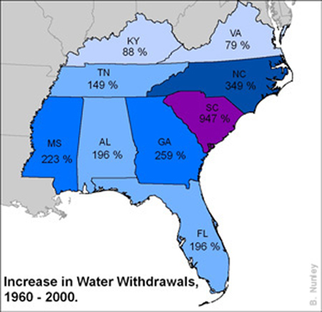

***Figure 2 – Water Resources in 40 years***

1. **Network Traffic Management under Disaster Conditions**

Mrs. Tüydeş is one of the most interesting professors on the department for me. Due to that, I was very curious about her presentation. To sum up, I was very right about my feeling.

Mrs. Tüydeş mostly was talking about her doctoral thesis which she made on the states. The presentation was more or less is from her experiences and studies. She gave examples from the states about the topic. Since I have been in the states for around 5 months, I can clearly saw that the topic was really important for that part of the world. One of the reasons for it is that in the USA, people have much more cars than normal. That means any disaster hits the states, they need to be more careful and systematic than any country in order to make a successful evacuation. In my opinion Turkey as a country needs something like. We may not have as many cars as the states have but also we do not have as many roads as the states have. It compensates the conditions of two countries. However as usual Turkey does not have enough plans or infrastructures for that issue. I hope in near future, we can deal with it more successful.

1. **Computational Modeling of Synthetic and Biological Materials**

From my point of view, this presentation did not mean so much to me because almost half of it was about “heart”, the organ. I spent around 60 minutes in order to understand why I am seeing such kind of presentation. In addition, I did not understand why the vice department of chair worked with medicine doctors in the states. However before the end, I finally understood the meaning of the presentation or I thought I did it.

I think the professor was trying to teach us how important the programming is. In the other words, he tried to show us that even if you are a civil engineer; if you know enough about programming, you can work on human heart. Maybe his aim was completely different than I thought but after that presentation I was completely sure that I will learn the programming on a good level.

Now I know that in our age, we as engineers should have very high level of computer skills in order to save time and have better solutions from problems that we face. Maybe that presentation lighted the biggest lamp on my head or drove me a path which I will never have a benefit from. I will see in future.

**2.2 TECHNICAL TRIPS**

1. **Steel Structures (ATAK ENGINEERING)**

WE had a great time on ATAK Engineering because from the first moment that we got the building there was a very warm welcome to us. They started their presentation with talking about ATAK ENGINEERING. It was founded in 1998 and they mainly focuses on steel and its design, reconstruction, construction, renovation and restoration. In addition to that, the company works on decoration, electrical-mechanical installation of buildings and variousconsultancy services and recreation. The company is proud of their work both in national and international level. Those mainly are Izmir Adnan Menderes Airport, Antalya International Terminal, Sukru Saracoglu Stadium, Ammonia-Urea Plant in Turkmenistan, Baltika Brewer Factory in Russia, Klin Brewery factory in Russia, Coca Cola factor in Romania, Toyota Plaza in Ankara Turkey, Raw Food Material Storage in Bandirma Turkey, Kirisworld Holiday Village in Turkey.

They briefed us about steel mainly. I learnt a lot about making steel structures but not the construction part of course because I need a high engineering level to do that. Actually I found some answers to questions that I have been wondering for a while. One of them was the necessity of the steel buildings. I could not come out a logical reason when I think that why people need steel buildings. More or less I can say that I am satisfied from the answers. Also we learnt some steps of steel constructions. Those are mainly: cold forming unit, automatic sheet and profile sand blasting unit, guillotine shear, CNC cutting machine,sheet bending machine. Some pictures from the topic are below:

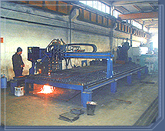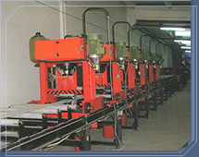

***Figure 3 – Atak Engineering***

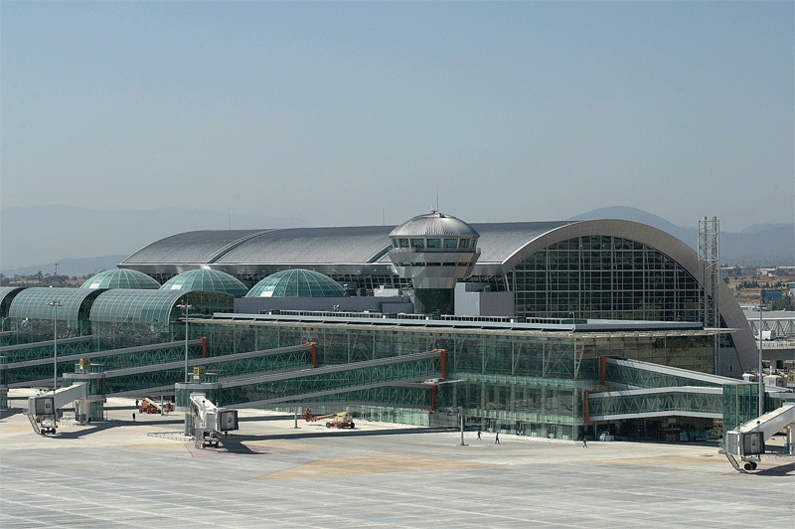

***Figure 4 – İzmir Adnan Menderes Airport***

1. **Excavation (PASIFIC INSAAT + EGE GROUP)**

Well, it was a very short trip indeed so I did not have many things to say. However my first impression was that “It was a very huge construction”. It was so deep also. I have never been on such a place as deep as it was. I thought that being a civil engineer can be very though job if you work on a big construction area because there are too many things that you have to control very well. A small mistake that you make on the beginning can cause very big problems after tons of steel and concrete are built above that small mistake.

Engieers we met talked mainly about hugeness of the construction. When I ask the biggest afraid they afraid, the answer was pretty much the same from the whole engineers: Money. They said that these kind of huge constructions need so much capital, the capital some of us cannot imagine. They also added that either the government or the big guys are capable of building them. Since there is so much money on table, everybody gets nervous quickly. They needed to finish it on time, otherwise everyday means loose of money, money that we cannot imagine.

I was pretty shocked that engineers were talking about money issue easily. However, I know that the first reason why there are civil engineers on the earth is to make constructions by using less capital. Because I believe that anybody who has very limited education level, can lead a construction but a successful engineer can make building in economical way with the desirable factor of safety.

1. **Kurtboğazı and Eğrekkaya Dams**

For me I can clearly say that those trips were the weakest ones because I can tell 2 reasons:

1. We did not see any details related with engineering. I mean it was just like a picnic trip. We only saw the parts which anybody can see when they go to a picnic near those dams. I was very disappointed about that issue because I want to work on dams or related topics in my professional life. I did not learn anything except from information from Wikipedia. Therefore since I do not want make copy-paste from Wikipedia, I want to skip that part.
2. About the lunch..! It was a full-day trip so we needed to have lunch out of Ankara. Sometimes companies cover students’ lunch and I think it is very logic. However, the place that we went together was extremely expensive. You need to pay ~10 TL in order to have a normal lunch. 10 TL can be a very high amount for some students. Plus it was a “must” trip that means students have to attend it. I think the department of Civil Engineering of METU should have covered it.

Here is a picture of dams:

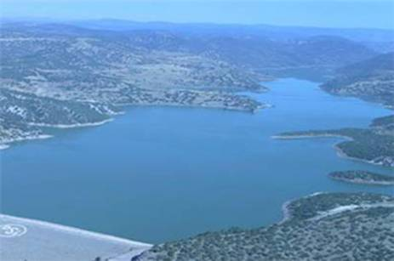

***Figure 5 – Eğrekkaya Dam***

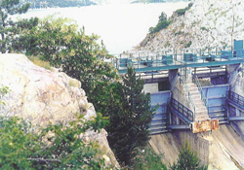

***Figure 6 – Kurtboğazı Dam***

1. **Ivedik Water Treatment Plants**

After the dams trip and the lunch, we went to Ivedik Water Treatment Plants. I need to say that they were very above my expectations. It should be normal because according to the tour guide, they are one of the biggest water treatment plants in the whole Europe. The center has ~10 different sections. Every section has its own duty in order to make the water usable. The steps are more or less are like that:

1. Dirty water comes from the dams
2. Helping water breathe and cleaning the water from heavy metals
3. Putting chemical stuff into the water in order to kill bacterium.
4. Arranging the PH level of water.
5. Pumping it to the city.

Working principle of it was so amazing. The center as a whole team must make a good job because the system is accurate. If a section works inadequately, the whole water needs to be cleaned from the beginning. To sum up, it was a very important trip of the whole summer practice. Everything went smoothly and I think most of the students enjoyed the hours they spent there.

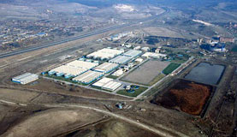

***Figure 7 – İvedikWater Treatment Plants***

1. **Ilgaz Traverse and KAM**

It was a quite long day. The places we visited are nearly 80 km away from the city center. However, they were very qualified trips and got me many experiences and helped me to create another view of perspective about civil engineering.

Fistly, the Ilgaz Traverse Factory was on the program. We arrived there around 10.30am. It was not a huge factory and office building but the things that they were creating were much more beyond their buildings! We were welcomed by a lady. I did not understand what her job is but she knew what she was talking about. She made us quite satisfactory information about the management of the factory, factory itself and how it works etc. Then the general manger met with us. I needed to admit that I did not expect they knew that much about the process of making traverse. We started our trip directly from the factory. We saw every steps of making a traverse. It was so interesting for me because it was a first time for me to be in a factory related with my study. They explained why it was so important to make them very strong. The reason being that is because when high speed trains go through them, they strength them with around 50.000 tons. That means if they are not strong enough, they can be cracked in 2 years and caused big catastrophic accidents. Because of that reason, they are making experiment on one traverse from every group that they make. They are making traverses 3 times in day so they needed to be sure that they are not making mistakes. The manager told us that they are making around 300.000 traverses per year. According to him, that is a big amount for a factory like it. In the end, he gave us the opportunity to see an experiment on a traverse. The experiment was so easy: They are putting load on the traverse up to 10.000KN. Our trip ended with a good lunch on the factory area.

After we left the factory, we made another 1-hour trip to KAM. They were so kind to us and took us directly to the conference room. There was beverages and something to eat. It was so important to 50 people who suffer from dehydration! The presentation was about the factory itself, management, history of the company and what they did till now. They were proud of what they made very much. I can tell that they are right to be proud of. They talked a lot about IKEA buildings because they made the every IKEA building in Turkey.

They divided to us 3-4 groups in order to make the trip more efficient. Before the factory trip, they briefed us about the factory and the process of what they make in there. They told that making prefabricate concrete is not always the best way! They are making it for very large buildings. Unless, the cost can be doubled for the small buildings. The biggest benefit from that business is to make big concrete in the factory. In other words, you do not need to make the walls, floors etc. on the place you make the building. Instead of that, you make all the big parts on the factory. In this way, you can make mass production and that means less money!

They firstly need the sizes of the walls, beams or etc. They made a model of them. On that model, they put the steel wires in order to make the concrete strong. They put different types and amount of steel to every parts of the building. They have the all calculations made before. They know exactly how much steel and concrete they need and in that part they do not need so much engineering knowledge. After they put the steel wires, they make the concrete on their model. After that process, they make them wait and send them to the construction area. According to them, transportation costs are really high. Because of that reason, it should not be made on small buildings. After they showed us every detail, they ended the trip by answering the questions from the students.

1. **GREEN BUILDING (ESER HOLDING)**



***Figure 8 – LEED Platinum***

I can clearly say that this trip was the most interesting thing from the whole SUMMER PRACTICE 2011. The reason is their building!!! Since I stated before in my report, I want to study and/or work on sustainability subject. However, it was pretty shame to me that I did not even know Eser Holding is dealing with this subject.

First impact is always so important so they made a very good first impact to all students. We just passed the whole building down and seated on the conference room. There was a gentleman, the manager of a unit on Eser Holding, was on the floor and started talking about Eser Holding and its values. Then he changed the subject into the sustainability. He continued his speech about Eser Green Building, which is the headquarters of the Eser Holding. He presented almost every detailabout the green building, from the first plan to present. He showed us clearly how they become very clear and decided to have one of the first green headquarters in Turkey. He also talked about how they built the building. He mentioned that they used around 35%, which is a very good figure, of the whole materials from building was collected near Ankara (350 km radius away). Also they use energy and water very efficiently. According to them, making this green building instead of a normal one costs them only 10% more. That means in 6-7 years, they started to have a plus from that building. If we consider the average of the building which is around 70 years, they made a clever job. They are very good case to show everybody: By being sustainable, you can also make much profit than by being not-sustainable. However I need to admit that questions from students were very miserable because they asked questions to prove them there cannot be a sustainable way of being a big holding. After those questions, they made us a big tour inside and around the building. They showed us everything, presented during the presentation. It was really cool to see those machines or architectures in real. In the end, we all went to a park, just near the building. The park is dedicated to children for helping them to understand the concept of sustainability. The park was designed by considering the sustainable rules. There was a small theatre which is heated by sun!!! Those kind of things light many lamp on small children mind so I can say that Eser Holding made a good job there..!

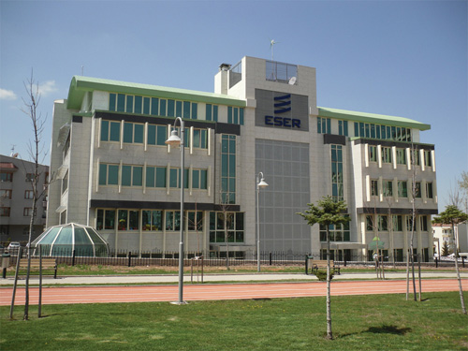

***Figure 9 – Eser Holding Headquarters***

1. **Landslides**

It was a short trip I can say about that. We were brought 45km away from the center to see lands. On that trip firstly we climbed around 15 minutes to a small hill to see real landslides. It was important for students to see such a real thing because sometimes it may be hard to understand when to see pictures or drawings from a book. After we are done with climbing, we saw the whole landslides. According to professors, that kind of climbing can cause serious accidents like falling down a boiling. The main reason of landslides was a big building which was built on the top of hills. They said that engineers who built the building could not calculate the total load in years. That means they could not predict that mass of the building would be very heavy for those lands. After here, we went to a road which was closed, thank God because asphalt of some parts of the road collapsed about 4 meters..! The reason of it is heavy rains and wrong calculating. As an engineer, we all need to consider the economy. However making a road twice cannot be compared by any extras or safety caution or human life. Sometimes I think that I wish being an engineer should not be that easy in Turkey. Before coming home, we passed by another landslide area. However this time, they did not close the road because they cannot close every road which has potential of landslides but the problem was that there were big landslides just near the road. Muck with lots of water and rocks were falling down to the road from the hill. It was not safe for the drivers because they made a silly accident due to those landslides or us..! We around 50 students were standing just near a very busy road. It was not safe at all because there were no warning for the drivers about 50 people on the road. Anyway there were no death on that day and I hope there will none in future CE300s. Maybe after my report will be read, some safety caution can be added the program before it is too late.

* 1. **SURVEYING**

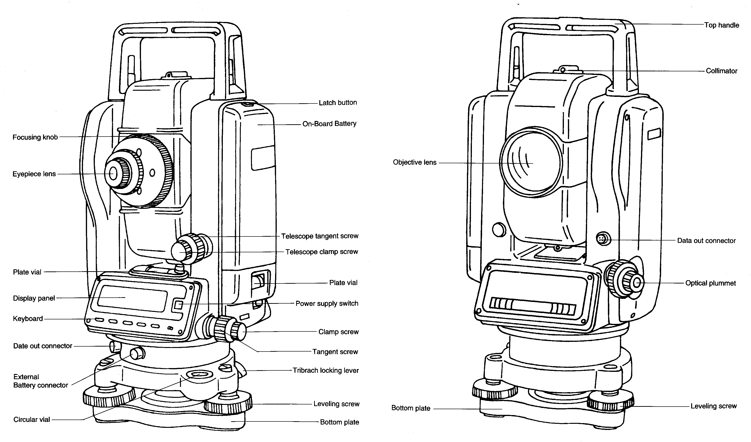

***Figure 10 – Total Station***

In surveying lectures we always followed that method: Before every area practice we had 30 minutes lectures about the topic which we are going to work on that day. Lectures and practices were organized well because we used ever details that we learnt from the lectures during the practice. I want to explain what we did briefly below

* 1. **Angle and Distance Measurement**

Firstly we just were given some practical information about Total Station. Those information were about TS itself, how to install and use it, angle and bubble settings etc. Those information were given only once due to lack of time. It was important to arrange the bubble well. Otherwise everything you measured would be wrong. We were divided into 5-6 groups and continued work with the same people for 3 weeks.

After installing the TS well and correctly, we started to measure angle. Firstly we measure some angle and repeated it 4 times in order to be correct on our work. To prevent some user errors, we used reverse angle method, which was a good method for that. Lastly, we measured 6 angles of a circle. In the end, we added the whole data up to have 400 grad because in TS we do not use degrees but grads. 400 grads=360 degrees.

In surveying distance measurement can be calculated with different ways. I believe we used the very basic way of it. Then we just started to measure the distance by using a reflector. The idea being it was so simple. TS sends waves to the reflector. When the waves reach the reflector, they rebound and came back to TS. TS calculated this distance by using the time of returning of the waves.

* 1. **Leveling**

After we had a lecture about leveling, we found ourselves on the field. In basic, leveling can be done by calculating evaluation differences between 2 points. One of them must be reference point in order to measure the others level. In TS since you do not use GPS, which leads you to know exact level from the sea level. When we use TS, we should not have business with the evaluation from the sea level, but evaluation from the point where we stand. So in that survey lectures, we measure evaluation of points relatively.

1. **Curve and Building Layout**

After a quick briefing about what we would do in the field, we went to the field. Our aim was to calculate distance from curve to tangent points and length of the curves. We used nails in order to determine critical points. We used again the reflector in order to measure the distance from the point to the TS. We finished the day by preparing our report.

1. **Traversing**

In order to determine a certain spatial referencing system for horizontal and vertical measurements can be performed traversing. Students measured the field by using the reference points which were given by instructors. These points were very important for calculating. We completed the closed area. They found errors of distances and angles. In this part of surveying students used distance and angle measurements together**.**

1. **Term Project**

In that project, we were required to prepare a topographic map of football stadium. In order to do this, firstly we needed to get around 120 points from the whole stadium. Those points were coded with their levels and locations. After we got the whole points, we gave them to our instructor and she gave us back them in AutoCAD format. After we got the final part, we printed it out and gave it back to the Instructor. In this way, we have completed our Summer Practice 2011 tasks.

**2.4 COMPUTER PROGRAMS LECTURES**

**MATLAB**

I believe that on the Mat lab lectures the main reason was to show student that there is a program called mat lab and this is how we use it. I am saying it because we only saw the basic things from mat lab such as calculation commands, ordering the terms, logarithmic functions, exponentials, square roots, differentials, basic operations on integers. Every lecture was prepared by a different instructor and they were all good what they were teaching. Those things made the lectures very logic. We were very lucky to learn those lectures for free. As far as I know if we want to learn them outside of the school, it may cost us around 200-300 TL. So I was aware of it and tried to learn as much as I could. The most important reason of the lectures was to show us the usage of it with matrices and plotting graphs. It was so important because dealing with matrices and plotting the graphs cannot be done by hand. Maybe somebody can do it by hand but it would not be one of thecleverest things in the world. Finding roots of matrices, adding, multiplication, dividing and ordering the rows and columns of matrices are the basic operations that taught for matrices. And also plotting graphs for specified definite data ranges with mat-lab is another part of lecture.

1. **CONCLUSION**

After a 4-weeks full –day-long summer practice, I need to admit that every minute I spent there was worth it. I am writing this because I have many reasons for it. Those reasons are:

* + 1. The program was really well-prepared one. That means every section on the schedule was serving an aim. Everything was just for helping student developing themselves.
    2. The instructors, except one, were really trying to help anybody who has questions or problems. They were sharing their knowledge without any hesitate wanted us to learn something from lectures.
    3. 3+1 week was really good and well-estimated time limit. We generally never got bored or extra-ordinary tired.
    4. The places that we have visited were good spots for such a summer practice. Unless I get CE300, I will never visit and see those factories in my life. That means CE300 is a unique opportunity for all of us.
    5. The schedule also covered its role.

In the light of all the information I wrote down in that report, I without any doubt can say that I am very happy to have CE300. I learnt much more beyond than I expected. It helped me a lot on shaping my thoughts about civil engineering and my future professional job. I hope one day I can be the one who help students or young people to learn and develop themselves about civil engineering. I decided to make a career on hydrology and sustainability.

Before I finish my report, I want to thank to everybody who made something on the CE300. We as students will always owe you something no matter we will do for you.

1. ***REFERENCES***

<http://www.nwf.org/Global-Warming/What-is-Global-Warming/Global-Warming-is-Causing-Extreme-Weather/Drought.aspx>

<http://www.atakltd.com.tr/site_eng.htm>

<http://www2.dsi.gov.tr/bolge/dsi5/ankara.htm>

<http://www.radikal.com.tr/Radikal.aspx?aType=RadikalDetayV3&CategoryID=85&ArticleID=1035027>

<http://www.suyapi.com/page.php?ID=72>

<http://www.yesilbina.com/haber/1/Turkiye-nin-Ilk-Platinum-Sertifikali-Yesil-Binasi.html>

<http://www.tombrownarchitect.com/>

<http://www.bg-map.com/userdata/cub-pr01.html>

[www.wikipedia.org](http://www.wikipedia.org)

APPENDIX