**CE332**

**CONSTRUCTION ENGINEERING AND MANAGEMENT**

**SCHEDULING AND RESOURCE ALLOCATION ASSINGNMENT**

**For unlimited resources case:**

If the sources are unlimited, the works which require the same resource are not related to each other. In other words, all excavations (or any other works) can be started at the same time. So; the total project time is shorter than the limited case as shown below. The below table shows the statistics for the unlimited case.

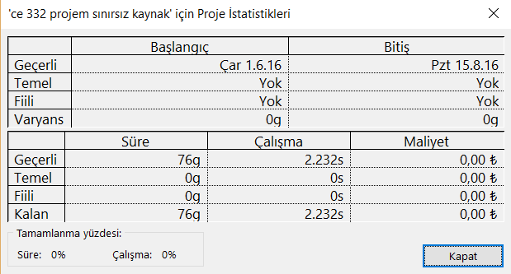

TABLE 1 Unlimited case statistics

**For limited resources case:**

If the sources are limited, the works are also related to a common resource. For example for the second step of excavation, first step must be finished. It means dependencies are changed because of having limited resource. As a result of this, total project time is longer than unlimited case as shown below. The below table shows the statistics for the limited case.

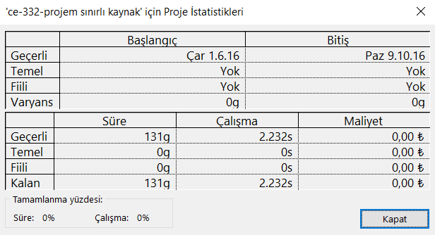

All other required information is shown below.

* **Unlimited case;**

|  |  |  |  |  |  |  |  |  |  |  |  |  |  |
| --- | --- | --- | --- | --- | --- | --- | --- | --- | --- | --- | --- | --- | --- |
| **Ad** | **Kimlik** | | **Erken Başlatma** | **Erken Bitirme** | | **Kaynak Adları** | | **Geç Başlatma** | | **Geç Bitirme** | | **Toplam Bolluk** | |
| Beginning of project | 1 | Çar 1.6.16 | | | Çar 1.6.16 | |  | | Çar 1.6.16 | | Çar 1.6.16 | | 0 gün |
| Excavation(abutment1) | 2 | Çar 1.6.16 | | | Sal 7.6.16 | | Excavator | | Çar 1.6.16 | | Sal 7.6.16 | | 0 gün |
| Excavation(pillar 1) | 3 | Çar 1.6.16 | | | Cum 3.6.16 | | Excavator | | Paz 26.6.16 | | Sal 28.6.16 | | 25 gün |
| Excavation(pillar 2) | 4 | Çar 1.6.16 | | | Cum 3.6.16 | | Excavator | | Çar 29.6.16 | | Cum 1.7.16 | | 28 gün |
| Excavation(pillar 3) | 5 | Çar 1.6.16 | | | Cum 3.6.16 | | Excavator | | Cmt 2.7.16 | | Pzt 4.7.16 | | 31 gün |
| Excavation(pillar 4) | 6 | Çar 1.6.16 | | | Cum 3.6.16 | | Excavator | | Cmt 2.7.16 | | Pzt 4.7.16 | | 31 gün |
| Excavation(abutment2) | 7 | Çar 1.6.16 | | | Paz 5.6.16 | | Excavator | | Cum 10.6.16 | | Sal 14.6.16 | | 9 gün |
| Foundation piles 2 | 8 | Cmt 4.6.16 | | | Cmt 18.6.16 | | pile driver | | Cmt 2.7.16 | | Cmt 16.7.16 | | 28 gün |
| Foundation piles 3 | 9 | Cmt 4.6.16 | | | Çar 15.6.16 | | pile driver | | Sal 5.7.16 | | Cmt 16.7.16 | | 31 gün |
| Formwork(abutment 1) | 10 | Çar 8.6.16 | | | Paz 19.6.16 | | carpenter crew | | Çar 8.6.16 | | Paz 19.6.16 | | 0 gün |
| Formwork(pillar 1) | 11 | Cmt 4.6.16 | | | Çar 8.6.16 | | carpenter crew | | Çar 29.6.16 | | Paz 3.7.16 | | 25 gün |
| Formwork(pillar 2) | 12 | Paz 19.6.16 | | | Per 23.6.16 | | carpenter crew | | Paz 17.7.16 | | Per 21.7.16 | | 28 gün |
| Formwork(pillar 3) | 13 | Per 16.6.16 | | | Pzt 20.6.16 | | carpenter crew | | Paz 17.7.16 | | Per 21.7.16 | | 31 gün |
| Formwork(pillar 4) | 14 | Cmt 4.6.16 | | | Çar 8.6.16 | | carpenter crew | | Sal 5.7.16 | | Cmt 9.7.16 | | 31 gün |
| Formwork(abutment 2) | 15 | Pzt 6.6.16 | | | Cum 17.6.16 | | carpenter crew | | Çar 15.6.16 | | Paz 26.6.16 | | 9 gün |
| Concrete foundation(abutment 1) | 16 | Pzt 20.6.16 | | | Pzt 20.6.16 | | concrete mixer | | Pzt 20.6.16 | | Pzt 20.6.16 | | 0 gün |
| Concrete foundation (pillar 1) | 17 | Per 9.6.16 | | | Per 9.6.16 | | concrete mixer | | Pzt 4.7.16 | | Pzt 4.7.16 | | 25 gün |
| Concrete foundation (pillar 2) | 18 | Cum 24.6.16 | | | Cum 24.6.16 | | concrete mixer | | Cum 22.7.16 | | Cum 22.7.16 | | 28 gün |
| Concrete foundation (pillar 3) | 19 | Sal 21.6.16 | | | Sal 21.6.16 | | concrete mixer | | Cum 22.7.16 | | Cum 22.7.16 | | 31 gün |
| Concrete foundation (pillar 4) | 20 | Per 9.6.16 | | | Per 9.6.16 | | concrete mixer | | Paz 10.7.16 | | Paz 10.7.16 | | 31 gün |
| Concrete foundation(abutment 2) | 21 | Cmt 18.6.16 | | | Cmt 18.6.16 | | concrete mixer | | Pzt 27.6.16 | | Pzt 27.6.16 | | 9 gün |
| Concrete setting time (abutment 1) | 22 | Sal 21.6.16 | | | Çar 22.6.16 | |  | | Sal 21.6.16 | | Çar 22.6.16 | | 0 gün |
| Concrete setting time (pillar 1) | 23 | Cum 10.6.16 | | | Cmt 11.6.16 | |  | | Sal 5.7.16 | | Çar 6.7.16 | | 25 gün |
| Concrete setting time (pillar 2) | 24 | Cmt 25.6.16 | | | Paz 26.6.16 | |  | | Cmt 23.7.16 | | Paz 24.7.16 | | 28 gün |
| Concrete setting time (pillar 3) | 25 | Çar 22.6.16 | | | Per 23.6.16 | |  | | Cmt 23.7.16 | | Paz 24.7.16 | | 31 gün |
| Concrete setting time (pillar 4) | 26 | Cum 10.6.16 | | | Cmt 11.6.16 | |  | | Pzt 11.7.16 | | Sal 12.7.16 | | 31 gün |
| Concrete setting time (abutment 2) | 27 | Paz 19.6.16 | | | Pzt 20.6.16 | |  | | Sal 28.6.16 | | Çar 29.6.16 | | 9 gün |
| Masonary work (abutment 1) | 28 | Per 23.6.16 | | | Cum 15.7.16 | | masonary crew | | Per 23.6.16 | | Cum 15.7.16 | | 0 gün |
| Masonary work (pillar 1) | 29 | Paz 12.6.16 | | | Pzt 20.6.16 | | masonary crew | | Per 7.7.16 | | Cum 15.7.16 | | 25 gün |
| Masonary work (pillar 2) | 30 | Pzt 27.6.16 | | | Sal 5.7.16 | | masonary crew | | Pzt 25.7.16 | | Sal 2.8.16 | | 28 gün |
| Masonary work (pillar 3) | 31 | Cum 24.6.16 | | | Cmt 2.7.16 | | masonary crew | | Pzt 25.7.16 | | Sal 2.8.16 | | 31 gün |
| Masonary work (pillar 4) | 32 | Paz 12.6.16 | | | Pzt 20.6.16 | | masonary crew | | Çar 13.7.16 | | Per 21.7.16 | | 31 gün |
| Masonary work (abutment 2) | 33 | Sal 21.6.16 | | | Sal 12.7.16 | | masonary crew | | Per 30.6.16 | | Per 21.7.16 | | 9 gün |
| Delivery of the preformed bearers | 34 | Çar 1.6.16 | | | Per 2.6.16 | | crane | | Per 14.7.16 | | Cum 15.7.16 | | 43 gün |
| Positioning (preformed bearer 1) | 35 | Cmt 16.7.16 | | | Per 28.7.16 | | crane | | Cmt 16.7.16 | | Per 28.7.16 | | 0 gün |
| Positioning (preformed bearer 2) | 36 | Çar 6.7.16 | | | Pzt 18.7.16 | | crane | | Çar 3.8.16 | | Pzt 15.8.16 | | 28 gün |
| Positioning (preformed bearer 3) | 37 | Çar 6.7.16 | | | Pzt 18.7.16 | | crane | | Çar 3.8.16 | | Pzt 15.8.16 | | 28 gün |
| Positioning (preformed bearer 4) | 38 | Paz 3.7.16 | | | Cum 15.7.16 | | crane | | Çar 3.8.16 | | Pzt 15.8.16 | | 31 gün |
| Positioning (preformed bearer 5) | 39 | Çar 13.7.16 | | | Pzt 25.7.16 | | crane | | Cum 22.7.16 | | Çar 3.8.16 | | 9 gün |
| Filling 1 | 40 | Cum 29.7.16 | | | Pzt 15.8.16 | | backfilling equipment | | Cum 29.7.16 | | Pzt 15.8.16 | | 0 gün |
| Filling 2 | 41 | Sal 26.7.16 | | | Cmt 6.8.16 | | backfilling equipment | | Per 4.8.16 | | Pzt 15.8.16 | | 9 gün |
| End of project | 42 | Pzt 15.8.16 | | | Pzt 15.8.16 | |  | | Pzt 15.8.16 | | Pzt 15.8.16 | | 0 gün |

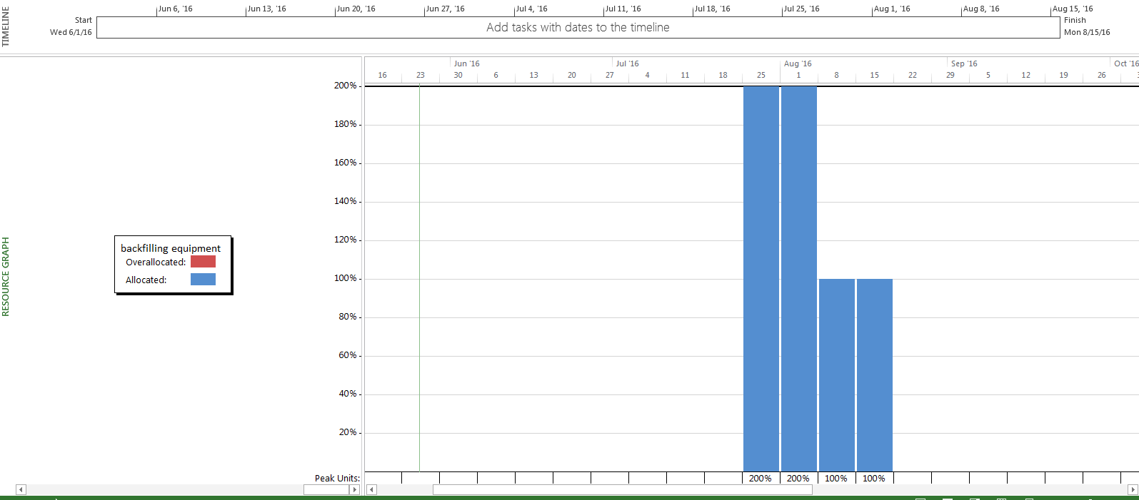

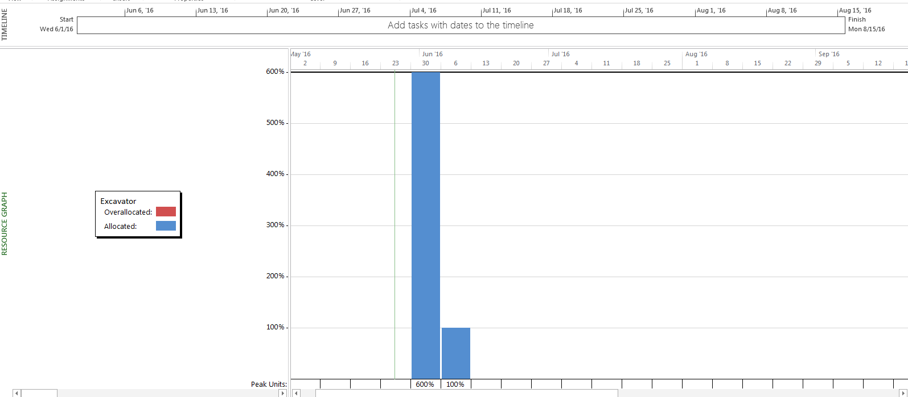

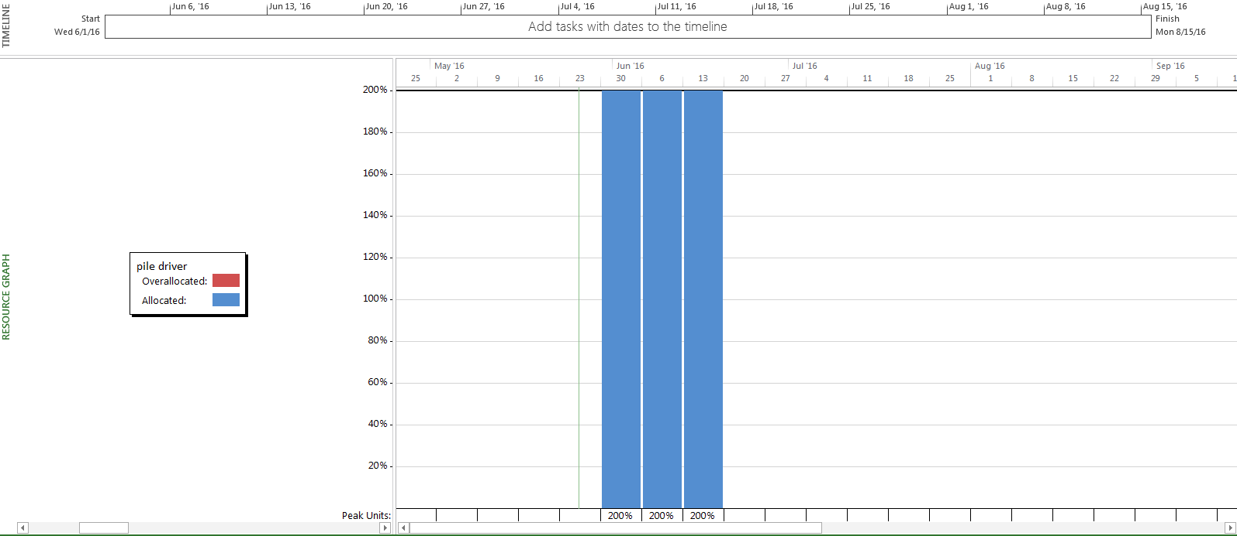

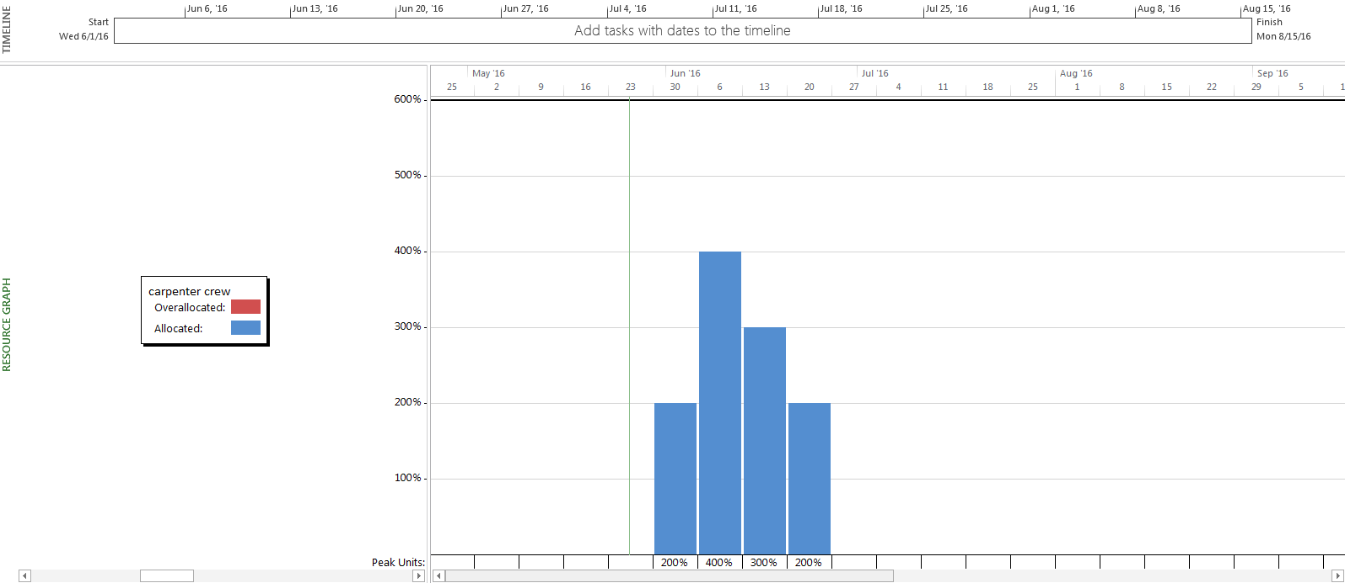

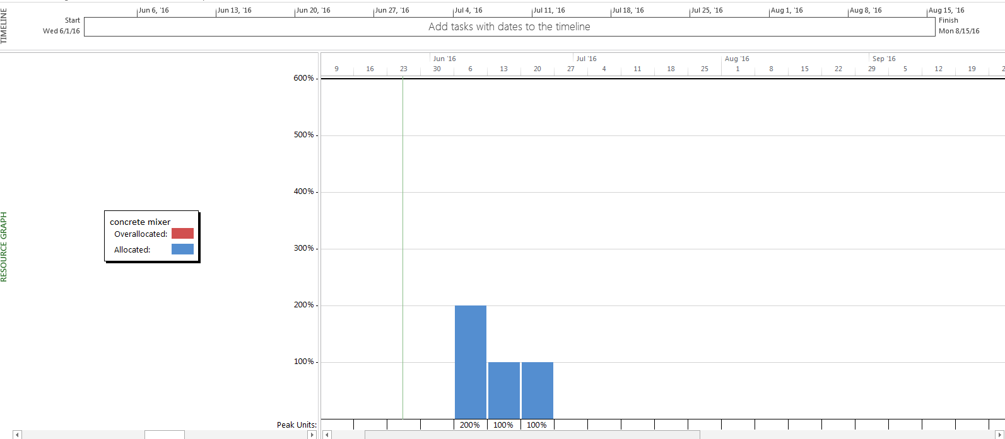

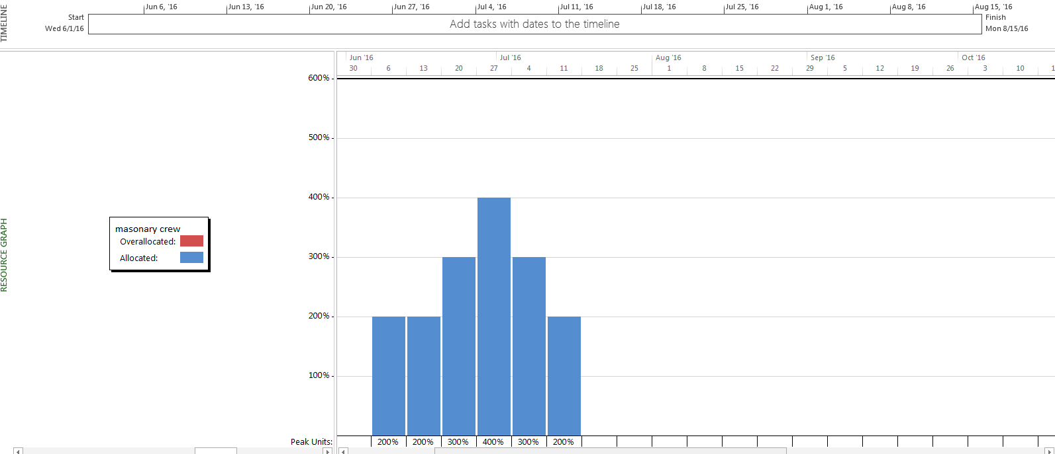

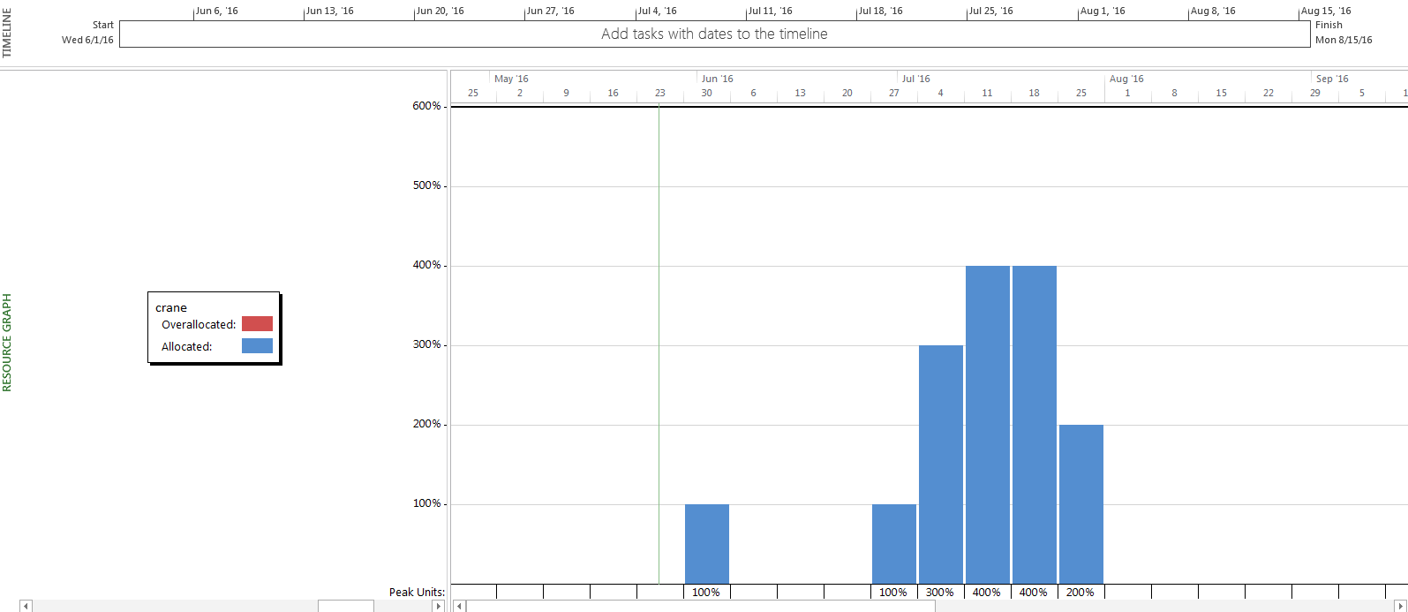

* **Limited case;**

|  |  |  |  |  |  |
| --- | --- | --- | --- | --- | --- |
| **Name** | **Early Finish** | **Early Start** | **Late Finish** | **Late Start** | **Total Slack** |
| Beginning of project | Wed 6/1/16 | Wed 6/1/16 | Wed 6/1/16 | Wed 6/1/16 | 0 days |
| Excavation(abutment1) | Tue 6/7/16 | Wed 6/1/16 | Tue 6/7/16 | Wed 6/1/16 | 0 days |
| Excavation(pillar 1) | Fri 6/10/16 | Wed 6/8/16 | Thu 7/7/16 | Tue 7/5/16 | 27 days |
| Excavation(pillar 2) | Mon 6/13/16 | Sat 6/11/16 | Tue 7/19/16 | Sun 7/17/16 | 36 days |
| Excavation(pillar 3) | Thu 6/16/16 | Tue 6/14/16 | Thu 7/28/16 | Tue 7/26/16 | 42 days |
| Excavation(pillar 4) | Sun 6/19/16 | Fri 6/17/16 | Wed 8/3/16 | Mon 8/1/16 | 45 days |
| Excavation(abutment2) | Fri 6/24/16 | Mon 6/20/16 | Mon 8/8/16 | Thu 8/4/16 | 45 days |
| Foundation piles 2 | Tue 6/28/16 | Tue 6/14/16 | Tue 9/27/16 | Tue 9/13/16 | 91 days |
| Foundation piles 3 | Sun 7/10/16 | Wed 6/29/16 | Sun 10/9/16 | Wed 9/28/16 | 91 days |
| Formwork(abutment 1) | Sun 6/19/16 | Wed 6/8/16 | Sun 6/19/16 | Wed 6/8/16 | 0 days |
| Formwork(pillar 1) | Fri 6/24/16 | Mon 6/20/16 | Tue 7/12/16 | Fri 7/8/16 | 18 days |
| Formwork(pillar 2) | Wed 6/29/16 | Sat 6/25/16 | Sun 7/24/16 | Wed 7/20/16 | 25 days |
| Formwork(pillar 3) | Mon 7/4/16 | Thu 6/30/16 | Tue 8/2/16 | Fri 7/29/16 | 29 days |
| Formwork(pillar 4) | Sat 7/9/16 | Tue 7/5/16 | Mon 8/8/16 | Thu 8/4/16 | 30 days |
| Formwork(abutment 2) | Thu 7/21/16 | Sun 7/10/16 | Sat 8/20/16 | Tue 8/9/16 | 30 days |
| Concrete foundation(abutment 1) | Mon 6/20/16 | Mon 6/20/16 | Mon 6/20/16 | Mon 6/20/16 | 0 days |
| Concrete foundation (pillar 1) | Sat 6/25/16 | Sat 6/25/16 | Wed 7/13/16 | Wed 7/13/16 | 18 days |
| Concrete foundation (pillar 2) | Thu 6/30/16 | Thu 6/30/16 | Mon 7/25/16 | Mon 7/25/16 | 25 days |
| Concrete foundation (pillar 3) | Tue 7/5/16 | Tue 7/5/16 | Wed 8/3/16 | Wed 8/3/16 | 29 days |
| Concrete foundation (pillar 4) | Sun 7/10/16 | Sun 7/10/16 | Fri 8/12/16 | Fri 8/12/16 | 33 days |
| Concrete foundation(abutment 2) | Fri 7/22/16 | Fri 7/22/16 | Sun 8/21/16 | Sun 8/21/16 | 30 days |
| Concrete setting time (abutment 1) | Wed 6/22/16 | Tue 6/21/16 | Wed 6/22/16 | Tue 6/21/16 | 0 days |
| Concrete setting time (pillar 1) | Mon 6/27/16 | Sun 6/26/16 | Fri 7/15/16 | Thu 7/14/16 | 18 days |
| Concrete setting time (pillar 2) | Sat 7/2/16 | Fri 7/1/16 | Wed 7/27/16 | Tue 7/26/16 | 25 days |
| Concrete setting time (pillar 3) | Thu 7/7/16 | Wed 7/6/16 | Fri 8/5/16 | Thu 8/4/16 | 29 days |
| Concrete setting time (pillar 4) | Tue 7/12/16 | Mon 7/11/16 | Sun 8/14/16 | Sat 8/13/16 | 33 days |
| Concrete setting time (abutment 2) | Sun 7/24/16 | Sat 7/23/16 | Tue 8/23/16 | Mon 8/22/16 | 30 days |
| Masonary work (abutment 1) | Fri 7/15/16 | Thu 6/23/16 | Fri 7/15/16 | Thu 6/23/16 | 0 days |
| Masonary work (pillar 1) | Sun 7/24/16 | Sat 7/16/16 | Sun 7/24/16 | Sat 7/16/16 | 0 days |
| Masonary work (pillar 2) | Tue 8/2/16 | Mon 7/25/16 | Fri 8/5/16 | Thu 7/28/16 | 3 days |
| Masonary work (pillar 3) | Thu 8/11/16 | Wed 8/3/16 | Sun 8/14/16 | Sat 8/6/16 | 3 days |
| Masonary work (pillar 4) | Sat 8/20/16 | Fri 8/12/16 | Tue 8/23/16 | Mon 8/15/16 | 3 days |
| Masonary work (abutment 2) | Sun 9/11/16 | Sun 8/21/16 | Wed 9/14/16 | Wed 8/24/16 | 3 days |
| Delivery of the preformed bearers | Thu 6/2/16 | Wed 6/1/16 | Sun 7/24/16 | Sat 7/23/16 | 52 days |
| Positioning (preformed bearer 1) | Sat 8/6/16 | Mon 7/25/16 | Sat 8/6/16 | Mon 7/25/16 | 0 days |
| Positioning (preformed bearer 2) | Fri 8/19/16 | Sun 8/7/16 | Fri 8/19/16 | Sun 8/7/16 | 0 days |
| Positioning (preformed bearer 3) | Thu 9/1/16 | Sat 8/20/16 | Thu 9/1/16 | Sat 8/20/16 | 0 days |
| Positioning (preformed bearer 4) | Wed 9/14/16 | Fri 9/2/16 | Wed 9/14/16 | Fri 9/2/16 | 0 days |
| Positioning (preformed bearer 5) | Tue 9/27/16 | Thu 9/15/16 | Tue 9/27/16 | Thu 9/15/16 | 0 days |
| Filling 1 | Wed 8/24/16 | Sun 8/7/16 | Tue 9/27/16 | Sat 9/10/16 | 34 days |
| Filling 2 | Sun 10/9/16 | Wed 9/28/16 | Sun 10/9/16 | Wed 9/28/16 | 0 days |
| End of project | Sun 10/9/16 | Sun 10/9/16 | Sun 10/9/16 | Sun 10/9/16 | 0 days |

