MIDDLE EAST TECHNICAL UNIVERSITY

DEPARTMENT OF CIVIL ENGINEERING

CE 344: MATERIALS OF CONSTRUCTION

LABORATORY REPORT 1: TEST ON PORTLAND CEMENTS

LAB GROUP: 8

SECTION 3

SUBMISSION DATE: 03/21/2014

Table of Contents

Objectives and Scope 1

Preliminary Remarks 1

Test Specimen 1

Apparatus 1

Test Procedures 2

Calculations 3

Results 4

Discussion of Results 4

References 5

**Objectives and Scope:** The main purpose of this laboratory was to familiarize students with Portland cement. Preparation of Portland cement, its specific gravity, fineness, consistency, flexural tensile strength and compressive strength is to be examined in this laboratory session.

**Preliminary Remarks:** Cement is the most commonly used material in constructions, but it is a non-homogeneous material, therefore its properties (such as behavior under axial load, elasticity, fineness, consistency, setting time etc.) must be within the predefined limitations, for sake of safety. There are some terms to be explained.

Consistency: Water amount in the cement. (Related with plasticity)

Plasticity: Ability of flow. (Related with workability)

Fineness: Average size of cement particles. (Related with setting time)

Setting: Loss of plasticity of cement.

**Test Specimen:** Specimen has a shape of square prism, with dimensions 4x4x16.

**Apparatus:**

**-**Le Chatelier Flask (Figure 1)

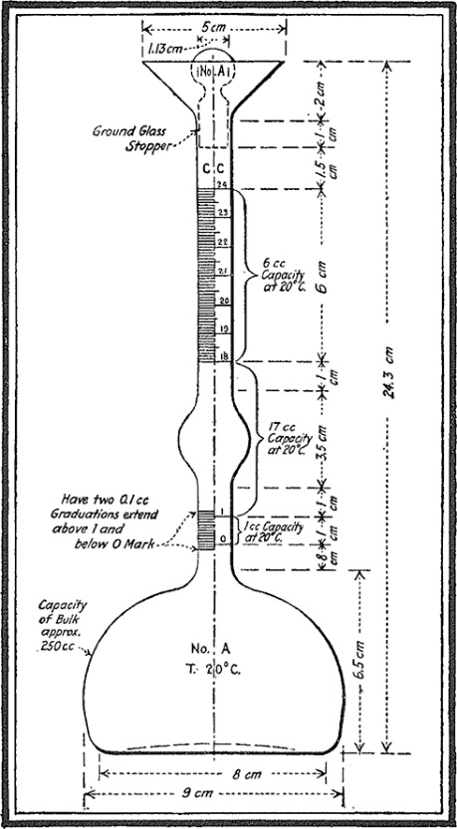

Figure 1: Le Chatelier Flask

-Blaine Apparatus (Manometer, Permeability Cell and Plunger) (Figure 2)

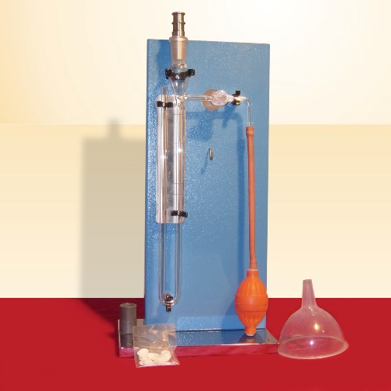-Mortar Agitator (Figure 3)

Figure 2: Blaine Apparatus

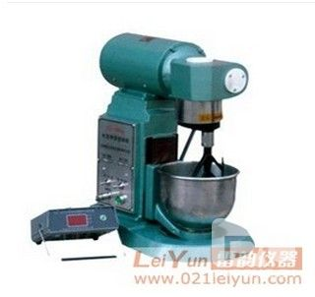

Figure 3: Mortar Agitator

-Flow Table, Flow Mold

-Caliper

-Tamper

-Trowel

-Straightedge

-Weighing Device

-Specimen Molds

**Test Procedures:** Specific gravity of cement used for our mortar specimen is found by putting a sample to a Le Chatelier Flask, which is filled with kerosene in order not to have any chemical reaction during the test. It is also subjected to Blaine fineness test, with this test we simply calculate the speed of air sucked into the tube due to pressure equilibrium. We do not calculate overall surface area, but we calculate pores in our cement sample, and compare it with our known values, so the result we obtained is a relative value.

Specimen is prepared by first putting water to our agitation vessel. Then pouring the cement and mixing them via the mortar agitator*,* which pours the sand in during the agitation process. The speed of agitation varies, and the mortar agitator has been set to that speed configuration (speed increases).

After the mixing process, specimen is put to a flow mold on flow table layer by layer tampered in every one, after one minute, unmold the specimen, then the flow test is done as follows. Specimen is lifted and dropped 25 times. Then the diameter is measured.

Flexural strength test is done to another specimen, which is hopefully 28 days old, due to lack of time. The procedure is as follows. Specimenis moist cured in the big white closet, fixed moisture and temperature until the testing time comes. The specimen is placed on the loading device, supports must touch to the sides of the specimen. Orientation is very important. Load is applied to the mid span.

Axial test is done to the cracked part of the flexural strength test specimen. Assuming that the parts not touching to loading device is not carrying any stresses (excess longitude is neglected). Test is done via putting the specimen to the loading device.

**Calculations:**

**1.** According to ASTM C188, The density of cement sample is calculated by dividing weight by the reading difference. The weight is 64 grams. Calculations are made with excel, table is given below.

According to ASTM C204, S = Ss*(T^1/2)/ (Ts) ^1/2 is going to be used in calculations. Where

S is the specific surface of test sample, Ss is specific surface of the standard sample used in calibration, T is measured time interval of manometer drop for test sample, and Ts is measured time interval of manometer drop for standard sample used in calibration.

|  |  |  |  |  |  |  |
| --- | --- | --- | --- | --- | --- | --- |
| Sample | Initial | Final | Density | Temp | t(sec) | Fineness(m2/kg) |
| Reference | 1 | 21.5 | 3.12 | 24 | 85 | 350 |
| A | 0.5 | 20.8 | 3.153 | 24 | 97 | 373.891 |
| B | 1.2 | 22.2 | 3.048 | 24 | 106 | 390.851 |
| C | 0.1 | 20.9 | 3.077 | 24 | 118 | 412.385 |
| D | 0.3 | 21 | 3.092 | 24 | 80 | 339.545 |

**2.** According to ASTM C1437, flow is the increase in average base diameter, and calculated with the addition of the ratio of measurements to the flow table diameter.

20.5/22.5 = 0.804 21.2/25.5 = 0.831

20.7/25.5 = 0.812 21.6/25.5 = 0.847

0.804+0.812+0.831+0.847 = 3.294% is the flow.

**3.** Flexural tensile strength is calculated by (Mc/I), where M = PL/4.

c = 2 cm, I = 2.134*10-7 m4 L = 10 cm.

|  |  |  |  |  |  |
| --- | --- | --- | --- | --- | --- |
| Sample Label | Specimen Type | Max Load at Fracture (kN) | Loading Type | Compressive Strength (Mpa) | Flexural Tensile Strength (Mpa) |
| 1 | Beam 4x4x16cm | 2.7 | Flexural Tension | - | 6.328 |
| 2 | 2.9 | - | 6.797 |
| 3 | 3.3 | - | 7.734 |
| 1 | Cube 4x4x4cm | 67.2 | Compression | 42 | - |
| 2 | 73.6 | 46 | - |
| 3 | 76.8 | 48 | - |
| 4 | 68.8 | 43 | - |
| 5 | 69.6 | 43.5 | - |
| 6 | 75.2 | 47 | - |

**Results:**

**1.** Cement A has high density, but B, C, and D has lower densities than reference sample.

Cement D’s fineness is low, but cements A, B, and C are finer than reference sample

**2.** 3% flow

**3.** Average compressive strength is 44.92 MPa. Average flexural tensile strength is 6.953 MPa

**Discussion of Results:**

**1.** Cement A needs more water and others need less water in order to be in the same consistency with reference. Hardening and setting will occur sooner and the heat of hydration will be higher in C, B, A, reference, D respectively.

**2.** No need of discussion since there is only one experiment result.

**3.** These values are good for a CEM 32.5 cement.

**References:**