MIDDLE EAST TECHNICAL UNIVERSITY

DEPARTMENT OF CIVIL ENGINEERING

CE 344: MATERIALS OF CONSTRUCTION

LABORATORY REPORT 3: TEST ON CONCRETE

LAB GROUP: 05

SECTION 2

SECTION 3

SUBMISSION DATE: 05/02/2014

Table of Contents

Objectives and Scope 1

Preliminary Remarks 1

Test Specimen 1

Apparatus 2

Test Procedures 2

Calculations 4

Results 9

Discussion of Results 9

References 10

**Objectives and Scope:**

The main purpose of this laboratory session is to familiarize students with concrete and its properties, such as slump, air content, compressive strength, and splitting tensile strength.

**Preliminary Remarks:**

Fresh concrete must be easily mixable and transportable, it must be flowable and compacting it must not be too hard, it must be uniform, it must not show any bleeding it must have a definite and fix setting time and a unit weight must be provided to it. Its workability, consistency, uniformity and no segregation is important. On the other hand, hardened concrete must have a predefined strength, durability, and abrasion resistance. They are both governed by the same variables, such as w/c ratio, type of cement, clarity of water, aggregate size and amount, and admixtures. Thus the receipt of cement is very important. Mainly strength of the concrete is going to be tested in this session.

Some terms to be explained for clarity;

Compressive strength: The capacity of compressive stress.

Drilled core specimen: Specimen taken from the casted concrete via a drill core.

Cubic specimen: Specimen which is casted to a cubic mold for testing.

**Test Specimen:**

Three specimen is taken from every 50 m3, when casting the concrete, in the form of 15x15x15 cubic samples. They are cured for 28 days, and then tested. Also nine cores (10 cm cylinders) from every story are taken in order to compare it with the cubic ones. Cylinder specimens diameters must not change more than 2% through its height, their ends can diverge from perpendicular plane only by 0.5°, and more than 0.05 mm roughness must be sawed or ground.

**Apparatus:**

Testing machine

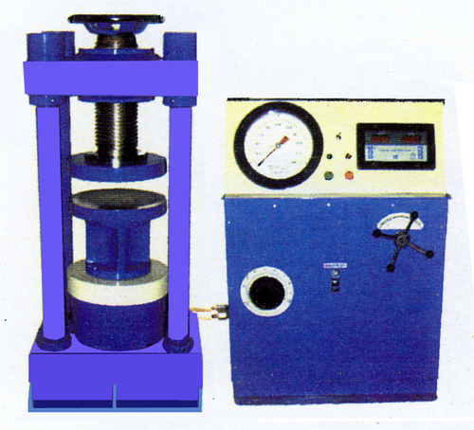

Figure 1: Compressive Strength Testing Machine

**Test Procedure:**

Specimens must tested as soon as possible after they are removed from their curing environment, if they are moist-cured. They shall be kept moist until the test. For better results, all test specimens are to be broken within the time interval indicated in table 1.

Table 1

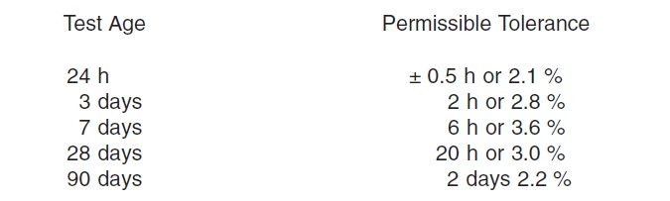

Make sure that the load indicator on the testing machine is set to zero, after placing the specimen but before loading begins. Also the top cap of the machine must be parallel to the specimens end. If unbonded caps are being used, before loading reaches ten percent of the strength of the specimen, the alignment of specimen and testing machine must be verified. 0.5° or bigger divergence is not acceptable. Load and unload to %10 strength and check the alignment until it is reached. In order not to shock the specimen, loading must be done continuously and with a specified rate, which is 0.25± 0.05 MPa for loading-controlled test machines, and some other value for displacement-controlled test machines, such as ours. For the first half of the expected strength, a higher rate is permitted. Compressive load must be applied until the load indicator shows a steadily decreasing load and a well-defined fracture pattern can be seen in the face of the specimen, such as figure 1.

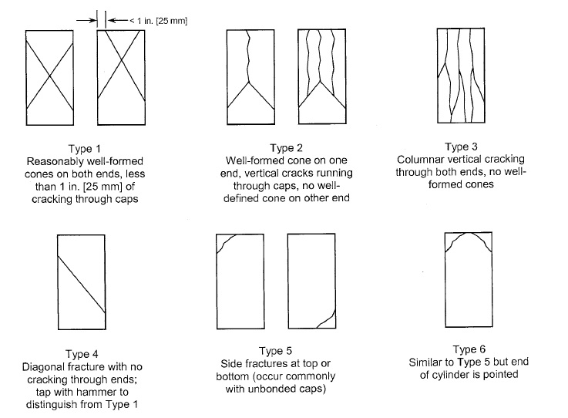

Figure 1

If there is a specimen break detector, automatic shit-off is prohibited until the load is dropped to 95% of the ultimate load. If unbonded caps are being used, a fracture like type 5 or 6 (figure 1) may occur before the ultimate load has been reached. If the fracture do not follow a specific pattern, draw it and describe it briefly. If measured strength is lower, examine the fracture area and look for large air voids (or bubbles), any segregation pointers, or big aggregate particles.

**Calculations:**

|  |  |  |  |  |  |  |  |  |  |  |
| --- | --- | --- | --- | --- | --- | --- | --- | --- | --- | --- |
| floor | Requested strentgh class | Compressive failure load (kN) | | | | | | | | |
| *Calculated compressive strength (MPa)* | | | | | | | | |
| First 50 m^3 | | | Second 50m^3 | | | Third 50m^3 | | |
| 3 | C25/30 | 833 | 825 | 850 | 823 | 837 | 805 | 828 | 851 | 842 |
| *37.02\** | *36.67\*\** | *37.78* | *36.56* | *37.2* | *35.78* | *36.8* | *37.82* | *37.42* |
| 2 | C30/37 | 832 | 823 | 829 | 827 | 841 | 828 | 830 | 840 | 848 |
| *36.98* | *36.56* | *36.84* | *36.76* | *37.38* | *36.8* | *36.89* | *37.33* | *37.68* |
| 1 | C30/37 | 817 | 825 | 832 | 835 | 849 | 842 | 850 | 831 | 854 |
| *36.31* | *36.67* | *36.98* | *37.11* | *37.73* | *37.42* | *37.77* | *36.93* | *37.96* |

Firstly, strength of cubic laboratory samples which based on test results are calculated.

The calculated compressive strength results which are shown on the table 1 are determined by P/A formula. Where P is the failure load and A is the cross sectional area of the cubic samples which is 150×150=22500mm^2.

Table 2: Compressive Load Results of the cubic samples

Representative calculations:

*= 833000/22500

**=825000/22500

Secondly, according to ASTM C39 compressive strength of cores are calculated. ASTM C39 says that calculate the compressive strength of the specimen by dividing the maximum load carried by the specimen during the test by the average cross-sectional area. additionally, it highlights that if the specimen length to diameter ratio is 1.75 or less, correct the result which is obtained by dividing the failure load by the cross sectional area by multiplying appropriate correction factor shown in the following table:

Table 3: correction factor wrt L/D

|  |  |  |  |  |
| --- | --- | --- | --- | --- |
| L/D: | 1.75 | 1.50 | 1.25 | 1.00 |
| Factor: | 0.98 | 0.96 | 0.93 | 0.87 |

Additionally, it offers using interpolation to determine correction factors for L/D values between those given in the table. In order to calculate correct strength values at first step failure load is divided by cross sectional area which is п×(100^2÷4) = 7853.982m^2 then it is multiplied with corresponding correction factor.

Table 4: Correction factors which are related with data

|  |  |  |  |  |  |  |  |  |  |
| --- | --- | --- | --- | --- | --- | --- | --- | --- | --- |
| L/D | 175/100 | 165/100 | 197/100 | 185/100 | 150/100 | 192/100 | 162/100 | 120/100 | 200/100 |
| factor | 0.98 | 0.972* | _ | _ | 0.96 | _ | 0.9696 | 0.918** | _ |

Representative calculations:

* = 0.98-[(0.1×0.02)/0.25]

** = 0.93-[(0.05×0.06)/0.25]

Table 5: First floor’s data & results

|  |  |  |  |  |  |  |  |  |  |
| --- | --- | --- | --- | --- | --- | --- | --- | --- | --- |
| Floor1 & requested strength class is C30/37, cross sectional area is 7853.982 mm^2 | | | | | | | | | |
| 1 | | 2 | 3 | 4 | 5 | 6 | 7 | 8 | 9 |
| Compressive load (kN) | 240 | 240 | 242 | 240 | 244 | 241 | 241 | 240 | 242 |
| Uncorrected strength (MPa) | 30.56* | 30.56 | 30.81 | 30.56 | 31.07 | 30.69 | 30.69 | 30.56 | 30.81 |
| Factor | 0.98 | 0.972 | - | - | 0.96 | - | 0.9696 | 0.918 | - |
| Corrected strength (MPa) | *29.95\*\** | *29.70* | *30.81* | *30.56* | *29.83* | *30.69* | *29.76* | *28.05* | *30.81* |

Representative calculations:

*= 240000/ 7853.982

**=30.56×0.98

Table 6: second floor’s data & results

|  |  |  |  |  |  |  |  |  |  |
| --- | --- | --- | --- | --- | --- | --- | --- | --- | --- |
| Floor2& requested strength class is C30/37, cross sectional area is 7853.982 mm^2 | | | | | | | | | |
| 1 | | 2 | 3 | 4 | 5 | 6 | 7 | 8 | 9 |
| Compressive load (kN) | 196 | 200 | 210 | 202 | 193 | 189 | 220 | 217 | 218 |
| Uncorrected strength (MPa) | 24.96* | 25.46 | 26.74 | 25.72 | 24.57 | 24.06 | 28.01 | 27.63 | 27.76 |
| Factor | 0.98 | 0.972 | - | - | 0.96 | - | 0.9696 | 0.918 | - |
| Corrected strength (MPa) | *24.46\*\** | *24.75* | *26.74* | *25.72* | *23.59* | *24.06* | *27.16* | *25.36* | *27.76* |

Representative calculations:

*= 196000/7853.982

**=0.98×24.96

Table 7: Third floor’s data & results

|  |  |  |  |  |  |  |  |  |  |
| --- | --- | --- | --- | --- | --- | --- | --- | --- | --- |
| Floor3& requested strength class is C25/30 & cross sectional area is 7853.982 mm^2 | | | | | | | | | |
| 1 | | 2 | 3 | 4 | 5 | 6 | 7 | 8 | 9 |
| Compressive load (kN) | 241 | 241 | 240 | 243 | 243 | 242 | 243 | 240 | 238 |
| Uncorrected strength (MPa) | 30.69* | 30.69 | 30.56 | 30.94 | 30.94 | 30.81 | 30.94 | 30.56 | 30.30 |
| Factor | 0.98 | 0.972 | - | - | 0.96 | - | 0.9696 | 0.918 | - |
| Corrected strength (MPa) | *30.08\*\** | *29.83* | *30.56* | *30.94* | *29.70* | *30.81* | *29.99* | *28.05* | *30.30* |

Representative calculations:

*= 241000/7853.982

**=30.69×0.98.

Thirdly, the strength results are collected and mean values (μ), ,standard deviations (σ) and coefficient of variation which is found by ratio of σ to μ as following :

First floor’s strength values , standard deviation, coefficient of variation of cubic samples and core samples :

Table 8: Strength values& statistic results of first floor

|  |  |
| --- | --- |
| Cubic samples | Core samples |
| 36.31 | 29.95 |
| 36.67 | 29.7 |
| 36.98 | 30.81 |
| 37.11 | 30.56 |
| 37.73 | 29.83 |
| 37.42 | 30.69 |
| 37.77 | 29.76 |
| 36.93 | 28.05 |
| 37.96 | 30.81 |
| Mean of cubic samples(μ)=37.09778 | Mean of core samples (μ)= 30.01778 |
| Standard deviation of cubic samples(σ)=0.66334 | Standard deviation of core samples(σ)=0.87182 |
| Coefficient of Variation ( σ/μ) = 0.01788 | Coefficient of Variation ( σ/μ) = 0.02904 |

Second floor’s strength values, standard deviation, coefficient of variation of cubic samples and core samples:

Table 9: values& statistic results of second floor

|  |  |
| --- | --- |
| Cubic samples | Core samples |
| 36.98 | 24.46 |
| 36.56 | 24.75 |
| 36.84 | 26.74 |
| 36.76 | 25.72 |
| 37.38 | 23.59 |
| 36.8 | 24.06 |
| 36.89 | 27.16 |
| 37.33 | 25.36 |
| 37.68 | 27.76 |
| Mean of cubic samples(μ)=37.02444 | Mean of core samples (μ)=25.51111 |
| Standard deviation of cubic samples(σ)=0.36049 | Standard deviation of core samples(σ)=1.450581 |
| Coefficient of Variation ( σ/μ) =0.009736 | Coefficient of Variation ( σ/μ) =0.05686 |

Third floor’s strength values, standard deviation, coefficient of variation of cubic samples and core samples:

Table 10: Strength values & statistic results of third floor

|  |  |
| --- | --- |
| Cubic samples | Core samples |
| 37.02 | 30.08 |
| 36.67 | 29.83 |
| 37.78 | 30.56 |
| 36.56 | 30.94 |
| 37.2 | 29.7 |
| 35.78 | 30.8 |
| 36.8 | 29.99 |
| 37.82 | 28.05 |
| 37.42 | 30.30 |
| Mean of cubic samples(μ)=37.00556 | Mean of core samples (μ)=30.02778 |
| Standard deviation of cubic samples(σ)=0.645002 | Standard deviation of core samples(σ)=0.854997 |
| Coefficient of Variation ( σ/μ) =0.01743 | Coefficient of Variation ( σ/μ) =0.028474 |

Note that mean and standard deviation values of samples are calculated by Excel program. Additionally, coefficient of variation is calculated by shown Formula.

Finally, strength class of concrete for each storey according to laboratory cubic samples and the core are shown following table:

Table 11: Strength values of concrete according to mean values of test results

|  |  |  |  |
| --- | --- | --- | --- |
|  | 1.floor ( C30/37 required) | 2.floor( C30/37 required) | 3.floor(C25/30) |
| Cubic sample | 37.09778 | 37.02444 | 37.0056 |
| Core sample | 30.01778 | 25.5111 | 30.02778 |

Therefore strength class of first floor according to laboratory samples is C37 but according to core samples it is C30. For second floor concrete it can be called C37 according to laboratory samples however core samples of second floor shows that it is C25. Lastly, although the laboratory samples of third floor state that it is C37, the core samples show it can be called C30.

**Results:**

Table 12 result table of 1.floor

|  |  |
| --- | --- |
| Results of first floor | |
| Cubic samples | Core samples |
| μ =37.09778 | μ = 30.01778 |
| σ = 0.66334 | σ =0.87182 |
| Coefficient of Variation = 0.01788 | Coefficient of Variation =0.02904 |
| Strength class C37 | Strength class C30 |

Table 13 result table of 2.floor

|  |  |
| --- | --- |
| Results of second floor | |
| Cubic samples | Core samples |
| μ 37.02444 | μ 25.5111 |
| σ =0.36049 | σ=1.450581 |
| Coefficient of Variation =0.009736 | Coefficient of Variation =0.05686 |
| Strength class C37 | Strength class C25 |

Table 14 result table of 3.floor

|  |  |
| --- | --- |
| Results of third floor | |
| Cubic samples | Core samples |
| μ 37.0056 | μ 30.02778 |
| σ =0.645002 | σ=0.854997 |
| Coefficient of Variation =0.01743 | Coefficient of Variation =0.028474 |
| Strength class C37 | Strength class C30 |

**DISCUSSION OF RESULTS:**

First of all standard deviations of core samples are higher than laboratory samples’ standard deviations. It is natural because in a laboratory a person can obtain more similar samples by helping of same curing process. Also, it is related with that in situ all members of structure can be exposed different environmental factors. Additionally, the laboratory samples have higher strength values due to curing process. Finally, second floor concrete’s core samples shows C25 strength property which is less than requested value and third floor concrete’s core samples shows that C30 strength property which is higher than requested values. The differences between requested values and test results can be occurs due to mistakes which is done in calculation process or some discrepancies in created calculation tables.

**References:**

ASTM C39