**MIDDLE EAST TECHNICAL UNIVERSITY**

**DEPARTMENT OF CIVIL ENGINEERING**

**CE 344: MATERIALS OF CONSTRUCTION**

LABORATORY REPORT 1: TESTS ON PORTLAND CEMENT

LAB GROUP-6

SECTION 3

SECTION 3

SECTION 4

SUBMISSION DATE: 11.04.2016

CONTENTS

-Object and Scope ...................................................................... 1

-Preliminary Remarks ................................................................. 1

-Test Specimen .......................................................................... 1

-Apparatus ................................................................................. 1

-Test Procedures ........................................................................ 2

-Calculations ............................................................................. 3

-Results ...................................................................................... 5

-Discussion of Results .............................................................. 6

-Conclusion ............................................................................... 6

-References ............................................................................... 7

**Object and Scope:**

The major aim of this lab is to present all behaviours of Portland cement. The scope is to determine Portland cement’s specific gravity, fineness, consistency, flexural tensile strength and compressive strenght.

**Preliminary Remarks:**

One of the most common construction material is cement. Cement is a hyraulic and non-homogenous material. Since it is non-homogenous, for safety, its properties must be fit in suggested limitations. Some of its properties also can be defined as follow:

-Setting: When cement is mixed with water it gains rigidity with time. That loss of plasticity can be defined as setting.

-Fineness: Fineness is the average size of the cement particles. A higher fineness means smaller particle size.

-Consistency: Water amount of a cement paste.

-Plasticity: Being spreadable and shapeable of the cement paste.

**Test Specimen:**

The specimens are 4x4x16 (cm) and 5x5x5 (cm)

**Apparatus:**

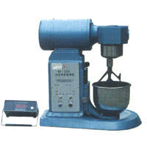 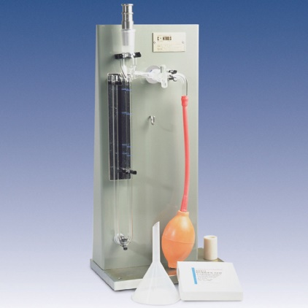

Fig. 1Mortar Agitator Fig. 2 Blaine Apparatus

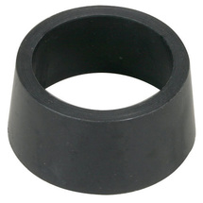

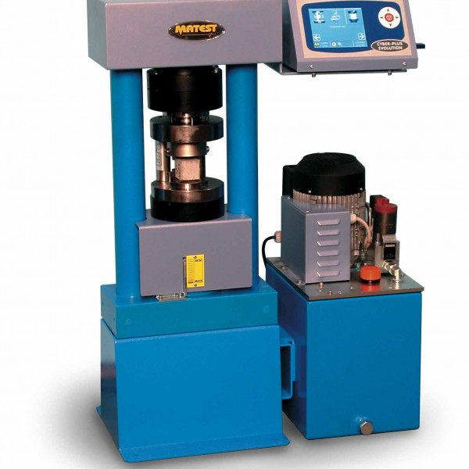

Fig. 3 Compressing Machine Fig. 4 Circular Test Container

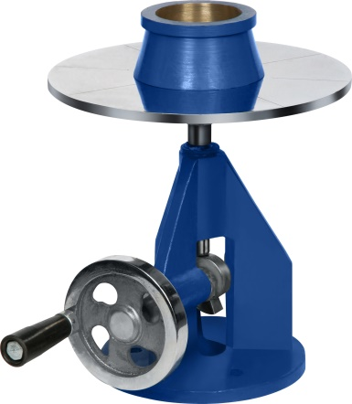

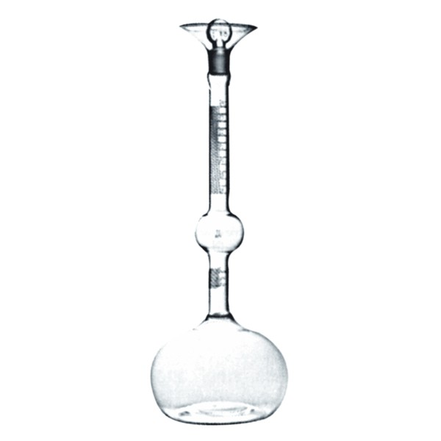

Fig. 5 Le Chatelier Flask Fig. 6 Flow Table

**Test Procedures:**

Cement paste is subjected to Blaine fineness test to determine the rate of air flow through the sample. In this test, a given of volume of air is passed through a prepared sample. Also, the number and the size of pores of the sample can be measured. So, it is possible to calculate fineness of sample.

Cement, sand and water are put into the mortar agitator to mixed properly. With speed increasement mortar agitator is started up. After mixing process the sample is put to a flow mold layer by layer. After molding first layer, the specimen is penetrated by a stick and then the second layer is mold. After one minute, the specimen is unmold and droped 25 times in the flow table. Then the diameter is measured.

Flexural strength is measured with 28 days old specimen. As first step of the procedure, the specimen is cured and then is placed on the loading device as its sides touching to the supports. The load have to be applied to mid point of the specimen. This test is applied till the specimen is cracked from the mid and the two cracked part of it is used in axial test. Axial loading test is done via compressing machine.

**Calculations:**

|  |  |  |  |  |  |
| --- | --- | --- | --- | --- | --- |
|  | Specimen | Cement 1 | Cement 2 | Cement 3 | Reference Cement |
| **Density Test** | Initial Reading (mL) | 0.4 | 0.3 | 0.4 | - |
| Final Reading (mL) | 20.7 | 21.4 | 22.9 | - |
| Density (g/cm3) | 3.15 | 3.03 | 2.84 | 3.09 |
| **Fineness Test\*\*** | Specimen Mass (g) | 2.60 | 2.50 | 2.34 |  |
| Duration (s) | 102 | 88 | 79 | 83 |
| Fineness (cm2/g)*** | 4257 | 3954 | 3747 | 3840 |
| **Flow Test\*\*\*\*** | Average Flow Diameter (Average Final Diameter) (cm) | 20.0 | 20.5 | 21.5 | - |
|  | Flow Percent (%) | 100 | 105 | 115 | - |

- According to ASTM C188:

Mc= Mt - Ma

Mc = Mass of cement used, g

**NOTE 4:** The amount of cement required will typically be about 64 g for Portland cement, and somewhat less for other types of cements.

ρ= Mc / V

ρ = density of cement, g/cm3

V = displaced volume of liquid, cm3

-**For Cement 1:**

ρ= Mc / V

ρ= 64/ (20.7- 0.4) = **3.15 g/cm3**

-**For Cement 2:**

ρ= Mc / V

ρ= 64/ (21.4- 0.3) = **3.03 g/cm3**

-**For Cement 3:**

ρ= Mc / V

ρ= 64/ (22.9- 0.4) = **2.84 g/cm3**

- According to ASTM C204

W= ρ*V*(1-ε)

Where,

W = grams of sample required,

ρ = density of test sample,

V = bulk volume of bed of cement,

ε = desired porosity of bed of cement.

-**For Cement 1:**

W= ρ*V*(1-ε)

W= 3.15*1.72* (1- 0.52)= **2.60 g**

-**For Cement 2:**

W= ρ*V*(1-ε)

W= 3.03*1.72* (1- 0.52)= **2.50 g**

-**For Cement 3:**

W= ρ*V*(1-ε)

W= 2.84*1.72* (1- 0.52)= **2.34 g**

- According to ASTM C1437

Flow = $\frac{Increase in Average Base Diameter}{Original Base Diameter}$

Flow in Percent = Addition of Readings in Flow

Flow in Percent = (20.0-10.0)/10.0= 100% for the first one.

Flow in Percent = [(20.0-10.0)+ (20.5-10.0)+ (21.5-10.0)]/ 3*100 = **106.67 %**

- According to ASTM C109

Compressive Strength = $\frac{\sum{\frac{P}{A}}}{3}$, which means the average of the 3 sample for each mortar where area A=50*50=2500 mm2. Average of mortars is below according to ASTM C109.

Compressive Strength = P/A but we need to find average values for the laboratory test.

-**For Mortar A:**

Ϭ = $\frac{(53.5+50+47.5)/2500}{3}$ = **20.1 MPa**

-**For Mortar B:**

Ϭ = $\frac{(35.3+37.5+39.7)/2500}{3}$ = **15 MPa**

-**For Mortar C:**

Ϭ = $\frac{\left(60.1+62.6+65.1\right)/2500}{3}$ = **25 MPa**

**Results:**

1. Density: ρ1=3.15 g/cm3, ρ2= 3.03 g/cm3, ρ3=2.84 g/cm3

2. Specimen Mass: W1=2.60g, W2=2.50g, W3=2.34g

3. Fineness: Cement 1 > Cement 2 > Cement 3

4. Compressive Strength: ϬA=20.1 MPa, ϬB=15 MPa, ϬC=25 MPa

**Discussion of Results:**

Cement 1 has greater density than Cement 2 and Cement 3, and also it is the only cement that denser than reference cement. So, to have the same consistency Cement 1 needs more water and Cement B and Cement C need less water than reference needs. In addition, the flow percent is approximately 106 % ( almost 110% is acceptable for experiment). Average compression strength of mortars is Mortar B is the greatest one. On the other hand, Mortar B is the least one as compression strength.

Fineness of cement types is resembles as cement 1 is the greatest one also cement 3 is the least one. Therefore, cement 1 has the biggest surface area of particles and then it need more water to enter reaction. In other words, more fineness value means more required water.

The results show that compressive strength of mortars are affected by the contents of the cement specimens. Simply, the strength is calculated by dividing the maximum load where fracture occurs and the cross-sectional area. According to ASTM C109 Standards the compressive strength has to be reported as the nearest 0.1 MPa. All calculations were done thanks to ASTM standards.

**Conclusion:**

In this laboratory session, we observed three different cement type and three different mortar type. We checked fineness, density, flow percent, compressive strenght values by using ASTM standards and then some different loads are applied on different types of cement. As a result, we compared cement types and got information about cements according to obtained results.

**References:**

**-**ASTM C109 / C109M - 16 Standard Test Method for Compressive Strength of Hydraulic Cement Mortars (Using 2-in. or [50-mm] Cube Specimens). (n.d.). Retrieved April 09, 2016, from http://www.astm.org/Standards/C109.htm

-ASTM C1437 - 15 Standard Test Method for Flow of Hydraulic Cement Mortar. (n.d.). Retrieved April 09, 2016, from http://www.astm.org/Standards/C1437

-ASTM C188 - 15 Standard Test Method for Density of Hydraulic Cement. (n.d.). Retrieved April 09, 2016, from http://www.astm.org/Standards/C188.htm

-ASTM C204 - 16 Standard Test Methods for Fineness of Hydraulic Cement by Air-Permeability Apparatus. (n.d.). Retrieved April 09, 2016, from http://www.astm.org/Standards/C204.htm

-Erdoǧan, T. Y. (2002). *Materials of construction*. Ankara: METU.