**MIDDLE EAST TECHNICAL UNIVERSITY**

**DEPARTMENT OF CIVIL ENGINEERING**

**CE 344: MATERIALS OF CONSTRUCTION**

LABORATORY REPORT 2: TEST ON AGGREGATES

LAB GROUP-6

SECTION 3

SECTION 3

SECTION 4

SUBMISSION DATE: 25.04.2016

CONTENTS

-Object and Scope ...................................................................... 1

-Preliminary Remarks ................................................................. 1

-Test Specimen .......................................................................... 1

-Apparatus ................................................................................. 1

-Test Procedures ........................................................................ 2

-Calculations ............................................................................. 3

-Results ...................................................................................... 5

-Discussion of Results .............................................................. 6

-Conclusion ............................................................................... 6

-References ............................................................................... 7

**Object and Scope:**

The main aim of this laboratory is to learn properties and behaviours of aggregates. For this reason, organic impurities, sieve analysis, soundness and water absorption also alkali reactivity potential are applied to get information.

**Preliminary Remarks:**

Aggregates are the natural or artificial inorganic granular materials used with a cementing medium to form mortar or concrete and to provide strength for concrete and mortar. They are composed of stones crumbled and they have some qualities as abrasion resistance, alkali reactivity, size etc. depend on time and locations. Also, aggregate proporties affect the proportioning of the materials that form the concrete, so they affect the economy.

Tests on aggregates are more important than the tests that are done on other contents of concrete. The reason for that is being natural of aggregates which means mostly we can not control the formation of that materials. On the other hand, cement is a man-made product.

Some significant terms for aggregates tests are expressed below:

- Soundness: is the ability of aggregates withstand the aggressive action to which the concrete containing them might be exposed, particulary due to weathering.

- Alkali-Aggregate Reactivity: leads to expansion and cracking of hardened concrete.

- Specific gravitiy: the density or the unit weight of a material is defined as its mass per unit volume.

- Abrasion resistance: is wearing by repeated rubbing or frictional forces and then resistance of aggregates is investigated by a test method called the ' Los Angeles testing method'.

- Absorption: when water penetrates into its pores during a specific time period, increasing in mass of aggregates.

- Saturated and Surface Dry States: All permeable pores are filled with water but the forces of the aggregate particles are dry.

- Relative density ( specific gravity ): ratio of the density of a material to the density of distilled water.

- Fine Aggregate: Aggregate particles which can pass #4 sieve.

- Coarse Aggregate: Aggregate particles which cannot pass #4 sieve.

**Test Specimen:**

In aggregate, fine portion of aggregates have to accumulate on lower layers mostly. Morever, coarse materials have to stay at the crest part and then segregation and wind affected to outer parts. In sampling, outer parts should be removed to reach inner layers. Also, more sampling from different locations, more accurate results. After getting sample, the quantity of them is reduced with two different methods. One of them is ' Sample Splitter (Fig.1)' that seperate the aggregates into two equal part.The second one is ' Quartering Method (Fig.2)' which can be done by dividing the laying in circular shape aggregates into 4 equal part and selecting the two opposing quarters as sample.

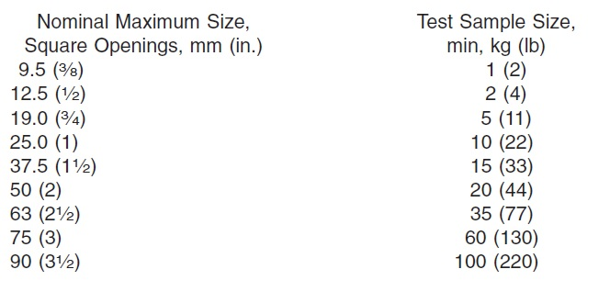 The specimen have to be prepared for the test after reaching an approval size of represantative sample. According to sieve analysis, fine portions of the aggregates should be at least 300 grams and then coarse ones should have the properties which tabulated below.

In this lab session, fine aggregates are our test specimen which all can pass from #4 sieve.

**Apparatus:**

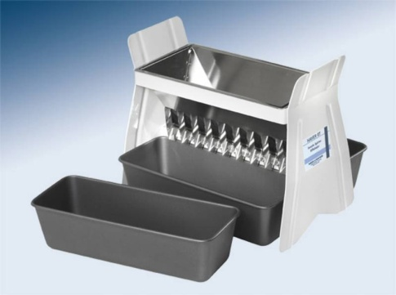 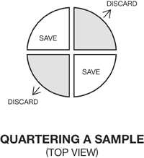

Fig.1: Sample Splitter Fig.2: Quartering Method

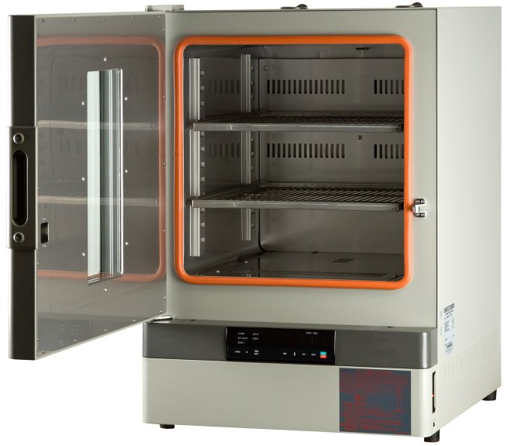 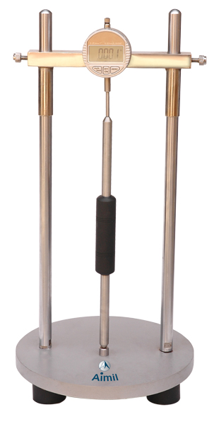

Fig.3: Oven Dry Fig.4: Lengthchange measure apparatus

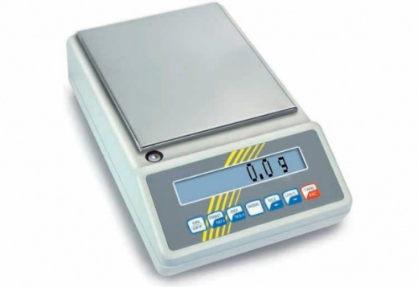 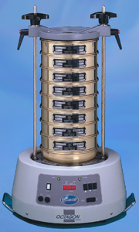

Fig.5: Balance Fig.6: Sieve Analysis

**Test Procedure:**

**The sieve analysis of aggregates ASTM C136**

By sieving, the particle size distribution of aggregates is determined. Sieve analysis test is series of sieves that are aligned according to their sieve openings as the largest sieve is at the top and the smallest sieve at the bottom (Fig.6). Also, a pan is placed at the very bottom of the sieve series to collect the aggregates particles which can be pass from the smallest sieve that is used in test. Before the test all particles should be dry to prevent lumps and clogging.

When aggregate sample is poured on the top sieve, to sift them shaking is needed. To do that, a sieve shaker can be used or the sieves can be shaked by hand directly. At the end of the shaking activity it is expected to that all materials are separeted and accumulated on sieves according to their size. By weighing the samples that are accumulated on each sieve, we have the retained particles mass. After we have mass retained for each sieve we can calculate the percent retained since we know the total mass of sample that is used before the test. Thus, cumulative percent retained and percent passing is found for sieves. This, help us to draw the gradation curve.

**Calculations:**

|  |  |  |  |  |  |
| --- | --- | --- | --- | --- | --- |
| Sieve | Sieve Opening (mm) | Mass Retained (g) | Percent Retained | Cumulative Percent Retained | Percent Passing |
| #4 | 4,75 | 0 | 0,0 | 0,0 | 100,0 |
| #8 | 2,38 | 43 | 8,6 | 8,6 | 91,4 |
| #16 | 1,19 | 98 | 19,6 | 28,2 | 71,8 |
| #25 | 0,71 | 71 | 14,2 | 42,4 | 57,6 |
| #30 | 0,595 | 36 | 7,2 | 49,6 | 50,4 |
| #50 | 0,297 | 88 | 17,6 | 67,2 | 32,8 |
| #100 | 0,149 | 160 | 32,0 | 99,2 | 0,8 |
| Pan | - | 4 | 0,8 | 100,0 | 0,0 |
| **Fineness Modulus** | **2.952** | | | | |

When we sum up the mass retained values it is 500 g which is our total sample. Percent retained is calculated by dividing the mass retained on each sieve to the total mass. For example for #16 sieve percent retained = $\frac{98}{500}x100=19.6\%.$ Cumulative percent retained, on the other hand, is the total percent of retained values above a sieve. For #16 sieve it is 8.6+19.6=28.2%. Percent passing is calculated by subtracting the cumulative percent retained by 100%. For the same sieve again, it is 100-28.2=71.8%.

According to ASTM C125 the fineness modulus of the aggregates is calculated by adding the cumulative percentages by mass retained on some specified sieves, not only sieves that are used during the test. The specified sieves are: #100, #50, #30, #16, #8, #4 sieves. Thus, we should not add the #25 sieve’s cumulative percent value to our calculation.

Fineness Modulus = $\frac{\sum{\% cumulative percent retained}}{100}$

So,

Fineness Modulus = $\frac{0+8.6+28.2+49.6+67.2+99.2}{100}=\frac{252.8}{100}=2.528$

**Results:**

After calculations, percentage of the materials that can be pass of each sieve is found as below:

|  |  |
| --- | --- |
| Sieve | Percent Passing |
| #4 | 100,0 |
| #8 | 91,4 |
| #16 | 71,8 |
| #25 | 57,6 |
| #30 | 50,4 |
| #50 | 32,8 |
| #100 | 0,8 |
| Pan | 0,0 |

Fineness Modulus is 2.528.

Particle size vs. percent passing graph (Gradation Curve) is drawn as following.

Graph 1 Particle Size vs. Percent Passing

**Discussion of Results:**

ASTM C33 gives the limit values for grading as follow:

|  |  |
| --- | --- |
| Sieve Sizes | Passing % |
| 9.5 mm | 100 |
| #4 | 95-100 |
| #8 | 80-100 |
| #16 | 50-85 |
| #30 | 25-60 |
| #50 | 10-30 |
| #100 | 2-10 |

When we compare our results to ASTM limitations, it is seen that for #50 we have 32.8% passing materials and it is more than the criteria. This, of course, affects our fineness modulus. Exceeding the limitations means the sampling was not successful completely.

The fineness modulus for fine aggregate should be between 2.15-3.38. So, our specimen can be considered as fine. When fineness modulus is calculated we do not consider the values of #25 sieve according to ASTM standards.

**Conclusion:**

To conclude, sieve analysis test is used to determine the gradiation of the aggreagtes. This help us to determine whether the materials compliance the design and requirements or not. So, sieve analysis test plays an important role of preparation of concrete properly, since conrete contents significantly amount of aggregates.

Fineness modulus is an index of the fineness of an aggregate which means the higher the fineness modulus, the coarser the aggregate. Different aggregate grading may have the same fineness modulus, besides. Fineness Modulus of fine aggregates is useful in estimating proportions of fine and coarse aggregates in concrete mixtures. This shows how it can be important for aggregates to satisfy the intended fineness modulus value.

**References**

-ASTM C125 - 15b Standard Terminology Relating to Concrete and Concrete Aggregates. (n.d.). Retrieved April 22, 2016, from http://www.astm.org/Standards/C125.htm

- ASTM C33 / C33M - 16 Standard Specification for Concrete Aggregates. (n.d.). Retrieved April 22, 2016, from http://www.astm.org/Standards/C33.htm

- Erdoǧan, T. Y. (2002). *Materials of construction*. Ankara: METU.