**MIDDLE EAST TECHNICAL UNIVERSITY**

**DEPARTMENT OF CIVIL ENGINEERING**

**CE 344: MATERIALS OF CONSTRUCTION**

LABORATORY REPORT 3: TESTS ON CONCRETE

LAB GROUP 6

SECTION 3

SECTION 3

SECTION 4

SUBMISSION DATE: 23.05.2016

CONTENTS

-Object and Scope ...................................................................... 1

-Preliminary Remarks ................................................................. 1

-Test Specimen .......................................................................... 1

-Apparatus ................................................................................. 2

-Test Procedures ........................................................................ 2

-Calculations ............................................................................. 3

-Results ...................................................................................... 3

-Discussion of Results .............................................................. 4

-Conclusion ............................................................................... 5

-References ............................................................................... 6

**Objective and Scope**

The main aim of this laboratory session is to observe properties of the concrete which are slump, unit weight, air content, compressive strength, flexural strength, tensile strength.

**Preliminary Remarks**

There are two phase of concrete, fresh and hardened. Fresh concrete is the plastic state of the concrete starting from the time that the concrete making materials are mixed until the concrete gains rigidity. For fresh concrete, being easily mixable, being sufficiently flowable, and having ability to be compacted without excess amount of energy are important. On the other hand, hardened concrete is the state of the concrete starting from the time that it gains rigidity to end of the service life.

“Unit weight” of the fresh concrete is the subject in this lab report. It is the weight of the concrete per unit volume (kg/m3). For different purposes concrete with different unit weights can be used. Heavy weight concrete ( >2600 kg/m3), normal weight concrete (~2400 kg/m3), and light weight concrete (<2000 kg/m3) are the types of concrete according to unit weight.

**Test Specimen**

- The diameter of the specimen is 10 cm, the height of it is 20 cm. (ASTM C39 )

- The length of the specimen is 32.5 cm. The dimensions of the cross section are 7.5 x 7.5 cm. Span length is 27.5 cm(ASTM C78)

- The diameter of the specimen is 10 cm, the height of it is 20 cm. (ASTM C496) -exactly the same as the cylindrical ones used in compression test

**Apparatus**

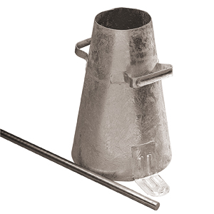

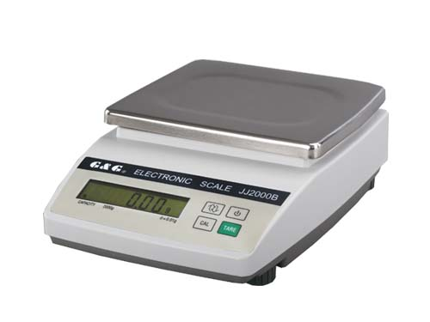

Fig. 1 Balance Fig. 2 Tamping Rod and Container

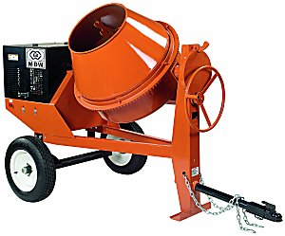

Fig. 3 Concrete Mixer

**Procedure**

Unit weight is a property of the fresh concrete. First, the concrete is prepared with mixing of aggreagtes, water, and cement in the concrete mixer ( Fig 3.). After the concrete is mixed, it is placed in the measure. But it should not be placed in one time, with 3 layers on the contrary. After the placing of each layer 25 times rodding is needed to compact the concrete. In addition the compaction, this action also make the layers act like they are one-piece. After the compaction and consolidation the surface of the concrete in the measure is flatten with trowel to get rid of the excessive amount of the concrete. After the surface of the concrete in the measure is clean enough, it is weighed to calculate the unit weight.

**Calculations**

- Density (unit weight), D= $\frac{M_{c}-M_{m}}{V_{m}}=\frac{25.5-6.7}{8}=2.35$ kg/ lt = **2350 kg/m3**

- For the compressive strength test and splitting tensile test:

Volume of one sample, V= πD2/4 x h = π(0.1)2/4 x 0.2 =**1.57 x 10-3 m3**

So, for three samples DxVx3= **11.068 kg** concrete is needed for each test.

- For the flexural tensile strength test:

Volume of one sample, V= b.d.l = 0.075 x 0.075 x 0.325 = **1.83 x 10-3 m3**

For three samples, m=DxVx3 **= 12.9 kg** concrete is needed.

**Results**

Unit weight of the concrete that is prepared in the lab session is calculated as 2350 kg/m3.

For different tests we need samples with different dimensions. According to their dimensions concrete required for each test for totally 3 samples is found as:

|  |  |  |  |
| --- | --- | --- | --- |
| **Test Name** | **Related Standard** | **Number of Samples** | **Required Concrete (kg)** |
| Compressive Strength Test | ASTM C 39 | 3 | 11,068 |
| Splitting Tensile Test | ASTM C 496 | 3 | 11,068 |
| Flexural Tensile Test | ASTM C 78 | 3 | 12,900 |

Table 1. Concrete Requirement of Tests

After those tests are applied, according to ASTM standards, strength of hardened concrete are calculated as the following:

|  |  |  |  |  |  |
| --- | --- | --- | --- | --- | --- |
| Name of the Specimen | Compressive Strength (MPa) | Name of the Specimen | Splitting Tensile Strength (MPa) | Name of the Specimen | Flexural Tensile Strength (MPa) |
| C1 | 30,03445387 | S1 | 2,700223326 | F1 | 0,807111035 |
| C2 | 34,95170601 | S2 | 2,799854341 | F2 | 0,830222144 |
| C3 | 32,67769971 | S3 | 2,850147314 | F3 | 0,853333252 |
| Average | 32,55461987 | Average | 2,783408327 | Average | 0,830222144 |

Table 2. Strength of the Hardened Concrete for Different Tests

**Discussion of Results**

Graph 1. Relation Between Compressive Strength and Splitting Tensile Strength

When the test results for our 3 specimen is plotted the linear relation between them can be found as S=0.0212C + 2.0919 where S is the splitting tensile strength and C is the compressive strength.

Graph 2. Relation Between Compressive Strength and Flexural Tensile Strength

The linear relation between compressive strength and flexural strength is F=0.005C +0.666.

* If we have a concrete specimen with compressive strength 120 MPa,

Splitting tensile strength, S=0.0212x120 + 2.0919 = 4.636 MPa

Flexural tensile strength, F=0.005x120 + 0.666 = 1.266 MPa

* If the actual spilitting and flexural tensile strength is 7 MPa and 10 MPa respectively, the errors are:

εs=

εf =

The relations that we found between compressive strength with splitting and flexural tensile strengths do not give the relation between them directly. As it can be seen from Graph 1 and Graph 2, the data points do not act linearly for different specimen results. But drawing a best line and assuming the points have a linearly relations give us the equations which are not true completely.

Also, the results shows us compressive strength is much much grater than the splitting tensile strength and the flexural tensile strength as a property of concrete.

**Conclusion**

In this experiment by calculating unit weight, first how much concrete is needed to prepare specimen for test is calculated. After that, using the given ultimate load for different test specimen, compressive strength, splitting tensile strength, and flexural tensile strength are calculated. By helping of ASTM specifications, standard tests on concrete bring to a successful conclusion.

**References**

ASTM C138 / C138M - 16 Standard Test Method for Density (Unit Weight), Yield, and Air Content (Gravimetric) of Concrete. (n.d.). Retrieved May 20, 2016, from https://www.astm.org/Standards/C138.htm

ASTM C39 / C39M - 16 Standard Test Method for Compressive Strength of Cylindrical Concrete Specimens. (n.d.). Retrieved May 20, 2016, from https://www.astm.org/Standards/C39.htm

ASTM C496 / C496M - 11 Standard Test Method for Splitting Tensile Strength of Cylindrical Concrete Specimens. (n.d.). Retrieved May 20, 2016, from https://www.astm.org/Standards/C496.htm

ASTM C78 / C78M - 15b Standard Test Method for Flexural Strength of Concrete (Using Simple Beam with Third-Point Loading). (n.d.). Retrieved May 20, 2016, from https://www.astm.org/Standards/C78.htm

Erdoǧan, T. Y. (2002). *Materials of construction*. Ankara: METU.