**MIDDLE EAST TECHNICAL UNIVERSITY**

**DEPARTMENT OF CIVIL ENGINEERING**

**CE 344 - MATERIALS OF CONSTRUCTION**

LABORATORY REPORT I - TESTS ON PORTLAND CEMENT

LAB GROUP 2

SECTION 4

SECTION 4

SUBMISSION DATE: 02.04.2017

Table of Contents

Object and Scope ...................................................................... 1

Preliminary Remarks ................................................................ 1

Test Specimen ........................................................................... 1

Apparatus .................................................................................. 1

Test Procedures ......................................................................... 2

Calculations ............................................................................... 3

Results ....................................................................................... 5

Discussion of Results ................................................................ 6

Conclusion ................................................................................. 7

References ................................................................................. 8

**Object and Scope**

The purpose of the lab is determining of the properties of Portland cement. The properties are specific gravity, fineness, consistency, compressive strength.

**Preliminary Remarks**

Cement is the most useful material according to many cases in construction materials. Because of hydraulic and non-homogenous structure of the cement mortar, it subjected to procedure to contruct. Definition of those properties as follow:

Setting: The time interval of getting rigid molucular structure after mixing with water and giving shape.

Fineness: Fineness is the definition of how small is the the cement particles.

Consistency: It defines how much water the cement paste consists.

Plasticity: Shapability and deformability of paste.

**Test Specimen**

The specimens have two different dimensions like 4x4x16 (cm) and 5x5x5 (cm)

**Apparatus**

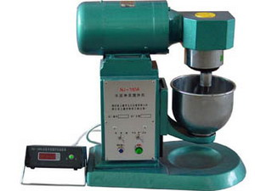 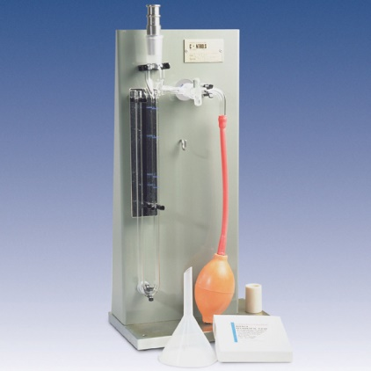

Figure 1- Mortar Agitator Figure 2- Blaine Apparatus

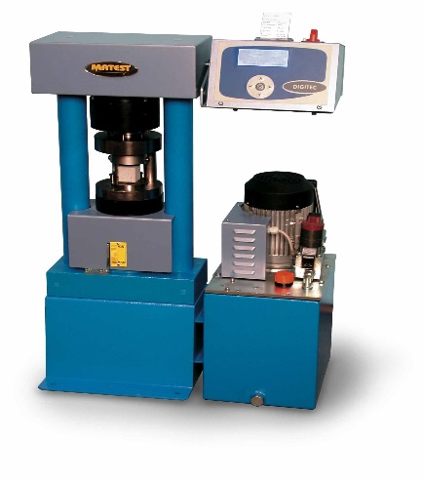 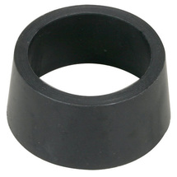

Figure 3- Compressing Machine Figure 4- Circular Test Container

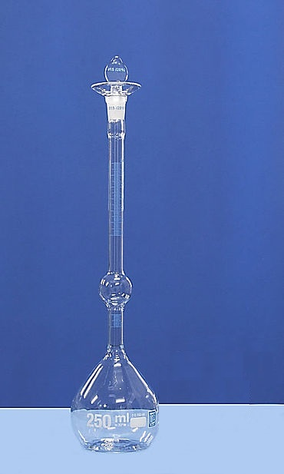  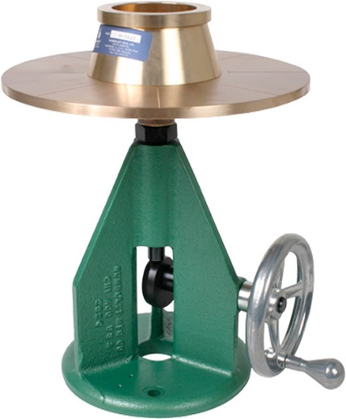

Figure 5- Le Chatelier Flask Figure 6- Flow Table

**Test Procedures**

Blaine fineness test shows the rate of air flow through the sample. Measuring the speed of air which passes trought the sample. The number and the size of pores of the sample would be defined with this test.

Cement and sand mixed with water so that we get mortar. A mixer which named like mortar agitator is started up. Mortar placed into circular test container. After placing the mortar, penetration is started with timekeeper. The sample is displaced after waiting one minute and droped 25 times in the flow table. At the end of the experiment we measure the diameter to analyze the specimen.

The specimen ,which prepared 28 days ago, subjected to compressive strength test with compression machine. First of all, the sample is placed into compression mahine and test is began. The machine gives load mid point of the specimen. This test is ends with the cracking of the sample.

**Calculations**

***According to ASTM C188 standard***

Mc= Mt - Ma

Mc = Mass of cement used, g

**NOTE:** The amount of cement required will typically be about 64 g for Portland cement, and somewhat less for other types of cements.

ρ= Mc / V

ρ = density of cement, g/cm3

V = displaced volume of liquid, cm3

-For Cement A:

ρ= Mc / V

ρ= 64/ (20.7- 0.6) =  **3.18 g/cm3**

-For Cement B:

ρ= Mc / V

ρ= 64/ (20.6- 0.4) = **3.17 g/cm3**

-For Cement C:

ρ= Mc / V

ρ= 64/ (20.3- 0.8) = **3.28 g/cm3**

***According to ASTM C204 standard***

W= ρ*V*(1-ε)

Where,

W = grams of sample required,

ρ = density of test sample,

V = bulk volume of bed of cement,

ε = desired porosity of bed of cement.

ε = 0.5, V = 1.72 cm3

-For Cement A:

W= ρ*V*(1-ε)

W= 3.18*1.72* (1- 0.5)= **2.73 g**

-For Cement B:

W= ρ*V*(1-ε)

W= 3.17*1.72* (1- 0.5)= **2.73 g**

-For Cement C:

W= ρ*V*(1-ε)

W= 3.28*1.72* (1- 0.5)= **2.82 g**

***According to ASTM C1437 standard***

Flow = $\frac{Increase in Average Base Diameter}{Original Base Diameter}$

Flow in Percent = Addition of Readings in Flow

Flow in Percent = (215-100)/100= 115% for the first one.

Flow in Percent = (200-100)/100= 100% for the second one.

Flow in Percent = (205-100)/100= 105% for the third one.

Flow in Percent = [(215-100)+ (200-100)+ (205-100)+)]/ 3*100 = 106.67 %

***According to ASTM C109 standard***

Compressive Strength = $\frac{\sum{\frac{P}{A}}}{3}$, which means the average of the 3 sample for each mortar where area A=50*50=2500 mm2.

-For Mortar X:

σ= $\frac{(37.2+36.4+35.4)/2500}{3}$ = 14.5 MPa

-For Mortar Y:

σ = $\frac{(60.4+62.7+61.9)/2500}{3}$ = 24.7 MPa

-For Mortar Z:

σ = $\frac{\left(46.2+47.4+49.6\right)/2500}{3}$ = 19.1 MPa

**Results**

1. Density: ρ1= 3.18 g/cm3, ρ2= 3.17 g/cm3, ρ3= 3.28 g/cm3

2. Specimen Mass: W1= 2.73 g, W2= 2.73 g, W3= 2.82 g

3. Fineness: Cement B > Cement C > Cement A

4. Compressive Strength: ϬX= 14.5 MPa, ϬY= 24.7 MPa, ϬZ= 19.1 MPa

Table 1. Density test, fineness and flow test results of cement samples

Cement Type

|  |  |  |  |  |  |
| --- | --- | --- | --- | --- | --- |
| Test Method | Specimen | Cement A | Cement B | Cement C | Reference Cement |
| **Density Test** | Initial Reading [mL] | 0.6 | 0.4 | 0.8 | - |
| Final Reading [mL] | 20.7 | 20.6 | 20.3 | - |
| Density [g/cm3] | **3.18** | **3.17** | **3.28** | - |
| **Fineness Test\*** | Specimen Mass [g] | **2.73** | **2.73** | **2.82** | - |
| Duration [s] | 60 | 100 | 80 | 83 |
| Fineness [cm2/g]** | **3265** | **4215** | **3770** | 3840 |
| **Flow Test\*\*\*** | Average Final Diameter [mm] | 215 | 200 | 205 | - |
|  | Flow Percent [-] | **115** | **100** | **105** | - |

Table 2. Fracture loads at 14 days

|  |  |  |  |
| --- | --- | --- | --- |
| Type  No | Mortar X [kN] | Mortar Y [kN] | Mortar Z [kN] |
| 1 | 37.2 | 60.4 | 46.2 |
| 2 | 36.4 | 62.7 | 47.4 |
| 3 | 35.4 | 61.9 | 49.6 |
| Average [MPa] | **14.5** | **24.7** | **19.1** |

**Discussion of Results**

The order of density from greatest to least is Cement C, Cement A and Cement B respectively. So, to have the same consistency Cement C needs more water than Cement B and Cement C. In addition, the flow percent is approximately 110% for this experiment. According to average compression strengths of mortars, Mortar Y has the greatest compression strength. And Mortar X has the least one.

When we compared the fineness of cement types, the Cement B is the greatest one also Cement A is the least one. For this reason, Cement B has the largest surface area of particles and then it will be needed more water when it reacts. In other words, more fineness value means more required water.

According to test results, the contents of cement specimens affect the compressive strength of mortars. Dividing the maximum load where fracture happens to the cross sectional area gives us the strength. By taking advantage of ASTM C109 standard, compressive strength is found. All works were done in the light of more than one ASTM standard.

The 28-day compressive strength of concrete, with or without entrained air, increases with an increase in cement fineness. The difference in compressive strength due to difference in fineness of cement. Thus, the match-up of given cements and mortars should be as indicated: Cement A is used to obtain Mortar X, Cement B is used to obtain Mortar Y, and finally Cement C is used to obtain Mortar Z.

**Conclusion**

In the first laboratory session, three different mortar type and three different cement type are examined. Fineness, density, flow percent, compressive strength are controlled by using ASTM standards. And different loads are applied to three different types of cement. As a conclusion, cement types are compared and obtained information about them in the light of test results.

**References**

-Erdoǧan, T. Y. (2002). *Materials of Construction.* Ankara: METU Press Publishing Company.

**-**ASTM C109 / C109M - 16 Standard Test Method for Compressive Strength of Hydraulic Cement Mortars (Using 2-in. or [50-mm] Cube Specimens). (n.d.). Retrieved April 01, 2017, from http://www.astm.org/Standards/C109.htm

-ASTM C1437 - 15 Standard Test Method for Flow of Hydraulic Cement Mortar. (n.d.). Retrieved April 01, 2017, from http://www.astm.org/Standards/C1437

-ASTM C188 - 15 Standard Test Method for Density of Hydraulic Cement. (n.d.). Retrieved April 01, 2017, from http://www.astm.org/Standards/C188.htm

-ASTM C204 - 16 Standard Test Methods for Fineness of Hydraulic Cement by Air-Permeability Apparatus. (n.d.). Retrieved April 01, 2017, from http://www.astm.org/Standards/C204.htm