**MIDDLE EAST TECHNICAL UNIVERSITY**

**DEPARTMENT OF CIVIL ENGINEERING**

**CE 344 - MATERIALS OF CONSTRUCTION**

LABORATORY REPORT 2: TEST ON AGGREGATES

LAB GROUP 2

SECTION 4

SECTION 4

SECTION 4

SUBMISSION DATE: 08.05.2017

CONTENTS

-Object and Scope ...................................................................... 1

-Preliminary Remarks ................................................................. 1

-Test Specimen .......................................................................... 2

-Apparatus ................................................................................. 3

-Test Procedure ........................................................................ 4

-Calculations ............................................................................. 4

-Results ...................................................................................... 5

-Discussion of Results .............................................................. 6

-Conclusion ............................................................................... 7

-References ............................................................................... 8

**Object and Scope**

According to this laboratory session, main aim is to learn properties and behaviors of aggregates. Thanks to that laboratory, organic impurities, sieve analysis, soundness and water absorption also alkali reactivity potential are used.

**Preliminary Remarks**

In order to obtain strength for concrete and mortar, aggregates are using which are the natural or artificial inorganic granular materials. Moreover, due to their properties such as abrasion resistance, alkali reactivity, size etc., they are preferable materials for improve concrete and mortar properties. Aggregates also composed of stones crumbled. Therefore, since aggregate materials are easy access materials, they reduce the cost of the main product. In other words, they affect the economy positively.

It is useful for us to know the properties of aggregate cement since aggregate proportion is very high. Due to that reason, tests on aggregates are more important than the other contents’ tests. Moreover, since aggregates obtained from the nature, they properties cannot control by human, and knowledge of that products is very benefitable. On the other hand, cement is a man-made product.

There are some significant terms for aggregates tests:

- Soundness: is the ability of the aggregates to resist volume changes to environmental effects:

* Freezing & throwing,
* Alternate wetting & drying,
* Temperature changes.

- Alkali-Aggregate Reactivity: leads to expansion and cracking of hardened concrete.

- Specific gravity: the density of a material is defined as its mass per unit volume.

- Abrasion resistance: is wearing by repeated rubbing or frictional forces and then resistance of aggregates is investigated by a test method called the ' Los Angeles testing method'.

- Absorption: when water penetrates into its pores during a specific time period, increasing in mass of aggregates.

- Saturated and Surface Dry States: All permeable pores are filled with water but the forces of the aggregate particles are dry.

- Relative density (specific gravity): ratio of the density of a material to the density of distilled water.

- Fine Aggregate: Aggregate particles which can pass #4 sieve.

- Coarse Aggregate: Aggregate particles which cannot pass #4 sieve.

**Test Specimen**

In aggregate, coarse materials have to stay at the crest part and portions have to accumulate on lower layers mostly due to particle sizes. Then outer part segregate and wind affect to outer parts. To get obtain inner layer sample, outer part should be removed. Moreover, in order to get much more accurate results, more sample should be taken from different locations. Samples are filtered and reduced with two different methods. One of them is ' Sample Splitter (Fig.1)' that separate the aggregates into two equal part. The second one is ‘Quartering Method (Fig.2)’ which can be done by dividing the laying in circular shape aggregates into 4 equal part and selecting the two opposing quarters as sample.

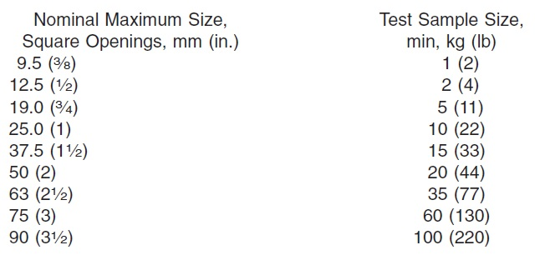According to sieve analysis, fine portions of the aggregates must be at least 300 grams and then coarse ones should have the properties which are showed below.

In this lab session, fine aggregates are our test specimen which all can pass from #4 sieve.

**Apparatus**

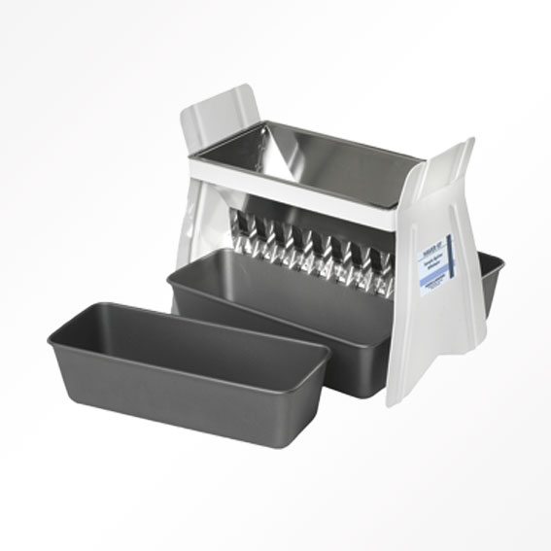 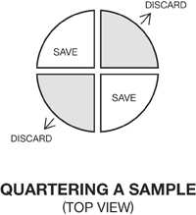

Figure 1. Sample Splitter Figure 2. Quartering Method

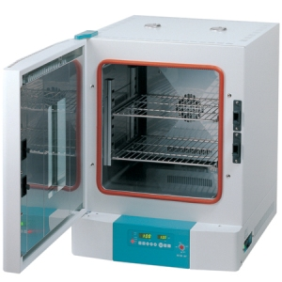 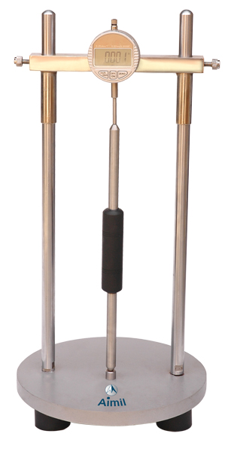

Figure 3. Oven Dry Figure 4. Lengthchange measure apparatus

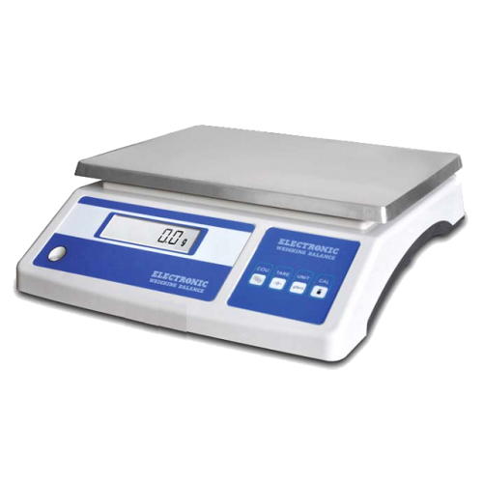 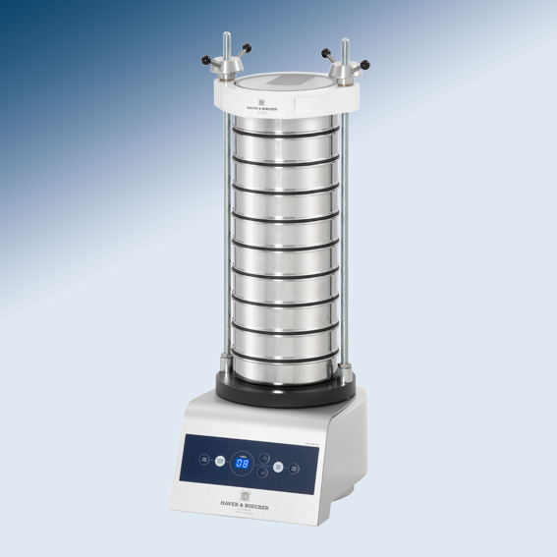

Figure 5. Balance Figure 6. Sieve Analysis

**Test Procedure**

**The sieve analysis of aggregates ASTM C136**

The aim of the sieving is determining the size of aggregates. Sieve analysis test is obtained by gathering the different size of sieves respect to their opening size from large one which lies at the top, to bottom (Fig.6). At the bottom pan is placed and it collects the particles which are smaller than smallest sieve opening. Aggregates must be dry to prevent particle from gathering.

The sample has different shape so that it needs shake to perform test. Sieves can be shaken by hand but shaking machine is more accurate. When the test is ended, separation is completed. To determine sample weighing is performed on each sieves and pan. Before the test we know the mass of the sample so that we can calculate percentage of retaining parts of sample at each sieve steps. By this way we can calculate and draw the gradation curve.

**Calculations**

|  |  |  |  |  |  |
| --- | --- | --- | --- | --- | --- |
| Sieve | Sieve Opening (mm) | Mass Retained (g) | Percent Retained | Cumulative Percent Retained | Percent Passing |
| #4 | 4,75 | 0 | **0,0** | **0,0** | **100,0** |
| #8 | 2,36 | 305 | **30,5** | **30,5** | **69,5** |
| #16 | 1,18 | 182 | **18,2** | **48,7** | **51,3** |
| #25 | 0,71 | 97 | **9,7** | **58,4** | **41,6** |
| #30 | 0,600 | 61 | **6,1** | **64,5** | **35,5** |
| #50 | 0,300 | 122 | **12,2** | **76,7** | **23,3** |
| #100 | 0,150 | 160 | **16,0** | **92,7** | **7,3** |
| Pan | - | 73 | **7,3** | **100,0** | **0,0** |
| Fineness Modulus | **3.131** | | | | |

When we sum up the mass retained values it is 1000 g which is our total sample. Percent retained is calculated by dividing the mass retained on each sieve to the total mass. For example for #30 sieve percent retained = $\frac{61}{1000}x100=6.1\%.$ Cumulative percent retained, on the other hand, is the total percent of retained values above a sieve. For #16 sieve it is 30.5+18.2=48.7%. Percent passing is calculated by subtracting the cumulative percent retained by 100%. For the same sieve again, it is 100-48.7=51.3%.

According to ASTM C125 the fineness modulus of the aggregates is calculated by adding the cumulative percentages by mass retained on some specified sieves, not only sieves that are used during the test. The specified sieves are: #100, #50, #30, #16, #8, #4 sieves. Thus, we should not add the #25 sieve’s cumulative percent value to our calculation.

Fineness Modulus = $\frac{\sum{\% cumulative percent retained}}{100}$

So,

Fineness Modulus = $\frac{0+30,5+48,7+64,5+76,,7+92,7}{100}=\frac{313,1}{100}=3.131$

**Results**

Respect to cumulative weight percentage of retaining is calculated at each sieve:

|  |  |
| --- | --- |
| Sieve | Percent Passing |
| #4 | **100,0** |
| #8 | **69,5** |
| #16 | **51,3** |
| #25 | **41,6** |
| #30 | **35,5** |
| #50 | **23,3** |
| #100 | **7,3** |
| Pan | **0,0** |

Fineness Modulus is found as 3.131.

Gradation curve (Particle size vs. Percent passing graph) is drawn at Graph 1.

Graph 1. Particle size vs. Percent passing

**Discussion of Results**

ASTM C33 limit for passing aggregate size:

|  |  |
| --- | --- |
| Sieve Sizes | Passing % |
| 9.5 mm | 100 |
| #4 | 95-100 |
| #8 | 80-100 |
| #16 | 50-85 |
| #30 | 25-60 |
| #50 | 10-30 |
| #100 | 2-10 |

At our results there is an exceeding, it can be observed that at #50 sieve, there are 23.3% passing materials so it is out of limitations. We can observe effect of exceeding at fineness modulus. Because of that the specimen is not completely successful.

Definition of fineness determined with fineness modulus if the sample’s fineness modulus is between 2.15 and 3.38 it called as fine. We can say that our sample is fine. Also, we neglect the values of #25 sieve according to ASTM standards.

**Conclusion**

To sum up, determining gradation of the aggregates is the main object of the test. That gradation allows us to classify our sample and justify it properly. This test has important role, when we prepare the concrete, it affects strength of concrete directly.

Fineness modulus tells us how coarse our sample but it is not the only criteria. Different sample with different percentage retaining could have same fineness modulus. So that fineness is important and useful in preliminary design but it is not enough to determine sample.

**References**

- Erdoǧan, T. Y. (2002). *Materials of construction*. Ankara: METU.

-ASTM C125 - 15b Standard Terminology Relating to Concrete and Concrete Aggregates. (n.d.). Retrieved May 5, 2017, from http://www.astm.org/Standards/C125.htm

- ASTM C33 / C33M - 16 Standard Specification for Concrete Aggregates. (n.d.). Retrieved May 5, 2017, from http://www.astm.org/Standards/C33.htm