**MIDDLE EAST TECHNICAL UNIVERSITY**

**DEPARTMENT OF CIVIL ENGINEERING**

**CE 344 - MATERIALS OF CONSTRUCTION**

LABORATORY REPORT 3 - TESTS ON CONCRETE

LAB GROUP 2

SECTION 4

SECTION 4

SECTION 4

SUBMISSION DATE: 29.05.2017

CONTENTS

-Object and Scope ...................................................................... 1

-Preliminary Remarks ................................................................. 1

-Test Specimen .......................................................................... 1

-Apparatus ................................................................................. 2

-Test Procedures ........................................................................ 2

-Calculations ............................................................................. 4

-Results ...................................................................................... 9

-Discussion of Results .............................................................. 9

-Conclusion ............................................................................... 10

-References ............................................................................... 10

**Object and Scope**

The main object of this laboratory session is to observing the concrete and its features, such as slump, air content, compressive strength, and splitting tensile strength.

**Preliminary Remarks**

Fresh concrete should be workable and shapeable, also liquid form must be prevented for workability, and it must be uniform. Avoiding from bleeding is another important process; it is relative with air content and plastic containing design. Its consistency, uniformity and no segregation is also important. Before pouring the concrete, we need to know and design some properties of concrete and they should be check after hardening. They could be designable with some properties and variables in fresh concrete components, like w/c ratio, type of cement, clarity of water, aggregate size and amount, and admixtures. So we use recipes for designing concrete. Checking process goes with strength tests after hardening.

There are some terms which we use in this session;

* Compressive strength: The capacity of compressive stress.
* Drilled core specimen: Specimen taken from the casted concrete via a drill core.
* Cubic specimen: Specimen which is casted to a cubic mold for testing.

**Test Specimen**

For controlling the uniformity, we take three specimens from every 50 m3, like 15\*15\*15 cubic specimen each of them. We apply curing process for 28 days. Also cylindrical cores are taken from site to compare with cubic ones. Cylinder specimens are cut to 10cm pieces and top and bottom parts get cap to distribute the stress uniformly.

**Apparatus**

Strength testing machine

C:\Users\OZAN\Desktop\Concrete_Compression_Test_Machine.jpg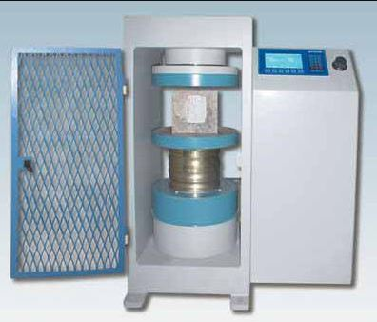

Figure 1. Strength Testing Machine

**Test Procedure**

Specimens are tested immediately after getting from curing to prevent the specimen from environmental impacts. For better comparable results, tests’ time interval is given in Table 1.

Table 1.

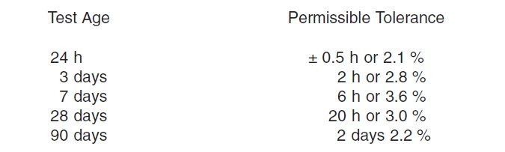

After place the specimen, load indicator is set to zero. When separable caps are used at test, the alignment of specimen and testing machine must be verified. It must be maximum 0.5°. to prevent from shocking the specimen, %10 loading-unloading process applied on specimen. Also displacement control is applied to proper testing. After reaching the half of the expected strength, loading rate is decreased. Test is continue until the crack are occur but the cracks could occur at the inside of specimen so that we understand the cracks from load indicator. Cracks can be occur as shown in Figure 2.

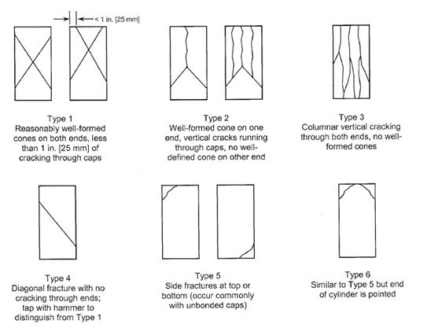

Figure 2. Schematic of typical fracture patterns

If the tasting machine has detector it would stop test at the drop of %95 of ultimate strength. Using separable caps may causes a fracture like type 5 or 6 (Figure 2) before reaching the ultimate strength. If the measured strength is lower than the expected one, crack area must be examine to determine reasons of the failure.

**Calculations**

Firstly, strength of cubic laboratory samples which based on test results are calculated.

The calculated compressive strength results which are shown on the Table 1 are determined by P/A formula. Where P is the failure load and A is the cross sectional area of the cubic samples which is 150\*150=22500mm2.

Table 2. Compressive load results of the cubic samples

|  |  |  |  |  |  |  |  |  |  |  |
| --- | --- | --- | --- | --- | --- | --- | --- | --- | --- | --- |
| Floor | Requested strentgh class | Compressive failure load (kN) | | | | | | | | |
| Calculated compressive strength (MPa) | | | | | | | | |
| First 50 m3 | | | Second 50 m3 | | | Third 50 m3 | | |
| 3 | C25/30 | 833 | 825 | 850 | 823 | 837 | 805 | 828 | 851 | 842 |
| *37.02\** | *36.67\*\** | *37.78* | *36.56* | *37.2* | *35.78* | *36.8* | *37.82* | *37.42* |
| 2 | C30/37 | 832 | 823 | 829 | 827 | 841 | 828 | 830 | 840 | 848 |
| *36.98* | *36.56* | *36.84* | *36.76* | *37.38* | *36.8* | *36.89* | *37.33* | *37.68* |
| 1 | C30/37 | 817 | 825 | 832 | 835 | 849 | 842 | 850 | 831 | 854 |
| *36.31* | *36.67* | *36.98* | *37.11* | *37.73* | *37.42* | *37.77* | *36.93* | *37.96* |

Representative calculations:

\*= 833000/22500=

\*\*= 825000/22500=

Secondly, according to ASTM C39 compressive strength of cores are calculated. ASTM C39 says that calculate the compressive strength of the specimen by dividing the maximum load carried by the specimen during the test by the average cross-sectional area. additionally, it highlights that if the specimen length to diameter ratio is 1.75 or less, correct the result which is obtained by dividing the failure load by the cross sectional area by multiplying appropriate correction factor shown in the following table:

Table 3. Correction factor with respect to L/D

|  |  |  |  |  |
| --- | --- | --- | --- | --- |
| L/D | 1.75 | 1.50 | 1.25 | 1.00 |
| Factor | 0.98 | 0.96 | 0.93 | 0.87 |

Additionally, it offers using interpolation to determine correction factors for L/D values between those given in the table. In order to calculate correct strength values at first step failure load is divided by cross sectional area which is п\*(1002÷4) = 7853.982 mm2 then it is multiplied with corresponding correction factor.

Table 4. Correction factors which are related with data

|  |  |  |  |  |  |  |  |  |  |
| --- | --- | --- | --- | --- | --- | --- | --- | --- | --- |
| L/D | 175/100 | 165/100 | 197/100 | 185/100 | 150/100 | 192/100 | 162/100 | 120/100 | 200/100 |
| Factor | 0.98 | 0.972\* | \_ | \_ | 0.96 | \_ | 0.9696 | 0.918\*\* | \_ |

Representative calculations:

\* = 0.98-[(0.1×0.02)/0.25]

\*\* = 0.93-[(0.05×0.06)/0.25]

Table 5. The first floor’s data & results

|  |  |  |  |  |  |  |  |  |  |
| --- | --- | --- | --- | --- | --- | --- | --- | --- | --- |
| Floor1 & requested strength class is C30/37, cross sectional area is 7853.982 mm2 | | | | | | | | | |
| 1 | | 2 | 3 | 4 | 5 | 6 | 7 | 8 | 9 |
| Compressive load (kN) | 240 | 240 | 242 | 240 | 244 | 241 | 241 | 240 | 242 |
| Uncorrected strength (MPa) | 30.56\* | 30.56 | 30.81 | 30.56 | 31.07 | 30.69 | 30.69 | 30.56 | 30.81 |
| Factor | 0.98 | 0.972 | - | - | 0.96 | - | 0.9696 | 0.918 | - |
| Corrected strength (MPa) | *29.95\*\** | *29.70* | *30.81* | *30.56* | *29.83* | *30.69* | *29.76* | *28.05* | *30.81* |

Representative calculations:

\*= 240000/ 7853.982

\*\*=30.56×0.98

**Table 6.** The second floor’s data & results

|  |  |  |  |  |  |  |  |  |  |
| --- | --- | --- | --- | --- | --- | --- | --- | --- | --- |
| Floor2& requested strength class is C30/37, cross sectional area is 7853.982 mm2 | | | | | | | | | |
| 1 | | 2 | 3 | 4 | 5 | 6 | 7 | 8 | 9 |
| Compressive load (kN) | 196 | 200 | 210 | 202 | 193 | 189 | 220 | 217 | 218 |
| Uncorrected strength (MPa) | 24.96\* | 25.46 | 26.74 | 25.72 | 24.57 | 24.06 | 28.01 | 27.63 | 27.76 |
| Factor | 0.98 | 0.972 | - | - | 0.96 | - | 0.9696 | 0.918 | - |
| Corrected strength (MPa) | *24.46\*\** | *24.75* | *26.74* | *25.72* | *23.59* | *24.06* | *27.16* | *25.36* | *27.76* |

Representative calculations:

\*= 196000/7853.982

\*\*=0.98×24.96

Table 7. The third floor’s data & results

|  |  |  |  |  |  |  |  |  |  |
| --- | --- | --- | --- | --- | --- | --- | --- | --- | --- |
| Floor3& requested strength class is C25/30 & cross sectional area is 7853.982 mm2 | | | | | | | | | |
| 1 | | 2 | 3 | 4 | 5 | 6 | 7 | 8 | 9 |
| Compressive load (kN) | 241 | 241 | 240 | 243 | 243 | 242 | 243 | 240 | 238 |
| Uncorrected strength (MPa) | 30.69\* | 30.69 | 30.56 | 30.94 | 30.94 | 30.81 | 30.94 | 30.56 | 30.30 |
| Factor | 0.98 | 0.972 | - | - | 0.96 | - | 0.9696 | 0.918 | - |
| Corrected strength (MPa) | *30.08\*\** | *29.83* | *30.56* | *30.94* | *29.70* | *30.81* | *29.99* | *28.05* | *30.30* |

Representative calculations:

\*= 241000/7853.982

\*\*=30.69×0.98.

Thirdly, the strength results are collected and mean values (μ), standard deviations (σ) and coefficient of variation which is found by ratio of σ to μ.

First floor’s strength values, standard deviation, coefficient of variation of cubic samples and core samples:

Table 8. Strength values& statistic results of first fl

|  |  |
| --- | --- |
| Cubic samples | Core samples |
| 36.31 | 29.95 |
| 36.67 | 29.7 |
| 36.98 | 30.81 |
| 37.11 | 30.56 |
| 37.73 | 29.83 |
| 37.42 | 30.69 |
| 37.77 | 29.76 |
| 36.93 | 28.05 |
| 37.96 | 30.81 |
| Mean of cubic samples(μ)=37.09778 | Mean of core samples (μ)= 30.01778 |
| Standard deviation of cubic samples(σ)=0.66334 | Standard deviation of core samples(σ)=0.87182 |
| Coefficient of Variation ( σ/μ) = 0.01788 | Coefficient of Variation ( σ/μ) = 0.02904 |

Second floor’s strength values, standard deviation, coefficient of variation of cubic samples and core samples:

Table 9. Values & statistic results of second floor

|  |  |
| --- | --- |
| Cubic samples | Core samples |
| 36.98 | 24.46 |
| 36.56 | 24.75 |
| 36.84 | 26.74 |
| 36.76 | 25.72 |
| 37.38 | 23.59 |
| 36.8 | 24.06 |
| 36.89 | 27.16 |
| 37.33 | 25.36 |
| 37.68 | 27.76 |
| Mean of cubic samples(μ)=37.02444 | Mean of core samples (μ)=25.51111 |
| Standard deviation of cubic samples(σ)=0.36049 | Standard deviation of core samples(σ)=1.450581 |
| Coefficient of Variation ( σ/μ) =0.009736 | Coefficient of Variation ( σ/μ) =0.05686 |

Third floor’s strength values, standard deviation, coefficient of variation of cubic samples and core samples:

Table 10. Strength values & statistic results of the third floor

|  |  |
| --- | --- |
| Cubic samples | Core samples |
| 37.02 | 30.08 |
| 36.67 | 29.83 |
| 37.78 | 30.56 |
| 36.56 | 30.94 |
| 37.2 | 29.7 |
| 35.78 | 30.8 |
| 36.8 | 29.99 |
| 37.82 | 28.05 |
| 37.42 | 30.30 |
| Mean of cubic samples(μ)=37.00556 | Mean of core samples (μ)=30.02778 |
| Standard deviation of cubic samples(σ)=0.645002 | Standard deviation of core samples(σ)=0.854997 |
| Coefficient of Variation ( σ/μ) =0.01743 | Coefficient of Variation ( σ/μ) =0.028474 |

Note that mean and standard deviation values of samples are calculated by Excel program. Additionally, coefficient of variation is calculated by shown formula.

Finally, strength class of concrete for each storey according to laboratory cubic samples and the core are shown following table:

Table 11. Strength values of concrete according to mean values of test results

|  |  |  |  |
| --- | --- | --- | --- |
|  | 1.floor ( C30/37 required) | 2.floor ( C30/37 required) | 3.floor (C25/30) required |
| Cubic sample | 37.09778 | 37.02444 | 37.0056 |
| Core sample | 30.01778 | 25.5111 | 30.02778 |

Therefore strength class of first floor according to laboratory samples is C37 but according to core samples it is C30. For second floor concrete it can be called C37 according to laboratory samples however core samples of second floor shows that it is C25. Lastly, although the laboratory samples of third floor state that it is C37, the core samples show it can be called C30.

**Results**

Table 12. The result table of 1st floor

|  |  |
| --- | --- |
| Results of first floor | |
| Cubic samples | Core samples |
| μ =37.09778 | μ = 30.01778 |
| σ = 0.66334 | σ =0.87182 |
| Coefficient of Variation = 0.01788 | Coefficient of Variation =0.02904 |
| Strength class C37 | Strength class C30 |

Table 13. The result table of 2nd floor

|  |  |
| --- | --- |
| Results of second floor | |
| Cubic samples | Core samples |
| μ 37.02444 | μ 25.5111 |
| σ =0.36049 | σ=1.450581 |
| Coefficient of Variation =0.009736 | Coefficient of Variation =0.05686 |
| Strength class C37 | Strength class C25 |

Table 14. The result table of 3rd floor

|  |  |
| --- | --- |
| Results of third floor | |
| Cubic samples | Core samples |
| μ 37.0056 | μ 30.02778 |
| σ =0.645002 | σ=0.854997 |
| Coefficient of Variation =0.01743 | Coefficient of Variation =0.028474 |
| Strength class C37 | Strength class C30 |

**Discussion of Results**

According to result of test, standard deviations of core samples’ are higher than laboratory samples’. It is simple because of laboratory conditions. In laboratory, people get more accurate sample, since they can fix the conditions as much as possible; on the other hand, at construction site, worker could not fix the conditions as they want and standard deviations increase. Moreover, curing of the sample is another important factor for those results. At laboratory we can obtain better cured samples as observed. Because of the fact curing procedure, the laboratory samples have higher strength values. Second floor concrete’s core sample is not provide sufficient strength since it shows C25 strength properties and third floor concrete’s core sample is provide much more strength, i.e. C30 properties, than requested values. The differences between requested values and test results can be occur due to mistakes which are done in calculation process or some discrepancies in created calculation tables.

**Conclusion**

In that lab session, we observe that test results and in situ results can be different due to conditions of surrounding and worker capacity. Because of that, construction phase should be done carefully since design procedure obtain according to optimum conditions.

**References**

ASTM C39 / C39M- 16 Standard Test Method for Compressive Strength of Cylindrical Concrete Specimens. (n.d.). Retrieved May 25, 2017, from https://www.astm.org/Standards/C39.htm

ASTM C42/C42M-16 Standard Test Method for Obtaining and Testing Drilled Cores and Sawed Beams of Concrete. (n.d.). Retrieved May 25, 2017, from https://www.astm.org/Standards/C42.htm