## Course No: 5620363 Date of Testing: 17.11.2008

## No and Title of Test: 23, Laboratory Vane Test

### Year and Section: 3, 02 Lab. Group: 4

## SURNAME, Other names of Student:

**OBJECT**

The object of the experiment is to determine the peak and residual undrained strength of soft, undisturbed or remoulded clay, assumed as saturated, using the laboratory vane apparatus.

**APPARATUS**

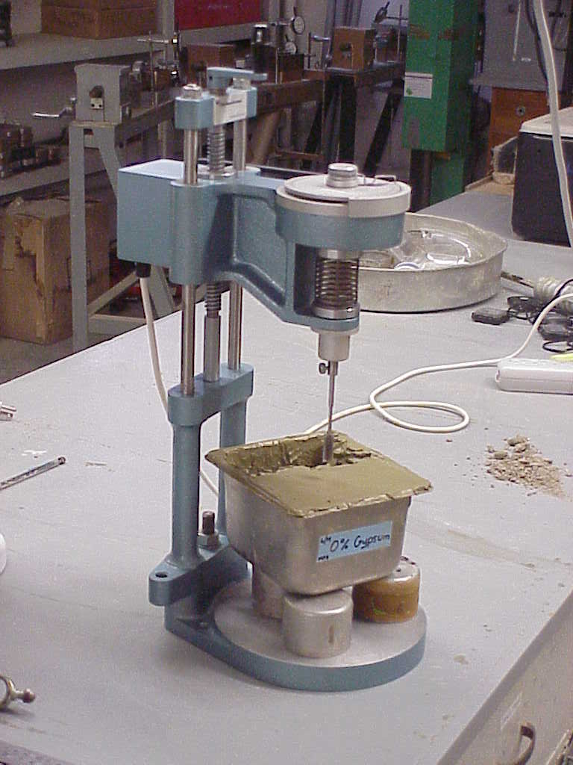

Vane Apparatus

<http://useit.umaine.edu/images/maingallery/vane%20app.JPG>

**THEORY**

dF = c*dA

dM = c*dA*r

dA=r*dr*dθ

T = π / 2 * D2 * H * (1 + D/(3*H)) * c

c = mobilized shear stress in the clay sample when a torque is applied.

H = height of vanes

D = diameter of circle circumscribing vanes.

**Shear Strength:** It is a term used to describe the maximum strength of soil at which point significant plastic deformation or yielding occurs due to an applied shear stress.

**PROCEDURE**

**(a) Calibration**

**1.** Apply a known torque to the vertical shaft carrying the vane and read off the angular deflection of the spring. The required torque can be applied by means of a thread wound round the 9.5 mm diameter section of the vane shaft, and pulled horizontally by passing it over a pulley supported independently on a horizontal axis, and placing weights on ah neger attached to its end.

**2.** Readings should be taken for loading and unloading stages and the mean spring deflection determined in order to eliminate the effect of friction at the pulley.

**(b)Testing Procedure**

**1.** If an undisturbed sample is available, transfer this into a Proctor or other suitable mould. Otherwise, remould about 1 kg of Ankara Clay with distilled water to a consistency corresponding to a water content of about 35%. Fill a C.B.R. mould with this clay, taking care not to trap any air in the sample. Place the sample so prepared on the base plate of the vane apparatus, centrally below the vane.

**2.** Rotation of the handle, having a horizontal axis, rotates a graduated disc which is coupled with the top of a helical spring. (Four springs of the varying stiffness are available, and the one giving as wide a range of readings as possible must be chosen according to the consistency of the sample tested, provided that the spring deflection does not exceed 180 degrees.) The lower end of this spring is coupled with the vane shaft and also with two pointers. The shorter of these pointers reads against the graduated disc and hence registers the relative angular motion between the top and bottom of the spring, that is, “spring deflection”. The longer pointer reads against a stationary graduated dial and hence gives the angular rotation of the vane.

**3.** Set the two pointers in contact with each other, with longer pointer reading a value close to zero. Take the initial readings of both pointers.

**4.** By turning the handle at the top of the screw spindle anticlockwise, lower the vane until it is just in contact with the top of the sample. Then give it 12 more turns so that the vane penetrates the sample by about three times its own height, H, in order to avoid the surface irregularities of the sample. Take the pointier readings once more to check whether any twist of the vane has taken place as it entered the soil.

**5.** Then apply a torque to the vane by steady clockwise rotation of the appropriate handle at a speed of one-quarter of a revolution every 10 seconds. During this process, take readings of the spring deflection (inner dial) and of the angular rotation of the vane (outer dial) at intervals of 10 seconds. Continue until the sample fails, this being indicated by a reduction in the spring deflection. If the spring deflection reaches 100 degrees, stop the test and repeat with stiffer spring.

**6.** Rotate the vane rapidly through two complete revolutions; then reduce the speed of rotation of the handle to the value used in (5), and take a final reading of the spring deflection and the angular rotation.

**7.** Raise the vane out of the sample by rotating the vertical spindle clockwise. Wipe the blades clear of adhering soil. Shift the sample so that the vane can be lowered to a point at least 30 mm from the point of the previous test and repeat steps (4) to (6).

**DISCUSSION OF RESULTS**

In this experiment, personal factor of the operator can affect the results because some steps in the procedure should be done properly. For instance, rotation of the handle should be 90° and reading should be done in every 10 seconds. In these steps, it is possible that some errors can occur. In order to avoid these types of error, human factor effect should be decreased by using digital devices such as a mechanic arm which rotates the handle exactly 90°. In addition, reading from digital devices decreases the error when we compare with reading from analog devices. Moreover, laboratory factors can also affect the results. The clay, which we use in the test, must provide some conditions like its water content must be about %35. If it less than %35, the clay becomes very hard so vane may not rotate or if it more than %35 the clay becomes very soft so vane may rotate freely. We can use this test to determine shear stress for a sample that may have slope stability problem.

**CONCLUSION**

In this experiment, the peak and residual undrained strength of soft, undisturbed or remoulded clay are determined. If we rotate the handle when there is no sample, we cannot read the spring deflection because there is no shear. If we fix the vane rod and start rotating the handle there is only spring deflection, we cannot read vane rotation.

**REFERENCES**

Lecture Notes

[www.answers.com](http://www.answers.com)

Mirata, T. (2001) Laboratory Instructions for Soil Mechanics Students, Department of Civil Engineering, METU