|  |  |
| --- | --- |
| **Course Name : CE 363** | **Date of Testing: 03.05.2010** |
| **No. and Title of Test : SML 20 DIRECT SHEAR BOX TEST ON SAND** | |
| **Year and Section: 3/1** | **Lab. Group : 04** |
| **SURNAME, Other names of student:** | |

# OBJECT

To determine the drained shear strength and the stress – strain characteristics of a sample of remolded sand, having particles not larger than 2 mm, by means of the direct shear box test.

# APPARATUS

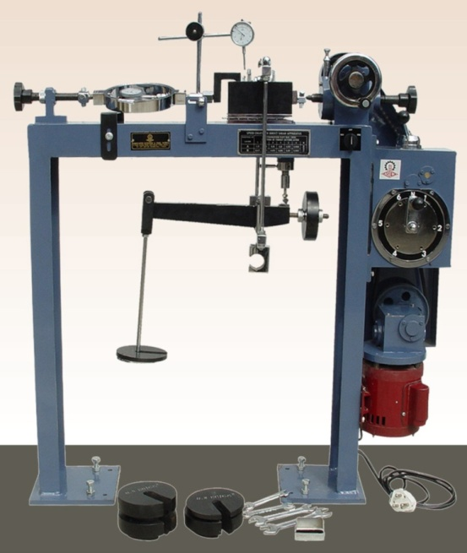

# THEORY

A vertical force is applied to the specimen with the help of a loading plate and shear stress is gradually applied on a horizontal plane by causing the two half of the box to move relatively. The shear force is recorded with the corresponding shear displacement. Thickness change of the specimen is also recorded. The test is repeated with different soil samples under different vertical forces. And, the failure shear stresses of each test are plotted against their normal stresses. The shear strength parameters can be obtained from the best line fitting the plotted points.

# TEST PROCEDURE

1. Measure the internal diameter of the shear box.
2. Place the upper screws until they just contact this plate. Adjust the lateral screws until they are just clear of the inner face of the shear box.
3. With the lower porous stone in place, and the two halves of the shear box keyed together by the two locating pins, measure the depth to the top of the porous stone using a vernier gauge. Taking care not to let any sand escape into the holes of the vertical screws, place sufficient sand in the shear box such that, when gauging disc is placed in position, its base rests on top of the sand, and its rim just touches the top of the box. Measure the depth of the circular part of the gauging disc in order to determine the initial thickness of the sand sample.
4. Replace the gauging disc by the pressure plate, mount the shear box on the loading machine, and set the yoke, carrying the hanger, on top of the pressure plate. Fix the vertical deflection gauge in position, and set it to zero.
5. Place a hanger weight necessary to give the desired normal stress. Record the change in the thickness of the sample.
6. By tightening the vertical screws on the upper half of the shear box by half a turn more, raise the upper half slightly relative to the lower half. Then tighten the lateral screws securing the upper half of the box on to the pressure plate, and slacken the vertical screws by at least one turn.
7. Remove the two locating pins.
8. Mount another dial gauge to measure the shear displacement. Adjust all three dial gauges to zero, and the strain rate setting to 1.2 divisions.

# CALCULATIONS and GRAPHS

Normal loads : P1=16kgf, P2=32kgf, P3=48kgf

Area of specimen : 0.00317m2

Normal Stresses : σ1=49.54717 kPa, σ2=99.09433 kPa, σ3=148.6415 kPa

δt = 0. 177 mm

T2=20- δt =19.823 mm

Proving ring constant: Cp= 0.00208 kN/div

|  |  |  |  |  |  |
| --- | --- | --- | --- | --- | --- |
| **Shear Displacement u (10^-3 in)** | **u (mm)** | **Vertical deflection v** | **Percentage ch. in ht.** | **Proving ring deflection** |  |
| 0 | 0 | 500 | 64.06699289 | 0 | 0 |
| 5 | 0.127 | 500 | 64.06699289 | 19 | 0.251861 |
| 10 | 0.254 | 500 | 64.06699289 | 27 | 0.357908 |
| 15 | 0.381 | 500 | 64.06699289 | 32 | 0.424187 |
| 20 | 0.508 | 499 | 63.9388589 | 36 | 0.47721 |
| 25 | 0.635 | 498.5 | 63.87479191 | 39 | 0.516978 |
| 30 | 0.762 | 498 | 63.81072492 | 42 | 0.556745 |
| 35 | 0.889 | 497.5 | 63.81072492 | 44 | 0.583257 |
| 40 | 1.016 | 496.5 | 63.74665792 | 45 | 0.596513 |
| 45 | 1.143 | 496 | 63.61852394 | 46 | 0.609769 |
| 50 | 1.27 | 495 | 63.55445694 | 47 | 0.623024 |
| 55 | 1.397 | 495 | 63.42632296 | 48 | 0.63628 |
| 60 | 1.524 | 494 | 63.42632296 | 48 | 0.63628 |
| 65 | 1.651 | 493.5 | 63.29818897 | 49 | 0.649536 |
| 70 | 1.778 | 493 | 63.23412198 | 49 | 0.649536 |
| 75 | 1.905 | 512.5 | 63.17005499 | 47 | 0.311512 |
| 80 | 2.032 | 512.5 | 65.66866771 | 65 | 0.430815 |
| 85 | 2.159 | 512.5 | 65.66866771 | 76 | 0.503722 |
| 90 | 2.286 | 512 | 65.66866771 | 83 | 0.550117 |
| 95 | 2.413 | 512 | 65.60460072 | 85 | 0.563373 |
| 100 | 2.54 | 511.5 | 65.60460072 | 87 | 0.576629 |
| 105 | 2.667 | 511 | 65.54053372 | 86 | 0.570001 |
| 110 | 2.794 | 510 | 65.47646673 | 84 | 0.556745 |
| 115 | 2.921 | 533 | 65.34833274 | 59 | 0.260698 |
| 120 | 3.048 | 531.5 | 68.29541442 | 84 | 0.371163 |
| 125 | 3.175 | 531 | 68.10321344 | 95 | 0.419768 |
| 130 | 3.302 | 530.5 | 68.03914645 | 99 | 0.437443 |
| 135 | 3.429 | 530 | 67.97507945 | 98 | 0.433024 |
| 140 | 3.556 | 530 | 67.91101246 | 95 | 0.419768 |



# DISCUSSION

We might have some errors because of that the placing of the top of the shear box might have not been perpendicular to horizontal displacement or the box might have not filled uniformly in this experiment.Morever, we might have read wrong the gauge readings.

# CONCLUSION

We can get the shear parameters due to the fact that soil behaviors under different loads from the experiment.

# REFERENCES

* Mirata, Türker (2001). Laboratory Instructions for Soil Mechanics Students. Middle East Technical University.